Sanwar Ali Ahmed
Student 1920465

Integrating Project Computing Foundation Year version
ACHA4008 Lego Spike Prime Project

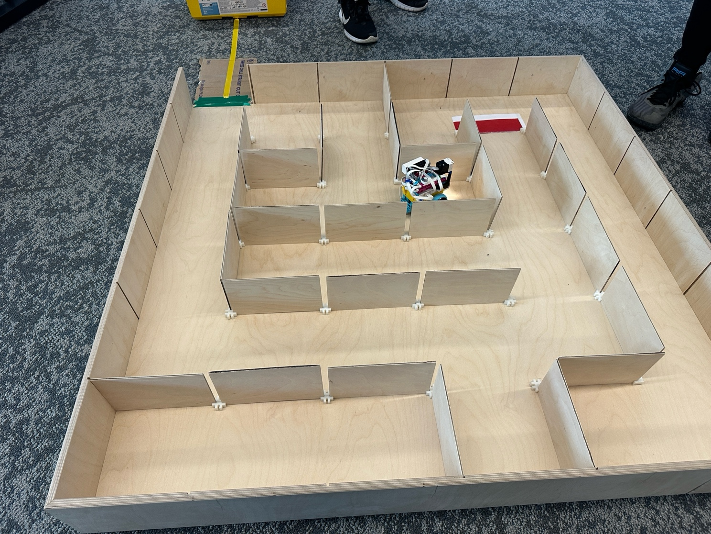

Table of content:
Table of Contents
Summary 4
Research 4
Illustrate / Plan 7
Design of the robot 10
Assess success of each stage of the problem 10
Lines: 10
Obstacle: 10
Maze 11
Maze obstacle 11
Conclusion 11

Summary
The overall objective is to program the robot so it may navigate through the maze whilst using sensors and programming parameters to overcome obstacles such as walls, and empty space to make relevant manoeuvres to readjust itself, ultimately finishing the maze automated not requiring any additional predetermined programming, this is the goal, if implemented correctly, this should theoretically navigate any given maze without any further intervention or programming, using hardware senses and software implementation in synchronisation, this could be implanted in real robots mapping and observing on given area.

Research
The main tools to solve the objective, two main components to this build, which is hardware and software, working in conjunction, software analysing input from sensors,
Building the robot components needed from Lego Spike,
1: Distance sensor
2: Colour sensor
3: Force sensor
4: Two medium motors
5: Large Hub

First constructing a basic driving Assembly, which then added all the necessary sensors from above list, making a complete robot with all sensors, however, before this process, basic movement experimentation needed to be done, for example make sure multi the right lettered USB port, in our example we had two motors so this could be independently controlled like speed, rotation, yaw angle, just alarm for precise pre-program movement
Or automation from sensors input, lots of readjusting program and how to solve the maze objective, for instance the colour sensor will follow particular coloured line before approaching obstacle, a force sensor would be activated in conjunction with the distance sensor, with the right program in this will be able to move around an object to get back onto the yellow line, using the same effort, the robot will tackle the maze start to finish.

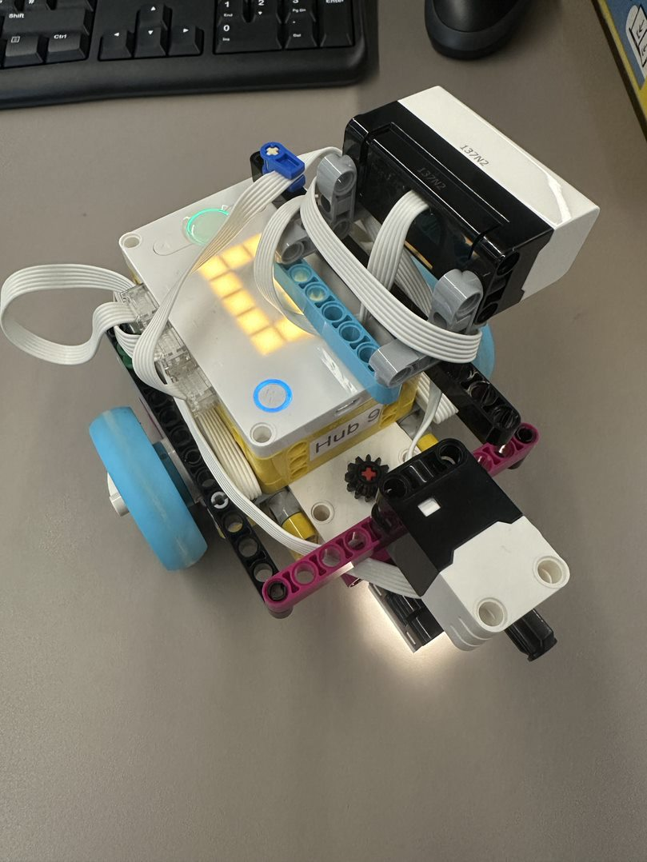

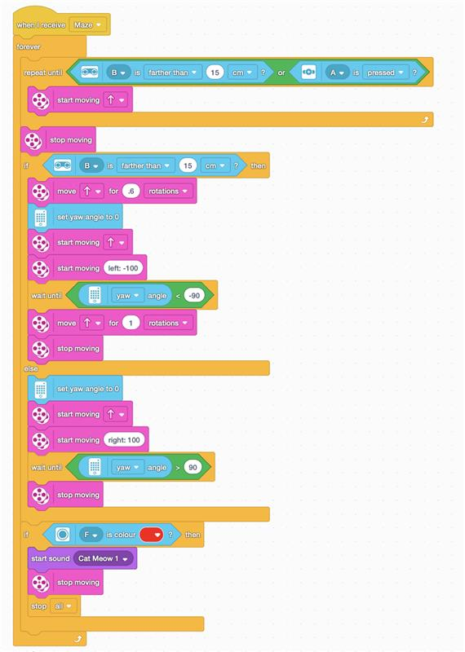

Some pictures of our robots on some sample programs for basic maneuver’s.

Illustrate / Plan
This was a gradual process, learning all intricacy of programming with the hardware,
From initial process, this was tested on real maze,

First stage follows the line with the colour sensor, demonstration, this was yellow,
This was achieved by programming the following, the program will start in the loop,
The loop will follow incremental left and right, for example, if the sensor picks up no yellow, turn right, if yellow is not detected, it will turn left, it will be in the continuous loop until which is end of yellow, which breaks out to the loop. Or colour sensor.

Second stage robot will hit the obstacle with the activation of the pressure sensor,
This will 90% turn to the right continue until the distance sensor is activated,
When blank space is detected, it will activate a program to turn left,
Until it reaches re-joins the yellow line.
This will reactivate the program above looping until yellow line finishes,

Third stage different block program will be activated once colour sensor detects green,
The robot will then use combination of force sensor and precious sensor, colour sensor is not active in the maze, example of Codes.

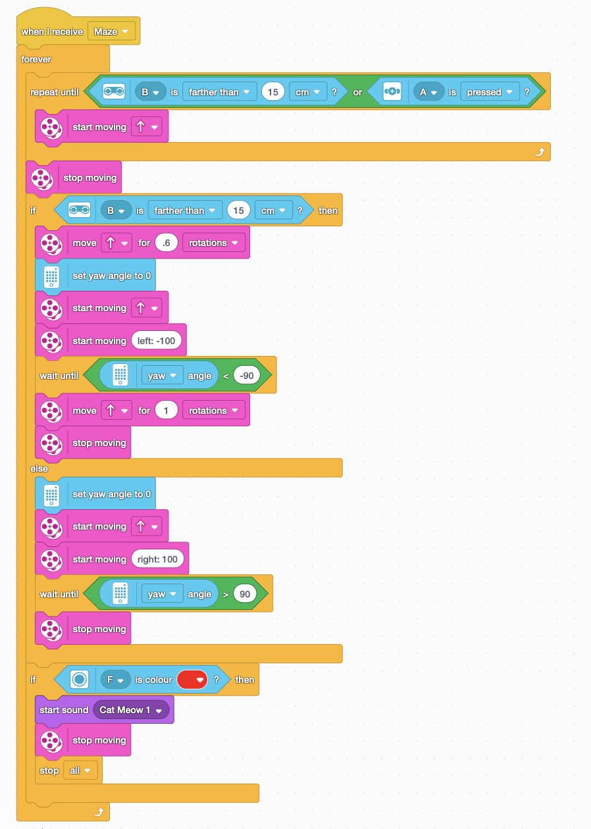

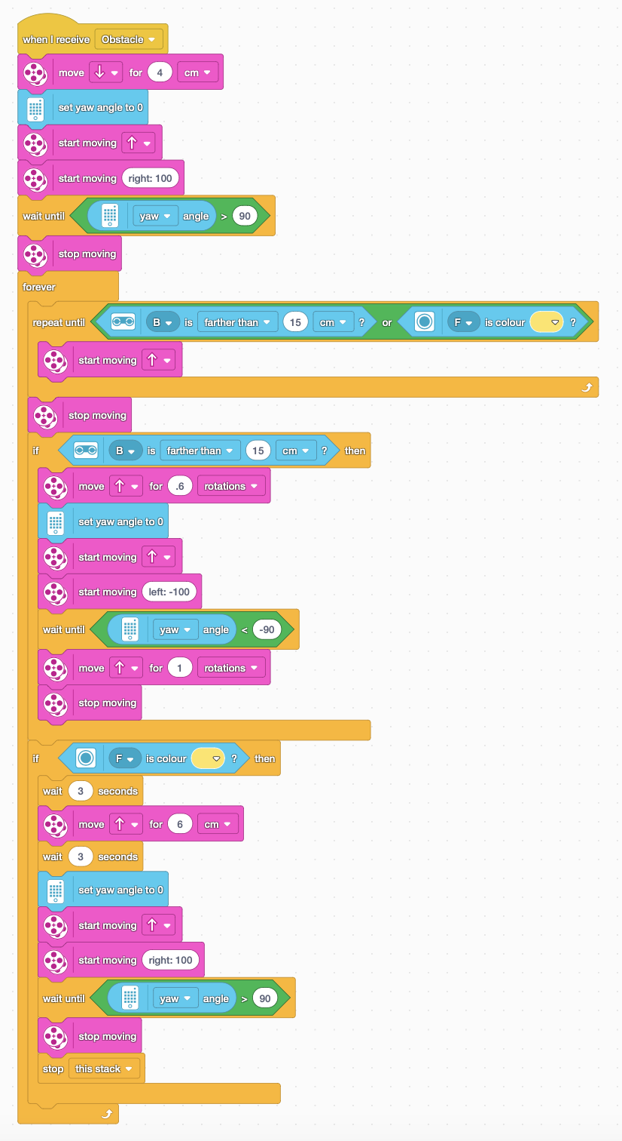

Design of the robot

This began with construction of robot, main components the hub, two motors
One Ball stabiliser instead of wheel, Two wheels, additional colour sensor on the bottom,
Distance sensor on one of the sides, pressure sensor on the front.

Colour sensor detects different range of colours,
Pressure sensor detects a solid object in front or an obstacle, which needs to be overcome in the program,
Distance sensor detect empty space or a space distance to the robot, this is vital for manoeuvre in a maze.

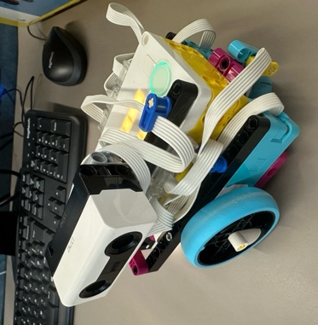

Assess success of each stage of the problem

Lines:
First goal was to get the robot successfully following a coloured line, this required very specific programming due to it making sure the robot did not deviate from the line, if diverted, it will reuse the colour sensor to allocate the line and proceed,

Obstacle:
Robot successfully navigating the line objective with the obstacle in the way, while successfully approaching the entry to the maze. To get this outcome, the obstacle is detected when the pressure sensor is activated, this will activate the program to slightly move back and turn 90° to the right, once this is proceeded, it will activate the distance sensor on the left side of the robot, while the robot is moving when the distance sensor detects empty space, the robot will turn 90° left, then it will use the distance sensor to remain alongside obstacle on the right whilst moving forward. As the obstacle we will be using is a box, while this is operating the colour centre is still active looking for yellow line for the colour sensor, once the yellow is detected, it will follow the yellow line until the green line is detected, beginning of the maze.

Maze:
The successful operation of the maze, the robot navigates through the maze successfully from start to finish starting at green line, successfully completing the maze once reached the red line at the end.
Robot needs to navigate using combination of pressure sensor and distance sensor.

Maze obstacle:
The robot needed the pressure so it detects obstacles, this would activate a 90° turn to the right, repeat if obstacle detected again turn right at 90°, in conjunction with the distance sensor to determine the direction,
If no obstacle is detective the robot will continue in conjunction with the distance sensor,
Determining if there’s empty space or an object in close proximity, if objects are close, the proximity, the robot will continue to move forward, if empty space is detected the robot will turn 90° left into the empty space, all the above programs is continuing once robot has successfully reached the red line at the end the colour sensor detect the red line to finish operation, end of successful program.

Conclusion

My understanding from perspective of hardware and software to overcome real world obstacles, in our case a predetermined maze,
You would have explicit understanding of hardware and software to perform the functions required to get the robot fully operate a successful outcome to the objective required,
Many trials and errors are required, even for the simplest moments and adjusting depending on input of sensors, indirectly teaching you the logical programming and logical steps required for the program to function properly.
Reinforcing basic hardware fundamentals and their abilities for different task, such as pressure sensor which is totally different to colour sensor, again both totally different to the distance sensor, in combination, you have all the hardware inputs needed,
This is dependent on how successful you programme with parameters this will determine how sensor performs task in combination.

We found the programming aspect is far more challenging than building the robot itself,
As many repeats of different variations of programming required to perform simple functions, this is a tedious and lengthy process which used to be completed, then modified,
Then moving onto the next program in block, until the program is considered finalised to carry out Objective successfully.

In my experience with my teammates, this is a great fundamental to starting robotics or programming if that was your desired subjects,
Further insight in the Lego spike we used and all specifications https://www.lego.com

Sanwar Ahmed

