

Programme: BA (Hons) Business Management
Module: Principles of Marketing
Module code: LCBB5015
Assignment Title: Component 2: Coursework: Group Report
Group Member’s Names and IDs:
Group Member 1:Stefanita-Cosmin Calarasu: 2328896
2.Nicoleta Samson: 2437295
3.Raluca Florina Nicolici :2311955
4.Adrian Merisan :2226309

Table of Contents
1. Introduction and Mission 2
1.1 Overview of the chosen company 2
1.2 Purpose of the report 2
2. Situational Analysis 3
2.1 PESTEL framework 3
2.2 SWOT analysis 5
2.3 Porter’s Five Forces 6
3. Marketing Strategy 8
3.1 STP analysis 8
3.2 Integrated marketing 9
3.3 Ansoff matrix 10
4. Marketing Mix Strategies: 7Ps analysis 10
5. Implementation and Control 12
5.1 KPIs analysis 12
5.2 Balanced scorecards 14
6. Conclusion and recommendations 14
7. References 16
8. AI declaration 19

1. Introduction and Mission

1.1 Overview of the chosen company
The selected company for completing this report is Aston Martin, which is a British Luxury automobile business which operates in the ultra-premium vehicle industry. Established in 1913, Aston Martin is well-known for extensive vehicle design and production of high-quality sports cars, grand tourers, and premium SUVs, which combine high-end engineering, superior design, and craftsmanship (Aston Martin, 2024). The product portfolio of the brand portrays a mixture of iconic or heritage models with advanced engineering, such as Vantage, DB12, and DBX models. Not only a vintage or iconic model, but DBX707 is Aston Martin's very first hyper car, which aligns with its innovation, racing designs, and sustainability strategy.
The business is looking forward to developing alternatives to the Internal Combustion Engine with a blended drive train process between 2025 and 2030. Designs included PHEV and BEV with a transparent plan to create a line-up of electric sports vehicles and SUVs (Aston Martin, 2024). The brand creates designs and exports vehicles to almost 56 countries worldwide with more than 2,500 employees dedicated to embarking on a sustainability initiative named 'Racing Green' (Amazon Web Services, 2026). However, Aston Martin's market capitalisation is almost 415.13 million GBP ($556.4m) in 2024, showing a strong market position in the luxury and sports car manufacturing sector globally (GlobalData, 2026). In the last two years, Aston Martin has been facing revenue decline, which was 1.27 billion GBP ($1.7b) in 2024, down by 20.7% compared to 2023 revenue cap (GlobalData, 2026). However, in the first quarter of 2026, Aston Martin ended up with a 16% year-on-year hike to 270.4 million GBP ($365.2m), effectively driven by additional funding support (Yahoo Finance, 2026). As a result, gross profitability increased by 44% to 93.9 million GBP with an enhancement in gross margin by 33.7% compared to 27.9% in the last year (Yahoo Finance, 2026). However, focus on sustainability and resilience in operations and marketing, ensuring market recovery for Aston Martin.

1.2 Purpose of the report
The main aim of the report is to look at Aston Martin's marketing strategies and examine how the brand is able to attract consumers. The business is dedicated to providing high-quality experiences to its customers, both in its vehicle customisation and in its innovations and resilience offerings for the automobile industry. The company is dedicated to delivering a superior design, which helps it stand out in the competitive luxury vehicle industry. The report features an analysis of the segmentation as well as a targeting approach, which will assist the business in understanding the possible credible customer bases.

2. Situational Analysis

2.1 PESTEL framework
Factors | Degree of impact | Impact
Political | High | The political debate in the UK regarding EV cars has created intense pressure on manufacturers like Aston Martin. For the last few months, Britain's plan to force a new EV car monopoly on people by 2035 has been a huge source of political instability (Forbes, 2026). It was predicted that the plan would be impossible and cause huge bankruptcy and job losses. However, the current government plans an EV market share of 33% in 2026, 38% in 2027, 52% in 2028, 66% in 2029, and 80% in 2030 (BBC News, 2026). For Aston Martin, changes in government policies disrupt global trade agreements and import tariffs, which might restrict vehicle import-export and affect manufacturing.
Economical | High | Currently, the UK's inflation rate is 2.8%, which was down from 3.3% in March but is still high compared to the Bank of England's target of 2% (BBC, 2026). As inflation rates rise, consumers are more inclined to cut down on purchases of goods such as cars that are considered luxuries. Inflation in the UK has also increased with a slight deceleration in the rate, up to 4.5% to 4.7% as a result of the downward effect on transport costs caused by Vehicle Excise Duty (VED) posts which were driven by the upward trend in energy cap and fuel prices, up 23% (Trading Economics, 2025). Therefore, the effect of the inflation rate on taxation and trade restrictions may cause an increase in manufacturing costs and the influence on the buying power of customers.
Social | Moderate to high | As per Chawla et al., (2023), in the current time, customers are reluctant to adopt new technologies, which are denoted as significant barriers to global EV adoption. Younger generations are increasingly valuing eco-friendly brands, encouraging luxury brands like Aston Martin to balance luxury performance with resilience.
Technological | High | In 2026, the estimated revenue cap of the EV market in the UK is projected to grow to 32.65 billion GBP ($43.8b) with an annual CAGR rate of 7.29% in 2026-2030 (Statista, 2026). However, governments are investing largely towards technology that might help boost EV production and hypercar technology for sustainable automobile manufacturing. In 2025, the UK government announced a backup of 10 million GBP of government funding for EV production to operate without large grid networks or off-grid systems (GOV.UK, 2025). These funds would encourage businesses to optimise technology and enhance production levels.
Legal | High | Changing laws and restrictions in the post-pandemic situation within the UK is a common issue for businesses to manage intellectual property rights and assets. For example, the UK's new Automated Vehicle Act 2024 restricted car technology and terminology under section 78, which officially authorised automated vehicles and self-driving cars (Institute for Global Automotive Regulatory Research, 2026). Due to safety concerns, businesses need to revaluate their marketing approaches and focus on more data authentication.
Environmental | High | Increasing concern for sustainability and carbon emissions in the global automobile industry is increasing resilience practices (Abdelaziz and Munawaroh, 2024). For example, the UK's net zero targets by 2030 creates pressure on businesses to reduce their carbon emissions and enhances sustainability practices accurately (UK Parliament, 2024). However, with growing customer awareness towards sustainability and government commitments, Aston Martin needs to enhance investment in hybrid and electric vehicle manufacturing with responsible marketing activities.
Table 1: PESTLE analysis of Aston Martin

2.2 SWOT analysis
Strengths
- Aston Martin has had a very strong brand reputation and visibility within the luxury automobile industry for over a century.
- The brand is well-known for its wide-ranging craftsmanship, diverse portfolio from SUVs to sports cars, and exclusivity in designs that ensure edge as well.
Weaknesses
- High production costs increase operating costs compared to other mass-market producers in the industry.
- Dependence on affluent customers only decreases its reach and makes demand vulnerable during economic downturns.
Opportunities
- Growing demands for hybrid SUVs and hyper sports cars are increasing market opportunities for luxury brands (Barakati et al., 2024).
- Increasing growth opportunities in markets like the Asia Pacific and the Middle East, embracing future development aspects for Aston Martin.
Threats
- Intense competition from other market leaders, including Ferrari, Bentley, Lamborghini, Porsche and BYD, is increasing competitiveness in the market.
- Changing environmental concerns and compliance might impact the operations of large-scale businesses (Jagani et al., 2024).

2.3 Porter’s Five Forces
Forces | Degree | Analysis
Threats of substitute | Moderate | There is limited substitute or alternative options available for customers in the automobile industry, particularly in the EV and sports car sections. Customers seek prestige and performance from luxury brands like Aston Martin, Ferrari, Bentley, or Lamborghini. However, the likelihood of threats of a substitute for Aston Martin is moderate, as there are no such direct or reliable alternatives.
Threats of new entrants | Low | Entering the luxury automobile industry requires huge capital investment with advanced engineering expertise to compete with market leaders (Yeung, 2024). Moreover, strong brand reputation, visibility, and distribution networks are core drivers in the luxury automobile industry to drive success. However, threats of new entrants for Aston Martin are low as it is difficult for new entrants to establish credibility and brand loyalty within the segment.
Bargaining power of customers | Moderate to high | Affluent buyers have high-end accessibility to different market leaders, and they can easily switch to brands based on processes, technology, performance, and design. However, customers looking for heritage and premium branding tend to stick with one brand instead of switching. On the other hand, customers are expecting quality and customer experiences that influence manufacturers' market activities. Thus, Aston Martin needs to enhance investment in technology and design to sustain quality and loyalty.
Bargaining power of suppliers | Moderate | Aston Martin has dedicated suppliers who provide high quality engineering materials, technologies and high performance components. The few suppliers needed for luxury inputs intensify the luxury influence and limit the power of the luxury inputs. Nevertheless, developing strategic partnerships and alliances with suppliers can decrease their power and influence on quality for Aston Martin.
Competitive rivalry | High | Despite the high capital requirement for new entrants, competitiveness in the Luxury automobile industry globally is highly due to the presence of market leaders, including Ferrari, Mercedes-Benz, Porsche and others. Aston Martin needs to focus on consistent product development and marketing investment, which are required to maintain market value and brand image.
Table 2: Porter’s five forces analysis of Aston Martin

3. Marketing Strategy

3.1 STP analysis
Segmentation
Demographic- primarily, Aston Martin targets high-income affluent customers aged from 30 to 70 years old who have significant purchasing power.
Geographic- Aston Martin is a UK-based brand, but it operates in global markets and is present in 56 countries. The business is targeting to enter emerging markets consisting of the Asia-Pacific, India, and the Middle East regions, whose high-end purchasing power locations and demands for luxury vehicles are strong enough.
Psychographic- Aston Martin focuses on appealing to adult customers who are looking for brand prestige, exclusivity, luxury, performance, high status, and sophisticated lifestyles with growing sustainability concerns. The targeted customers want products to convey their success and importance to the society with a premium emphasis are fundamental focus of Aston Martin.
Behavioural- The business targets consumers who show a strong brand loyalty, appreciate bespoke personalisation, and are willing to pay high prices for sustainability, resilience, craftsmanship, exclusivity, and high-quality performance,
Target market
Age group | Primary targets are affluent customers aged between 30 and 70 years old.
Income status | High-net-worth customers with stable financial conditions, as the cost of products is high compared to mass market producers.
Places and locations | Primary targets are urban locations to appeal to high-class customers who seek heritage and performance.
Table 3: Target market analysis of Aston Martin
Market position map
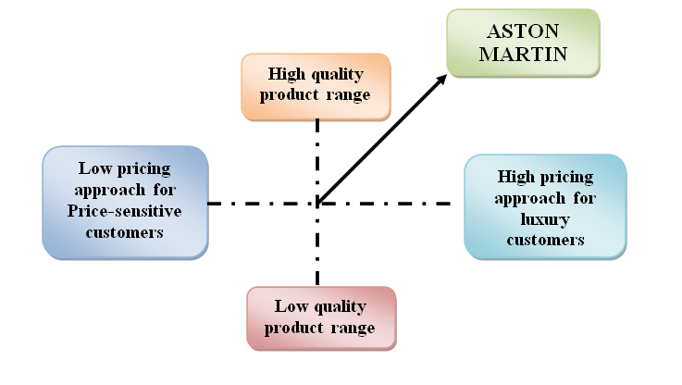
Figure 1: Market position of Aston Martin
Figure 1 shows that Aston Martin is focusing on the high-quality and high-price market segment to appeal to high-net-worth customers.

3.2 Integrated marketing
According to Firmansyah et al., (2022), due to the changing nature and high dynamics in the automobile industry, brands are focusing on large-scale promotions to neutralise market competition and introduce their products through different promotional activities like prizes, lucrative offers, and discounts. However, Aston Martin focuses on an integrated marketing approach through enhancing communication between the customer and brand in all marketing channels. As argued by Blakeman (2023), integrated marketing enhances communication approaches through multi-faceted ways that ensure customers' issues are resolved, and they become satisfied. However, Aston Martin focuses on employing public relations, advertising, social media marketing, sponsorships, and website marketing. The business sponsors different motorsport activities, such as Formula 1, and different experiential events, which help in reinforcing its brand image as a premium automobile brand. Through a well-coordinated marketing strategy, Aston Martin has consistently delivered a message of exclusivity, performance and refinement to all customer interactions.

3.3 Ansoff matrix
Ansoff Matrix is a strategic planning tool which helps businesses address market growth opportunities. It has four quadrants with four strategies, including market penetration, market development, product development, and diversification (Zugay and Zakaria, 2023). For Aston Martin, the most effective strategy adopted by the brand is Product development, in which the brand consistently focuses on innovating new vehicles as well as improving existing models with new features. Its diverse product portfolio included luxury SUVs, hybrid vehicles, hyper sports cars, and EVs, according to changing customer preferences and environmental concerns. For instance, Aston Martin's attention is directed at making the most of the electrification of the DBX SUV model. With this approach, Aston Martin is able to further reinforce its market competitiveness and continue to focus on the premium car market.

4. Marketing Mix Strategies: 7Ps analysis
Product strategy- The product portfolio of Aston Martin is quite lucrative and diverse as it includes cars, grand tourers, hypercars and luxury SUVs. The products are designed to deliver high-quality performance, exclusivity and luxury craftsmanship. There are various models offered by Aston with a mixture of heritage and technology, such as Vantage, DB12, Vanquish and DBX ranges. The core motto of the brand is to deliver cutting-edge engineering and exclusive customisation options to target customers. The brand effectively invests in sustainable practices through EVs and hybrid car manufacturing to achieve evolving customer demand and sustainability requirements in the market.
Pricing strategy-The pricing strategy of Aston Martin is premium and high-priced due to exclusivity and luxury brand positioning. The brand focuses on attracting affluent customers and high-class audiences. Aston Martin sells vehicles at a high price compared to affordable and mass-market vehicles. According to Shao et al., (2022), customers in the automobile industry are willing to pay premium pricing for green practices and reducing risks of carbon emission and are interested towards environmentally friendly brands. Nevertheless, premium pricing assists the brand to reinforce the concept of exclusivity, craftsmanship, quality and prestige in addition to increasing profitability.
Place of distribution- Aston Martin imports products worldwide with a strong global network of authorised dealerships and showrooms located in key luxury markets across Europe, North America, the Middle East and Asia-Pacific. The business provides services to 56 countries globally and is considered one of the luxury car brands globally. In addition, Aston Martin also has a digital presence through its website that enables customers to view 3-d models and communicate with customer service virtually.
Promotion- Aston Martin's marketing activities include internet marketing, taking part in motorsport, sponsoring motorsport, high-end advertising and public relations. The Aston Martin Aramco F1® team serves as a global promotional platform and high-end accessibility to innovation from the pinnacle of the motor sports and vehicle industry (Aston Martin, 2026). Aston Martin's almost 60-year-old partnership with the James Bond film franchise has helped to boost its global brand recognition (Aston Martin, 2024). The iconic presence of Aston Martin's ultra-luxury Tourer DB12 is recognised as the great Bond 007, courtesy of which it attracted customers effectively. In addition, the brand extensively invests in social media marketing, invitation-only events and luxury goods partnerships to improve customer engagement and brand image.
People- Employees play a crucial part in delivering services and optimising business performance in a competitive market like the luxury automobile industry. There are almost 2500+ employees operating worldwide to extend the brand experience of Aston Martin. Effective customer satisfaction and quality products are ensured by skilled engineers, designers, techs and customer service professionals (Venkat et al., 2023). This expertise enhances the company's image for expertise, originality, and personalised service.
Physical evidence- Physical presence of Aston Martin occurred through its luxurious showrooms, premium car designs, branded items and state-of-the-art production inventories. In addition, Aston Martin uses virtual reality technology in its showrooms with XR/VR headsets for delivering a never-before-seen experience to customers regarding products like the Aston Martin DBX (Lenovo Story Hub, 2021). The luxury positioning of the brand and the consumer's trust towards the product portfolio are substantiated by the high quality of goods, the sophisticated interior design and the unique design of the car.
Process- Aston Martin is dedicated to delivering an exceptional customer experience from initial car selection to aftercare. The brand's ‘Aftercare Intensified' initiative delivers an unrivalled experience with tailored services to reach unique Aston Martin models (Aston Martin, 2026). The consistent services and maintenance with industry-specific warranties provide peace of mind to customers for extensive after-sales services. It has a large number of sophisticated manufacturing processes and strict quality assurance checks to ensure that all vehicles meet customer expectations. However, good maintenance and services can leverage customer loyalty.

5. Implementation and Control

5.1 KPIs analysis
KPIs are essential for businesses as they assist in assessing whether objectives related to sales, growth, and satisfaction are achieved or not (Camilleri, 2024). Effective implementation of Aston Martin’s marketing strategy needs consistent monitoring and focus on Key performance indicators or KPIs.
Annual revenue growth- It is one of the important KPI for Aston Martin to evaluate the effectiveness of sales and strategic marketing planning.
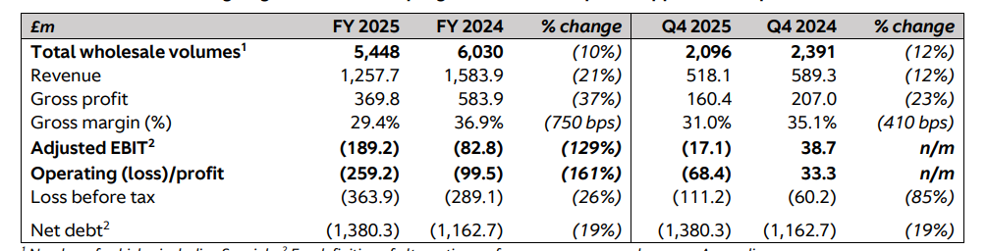
Figure 2: Annual revenue of Aston Martin
(Source: Aston Martin Lagonda Global Holdings plc, 2025)
Figure 2 shows revenue data of FY 2025 and FY 2024, in which the average selling price of products increased by 5% while gross profit declined (Aston Martin Lagonda Global Holdings plc, 2025). On the other hand, it can be seen that the commencement of manufacturing of Valhalla, with 152 deliveries in 2025 (Q4), supports strong financial performance and revenue growth.
Vehicle Sales Volume
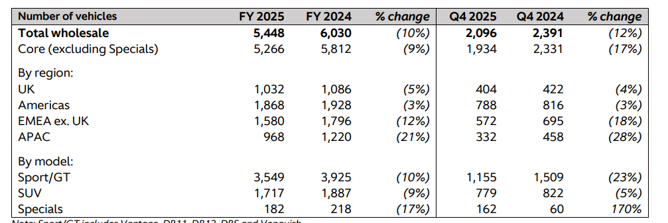
Figure 3: Vehicle sales of Aston Martin in 2025 FY
(Source: Aston Martin Lagonda Global Holdings plc, 2025)
Figure 3 shows that Aston Martin's performance in 2025 was quite satisfactory despite high-level challenges in the global automobile industry, including geopolitical conflicts and a high inflation rate. However, FY 2025 total vehicle volume was down by 10% at 5,448, which was 6,030 in 2024 FY (Aston Martin Lagonda Global Holdings plc, 2025). The brand is maintaining a disciplined approach to manage a consistent balance between production and market demands, along with overcoming market losses.
Customer retention rate
It is an important KPI which indicates the business’s ability to maintain a long-term relationship with customers (MoghadasNian and Takzare, 2024). Aston Martin focused on launching four new derivatives to expand and improve its model to provide customers with choices and enhance its retention level.

5.2 Balanced scorecards
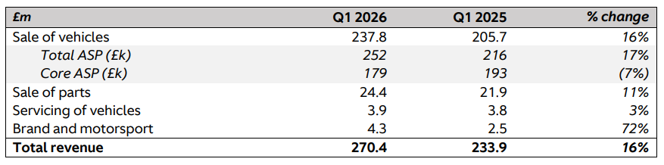
Figure 4: Comparison of the financial cap of Aston Martin in 2026 and 2025
(Source: Aston Martin Lagonda Global Holdings plc, 2026)
Perspectives | Objectives | Performance evidence
Financial | Enhancing revenue and profit | Figure 4 shows that total revenue increased by 16% (Aston Martin Lagonda Global Holdings plc, 2026).
Customer satisfaction | Increase demands and loyalty | Vehicle sales enhanced by 17% (ASP)
Internal process and growth | Enhance brand value and after-sales performance | Parts sales increased by 11% which leveraged brand revenue increased by 72% (Aston Martin Lagonda Global Holdings plc, 2026).
Table 4: Balance scorecard analysis of Aston Martin

6. Conclusion and recommendations
Lastly, it can be concluded that Aston Martin has a strong market position in the Luxury automobile industry globally. The STP evaluation illustrates that the business effectively targets affluent customers seeking performance and standard. Thereafter, 7Ps supports its premium marketing position and pricing through fostering innovative productions and strong promotional activities. To strengthen performance, the following approaches can be followed,
- People are looking for sustainability, but a high price range has become the biggest concern for producers. Hence, Aston Martin is recommended to increase its investment in sustainability features like carbon neutrality in vehicles.
- It is suggested that the business enhance its digital marketing and customer engagement activities for promising growth. The market for the sale of luxury cars in emerging countries, such as India, UAE and other developing nations, is growing and creating new opportunities for Aston Martin marketing.

7. References
Abdelaziz, S. and Munawaroh, M., (2024). Mitigating supply chain vulnerabilities: a bibliometric analysis of sustainable logistics for resilience and risk management with perspectives on the automotive industry. International Journal of Automotive Science And Technology, 8(4), pp.544-588.
Amazon Web Services (2026). Aston Martin & Data Reply – Amazon Web Services (AWS). Available at: https://aws.amazon.com/partners/success/aston-martin-data-reply/ [Accessed 13 Jun. 2026].
Aston Martin (2024). About Us. Available at: https://www.astonmartin.com/en/corporate/about-us [Accessed 12 Jun. 2026].
Aston Martin (2024). Q by Aston Martin Celebrates 60 Years of Iconic James Bond Partnership with DB12 Goldfinger Edition | Aston Martin. Available at: https://www.astonmartin.com/en/our-world/news/2024/10/14/q-by-aston-martin-celebrates-60-years-of-iconic-james-bond-partnership-with-db12-goldfinger-edition [Accessed 13 Jun. 2026].
Aston Martin (2026). Aftercare Intensified. Available at: https://www.astonmartin.com/en/owners/aftercare [Accessed 15 Jun. 2026].
Aston Martin (2026). Strategy. Available at: https://www.astonmartin.com/en/corporate/about-us/strategy [Accessed 15 Jun. 2026].
Aston Martin Lagonda Global Holdings plc (2025). Preliminary Results for the Twelve Months Ended 31 December 2025. Available at: https://www.astonmartin.com/-/media/corporate/documents/fy-results-2025/aston-martin-lagonda-fy-2025-results.pdf [Accessed 15 Jun. 2026].
Aston Martin Lagonda Global Holdings plc (2026). First Quarter Results for the Three Months Ended 31 March 2026. Available at: https://www.astonmartin.com/-/media/corporate/documents/2026/aston-martin-lagonda-q1-2026-results.pdf?rev=f65972979b214ba294fb5f300d5d9ac7 [Accessed 15 Jun. 2026].
Barakati, P., Bertini, F., Corsi, E., Gabbrielli, M. and Montesi, D., (2024). Luxury car data analysis: a literature review. Data, 9(4), p.48.
BBC (2026). UK Inflation Rate: How Quickly Are Prices Rising? Available at: https://www.bbc.com/news/articles/c17rgd8e9gjo [Accessed 15 Jun. 2026].
BBC News (2026). UK Electric Car Sales Target Set to Be Weakened. Available at: https://www.bbc.com/news/articles/cx2dmwmj4dmo [Accessed 15 Jun. 2026].
Blakeman, R., (2023). Integrated marketing communication: creative strategy from idea to implementation. Bloomsbury Publishing PLC.
Camilleri, E., (2024). Key performance indicators: The complete guide to KPIs for business success. Routledge.
Chawla, U., Mohnot, R., Mishra, V., Singh, H.V. and Singh, A.K., (2023). Factors influencing customer preference and adoption of electric vehicles in India: a journey towards more sustainable transportation. Sustainability, 15(8), p.7020.
Firmansyah, F., Setiawan, M., Rohman, F. and Indrawati, N.K., (2022). Dimensions of integrated marketing communication in the automotive industry. Journal of Positive School Psychology, 6(5), pp.1-13.
Forbes (2026). U.K. EV Rule Dilution Spurs Protest, but Industry Will Breathe Easier. Available at: https://www.forbes.com/sites/neilwinton/2026/06/15/uk-ev-rule-dilution-spurs-protest-but-industry-will-breathe-easier/ [Accessed 15 Jun. 2026].
GlobalData (2026). Aston Martin Lagonda Global Holdings Plc: Overview. Available at: https://www.globaldata.com/company-profile/aston-martin-lagonda-global-holdings-plc/ [Accessed 14 Jun. 2026].
GOV.UK (2025). £10 Million for Cutting Edge Tech to Help Futureproof England’s Electric Vehicle Chargepoint Supply and Keep Drivers Moving. Available at: https://www.gov.uk/government/news/10-million-for-cutting-edge-tech-to-help-futureproof-englands-electric-vehicle-chargepoint-supply-and-keep-drivers-moving [Accessed 16 Jun. 2026].
Institute for Global Automotive Regulatory Research (2026). UK: New Law Restricting Marketing of Automated Vehicles - Institute for Global Automotive Regulatory Research. Available at: https://igarr.com/de/2026/04/07/uk-new-law-restricting-marketing-of-automated-vehicles/ [Accessed 14 Jun. 2026].
Jagani, S., Marsillac, E. and Hong, P., (2024). The electric vehicle supply chain ecosystem: changing roles of automotive suppliers. Sustainability, 16(4), p.1570.
Lenovo Story Hub (2021). Aston Martin Uses Immersive Technology to Evolve Their Business and Ensure the Ultimate Customer Experience - Lenovo StoryHub. Available at: http://news.lenovo.com/aston-martin-uses-immersive-technology-to-evolve-their-business/ [Accessed 15 Jun. 2026].
MoghadasNian, S. and Takzare, S., (2024). Enhancing airline customer experience: A strategic approach to KPI-driven management. In The 8th International Conference on Management, Accounting, Economics and Social Sciences (pp. 1-17).
Shao, J., Li, W., Aneye, C. and Fang, W., (2022). Facilitating mechanism of green products purchasing with a premium price—Moderating by sustainability‐related information. Corporate Social Responsibility and Environmental Management, 29(3), pp.686-700.
Statista (2026). Electric Vehicles - United Kingdom | Market Forecast. Available at: https://www.statista.com/outlook/mmo/electric-vehicles/united-kingdom?srsltid=AfmBOorDHZrlUscTd3tO-gZf26eYTP7zU2917h4h6QQRp4lYL7Lr71zU [Accessed 14 Jun. 2026].
Trading Economics (2025). United Kingdom Inflation Rate. Available at: https://tradingeconomics.com/united-kingdom/inflation-cpi [Accessed 14 Jun. 2026].
UK Parliament (2024). The UK’s Plans and Progress to Reach Net Zero by 2050. Available at: https://commonslibrary.parliament.uk/research-briefings/cbp-9888/ [Accessed 13 Jun. 2026].
Venkat, M.V.V., Khan, S.R.K., Gorkhe, M.D., Reddy, M.K.S. and Rao, S.P., (2023). Fostering talent stability: a study on evaluating the influence of competency management on employee retention in the automotive industry. Remittances Review, 8(4), pp.2300-2328.
Yahoo Finance (2026). Aston Martin Narrows Losses Despite Rising Debt in First Quarter. Available at: https://finance.yahoo.com/markets/stocks/articles/aston-martin-narrows-losses-despite-173459720.html [Accessed 12 Jun. 2026].
Yeung, G., (2024). Competitive dynamics of lead firms and their systems suppliers in the automotive industry. Environment and Planning A: Economy and Space, 56(2), pp.454-475.
Zugay, B. and Zakaria, R., (2023). Ansoff matrix. SAGE Publications, Inc.

