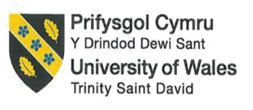

Contemporary Themes in the Hotel and Hospitality Sector
BMIH6001

Student Name: Romeo Popescu
Student ID: 1922487

Abstract
Accommodation businesses like hotels, restaurants, resorts, and event spaces are all part of the hospitality industry. They all serve guests, tourists, and locals. The economic and social importance of this business is clear because it makes a big difference in local economies and job opportunities. A lot of resources are used by the hotel industry, and it can have a big effect on the environment and the people who live nearby.

Table of Contents
Assignment 1 3
Abstract 3
Introduction 4
Overview of Literature 5
Eco-friendly Practices 5
Sustainability and Green Initiatives 5
Application to the hotel and hospitality sector 6
PESTLE Analysis 6
Industry Responses and Critical Reflection 8
Strengths 8
Limitations 9
Future policy and management options 9
Conclusion 11
Assignment 2 12
References 18

Introduction
Sustainable hospitality entails incorporating environmentally friendly techniques into all aspects of the industry’s operations. This includes eliminating waste, conserving energy and water, procuring local and organic products, and promoting responsible tourism (Iddawala, Welengoda, and Rathnayaka, 2024). As people care more about social responsibility and protecting the environment, the idea of sustainability is becoming more popular in many companies. A lot of changes are happening in the hospitality business to make it more environmentally friendly. Sustainable hospitality tries to combine an amazing guest experience with the well-being of the environment and society. This is happening in all areas of travel, leisure, and lodging. A 2022 study on sustainable travel found that 81% of travellers around the world said that travelling in a way that doesn’t harm the environment was important to them (Khatter, 2023). Half of those travellers said that climate change made them want to make better choices for the environment (Prud’homme and Raymond, 2013). By doing so, the sector may gain numerous benefits, including lower operational costs, higher brand perception, increased guest loyalty, and, most crucially, a beneficial environmental impact. The paper will illustrate the impact of sustainable practices in the hospitality sector in enhancing customer service. Sustainability is a way for people and groups to make big changes, like slowing down climate change, protecting natural resources, and encouraging responsible tourists.

Overview of Literature
At a time when caring for the earth is very important to everyone, businesses are being pushed to use environmentally friendly methods. The hotel business is one of these that stands out because it uses a lot of resources, especially water. One area that could use some improvement is how the house is cleaned. Making small changes could save a lot of water. The collected water is used for many things, like cleaning the hotel’s hallways and service areas and giving plants in the green areas water (Sakshi et al., 2020). By using this resource that wasn’t being used before, the hotel shows it cares about the environment and cuts down on the costs of running its business related to water use. In this field, it’s impossible to stress enough how important it is to use safe methods. So, the paper will mostly show how hotels can use sustainable and eco-friendly methods.

Eco-friendly Practices
Smart ways to save water low-flow plumbing features are becoming more popular in many places, including hotels. These faucets are made to use less water while still doing their job, which is good for both the environment and businesses. When it comes to the hotel business, where water use can be high, installing low-flow bathroom fixtures can have many benefits. Madanaguli et al. (2023) discovered that low-flow fixtures can save as much as 50% more water than regular faucets. This big cut not only saves water but also cuts down on the energy needed to heat water, which lowers total energy use and greenhouse gas emissions. Having low-flow valves is helpful in more ways than one. A study from 2023 by Modica et al. says that hotels that use these features get huge discounts. A hotel of this size can save around $25,000 a year on water costs this way. Hotels that use low-flow fixtures can often get green certifications like LEED (Leadership in Energy and Environmental Design), which can help them sell more rooms and bring in eco-friendly guests (Malheiro et al., 2020).

Sustainability and green initiatives
Water-saving measures by the hotel may be liked by people who stay in rooms with low-flow plumbing faucets. The guest experience can be improved by fixtures that use less water while maintaining the same level of performance and water flow (Malheiro et al., 2020). Customers might be more likely to stick with a business that cares about the environment, which could lead to good reviews and repeat business. Green and sustainable hotels can use devices that use less water to have a smaller impact on the environment. By using low-flow plugs, hotels can make it look like they care about the environment. If the weather is right and the yard is set up right, smart irrigation systems can cut the water used outside by 20% to 40%, according to Shereni et al. Smart irrigation systems help hotels be better for the environment by decreasing the use of harmful chemicals like pesticides and fertilisers and keeping the grounds healthy. An investigation by the World Resources Institute (WRI, 2021) says that hotels that have smart irrigation systems have happier guests, save money on water, and make their sites look better.

Application to the hotel and hospitality sector

PESTLE Analysis
Political | All over the world, environmental rules are getting tighter to deal with the lack of water and encourage long-term use. Groups like the Environment Agency work for the UK government and make rules. As an example, Fernández-Robin et al. (2019) says that the UK Water Industry Act of 1991 sets rules for how to run water and sewage systems. The Greater London Authority (GLA) made the London Plan, which says that new buildings must-have features that save water. To save water, it has strict rules.
Economical | A mid-sized hotel could save between $20,000 and $30,000 a year on water costs by putting in equipment that uses less water and doing regular upkeep to fix leaks and cut down on waste (Madanaguli et al., 2023). Hotels spend a lot of money on energy to heat water. Less water use, especially hot water use, can help hotels save electricity and money on their power bills. (Bruns-Smith et al., 2015) For example, low-flow showerheads lower both the amount of water used and the energy needed to heat the water, which saves even more money.
Social | As people learn more about climate change, resource loss, and how human actions affect the environment, they become more aware of their own ecological footprint. Eco-friendly hotels often focus on using natural, non-toxic materials, serving organic food, and offering wellness-focused services, which appeal to tourists who care about their health.
Technological | Modern methods for recycling water clean and use wastewater for things other than drinking, like flushing toilets, watering plants, and cooling air (Oliveras-Villanueva et al., 2020). These tools help hotels use less water overall and encourage environmentally friendly ways to handle water. Using past data and current trends, predictive analytics can guess how much water will be used in the future (Munir, 2022). This lets hotels guess when they will use the most water and make plans for those times, which leads to better water management.
Legal | The Water Industry Act of 1991 and later changes to it in the UK require efficient use and control of water (Floričić, 2020). To meet these guidelines, hotels must take steps to save water and make sure that their water use is sustainable. Green Key and LEED (Leadership in Energy and Environmental Design) certifications help hotels set up and keep up with environmental practices like saving water.
Environmental | The hospitality business is under a lot of pressure to use water more sustainably because of how much it uses in guest rooms, kitchens, laundry rooms, swimming pools, and landscaping. If hotels don’t do anything, they could hurt the environment, have problems running their businesses, and have their costs go up as water gets harder to get and more expensive (Floričić, 2020). Hotels that save water use less energy to heat and move water, which lowers the amount of greenhouse gases released into the air. The United Nations’ Sustainable Development Goals (SDGs) and other larger environmental and sustainability goals are in line with this all-around method of managing resources.

Industry Responses and Critical Reflection
Being environmentally friendly in a hotel means more than just using less energy and water and properly dealing with waste. Collectively, these strategies can assist hotels in being eco-friendlier and more long-lasting (Fonseca and Carnicelli, 2021). Worldwide, people are becoming more aware of environmental problems and are looking for places that put sustainability first.
Marriott International has saved a lot of water by buying state-of-the-art tools and showing workers how to use them for long periods of time. These steps have helped Marriott properties save a lot of water, which proves that their green programmes are effective (Marriott International, 2022). It can be hard for Marriott to get these ideas across the world because its properties are spread out and vary in size and location (Oliveras-Villanueva et al., 2020). It doesn’t matter that these things are going wrong; Marriott is still committed to its overall plan to save more water.
The Green Engage system was created by the InterContinental Hotels Group. It is a state-of-the-art tool that lets hotels watch how much water they use by monitoring it live and reviewing the information (Melissen, 2013). Since it was put in place, the Green Engage method has saved about 1.5 billion gallons of water (IHG 2020). When hotels use smart irrigation systems, they use less harmful chemicals like fertilisers and pesticides, which is better for the earth and keeps the grounds healthy. This way helps IHG properties keep track of the water they use, figure out where they’re wasting it, and make plans to cut back on water use (Sakshi et al., 2020). Smart irrigation systems make hotels’ grounds look better, make guests happy, and save them money on water. Hilton Worldwide has installed low-flow fixtures, smart irrigation systems, and water recycling technology across all of its properties as part of a complete water stewardship plan. Because of this plan, 20% less water is being used per occupied room (Hilton, 2021). This shows how committed the company is to being environmentally friendly.

Strengths
- Strategies that help people save water led to big cost cuts.
- Better brand image and more people choosing hotels that are better for the environment.
- Compliance with rules and norms for the environment.

Limitations
- Difficulty in adopting techniques consistently across various geographical regions and property kinds.
- Significant expenditure is required to implement modern technologies.
- There is a need for ongoing monitoring, maintenance, and staff training.

Future policy and management options
The main idea behind green hospitality is to make sure that guests are comfortable and well-cared for while also reducing the damage that hotel activities do to the environment. This means putting in place sustainable practices, spending on eco-friendly technologies, and making more people aware of problems facing the environment (Sharma, 2023). Green hospitality is more than just having a green building. Sharing sustainable practices with people, helping out in the community, and backing eco-friendly projects are also part of this. Hotels and spas should be good for both people and the earth, according to this comprehensive plan (Fernández-Robin et al., 2019). Lodging businesses can show they care about the environment by prioritising sustainability. Plus, if it’s done right, it can bring in more eco-friendly tourists.
Hotels stay sustainable and keep their customers happy by coming up with creative and eco-friendly ways to do things. These businesses know that today’s tourists often put environmental duty first, so they want to create an atmosphere where eco-friendly activities are an important part of the hospitality experience (Pereira et al., 2021). A lot of hotels and motels are using new technologies to lower their carbon footprints because using too much energy is still a big problem in the hospitality industry. Some of these are LED lights, solar panels, and heating and cooling systems that use less energy. Smart sensors can also be used to change the lighting and temperature of a room based on who is in it, so no energy is lost. Managing trash well is important for any company that cares about the environment. Hotels can cut down on waste in many ways, such as by starting recycling schemes, limiting single-use plastics, and offering reusable alternatives for things like towels and toiletries (Floričić, 2020). Food waste can also be turned into useful materials for local farming projects through composting programmes.
To get hotels to use water-saving methods, governments should make or expand incentive programmes. Another example is that the UK government could make its Enhanced Capital Allowance (ECA) strategy include more tools for saving water. Fewer restrictions on how much water hotels can use may encourage them to use eco-friendly ways (Bruns-Smith et al., 2015). Rules may say that new hotels and big changes need to use fixtures and systems that use less water. The UK might create more in-depth green certification schemes for the hospitality industry based on the success of programmes like the Green Tourism Award (Singal and Rhou, 2017). These certificates should make it clear to hotels how to meet and maintain high standards for sustainability and stress how important it is to save water.
It is also very important to teach people the right way to get rid of trash so that these projects are successful. There is a lot of food waste in the restaurant business. One way for hotels to fix this is to offer flexible meal choices or limit the size of portions in restaurants. Helping the community and lowering food waste can also be done by giving extra food to food banks or charities in the area (Legrand et al., 2022). Environmentally friendly supplies and goods can help local economies, lower a hotel’s carbon footprint, and make the workplace healthier for both employees and guests. To be more eco-friendly, a hotel can buy things in an eco-friendly way and use good shopping habits. As part of these steps, Malheiro et al. (2020) say to carefully choose sellers based on how socially and environmentally responsible they are and to buy as many local and organic goods as possible. A hotel can also show it cares about the environment by working with its suppliers to send fewer boxes and better packages.

Conclusion
Many hotels and resorts today can make a big difference in how little damage they do to the environment while still meeting the needs of eco-friendly visitors. These groups can also save money, improve their standing, and help make the future better for everyone (Bruns-Smith et al., 2015). Supporting these kinds of practices helps the hospitality business keep coming up with new ideas and has positive effects on society and the environment. These practices include using energy-saving technologies, waste management strategies, responsible sourcing, and water conservation measures.

Assignment 2
Introduction
People are becoming more worried about environmental protection and social responsibility, so many businesses are starting to use the idea of sustainability. Using eco-friendly methods in every part of the hotel business is what “sustainable hospitality” means. The Cambridge Institute for Sustainability Leadership says that tourism is responsible for about 5% of the world’s greenhouse gas emissions. By 2035, that number is expected to have grown by 130%. Hotels that make these schemes clear to guests and offer incentives for them to participate not only have less of an effect on the environment but also get guests involved in activities that are good for the environment (Shereni et al., 2023).
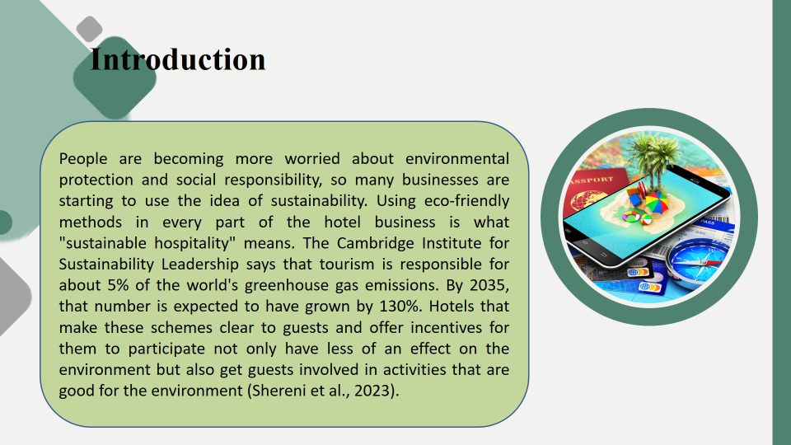
Overview of Literature
Hotels that regularly use cleaning methods that are safe for the environment can greatly reduce the damage they do to the environment and also be in line with goals for sustainable management. Laundry and dishwashing machines that use less water can help businesses cut down on water use, which is an important part of being environmentally friendly in the hotel industry (Pereira et al., 2021). With smart bathrooms and low-flow fixtures, you can save water while still making guests comfortable. The Cambridge Institute for Sustainability Leadership says that tourism is responsible for about 5% of all greenhouse gas emissions in the world. This number is expected to have grown by 130% by 2035. Up to 15% of the UK’s greenhouse gas emissions come from this sector, which also makes 920,000 tonnes of food trash every year (Floričić, 2020). Also, businesses in the hotel industry spend more than £1.3 billion a year on energy, which releases more than 8 million tonnes of carbon into the air. Paymentsense research shows that 66% of UK customers think that ethical factors are important when choosing where to eat. Visit England research shows that 58% of British would rather stay in places that have green prizes and use eco-friendly methods (Oliveras-Villanueva et al., 2020).
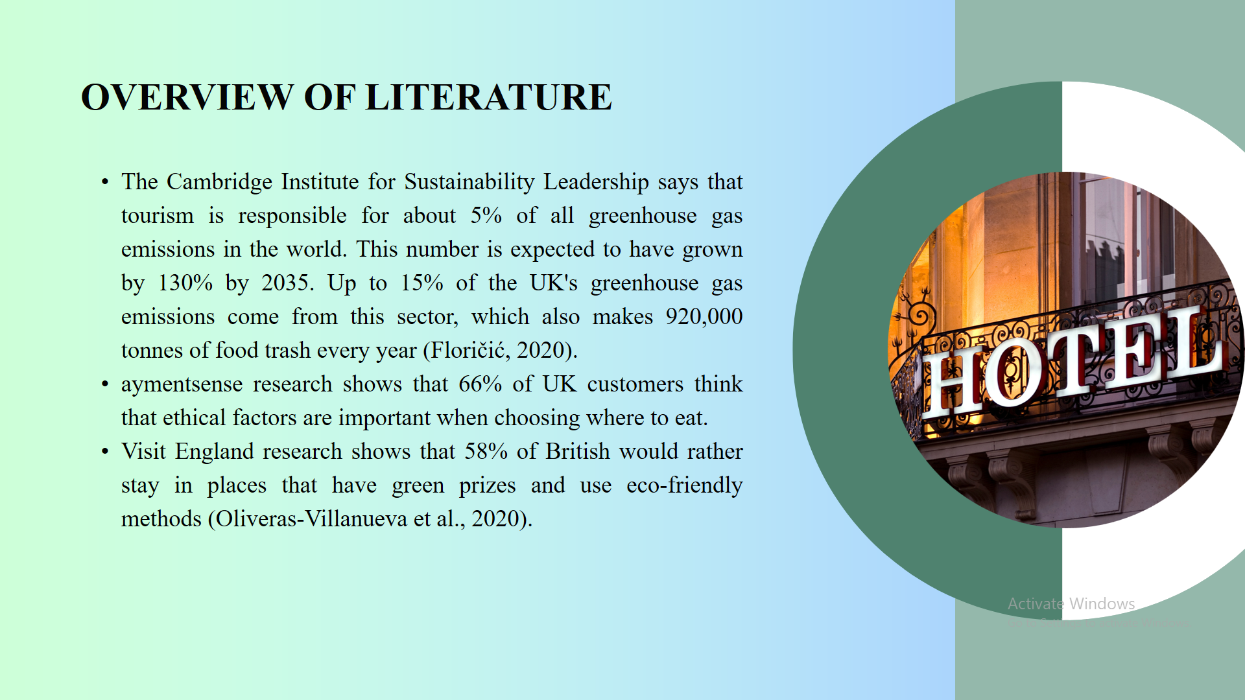
John Elkington came up with the Triple Bottom Line (TBL) theory in 1994. It changes the way companies are usually judged by their success by adding social and environmental factors to the financial ones. “People” deals with the social duty side of the business by focusing on fair labour standards, getting involved in the community, and keeping visitors happy (Pereira et al., 2021). “Planet” means caring for the earth, which means doing things to reduce waste, save water, and lower carbon footprints (Chen et al., 2020). Installing systems that use less energy, technologies that save water, and strict recycling programmes could help the environment. Subsequently, “Profit” ensures that businesses can utilise eco-friendly methods that bring in money. Long-term success for hotels depends on finding a balance between making money and taking care of people and the environment. Hotels that use TBL’s ideas not only do better than their competitors, but they also make the world a better place and help their own communities. Also, people who care about the earth buy from them.
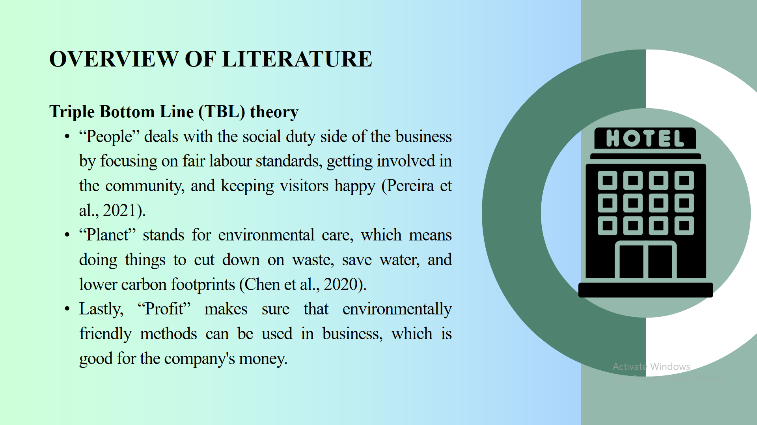
Business owners of hotels use the word “CSR” to describe many different actions that make communities stronger and the environment better. Using tools that use less energy can help hotels cut down on their carbon footprint and costs. Incorporating LED lights, tools that use less energy, and smart HVAC systems that adjust based on the number of people in the space are some examples of this. Another important part of CSR in the hotel business is saving water (Eggeling, 2020). Hotels can save water by putting in low-flow fixtures in the kitchen and bathrooms, recycling greywater, and greenery that doesn’t need much water. By using these methods, not only are important water supplies protected, but they also save a lot of money and meet rising environmental standards (Iddawala et al., 2024).
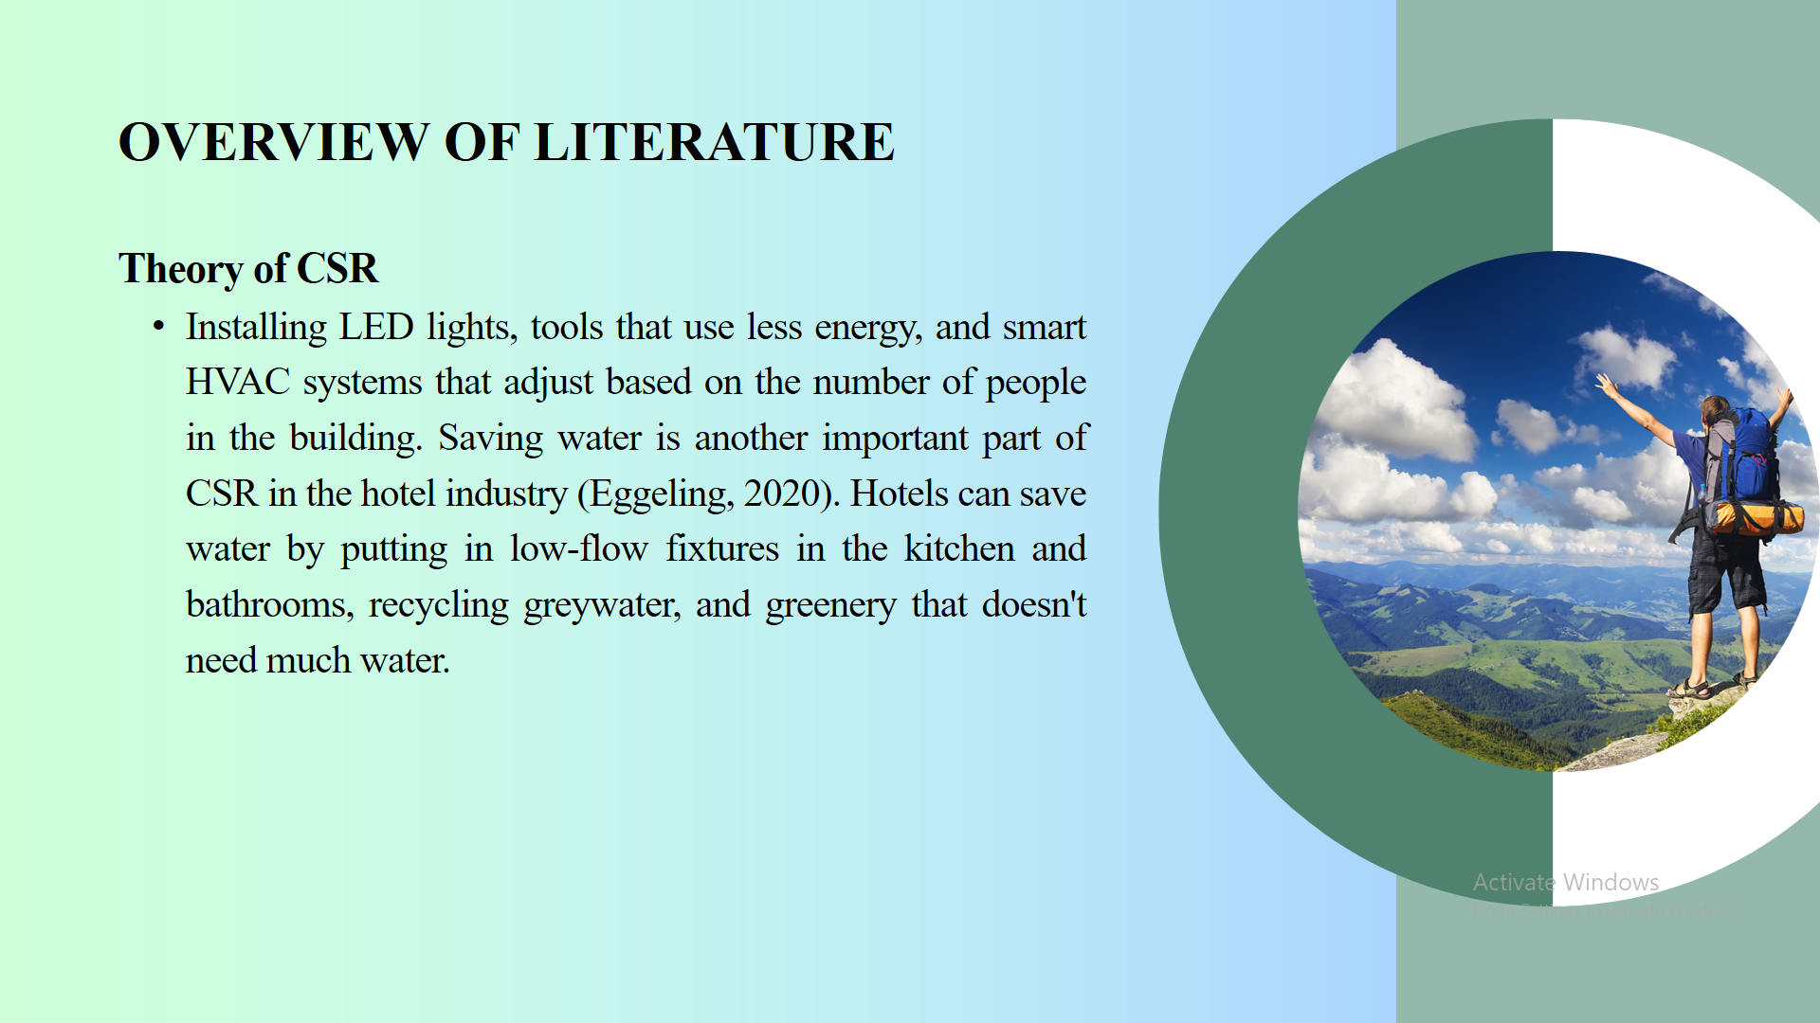
ISO 14001 is one of the most well-known EMS standards. It gives businesses an organised way to handle their environmental duties in a way that supports the environmental pillar of sustainable development (Munir, 2022). It is very important to set clear environmental goals and aims. Some of these goals could be to use less water and energy, make less trash, and release fewer greenhouse gases. To be tracked and reached, these goals should be SMART, which stands for specific, measured, attainable, relevant, and time-bound.
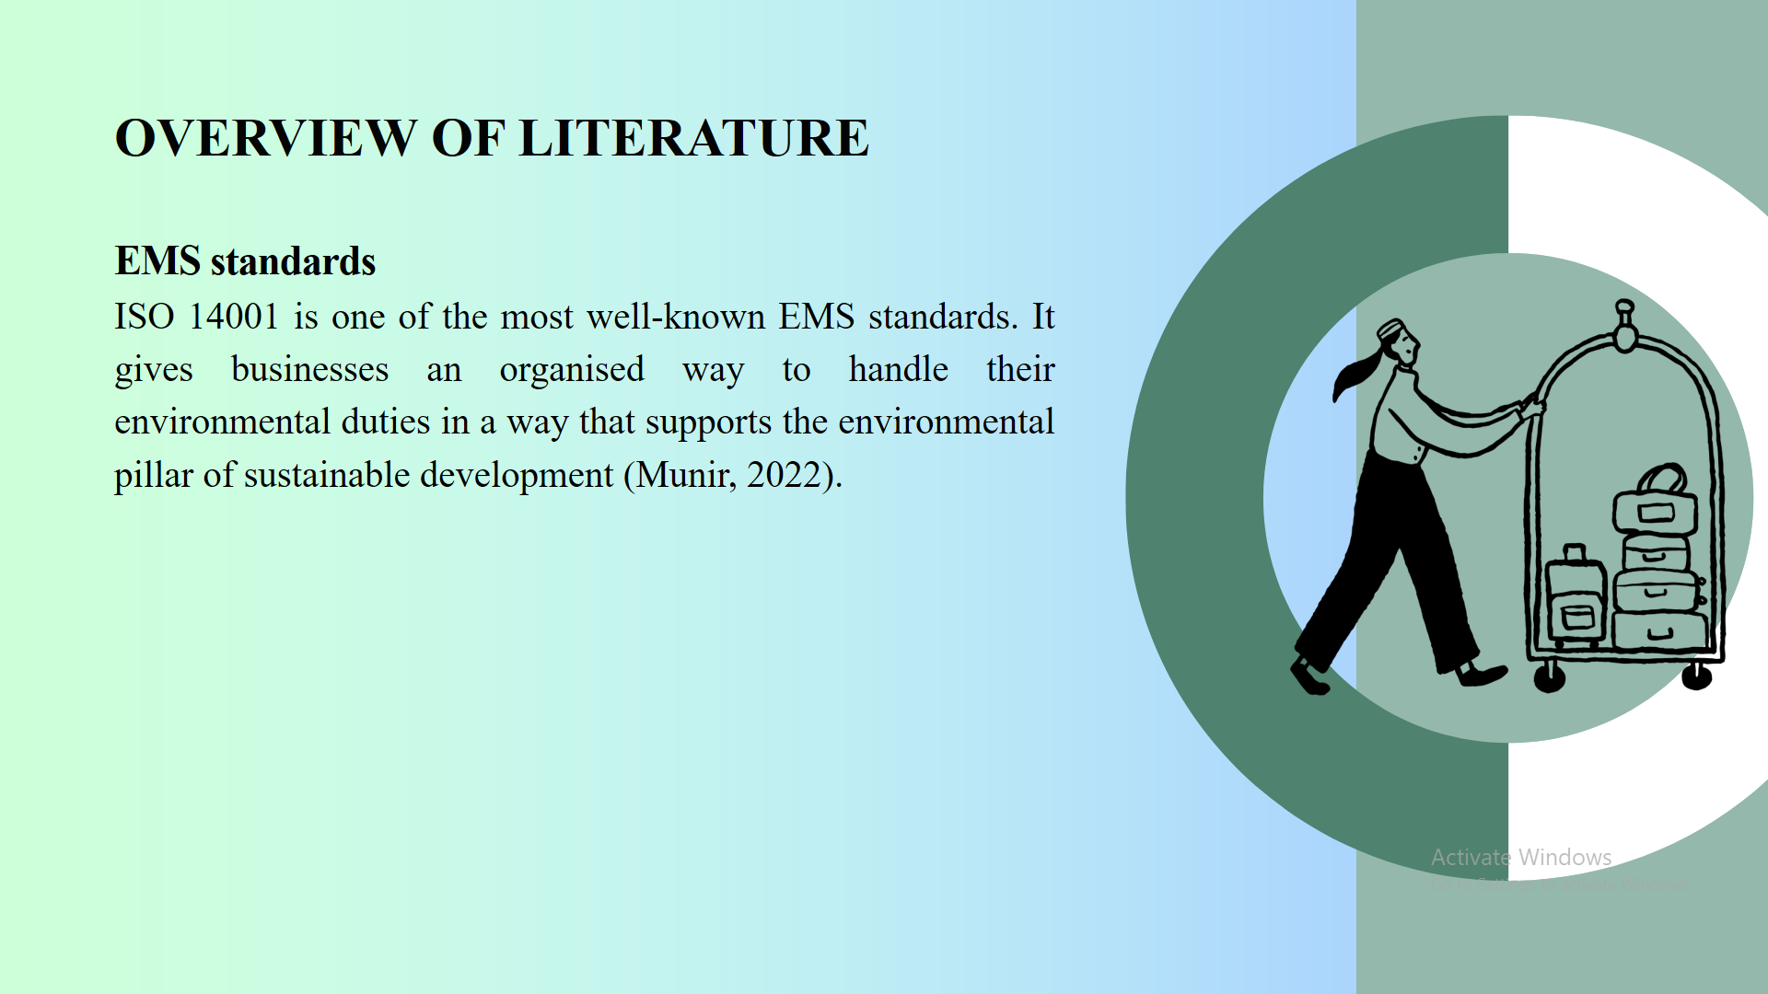
Application to the Hotel and Hospitality Sector
PESTLE Analysis
Political | The UK government has set rules through organisations like the Environment Agency. For example, the UK Water Industry Act of 1991 sets rules for managing water and sewage systems. The Greater London Authority (GLA) made the London Plan, which says that new buildings must-have features that save water. To save water, it has strict rules (Chen et al., 2020).
Economical | A mid-sized hotel could save between $20,000 and $30,000 a year on water costs by putting in equipment that uses less water and doing regular upkeep to fix leaks and cut down on waste. For example, low-flow showerheads lower both the amount of water used and the energy needed to heat the water, which saves even more money (Eggeling, 2020).
Social | As people learn more about climate change, resource loss, and how human actions affect the environment, they become more aware of their own ecological footprint. Eco-friendly hotels often focus on using natural, non-toxic materials, serving organic food, and offering wellness-focused services, which appeal to tourists who care about their health.
Technological | Using past data and current trends, predictive analytics can guess how much water will be used in the future. This lets hotels guess when they will use the most water and make plans for those times, which leads to better water management.
Legal | The Water Industry Act of 1991 and later changes in the UK require efficient use and control of water. To meet these guidelines, hotels must take steps to save water and make sure that their water use is sustainable (Khatter, 2023). Green Key and LEED (Leadership in Energy and Environmental Design) certifications help hotels set up and keep up with environmental practices like saving water.
Environmental | Hotels that save water use less energy to heat and move water, which lowers the amount of greenhouse gases released into the air. The United Nations’ Sustainable Development Goals (SDGs) and other larger environmental and sustainability goals are in line with this all-around method of managing resources (Munir, 2022).
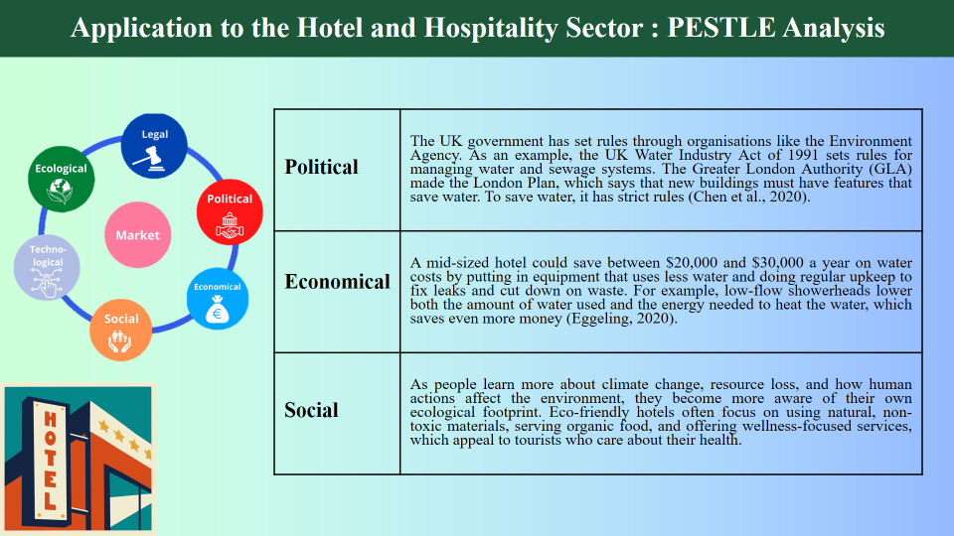
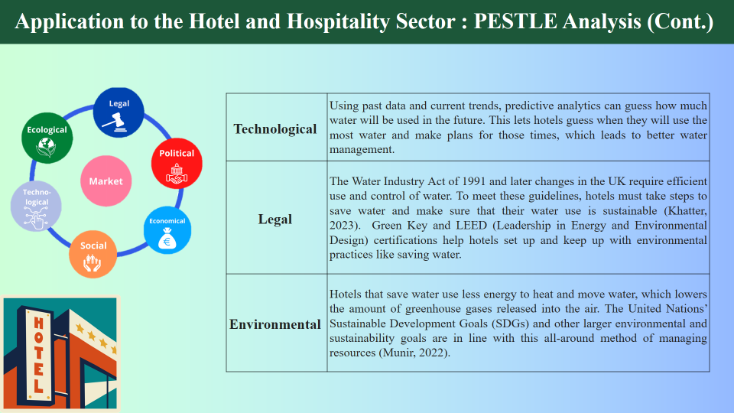
Industry Responses on Sustainable Practices
Hilton Worldwide has installed low-flow fixtures, smart irrigation systems, and water recycling technology across all of its properties as part of a complete water stewardship plan. Because of this plan, 20% less water is being used per occupied room (Hilton, 2021). This shows how committed the company is to being environmentally friendly.
InterContinental Hotels Group made the Green Engage system, a cutting-edge tool that lets hotels control how much water they use by tracking it in real-time and analysing the data (Melissen, 2013). The Green Engage method has saved about 1.5 billion gallons of water since it was put in place (IHG 2020). This method lets IHG properties keep track of how much water they use, find areas where they aren’t using it efficiently, and take specific steps to save water (Sakshi et al., 2020).
Marriott International has done a great job of saving water by getting state-of-the-art tools and teaching workers for long periods of time. Because of these efforts, Marriott properties have saved a lot of water, which shows that their sustainability programmes are working (Marriott International, 2022). However, Marriott has trouble spreading these ideas around the world because its properties are spread out in different places and are different sizes, which can make it hard to do things the same way everywhere.
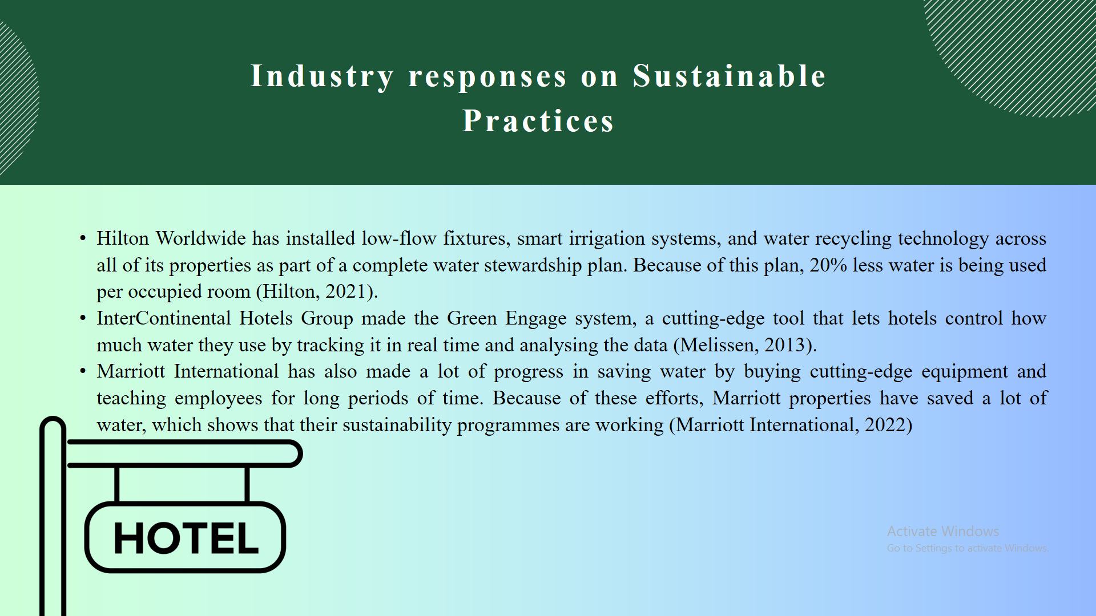
Strengths
- Strategies that help people save water lead to big cost cuts.
- Better brand image and more people choosing hotels that are better for the environment.
- Compliance with rules and norms for the environment.
Limitations
- Difficulty in adopting techniques consistently across various geographical regions and property kinds.
- Significant expenditure is required to implement modern technologies.
- There is a need for ongoing monitoring, maintenance, and staff training.
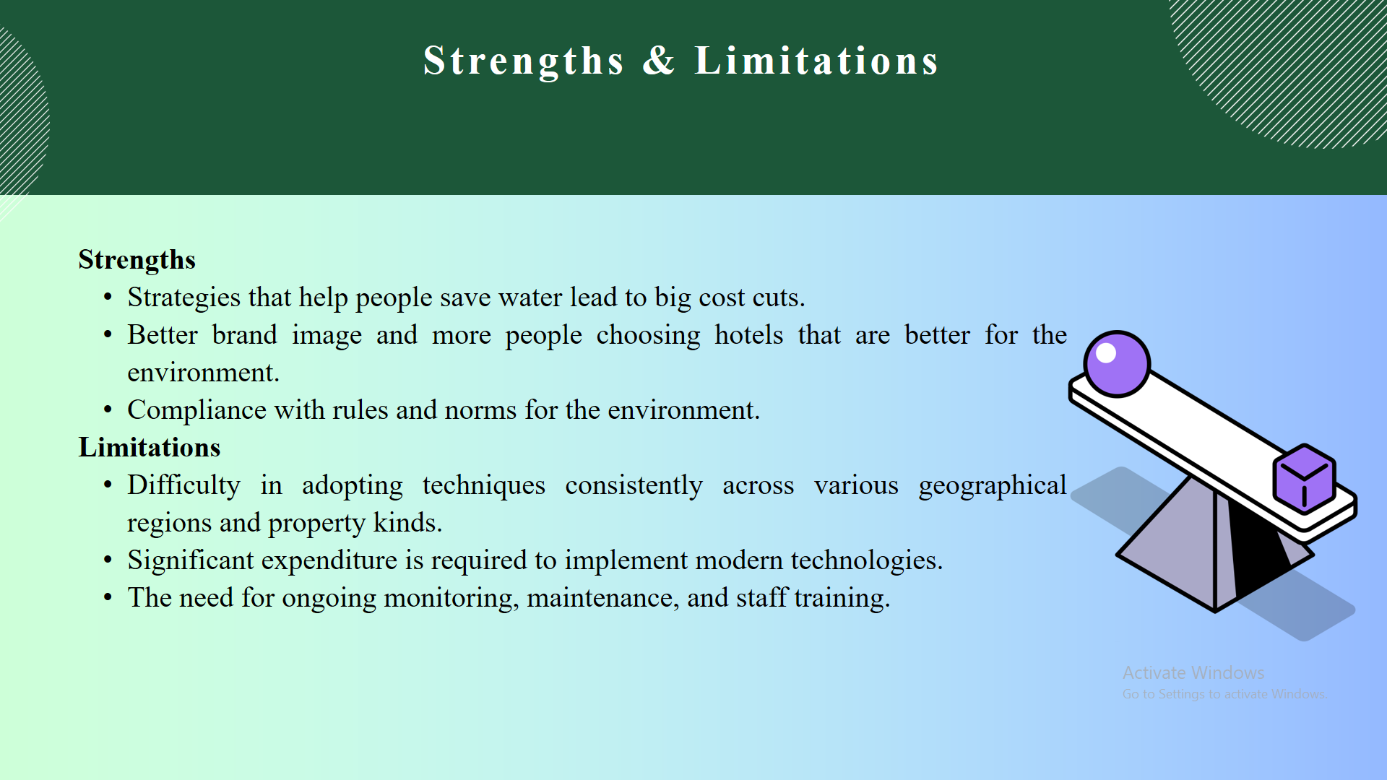
Evaluate Future Policy and Management Options
Hotels stay sustainable and keep their customers happy by coming up with creative and eco-friendly ways to do things. A lot of hotels and motels are using new technologies to lower their carbon footprints because using too much energy is still a big problem in the hospitality industry (Sakshi et al., 2020).
Some of these are LED lights, solar panels, and heating and cooling systems that use less energy. Smart sensors can also be used to change the lighting and temperature of a room based on who is in it, so no energy is lost. Managing trash well is important for any company that cares about the environment.
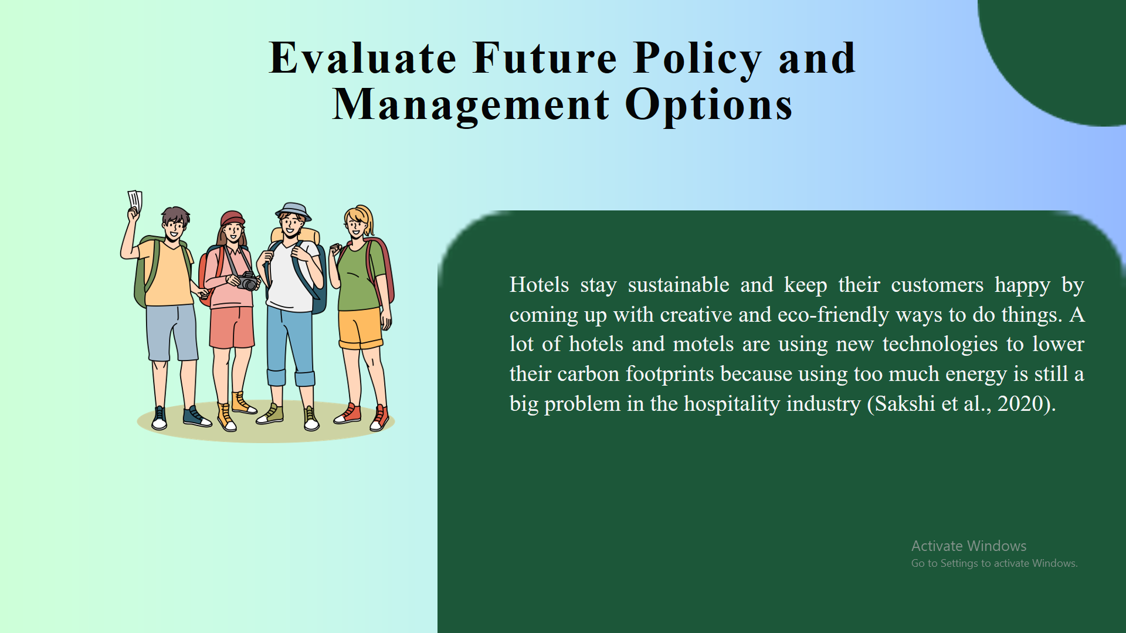
To reduce trash, hotels can do many things, such as start recycling programmes, limit single-use plastics, and provide reusable options for toiletries and towels (Modica et al., 2020). By composting, food waste can also be turned into materials that can be used in local gardening projects.
The UK might create more in-depth green certification programmes just for the hospitality industry, building on schemes like the Green Tourism Award (Malheiro et al., 2020). These certificates should make it clear to hotels how to meet and maintain high standards for sustainability and stress how important it is to save water.
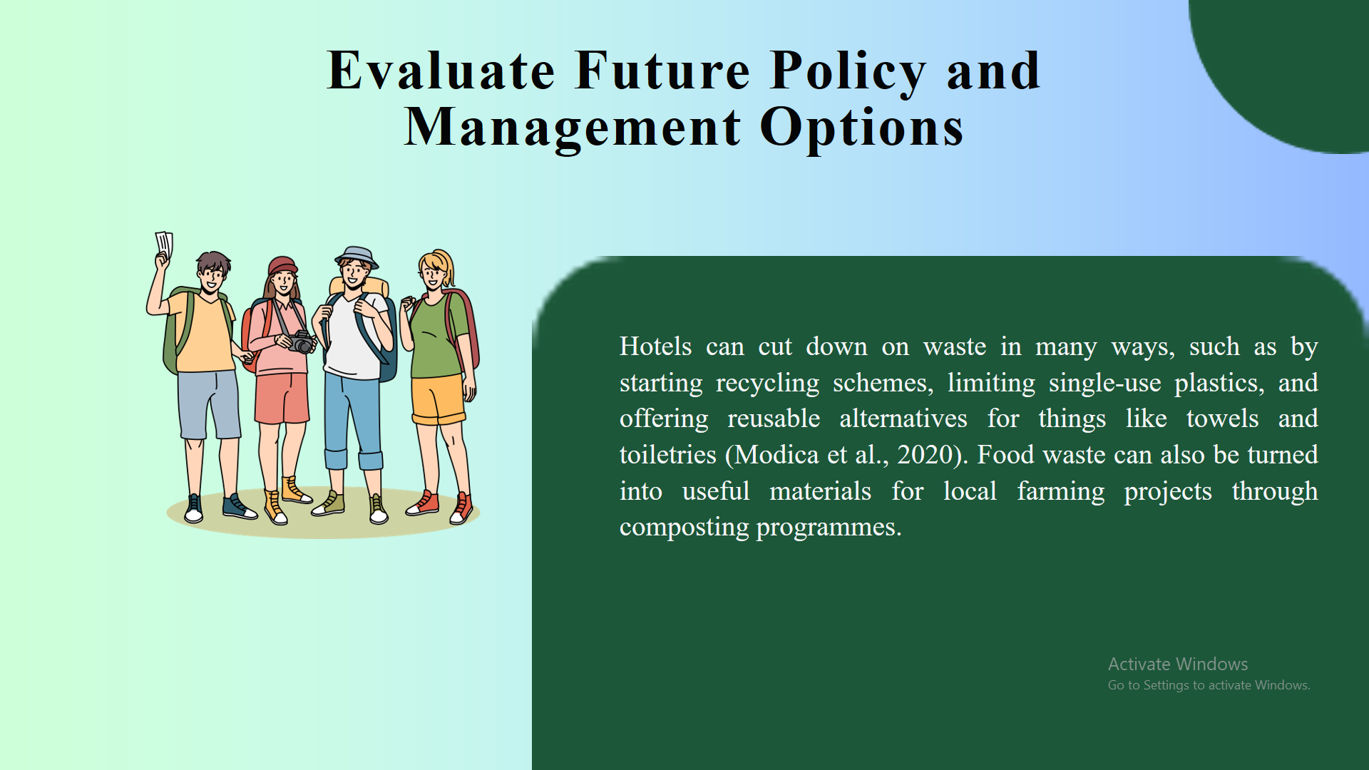
Conclusion
Many hotels and resorts today can make a big difference in how little damage they do to the environment while still meeting the needs of eco-friendly visitors. These groups can also get ahead, save money, and help make the world a better place for everyone. Supporting these kinds of practices helps the hospitality business keep coming up with new ideas and has positive effects on society and the environment.
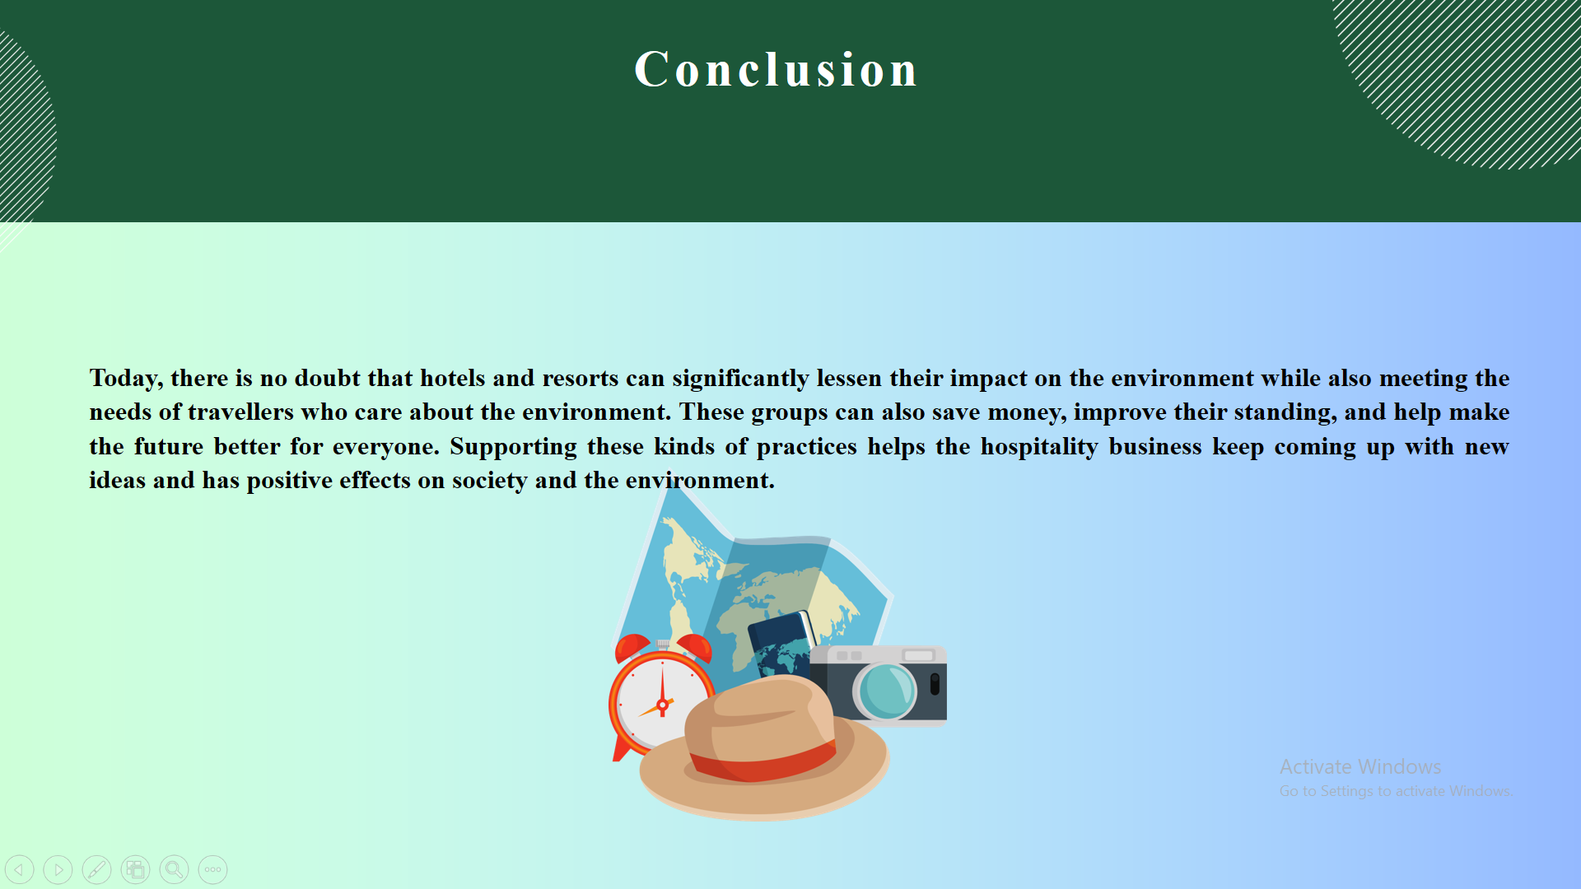

References
Bruns-Smith, A., Choy, V., Chong, H. and Verma, R., 2015. Environmental sustainability in the hospitality industry: Best practices, guest participation, and customer satisfaction.
Chen, J., Sloan, P. and Legrand, W., 2020. Sustainability in the hospitality industry. Routledge.
Eggeling, J., 2020. Sustainable tourism practices in the hospitality sector: A case study of Scandic.
Fernández-Robin, C., Celemín-Pedroche, M.S., Santander-Astorga, P. and Alonso-Almeida, M.D.M., 2019. Green practices in hospitality: A contingency approach. Sustainability, 11(13), p.3737.
Floričić, T., 2020. Sustainable solutions in the hospitality industry and competitiveness context of “green hotels”. Civil Engineering Journal, 6(6), pp.1104-1113.
Fonseca, A.P. and Carnicelli, S., 2021. Corporate social responsibility and sustainability in a hospitality family business. Sustainability, 13(13), p.7091.
Higgins-Desbiolles, F., Moskwa, E. and Wijesinghe, G., 2019. How sustainable is sustainable hospitality research? A review of sustainable restaurant literature from 1991 to 2015. Current Issues in Tourism, 22(13), pp.1551-1580.
Iddawala, J., Welengoda, B.M. and Rathnayaka, B.T., 2024, March. Sustainability Practices in the Hospitality Industry: Evidence from Chain Hotels in Kandy. In International Conference on Tourism Research (Vol. 7, No. 1, pp. 130-139).
Khatter, A., 2023. Challenges and Solutions for Environmental Sustainability in the Hospitality Sector. Sustainability, 15(15), p.11491.
Legrand, W., Chen, J.S. and Laeis, G.C., 2022. Sustainability in the hospitality industry: Principles of sustainable operations. Routledge.
Linneberg, M.S., Madsen, M.T. and Nielsen, J.A., 2019. Micro-level translation of corporate sustainability: When strategy meets practice in the Danish hospitality sector. Journal of Cleaner Production, 240, p.118159.
Madanaguli, A., Dhir, A., Joseph, R.P., Albishri, N.A. and Srivastava, S., 2023. Environmental sustainability practices and strategies in the rural tourism and hospitality sector: A systematic literature review and suggestions for future research. Scandinavian Journal of Hospitality and Tourism, 23(1), pp.1-28.
Malheiro, A., Sousa, B.B., Liberato, D. and Liberato, P., 2020, April. Sustainability in tourism and hospitality: Trends and challenges. In 35th IBIMA conference education excellence and innovation management: A 2025 vision to sustain economic development during global challenges (pp. 15545-15555). IBIMA.
Melissen, F., 2013. Sustainable hospitality: a meaningful notion?. Journal of sustainable tourism, 21(6), pp.810-824.
Modica, P.D., Altinay, L., Farmaki, A., Gursoy, D. and Zenga, M., 2020. Consumer perceptions towards sustainable supply chain practices in the hospitality industry. Current Issues in Tourism, 23(3), pp.358-375.
Munir, K., 2022. Sustainable food waste management strategies by applying practice theory in hospitality and food services-a systematic literature review. Journal of Cleaner Production, 331, p.129991.
Oliveras-Villanueva, M., Llach, J. and Perramon, J., 2020. Service quality in hospitality and the sustainability effect: Systematic literature review and future research agenda. Sustainability, 12(19), p.8152.
Pereira, V., Silva, G.M. and Dias, Á., 2021. Sustainability practices in hospitality: Case study of a luxury hotel in Arrábida Natural Park. Sustainability, 13(6), p.3164.
Pérez, A. and del Bosque, I.R., 2014. Sustainable development and stakeholders: A renew proposal for the implementation and measurement of sustainability in hospitality companies. Knowledge and Process Management, 21(3), pp.198-205.
Prud’homme, B. and Raymond, L., 2013. Sustainable development practices in the hospitality industry: An empirical study of their impact on customer satisfaction and intentions. International journal of hospitality management, 34, pp.116-126.
Sakshi, Shashi, Cerchione, R. and Bansal, H., 2020. Measuring the impact of sustainability policy and practices in tourism and hospitality industry. Business Strategy and the Environment, 29(3), pp.1109-1126.
Sharma, R., 2023. Hospitality sustainable practices, a global perspective. Worldwide Hospitality and Tourism Themes, 15(3), pp.212-219.
Shereni, N.C., Saarinen, J. and Rogerson, C.M., 2023. Sustainability drivers and challenges in the hospitality sector in Zimbabwe. Tourism: An International Interdisciplinary Journal, 71(3), pp.492-504.
Singal, M. and Rhou, Y., 2017. Corporate social responsibility in the hospitality sector. Boston hospitality review, 5(1), pp.1-16.
van Rheede, A. and Blomme, R.J., 2012. Sustainable practices in hospitality: A research framework. In Advances in hospitality and leisure (pp. 257-271). Emerald Group Publishing Limited.

