

Jennifer Hill

BEng Electrical and Electronic Engineering

Applied Programmable Logic Controllers

ACDA6000

Contents
Table of Figures 3
Introduction 4
Allen-Bradley ControlLogix 5
Siemens S7-1200 6
Mitsubishi Electric MELSEC Q Series 7
Ladder Logic Program 8
PLC Simulator 8
Operational Control 8
Movement Process 9
Pusher Operation 12
Counting Operation for Box Sizes 13
Warnings and Alarms 15
Emergency Stop 15
Scale Conveyor Operation 16
Automatic Reset Weight Process 16
Scale Conveyor Weighing Cycle 16
Displaying Weight in Factory Simulation 16
Sorting the Medium Small and Medium-Large Boxes 17
Alarm for Possible Box Losses 17
Safety Door Alarm 22
HMI Screens 23
Warning and Alarm Strategy 25
Large Package Loss strategy- 25
Medium Package Loss strategy- 25
Small Package Loss strategy- 25
Operational Flow Chart 26
Conclusion 27
References 27

Table of Figures
Figure 1: Allen-Bradley ControlLogix 5
Figure 2:Siemens S7-1200 6
Figure 3: Mitsubishi Electric MELSEC Q Series 7
Figure 4: PLC Simulator 8
Figure 5:Operational Control 8
Figure 6: Movement Process 9
Figure 7:Movement Process 10
Figure 8:Movement Process 11
Figure 9: Pusher Operation 12
Figure 10: Sensor 2 and Pusher 1 for medium counting and sorting. Sensor 8 for small box count 12
Figure 11:Counting Operation for Box Sizes 13
Figure 12: Total Counter sensor 1. Large box pusher 0 and sensor 0 14
Figure 13: Warnings and Alarms 15
Figure 14: Emergency Stop Program 15
Figure 15: Start, Stop and emergency stop buttons in factory I/O 15
Figure 16:Scale Conveyor Operation 16
Figure 17:Automatic Reset Weight Process 16
Figure 18:Scale Conveyor Weighing Cycle 16
Figure 19:Displaying Weight in Factory Simulation 16
Figure 20: Medium Box Sorter including display, sensors for counting and setting the weighing process, as well as Pop-up sorter. 17
Figure 21:Sorting the Medium Small and Medium-Large Boxes 17
Figure 22:Alarm for Possible Box Losses 18
Figure 23: Data block- Limit PLC Blocks 18
Figure 24: Manual Setting Parameters 19
Figure 25:Stack Light Colour Indications 20
Figure 26: HMI Stack Lights representation. 21
Figure 27: stack lights and warning lights during start of operation. 21
Figure 28:Safety Door Alarm 22
Figure 29: Open door alarm HMI. 23
Figure 30: HMI HOME SCREEN 23
Figure 31: Warnings/ Alarms Screen 24
Figure 32: Engineers Screen 24
Figure 33: Operational Flow Chart 26

Introduction
The report will be detailing the process of writing a logic program on the TIA V16 Siemens programming software connected to Factory I/O, a factory simulating software.
The aim of the project is to sort 4 different packages based on size and weight and will be able to be controlled and monitored by an operator from a HMI screen, a Warning/Alarm Screen for specific fault that have been triggered and an engineering screen for manual alarm reset controls.

Allen-Bradley ControlLogix

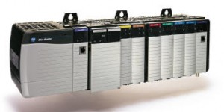
Figure 1: Allen-Bradley ControlLogix

[1] Pros:
Has a wide range of processors and I/O modules, for applications ranging from small to large.
ControlLogix supports integrated motion control capabilities, which is good for applications for motion control.
Being a widely used brand in the industry, Allen-Bradley PLCs have details instructions and tutorials document online.
Cons:
ControlLogix PLCs can be relatively expensive especially for small automation applications.
Programming software for Allen-Bradley PLCs might need additional licensing and so extra cost.
ControlLogix programming can be complicated, especially for beginners, compared to other PLC programs.

Siemens S7-1200

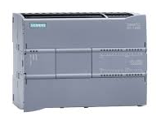
Figure 2:Siemens S7-1200

[1] Pros:
The S7-1200 series is compact, making it great for small places.
S7-1200 PLCs come with integrated Ethernet ports making it easy for online communication.
Siemens S7-1200 PLCs are generally more affordable than most PLC’s making it suitable for small applications.
Cons:
May not be suitable for larger, more complex applications.
Smaller models in the S7-1200 series have smaller memories.
Siemens programming software, may have limitations, restricting the complexity of programs.

Mitsubishi Electric MELSEC Q Series

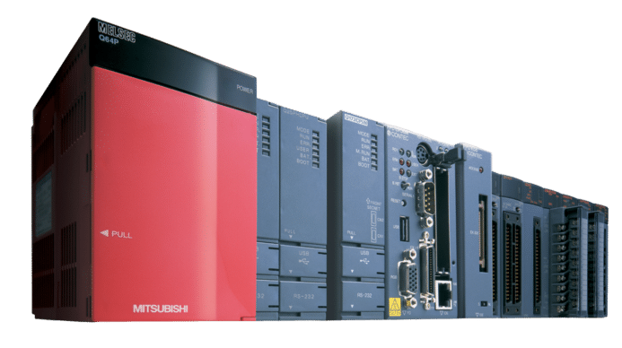
Figure 3: Mitsubishi Electric MELSEC Q Series

[1] Pros:
MELSEC Q Series PLCs has high-speed processing, making them suitable for demanding industrial applications.
The design of MELSEC Q Series allows for flexibility, enabling easy modifications of the system.
MELSEC Q Series PLCs has diagnostic abilities for efficient troubleshooting and maintenance.
Cons:
MELSEC Q Series PLCs are more expensive.
Programming for MELSEC Q Series can be complex so advanced knowledge and experience would be needed.
May have limited availability or support.

Ladder Logic Program

PLC Simulator
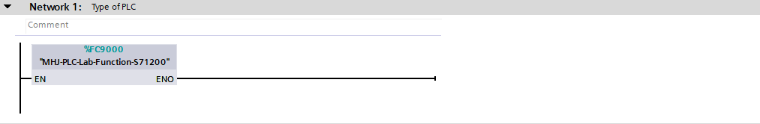
Figure 4: PLC Simulator

Operational Control
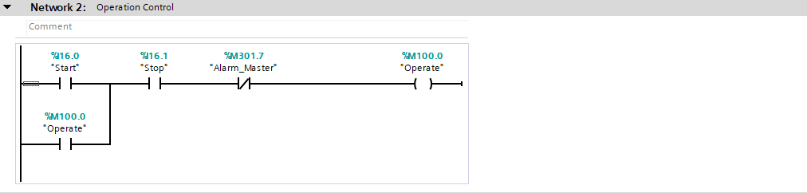
Figure 5:Operational Control
Alarm Master incorporated to stop process if triggered.

Movement Process
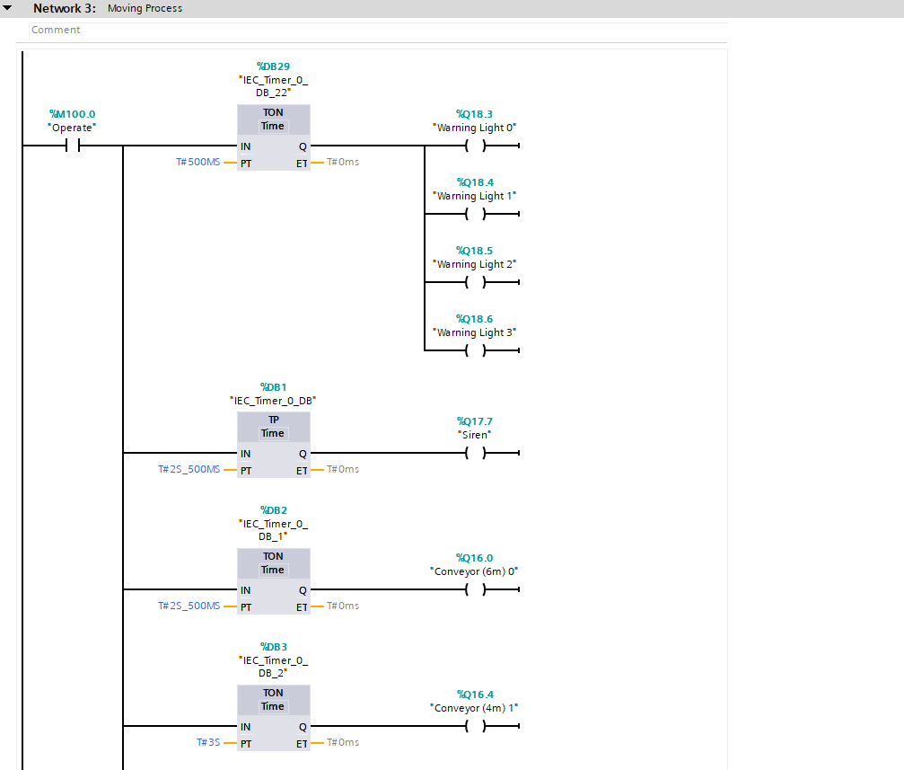
Figure 6: Movement Process
The warning lights and siren and started first for the safety of operator and engineers.

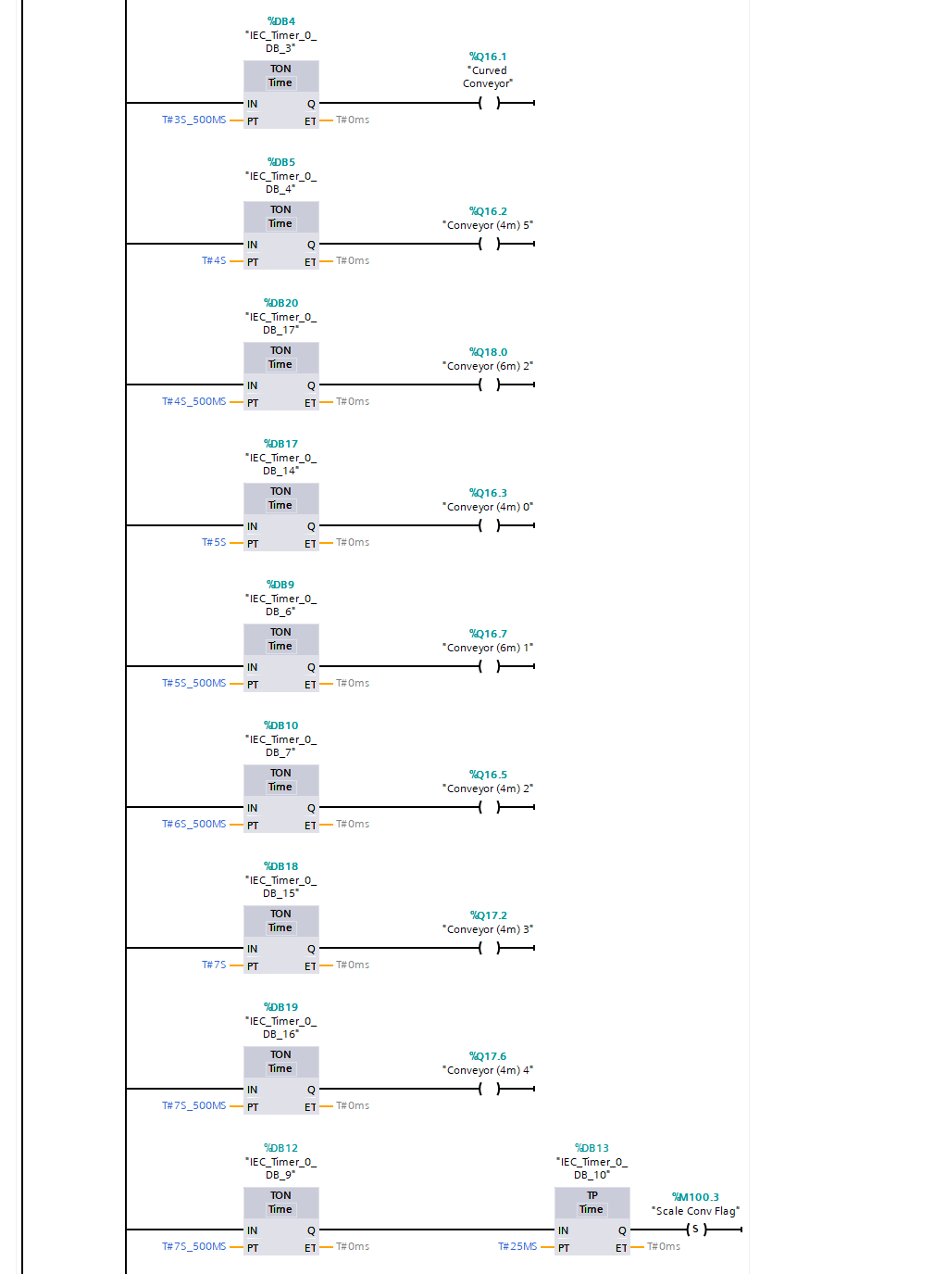
Figure 7:Movement Process
The conveyors are started in sequences as to not overload the startup process.

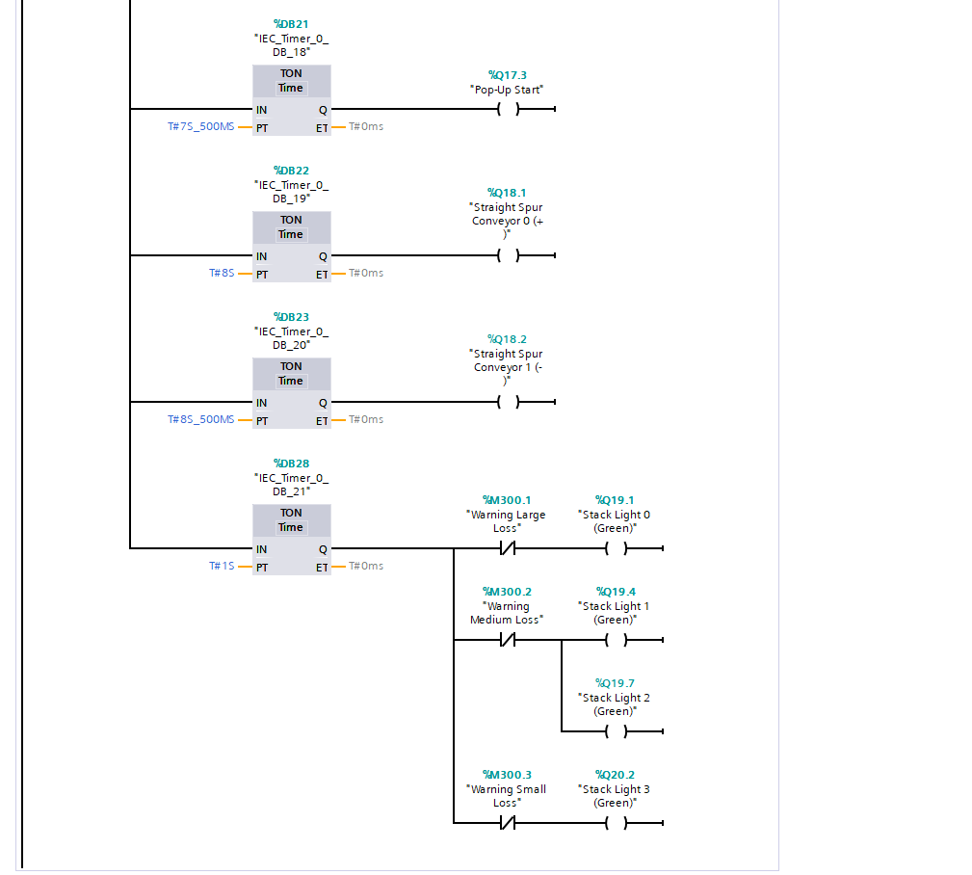
Figure 8:Movement Process
Stack lights are set to green to represent the working operation of each package process.
Warning losses are set on the normally closed contacts so that orange lights will show for warning signals.

Pusher Operation
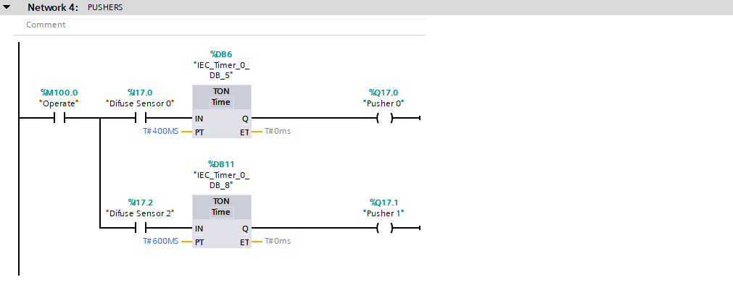
Figure 9: Pusher Operation
The pushers are sets to very specific times reactivity after the sensor trigger to ensure to evenly push the packages onto the next conveyor.

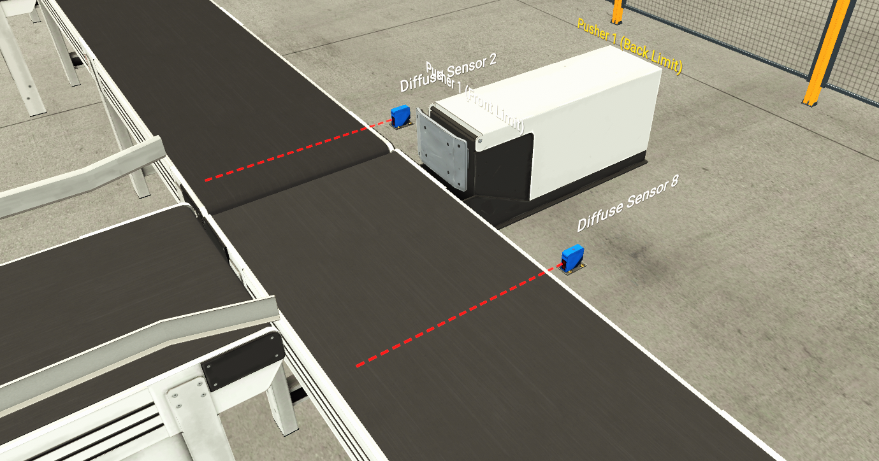
Figure 10: Sensor 2 and Pusher 1 for medium counting and sorting. Sensor 8 for small box count

Counting Operation for Box Sizes
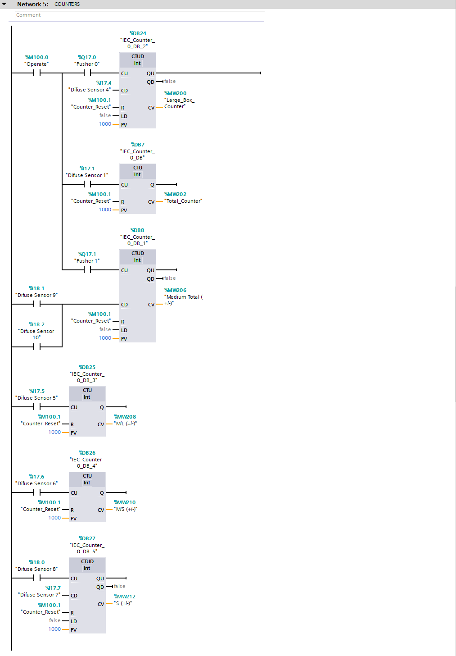
Figure 11:Counting Operation for Box Sizes
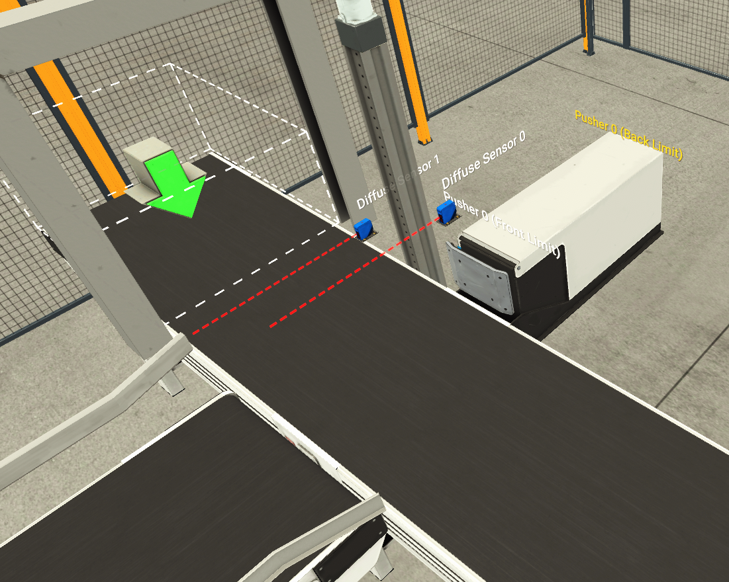
Figure 12: Total Counter sensor 1. Large box pusher 0 and sensor 0

The Counters are each set with the Counter Reset program to able the operator to stop the process at any time.

Warnings and Alarms
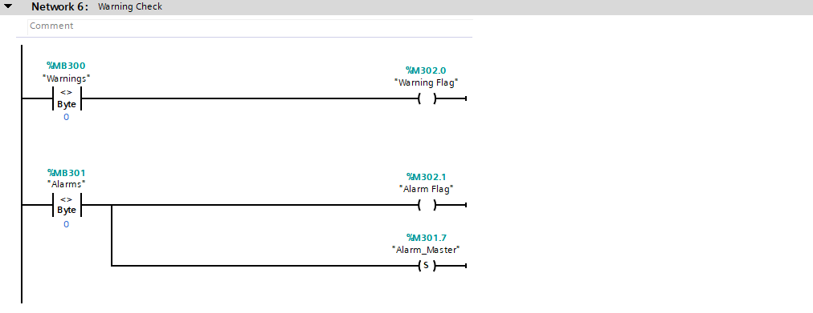
Figure 13: Warnings and Alarms
The Warning and Alarm Byte on the Not Equal Comparator are set to 0 for if any program triggers the sequence, the Warning/Alarm flag will be shown on the HMI screen.

Emergency Stop
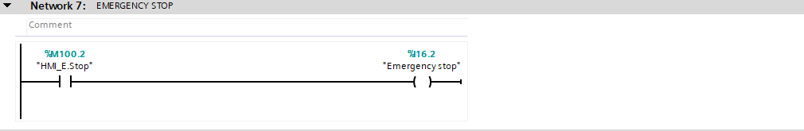
Figure 14: Emergency Stop Program
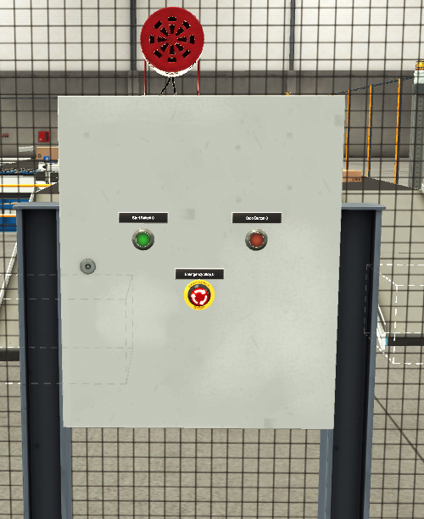
Figure 15: Start, Stop and emergency stop buttons in factory I/O
Emergency stop HMI button is connected to the simulated button in Factory I/O

Scale Conveyor Operation
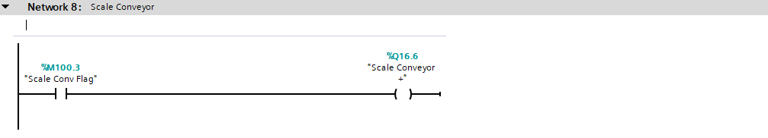
Figure 16:Scale Conveyor Operation

Automatic Reset Weight Process
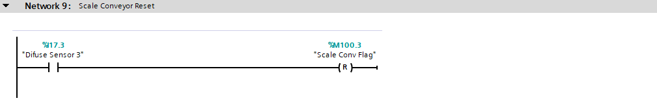
Figure 17:Automatic Reset Weight Process
Difuse Sensor 3 reset the weighing cycle on triggered by the medium packages.

Scale Conveyor Weighing Cycle
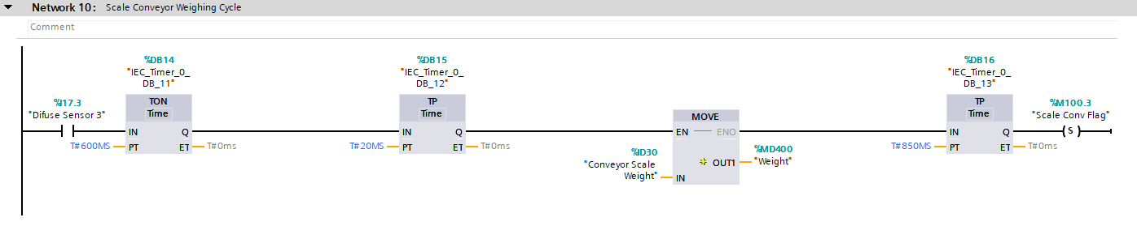
Figure 18:Scale Conveyor Weighing Cycle

Displaying Weight in Factory Simulation
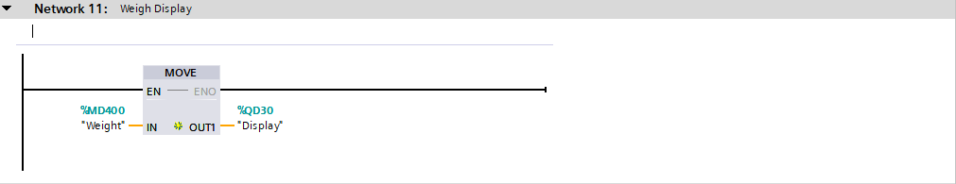
Figure 19:Displaying Weight in Factory Simulation
The weight the medium boxes are displayed on the simulated display in Factory I/O.
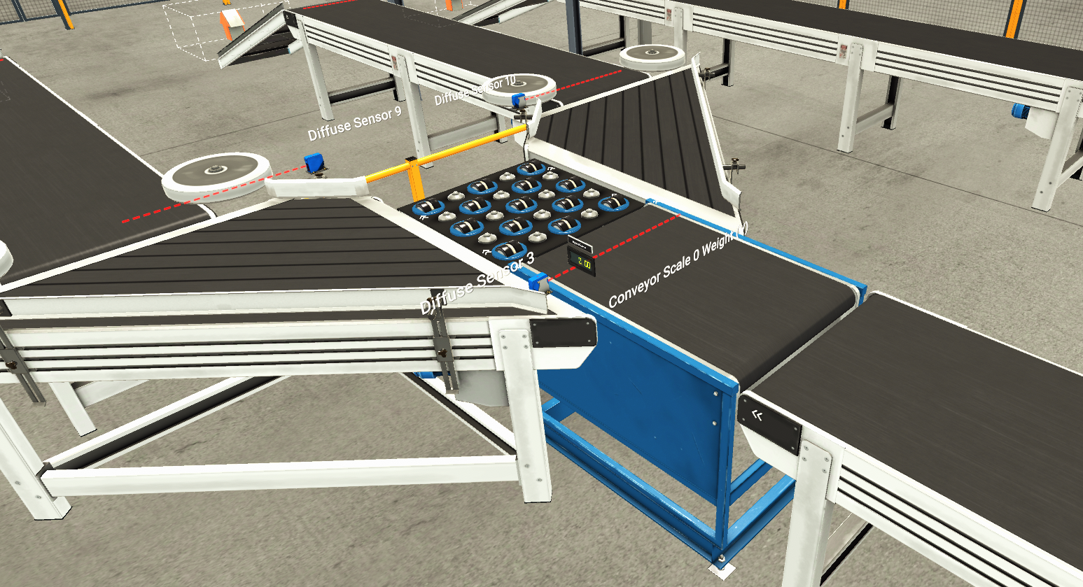
Figure 20: Medium Box Sorter including display, sensors for counting and setting the weighing process, as well as Pop-up sorter.

Sorting the Medium Small and Medium-Large Boxes
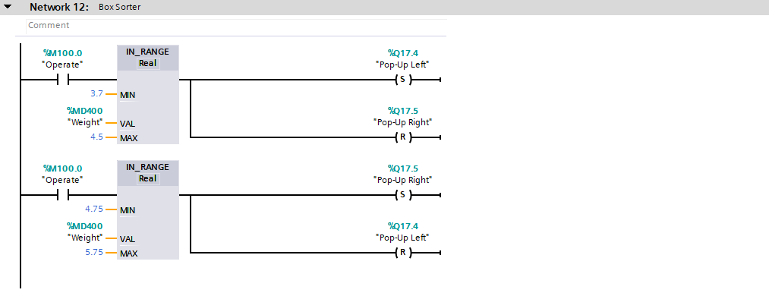
Figure 21:Sorting the Medium Small and Medium-Large Boxes
When the weight of the package is read, the pop-up start will operate Right or Left depending on whether the package is lighter or heavier than 4.75kg (simulated).

Alarm for Possible Box Losses

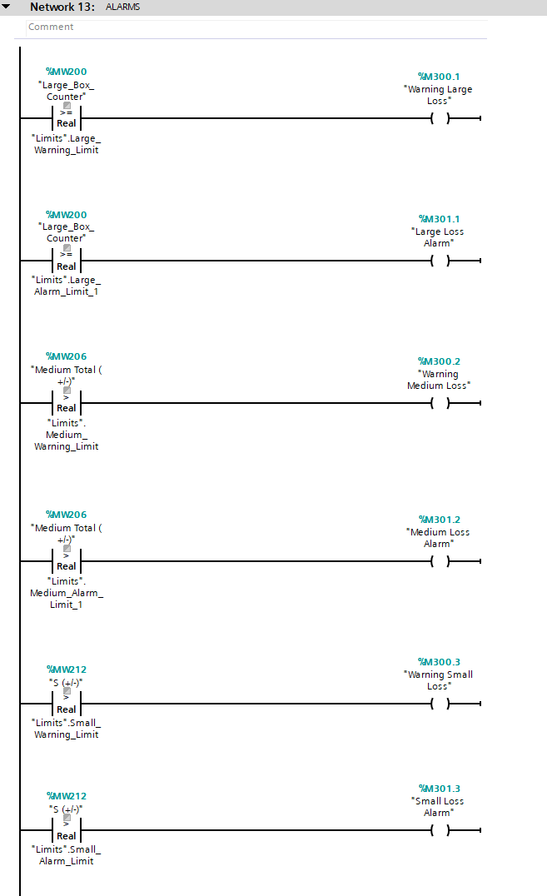
Figure 22:Alarm for Possible Box Losses
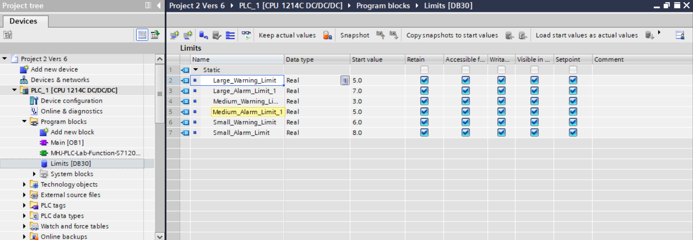
Figure 23: Data block- Limit PLC Blocks
The sum default limits are set in the Limits data block and are able to be changed by the engineer in the Engineers Screen in the Set Parameters section.
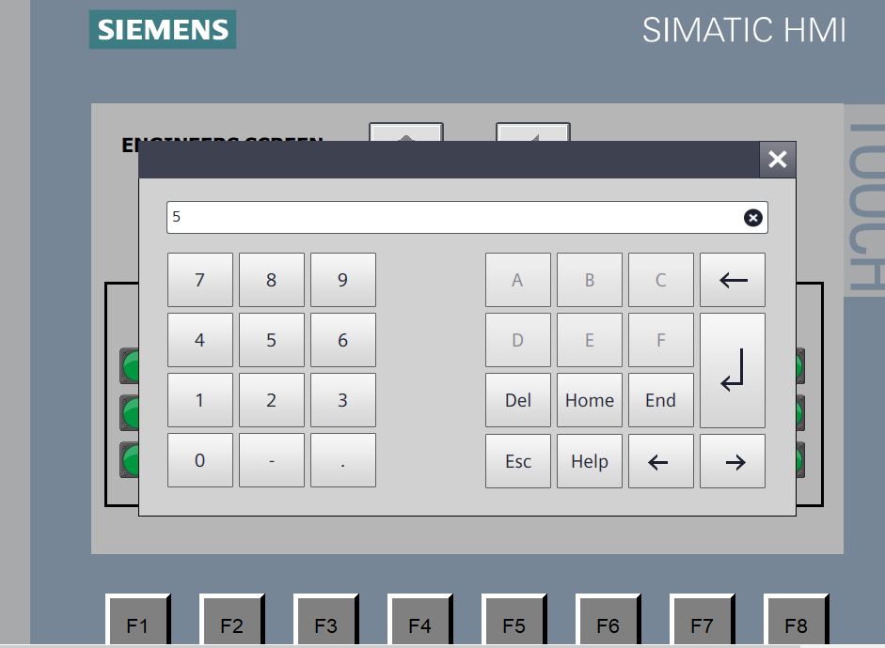
Figure 24: Manual Setting Parameters

Stack Light Colour Indications

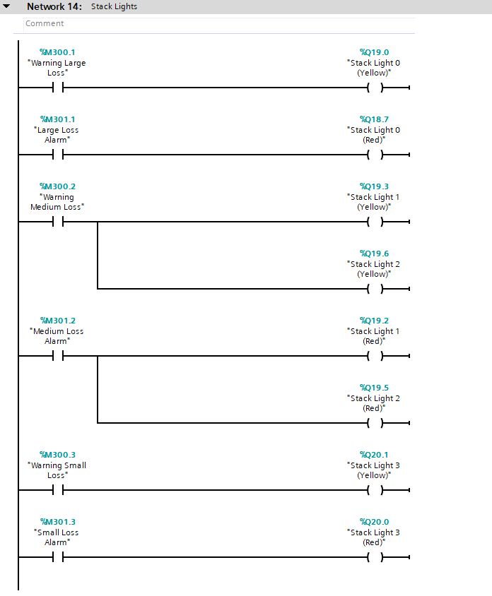
Figure 25:Stack Light Colour Indications
Stack light colours set Red for alarm and yellow for warning on each package conveyor root.
They are also represented on the HMI Screen.
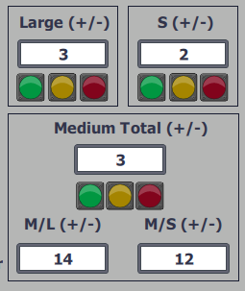
Figure 26: HMI Stack Lights representation.

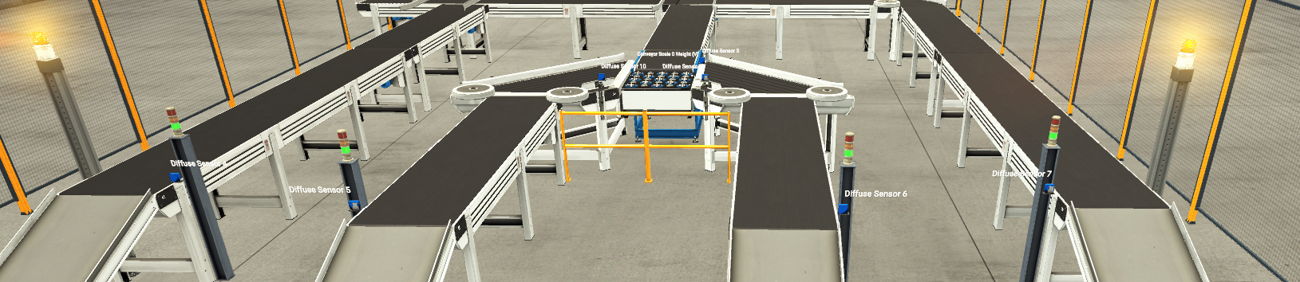
Figure 27: stack lights and warning lights during start of operation.

Safety Door Alarm
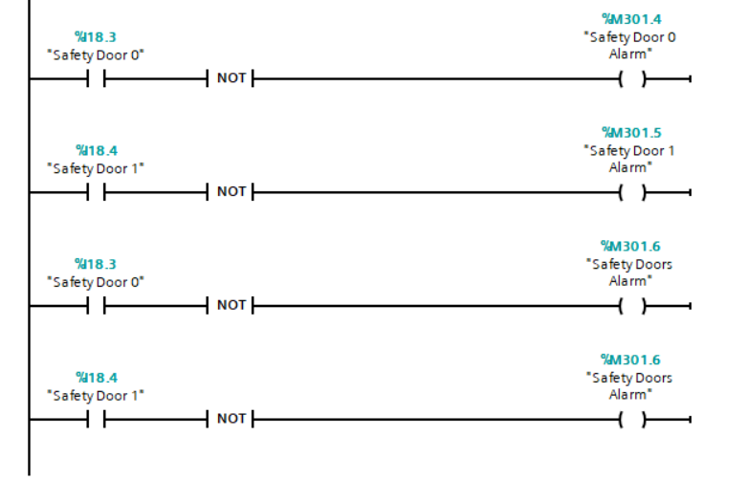
Figure 28:Safety Door Alarm
For the safety of persons working in the area, the 2 safety doors are set to STOP the entire process as soon they are opened, then shown on the HMI screen to indicate which doors are open. The master alarm will have to be reset for the process to start again.

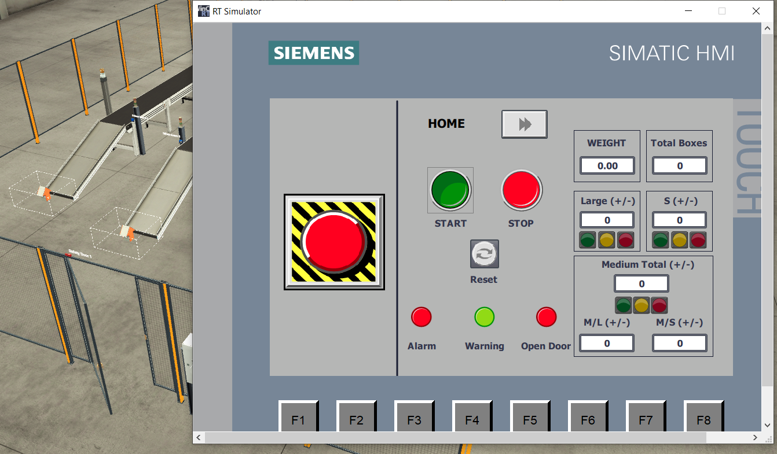
Figure 29: Open door alarm HMI.

HMI Screens
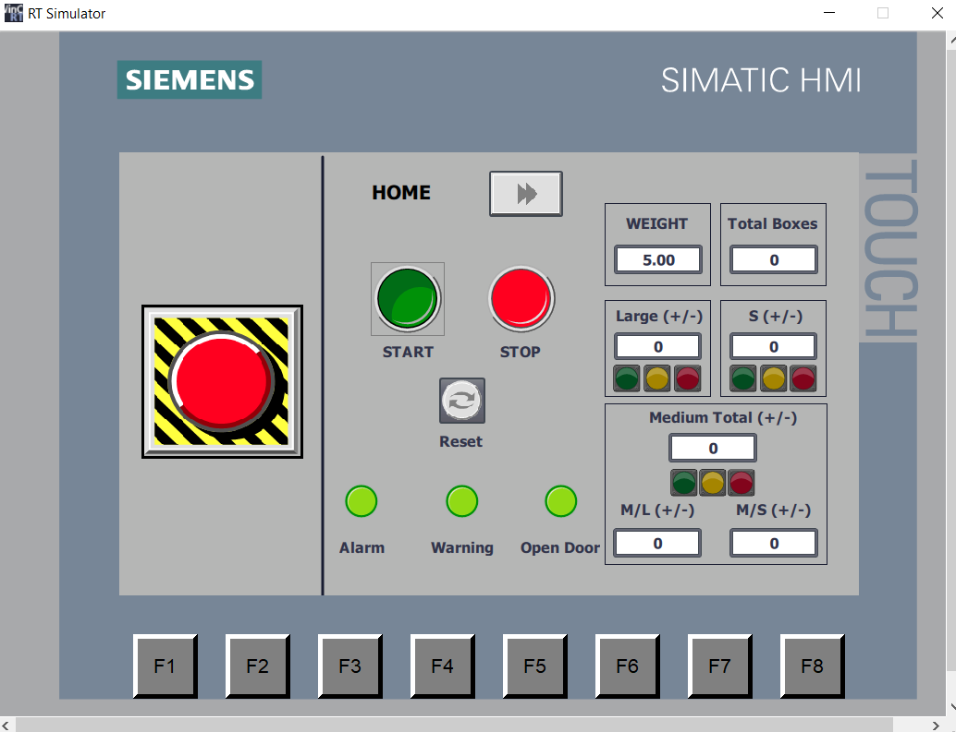
Figure 30: HMI HOME SCREEN
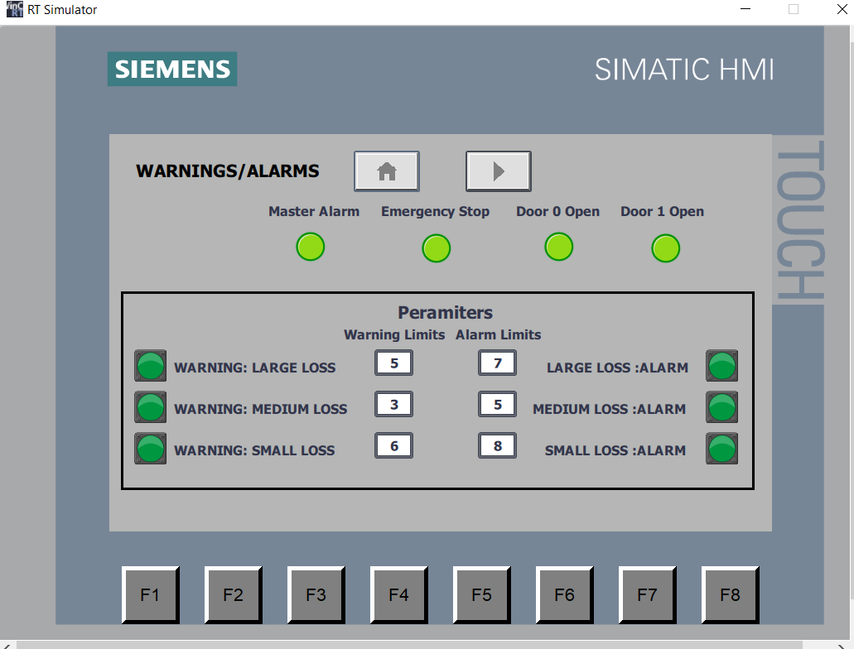
Figure 31: Warnings/ Alarms Screen

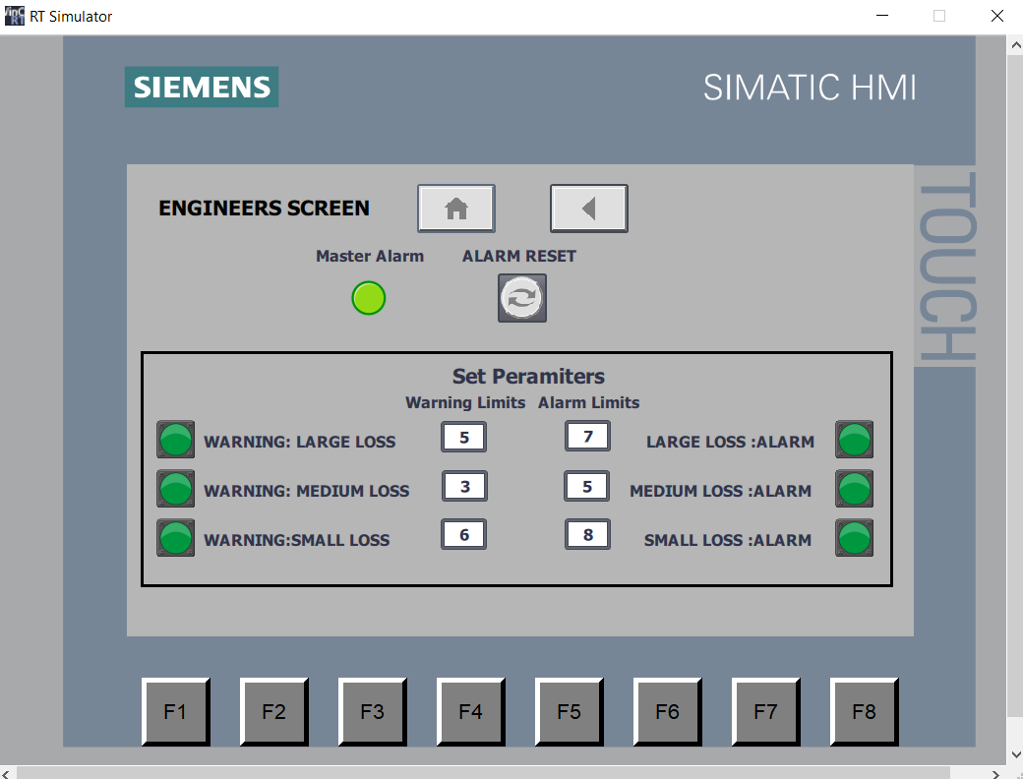
Figure 32: Engineers Screen

Warning and Alarm Strategy

Large Package Loss strategy-
If pusher 0 is activated, it triggers the Large Box counter.
If the package reaches the end of the conveyor root the sensor at the end will lower the total large box count.
The Warning light is triggered at sum to give the operator a change to rectify the possible loss.
The Alarm Light is triggered at a sum that is unacceptable number of losses and so STOPS the entire process.

Medium Package Loss strategy-
If pusher 1 is activated, it triggers the Medium Box counter.
If the package reaches the end of the conveyor root the sensor at the end will lower the total medium box count.
The Warning light is triggered at sum to give the operator a change to rectify the possible loss.
The Alarm Light is triggered at a sum that is unacceptable number of losses and so STOPS the entire process.
As the medium box split off by weight, there are sensors on each side after the split to total count of both sizes.

Small Package Loss strategy-
If sensor 8 is activated, it triggers the Small Box counter.
If the package reaches the end of the conveyor root the sensor at the end will lower the total small box count.
The Warning light is triggered at sum to give the operator a change to rectify the possible loss.
The Alarm Light is triggered at a sum that is unacceptable number of losses and so STOPS the entire process.

Operational Flow Chart
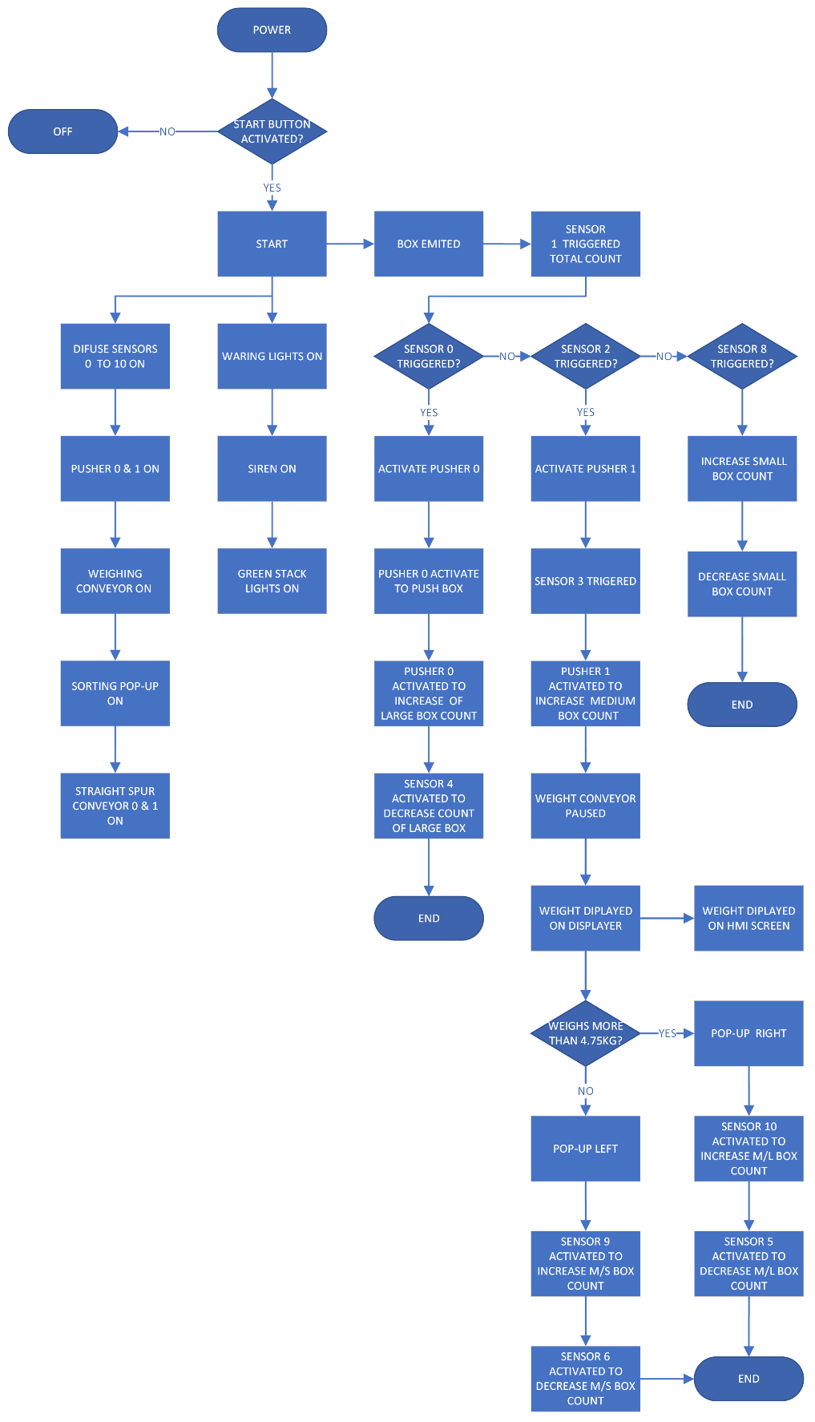
Figure 33: Operational Flow Chart

Conclusion
The program is created to be flexible to the user on the HMI Screens as well as secure to ensure that on the engineers would be able to change the parameters.
The Warning and Alarm system set in place is a relatively basic system to be able to account for any lost boxes.
An improvement that would be recommended is functional HMI buttons to check the pushers and sorters manually for efficient fault finding.

References

[1] PLC comparison: Allen-Bradley vs. Mitsubishi «, https://www.pdfsupply.com/blog/index.php/2021/01/18/plc-comparison-allen-bradley-vs-mitsubishi/ (accessed May 13, 2024).

