Question 1
Explain the Term stoichiometric mixture.
The stoichiometric mixture in a pyrotechnic, is a mixture containing a fuel and an oxidizer in such a ratio that both the reactants are exhausted after the completion of the reaction. Stoichiometry, in general, gives us information about the relative quantities of reactants (Fuels and Oxidants) involved in a reaction.
Draw a graph which illustrates how performance (e.g. energy output) changes with respect to ingredient ratio for a binary system in Joules per gramme of mixture
The energy output (or heat of reaction) should rise towards the stoichiometric ratio and decay thereafter.
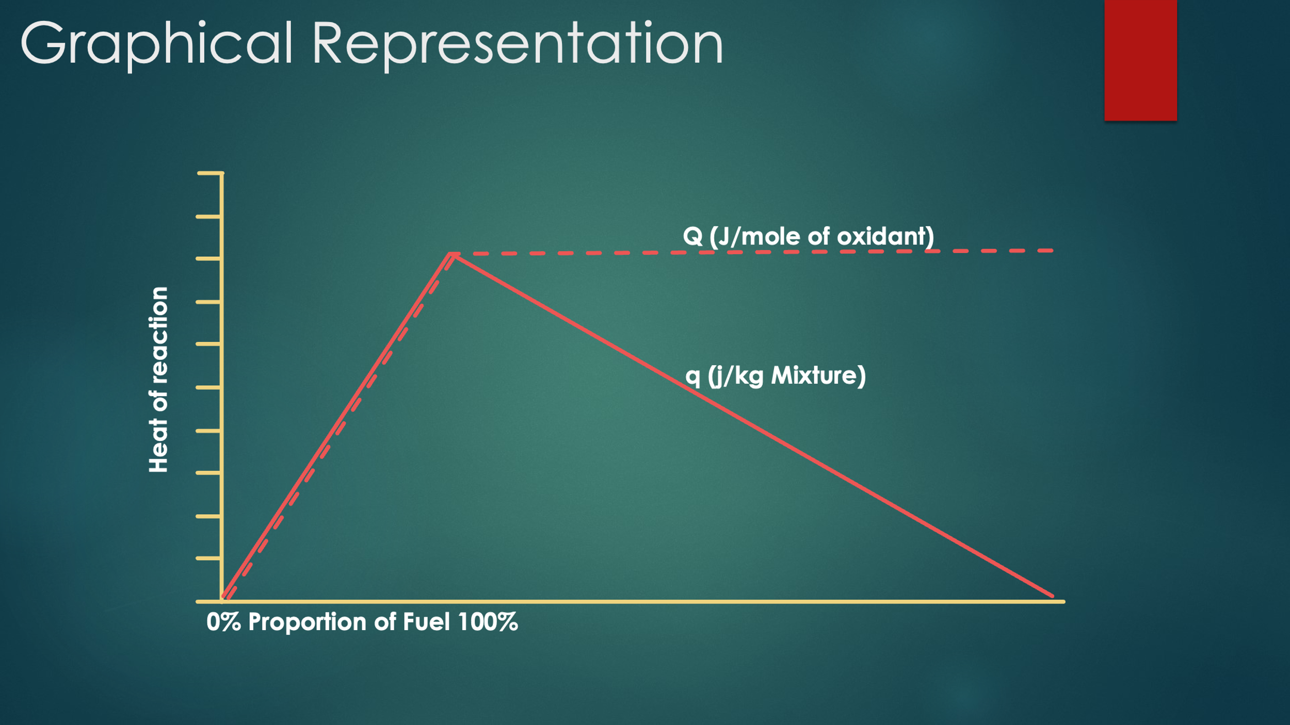
How does the energy output change when measured as Joules per mole of oxidant available?
The output should climb steadily to the point of the stoichiometric ratio and then plateau. If there is an excess of fuel, only that consumed by the oxidant will give rise to any reaction output. When normalised to per mole of oxidant this represents a plateau.

Why, for an illuminating flare, does the peak performance occur at 60% magnesium when the stoichiometric mixture calls for 56% magnesium?
Fuel in excess of the stoichiometric mixture is consumed by atmospheric oxygen. Magnesium is not burned “in situ” but ejected from the flame as particles

Question 2
Describe the makeup and function of a typical coloured smoke composition.
A typical coloured smoke composition is made up of three components. A fuel, an oxidiser, and a dyestuff of the appropriate colour. The heater mixture should be low temperature, and high gas, so as to sublime the dyestuff, allow it to condense without damage, and be transported on the gas stream.
The components are usually tumbled together to form an homogenous mix and then consolidated into a perforated pellet for installation into the grenade or cannister.

The potential reaction chemistry for a typical heater mix may be described as follows
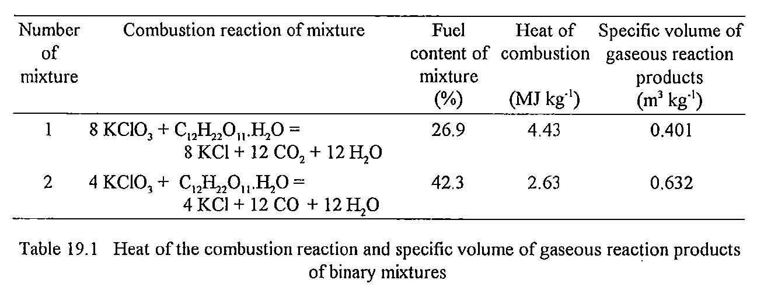
Which of these two schemes is acceptable and why?
The fuel rich mixture is desirable because it produces a higher volume of gas per gramme of composition (The number of moles of gas is important). One mole of gas occupies 24 dm³ , thus gas volumes per mole are equivalent, but they are produced at a much lower heat in the second reaction. Thus damage to the dyestuff is avoided.

Question 3
Sketch a typical Infra-Red Decoy Cartridge and describe its function
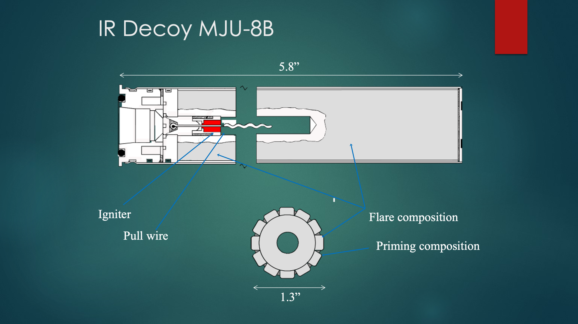
The flare payload is ejected from a launcher of the appropriate design on the aircraft, either on command or by automatic means, the ignition of the flare is usually parasitic from the squib or ejection cartridge.
The flare is wrapped in aluminium foil to retain some pressurisation and allow prompt ignition, as soon as possible after ejection. The flare payload then burns to present a false target to the incoming threat.
Safety features such as bore riders, and g latches are used to prevent ignition of the flare payload in the cartridge case.
Reaction loads are measured to prevent damage to the aircraft structure
How does the spectrum of a typical MTV flare differ from that of the target aircraft?
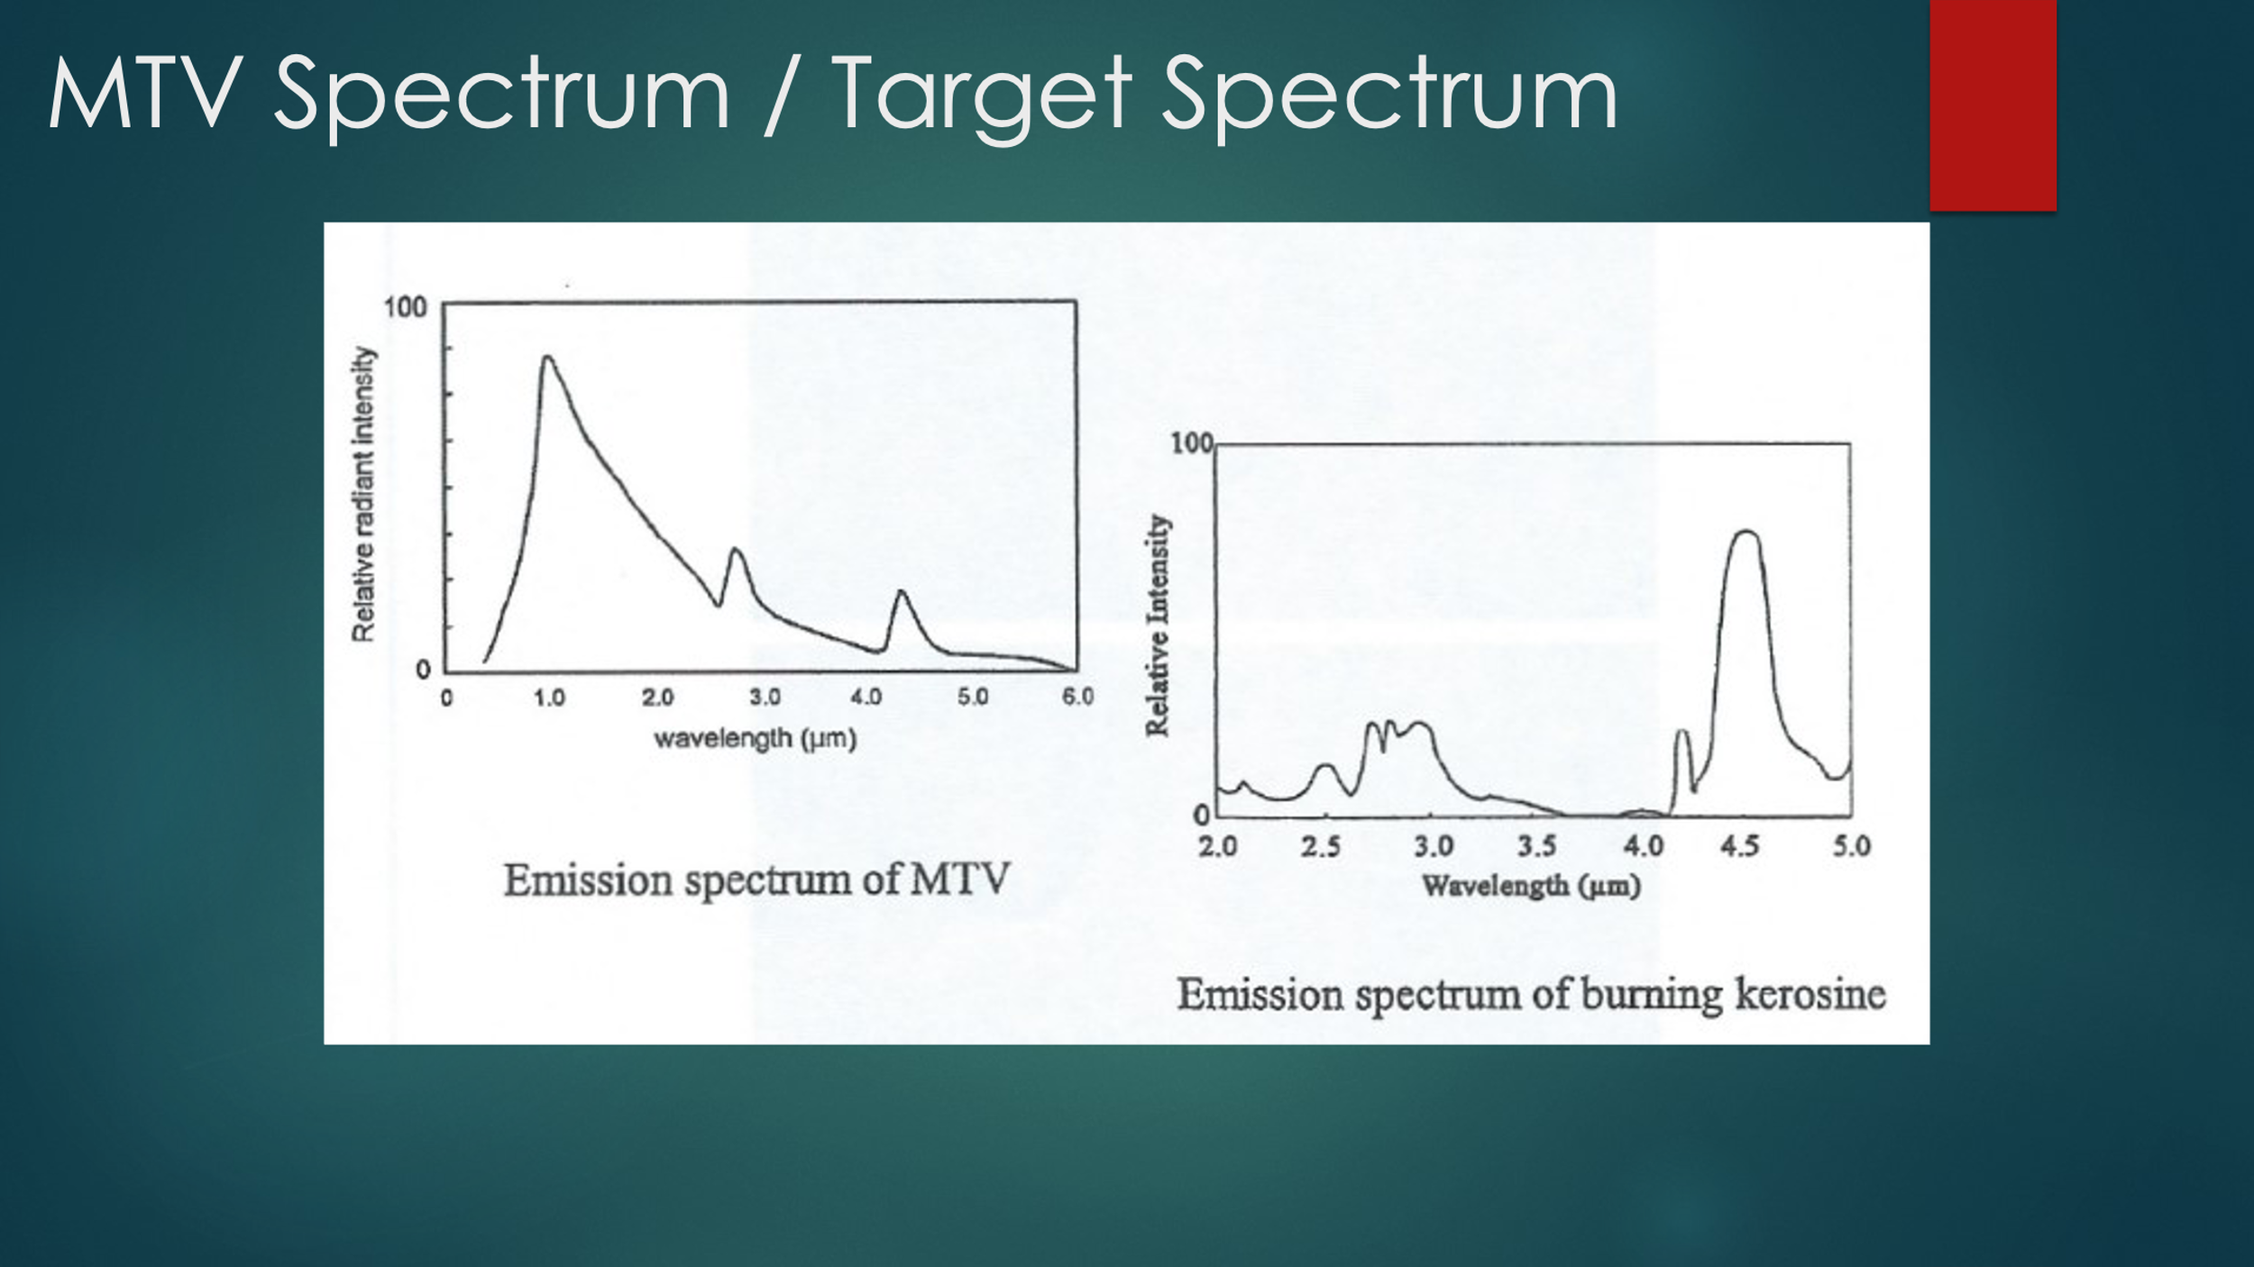
The emission spectrum of a typical MTV flare resembles a grey body radiator at approximately 2000 deg. C. There are a few features created by the various carbon species in the flame, but it remains predominantly grey body emission.
The target spectrum of burning kerosene shows the characteristic features associated with specific CO₂ emissions.

How might these differences be used to discriminate between real and false targets?

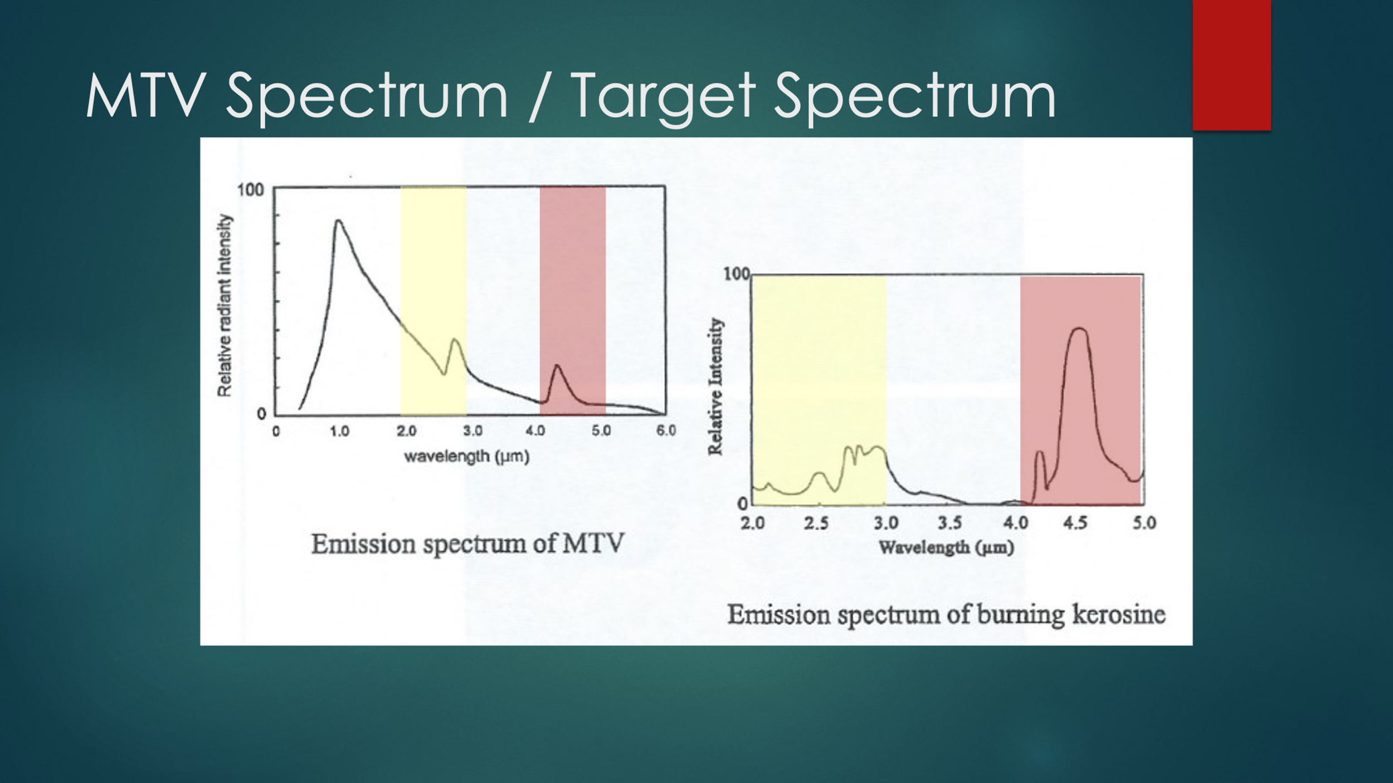
If the detector can filter the output into discrete high and low wavelength bands and compare the ratio between long and short wavelengths, the “real” target will have a higher long wave out put than short wave. Energy under the yellow portion of the curve is lower than the red. The MTV flare will be the converse.

Question 4
What are the issues associated with the reaction between Phosphorus and Water?
Phosphorus reacts with water to produce phosphine which is a colourless fishy smelling gas. Phosphine is poisonous and spontaneously combustible. Concentrations at which the gas is poisonous are below the detection threshold of the olfactory receptors and “nose blindness” is also a recognised phenomenon.
The gas also corrodes copper components such as wiring, bridge wires and foils in smoke stores.
    - 2.P₄ + 12.H₂O → 5.PH₃ + 3.H₃PO₄
    - 3.5 P₄ + 21 H₂O + 11.275 O₂ 5.2 H₃PO₄ + 7.15 H₃PO₃ + 0.65 H₃PO₂ + PH₃

How is this emergence managed in the treatment of red phosphorus?
Phosphorus can be micro encapsulated, using melamine and other polymers to reduce the phosphine split rate. A 5000 fold reduction over a 28 day period has been achieved.
What are the considerations for smoke composition ingredient selection that have to be taken as a result?
Ingredients that are non-hygroscopic are strongly recommended to avoid the inclusion of water
Metallic fuels are to be avoided, The acids produced in the decomposition process react with them to produce hydrogen gas, and increase the outgassing issues.
Sulphur containing formulations are to be avoided because of compatibility issues. (Decatenation of S8 chains) Sulphur less GP to be used.

Question 5
What are the ingredients of gunpowder?
Saltpetre (Potassium Nitrate) 75 Charcoal 15 Sulphur 10
Besides controlling the percentages of the constituent chemicals, what do we need to do to ensure complete and rapid combustion?
The components need to be finely divided and evenly mixed. Normal hand mixing is generally insufficient to obtain a smooth burning powder that will burn leaving little residue.
How is this achieved in the manufacturing process?
The correct type of charcoal should be selected depending on the end purpose of the powder. Alder is used for general purpose powders. Beech for large calibre guns, and Alder Buckthorn for fuze powder. The pore structure of the original wood is critical to function.
The ingredients are sieved to seize them, and remove any foreign objects.
The powder is then made into a paste with water and crushed together, typically in an edge runner mill.
The powder is then pressed into a cake
The cake is then broken up and sieve sized into the various grain sizes required to control the combustion rate.
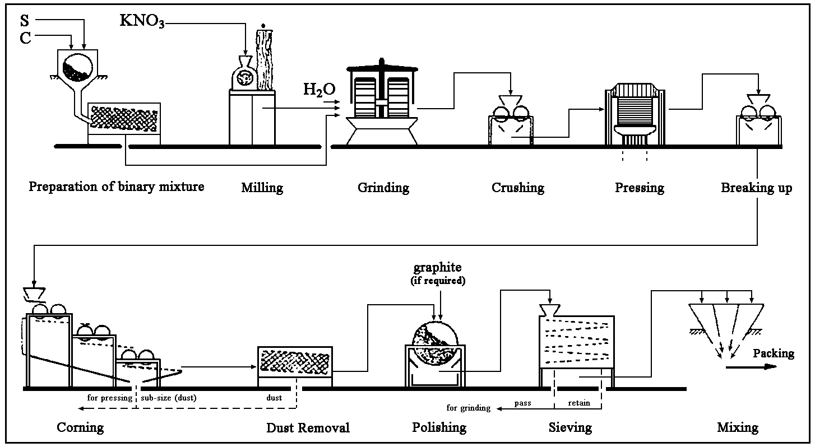

Question 6
See, below, the spectra of a blue and red flare

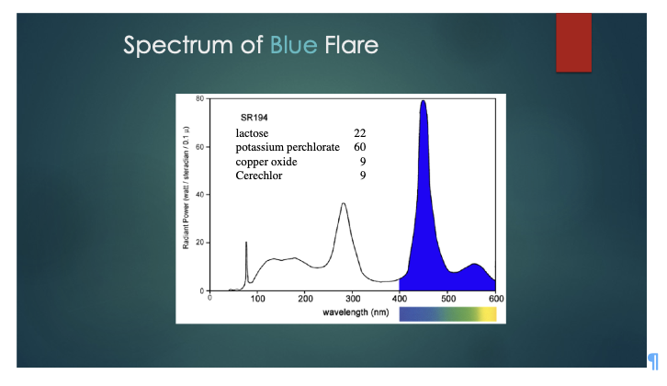

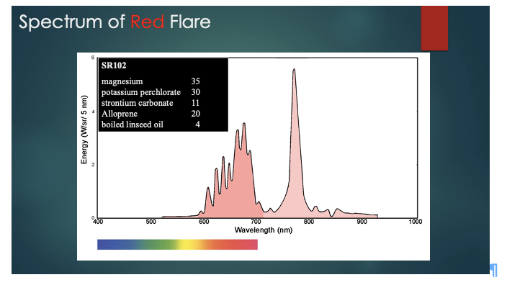

What do these spectra tell us about the combustion of each flare?
A. The blue flare has a cooler burning temperature.
[1 mark]
Why do we need different combustion regimes?
A .If the temperature of the blue flame increases the emitting species are changed giving a green flame
[1 mark]

What is the function of each of the ingdients in the mixes (fuel, oxidiser, chlorine donor, colour provider, binder, or anti-corrodant?)
Solution
SR 194 | Ingredient | Primary Function | Secondary function
Blue Flare | Lactose | Fuel
Blue Flare | Potassium Perchlorate | Oxidant | Chlorine Donor
Blue Flare | Copper Oxide | Colour Provider | Oxidant
Blue Flare | Cerechlor | Binder | Chlorine Donor
SR 102 | Ingredient | Primary Function | Secondary function
Red Flare | Magnesium | Fuel
Red Flare | Potassium Perchlorate | Oxidant | Chlorine Donor
Red Flare | Strontium Carbonate | Colour Provider | Oxidant
Red Flare | Alloprene | Binder | Chlorine Donor
Red Flare | Boiled Linseed Oil | Binder | Anti corrosion coating
(Cerechlor and alloprene are commercial names for chlorinated rubbers / sealants)

