

Assignment

By Matthew Taylor

Contents
Task 1 3
Task 2 6
Task 3 9
Task 4 13
References 14

Figure 1 – Simple and Complex waveform 3
Figure 2 – Noice and Impulse waveform 3
Figure 3 – Square waveform 5
Figure 4 - Triangular waveform 5
Figure 5 - Sawtooth waveform 5
Figure 6 – Aperiodic waveform from MATLAB function. 6
Figure 7 – Amplitude of Fourier Transform 7
Figure 8 - angle of Fourier Transform 7
Figure 9 – Fourier Transform Equation 7
Figure 10 -MATLAB Command Window 8
Figure 11 - Fourier Transform over a range of frequencies 8
Figure 12 – plot of the provided waveform. 10
Figure 13 - Fourier Transform of x(t) 11
Figure 14 – same Fourier Transform of x(t) with a higher sample rate 12
Figure 15 – using MATLABs Fast Fourier Transform function. 13

Task 1
a. Write down an explanation for how one might differentiate simple periodic, complex periodic, impulse and noise waveforms by their shape.

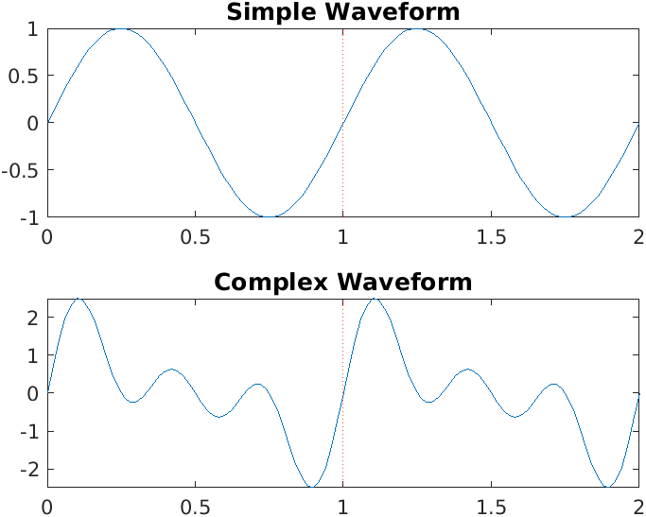
Figure 1 – Simple and Complex waveform

Simple and complex waveforms are both periodic as the shape of the waveform repeats itself every cycle, which can be seen in the graphs in figure 1, where what follows the red line in a replication of the waveform before it.
A complex waveform is made up of at least two sinusoidal waves, but possibly many more, and the complex waveform can be expressed as the sum of a number of these sinusoidal waves. These sine waves can vary in frequency, amplitude, and phase, to make up the complex waveform. Common complex waveforms include square, sawtooth, and triangular waves. Complex waves are visually distinct from simple waveforms, as they are not sinusoidal, but are periodic.
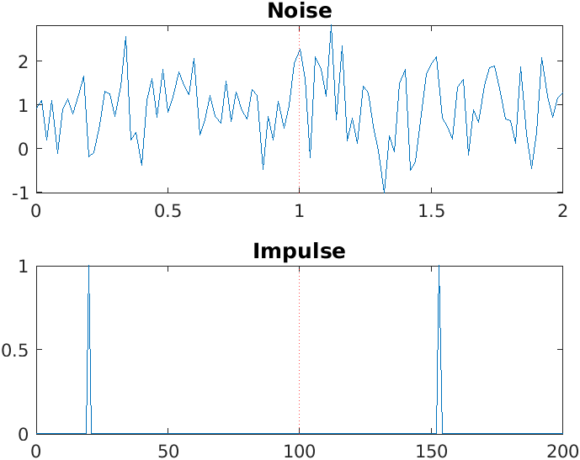
Figure 2 – Noice and Impulse waveform

Noise and impulse signals are distinct from simple and complex waveforms as these are both not periodic, as they do not repeat themselves each cycle. In figure 2 both waveforms have been drawn out, and the difference between them can be seen. The noise, in this case white gaussian noise, is constantly present and is often represented by a signal to noise ratio (SNR). Noise appears commonly in the environment from cables that carry an alternating current, devices that emit electromagnetic energy, and many other devices. Commonly mains wiring can interfere with nearby electronics by as it is a 50Hz periodic wave. There are also devices that emit electromagnetic energy as part of their normal function like wireless transceivers, including WIFI at 2.4 GHz and 5 GHz. Microwaves also emit electromagnetic energy and although microwaves are shielded, there will be stray radiations. Different locations will be affected by different frequencies and to different extents.
Impulse noise also appears in the environment, they can be seen near broken wires, switches, relays, or electro-mechanical telephone exchanges (Price & Goble, 1993). The Impulse noise is characterised as a very short pulse, no longer than 100ms to 200ms. (Sobolewski, 2003).

b. Define Fourier series and Fourier Transform. Explain the importance of Fourier Transform in the field of engineering.

A Fourier series describes the sum of sine and cosine waves within a complex waveform accounting also for their amplitude. These sine and cosine waves are harmonically related which is to say their frequency is an integer multiple of the fundamental frequency. The complex wave can be graphed in the time domain, showing the complex waveform. (Tolslov, 1976)
A Fourier Transform describes frequency domain representation of a complex wave, as well as the mathematical operation to go from the time to the frequency domain. The Fourier Transform is expressed as linear equation showing the component wave’s frequencies and amplitudes. The Fourier Transform of a complex wave can be plotted in the frequency domain, where the fundamental frequency and its integer multiples can be graphed with their different amplitudes.
The Fourier Transform is an important tool within electronic engineering as well as the wider engineering field as it applies to seemingly unconnected applications. Fourier Transforms are used applications like, storing audio mp3 files and even images like jpeg files, for the diffraction of electromagnetic radiation, and for the analysis of electrical circuits. A Fourier Transform often makes working with complex waves simpler, as it is usually accurate and acceptable to work on the simpler sine functions individually before returning back to the complex waveform. (Nussbaumer, 1981)

c. Write out definitions in your own words of the terms fundamental frequency, harmonic and spectrum.

A Fourier series is a complex waveform with multiple waves adding together to create the complex shape. The wave with the lowest frequency determines the fundamental frequency of the complex waveform.
A harmonic wave is a integer multiple of the fundamental frequency, so a complex wave with a fundamental frequency of 2Hz has harmonics at 4Hz, 6Hz, and any multiple of 2Hz with a whole number.
The frequency spectrum describes the frequencies and their amplitudes contained in a waveform. A waveforms frequency spectrum can be plotted in the frequency domain.
d. Explain the amplitude relationship of the harmonics in triangular, sawtooth, and square waveform.
$$x\left(t\right)=\frac{4}{π}\sum_{n=1}^{∞}{\frac{sin⁡(2π\left(2n-1\right)ft)}{2n-1}}$$
$$=\frac{4}{π}\left(\sin\left(ωt\right)+\frac{1}{3}\sin\left(3ωt\right)+\frac{1}{5}\sin\left(5ωt\right)+⋯\right)$$
Figure 3 – Square waveform

$$x\left(t\right)=\frac{8}{π^{2}}\sum_{i=0}^{N-1}{{\left(-1\right)}^{i}n^{-2}\sin\left(2πf_{o}nt\right)}$$
Figure 4 - Triangular waveform
$$x\left(t\right)=a\left(\frac{1}{2}-\frac{\sum_{n=1}^{∞}{{(-1)}^{x}\frac{2πnft}{n}}}{π}\right)$$
Figure 5 - Sawtooth waveform

Like a square wave, the triangle wave contains only odd harmonics. However, the amplitude of the higher harmonics reduces much quicker than in a square wave. The amplitude in the triangular waveform is specifically proportional to the inverse square of the harmonic number (n) as opposed to just the inverse in a square wave. A sawtooth waveform contains an even amount of odd and even harmonics unlike the previously mentioned square and triangle waveform. (Morin, 2009)

Task 2

a. Plot $X\left(if\right)=8sinc(8πf)$ as purely real function using MATLAB.

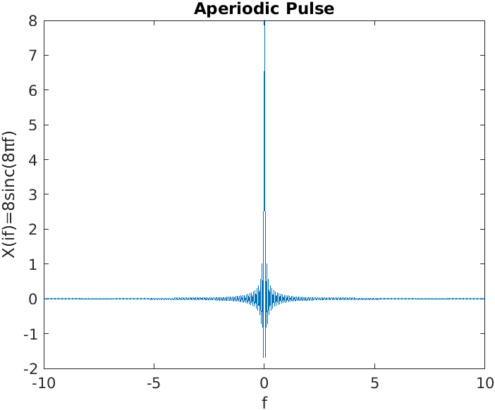
Figure 6 – Aperiodic waveform from MATLAB function.
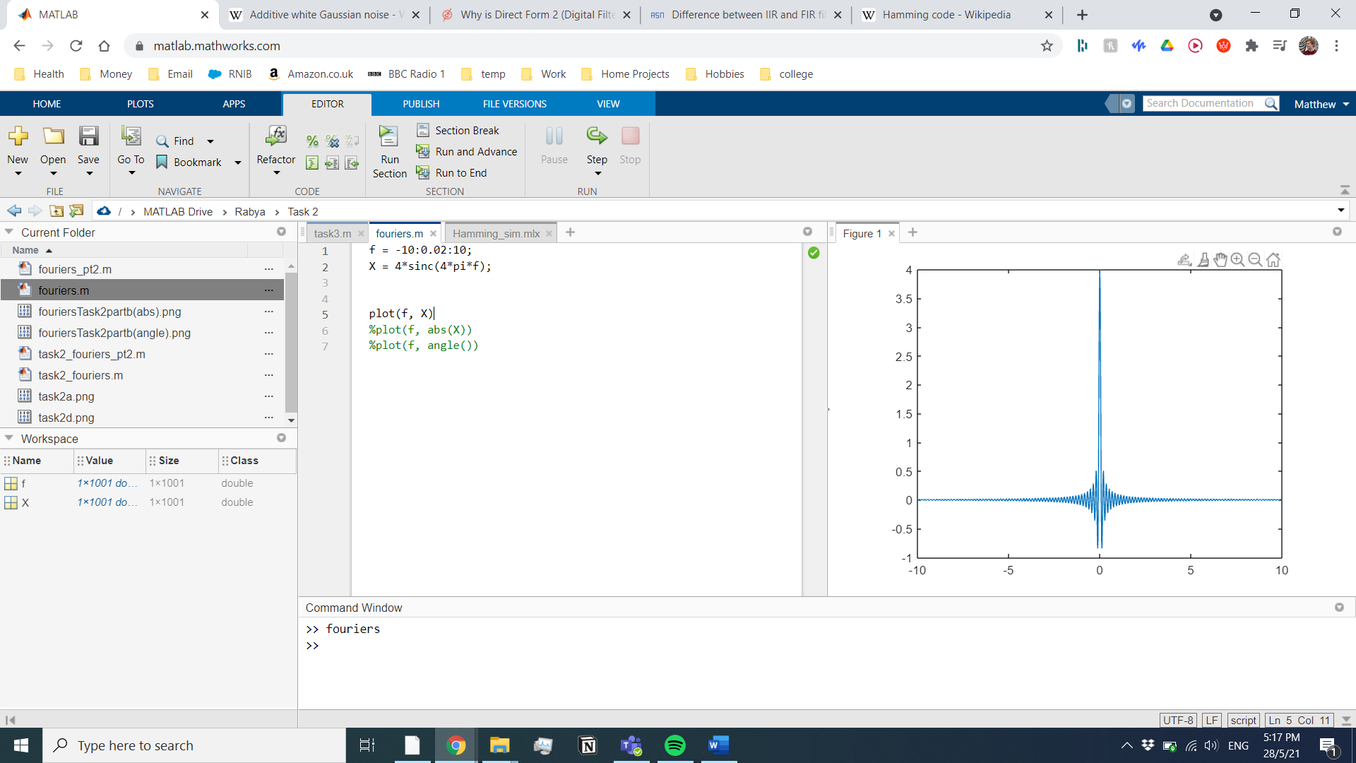
To generate this plot, I used the sinc function, followed by the plot function.

b. Plot the above Fourier Transforms as a complex function by plotting the amplitude and phase spectrum separately.

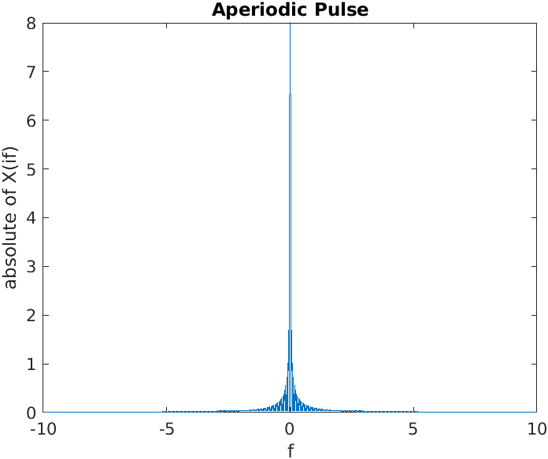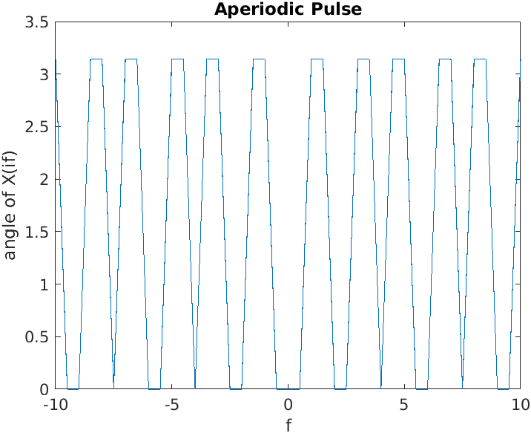
Figure 7 – Amplitude of Fourier Transform
Figure 8 - angle of Fourier Transform
These graphs were plotted by using the same function as above, before passing the results into separate functions to plot the new results. I uncommented the lines, as required and exported the graph. The abs function takes the absolute value of the number, and is it’s in the plot function that is the value that’s used for the graph. The Angle function is used in the same way, so that the phase spectrum can be plotted.

c. Find the Fourier Transforms of the above plus numerically using the formula:
$$X\left(if\right)=\int_{-∞}^{+∞}{x\left(t\right)e^{-j2πft}dt}$$
Figure 9 – Fourier Transform Equation
$$X\left(if\right)=\int_{-4}^{4}{1e^{-j2π(0)}dt}$$
$$X\left(if\right)={\left[t\right]}_{-4}^{4}$$
$$X\left(if\right)=4-(-4)$$
$$X\left(if\right)=8$$

d. Perform the above integration in part (c) using the trapZ command in MATLAB.

Using the command window in MATLAB, I set a variable for f and t, the typed in the integration using the trapZ function, the result of which is 8.

  - 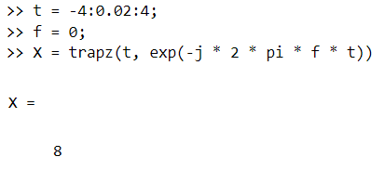
Figure 10 -MATLAB Command Window

e. Plot the complete transform in part (d) over a range of frequencies.
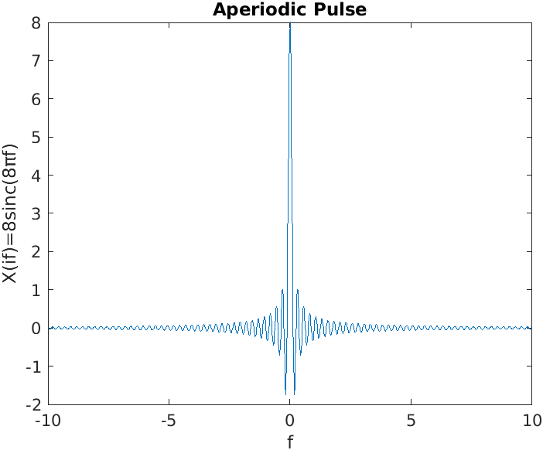
Figure 11 - Fourier Transform over a range of frequencies
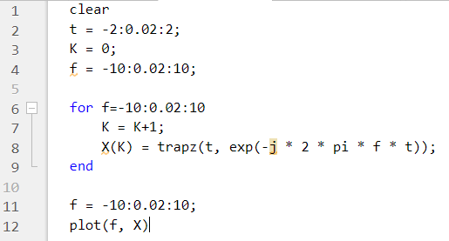
To be able to generate the data required for a range of frequencies requested, I used a for loop to iterate through the range. On first the first run I found the plot unclear, so I decreased the iteration size, and therefor increasing the number of loops. This generated the more legible graph above.

f. Discuss your result.

Over this task I have calculated the Fourier transform for the equation $X\left(if\right)=8sinc(8πf)$ using multiple methods showing the validity of them. Firstly I showed at f = 0, that the amplitude is 8 by integrating with the trapz function. I also plotted the equation in the frequency domain using two methods. I also showed how the amplitude is 8, mathematically.

Task 3
a. Using MATLAB plot the amplitude spectrum of the signal below by creating a vector, x, with sampled values of the continuous time function (sample the signal every 0.0002 seconds and create a sequence of length 250)

$$x\left(t\right)=\cos\left(2π130t\right)+\cos\left(2π320t\right)+\cos\left(2π440t\right)+cos⁡(2π560t)$$

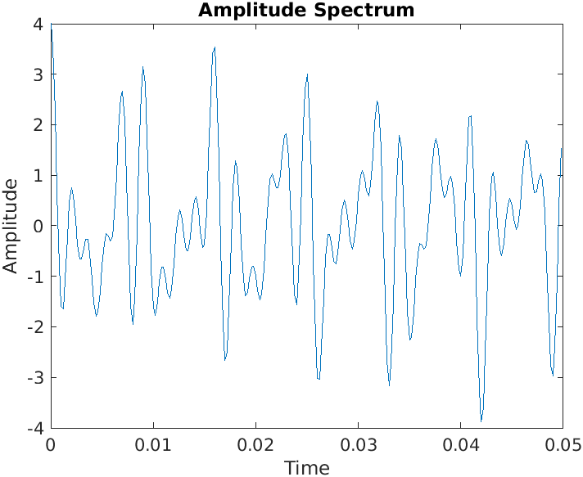
Figure 12 – plot of the provided waveform. 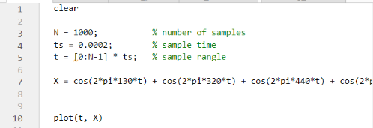
I plotted the amplitude spectrum with the above code.

b. Find approximate the Fourier Transforms integral for 0 ≤ f ≤ 1000 Hz.

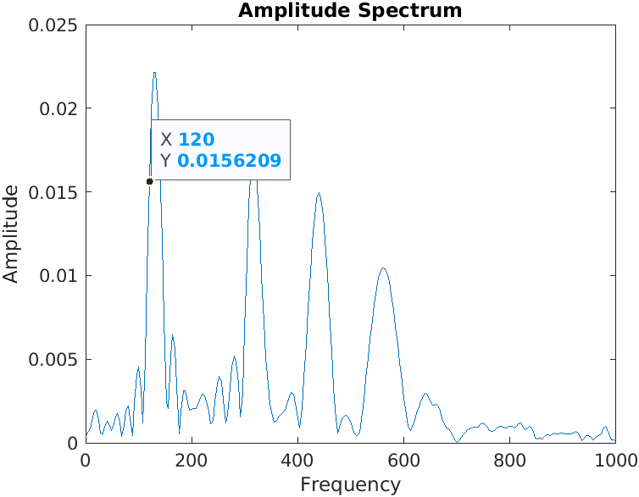
Figure 13 - Fourier Transform of x(t)
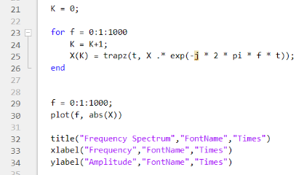
I plotted the frequency spectrum with the above code. I used a for loop to iterate through the frequencies. The last lines add a title and labels for the axis.

c. Show that the value of the sampling interval and number of samples taken affect the approximation (you can observe the effects of the sampling interval and number of samples by changing their values). Discuss your observations.

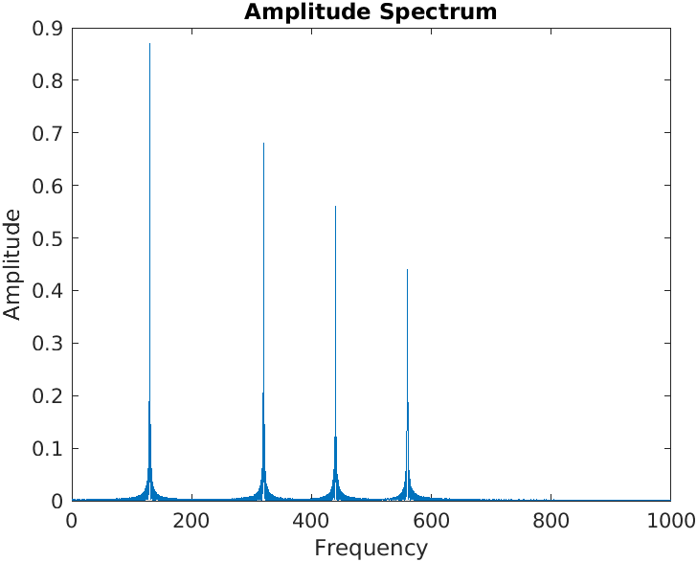
Figure 14 – same Fourier Transform of x(t) with a higher sample rate

When the sample rate is increased there are more data points to construct the data as well as reducing aliasing.

Task 4

a. Use Fast Fourier Transform (FFT) to plot approximate the Fourier transform of the same four-frequency signal x(t) used in task 3 above, by producing a sequence of samples of length N = 250 spaced every Ts = 0.0002 seconds. Discuss reasons of observing frequencies not correspond to the actual frequencies in the Fourier transform.

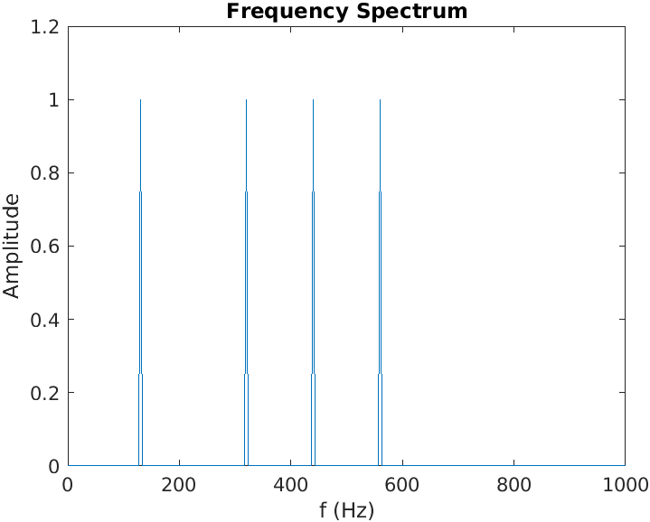
Figure 15 – using MATLABs Fast Fourier Transform function.

b. Produce a spectrum plot that only shows frequencies correspond to the actual frequencies in the Fourier transform by applying the fftshift function.

References
Morin, D., 2009. Waves, Cambridge, Massachusetts: Harvard University.
Nussbaumer, H. J., 1981. The Fast Fourier Transform. Fast Fourier Transform and Convolution Algorithms, Volume 2, pp. 80-101.
Price, J. & Goble, T., 1993. Telecommunications Engineer's Reference Book. 1st ed. Oxford: Butterworth-Heinemann.
Sobolewski, J. S., 2003. Encyclopedia of Physical Science and Technology. Third Edition ed. Cambridge, Massachusetts: Academic Press.
Tolslov, G. P., 1976. Fourier Series. First (translated) ed. New Jersy, USA: Dover Publications.

