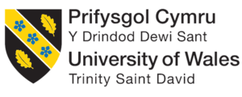

Student Name: Talida Raducan
Student Code: 2013549
Module Name: Personnel Resourcing Development
Assignment title: The impact of COVID-19 and Rebuilding the Workforce for Hotel Trinity

This essay is written with the main purpose of discussing and analysing the impact that the Coronavirus Pandemic has had upon the given hotel- Hotel trinity. The essay has got few main aspects to focus on according to what has been studied in the Personnel Resourcing Development module. It is essential to mention from the start that personnel resourcing has to do with the employees that represent the workforce of a company, working daily to complete tasks and help the company grow in the industry (Jackson & Rowley, 2010). Having this in mind, the at the base of the main body, a clear and complex explanation of the employee lifecycle will be discussed along with pillars of Personnel Resourcing Development. To discuss about the hotel, and help the audience understand the current external environment of the hotel, a PESTLE analysis will be attached as well to check and track the risks that the hotel is exposed to. All the information that is going to be included will be extracted from valid resources which have been written by informed professionals and verified by other professionals.

According to the Office for National Statistics (2021), the hospitality industry has been highly hit by the COVID-19 pandemic and the restrictions that have been put in place, also being one of the most affected industries, which apart from the COVID-19 has also been affected by Brexit, so two severe aspects in the society have happened to drive the hospitality industry to slow failure. Data published by the Office for National Statistics represents the fact that there were approximately 1650000 employees that have been furloughed in the hospitality industry (Osborne, 2020), meaning that they were paid a smaller amount of money that they would have normally been, while not having what to work.
However, the situation has started to improve in April 2021, when the number of furloughed people in the hospitality industry has fallen to only 590000 employees. According to the picture attached below, which represents the business turnover in the hospitality industry, the period between March 2020 and August 2020 has been the most critical one, like the struggle situation which has appeared again during the winter season of 2020 and 2021 (Jolly, 2020). It is critical for hotel owners to deal with such situations especially because all the money that have been accumulated until 2019 could have not been reinvested into aspects that bring more profit to the company, but the money was needed for costs that are compulsory in the business for it to survive, such as bills, materials, employees, etc.
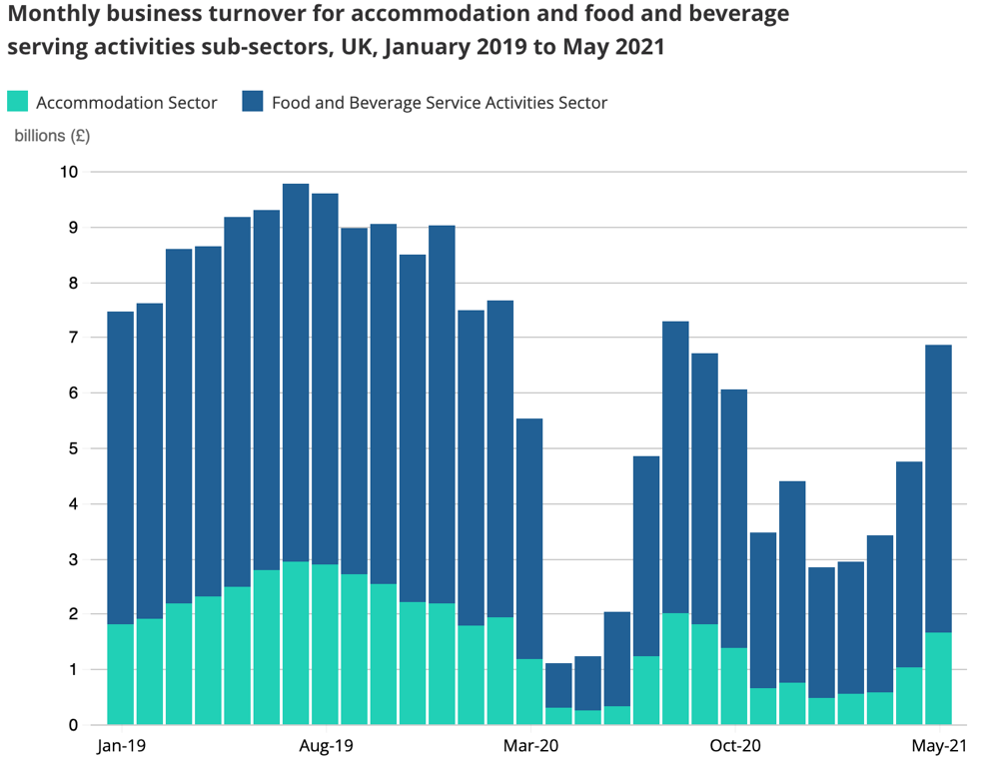
Now that the overall situation with the COVID-19 and the consequences that the hospitality industry had to suffer because of it has been discussed, it is important to go further in discussing what is been required for this essay. To introduce the employee lifecycle, one key thing to say is that the employees are the most important to a business’s success next to the customers and this because, depending on the work they perform at the workplace, the product or service that is being offer is qualitative or not (Ikin, 2017). If the products and services they offer based on their work is not of a high quality, then the customer will not be satisfied either and the company will not go up in profit, but low (Dibble, 1999). Having this in mind, when it comes to the employee lifecycle, first thing to say is that the employee lifecycle is a method used for organization to view how each employee in engaging in the company they work for (Brantley et al, 2019). According to studies, there are six stages that build up this model: Attraction, Recruitment, Onboarding, Development, Retention and Separation (Kakade, 2019).

Starting with the first element- attraction, this is the stage where the company has to put effort into pointing out why people should work in the company. This process should start before the application list is open to ensure that the imagine of the brand is seen and that people will be attracted to be part of a such committed team that works for the accomplishment of important tasks in the company.

Going further to the recruitment stage, this is the second step of the employee lifecycle where the company is responsible for promoting and putting into evidence the positions that are available in the company. During this process, the best-experienced and skilled people are being looked for as they are the ones that can catch up the hang of the work that needs to be done while having a decent performance too (Nikolaou & Oostrom, 2015). Some of advice for this step is to ask for referral from your existing team; try out various recruitment platforms such as LinkedIn or Indeed.

Looking into onboarding, this is the step of employee lifecycle where the fresh-employed individual is getting used to the activities, procedures and processes that need to be followed in the position it has been hired. In some cases, companies do also have an organized training for the new employees (Sims, 2010). Especially in hotels, the period of training is very important because each hotel has its unique procedures and ways in which the guest’s expectations are being met, reason for which the new employee needs to familiarize with the expectations of the employer.

The fourth element of the employee lifecycle is the development, this step represents the process where the employer is working along with the employees to create a strong professional bond between the employees and make them understand the importance of their commitment and collaboration as a team for the growth of the company (Harrison, 2012). Some advice for this process includes encouraging the employees to learn from external sources why teamworking is important and how this can be enhanced.

The second last element from this lifecycle is retention, this process represents the period where the employees are checked periodically to make sure that they do not have any concerns regarding the role that they have in the company or anything like this (Taylor, 2002). At the same time, it is also the stage where the employer can denote if the employees are doing the right work according to the missions and goals that are set by the company. Some advice for this process has to do with the open communication between the employer and employee as sometimes, the gaps that exist can be filled after a great discussion where the employee to understand exactly what the employer expects. Another advice has to do with the requirement of employee feedback which to be addressed to the other members of the team, or even to the employer so each person knows what is irritating about them.

Lastly, looking into separation, this is the sixth step, but also a very important one and this because this element from the employee lifecycle discusses about periods of employees when they must finish working in the company for some normal reasons such as retirement, or personal reasons. It is essential for the employer to treat this process equally for each employee that needs or takes the decision of leaving the company. Some of the suggestions that employers could consider for this last stage of the employee lifecycle include understanding the reasoning behind the resignation, remain positive, ask for honest feedback, remind the remained number of employees to keep focused and optimist.

After a great consideration of each element of the employee lifecycle, looking into Hotel Trinity and the fact that same as most other hotels has lost employee’s motivation due to furlough for a very long time, it is the situation where the hotel needs to look after strategies and great management plan to regain the motivation and capabilities of the employees which have lost the track of activities that need to be completed. Therefore, the hotel must focus on the fourth step- development, where the employer should work towards developing the skills and abilities of the employees. Now, due to the COVID-19 pandemic some of the way in which such attributes have a different way to be accomplished. Therefore, the employees must be acknowledged about these, so they adapt to the new conditions.

As mentioned in the introduction the next thing to discuss in this essay is the PESTLE analysis of the Hotel Trinity which is in Central London. The PESTLE analysis is a business tool applied by companies with the main aim of investigating the external environment of the company that could impact potential results and activities that are being undertaken by the hotel (in our situation) to boost reputation and revenue. PESTLE as a tool represent the abbreviation of six main factors that the tool investigates to outline how each factor could affect the performance of the company (Perera, 2017). The six factors PESTLE looks at are: political factors, economic factors, social factors, technological factors, legal factors, and environmental factors. They are all extremely important to investigate and know.
Starting with the Political Factors, these are the ones that have to do with the decisions that are being taken by the government and other political institutes. Therefore, one factor that can negatively influence the Hotel Trinity has to do with the rules and regulations that are followed for transportation of both raw material and people that want to travel to United Kingdom from another country. The restrictions in transport from one country to another will significantly decrease the number of customers that will use the services of the hotel (Brians, 2013).

The economic factors are in the interest of any hotel that lays in the hospitality industry and this because they are obviously existing for money and profit, which to be reinvested and boosted. Some of the economic factors that could negatively influence the way the hotel runs include the raise of tax that is paid for employees, increase of wages, boost in transportation prices, and so on (Rahman, 2020). These are all important to keep an eye on because the owner of the hotel must be always prepared to financially adapt to any change in the mentioned.

Going further to the social factors, these are directly related to the preferences of the customers, target segmentation and so on. These factors are vital for the hotel because Hotel Trinity should be informed on what the guests are expecting no matter where they are coming from (Uysal & Williams, 2013), and they should be treated according to their characteristics. The four segments of marketing (demographic, psychographic, behavioural, and geographic) should be used to classify each guest (McDonald, 2012).

Looking into the technological factors, in the current world we live in, these need a great attention because each business from the hospitality industry is looking after methods and strategies to be applied to take advantage of the opportunities that technology offer and make the contact with the guest as limited as possible while they stay in the hotel, and this not only to limit the chance of infection, but also to become unique in the eyes of the guests (Connolly & Nyheim, 2013).

The legal factors, play a vital role in the “health” of a hotel and this because these have to do with changes that are made in pieces of legislations, acts. Some of the major policies and pieces of legislation that the hospitality industry needs to be careful at includes the employment act, the equality act, data protection act, health, and safety at the workplace act, and so on (O’Fallon, & Rutherford, 2010). Any changes that are made in any of the mentioned, must be quickly adapted by the hotel and all the employees must be informed about the changes that have been made, to avoid potential confusion in conflictual situation.

Lastly, the environmental factors are directly linked to the promoting of sustainable practices. One of the main factors that Hotel Trinity needs to pay attention to has to do with the activities that most hotels have started to apply to promote sustainability and a green world where the air we breathe is clean, and the actions that are taken are environmentally friendly. Some suggestions include reducing the use of plastic in the door keys that are given, make use of technology to replace them, same about the use of paper in offices, replace them with online documents (Gardetti & Torres, 2017).

Looking into what had been discussed throughout the PESTLE analysis, the main thing to say is that there are quite a few preventive measures that Hotel Trinity could put in place during their process of recovery of the workforce of the company. The most important thing that they need to focus on is around the economic factors and political factors especially because aspects keep changing even from day to day due to the variation of numbers and statistics regarding COVID-19.

Overall, after a great consideration of the pandemic impact upon the hospitality industry as a whole, and even particularly upon the Hotel Trinity, given as an example, the main thing to outline is that the recovery of the employees that were dedicated to their workplace before being furloughed will be hard, however, by applying the right strategies and by following the employee lifecycle, the hotel has increased chances of rehabilitating the employees that work upon the success of the business.

List of References

Brantley, W. A., Kemsley, S., & Palmer, N., (2019), Best Practices for Knowledge Workers: Innovation in Adaptive case management. Future Strategies Inc, pp: 98-99

Brians, A., (2013), Impact of Globalization on Hospitality. GRIN Verlag, pp: 8-9
Connolly, D. J., & Nyheim, P. D., (2013), Technology strategies for the hospitality industry. Pearson Higher Education, pp: 23-24

Dibble, S., (1999), Keeping your valuable employees: retention & strategies for your organization’s most important resource. John Wiley & Sons, pp. 26-28

Gardetti, M. A., & Torres, A. L., (2017), Sustainability in Hospitality: How innovative hotels are transforming the industry. Routledge.

Harrison, R., (2012), Employee Development. Orient BlackSwan, pp: 380

Ikin, M., (2017), Handbook of Employee Commitment. Scitus Academic LLC, pp: 102-103

Jackson, K., & Rowley, C., (2010), Human Resource Management: The key concepts. Routledge, pp. 15-17

Jolly, J., (2020), Covid-hit UK Hotels unlikely to recover for four years, says PwC. The Guardian News.

Kakade, S., (2018), Employee Life Cycle: Definition., (online) available on: https://searchhrsoftware.techtarget.com/definition/employee-life-cycle last accessed on: 19th October 2021

McDonald, M., (2012), Market segmentation: how to do it and how to profit from it. John Wiley & Sons, pp: 452-453

Nikolaou, I., & Oostrom, J. K., (2015), Employee Recruitment, Selection, and Assessment: Contemporary Issues for Theory & Practice. Psychology Press, pp: 18-21

Office for National Statistics (2021), Coronavirus and its impact on UK Hospitality: January 2020 to June 2021., (online) available on: https://www.ons.gov.uk/businessindustryandtrade/business/activitysizeandlocation/articles/coronavirusanditsimpactonukhospitality/january2020tojune2021 last accessed on: 18th October 2021

O’Fallon, M. J., & Rutherford, D. G., (2010), Hotel Management & Operation. John Wiley & Sons, pp: 450-452

Osborne, H., (2020), Hotels, restaurants and pubs have furloughed 80% of staff, ONS Finds. The Guardian News.

Perera, R., (2017), The PESTLE analysis. Published by: Nerdynaut, pp: 4-6

Rahman, M., (2020), PESTLE analysis of the hotel industry. (online) available on: https://howandwhat.net/pestel-analysis-hotel-industry/ last accessed on: 20th October 2021
Sims, D. M., (2010), Creative onboarding programs: tools for energizing your orientation program. McGraw Hill Professional, pp: 280-283.

Taylor, S., (2002), The employee retention handbook. CIPD Publishing, pp: 250-251

Uysal, M., & Williams, J. A., (2013), Current issues and development in Hospitality and Tourism Satisfaction. Routledge. 119-120

