PROGRAMME: BA (HONS) LEADERSHIP AND MANAGEMENT SKILLS FOR THE WORKPLACE
MODULE: UNDERSTANDING AND ENGAGING IN THE CUSTOMER EXPERIENCE
Module code: BMSW 5103
RODICA VIORICA CUC 1906092
LECTURER NISHI RAMSURRUN
Executive Summary
This report will look into the context of customer experience, which is at the heart of Amazon's concerns in the last few years operating from the Seattle headquarters in the US. Furthermore, the company has lost numerous customers due to its lacking of initiative and identification of specific adaptations to improve the customer service delivery. For the same purpose, the company has undergone numerous developments that will be addressed throughout the report. It will also use specific models and theories to justify the claims.

Table of Contents
1.0 Introduction 4
2.0 Theories to underpin the context of the report 4
2.1 Marketing Mix 4
2.2 Ansoff Matrix 6
2.3 Porter’s Five Forces 7
2.4 Communication Mix 8
2.5 Stakeholder Map 9
3.0 Critical analysis of internal and external factors that influences the organisation's quality systems and controls for customers in times of crisis like the covid-19 10
4.0 Identify the systems that support the organisation's quality processes and provide critical understanding of which those systems are effective in meeting customer requirements and maintaining good customer relationships during a crisis like covid-19 13
5.0 Conclusion 15
References 17

1.0 Introduction
This report will deal with the multinational tech giant and e-commerce organisation of Amazon. In the last few years, Amazon’s customer executive decision making has undergone topsy turvy changes. Especially as the company has brought about a fresher perspective to help cater to the needs of the customers. A key factor behind influencing the same is ‘tech’. With the company not minding more deals taking place throughout the internet, the design sprint process allows Amazon to eradicate the roadblocks for customers about feedback, revamp processes to cater for needs in a better manner, and analyse consultations to bring about more products. This will be tested around the entire report in the context of Amazon, and also the quality and control systems will be examined within the company to inspire better customer relationships for the organisation. In the end, the report will focus on how covid-19 has affected these considerations as a whole.

2.0 Theories to underpin the context of the report

2.1 Marketing Mix
The concept of the marketing mix was popularised by Neil Borden in the year 1950, and it was broadened through later publishings that emphasized the advertising means of organisations that can significantly impact the customer experience. In the case of Amazon, the same can be laid down as follows.
Product
It is through product or service that an organisation can truly fulfil customer demand. The service in this case can be compelling enough to allow customers to create a new demand altogether. After ascertaining the technical feasibility of streaming, and the popularity that iPods achieved in the same reign. Amazon has increased its importance around its digital media ecosystem, which is integrated directly into its main store (Statt, 2018). This allows the company to ensure a two-day shopping spree among its loyal customers and the interested ones, on a few occasions to attain benefits in which they can utilise two products at the same time. The subscription connection with the main retail centre, allowed Amazon to increase over 100 million paid users mostly during the covid-19 period (Statt, 2018).
Price
This is generally the cost that has to be borne by the customers, however, it might sometimes become the cost they have to bear due to the mistake of choosing a product. Therefore, company-related marketers try to connect the product price with the real or perceived value. Due to the competitive growth of many short time e-commerce organisations like Argos, Tesco, and others. It was important that Amazon lived up to its reputation and did not lose its existing customer groups, because of which they tweaked the costs surrounding its prime memberships. Despite the membership requiring customers to sign-up with an electronic benefits transfer card for qualifying, the cost of Prime membership came to about $10.99 per month, instead of the usual $15-19 (Perez, 2017). This discounted membership offer was to grant middle-class customers the perks of enjoying Prime through video streaming, Kindle library access, and others. The penetration was especially aimed at households with $112,000 a year annual income. As a result, Amazon received 70% positive responses from the same households (Perez, 2017).
Promotion
These include advertising, public relations, and promotional strategy. The main goal is to encourage buyers into accessing the service or product as to why they need it, and what form of the price they should be willing to pay for the same. In the above case, Amazon has been slow to jump onboard its social media strategy. When the company decided to believe in the same, they brought together fresher strategies to boost shopping during the holiday season (etaileast.wbresearch.com, 2016). For instance, the company kicked off the holiday shopping season by hosting promotional codes through Snapchat, which is the third most popular application among Millennials (Tode, 2017). The organisation has even planned community moderation, by encouraging consumers to vote for the products and services. This provides an understanding of what can be changed by the company about products. It registered over 28.7 million users overseas and 2.7 million followers exclusively through Twitter (Tode, 2017).
Place
The company can make decisions regarding a place when they are trying to decide why they should sell a product and how to deliver the product or service to the market. In the country of the UK, the city of Birmingham has become a primary location for the company to invest through digital devices (Intranet.Birmingham.ac. the UK, 2022). That creates a hybrid learning environment for its executives and also encourages more customers to undertake online chat systems that bring them directly to face the trained workers.

2.2 Ansoff Matrix
Another matrix implemented by Igor Ansoff and published in the Harvard Business review in 1957, includes certain factors that might evaluate a company’s capacity to channel its products and services within a few markets.
Market Penetration
Under this strategy, a firm might use its existing products within the existing market, and aim at extracting a larger market share than predicted. There are different brands with which Amazon deals around the market in the US, however for the brand KAVAJ which is a producer of leather items for men and women the company decided to lower the prices by $3 to inspire more new buyers (Klement, 2017). This resulted in close to $19 million in revenue from the US market alone (Klement, 2017).
Product Development
To bolster its services, Amazon decided to try its hand at something new by launching the 'Product opportunity explorer'. This new feature provides anonymised data on trends within product sub-categories, and the tool allows specific tracking of search term volumes around products and their history in categorisation matching pricing trends. The tool allows Amazon to fill out its overall product selection, by encouraging customers to prefer sub-category searches and getting fulfilled by overall product qualities (Waters, 2021). This helped with their research and development process by giving Amazon better control in managing the products. Allowing at least 90 days for the product to stay available for customers.
Market Development
This strategy tends to enable a firm to enter a new market with the existing products. That can be seen especially when Amazon calculates floor prices after comparing foreign market requirements overall. For instance, 70% of the organic sales for the company happen through organic searches, and this is where Amazon can use the brand of KAVAJ to influence the market in Birmingham (Shah, 2022).
Diversification
The company generally enters a new market with a new product, although this strategy tends to be risky as both product or service and market development are required. With such a consideration in mind, Amazon can use a related diversification strategy that might allow it to gain synergy within Birmingham. For instance, KAVAJ could create a new line of leather wallets for the consumers in Birmingham itself (Waters, 2021). In other ways, KAVAJ can also create a new line of fashion products that might appeal to consumers differently.

2.3 Porter’s Five Forces
In terms of competitive analysis, a model implemented by Michael Porter in the year of 1980 could also provide a better clarity with regards to the competitive push that Amazon can attend to in terms of its customer executive decision making.
Bargaining power of suppliers: This element within the five forces analysis of the framework, addresses how the suppliers can either drive the prices down or increase the prices. The input price consideration is also important in this context that can allow a company to think before they move to another supplier. As Amazon works with different supplier departments, especially in the form of third parties, suppliers tend to increase their prices between $29 to $40 for t-shirts, books, and different furniture items. This was mainly due to inflation in the US which accounted for 7% (Shah, 2022). The overall price of suppliers has also grown by 10-12% as well on an average. The bargaining price of suppliers is high.
Bargaining power of buyers: Customers can have the impact of driving its prices down, and it also depends on how many customers the company can bring to the market. Amazon has intended to target raising its annual subscription with the assistance of its 'Prime programs'. Over the years this strategy inspired more one to two-day deliveries, raising the annual profits to $14.3 billion and thus increasing their bargaining power (Anderson, 2022).
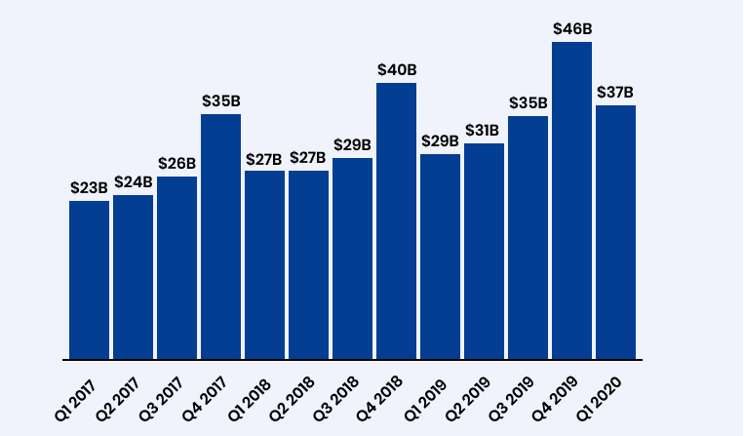
Figure 1: Amazon sales in the last few years
(Source: https://www.repricerexpress.com/amazon-statistics/)
Threats of substitutes
There are numerous substitute goods and services that can be used by organisations towards, looking into the favourable terms or wanting customers to open up to new options. Amazon has recently launched AWS private 5G, and this provides the customers with a specific network capacity that can favour the customers using their mobile devices within the company. The mobile devices will be supported with specific hardware, software systems, and others that might better meet the per-device costs associated with the 5G technology (Sonin, 2019). That will help the software to run better and provide private network access for accessing product-related information and purchasing the same especially used by companies like Tesco, and Argos (Malik, 2021).
Potential of new entrants
Some new entrants are entering the US market for e-commerce retailing, like Best Buy, HomeDepot, and Costco who are receiving traction around the industry. These e-commerce companies have fulfilled almost 70% of the orders in bulk and helped the firm create valuable revenue (Sonin, 2019). However, these organisations are less in number.
Competition in the industry
Some fierce competitors within the e-commerce industry include the likes of eBay and Walmart, which can deliver the similar promises laid down by Amazon. This might impact services that a company like Amazon intends to establish across its e-commerce industry. That makes a competitive power higher around the market (Sonin, 2019).

2.4 Communication Mix
There are different facets associated with the communication mix, that can link other elements of the marketing mix together and can be explained in the below manner towards Amazon.
Firstly, in terms of advertising brand popularisation has taken new heights, especially by considering creative and emotional factors that can help in grabbing consumer attention. As the eCommerce giant deals in the majority of retailing activities, brand enhancement is conducted by promoting its 'diversified fulfilment logistics'. These include the likes of brands backed by Amazon or fulfilled by merchant promotions that are generally conducted via Amazon web services and in certain cases prime membership services (Whedon, 2020). This allows the clients to sell their products with trust assurance that is majorly obtained from the customers.
Secondly, direct marketing is also used by Amazon, especially when they intend to diversify the meaning by broadcasting brand-related information to a larger number of consumers. Amazon has managed to launch a social feature called 'Spark' that allows its sellers to showcase their products within its platforms (Firstpost.com, 2017). The Spark platform allows Amazon to encourage users towards sharing photos, videos, and related social media posts through mobile devices the likes of which include Apple iOS (Firstpost.com, 2017). Some users also create a cross between Instagram and Pinterest to ensure a touch of e-commerce efficiency.
Thirdly, Amazon looks to bridge its customer execution mainly by bridging promotional offers and the services that the company has to offer. This makes the sales promotion schemes important in the context of the organisation, especially in countries like India Amazon tends to hold promotional events that boost the total sales from clothing items to electronic items. The company gives its consumer's combo offers that are not generally available, and sometimes the creative content is fused with the offers (Verma, 2020). For instance, a pair of jeans might be available for $90, while in the off-season it might not carry the same combo offers (Verma, 2020).

2.5 Stakeholder Map
It is important that from a standpoint of an organisation, Amazon tries its stakeholder apprised by meeting their expectations. The potential stakeholders associated with the organisation can be explained in the below manner.
Keep Satisfied: These include the vital stakeholders who have both a stake in the organisational adaptations for meeting its customer expectations and need to show the developments within the firm. It includes the likes of the CEO of the company Andy Jassy, Trisha Berard the HR director, and other sales department heads (Wingate, 2021). However, these shareholders tend to have the least interest in the affairs of the firm.
Managing closely: Around these shareholders only team leaders and project managers internally and suppliers are the primary constituents and might have both higher influence and higher interest in the customer execution-related decisions within Amazon.
Minimal contact: This involves the executive teams who are associated with providing consumers with the most valuable contacts. In most cases, the executive teams are managed by the administrator (Wingate, 2021). These groups have both low interest and low influence over the affairs of the business.
Show consideration: The people involved in the back offices channel the decisions of the executive teams and administrators (Wingate, 2021). They might have low influence over the customer execution decisions, but have a greater interest as shareholders.
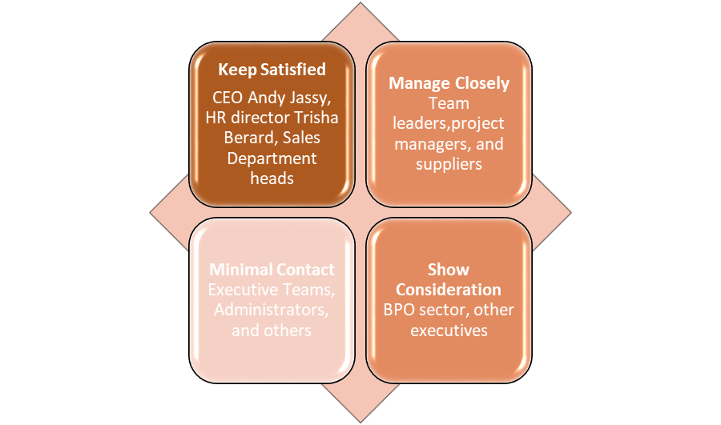
Figure 2: Stakeholder Map for Amazon
(Source: Self-created)

3.0 Critical analysis of internal and external factors that influences the organisation's quality systems and controls for customers in times of crisis like the covid-19
Order to analyse of the internal and external factors that influence Amazon's quality systems and controls can be explained through the GAP model as proposed by A. Parasuram, Valarie Zeithaml, and Leonard Berry in 1985. This framework assists an organisation like Amazon to understand customer satisfaction and identify the deviations that occur around service delivery to prevent potential customers from receiving the proper results (Panwar et al., 2019). Each element can be explained in the above context through the model application.
First Gap: Gap between management perception and customer expectation
This gap tends to arise when the management or service provider does not properly analyse the customer requirements. It also arises mainly due to insufficient communication that takes place between contact employees and their next managers. There is an absence of market segmentation and as a result, the gap occurs due to a lack of market research. While accepting that Amazon works through a 'culture of metrics' nowadays the organisation uses customer data for everything except inventing products to satisfy the customers. These inventions in most cases seldom solve the problem for the company. This impacts the company in many ways as they are not familiar with customer-related assistance, in the matters of improving an existing popular product they might use for convenience. Similar to how, 86% of the shredded cheese product suffers from a lack of sales within the organisation, due to a lack of improvement as recommended by customers (Montebello, 2021). Amazon is only dependent on its 15% loyal customers, to turn the negative indicated above into a positive (Montebello, 2021).
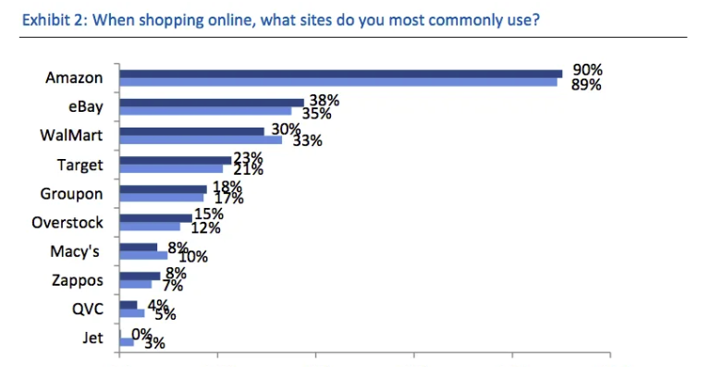
Figure 3: Customers lost by Amazon through inefficiency
(Source: https://finance.yahoo.com/news/charts-show-amazon-blowing-away-165827445.html)
Second Gap: Gap between service quality specification and management perception
The gap arises when management or service providers might address the actual needs of the customers. However, they might fail to back the same through proper performance management planning. This can be due to poor service design, lack of appropriate physical evidence, and improper management of new service development. Amazon has been embroiled in similar criticism in the last few years, due to unending complaints from customers regarding their delivery executions (Korn, 2021). The advertising standards authority received 280 complaints on behalf of the organisation, in which Prime customers complained that their product was delivered within the estimated delivery date (Korn, 2021). The only positive out of the same has been the multiple options presented by the retailer towards its customers in which they can connect the delivery urgency into the order for a swift response. The results have been slow to arrive in the same context.
Third Gap: Gap between service quality specification and service delivery
It arises when the service executor is generally plagued due to the performance of service personnel. The majority of the situations developed around the same might be due to improper training for the workers, inability to set delivery standards, and in some cases, it can also be the result of improper compensation systems. Amazon has been accused of harshly treating its workers, due to the arising pressure that has been building ever since the pandemic intervened. That resulted in a drastic increase in their order processing from 10% to 40% packages than what is considered normal a year. However, due to the problems of facing their managers directly, and more due to the covid-19 work from home criteria. Most employees have shown a 60% drop in efficiency and hiring 100,000 workers by the company resulted in 50% leaving the enterprise upon joining (Newton, 2020). However, Amazon has managed to push the compensations and added new training for the service delivery personnel to help them in accomplishing a 7% rise in efficiency (Newton, 2020). This has brought his service executions down in the last few years as well. The company has also failed to respond to the sudden spike in demand for the products.
Fourth Gap: Gap between external communication and service delivery
Customer expectations tend to be motivated by statements or advertising promises made by the organisation. The gap however prevents the delivery of the demands generated from the above appeal and fulfilled at the time of delivery of the service. Amazon at times has misled customers, by not being clear enough in their indications of search results through paid advertisements. This resulted in complaints by the Federal Trade Commission labelling the company as filing more than 130,000 products in violation of all the FTC guidelines (Korn, 2021). In some cases, the search results of Amazon were considered to be completely deceptive, especially by providing sponsors without much clear indication of the benefits generated by the product. As sponsored advertisements influence a mass majority of consumers into taking up a product, this might have been manipulated by the company. Ultimately results in a fake notion about the product. Meanwhile, Amazon refuted any such accusations that prevented them from responding to the curious demands of the customers. The service delivery has not weakened due to the same in the erstwhile period.
Fifth Gap: Gap between experienced service and expected service
A gap arises when the consumer misunderstands the service quality, however, if the company intervenes by conducting random quality checks and consumer satisfaction it might be projected to the consumer that something is amiss. Therefore, organisations need to avoid too many service quality checks, and at the same time ensure that minimum quality expectation is fulfilled. Amazon has robust modern data infrastructures that rely on numerous technologies such as REST, API, distributed systems, and other rational databases or data lakes including web resources. However, too much data ingestions sometimes clog the systems of Amazon which increase delays in executing service delivery assurance and this becomes difficult to overcome. The company instead reduces their importance for complicated checks in the systems that create constraints in data distribution (Babitz, 2021). Amazon also makes flexibility in its functioning by growing on incremental datasets and this increases the quality of data and does not compromise the same. For instance, flexible technology brings consistency of scalar variables that might help Amazon to compare the current results, and establish a comparison to the assumed expectations. This might improve the arising impacts from overall data quality by setting together with a few standard algorithms the same can be improved in a better manner. The company has a limited number of IT-related programmers and professionals who might consult in the same process. This further prevents them from generating a better quality service execution and thus prolongs the gap and service efficiency. As seen in the previously used marketing models, Amazon's reliance on its Prime subscribers has increased, which might create mismanagement in handling bulk data (Babitz, 2021).

4.0 Identify the systems that support the organisation’s quality processes and provide critical understanding of which those systems are effective in meeting customer requirements and maintaining good customer relationships during a crisis like covid-19
McLean et al., (2018), considers the context of customer relationship management to provide a base for creating good relations and long-term associations. In the above context of Amazon, a similar model can be used to reflect the same notion, especially after considering the above issues that were identified in the service execution or delivery. The IDIC model also known as Identify, differentiate, interact, and customise model developed by Peppers and Rogers in 1995 can be implemented in the below manner. The framework tries to assess the customer expectations and how a business like Amazon can deliver the required value towards the same expectations. A factorial analysis will be conducted in the context of the organisation and also described at the same time.
Identification: Before venturing into customer relationship management it is first important to understand the needs that customers bring into the equation. The customer needs for the same reason need to be distinctly divided between wants and preferences. This assists the organisation to focus on their service delivery executions with the products in mind. For this reason, Amazon has been quite receptive with regards to accessing consumer information, for this reason, they launched a new program whereby loyal consumers upon purchasing their products can respond to short surveys. These surveys will give the company new customer leads, who might be sent specific catalogues through emails. For starters, Amazon has also decided to pay their loyal customers towards bringing new customers, especially by starting them off with a $10 reward in their Amazon pay balance (Perez, 2020). This gives the company a significant opportunity into bringing into play the opt-in or opt-out feature, whereby they can understand the customer expectations mostly about their disinterests rather than interests. To ensure convenience in signing up, the company has also launched the Amazon 'Shopper panel', to assist customers in their searches for products within the online stores (Perez, 2020). In terms of privacy-related information, the company does not store the personal information of the customers which allows them to feel the need for required security and not influence the feedback systems in the company.
Differentiation: The next phase involves differentiating for customer expectations, where differentiation has to be made through value and needs. This differentiation helps the organisation to prepare strategies that might issue company goals to properly meet customer expectations. The differentiation also helps to carry out value to loyal customers and is focused on either extending the product extension or bringing out new service executions that might impact the customer experience before covid-19. As Amazon's primary service dependence has been solely on its Prime subscribers, in most cases it has managed to extend the benefit of Prime subscriptions beyond its website. That means the company has also been interested in boosting the revenues from the merchant sites that might use its delivery systems (Republic World, 2022). Also, Amazon has brought into the fray 'Buy with Prime' for ensuring that eligible products can be listed on merchant websites, especially with services from the main website encountering sudden breakdowns. To resolve the same, the Amazon account has made integral revamps to their system that can bring about better uniformity in the decision making of customers. That also gives customers gradual flexibility, especially with regards to not forcing the newcomer customers into choosing a permanent subscription. That can allow them to be versatile in their selection choice and from the same give the customer’s specific preferences to manage the products. In the same manner, Amazon has managed to influence over 200 of its customers to try the new service extension and gain benefits through free deliveries and timely returns (Republic World, 2022).
Interaction: This section deals with the interaction between an organisation with its potential customers to understand the actual needs and demands of the customers. The interactions are mainly based upon the needs and values of customers. It also emphasizes collecting feedback, and opinion and analyzing customer complaints efficiently. In the aspect of the company Amazon, it seems that the company greatly emphasizes creating a strong medium of interaction with its customers but it has been also noticed that in some instances the company has omitted segmentation and also failed to encounter proper interaction with its customers, where it has been found that their 86% of shredded cheese products as failed to meet the demand of the customers and thus the company has incurred huge losses. It is further found that to overcome the issue of interaction with their customers the company has undertaken various steps. At the advent of this matter, the company announced that if Amazon's self-service FAQs and community forums fail to solve the problems of the consumers then the consumers can directly call the executive of Amazon where they will get 24/7 caller support. The company has further emphasized developing a free customer service support that is "Mayday". Where the owners of Amazon fire phone can drive instant connection with the tech support through a video by pressing a "Mayday" button. Not only this the company to trigger the customer services has introduced "live chat, email and helpdesk" to provide multi-channel customer support services (Hinshaw, 2019).
Customisation: The process of customisation deals with the customisation of products and services to be entertained by an organization based upon the customer's feedback. It seems to be of great significance in nature as it enables an organization to satisfy the actual needs of the customers. It has been found that Amazon has already undertaken effective measures for customizing its products through its consumers. The company to customize its product list has initiated making use of "WebFX” and the same has enabled its clients to manage about 12.9 million transactions. Regarding this matter, it further seems that the company has developed "Amazon custom" Which tends to offer customisable products from professional sellers. This system has facilitated the shoppers to customize products on Amazon custom through "text, images, logos" and many more. The Amazon customer also provides a facility relating to custom selling of products which requires a subscription cost of $39.99. In the aspect of this matter, it can be stated that the company shall focus on providing customisation to all their product lines. As this will enable the company to increase the service quality and will also increase the customer experiences to the fullest extent (Berry, 2020).

5.0 Conclusion
This report concludes that the company of Amazon has experienced deferential changes in influencing the customer experience. That not only resulted in them losing more customers during the pandemic intervention, but also implementing necessary changes that might influence the customer service orientations. To understand the performance in the same context, the report utilised many frameworks that included the likes marketing mix, Ansoff matrix, and even competitive strategies. The data from the same results were then used to identify specific gaps in service quality assurance. In the later sections of the report, it was seen that there were ample avenues through which Amazon can maximise their service commitment altogether. However, to maximise the number of interventions, it was also important for the organisation to note its customer delivery issues and improve about development. This was addressed using the IDIC model in the latter section of the report.

References
Anderson, G. (2022). Will Amazon’s customers go along with its Prime rate increase? – RetailWire. [online] retailwire.com. Available at: https://retailwire.com/discussion/will-amazons-customers-go-along-with-its-prime-rate-increase/ [Accessed 12 Apr. 2022].
Babitz, K. (2021). How Google, Uber, and Amazon Ensure High-Quality Data at Scale. [online] Medium. Available at: https://medium.com/swlh/how-3-of-the-top-tech-companies-approach-data-quality-79c3146fd959 [Accessed 12 Apr. 2022].
Berry, S., (2020). Amazon Custom: How to Start Selling Custom Products [Guide]. [online] WebFX. Available at: https://www.webfx.com/blog/marketing/amazon-custom/ [Accessed 16 Apr. 2022].
etaileast.wbresearch.com (2016). Amazon’s Social Media Marketing Strategy To Inspire Buyers. [online] eTail Boston 2020. Available at: https://etaileast.wbresearch.com/blog/amazons-engaged-buyers-drive-social-media-revenue [Accessed 4 Apr. 2022].
Firstpost.com (2017). Amazon enters social media with Spark, a social shopping platform for Prime members- Technology News, Firstpost. [online] Tech2. Available at: https://www.firstpost.com/tech/news-analysis/amazon-enters-social-media-with-spark-a-social-shopping-platform-for-prime-members-3836683.html [Accessed 12 Apr. 2022].
Hinshaw, M. (2019). 8 customer service strategies you can steal from Amazon. [online] Mcorpcx.com. Available at: https://www.mcorpcx.com/articles/8-customer-service-strategies-can-steal-amazon [Accessed 16 Apr. 2022].
Intranet.Birmingham. ac.UK (2022). Get a £20 Amazon voucher for sharing your views on digital devices. [online] University of Birmingham. Available at: https://intranet.birmingham.ac.uk/student/news/public/winter-2022/get-a-20-amazon-voucher-for-participating-in-focus-group.aspx [Accessed 4 Apr. 2022].
Klement, K. (2017). The Secret Amazon Pricing Strategy to Crush the Competition. [online] The BigCommerce Blog. Available at: https://www.bigcommerce.com/blog/amazon-pricing-strategy/#3-steps-to-selling-successfully-on-amazon [Accessed 12 Apr. 2022].
Korn, J. (2021). Amazon is misleading consumers with 'deceptive' ads in search results, the FTC complaint says. [online] CNN. Available at: https://edition.cnn.com/2021/12/09/tech/amazon-ftc-soc-filing/index.html [Accessed 12 Apr. 2022].
Malik, A. (2021). Amazon launches preview of new AWS Private 5G managed service. [online] TechCrunch. Available at: https://techcrunch.com/2021/11/30/amazon-announces-the-preview-of-aws-private-5g/ [Accessed 12 Apr. 2022].
McLean, G., Al-Nabhani, K. and Wilson, A. (2018). Developing a Mobile Applications Customer Experience Model (MACE)- Implications for Retailers. Journal of Business Research, [online] 85, pp.325–336. Available at: https://strathprints.strath.ac.uk/63220/1/McLean_etal_JBR_2018_Developing_a_mobile_application_customer_experience_model.pdf [Accessed 12 Apr. 2022].
Montebello, L. (2021). Amazon was accused of misleading customers with delivery times. [online] CityAM. Available at: https://www.cityam.com/amazon-accused-of-misleading-customers-with-delivery-times/ [Accessed 12 Apr. 2022].
Newton, C. (2020). Amazon’s poor treatment of workers is catching up to it during the coronavirus crisis. [online] The Verge. Available at: https://www.theverge.com/interface/2020/4/1/21201162/amazon-delivery-delays-coronavirus-worker-strikes [Accessed 12 Apr. 2022].
Panwar, D., Anand, S., Ali, F. and Singal, K. (2019). Consumer decision making process models and their applications to market strategy. International Management Review, [online] 15(1), pp.36–44. Available at: http://www.imrjournal.org/uploads/1/4/2/8/14286482/imr-v15n1art3.pdf [Accessed 12 Apr. 2022].
Perez, S. (2017). Amazon launches a low-cost version of Prime for customers on government assistance. [online] TechCrunch. Available at: https://techcrunch.com/2017/06/06/amazon-launches-a-low-cost-version-of-prime-for-customers-on-government-assistance/ [Accessed 4 Apr. 2022].
Perez, S. (2020). Amazon launches a program to pay consumers for their data on non-Amazon purchases. [online] TechCrunch. Available at: https://techcrunch.com/2020/10/20/amazon-launches-a-program-to-pay-consumers-for-their-data-on-non-amazon-purchases/ [Accessed 12 Apr. 2022].
Republic World (2022). Amazon extends Prime perks to merchant sites. [online] Republic World. Available at: https://www.republicworld.com/technology-news/e-commerce/amazon-extends-prime-perks-to-merchant-sites.html [Accessed 12 Apr. 2022].
Shah, S. (2022). Amazon Briefing: Faced with piling costs, Amazon third-party sellers are raising prices to stay profitable. [online] Modern Retail. Available at: https://www.modernretail.co/platforms/amazon-briefing-faced-with-piling-costs-amazon-third-party-sellers-are-raising-prices-to-stay-profitable/ [Accessed 12 Apr. 2022].
Sonin (2019). Internet Shminternet: Amazon’s Obsession with Customers. [online] Sonin. Available at: https://sonin.agency/internet-shminternet-amazons-obsession-with-customer-experience/ [Accessed 22 Apr. 2022].
Statt, N. (2018). How Amazon’s retail revolution is changing the way we shop. [online] The Verge. Available at: https://www.theverge.com/2018/10/23/17970466/amazon-prime-shopping-behavior-streaming-alexa-minimum-wage [Accessed 4 Apr. 2022].
Tode, C. (2017). Amazon boosts social prowess with Snapchat, and Instagram, but more needed | Retail Dive. [online] www.retaildive.com. Available at: https://www.retaildive.com/ex/mobilecommercedaily/amazon-boosts-social-prowess-with-snapchat-instagram-but-more-needed [Accessed 4 Apr. 2022].
Verma, J. (2020). Sale Day Strategies: Role of social media in Flipkart & Amazon India’s festive bonanza. [online] Social Samosa. Available at: https://www.socialsamosa.com/2020/10/flipkart-amazon-india-sale-day-strategies/ [Accessed 12 Apr. 2022].
Waters, M. (2021). Amazon is launching a new tool to boost sellers’ product assortments. [online] Modern Retail. Available at: https://www.modernretail.co/platforms/amazon-is-launching-a-new-tool-to-boost-sellers-product-assortment/ [Accessed 12 Apr. 2022].
Whedon, S. (2020). What To Do With Amazon Ads When Inventory Management Causes Problems. [online] Teikametrics. Available at: https://www.teikametrics.com/blog/what-to-do-with-amazon-ads-when-inventory-management-causes-problems/ [Accessed 12 Apr. 2022].
Wingate, M. (2021). Why Jeff Bezos Thinks Market Research Isn’t Useful. [online] www.digsite.com. Available at: https://www.digsite.com/blog/why-jeff-bezos-thinks-market-research-isnt-useful [Accessed 12 Apr. 2022].

