BA (HONS) LEADERSHIP AND MANAGEMENT SKILLS FOR THE WORKPLACE

LEADING AND IMPLEMENTING CHANGE(LIC)

LCLM6003

Student Name: Gurpreet Kaur
Student No: - 2309090
Lecturer Name: - Stephen Malone
Submission Date:- 30.03.2026

TABLE OF CONTENTS
1. Introduction to the Organisation 4
1.1 Overview 4
1.2 Mission, Vision and Values 5
1.3 Rationale 6
2. Environmental and Organisational Analysis 6
2.1 External Environment Analysis (PESTLE) 6
2.2 Internal Environment Analysis (SWOT) 8
2.3 Triggers for Change 9
3. Review and Evaluation of Change Management Model 10
3.1 Application of the Kotter Model in Tesco 10
3.2 Short-Term Wins and Continuous Improvement 12
3.3 Critical Evaluation of the Model 13
4. Leadership and Organisational Culture in Change 13
4.1 Leadership Styles and Change Management 13
4.2 Organisational Culture and Change 14
5. Proposed Strategic Change Management Plan 15
5.1 Change Vision and Objectives 15
5.2 Stakeholder Analysis 15
5.3 Change Management Plan with Implementation Framework and its evaluation 17
5.4 Communication Plan and its evaluation 17
5.5 Financial and Resource Plan and its evaluation 18
5.6 Risk Assessment and Mitigation and its evaluation 19
5.7 Evaluation and KPIs 20
6. Evaluation and Discussion with the Critical Reflection 21
7. Conclusion 22
References 24

1. Introduction to the Organisation

1.1 Overview
Tesco PLC is a global retailing grocery as well as general merchandise company which is founded in 1919 by Jack Cohen (1898-1979). Its foods together with the beverages, clothing, equipment alongside even finances are all product lines (Utama et al., 2022). In the United Kingdom (UK), Tesco has been the most popular brand following with has consistently led the market share rankings in the grocery market with 28.4% (Forbes, 2025).
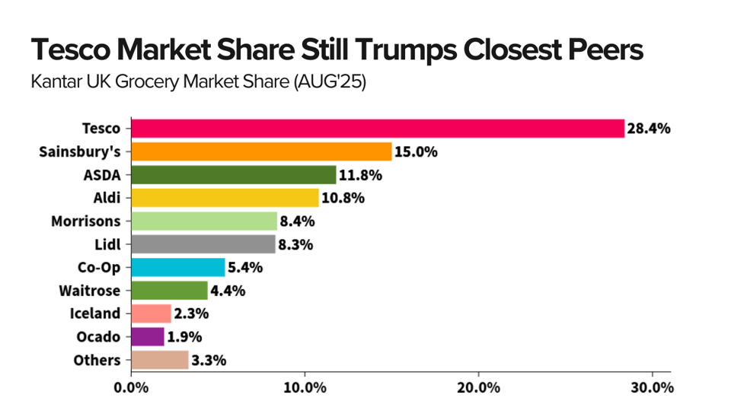
Figure 1: Market share
(Source: Forbes, 2025)
The company operates in the global market which has an approximate of 341,000 employees alongside it is headquartered in Hertfordshire, United Kingdom. By 2025, Tesco has been counted 5,040 stores all over the world without the franchise stores (Statista, 2025a).

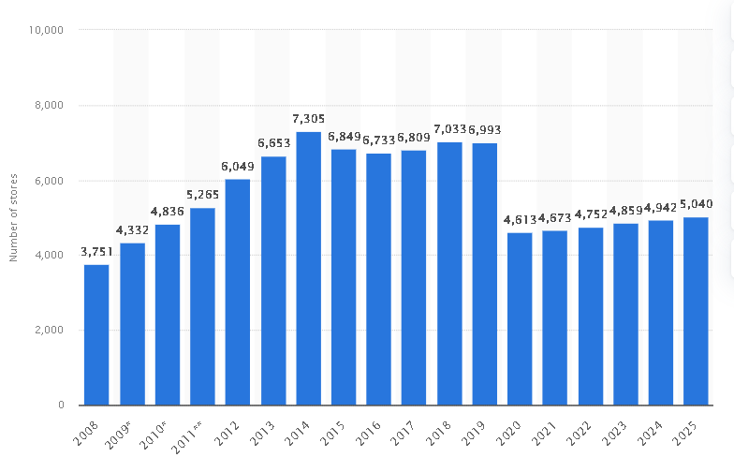
Figure 2: Tesco stores
(Source: Statista, 2025a)

1.2 Mission, Vision and Values
According to the records the mission of the company is to make the customers, communities together with the planet with about a little better every day. This mission informs the strategic choices and business practises at Tesco and shows the organisational clientele, sustainability and community support.

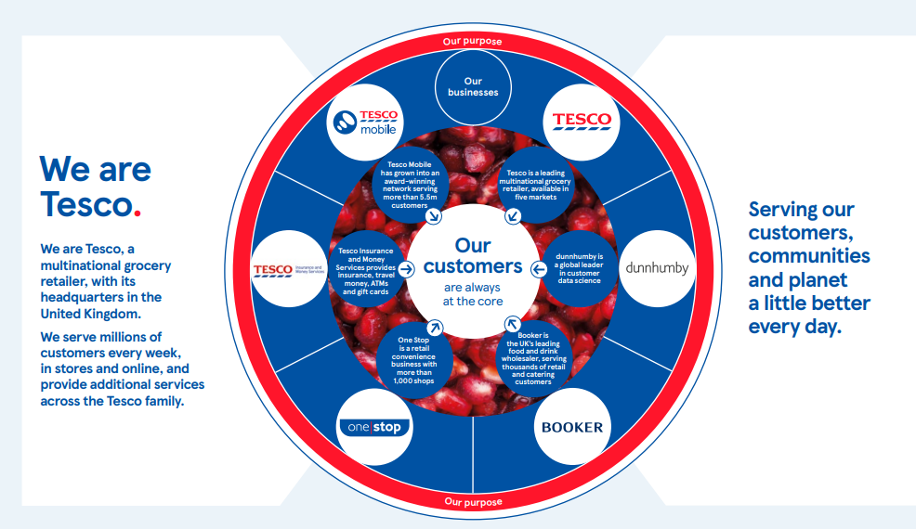
Figure 3: Tesco Values
(Source: Tesco, 2025)
Tesco is also concerned with the good organisational values which define its culture and business practises. These values include serving the first customers, respecting people, and making minute adjustments that can lead to a difference. The principles assist employees and managers to provide a more quality service, long-term relationships with suppliers and customers, and responsible business practises.

1.3 Rationale
Tesco has been chosen in this change management report, as it is a large organisation in the global retail sector that is undergoing a high rate of technological and competitive changes. The retailing industry is also transforming because of the growth of digital platforms, online shopping, and data-driven businesses (Ocran, 2023). As me being a part of this major multinational company with physical and online stores, I feel Tesco offers a suitable case of discussing organisational change and strategic transformation and managing digital innovation in an extremely competitive landscape.
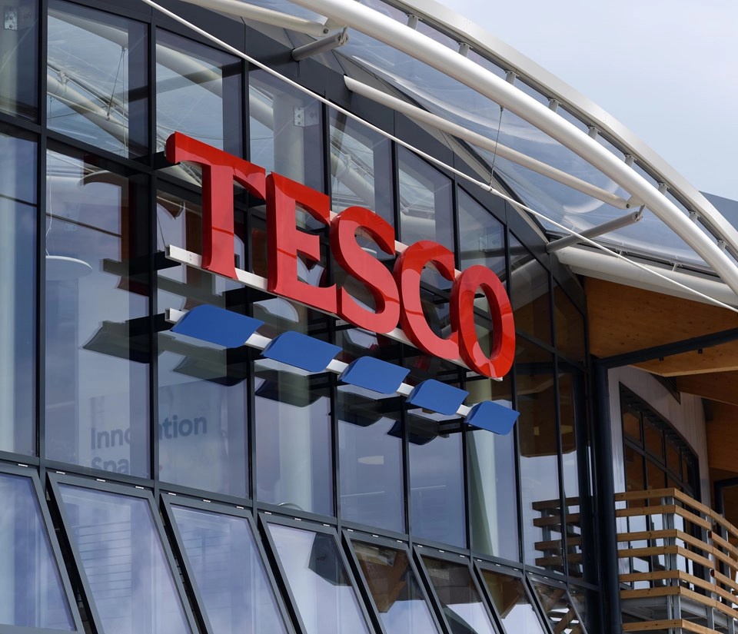
Figure 4: Tesco
(Source: Tesco, 2026a)

2. Environmental and Organisational Analysis

2.1 External Environment Analysis (PESTLE)
Tesco explains how digital disruption, technology innovation and the evolving consumer behaviour have done much in shaping the strategy and the activities of the organisation. The retail sector around the world has undergone significant change because of the popularity of online stores, artificial intelligence (AI), digital information analytics and fast delivery networks. Tesco has countered by investing in online tools, including Tesco Online Grocery Platform, Tesco Mobile App, Clubcard data analytics, Tesco Marketplace, Scan-as-You-Shop technology and Whoosh rapid delivery.
Factor | Analysis
Political | Tesco engages in a very regulated retail sector and has to abide by the government laws regarding food safety, legislation in the employee sector, protection and trading standards of the consumers. Such policies affect the supply chain, sourcing of products and operational processes (Patel et al., 2021). The Clubcard pricing option by Tesco gives discounts to the clubcard members. Nonetheless, this can also become a political and ethical issue regarding price discrimination, as when a customer does not have a Clubcard, he must pay a high price on the same product (Heidary et al., 2022). The governments can come up with tougher policies to secure equitable discounts to every consumer, particularly in times of cost-of-living crisis.
Economic | Customer purchasing behaviour highly depends on the economic conditions, such as inflation and the increased cost of living. Consumers are increasingly price-conscious and are focusing on value products. For higher food prices rise, Tesco may promote multi-buy offers such as the “buy 2 for £3” for the maintenance of their sales volume while helping their customers in the management of the budgets (Watt et al., 2023).
Social | Lifestyle shifts among consumers have heightened their need for convenience and online shopping. Consumers are currently more likely to favour alternative shopping practises like online grocery identification, mobile phone applications, click-and-collect and doorstep delivery (Meng, 2024). Tesco has grown its online shopping and aligned its physical store system with an online platform to offer an omnichannel shopping experience.
Technological | A significant force influencing retail is technology. Tesco boasts of one of the biggest online grocery stores in the UK, with an online sales figure of about £6.8 billion and an online order volume of about 1.33 million orders every week. Digital applications like Whoosh, which is spread across 1,500 or so stores, and Tesco Marketplace, where the range of products is provided at 400,000, enhance customer convenience and diversify the range of products.
Legal | Tesco should have proper pricing and labelling. Tesco might even be sued out of court and reputation can be ruined in case of a misleading price on one of the products or wrong labelling. Tesco would face hefty fines imposed after data security laws and lose consumers’ confidence in case it is not careful about customers information like Clubcard (Watt et al., 2023).
Environmental | Retailers are growing increasingly focused on environmental sustainability. Tesco has also come up with sustainability measures which are designed to lower operational carbon emissions as well as enhance supply chain sustainability. These activities impact the logistics processes, packaging minimization and eco-friendly product procurement. In case the sales of fresh products such as fruits and vegetables, or bakery products are low and Tesco has instituted the policy of offering wonky vegetables (vegetables with defects) at low prices in an effort to cut waste and help farmers.

2.2 Internal Environment Analysis (SWOT)
SWOT Factor | Analysis
Strengths | Tesco enjoys a high market share and brand name in the UK food market. Its developed digital footprint consists of a significant internet-based grocery service and data systems like the Clubcard loyalty programme, which created promotional and information programmes for its customers gives them customised promotions, information and customer feedback via data analytics. Tesco also enjoys their store network, which can facilitate in-store shopping as well as online order fulfilment. The physical stores serve as distribution centres for online orders and quick-delivery services that help to integrate online and offline stores.
Weaknesses | The high operational costs incurred in maintaining a large network of physical stores have to do with staffing, logistics and property costs. Tesco also has a sophisticated global supply chain of thousands of suppliers. Moreover, digital transformation demands life-long investment in technology infrastructure, delivery systems and personnel training.
Opportunities | Most significant growth opportunities are offered by digital innovation. Tesco Marketplace platforms enable collaboration with third-party sellers to enlarge the range of products and income. Quick delivery, such as Whoosh, also enables Tesco to respond to the growing demand for convenience (Global Banking and Finance, 2026). The use of AI and data analytics can also enhance demand predictions alongside the personalised customer experience.
Threats | Tesco is being strong competition by discounters such as Aldi and Lidl which have been continuing to grow within the UK. Prices are also forced by online competitors like Amazon (Ndlovu, 2024). Increased inflation, supply chain elements, rising energy and labour expenses also influence drastically the profitability rates, as well as the efficiency of Tesco.

2.3 Triggers for Change
Organisational change in Tesco has been instigated by several factors which have been associated with digital disruption and technological innovation. The rapid development of online grocery shopping is one of the most significant triggers. In the United Kingdom, online sales have risen to about 13.5% of Tesco's total sales, which shows the rising relevance of digital channels in retail.
The other driver is the increased application of digital data analytics as enabled by the Clubcard programme, enabling Tesco to understand the buying patterns of customers and provide personalised offers. These insights would help the company develop improved product recommendations and marketing strategies.
Another important change that Tesco has experienced is the introduction of Meticulous changes such as Whoosh fast delivery technology. The service will allow the customers to place their orders of their groceries through the mobile applications and receive it within a short period of time, thereby increasing their convenience and customer satisfaction (Global Banking and Finance, 2026).
Finally, the existence of competition in the grocery market together with the growing needs of the customers in terms of convenience, value and speed have motivated Tesco to continue investing in digital technologies and operational improvements. With the help of digital tools such as AI-based analytics, mobile shopping applications, and fast delivery services, Tesco adapted its business model to remain competitive in the evolving world of retailing.

3. Review and Evaluation of Change Management Model

3.1 Application of the Kotter Model in Tesco
The change management strategies adopted at Tesco point to a number of phases in the Kotter Eight-Step Change Model, especially in the face of the fast-growing digital retail and online shopping services (Laig and Abocejo, 2021).
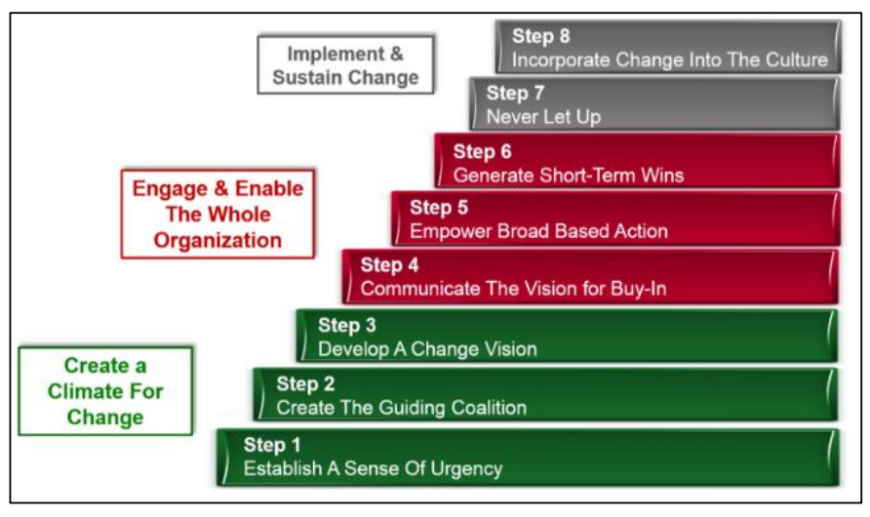
Figure 5: Kotter Eight-Step Change Model
(Source: Laig and Abocejo, 2021)
1. Creating Urgency: According to the records, Tesco was aware of the growing presence of digital retail and online shopping. Online sales amounted to £6.8 billion and increased 10.2% year on year, showing the fast transition of customer buying behaviour towards online.
2. Creating a Guiding Coalition: At Tesco, digital transformation strategies have been coordinated at the top management level with technology, logistics and customer-based innovation being developed across the entire organisation to reflect market changes (Wolniak et al., 2024).
3. Developing a Vision and Strategy: Tesco’s digital strategy is aimed at extending the online environment and making customers’ lives more convenient. An example is the introduction of Tesco Marketplace, which offers access to more than 400,000 products offered by third-party sellers, thus greatly broadening the range of products to access using digital channels.
4. Communicating the Vision: Tesco shares its digital transformation by investing in customer platforms and delivery services. Whoosh, a fast delivery service, has expanded to over 1,500 stores, which serves as a good representation of its strong adherence to a faster and more convenient online shopping approach.
5. Empowering Employees to Take Action: Online system implementation would be done with an alignment of the online store workers with the online logistics teams and online digital infrastructure so that online orders and delivery can be synchronised (Wolniak et al., 2024.
6. Building Short-Term Wins: Tesco achieved real advances in online operation, guaranteeing 1.33 million online purchases weekly and a typical basket value of 109 Euros on which it highlights high customer adoption.
7. Sustaining Acceleration: The company constantly creates digital services, delivery capacity and product offerings to continue growing.
8. Change the Culture: Digital innovation and customer convenience have been introduced into the operational strategy, which proves the long-term orientation of the technological transformation throughout the organisation.

3.2 Short-Term Wins and Continuous Improvement
The model has been developed by Kotter focuses on achieving short-term victories for ensuring that the organisation remains in the motion. As an example, the company announced that the average online orders expanded to approximately 1.33 million in a week, with the average basket size continuing to grow to £109 (Tesco, 2025b). Such advancements suggest an increase in online retail usage among customers and reflect the initial success of online investments.
Moreover, Tesco is still streamlining the gains through building up logistics facilities and increasing delivery capacity. The company has also launched urban fulfilment centres and enhanced the accuracy of orders, and the rate of perfect orders has gone up in a big way, with the level of customer satisfaction. These operational improvements portray the advanced stages of the Kotter model, when organisations strengthen changes and entrench new systems into the normal business processes.

3.3 Critical Evaluation of the Model
Despite the Kotter model offering a systematic approach to the management of large-scale organisational change, it has certain shortcomings as well (Laig and Abocejo, 2021). The model supposes rather a slow process of change, which might be hard in the context of a rapidly evolving retailing business where technological changes take place at an alarming pace. An example is needed here and Tesco must continuously react to evolving consumer demand, digital and market dynamics, such that change may happen across different organisational functions simultaneously rather than being a straight run process.
Nevertheless, the model remains helpful as it places emphasis on leadership allegiance, communication and quantitative change, which are essential factors of leading multidimensional organisational transformation. The online service growth and overall improvement in operational scale of Tesco show how well-structured change initiatives can help keep competition competitive in the retail industry in the long-term.

4. Leadership and Organisational Culture in Change

4.1 Leadership Styles and Change Management
Various leadership styles may affect the effectiveness of change implementation in organisations. Transformational leadership is especially applicable to organisational change as it aims at motivating employees to adopt innovation and organisational improvement. Transformational leaders possess a vision of the direction travelled by the organisation and motivate the employees to strive to achieve organisational objectives (Wahyuwardhana and Wisesa, 2024). Tesco leadership behaviours have been targeted towards bringing in fresh ideas, listening to the workers and creating teamwork within the organisation. Such behaviours facilitate organisational change as employees are free to be innovative and part of problem-solving in the transformation processes.
Situational leadership is another leadership strategy that can be applied in organisational change. In this strategy, managers change their leadership style based on the capabilities of employees, the needs of the organisation and the degree of change being introduced (Mardikaningsih and Darmawan, 2022). Situational leadership can be implemented within big organisations like Tesco to support managers in offering proper directives in complicated organisational transitions like digitalisation, logistics and emerging retail solutions. The managers are able to modify leadership styles to suit various teams and departments to help the employees get the support needed to prevent resistance to change.
Transactional leadership is also significant in ensuring efficiency in operations. This leadership style is performance management, goal setting and reward systems (Dong, 2023). Transactional leadership can be useful to sustain employee performance and accountability in the view of retail organisations, where consistency in operations and quality of services is paramount. Performance monitoring, reward systems, and clear targets can ensure that employees remain in management levels of operations as changes are undertaken within organisations.

4.2 Organisational Culture and Change
The culture that is present in organisations plays a big role in the reaction of employees to changes. Culture is a set of values, beliefs and behaviours that are shared and form the way people in an organisation relate. At Tesco, the culture of the company is heavily related to the core values in that the company believes that it has No one tries harder for customers, they treat people how they want to be treated,d and Every little help makes a big difference. These principles support the relationship of employees with both customers, peers and society.
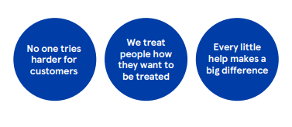
Figure 5: Core values
(Source: Tesco, 2022)
The organisational culture model constructed by Edgar Schein suggests that culture is analysed at three levels with artefacts, values and underlying assumptions (Khaddour, 2024). Tesco has artefacts like visible practises likecustomer service standards and community programmes. The corporate values focus on the customer, respect for others and continuous improvement that assist in teamwork and innovation in the course of change within the organisation.
Equally, other cultural orientations emphasise the significance of organisational values and collective teamwork in the determination of employee behaviour. The organisational culture that fosters collaboration within the departments and organises the employees to embrace change initiatives is created by Tesco through its focus on teamwork, trust and respect.

5. Proposed Strategic Change Management Plan

5.1 Change Vision and Objectives
The strategic change suggested will ensure Tesco can enhance its digital retail facilities, increase its online grocery and improve its efficiency in its operations. The internet sales of Tesco have already been 6.8 billion euros, and there is a year-on-year increase of 10.2%, and within the retailing strategy, there are 1.33 million digital firsts that are processed in the online order each week, which underscores the use of online shopping by the store (Tesco, 2025b).
The goal is to build on Tesco as a top omnichannel retailer through the incorporation of superior digital platforms, data-based decision making and effective logistics.
The main goals wouldn't be less than doubling the 13.5% of online sales in total UK sales, improving customer experience and developing faster delivery services like Tesco Whoosh, which is already present in more than 1,500 stores.

5.2 Stakeholder Analysis
Mendelow’s Stakeholder Matrix
Power/Interest | High | Low
High | Senior management, investors | Government, regulators
low | Employees, customers | Local communities, minor suppliers
Evaluation:
This stakeholder matrix provides a mapping of the stakeholders of Tesco in different categories.
The employees will perform operational modifications at stores, logistics centres, and digital platforms. Store teams deal with order fulfilment, delivery services and customer services on online purchases.
One of the key stakeholders is customers, as their growing online shopping and convenience service requirement is the driver of the digital strategy of the company. According to Tesco, the mean size of the online basket has risen to an average of £109 per order, which proves the heightened significance of online shopping.
The suppliers and partners are also important to the product availability and logistics services. By 2023, Tesco had over 30bn Euros of its suppliers spread across over 3400 farmers and other suppliers in the UK and 90% of Tesco suppliers are located in the UK. The introduction of Tesco Marketplace, which sells over 400,000 products created by third parties, proves how alliances aid in diversifying the range of products and enhancing digital stores.

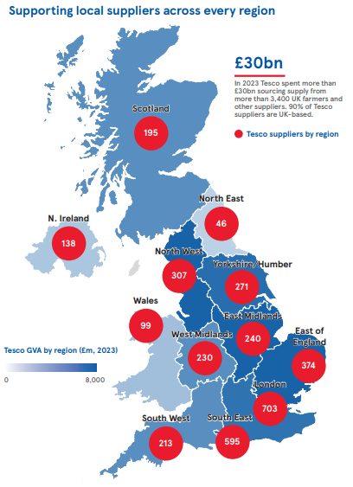
Figure 7: Suppliers
(Source: Tesco, 2026)
Investors and top management have the role of funding digital innovation as well as financial sustainability in the long term. They must be supported to deploy large-scale technological investments.

5.3 Change Management Plan with Implementation Framework and its evaluation
Tesco's strategic change implementation process can be structured on a model of change management in line with the Kotter model.
Tesco should establish a feeling of urgency by emphasising the fact that its rivals are increasing in numbers due to discount stores and its customers are dissatisfied with the pricing tactics (e.g., Clubcard-only deals). This will make the employees realise why change is essential.
Tesco will need to establish a guiding team that includes senior managers and store leaders who will facilitate and spearhead the change. Good leadership guarantees congruency at all the levels.
Tesco should formulate and communicate a vivid vision, which can be reflected in providing fair prices to all its customers but retain its loyalty schemes (Laig and Abocejo, 2021). Meetings and training and internal platforms should all be used to communicate this vision consistently.
The firm should then empower by considering employees through training and eliminate obstacles to change. As an example, employees should get acquainted with new pricing mechanisms or methods of customer services.
To sustain the motivation, short-term victories should be pointed towards better customer satisfaction or more sales. Tesco is able to consolidate the improvements and repeat the process of refining strategies before ultimately incorporating the change into the organisational culture.
The benefits of this model are that there is structured transition which guarantees a step by step transition which minimise opposition and misunderstanding among the employees (Ocran, 2023). It also encourages good leadership and effectiveness in communication. Nonetheless, it is time consuming, and might be inflexible in dynamic retailing. On the whole, it is appropriate to Tesco because it strikes the right balance between the strategic direction and the involvement of employees.

5.4 Communication Plan and its evaluation
Communication is vital in getting the employees as well as the stakeholders to be cognizant of the objectives and the value of organisational change. Tesco has maintained the communication of strategic developments to the workforce through weekly leadership brief sessions, operations and online training programmes.
Communication is advisable to focus on the benefits of digital transformation, such as customer convenience, business operation efficiency, and new business opportunities. Indicatively, the fast online orders growth, which is currently more than 1.33 million orders in a week, is an indicator of the impact of online services on organisational growth.
Constant contact among leadership teams, store managers and operating staff can assist in making employees aware of the roles in the implementation of new technologies and systems of delivery to the customers.

5.5 Financial and Resource Plan and its evaluation
Financial Plan
The financial strategy implemented by Tesco aims at enhancing its online shopping infrastructure and distribution. The company will be further investinginn online platforms that already achieve £6.8 billion in yearly online sales with approximately 1.33 million orders each week. The investments will help to increase the number of delivery slots by 70,000, scale Whoosh rapid delivery to 1,500+ stores and strengthen Tesco Marketplace with 400,000+ items (Statista, 2025). These investments are meant to enhance online contributions by more than 13.5% of sales in the United Kingdom and enhance efficiency in operations.

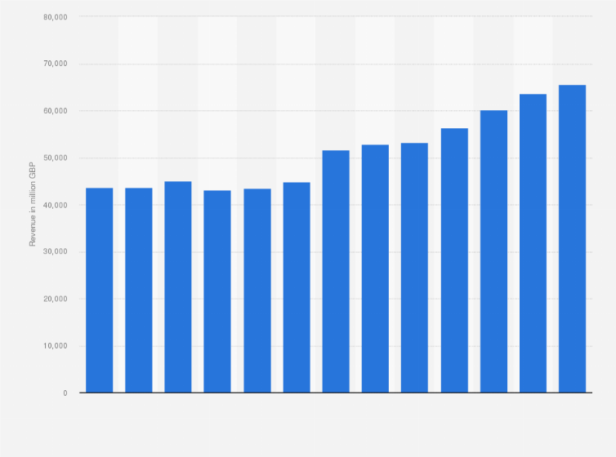
Figure 8: Revenue
(Source: Statista, 2025)
Resource Plan
The resource plan will also involve investment in digital infrastructure, logistics technology and training of employees. Tesco will increase online fulfilment centres, delivery fleet and speedy delivery service like Whoosh. Other resources encompass data analytics, supply chain management and experienced employees to attend to 1.33 million online orders weekly and facilitate Tesco Marketplace, which is currently developing.

5.6 Risk Assessment and Mitigation and its evaluation
There are various threats that can be experienced in the process of implementing the Tesco digital transformation strategy.
One of the risks is operational complexity, which demands effective coordination of stores, distribution centres and delivery partners to handle more than 1.33 million weekly online orders.
Technological disruption is another risk that can take place in case digital platforms or logistics systems fail in their work.
The same situation can happen with the introduction of new technologies and digital processes, which cause employee resistance. This risk can be minimised through training programmes and effective communication, where the employees can be equipped with the skills to utilise new systems.
Operational risks can also be mitigated through the phased adoption of digital technologies and constant surveillance.
Risk Assessment Table
Risk | Likelihood | Impact | Risk Level | Mitigation
Operational complexity | High | High | Extreme | Logistics coordination
Technology failure | Medium | High | High | System backup
Employee resistance | Medium | Medium | Moderate | Staff training
Cybersecurity risk | Low | High | Moderate | Data protection
Delivery delays | Medium | Medium | Moderate | Process monitoring

5.7 Evaluation and KPIs
Tesco can use a number of key performance indicators (KPIs) to measure the effectiveness of the strategic change plan.
The initial KPI is online sales growth, which at present is £6.8 billion per year, which is among the significant units of Tesco's digital strategy.
The second KPI is the online order volume, at the moment averaging 1.33 million orders per week, implying the adoption of digital shopping services by the customers.
Average basket value is another significant metric that has been growing to around £109 per online order, indicating that customers are spending a great deal on online platforms.
Other KPIs are customer satisfaction, delivery efficiency and growth of digital marketplace products, which are already more than 400,000, all offered via Tesco Marketplace.

6. Evaluation and Discussion with the Critical Reflection
The strategic change plan suggested to Tesco is aimed at reinforcing digital retail, growing online and enhancing operational efficiency. Among the key advantages of this change plan, there will be the fact that it corresponds to the current strategic priorities of Tesco that are digital innovation, operational efficiency, and customer convenience. Online retailing has already shown a good pace of growth with digital grocery sales of £6.8 billion and online orders of over 1.33 million in a business week, highlighting the significance of the digital change to business competitiveness in future. The digital infrastructure and delivery systems can thus be expanded to get customer satisfaction and business growth in the long-run.
The change plan is also a strength as it complies with the sustainability strategy of Tesco. The transactional leadership also plays an important role in the operations efficiency. This is performance management, goal setting and reward systems (Dong, 2023). Transactional leadership may come into play to maintain the employee performance and responsibilities according to the perception of the retail organisations, where in stability of operation and services quality reign supreme. Employees can be kept within the management levels of operations through performance monitoring, reward systems, and set targets as changes are made within organisations. Through these endeavours, it is shown that digital change and operational efficiency can also lead to mitigating the effect of environmental impact due to better logistics, energy efficiency and supply chain management.
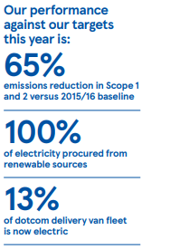
Figure 9: Performance
(Source: Tesco, 2025)
In spite of these strong points, there are also a number of limitations to the proposed change plan. Massive digital evolution demands mass financial funding in technology, transportation infrastructure and workforce education. There is also the risk of having a complex operational process due to the implementation of new digital platforms and delivery systems across thousands of stores (Wolniak et al., 2024. Also, workers can develop resistance to change in technology in case of a lack of proper training and support. These issues may cause the implementation process to decelerate and the risk of operations to rise.
The change process also has ethical considerations. Digital retail systems tend to be based on customer information and online platforms, with issues of privacy of data and responsible use of consumer information emerging (Wolniak et al., 2024. Organisations should make sure that data is handled in a safe and transparent way to retain the trust of customers. Moreover, automation and computerisation can also have an impact on the employment systems that will demand responsible management of the workforce and reskilling measures.
On the sustainability front, Tesco's strategic plans and initiatives show a great desire to be responsible in doing business. The company has been making 100% renewable electricity use in its operations and still invests in low-carbon logistics provision and recyclable packaging. Such moves facilitate the sustainability of the organisation in the long run and enhance its image as a responsible retailer.

7. Conclusion
The report examined the strategic organisational change that was required in Tesco in relation to the changing retail environment that was marked by digital disruption, online shopping and a growing level of competition. The external and internal environment analysis indicated that technological innovation, shifting consumer behaviour and cost pressures are critical change agents in the retail business. Both the PESTLE and SWOT analyses revealed that although Tesco has the positive factor of good brand awareness, a vast network of stores, and highly developed digital platforms, the company has to keep on enhancing its digital framework and efficiency in its operations to stay competitive.
The review of change management models promoted the applicability of the Kotter Eight-Step Change Model to lead the change in large organisations..The current digital initiatives of Tesco, including the growth of online grocery shops and ordering and delivery services ,are variations of multiple steps of the Kotter model, including the formation of urgency, the design of a strategic vision and short-term wins. Leadership and culture within an organisation were also cited as other critical aspects in change management. The engagement of employees, the operational stability, and successful deployment of the digital transformation initiatives can be facilitated by the application of transformational, situational and transactional leadership.
The strategic change management plan proposed focused on supporting the Tesco omnichannel retail strategy through its increased digital services, enhanced delivery capacity, and improved data-driven decision-making. The main targets involve growth in online sales, which is already £6.8 billion, 1.33 million online orders per week, and the expansion of rapid delivery in over 1,500 stores. Other key stakeholders, communication strategies, in terms of financial investments and key performance indicators that would enable the plan to be adequately implemented were also identified.

References
Dong, B. (2023) ‘A systematic review of the transactional leadership literature and future outlook’, Academic Journal of Management and Social Sciences, 2(3), pp.21-25. https://pdfs.semanticscholar.org/8158/5768e874415ebf8b69fee2520929c0e283cb.pdf
Forbes (2025) Tesco Share Price: The ASDA Threat Is Over. Available at: https://www.forbes.com/sites/johnchoong-1/2025/09/01/tesco-share-price-the-asda-threat-is-over/ (Accessed on: 07-03-2026)
Global banking and finance (2026) Britain's tesco turns rapid-delivery threat into competitive edge. Available at: https://www.globalbankingandfinance.com/britains-tesco-turns-rapid-delivery-threat-competitive-edge/ (Accessed on: 07-03-2026)
Heidary, K., Custers, B., Pluut, H. and van der Rest, J.P. (2022) ‘A qualitative investigation of company perspectives on online price discrimination’, Computer Law & Security Review, 46, p.105734. DOI: https://doi.org/10.1016/j.clsr.2022.105734
Khaddour, W.N. (2024) ‘Critical realism and organizational culture-framing Schein’s model of studying organizational culture by using critical realism philosophy’, Open J Philos, 15(1), pp.77-97. DOI: https://doi.org/10.4236/ojpp.2025.151006
Laig, R.B.D. and Abocejo, F.T. (2021) ‘Change management process in a mining company: Kotter’s 8-step change model’, Journal of Management, Economics, and Industrial Organization, 5(3), pp.31-50.
Mardikaningsih, R. and Darmawan, D. (2022) ‘Situational Leadership Strategies to Improve Change Manage-ment and Team Performance’, Journal of Social Science Studies, 2(1), pp.247-252. https://jos3journals.id/index.php/jos3/article/download/151/216
Meng, S. (2024) ‘Operation Management of Grocery Retailer in the UK: A Case of Tesco’, Pacific International Journal, 7(2), pp.136-142. DOI: 10.55014/pij.v7i2.586
Ndlovu, S.G. (2024) ‘Private label brands vs national brands: new battle fronts and future competition’, Cogent Business & Management, 11(1), p.2321877. DOI: https://doi.org/10.1080/23311975.2024.2321877
Ocran, J.N. (2023) ‘The Tesco Group and Sustainable Operations Management’, Journal of Earth and Environmental Science Research. SRC/JEESR-264. (5), 212, pp.2-6. DOI: doi.org/10.47363/JEESR/2023
Patel, S., Dora, M., Hahladakis, J.N. and Iacovidou, E. (2021) ‘Opportunities, challenges and trade-offs with decreasing avoidable food waste in the UK’, Waste Management & Research, 39(3), pp.473-488. DOI: 10.1177/0734242X20983427
Statista (2025) Annual revenue of Tesco Group in the United Kingdom (UK) and the Republic of Ireland from financial year 2013 to 2025. Available at: https://www.statista.com/statistics/490931/tesco-group-finance-revenue-united-kingdom-uk/?srsltid=AfmBOopQxKAgr2nKFY7v-aTEbrQiKQMUJGdVY2f8ZzD5P4gb5qGxbvkb (Accessed on: 07-03-2026)
Statista (2025a) Tesco's number of stores worldwide from 2008 to 2025. Available at: https://www.statista.com/statistics/238667/tesco-plc-number-of-outlets-worldwide/?srsltid=AfmBOorVqNCbyZBBfuqZ1f5zSn02I8XuumK1oAw7fyH-iCXQjwquS5L2 (Accessed on: 07-03-2026)
Tesco (2022) Annual Report and Financial Statements 2022. Available at: https://www.tescoplc.com/media/eswhcoi2/tesco-annual-report-2022.pdf (Accessed on: 07-03-2026)
Tesco (2025) Tesco PLC Annual Report and Financial Statements. Available at: https://www.tescoplc.com/media/ky0bfwpo/tesco_ar25_interactive.pdf (Accessed on: 07-03-2026)
Tesco (2025a) Core Purpose and Values. Available at: https://www.tescoplc.com/about/how-we-do-business/core-purpose-and-values (Accessed on: 07-03-2026)
Tesco (2025b) Tesco plc preliminary results 2425 press release. Available at: https://www.tescoplc.com/media/mxfjrk4x/tesco-plc-preliminary-results-2425-press-release.pdf (Accessed on: 07-03-2026)
Tesco (2026) Tesco’s economic and social impact 2025. Available at: https://www.tescoplc.com/media/vtbj2jpt/20250218-tesi-report.pdf (Accessed on: 07-03-2026)
Tesco plc (2026a) Stakeholders. Available at: https://www.tescoplc.com/investors/corporate-governance/stakeholders (Accessed on: 07-03-2026)
Utama, A.G.S., Verma, M., Ng, J.Y., Kee, D.M.H., Nga, C.S., Izzati, N.N., Ng, Y.X. and Khoiruwnia, F. (2022) ‘A Research on Tesco's Consumer Purchasing Behavior towards E-Commerce during the Pandemic Period’, International Journal of Accounting and Finance in Asia Pasific (IJAFAP), 5(1), pp.53-63. DOI: https://doi.org/10.32535/ijafap.v5i1.1415
Wahyuwardhana, M.H. and Wisesa, A. (2024) ‘The role of democratic transformational leadership style in supporting clan organizational culture’, International Journal of Current Science Research and Review, 7(2), pp.1312-1324. DOI: 10.47191/ijcsrr/V7-i2-49
Watt, T., Beckert, W., Smith, R. and Cornelsen, L. (2023) ‘The impact of price promotions on sales of unhealthy food and drink products in British retail stores’, Health economics, 32(1), pp.25-46. DOI: 10.1002/hec.4607
Wolniak, R., Stecuła, K. and Aydın, B. (2024) ‘Digital transformation of grocery in-store shopping-scanners, artificial intelligence, augmented reality and beyond: A review’, Foods, 13(18), p.2948. DOI: https://doi.org/10.3390/foods13182948

