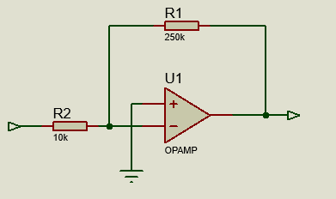
Tutorial 1 solutions

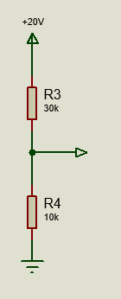

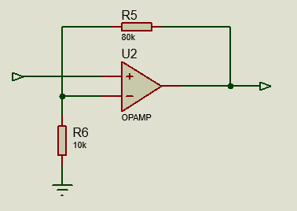

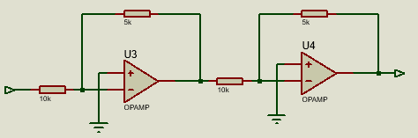

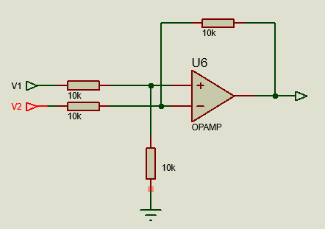

Gain = V1-V2
When all resistors are equal

- The removal of common mode noise induced into transmission lines.

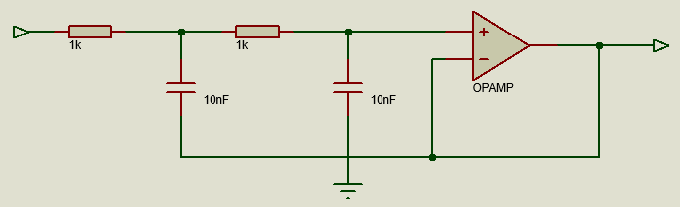

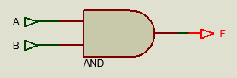

A | B | F
0 | 0 | 0
0 | 1 | 0
1 | 0 | 0
1 | 1 | 1

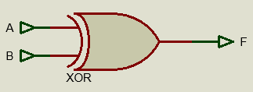

A | B | F
0 | 0 | 0
0 | 1 | 1
1 | 0 | 1
1 | 1 | 0

- An analogue signal is infinitely variable with time, whereas a digital signal is a pair of discrete voltage levels used to represent the data ‘0’ or ‘1’.

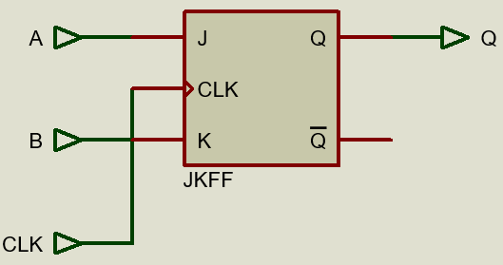

J | K | Q
0 | 0 | Q
0 | 1 | 1
1 | 0 | 1
1 | 1 | /Q
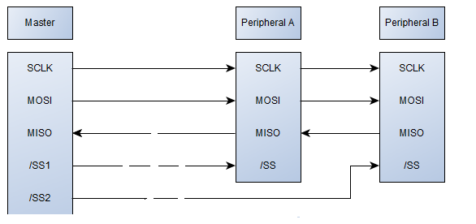

  - Sclk – serial clock
  - Mosi – Master out slave in
  - Miso – master I slave out
  - SS – Slave select

- A signal is a change in physical property that can produce a detectable variation in space or time.

- A system is a set of things working together as parts of a mechanism or an interconnecting network, a complex whole.

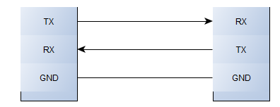

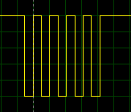

Start Data Stop

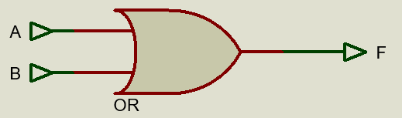

A | B | F
0 | 0 | 0
0 | 1 | 1
1 | 0 | 1
1 | 1 | 1
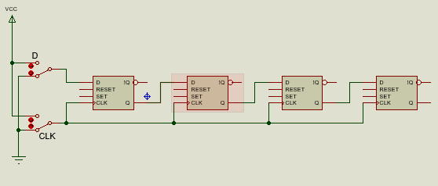

Data is entered into the shift register from the left by setting the D switch and toggling the CLK on and off. After each toggle of the clock the data entered is shifted synchronously to the next flipflop to the right. The data emerges from the shift register after 4 clock pulses.

