A Handbook for Early Years Key Workers: A guide for transitions


(Source: Mindtools, n.d)

Introduction 2
Transitions 3-4

The Needs of the Child 5-9

The Role of the Adult 10-12

Partnership Working 13-14

Interventions 15-17

Purposed outcomes 18-19

Reference list 20-23

Introduction

This handbook is aimed to help key workers, working through transitions with children within early years settings. Throughout this handbook there will be information about what is meant by transition, the needs of the child, the role of the adult, partnership working and interventions during transitions. Different developmental and learning theories in regards to transitions will also be looked at throughout this handbook. It is important this handbook is used during transitions within early years settings to ensure children have a smooth transition.

Transitions

What is Transition?
The way people respond to going through change is known as transition. When someone experiences transition, they have to familiarise themselves to different conditions and situations to be able to include the change into their life (Kralik, Visentin and Van Loon, 2006).

Transitions are also life experiences of change over a period of time. Transitions is the process of change. An example of this in an early years setting is a child moving from one setting to another. Transitions are seen as a process which is shaped by social structures and all parents, children and practitioners are involved in the process (Welsh Government, 2017).

Educational transitions take place in childhood in western culture. This can be children under the age of 3 going to creche or toddler groups. When children transition into school, they can make multiple transitions through the day where they may go from breakfast club into their class and some children might even go to after school clubs which is another transition (Dunlop and Fabian, 2007, p.4).

Every Child Matters (2021) believe transitions from one setting to another such as starting school, moving to a new class or even a school club may be seen as a normal part of life for some people however it is a milestone for children, and they have a huge impact on their development. These transitions can be exciting new opportunities for children. However, sometimes there can be some doubt about new and different surroundings where expectations are not met. It is crucial that transition is right for every child and is not something that will just happen and always work out straight away. Instead of a transition being seen as an event involving parents, children and practitioners, it should be seen as a process.

The Needs of the Child
.

It is vital to understand the development of a child in an early years setting. Every child is unique, sometimes people generalise some development patterns, but it should always be remembered that every child is unique and individual and can all have different personal needs. There are a range of theories which practitioners working within early years settings need to recognise to have a clear understanding of a child’s development (Lindon and Brodie, 2016, p. 1).

Maslow’s Hierarchy of Needs

In the 1940s Maslow alongside Carl Rodgers, presented a new approach to humanistic psychology. Maslow throughout his studies studied the construction of people’s needs. These needs were then later formed into a structure of a pyramid by his readers and supporters. Maslow believed there are five levels of needs. Starting from the bottom of the pyramid the five needs are psychological needs; Security needs; Recognition needs; Esteem needs, and Accomplishment needs (Pichère, 2015, p. 6)

Maslow’s Hierarchy of Needs offers a model to outline the needs of a person from simple functions such as sleeping and eating to the more fulfilling needs which as self-improvement and practicing hobbies. Even though Maslow was a psychologist his model is used in economics and business. Maslow’s model gives a simple and successful way to identify different needs of an individual (Pichère, 2015, p.7).

To begin at the bottom of the pyramid is physiological needs, these are basic physical needs which for example can be when a child is thirsty, they will drink or when they are hungry, they will eat (Hopper, 2020). Eating, sleeping, breathing and drinking are all physiological needs which re the most important as they are functions needed for survival. They surpass needs for security, esteem and the other needs of the hierarchy (Pichère, 2015, p.9).

Next on the hierarchy of needs in safety/security needs. A safe environment is the next need that needs to be met after all physiological needs are met. Even in early childhood safety needs are apparent as children should be in a safe environment and if these are not met children usually react with anxiety or fear (Hopper, 2020). In this category also falls safety from theft and damage.

When the first two areas of needs are met, next comes needs in relation to affection, love and the feeling of needing to belong. The social nature of a person is considered in this stage of the hierarchy of needs. This stage is known as the love and belonging stage (Pichère, 2015, p.9).

Both relationships with family and friends and relationships in a romantic way fall under this need. Another feeling which lays in their category of needs is a feeling of belonging in a social group. Since Maslow found the hierarchy of needs, further research has been made and it has been found a person’s physical health can better from having social connections. However, on the other hand feeling isolated can lead to negative effects on health and well-being (Hopper, 2020).

The fourth part of the hierarchy of needs is Esteem. This need also includes having the aspiration to feel good about ourselves. There are two components included in this need according to Maslow, the first component is feeling good/ having self-confidence and the second involves feeling appreciated by other people. This includes others recognising achievements made. People will find confidence when their esteem needs are met (Hopper, 2020).

Finally, At the top of Maslow’s hierarchy of needs is the need of self-actualisation. Where all the needs below are all reliant on the perceptions of others, self-actualisation is associated with the individual’s development (Pichère, 2015, p.9). The feeling of being fulfilled falls under self-actualisation at the top of the hierarchy and having the feeling of living up to personal potential. This need will be seen differently for every individual (Hopper, 2020).

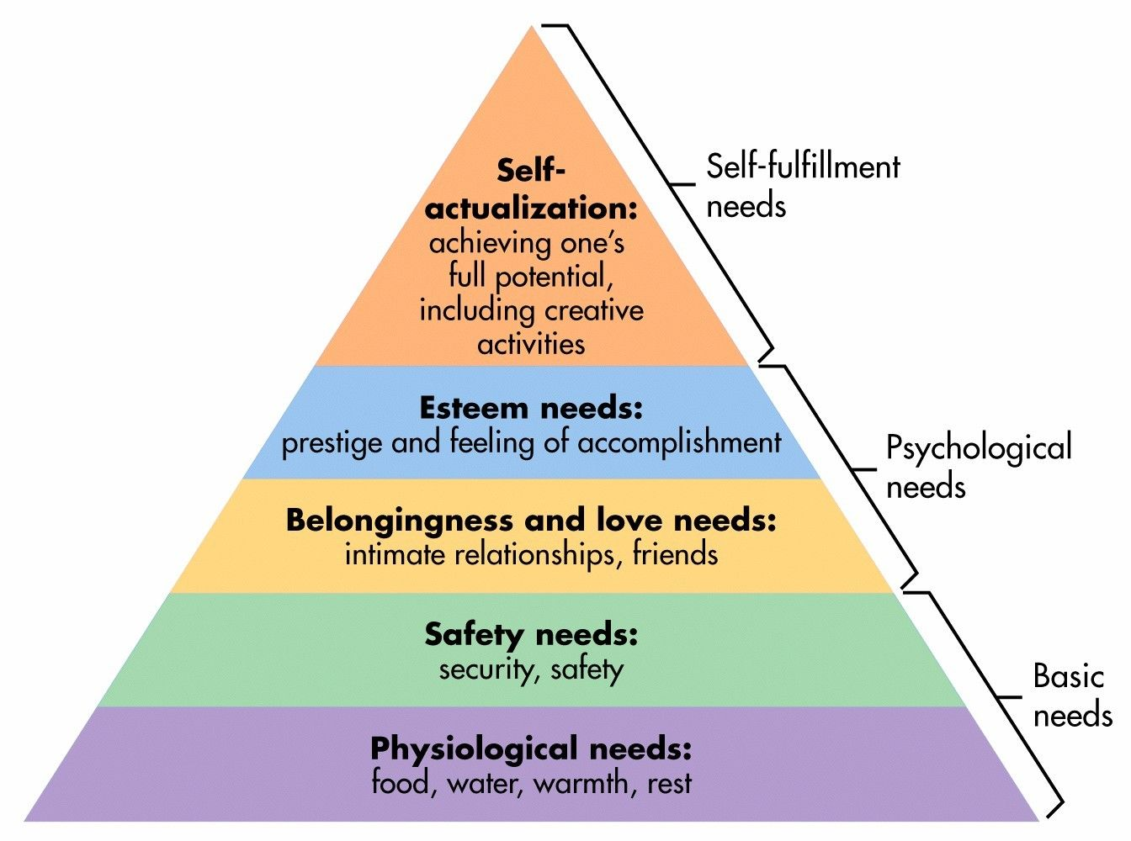
(Source: Simply Psychology, 2020)

John Bowlby – Attachment

The attachment theory was first outlined in 1958. It is still today a subject of research and debate. The most popular name in relation to attachment is John Bowlby. He expressed the basic principles of the theory. Bowlby’s theory was connected to the understanding of the perception of parenting. He explored how the experiences a baby goes through may have an effect on the overall well-being of the person they will be when they grow up (O’Connor, 2017, p.2). He transformed the way people think about a child’s attachment to their mother and the disruption it has when experiencing separation. Ainsworth’s advanced methodology helped in testing some of Bowlby’s ideas and also helped to expand the theory and some of the new directions which now take place are down to Ainsworth (Bretherton, 1992, p.759). An attachment in the attachment theory is a relationship which develops from a child’s natural need for security, safety and protection (O’Connor, 2017, p.2).

The Role of the Adult

Communication
When children make positive relationships, they will respond to non-verbal and verbal communication and also eye contact. Children will anticipate and initiate communication with other people and they learn to answer in multiple ways. Children will learn to react this way by watching, listenin and imitating other individuals and also by listening and joining in with stories, rhymes and sounds (Early Years Matter, 2021).

Sandra Brouet (no date) believed that, no matter what the setting is, experiencing effective communication is vital to enable positive relationships to happen with young people, children and their families. Having effective communication doesn’t only help having a happy environment, it is also an essential part of study for the majority of children.

The people, places and spaces children come into contact with have a huge impact on their development. The child is placed in the centre on the complex network in Urie Bronfenbrenner’s biological model of development. Bronfenbrenner’s influence has been extensive in early years education (Hayes, O’Toole and Halpenny, 2017, p.2).
Bronfenbrenner believed that the development of children is not just psychological, but it contains four foundations. These are society, politics, culture and economy. The direct environment to the child is the core environment, including themselves within the environment and this is known as Microsystem (Soyer, 2019, p.77). Any type of environment the child finds themselves spending a lot of time at are structures of the Microsystem. These types of environments may be school, home or social groups (Tudge, 2009, p.201). This layer of the system has the most influence on the child early on in life. Bronfenbrenner describes the relationships at this layer bi-directional as the behaviour of a child can be influenced by family and also the other way around (Krishnan, 2010).
The second immediate layer is called the Mesosystem and includes the Microsystem. This layer concentrates on the connections between multiple systems, mainly two different microsystems. This means what happens in one microsystem can have an effect on what happens in another. For example, things that occur at home can effect what happens in school. More importantly, the involvement of parents and teachers in a child’s education, if reciprocated till help mesosystem to operate (Krishnan, 2010)
The third layer of the system is called the Exosystem. This system will have an impact on a child’s development even though they are not having direct contact with it. This system includes micro and meso systems. Which means it has an impact on the wellbeing on individuals who have contact with the child (Krishnan, 2010)
The four and outermost layer is known as the macrosystem. The macrosystem has an influence on all layers beneath it in the ecosystem. Parts of the macrosystem which effect the lower layers are economic \disruption, cultural characteristics and political upheaval, all of these can either collectively or individually affect development (Krishnan, 2010).

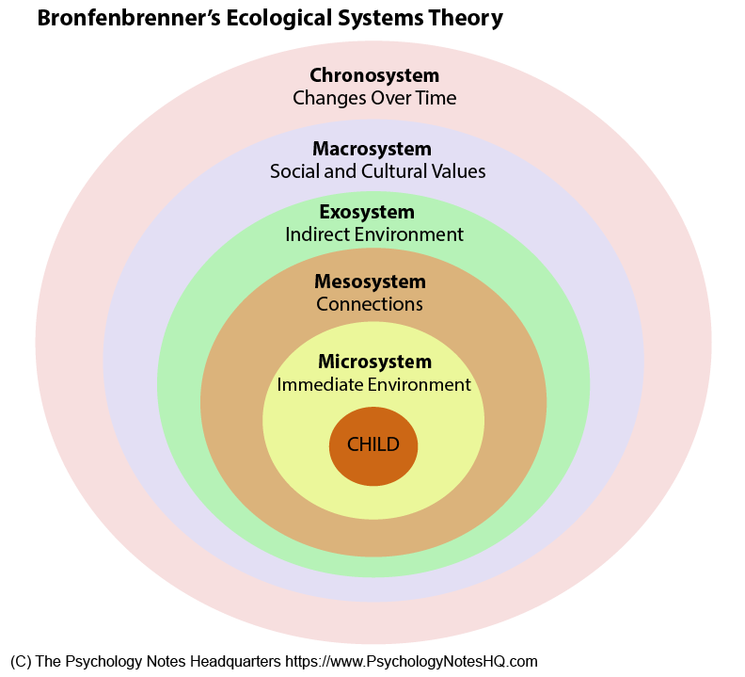
(Source: The Psychology Notes HQ, no date)

Partnership working
Partnership working

It is often thought that parents are a child’s primary educators. It has been observed that having a positive and strong relationship between their parents and teachers/ school staff can be majorly beneficial for the child. Benefits experienced by the child can be having an increased motivation, having a positive attitude towards education/learning, having an improved self-esteem, more confidence and less chance of behavioural problems. It is not just the child that benefits from teacher, parent relationships, the parents will have an enhanced relation with the school, they will also have a better understanding of their child’s education and how they are getting on in school, this gives them more confidence on helping their child at school with work/ homework. Teachers also get benefits from having positive relationships with parents, they gain job satisfaction and have a better understanding of the child (Brinn, 2021, p.53).
To allow working in partnership to be successful, both sides need to value each other equally. This can be different discipline teams in early education working in partnership with families to ensure each individual child’s personal needs are met. Working in partnerships can happen positively when agreements are met about sharing data and confidentiality. There are huge benefits of working in partnership letting families share information about how their child is developing and supporting their children with certain needs to ensure they are getting managed support (Early Years Matter, 2021).

The importance of transitions being organised and accomplished carefully is emphasised by good practice, considering the needs of children and showing parents respect as partners with supporting their children through learning and transitions. To allow children to experience a smooth transition it is important all staff are committed to the process in having effective communication systems and sharing information procedures (Welsh Government, 2017).

It is important that every individual working with children and their families through times of transition understand the process to allow a smooth transition. It is also a major factor that everyone involved in the transition ensures that ongoing communication takes place throughout. It is vital to always make sure parents are involved in the transition process and that there is always time set aside to keep developing positive relationships with them and talk about any issues or worries they may have. Finally, having arrange of ways to communicate with parents. These may be, phone calls, Video calls, face to face visits, letters, emails, social media or newsletters.

Interventions

There are many interventions that are put into place during transition for children. These enable the transition to run smoothly. Interventions include professional practitioners within the setting liaising information with parents of the children and vice versa and also many physical procedures are put into place to ensure an easy transition.

To enable a smooth transition to take place going from home to a nursery foundation phase setting, the child is placed in the middle of planning for the transition. Their needs are recognised, and they are treated as individuals, to make sure they feel confident and safe through every part of they transition. Some children will find the process of the transition more difficult than others and this is recognised by professionals. To enable an effective transition to take place, it is important that any additional or specific needs of the child or their family are acknowledged and planned for. Also making sure that the needs of children and their families who have different cultural and ethnic backgrounds and different faith groups are valued and respected (Welsh Government, 2017).

Children going through this transition will feel more at ease with their new environment and comfortable if they are familiar with the setting and people within it. This can be done by gradual settling in sessions, the children will be given the chance to meet staff and get a feel of the environment and new routines they will be using (Welsh Government, 2017).

Another idea which is used in many settings which supports transitions Is supporting material like an ‘All about me’ sheet they are fill in or a One Page profile. This will benefit both the children and the practitioners to get more of an insight to the child’s home life and see information about people they have in their life who are important to them, they like to do/ learn about and what they do not like doing or what distresses them (Welsh Government, 2017).

Play

For children to develop and bond with others play is essential. Parents are like their child’s first teacher before they go into the foundation phase, play is where a lot of teaching will take place. This is where children learning what is expected from them and learning family rules. Play helps children learn the way to act within society. For a child to have a health development play is important. There is research which found that after birth 75 percent of the brain develops after birth. The formation of connections between nerve cells is helped by play as it stimulates the brain throughout the process, and this will help the progression of development. Fine and gross motor skills are improved by this process. Fine motor skills include being able to hold a pencil or pen and gross motor skills include being able to run or jump. Play also have an important role in development of socialisation skills and language (Anderson-McNamee, 2010, p.1).


(Source: Pintrest, no date)

Friedrich Froebel

Play and the role it has in the development of a child was strongly viewed by Froebel. He believed that it nurtured emotional well-being and pleasure and was an essential source of benefit. Froebel believed that a young child’s education is crucial for their development, individually and socially. Child Nurture and Activity Institute was the name of his first kindergarten. Kindergarten can be known as wither a garden of children or a garden for children (Pound, 2019, p.18). In a Froebelian Kindergarten, play and being in an outdoor setting was predictably a primarily important. From the age of one to seven, children would be encouraged to go outdoors and appreciate nature. Essentials to learning were light and space and it was provision in his kindergartens to go for nature walks (Pound, 2019, p.19).

Proposed Outcomes

There are four purposes that have been set out in the New Curriculum for Wales by the Welsh Government (2020). These four purposes are:
- All children will be supported and help to become learners who are ambitious and efficient learners who are prepared to learn during their lifetime.
- People ready to play a full part in life and work, who are creative, imaginative contributors.
- Informed, ethnical citizens of the world and in Wales.
- Finally, confident and health individuals who are prepared to live a fulfilled life as a valued person in society.

It is known that when children are well settled and happy, they will have a higher well-being and learn better from it. It is also known that support is needed for children to adjust from moving to different places and interacting with different people. It is essential for a transition plan to be made to meet children’s individual needs. The practitioner will continue to have a huge importance as they can create an emotional security for a child and their parents. Having a good relationship with a child’s parents the practitioner can help the child through their transition into a school setting from home. The child would otherwise have to act as a link between parents and key worker if a good healthy relationship is not formed (Gunning, 2018).

(Source: Stonebridge College, 2018)

Reference List

Anderson-McNamee, J. K. (2010) The Importance of Play in Early Childhood Development. Available at: http://lanefacs.pbworks.com/w/file/fetch/65563699/Importance%20of%20Play.pdf (Accessed: 26 November 2021).
Bretherton, I. (1992) ‘The Origins of Attachment Theory: John Bowlby and Mary Ainsworth’, Developmental Psychology, 28(5), pp. 759-779.
Brinn, M.S. (2021) ‘Partnership Working between Home and School’, in Benedetto, L and Ingrassia, M. Parenting: Studies by an Educational and Transactional Perspective. London: Intech Open.

Brouet, S. (no date) Effective communication in early years settings. Available at: https://www.earlylearninghq.org.uk/earlylearninghq-blog/effective-communication-in-early-years-settings/ (Accessed: 24 November).

Dunlop, A.W. and Fabian, H. (2007) Informing transitions in the early years. Berkshire: McGraw-Hill Education.

Early Years Matter (2021) Communication and Language (CL). Available at: https://www.earlyyearsmatters.co.uk/our-services/school-and-nursery-improvement-partner/communication-and-language-cl/ (Accessed: 24 November 2021).
Early Years Matter (2021) Transitions. Available at: https://www.earlyyearsmatters.co.uk/eyfs/positive-relationships/transitions/ (Accessed: 22 November 2021).

Early Years Matter (2021) Working in Partnership. Available at: https://www.earlyyearsmatters.co.uk/eyfs/positive-relationships/working-in-partnership/ (Accessed: 24 November 2021).

Gunning, C. (2018) Transitions. Available at: https://www.early-education.org.uk/transitions (Accessed: 26 November 2021).

Hayes, N. O’Toole, L and Halpenny, A.M. (2017) Introducing Bronfenbrenner. London: Routledge.

Hopper, E. (2020). Maslow’s Hierarchy of Needs Explained. ThoughtCo, ThoughtCo, 24.

Kralik, D. Visentin, K and Van Loon, A. (2006) ‘Transition: A literature review’, Jan Leading Global Nursing Research, 55(3), pp, 320-329.
Krishnan, V. (2010) Early Child Development: A Conceptual Model. Available at: https://www.ualberta.ca/community-university-partnership/media-library/community-university-partnership/research/ecmap-reports/ecd-conceptualmodel.pdf (Accessed: 24 November 2021).
Lindon, J. and Brodie, K. (2016) Understanding Child Development 0-8 Years. 4th edn. London: Hodder Education.

O’Connor, A. (2017) Understanding Transitions in the Early Years. 2nd edn. London: Routledge.

Pound, L. (2019) How Children Learn. Practical Pre-School Books: London.

Simply Psychology. (2020) Maslow’s Hierarchy of Need. [image] Available at: https://www.simplypsychology.org/maslow.html (Accessed: 23 November 2021).
Soyer, G.F. (2019) ‘Book Review: The Ecology of Human Development by Urie Bronfenbrenner’ Journal of Culture and values in Education, 2(2), pp. 77-80.

Stonebridge College (2018) The Stonebridge College Guide to Becoming an Early Years Practitioner. [image]. Available at: https://www.stonebridge.uk.com/blog/early-years-and-child-care/a-guide-to-working-as-an-early-years-practitioner/ (Accessed: 27 November 2021).

The Psychology Notes HQ. (no date) What is Bronfenbrenner’s Ecological System Theory?. [image] Available at: https://www.psychologynoteshq.com/bronfenbrenner-ecological-theory/ (Accessed: 25 November 2021).

Tudge, J. R. H. (2009) ‘Uses and Misuses of Bronfenbrenner's Bioecological Theory of Human Development’ Journal of Family Theory and Review, 1(4), pp. 198-210.

Welsh Government (2017) Transition Guidance: Flying Start – Annex. Available at: https://gov.wales/sites/default/files/publications/2019-07/flying-start-transition-guidance-for-professionals.pdf (Accessed: 24 November 2021).

Welsh Government (2020) Developing a vision for curriculum design. Available at: https://hwb.gov.wales/curriculum-for-wales/designing-your-curriculum/developing-a-vision-for-curriculum-design/#curriculum-design-and-the-four-purposes (Accessed: 27 November 2021).

