Introducing the Modern Workplace
Module code: LCBB4003

Assessment 2 – Organisational Behaviour & Performance

Student Name: Svetoslav Hristov Radev
Student ID: 2030542

Background of Amazon and why Amazon has decided to move onto a physical store?
During the completion of this research I was able to conduct sufficient study in understanding the background of Amazon organisation which is also known as the largest online retail store as well as biggest E-Commerce Marketplace existing in the present global market. During the conduction of the research I was interested in understanding and gathering information regarding the establishment in the past of the organisation and I have found out that the company has been operating in the market since 1994 by Jeff Bezos, in Bellevue, Washington. The organisation was founded by its current owner in his residence garage and has been able to gradually expand their business operations through the appropriate use of the internet across various corners of the USA and the rest of the world. During 2019 Jeff Bezos, who is also the founder and current owner of the multinational company, was awarded the Person of the Year award for his dedication and experience in Amazon. As I was collecting information regarding the organisation I had found out that apart from providing excellent service to the online retail sector through the effective use of the internet the organisation had invested in introducing an online video streaming match form in the year 2005 where consumers were able to purchase subscriptions for $79. The platform named Amazon Prime had later developed into an ott platform which provided their consumers with divorce range of movies, original series as well as television series (Petruska, 2018).
The organisation have been operating in various marketplaces for more than two decades and they have been able to expand the operation from being present in the online retail marketing sector through online video streaming platform grocery and offline physical store named Blue Water shopping centre in Kent. Since their establishment and operations in the market the organisation has focused on providing an online E-Commerce base marketplace to various brands across the world and created a diversified E-Commerce platform where thousands of products can be compared by the consumers and brought to multiple payment methods. These easily accessible and diversified options have been able to attract the large number of consumers to purchase the product through Amazon platform. During the conduction of my research and completing the study I have collected some knowledge about the ability and the intention of the organisation to provide their consumers with maximum possible satisfactory results through extending their performance amplitude in the maximum possible dimensions. This ability of the organisation has helped in creating widespread brand recognition and a distinct consumer market (Weise, 2020). While I was conducting the research I had also gathered some information on the recent approach of the organisation to extend their operations in the offline market as well. Collecting information for the sake of the research have enabled me to gain understanding regarding there extension of consumer market from being an online bookstore to and widespread worldwide retail sector where the consumers can purchase products ranging from the daily essential commodities, various accessories as well as baby product, beauty product, groceries, health, personal care item, scientific supplies, jewellery, electric appliances watches and many more.
As I have researched and analysed on the physical and online stores of Amazon, along with its operational value to both of them, I have inferred that, Amazon’s initiation and introduction of physical stores have been the new edition within their business operation, which will further be run through their expert and skilled functional units. As I have developed knowledge and explored more about Amazon's reason for deciding to move onto physical stores, I have acknowledged their conspicuous yearning of reducing the delivery cost. Referring to and stressing on this matter of fact, Amazon has further been highlighted as the company desiring to reduce its overall costs and investments, spent on regular delivery of goods in different parts of the country (Buchanan and Huczynski, 2019). Furthermore, customers belonging from a Prime membership account and having a cart total over $10 are provided with the offer of free shipping, which caters no additional delivery charge for the shipment of the product. These include larger cost for human labour and resources along with an additional expenditure of vehicles, which impart significant impact on amazon’s financial strategy, leading to a cost constraint. I have therefore developed this theory that Amazon, with the help of establishing and opening physical stores in different areas, will be able to reduce and control regular delivery for the online orders to a significant extent, which will further contribute to the company's productivity and enhanced operational value (Armstrong, 2012). Adding to this, throughout my analysis and research on Amazon’s decision of shifting to physical stores, the provision of more options for the customers in terms of products, have been deduced to be a significant reason for opening up stores. I have further evaluated the SCARF Model used in Mullins and McLean (2019), from which I have been able to relate Amazon's decision of moving towards physical stores, with that of their aim to become more employable in the market. As Amazon determines to open its physical store, it will require human resources for various functional units, which will directly contribute to the national economy and employment at large (Armstrong, 2012). As per my analysis, ‘SCARF’ model refers to the status of an entity, stating its position in terms of its relation with others. Therefore, referring to Amazon’s status in the physical market, I can further bestow upon the fact that, Amazon, with the intention of attaining larger consumer base and revenue, has decided to move towards physical stores, owing to its determination of attracting the loyal customers in its traditional operation as well. I have further come across the aspect of multiple customers not having the digital literacy to inherit the Prime subscription of Amazon, adhering to which, the company has been determined to open its physical stores, while providing such customers with the opportunity of getting prime benefits (Buchanan and Huczynski, 2019).

Reference
Armstrong, M., (2012). Armstrong’s hand book of. Human Resource management practice, 12.
Buchanan, D.A. and Huczynski, A.A., (2019). Organizational behaviour. Pearson UK.
Mullins, L.J. and McLean, J.E., (2019). Organisational behaviour in the workplace. Harlow: Pearson.
Petruska, K., (2018). Amazon Prime video: Where information is entertainment. In From Networks to Netflix (pp. 355-364). Routledge.
Weise, K., (2020). Bezos Takes Back the Wheel at Amazon. International New York Times, pp.NA-NA.

Introducing the Modern Workplace
Module code: LCBB4003

Assessment 2 – Organisational Behaviour & Performance “Presentation”

Student Name: Svetoslav Hristov Radev
Student ID: 2030542


Amazon is considered to be one of the largest online retail stores existing globally. The company is ever present since 1994 and has been one of the largest names within the retail market. Amazon has been quite proficient with their quality of the product and along with it customer obsession. They always try to meet the demands of the customers by trying to reach every other extent possible. The following group presentation is based on a physical store which Amazon is willing to set up at the Bluewater Shopping centre in Kent. This store would be a 4-star store with availability of non-food products. The following power-point presentation is based on contemporary approaches; including behaviour, skills, knowledge and usage of different applications which are to be undertaken is being presented to the CEO.
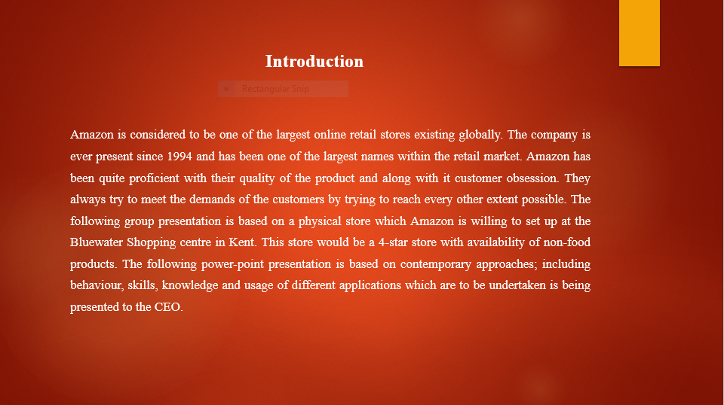

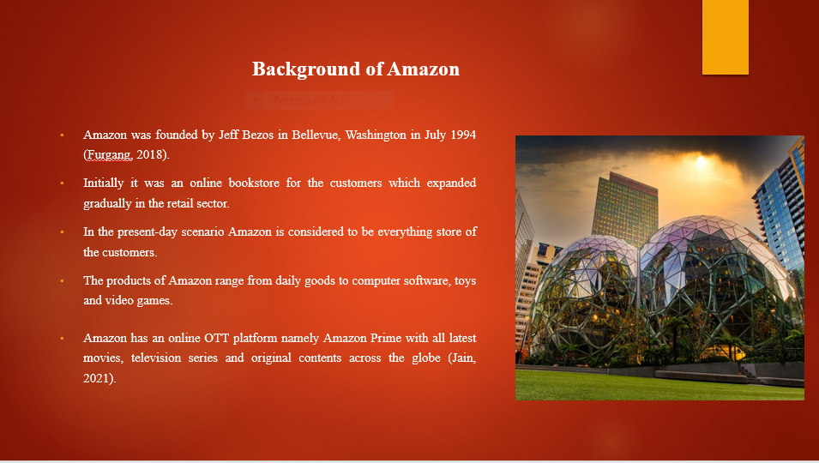
Amazon is one of the largest online-retail stores existing across the global scenario. The company was founded by the current owner of the company Jeff Bezos in 5th July, 1994 at his Bellevue Washington residence’s garage. At first Amazon was known for selling books for their customers within the US market. The company since 1998 started to expand gradually with the emergence of the internet across the USA. Currently, the company is considered to be an everything stores as they provide a wide range of products for their customers which includes daily food products and along with-it computer software, toys and video games (Salomão et al., 2021). In 2019, Jeff Bezos was awarded with the Person of the year award for his wide experience with Amazon. Amazon Prime was introduced in the market in 2005, where the customers can subscribe for $79 to get access to a wide range of products and comets. Later, Amazon OTT (Over the top) platform was introduced in 2015 which is one of the popular web platforms with a wide range of movies, television series and Amazon produced original contents.

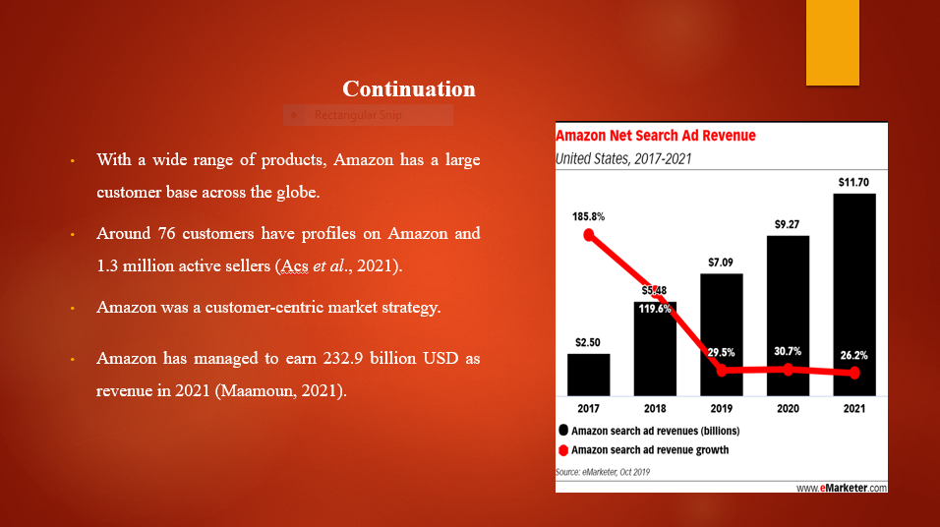
Approach from Amazon has been quite customer centric since their arrival within the market. The company always tried to live upto the demands of the customers and tried them to satisfy their needs. In the present-day scenario Amazon has 76 million customer profiles under their belt and they have got 1.3 million active sellers present. The company has always tried to provide the best quality product for their customers with the wide range which is available in their online stores. This states that Amazon tries to live-upto the expectations of their customers with their market strategy and leadership approach. The company believes that providing quality service to the costumes would help them to top the charts of online retail market on a global scale. Amazon has managed to attain 232.9 billion USD as revenue in 2021 financial year, making them one of the largest names within the online retail sector presently existing (Sousa et al., 2020).

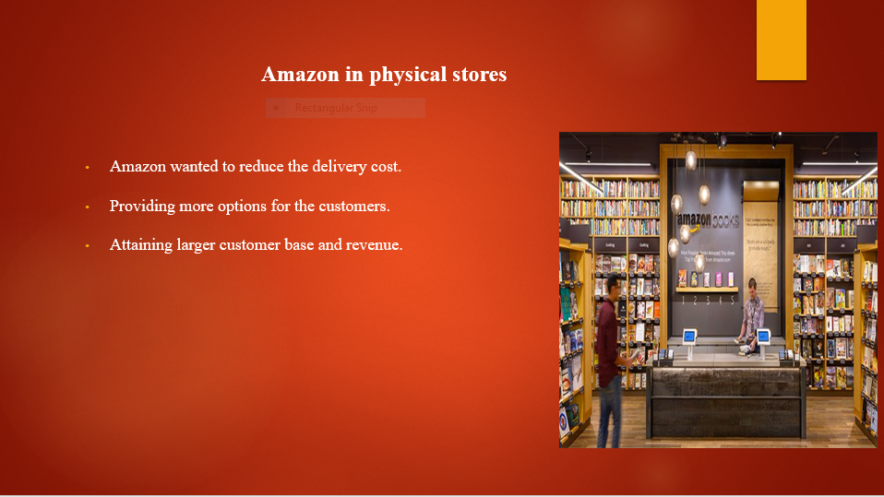
Physical stores is one of the news editions from Amazon. They are considered to be the king of online retail stores yet through their physical stores the company is looking to increase their revenue making within the market. There are several reasons why Amazon is looking to include physical stores. Firstly, the company wants to reduce the delivery cost which is caused due to the regular delivery of goods in different parts of the country. It includes larger labour and vehicle cost too which certainly has an impact on the budget of Amazon since the global pandemic (Johnston, 2018). Inclusion of these physical stores provides a wide range of options for the customers of Amazon. As it can be observed that many customers are not capable of getting prime membership due to the lack of digital literacy these stores of Amazon can easily provide them with that opportunity where they can get the prime benefits. Even the customers can choose from the wide range of quality products which are available within the stores (Althafairi et al., 2019). This would help Amazon to increase with their customer base within the offline retail market. Lastly, as Amazon is a customer-oriented company this would help them to reach out to their customers and help themselves to increase their revenue collection.

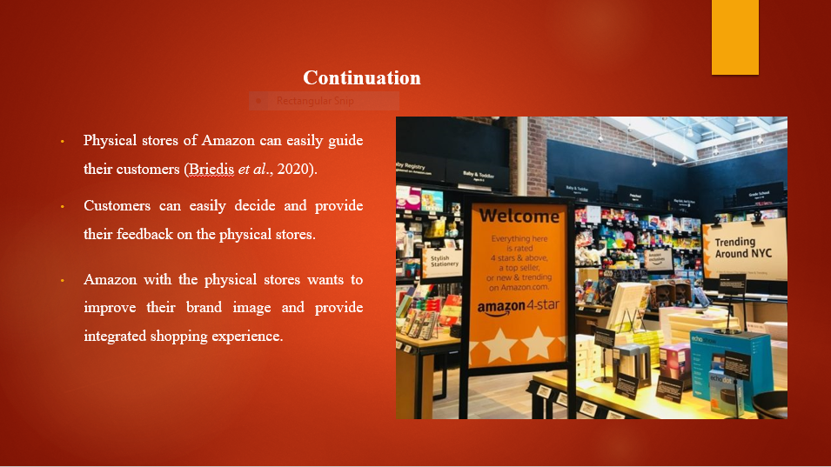

Customers of Amazon are of a wide range and their popularity is expanded with diversity and access to several cultures. These physical stores of Amazon would provide them with an opportunity to guide their customers to select the products as per their choice. In the online stores the customers often get into a dilemma of not understanding about the quality or size of a product which can be sustainable for them. These stores would provide them with that opportunity to help these customers to choose and understand what is correct and incorrect for their use. Along with-it feedback has been one of the major supports for Amazon to improve on their quality of the products. They are constantly working on the basis of the customer feedback in their online stores, through their physical stores the company can get direct feedback on the customer inputs and can easily work on it to provide better customer prince and satisfaction. With these physical stores which Amazon is trying to introduce in the global arena, it would help them to improve on their brand image widely (Vollero et al., 2021). This is one of the biggest advantages for Amazon management to achieve with larger revenue collection. Along with it an integrated shopping experience can be provided to the customers and help them to satisfy their needs.
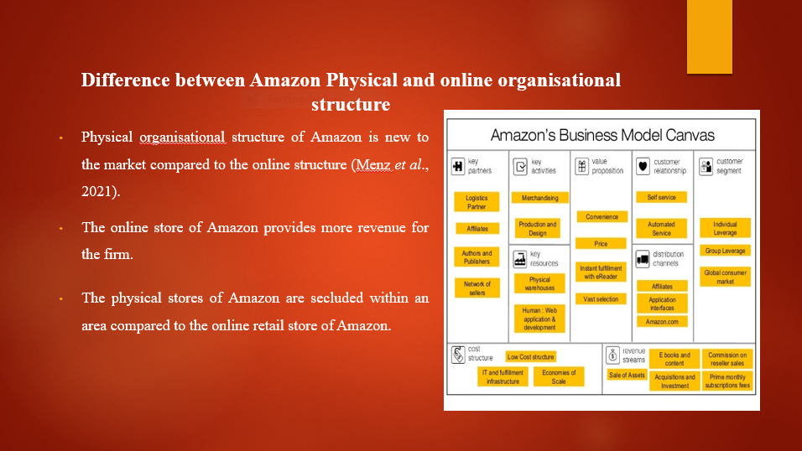

Amazon has newly introduced their physical stores for their customers within the market. They mainly conducted their business within the online setup for the last 20 years. Yet this online set up of Amazon provides the main revenue collection for the firm (Zhang et al., 2019). The main reason behind it is that the stores are only secluded into a specific area with limited product range, whereas in the online structure the customers can avail with any product which they want to buy

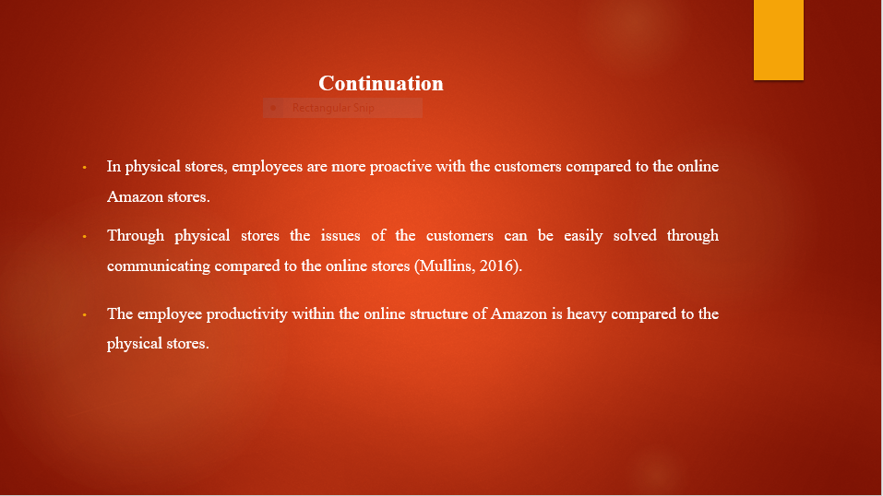
The employees working within the physical stores of Amazon are required to be more proactive compared to the online stores. The reason behind is quite simple as the employees are required to communicate face-face with their customers in the physical stores and they can eventually solve any issue which is present. It can be difficult at times within the online set-up due to connectivity issues or even the customer failing to understand the employee insight (Zhang et al., 2019). Whereas, it can be stated that employee productivity in order to communicate and satisfy the customers within Amazon’s online set-up is quite heavy compared to the existing physical stores.

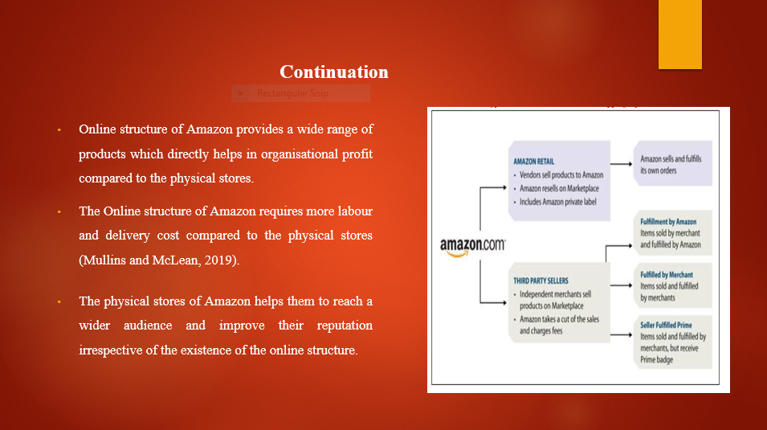
In the online set-up of Amazon, it provides with a wide range of products for the customers and it helps in attaining with more organisational profit compared to the physical stores. Yet, in physical stores Amazon can easily cut short with their labour and delivery cost which is high in the online set up. Whereas, these physical stores of Amazon can easily reach a wider audience who are not actively present within the online set up. It helps to improve the reputation of the organisation

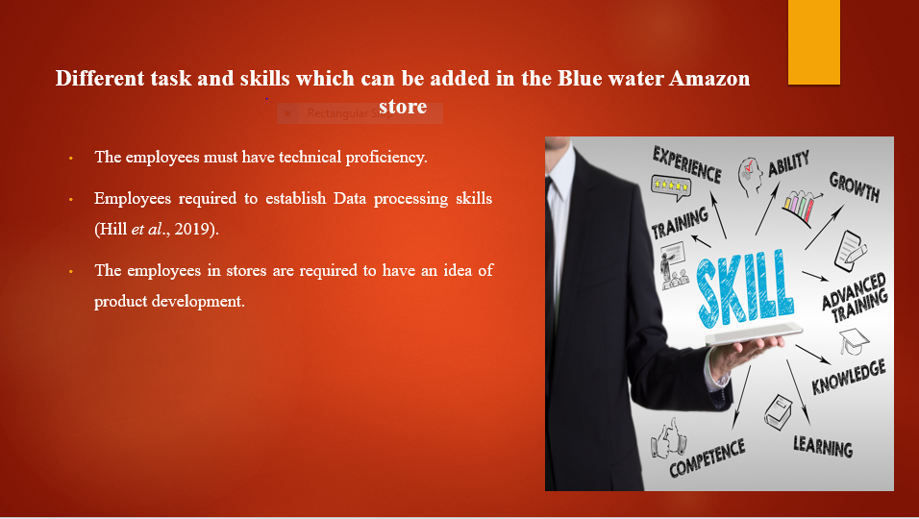
Skills are the most important aspect which the employees of Blue water Amazon store of Kent needs to have in order to run the store successfully. Technical understanding is important as Aeon is most based on online proficiencies. The employees of the Amazon store in Blue water mall need to have proper data processing skills to understand the values involved (Schwenkel et al., 2020). As the employees need to communicate with the customers directly within the stores, they need to have a proper idea on product development
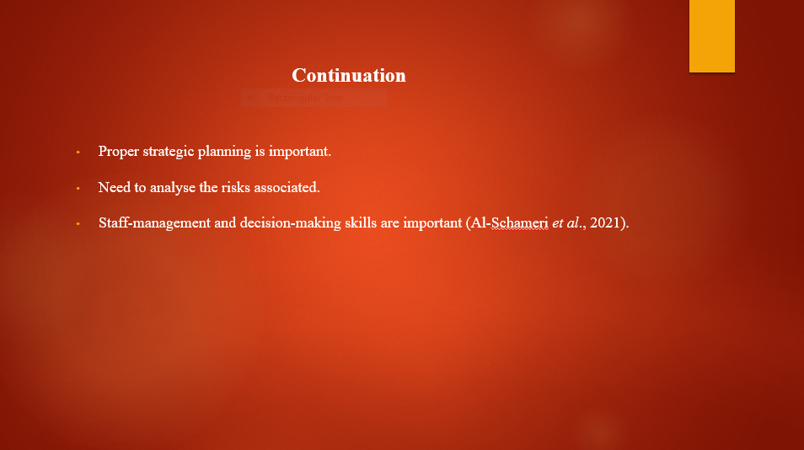
The employees of Amazon store at the Blue Water mall in Kent need to have proper strategic planning on the approaches which they are willing to undertake within the stores. This planning would help them to attain customer demand and sales. The risk which is associated with the physical store business is needful to be analysed as Amazon is new in the market (Zhu et al., 2022). They need to adhere to the competitiveness. Lastly, the existing staff are to be managed properly so that they can be productive and helpful towards the customers visiting the store.

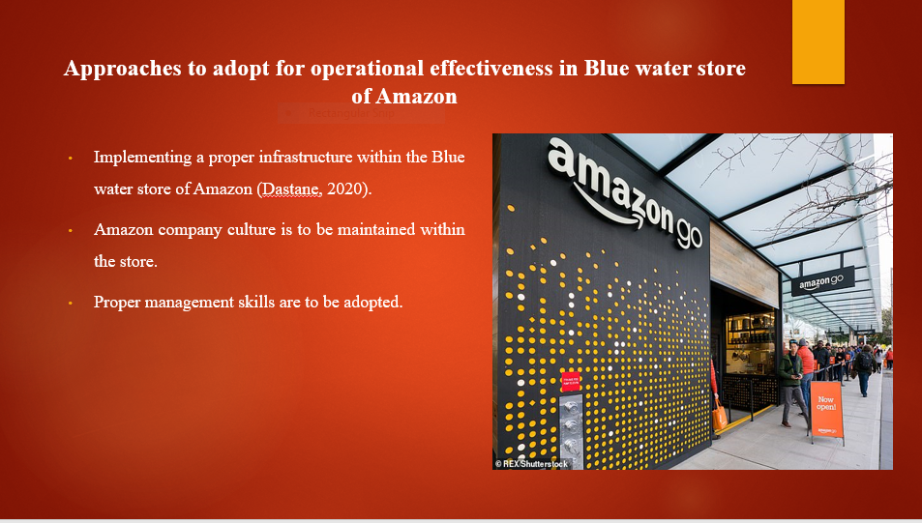
The infrastructure within the Blue Star mall store of Amazon needs to be up to the mark. As there are several similar types of companies already existing within the mall it is required to be a crucial approach. Amazon has a diversified company culture with a hierarchical leadership structure which is to be maintained in the store (Zhu et al., 2022). The existing managers of the stores need to have proper management skills to handle the internal and external factors involved


The managers of these stores need to ensure the employees on the importance of time management in order to achieve productivity and revenue. Along with it the store needs to undertake a futuristic approach in order to overcome the barriers which they might face on entering the physical store market within a mall. The employees need to be adaptable with the company culture and need to be trained properly and make them understand the value of the organisation.

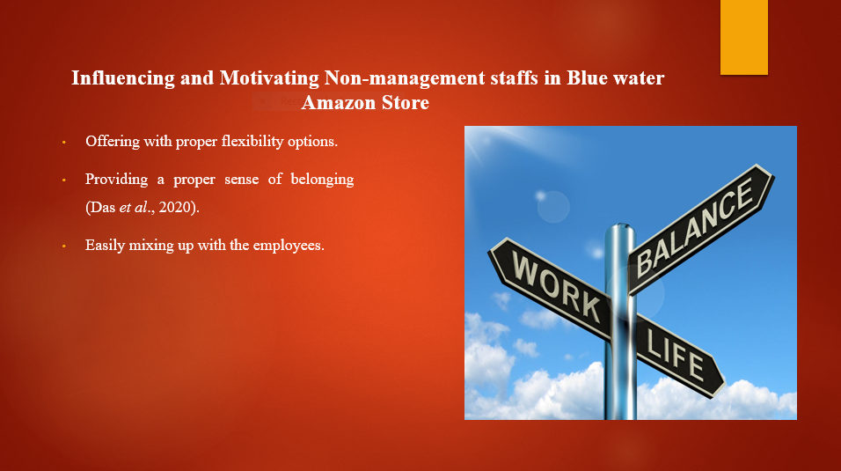
The employees working with the stores should be restricted with company policy. They are to be provided with proper flexibility to that extent which might improve their productivity. The employees of Blue Star mall Amazon store are to be treated in a manner that they should feel like home. It is important in order to attain productivity. The managers are to be friendly with the employees and discuss small jokes in the middle of the work. As it will provide a light environment within the workplace

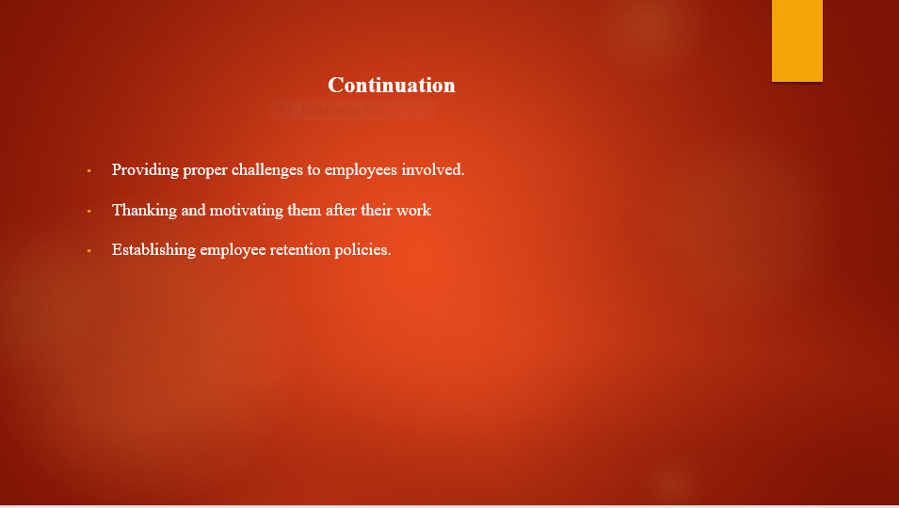
The employees working within a firm might feel motivated with the introduction of proper challenges when it is being thrown at them. It would help them to work with dignity and courage. Or else they might lose their interest in the job. Followed by this the employees are to be thanked for their insights at work and motivate them regularly for better outcomes. Lastly, the management needs to implement an employee retention strategy to make the employees feel secure about their position within the Amazon store of Blue Star Mall

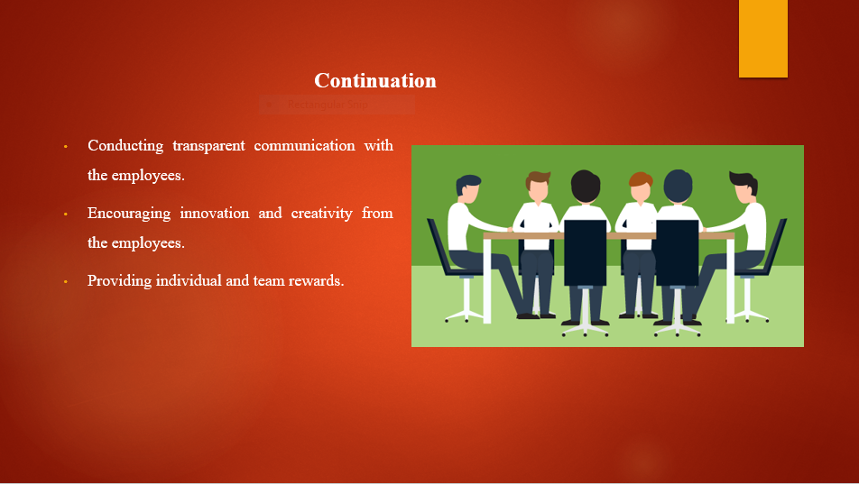
The management of Amazon store of Blue water mall in Kent, needs to conduct with transparency in communicating the employees involved. Along with it the employees are to be encouraged on the basis of their innovative approaches which they try to implement at the workplace and along with the employees are to be rewarded on the basis of their individual and team performance.
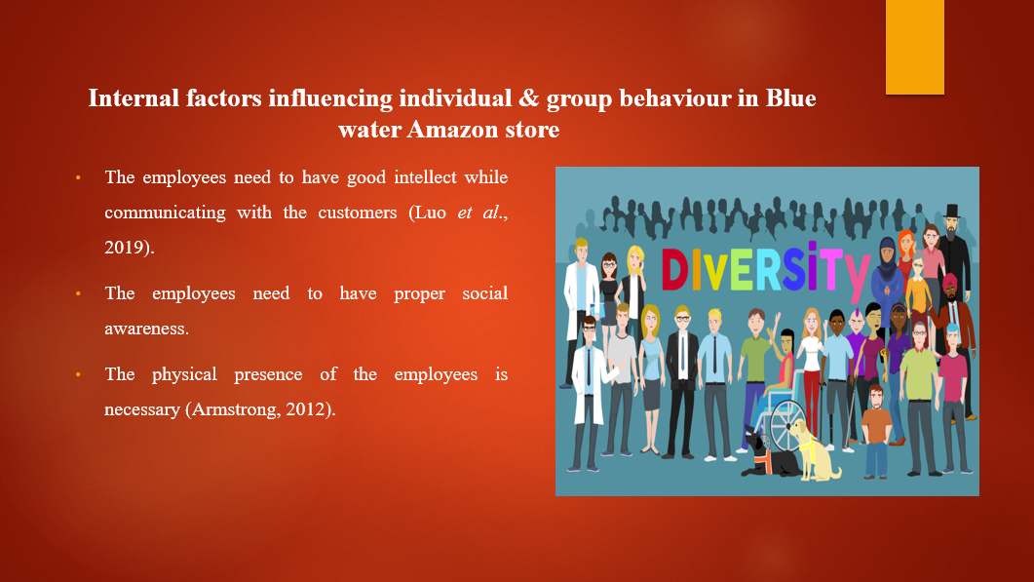

The employees must have a good intellect while communicating with the customers involved. This would provide a competitive advantage for management associated with the physical store of Amazon to maintain a good relationship. The employees should be acknowledged to maintain a good social awareness while communicating with the customers rather than being rude (Armstrong, 2012). The presence of employees within the store at the Blue water mall needs to be at large in order to guide the customers
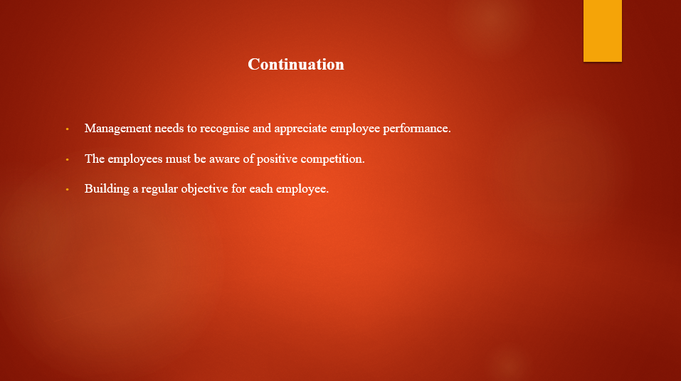
The management needs to recognise the employee performance and they should be appreciated on the basis of it. It would help in improving the confidence of the employees. The positive competition should be present within the firm. The existing retail stores within the Blue water mall are to be recognised and stated on to the customers in order to work on the basis of it. There should be a proper objective as per Amazon which each and every employee involved are to be followed.
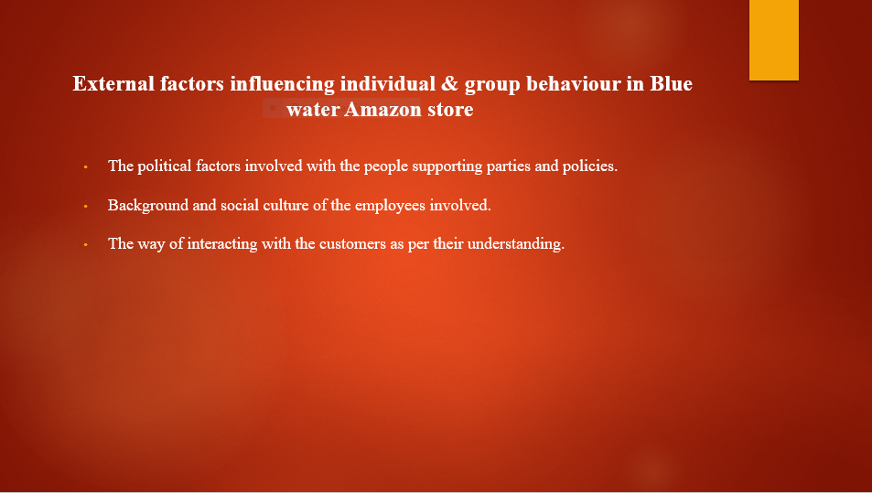
The political parties make a huge difference within the behaviour of the employees which directly impacts on organisational performance. The management needs to make it clear about the social stigmas which are present and how to keep them aside by working within a diversified work culture
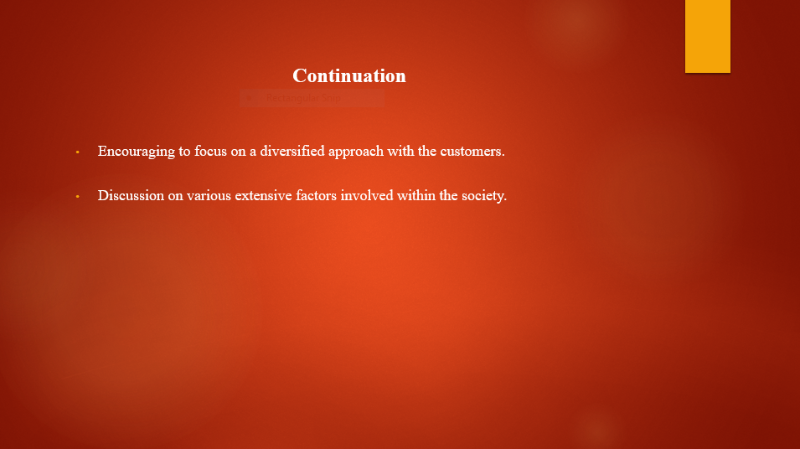
The management in order to improve with their performance needs to encourage the employees to undertake more of a diversified approach to avoid any existing issue with the customers. The discussion with the employees are ed to be quite extensive as the discussion must involve the variolisation factors.

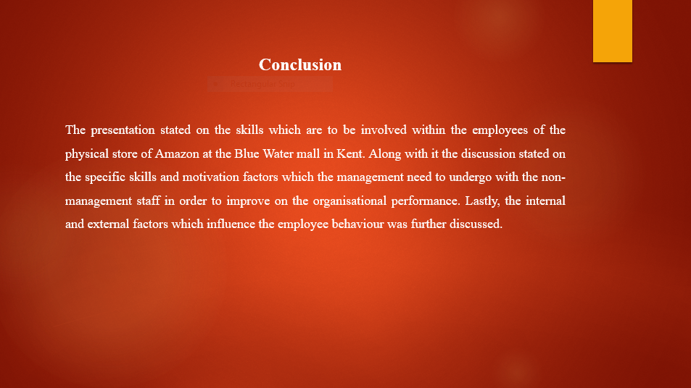
The presentation stated on the skills which are to be involved within the employees of the physical store of Amazon at the Blue Water mall in Kent. Along with it the discussion stated on the specific skills and motivation factors which the management need to undergo with the non-management staff in order to improve on the organisational performance. Lastly, the internal and external factors which influence the employee behaviour was further discussed

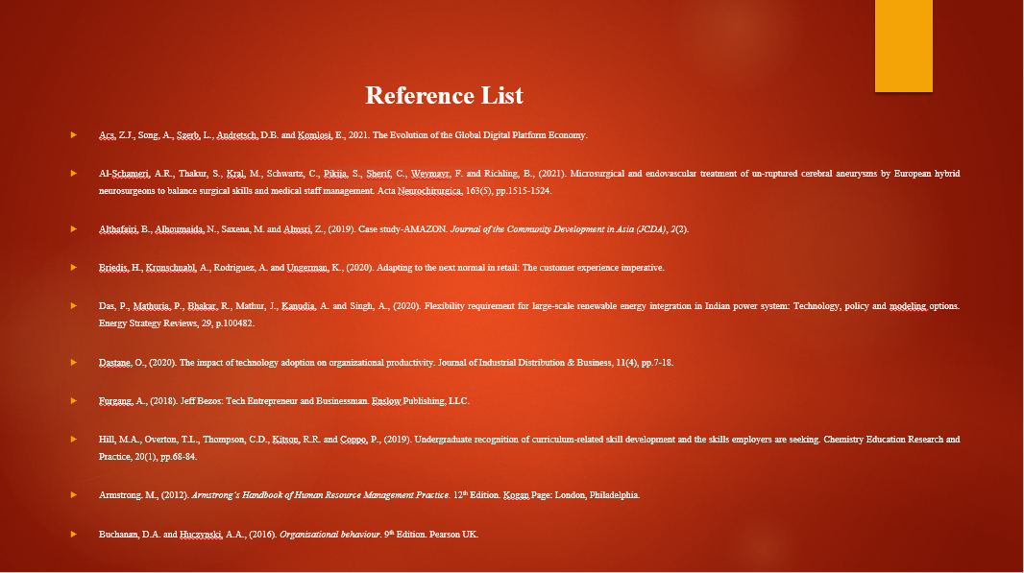

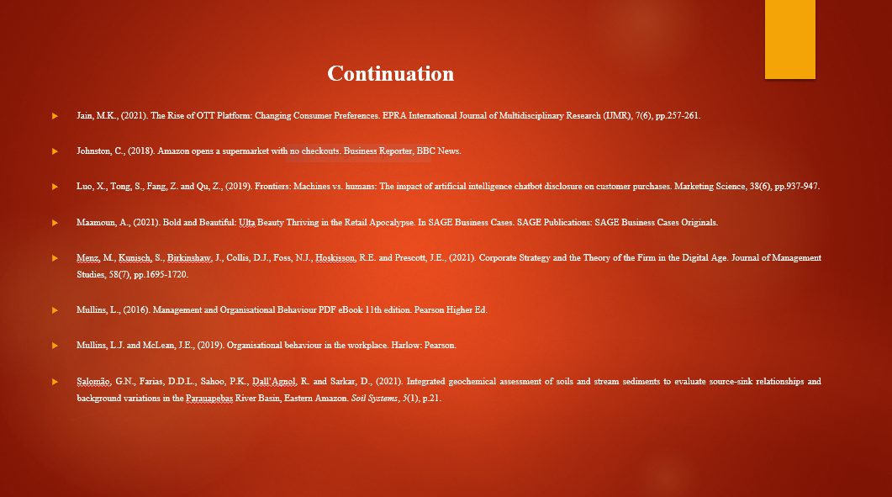

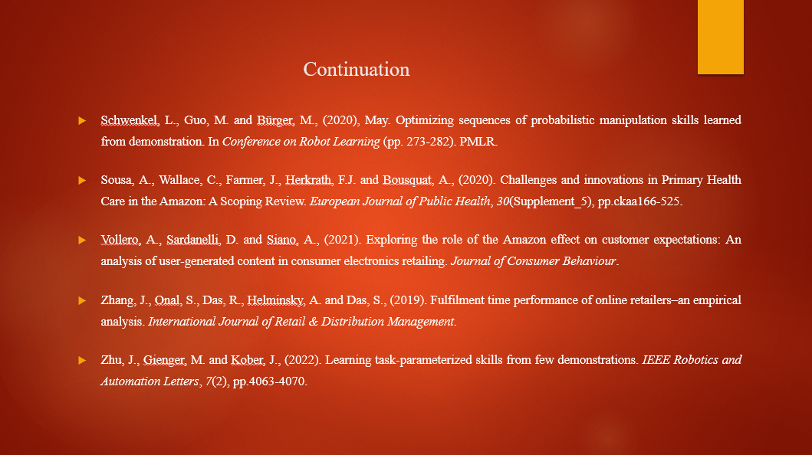
Acs, Z.J., Song, A., Szerb, L., Audretsch, D.B. and Komlosi, E., 2021. The Evolution of the Global Digital Platform Economy.
Al-Schameri, A.R., Thakur, S., Kral, M., Schwartz, C., Pikija, S., Sherif, C., Weymayr, F. and Richling, B., (2021). Microsurgical and endovascular treatment of un-ruptured cerebral aneurysms by European hybrid neurosurgeons to balance surgical skills and medical staff management. Acta Neurochirurgica, 163(5), pp.1515-1524.
Althafairi, B., Alhoumaida, N., Saxena, M. and Almsri, Z., (2019). Case study-AMAZON. Journal of the Community Development in Asia (JCDA), 2(2).
Armstrong. M., (2012). Armstrong’s Handbook of Human Resource Management Practice. 12th Edition. Kogan Page: London, Philadelphia.
Briedis, H., Kronschnabl, A., Rodriguez, A. and Ungerman, K., (2020). Adapting to the next normal in retail: The customer experience imperative.
Buchanan, D.A. and Huczynski, A.A., (2016). Organizational behaviour. 9th Edition. Pearson UK.
Das, P., Mathuria, P., Bhakar, R., Mathur, J., Kanudia, A. and Singh, A., (2020). Flexibility requirement for large-scale renewable energy integration in Indian power system: Technology, policy and modeling options. Energy Strategy Reviews, 29, p.100482.
Dastane, O., (2020). The impact of technology adoption on organizational productivity. Journal of Industrial Distribution & Business, 11(4), pp.7-18.
Furgang, A., (2018). Jeff Bezos: Tech Entrepreneur and Businessman. Enslow Publishing, LLC.
Hill, M.A., Overton, T.L., Thompson, C.D., Kitson, R.R. and Coppo, P., (2019). Undergraduate recognition of curriculum-related skill development and the skills employers are seeking. Chemistry Education Research and Practice, 20(1), pp.68-84.
Jain, M.K., (2021). The Rise of OTT Platform: Changing Consumer Preferences. EPRA International Journal of Multidisciplinary Research (IJMR), 7(6), pp.257-261.
Johnston, C., (2018). Amazon opens a supermarket with no checkouts. Business Reporter, BBC News.
Luo, X., Tong, S., Fang, Z. and Qu, Z., (2019). Frontiers: Machines vs. humans: The impact of artificial intelligence chatbot disclosure on customer purchases. Marketing Science, 38(6), pp.937-947.
Maamoun, A., (2021). Bold and Beautiful: Ulta Beauty Thriving in the Retail Apocalypse. In SAGE Business Cases. SAGE Publications: SAGE Business Cases Originals.
Menz, M., Kunisch, S., Birkinshaw, J., Collis, D.J., Foss, N.J., Hoskisson, R.E. and Prescott, J.E., (2021). Corporate Strategy and the Theory of the Firm in the Digital Age. Journal of Management Studies, 58(7), pp.1695-1720.
Mullins, L., (2016). Management and Organisational Behaviour PDF eBook 11th edition. Pearson Higher Ed.
Mullins, L.J. and McLean, J.E., (2019). Organisational behaviour in the workplace. Harlow: Pearson.
Salomão, G.N., Farias, D.D.L., Sahoo, P.K., Dall’Agnol, R. and Sarkar, D., (2021). Integrated geochemical assessment of soils and stream sediments to evaluate source-sink relationships and background variations in the Parauapebas River Basin, Eastern Amazon. Soil Systems, 5(1), p.21.
Schwenkel, L., Guo, M. and Bürger, M., (2020), May. Optimizing sequences of probabilistic manipulation skills learned from demonstration. In Conference on Robot Learning (pp. 273-282). PMLR.
Sousa, A., Wallace, C., Farmer, J., Herkrath, F.J. and Bousquat, A., (2020). Challenges and innovations in Primary Health Care in the Amazon: A Scoping Review. European Journal of Public Health, 30(Supplement_5), pp.ckaa166-525.
Vollero, A., Sardanelli, D. and Siano, A., (2021). Exploring the role of the Amazon effect on customer expectations: An analysis of user‐generated content in consumer electronics retailing. Journal of Consumer Behaviour.
Zhang, J., Onal, S., Das, R., Helminsky, A. and Das, S., (2019). Fulfilment time performance of online retailers–an empirical analysis. International Journal of Retail & Distribution Management.
Zhu, J., Gienger, M. and Kober, J., (2022). Learning task-parameterized skills from few demonstrations. IEEE Robotics and Automation Letters, 7(2), pp.4063-4070.

