Task 1 – Academic Report
Student Name: Hasina Ibrahim Sheikh
Student Number:2122535
Lecturer Name: Joanne Davies
BMSW4002_BIRM
Effective Team Working and Communication

Summary
What does it mean to have or be an effective team? Understanding the questions to ask and identify how a group of individuals can develop into a team based on a shared goal. Diving further into the attributes of a successful team, its impact, and the potential ways leaders can build an effective, collaborative and effective team.

[ Word Count: 2,172, excluding in-text citation]
Contents

Introduction 3
Overview of Team working 3
Models of Team development 5
Team Roles 8
Discussion 9
Conclusion and recommendations 11
Reference List 12

Introduction

This report aims to discuss potential solutions to the current issues and their impact on Pelsall Hall Care Home. For the manager, Steve Brookes, it will discuss three proven team-building models and how they could be used to develop an effective team, working collaboratively to deliver consistently high-quality care services to its residents. This report will also look at team roles and composition to further validate solutions that Steve can implement.
Efficient collaboration of teams is of the utmost importance when presenting care. Without it, as the care home has experienced, the level of care could be impaired. There are multiple elements to an effective team in the care setting, such as communication, social interactions, respect, and understanding. If any one of these elements is compromised, efficient teamwork does not happen. This applies to all levels of an organization, as such, in a care home with multiple individuals from nurses, cleaners, assistants, managers, and supporters. Each with specific tasks, working together to achieve a common goal – providing high-quality care.

Overview of Team working

A team in healthcare refers to a group of professionals who work together to provide care for patients. “A team is several individuals working as one to achieve a particular goal to which they are mutually committed” Morgan P (2017) Business student's guide to study and employability. Available: Campus Library (25 June). To further break down the definition into several key points: 1) A team in healthcare is composed of different disciplines and specialties that come together as one unit; 2) Teamwork takes many forms, including communication and coordination between members; 3) The goal of teamwork is always the patient’s best interest; 4) Every member must be willing and able to contribute their expertise towards the success of the team-based approach.
There is often confusion as to what several individuals working together are called, a group or a team. Comparative to the above team definition, “A group is usually defined as the number of people sharing something in common and meeting together about their shared characteristics” Morgan P (2017). The key term used between the two definitions is – a common goal (e.g achieving 5-star patient feedback) and shared characteristics (e.g. spending time with the elderly).
Differences | Teams | Groups
Size | Limited | Medium or Large
Selection | Crucial | Immaterial
Leadership | Shared or rotating | Solo
Perception | Mutual Knowledge and Understanding | Focus on the Leader
Style | Role spread Co-ordination | Convergence/Conformism
Spirit | Dynamic interaction | Togetherness, persecution of opponents
Table 1 - Teamwork vs Groups [Source: Grifith, BA & Dunam (2014) Working in Teams Available: ProQuest Ebook Central. [30 June]
Specific parameters that need to be met, if a group is to be considered a team, were identified by Hackman (2009). These five basic conditions are:
- A group of identifiable individuals who genuinely work collectively to achieve a common set of goals.
- The need to understand and embrace a shared purpose.
- Including the right quantity, type, and responsibilities in the right ways. Governing them by the right norms and shared values.
- Surroundings and associates should facilitate success.
- An outside viewpoint and support at critical stages in any group’s development.
The term ‘effective’ is the ability to be successful in producing a desired or intended result. There are several ways to identify if the individuals working at Pelsall Hall Care Home are an effective team, one of which is based on the original discovery by Michael West (Aston University) on the NHS. They highlighted both the benefits of ‘real’ teams but also the damage caused by ‘pseudo’ teams. From their research and others exploring this field, questions can be asked when introducing or testing effective teams within an integrated care initiative. (See Figure 1).
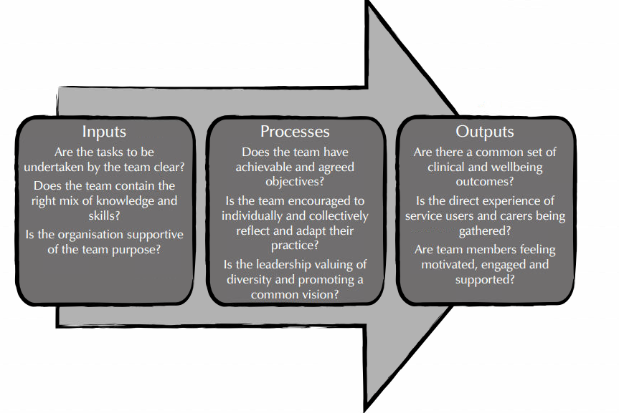
Figure 1- The Input–Process–Output Model of team effectiveness - West and Lyubovnikova (2013), the Illusions of the team working in health care. Available: ProQuest eBook Central. [Accessed 30 June 2022]

Models of Team development

Groups of individuals change and develop over time, with each stage changing the dynamic and features of the group towards the Members’ team. Members’ approach changes compared from the first to the tenth or twentieth meeting. There is always a type of dynamic social system in place as described by Arrow et all (2004) Time, Change, and Development: The Temporal Perspective on Groups. Available: SAGE journals [1 July].
Group development models highlight the common stages a group goes through and the differences between them. The table shows the different stages of 3 development models: Bruce Tuckman (1965), Susan Wheelan (1999), and Connie Gersick (1988).
Tuckman (1965) | Wheelan (1999) | Gersick (1988)
Forming | Dependency and Inclusion | Phase 1 (Stability)
Storming | Counter dependency and Fight | Transition (Instability)
Norming | Trust and Structure
Performing | Work and Productivity | Phase 2 (Stability)
Adjourning
Table 2 - Comparing Models of Group Development Source: Maund, A. et al. (2017), Certificate in higher education : skills for the workplace student yearbook. Available: SAGE (1 July)
Familiarity with the stages can help managers to recognize changes and be prepared. Bruce Tuckman in 1965 model has 5 stages. Susan Wheelan (1999) constructed a linear model that includes concepts similar to Tuckman, both describing the relationship of group members. Connie Gersick, 1988 has a simplified stage of development, only evolving by going through instability and stability stages. The model is more aligned with the task dimension.
Each model is similar in concept, for the care home, Tuckerman’s model should be used as described below but also because it is the only model that describes a stage regarding the ending of groups or teams as they prepare to go their separate ways, usually after achieving their goal. Working in a care home will have an emotional impact in most cases and saying bye may be a happy event, but for others, there may be sadness. In either case, it is important to discuss lessons learned from the development. This will not only help the members move on but also the manager with future groups, and improvement plans.
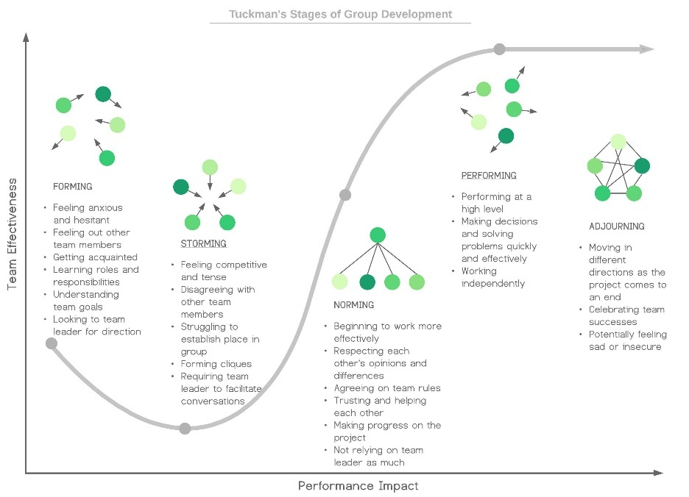
Figure 2 - Tuckman's Stages of Group Development
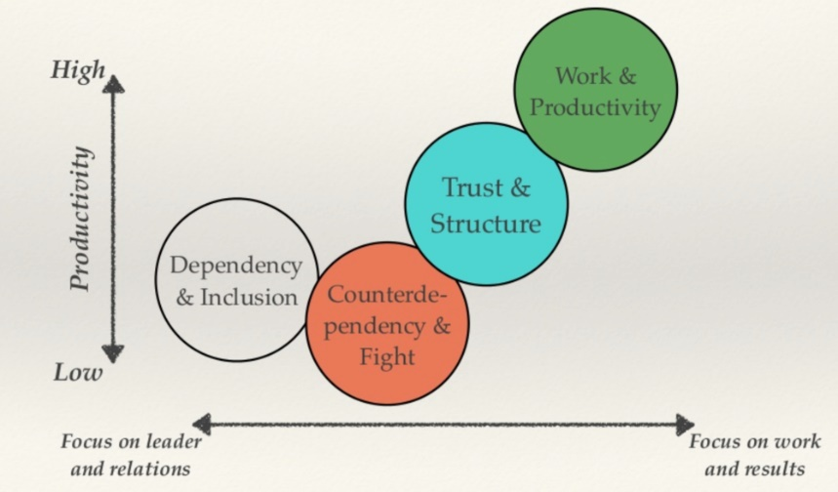
Figure 3- Wheeland's Stages of Group Development

Individuals at first think about fitting in. It is at this forming /dependency stage that self-assessing against others is conducted, being much more apprehensive. Individuals join to form an initial group, their role, and purpose within the group in most cases lack clarity. Managers can aid in establishing clear objectives, and accountability expectations, remove roadblocks and provide feedback. This stage brings stability, formation, and inclusion of each individual into a group.
During the storming / counter-dependency stage, members become irritated within the current group. Some will become unhappy with the direction or decisions, resulting in disagreements. As the initial inclusion of the group wears off, group members are more daring. This stage of instability is essential for the development of the group. “A small amount of interpersonal tension can be helpful, too much can engender negative emotional contagion that can sabotage trust.” Griffiths and Dunham, (2014), Working in Teams. Available: ProQuest eBook Central (1 July).
This is most likely the stage that Steve’s team at Pelsall Hall Care Home is going through, as some working well, whilst others are rebelling, misunderstanding the issues, and not getting the full picture.
The following stages are dedicated to further developing a more precise and effective team to achieve a common goal. Managers at this stage can support the team by allowing them to work more independently, delegating, allowing autonomy, providing support, and removing obstacles. Relationships develop and productivity increases – an effective team. “During this stage, effective groups spend 85% of their time on task completion”. Griffiths and Dunham, (2014), Working in Teams. Available: ProQuest eBook Central (1 July).

Team Roles

Griffiths and Dunham, (2014), Working in Teams: Moving from High Potential to High Performance. Available: ProQuest Central (1 July) highlighted the importance of team composition, the people who are in a team, and their roles. Depending on the goal of the team, ensuring the right balance of personality, competencies, skills, and experience will most likely result in a consistent high-quality care service.
It is important to think about the type of person placed within the team and their personalities, especially with new hires. “Belbin and others argued that the combination of personalities in a team or the combination of individual team member roles could significantly improve or diminish the ability of a team to complete a particular task” Morgan P (2017) Business student's guide to study and employability. Available: Campus Library (2 July). To further aid in ensuring the correct types of members are in a team, Meridith Belbin developed a model with 9 roles that are divided into 3 categories.
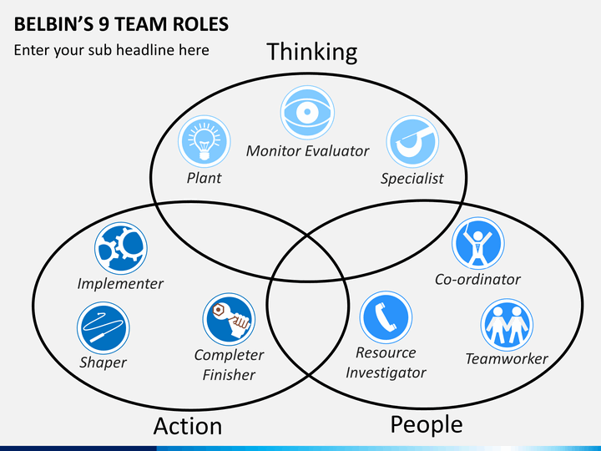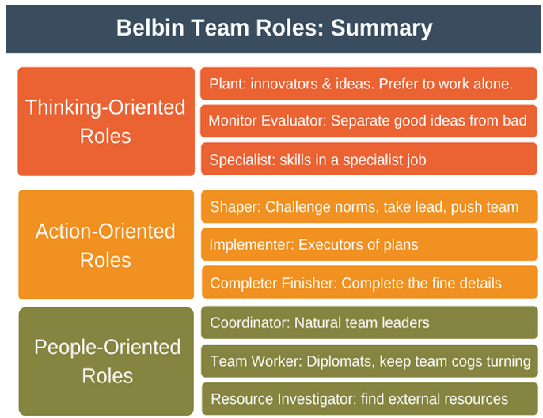
Knowing about Belbin's Team Roles model can further help to recognize potential strengths and weaknesses within the team, resolve the conflict between team members, and understand and appreciate everyone's contributions. Roles in a care home include Senior/care workers, managers, registered nurses, and activities coordinators. As an example, for the care home, a team would have:
- Thinking-Orientated Roles forms around team members who provide good ideas, suitable for a specific job.
  - Plant: Activity and Support Co-ordinator
  - Monitor Evaluation: Facilities Manager
  - Specialist: Therapist
- Action-Oriented Roles are members who do the do’s, ensuring that what needs to be done is completed in the best possible way.
  - Shaper: Nurse / Doctor
  - Implementer: Nurse/Care worker
  - Completer: Care / Support worker
- People-Oriented Roles mostly relate to management or collaboration activities, interacting with various internal and external teams. They tend to see the wider picture.
  - Co-ordinator: Care Manager / Lead
  - Team Worker: Lead / Administrator
  - Resource Investigator: Administrator
Based on Belbin Framework, a team may have a variety of different challenges in healthcare if the team is not composed adequately or if several members are completing the same actions. By not having a variety of strengths, collaboration, communication, and activities required to be completed will remain unfulfilled Armstrong Persily, (2013) Team leadership and partnering in nursing and health care. Available: GoogleEBook (30 June). The healthcare industry is very tough and demanding, individuals need to be flexible and should be capable of multitasking, and performing different roles when required.

Discussion

A successful team is a group of individuals with a set of different roles that have evolved together and work effectively to accomplish a common goal.
Firstly, the team composition is crucial, which is usually set by managers. Within a care home of 200 elderly residents who need help with activities such as washing, clothing, moving, and eating – having more doctors than nurses or care workers would be detrimental. The common goal to provide high-quality healthcare will be based on the role and its associated activities required by the residents.
There is currently no set ratio that must be achieved by care homes however if the number of staff in a care home is not able to provide the care and support residents require, then they have not achieved the required staff ratio. The Care Quality Commission (CQC), which is the regulator body for care homes in England, states in their regulation that:
“Providers must deploy sufficient numbers of suitably qualified, competent, skilled and experienced staff to make sure that they can meet people's care and treatment needs” (CQC (2021), Health and Social Care Act 2008 (Regulated Activities) Regulations 2014: Regulation 18, Available: https://www.cqc.org.uk/guidance-providers (3 July)
Furthermore, splitting bigger teams into smaller diverse teams has shown to contribute to a successful team, as an investigation found by Susan A. Wheelan (2009), Group Size, Group Development, and Group Productivity, Available: SAGE Publication (3 July)
Productivity. The research compared group productivity between small (3-8) and larger (9+) teams, which found that “Work-group size is a crucial factor in increasing or decreasing both group development and productivity”. Wheelan, S.A., (2016), Creating Effective Teams, Available: Campus Library, (: 28 June) also states, “In small groups, each member and the leader can discuss her or his ideas and participate in decision making” which can improve high-quality case as decisions need to be made much more quickly however a balance needs to be maintained so members within a team do not get burnt out or overworked.
Secondly, the principles and values of each member are equally crucial to ensure a successful team. The Culture Code by Coyle, D. (2018), The Culture Code, Available: London: Random House Business. (3 July) identifies the secrets to achieving success, discussing three primary skills; Build Safety, Share Vulnerability, and Establish Purpose.
- Build Safety - By using body language and eye contact to overcommunicate, they are showing attentiveness to what is being said. Demonstrate fallibility, they’re only human and can be wrong. React appropriately to any feedback or news, even if it’s negative. In a busy environment, team members can misunderstand each other, as experienced by Steve’s team, the above methods provide a sense of trust and safe surroundings, improving the relationship and limiting negative impact.
- Share Vulnerability – As a leader be vulnerable, step up and deliver any news, even negative in person and listen attentively. Connecting as a human with members of the team can bring personal barriers down and enable trust and understanding, improving team growth and strength.
- Establish Purpose – Name and rank priorities, being extra clear. A common cause of team tension is confusion and assumption, this aims to remove both enabling collaboration, direction, confidence, and effective teamwork.

Conclusion and recommendations

Overall, based on the research gathered, all members of a group will evolve by going through one of the developmental models mentioned above, it is inevitable. However, not all groups will successfully develop into an effective successful team. There are several complex factors as identified by Wheelan, Coyle, and Belbin that will impact a group’s development such as size, culture, skills, role, environment, management, and personality. It is important now within the healthcare sector, to ensure managers and leaders support, implement, communicate and identify the correct individuals to group and channel their development to ensure goals are met and importantly, consistently high-quality healthcare is delivered.
This report recommends the following actions, Pelsall Hall Care Home manager, Steve Brooks, should take to build a high-performance, communicative and collaborative team:
- Review current team skills and identify gaps.
- Restructure teams to create smaller and diverse teams (5-9), where possible.
- Facilitate frequent team communication sessions and building exercises
Leadership styles for supporting others are essential, it will optimize the team’s performance through concern for both each member as well as the whole team. “Performance in the areas of leadership and teamwork is complex and decisions require a fine balance to consistently maintain effective performance and a healthy working environment.” Geraghty, A.& Peterson, Brown, S., (2018) Leadership and working in teams, Available: https://doi.org/10.1016/j.mpsur.2018.07.013. (4 July)

Reference List

Griffith, B., and Dunham, E., (2015), ‘Working in Teams: moving from high potential to high performance’, SAGE Publications, pp10-15
Arrow, H. et al. (2004) ‘Time, Change, and Development: The Temporal Perspective on Groups’, Small Group Research, 35(1), pp. 73–105. Available DOI: 10.1177/1046496403259757.
Persily, C.A., (2013) ‘Team leadership and partnering in nursing and health care’, Springer Publishing Company, pp 6-7. Available Google eBook.
P. Morgan. (2017). ‘The business student’s guide to study and employability’ SAGE Publications, pp 204
CQC, (2021) ‘Regulation 18: Staffing’, Health and Social Care Act 2008 (Regulated Activities) Regulations 2014: Regulation 18. Quality Commission, Available: https://www.cqc.org.uk/guidance-providers/regulations-enforcement/regulation-18-staffing#guidance
Susan A. Wheelan (2009), ‘Group Size, Group Development, and Group Productivity’ Small Groups Research, SAGE Publication, 40(2), pp 248-249. Available: SAGE Publication

Wheelan, S.A., (2016), ‘Creating Effective Teams’, SAGE Publication 5th Edition, pp131
D. Coyle, (2018), ‘The Culture Code’, Random House, pp 20-60.
Geraghty, A.& Peterson, Brown, S., (2018), Leadership and working in teams, Surgery (Oxford), 36(9), pp.503-508, Available: https://doi.org/10.1016/j.mpsur.2018.07.013.
[Table 1] Griffith, BA, & Dunham, EB (2014) ‘Working in Teams: Moving From High Potential to High Performance’, SAGE Publications, pp11
[Table 2] Maund, A. et al. (2017) ‘Certificate in higher education : skills for the workplace student yearbook’. SAGE Publication, pp18
[Figure 1] West and Lyubovnikova (2013) ‘Illusions of the team working in health care.’, Journal of Health Organization and Management, 27(1), pp 4. Available: ProQuest Ebook Central. [30 June 2022]

