Dissertation

The impact of digital marketing on consumer behaviour, a case study of Samsung.

Student Name: Marin Casu
Student Number: 1922137
Supverisor Name: Tushara Balendran
Course: BA Business Management
Module Code: LCBB6000
Submission Date: 05/05/2023
Abstract
In Chapter 1, there is mention of the background information of the topic on which the research is made. In this part, the rationale and significance of the research have been presented by giving information about the overall research structure. A research gap is also present there with its aim objectives and research question.
In chapter 2 different scholarly information has been provided on the research topic. The first concept of digital marketing has been discussed. There is also mention of consumer behaviour related to decision-making. Honeycomb theory is given as digital marketing theory with its relation to Samsung digital marketing. The impact and challenges of digital marketing are also described with its overcoming strategy. The literature review gap is also discussed.
In chapter3, the process of conducting the research methodology on the impact of digital marketing on the consumer behaviour of Samsung is discussed. The researchers have picked a suitable framework for research methodology which is Saunders Research Onion. The researchers have gone through a series of steps - research design, approach, philosophy etc to explain their research methodology.
The fourth chapter of the research has shown the results of the survey that was conducted among 30 employees of Samsung. From the survey, it has been known that the company has been positively impacted by their approach to implementing digital marketing. Many individuals from many departments were selected for the survey who answered the questions about the impact of digital marketing on consumer behaviour in Samsung. It has been known from the results that consumers are been more attracted towards thor brand through this.
In Chapter 5, the research questions rightfully justify the objectives of the research. All the questions of the research are elaborated on the approaches of the research where all the basic creeds are gone through. The impacts of digital marketing in terms of focusing on the key potential of consumer behaviour are looked into properly with the help of several relevant questions. On the other hand, the challenges of the company in terms of managing digital marketing are also elaborated in the chapter with proper questions. It also deliberates the strategies of Samsung to mitigate the obstacles with the help of proper recommendations. The future scope of the research has also been fostered in the chapter where it delineates the fact that the qualitative approaches of an interview can be utterly useful for future research.

Table of Contents
Chapter 1: Introduction 6
1.1 Introduction 6
1.2 Background of the research 6
1.3 Rationale of the research 7
1.4 Significance of the research 7
1.5 Reserch gap 8
1.6 Aim and objectives of the research 8
1.6.1 Aim 8
1.6.2 Objectives 8
1.7 Research questions 8
1.8 Structure of the research 8
Chapter 2: Literature review 10
2.1 Introduction 10
2.1.1 Concept of digital marketing 10
2.1.2 Concept of consumer behavior and decision-making process 11
2.1.3 Theory Related to digital marketing 11
2.1.4 Comparison between honeycomb model and RACE model 13
2.1. 5 Advantages and Disadvantages of HoneyComb Model 13
2.1.6 Impact of digital marketing on consumer behavior 14
2.1. 7 Challenges related to digital marketing impacting consumer behaviour 15
2.1.8 Strategies to overcome the challenges 15
2.2 Gap in literature 15
2.3 Summary 16
Chapter 3: Research Methodology 17
3.1 Introduction 17
3.2 Research Onion 17
3.2.1 Research Design 18
3.2.2 Research Philosophy 18
3.2.3 Research Approach 18
3.2.4 Research Strategy 19
3.2.5 Types of Investigations 19
3.2.6 Research Choice 20
3.2.7 Time Horizon 20
3.2.7 Sampling 21
3.2.8 Data Collection and Analysis 21
3.3 Ethical Considerations 22
3.4 Summary 22
Chapter 4: Analysis and Discussion 23
4.1 Limitations of the survey 35
Chapter 5: Conclusion and Recommendations 37
5.1 Conclusion 37
5.3 Linking with Objectives 37
5.3 Recommendations 39
5.4 Future Scope 40
References 41
Appendix 1: Survey questions 45

List of figures

Figure 1: Saunders Research Onion 18
Figure 2: Survey result of Qestion 1 24
Figure 3: Survey result of Question 2 25
Figure 4: Survey result of Question 3 26
Figure 5: Survey result of Question 4 27
Figure 6: Survey result of Question 5 28
Figure 7: Survey result of Question 6 29
Figure 8: Survey result of Question 7 30
Figure 9: Survey result of Question 8 31
Figure 10: Survey result of Question 9 32
Figure 11: Survey result of Question 10 33
Figure 12: Survey result of Question 11 34
Figure 13: Survey result of Question 12 35
Figure 14: Survey result of Question 13 36

Chapter 1: Introduction

1.1 Introduction
Through this research paper, the discussion will be made on how digitalization in the marketing area has impacted consumer behaviour. With a special reference to Samsung, different types of digital marketing techniques will be discussed in the topic. Digital marketing means online marketing where any brand can connect with their potential customer using the huge advantage of the internet (Mailchimp, 2023). It can be done through email or social media in which web-based advertising will describe a brand's product or service to the customer. There are different categories of digital marketing in which search engine optimization, content marketing, pay-per-click and social media marketing are some common options (Gustavsen, 2022). Over the few decades, digital marketing has become a vital step for organisational marketing strategy. As a form of marketing, it allows brands to come in contact with a vast audience. For getting proper results from the research on how digital marketing creates an impact on consumer behavior in Samsung company brand research will be done. Through the setting of the research question with the research aim and objective the significance of doing this research also will be discussed with its doing method. By using proper methods the research will be able to identify how consumers are affecting the digital marketing policy of Samsung.
The research paper will focus on Samsung’s digital marketing impact on consumer behaviour. In the background of the research, different kinds of IoT solutions which Samsung has used for its business will be included. It will describe how digital marketing has contributed to Samsung's social status. By expanding its social media marketing the company has given the customer to tell about their product shipping experience to its customer. Through the rationale and significance of the research, the vast client base of the company will be covered. The research will provide the importance of digital marketing in affecting consumer behaviour. The research question will focus on its social media marketing challenge and its mitigation strategy.

1.2 Background of the research
As the research has focused on Samsung's digital marketing impact on consumer behaviour the focus will be set on Samsung's digital marketing. The 'YouMake' campaign has gained global recognition (Iide, 2023). It will empower its users across the world to reflect on their life through their devices. The smartphone and large screen devices of the company have got a bespoke vision which is more than home appliances through this camping. By enabling SmartThings loT solutions a custom control is offered to the company to make a better way of personalisation of their product and service (Samsungsds, 2023). Samsung's success in digital marketing has been attributed to its social status. Through the extension of social media marketing the company has provided its customers with a chance to share their experience in a family circle. As the brand has aimed to upgrade its social profile on all major social networks, it has well presented itself on major social media sites. The customer care team of the company is always ready to help their customer with any digital marketing-related problem. As the research background will be based on Samsung's digital marketing effect on customer behaviour, the company's SDS digital marketing service will facilitate its customer (Samsung, 2023).

1.3 Rationale of the research
The purpose of this research is to let students as well as other electronic companies understand how digital marketing can impact consumer behaviour. Samsung is an electronic company that has given the chance to digital marketing long decades ago. However, the fact has shown that in the technology playground of digital culture, the company has given its customer an offer to use their product without a sale in the first case. The company wanted to see whether their consumer can handle their digitally upgraded product or not. The vast client base of the company will be covered in the study as artists, videographers, and online celebrities talk about how they have used technology to create art and disprove the individuals who told them "you can't." Most customers are grateful to the company that their digital marketing experience has got a better start with Samsung. The research will analyse their view about Samsung's digital marketing (Wsj, 2023).

1.4 Significance of the research
The research has provided the importance of digital marketing in affecting consumer behavior. There is no doubt that digital marketing allows consumers to decorate a customised shopping experience. It is shown that consumers prefer instant feedback on researching a new product. A brand like Samsung has crafted as well as modified a tailored shopping experience to throw a significant impact on consumer purchases. The research paper will help other companies to know how Samsung has got competitive advantage through its social media marketing (Staffordglobal, 2023). Customers like to do research before buying a product. They will search for the product information on the internet and also will go through the reviews of other users who have already used the products. Samsung has changed its online business mode from time to time to make the technology adjust to the new digitalised world and customers have got the upgraded version of the technology from their trusted brand. From the research, it can be known how online advertising has helped the company to capture its audience with a broad geographic area to strengthen the brand's digital marketing (Webfx, 2023).

1.5 Reserch gap
The research can be done through primary data collecting methods. Then more authentic information can be taken from consumers about how digital marketing creates an effect in their behaviour. Primary information is not enough to find authentic information about any research topic. During the survey, the researcher asked the question to some employees who do not have any clear knowledge of Samsung digital marketing. So they are not able to give an accurate answer. There are many secondary published sources which have given clear demonstrations of Samsung's digital marketing. Researchers can use those sources to take the information. The combination of primary and secondary data can make the research more successful.

1.6 Aim and objectives of the research

1.6.1 Aim
To understand the impact of digital marketing on consumer behaviour through the study on digital marketing of Samsung.

1.6.2 Objectives
1. To determine the impact of Samsung’s digital marketing strategies on consumer behaviour.
2. To analyse the challenges faced by Samsung when implementing its digital marketing strategies.
3. To evaluate the overcoming strategies to eliminate the issues.

1.7 Research questions
1. What is the impact of Samsung’s digital marketing strategies on consumer behaviour?
2. What are the challenges faced by Samsung when implementing its digital marketing strategies?
3. What are the overcoming strategies to eliminate the issues?

1.8 Structure of the research
The research will provide a brief introduction to the topic in which the definition of digital marketing and its importance on consumer behaviour will be discussed. The background of the research will provide brief information about how Samsung's digital marketing is judged by its customers. The aim and objective of the research are based on the case study through which the questions are made. The research gap will be included in the introduction part which will focus on what could have been done better for presenting the research topic more effectively. In the literature review, part of the different theories and model definitions of digital marketing and consumer behavior will be discussed. In this part of the research structure, a scholar's information will be given. As a literature review part, a gap will be shown in not using more than one theory of digital marketing. The concept of digital marketing, consumer behaviour with the relation of decision making and the challenges of digital marketing will be focused on in the chapter. In the methodology part, the research process will be demonstrated by telling about its philosophy, approach and data collection process etc. The strategy of the researcher with a chosen method for data collection will also be included in the topic. A clear demonstration will be made about how the research will maintain its ethical status. Findings, analysis discussion and recommendations will be also included to give the research paper a complete look with informative data.

Chapter 2: Literature review

2.1 Introduction
The literature review will describe the concept of digital marketing while focusing also on the concept of consumer behaviour. Honeycomb digital marketing theory will be discussed which have a relation to digital marketing and consumer behaviour. The impact of digital marketing on consumer behaviour and different kinds of challenges which are faced by consumers to adopt digital marketing in Samsung get a discussion in this chapter. Different kinds of strategies are discussed to overcome this challenge by notifying the gap in the literature. Definition of consumer behaviour and their relation with decision making process will get special mention in the part.

2.1.1 Concept of digital marketing
According to Puthussery, (2020), Digital marketing is marketing which stresses business products and service promotion through the utilization of digital technology. A digital marketing platform is generally an online platform based on digital channel experiences to the end user. From the economical background digital marketing has developed by redirecting the traffic in the advertising industry. The usefulness of digital marketing in e-business includes all the activities which are designed and developed within a business via the internet. From an operational perspective, this type of marketing provides a unique platform for customer behavior by saving a lot of time through the use of technology (Chaffey and Ellis-Chadwick, 2019). Digital marketing is the act of promoting something through digital marketing channels. In a simple sentence, electronic devices are included in this digital marketing. Top Most company’s around the world do online marketing because it has helped them in gaining more revenue. Digital marketing is considered a general term through which a company connects with its customer through electronic technology. Positive circumstances are provided through online platforms which add a large level of customer base to a business. Digital marketing helps an organization to appeal to a much longer audience which cannot be achieved through traditional marketing. For example through digital marketing, a company can improve their holiday sales just by sharing their product launch news in social media. There are different types of digital marketing techniques available to the customer. The list includes search engine optimization, pay-per-click, social media marketing, mobile marketing etc (Gills and Horwitz, 2023).

2.1.2 Concept of consumer behavior and decision-making process
According to Qazzafi, (2019), Understanding the consumer behaviour process is the key success of any organization. Consumer behaviour means how consumers make their decision to buy, select and use any product or service. In simple words, consumer behaviour is the decision-making process and actions of the people who purchase a service or product for personal consumption. It also emphasizes the decision-making process which gives stress on consumers’ physical activity which makes consumers engage when evaluating goods and services. The decision-making process of the consumer gets shaped by the experience they make at the time of buying any goods or service. Different kinds of cultural, social, individual, as well as psychological processes, affect consumers’ decision-making. Post-purchase behavior goes through a lot of changes during the decision-making process.
Consumer decision-making is a process which follows five steps. Understanding the consumer decision-making process is important for marketers as it helps them to understand what conditions motivate customers to buy the product or service. When marketers develop a marketing strategy they set their target audience by judging their behaviour. So a more successful marketing strategy will come out if the marketer understands how customers shape their purchasing decisions. A buyer's decision-making process is based on five components. At first, they need to recognise their need to make any purchasing decision. After recognition of their need, they will do information searches regarding their products. In this case, nowa days digital media plays a huge role. In the evaluation and alternative stage, consumers will choose from alternative options according to their cost and benefit. For example, if a consumer found that a particular product is available at the cheapest price in another company they will go for it. Besides product’s reliability and warranty also matter at this stage. The fourth stage is related to consumer pricing decisions where they buy the product or service after making up their mind. Post-purchasing behaviour expresses their post-purchase evaluation after buying the product. In this stage, they get the actual benefit of the product after using it and tell others about the benefit and cons of the product (Lucidchart, 2023).

2.1.3 Theory Related to digital marketing
According to Slater (2021) There are seven categories of Honeycomb model which affect a company’s social media strategy
Identity
One of the important things in any organization's digital marketing policy is its identity. Consumers will believe in the company if they can provide their trust through their social media image.Social media marketing needs to be identified with its proper strategy. Samsung also does digital marketing to identify their customer behaviour.
Presence
To humanize digital business to the audience, presence in social media is vital. Userpresensence creates a significant awareness to the company to introduce their next strategic moves. Samsung makes the knowledge between their two users to get relevance about their knowledge. They also see their consumer status to make them feel their presence on social media.
Relationships
The relationship between two common users varies a lot in building a multilayered relationship in social media. Through their relationship, they indirectly improve brand image.
Depending on the relations of their customers, Samsung determines their social media strategy. They want to connect with their customers in a digital way which will encourage their association with digital marketing (Samsungsds, 2023).
Reputation
Reputation gives stress on the brand status and its user feedback for it. A brand's reputation can vary for its user's sentimental change. Reputation is impressive when a brand increase profit through its reputation. The reputation of Samsung has given the company an extra advantage in digital marketing by referring to rules and protocols through it. Consumers are attracted by a company's product quality which is interconnected with its reputation.
Groups
Rules and protocols are referred to through the group. In social media sites, some groups are explicit and some are implicit. However, these criteria can overlap also. When a group is formed in social media its member behavior is controlled by some regulations. Consumers formed a group in social media according to their choice which they share reciprocal from their social media connection. Samsung's consumers also make a group among themselves to share their product experience with the company. They use social media to create a one-on-one communication relationship which creates a positive effect on their customer. Their buying behavior has increased by getting attracted through Samsung’s brand-building campaign (Tringali, 2022).
Conversations
Conversations can boost the relationship as a reason for engagement. Conversations exchanged between brands establish their reputation in the market and increase their customer base when consumers communicate through social media.
Samsung establishes a nature of tone to their customer service which is provided by the business. The Customer's nature of conversation here will depend on samsung digital marketing speed , frequency and context. Contribution of Samsung to digital marketing increases its conversation with its customers. The key goal of Samsung's digital marketing is its adventurous branding which increases its reputation. It's an out-of-the-box marketing strategy in digital marketing giving establishment of its auxiliary activity on social media.
Sharing
Social media sites are prominent places for sharing content. So, content sharing is the common ground of brand user bonding building. Brands optimize their sharing content which they post on their social media.
According to Cardenal et al. (2019), cross-level interactions between the origins of news and political interest and ideology are hampering social media's reputation. So, a rather complex picture arise sometimes regarding selective exposure to online business which can bring harmful impact
Samsung shares their products' prominent features on social media which tell about their features in social media. They optimize the content based on their objects which share through their products feature algorithm . Through their social media presence they share their product content with their consumers.

2.1.4 Comparison between honeycomb model and RACE model
HoneyComb model framework is one of the worthwhile digital marketing models where each phase comes with benefits and helps the audience to identify their target market. Through this model, companies focus on the customer effort who is interested in a product or service. Through this model, Samsung can understand which digital channel will be best for its social media strategy. Through customer engagement, the company can build a relationship with its customer (Digitalstrategyone, 2023).
The RACE model allows a company’s digital marketing strategy to set an easy track for goals. Through a streamlined process, companies can identify the strengths and weaknesses of their strategy which enable them to make changes to improve their strategy quickly. The RACE framework is an effective method to improve a company’s ROI for digital marketing than the honeycomb model. AS a timeline is included in this model, companies can reach their goal sooner after applying this model in their digital marketing policy (Shout, 2023).

2.1. 5 Advantages and Disadvantages of HoneyComb Model

Advantages
I) honeycomb model enables a company to focus on how social media marketing works.
II) By making a structuring strategy it will help a company to ensure that no crucial area can be left out of their strategy (Targetinternet, 2023).
Disadvantages
I) Sometimes fake news spreads through social media about a company’s product which can damage honeycomb framework’s reputation.
II) Unequal distribution of the product’s related knowledge can cause relationship damage for a company with their customer. (Talwar et al. 2020).

2.1.6 Impact of digital marketing on consumer behavior
According to Alghizzawi, (2019) there is no doubt in the fact that the impact of digital marketing plays a vital role in consumer buying behavior. Nowadays an immense level of information is spreading through the internet. Technological advancement has made the world a global village. Consumers nowadays use digital communication to search for product information. Most people like to do online shopping because it seems to be more time-saving for them. Digital marketing in the future will be implemented to a large extent in the digital environment. Digital marketing through mobile technologies and social media platforms has become a part of consumers’ daily life. The revolution in digital technology has made the habit of new generations to communicate with different business organizations to let them know about their preferences. Feedback has become now more instant to keep the centre attention on customer behavior for business growth.
Digital marketing has now become the most common method which is employed by marketers of communicating with their customers through their products and service. S this is necessary to understand the impact of digital marketing on consumers to maximize its value creation. Businesses all over the world are adopting digital technology to maximize their customer networks. The pandemic period has brought the opportunity to show its importance to the millennial consumer as it allows marketers to connect with a broader customer base within a shorter period. In a highly competitive market technology advancement is used to impact consumer behavior. Grabbing wide-area digital marketing involves exploring business by reducing its cost and expanding its business globally. In recent times digital marketing has had more scope in shaping consumer behaviour as they are satisfied with online shopping. They find digital marketing much more satisfying than traditional marketing. The growing possibility of digital marketing is to provide marketing opportunities to its customers so that it can do more comparisons with other companies’ products according to their social media analysis. With updated technology and internet engagement in business consumer behaviour has seen a change in respect of product purchasing. So it can be said that digital marketing soon will grab the traditional marketing place by showing its tremendous impact on consumer behaviour (Schutte, and Chauke, 2022).

2.1. 7 Challenges related to digital marketing impacting consumer behaviour
As online marketing has brought different kinds of advantages, some challenges have also become associated with it. One of the major challenges that are impacting the consumer who does online marketing is its security related problem. Information privacy of consumers often becomes the victim of hacking even without their consent. It is now clear that different companies share their customers' information with third parties without asking their permission. Besides online marketing, there is no face-to-face contract with business authority which seems to negatively affect consumer buying behaviour. Products or services have to be ordered online which raises a doubtful attitude about online transactions. Consumers do a lot of market research before buying any expensive product (Iaetsdjaras, 2023).

2.1.8 Strategies to overcome the challenges
Generating online Traffic can be a fruitful strategy to overcome digital marketing challenges. The content of the website must be good so that customers can get enough information about the product. For this business owners can use different kinds of paid and non-paid advertising techniques. Business owners have to understand buyer personas as a part of their digital marketing strategy. Organizations. Will measure the content ROI accurately to avoid data security issues. Consumers tend to hold a doubtful mentality about expensive product buying. So, owners should produce different kinds of customer reviews on their websites from which the new customer feels interested to buy the company's product (Gregory, 2022).

2.2 Gap in literature
Samsung is a leading player in the global electronics market, offering a wide range of products that cater to various consumer needs. While there is some research available that examines Samsung's digital marketing strategies and their impact on consumer behaviour in developed markets, such as the United States and Europe, there is a gap in knowledge regarding how these strategies are adapted and implemented in emerging markets.
Emerging markets, such as Southeast Asia, India, and Africa, have different consumer behaviours and preferences compared to developed markets. These markets are characterized by lower incomes, limited access to credit, and a higher degree of price sensitivity (https://www.worldbank.org/en/region/sar/overview). In addition, consumers in these markets may have different cultural values and attitudes towards technology, which may impact their purchase decisions and loyalty towards brands.
Given these differences, it is crucial to understand how Samsung's digital marketing strategies are adapted and implemented in emerging markets. For example, Samsung may need to develop localized marketing campaigns that are tailored to the unique needs and preferences of consumers in these markets. They may also need to adopt different pricing strategies to remain competitive and appealing to these consumers.
Despite the growing importance of emerging markets for Samsung's global growth, there is currently a gap in knowledge regarding how Samsung's digital marketing strategies are adapted to these markets and their impact on consumer behaviour. Further research in this area is needed to better understand how Samsung can effectively engage with consumers in emerging markets and increase its market share in these regions.
2.3 Summary
The Literature review part has described the concept of digital marketing by giving the main focus on the concept of consumer behaviour. The concept of digital marketing has been described by giving examples of different kinds of digital marketing. Honeycomb has come in the section which has a relation to digital marketing and consumer behaviour of Samsung. The impact of digital marketing on consumer behaviour has also been discussed and different kinds of challenges which are faced by consumers to adopt digital marketing in Samsung get a discussion in this chapter. Different kinds of strategies are discussed to overcome this challenge by notifying the gap in the literature.

Chapter 3: Research Methodology

3.1 Introduction
Methodology is known as the process through which a researcher can carry out the entire research. The methodical and logical procedure which researchers use for planning, carrying out, and evaluating their research is stated as research methodology. It is a collection of theoretical and practical guiding principles that direct the scientific and impartial gathering and evaluation of data. In this research, many techniques have been chosen in order to construct the research properly. In order to have a proper outcome the right processes have been chosen for the research which will be discussed here. From the research methodology the validity and reliability of a research can be known.

3.2 Research Onion
The researcher has chosen a research model that consists of several methods to collect data about the research topic. Here, the researcher has chosen the Saunders Research Onion. The Saunders Research Onion offers a helpful framework for establishing the various phases of a research project and can assist researchers in organising and carrying out their research in a methodical and organised manner. This model was constructed by Saunders in the year 2007. There are different stages like research philosophy, research approach, research strategy, data collection process and more. For evaluating the model properly, the researcher has analysed the outer ones first and gradually moved towards the innermost one. Thus, research philosophy has been analysed firstly as it is the most philosophical one and the inner layers become more tactical which are analysed later on. By following this model properly, the researcher has been able to find out the impact of Samsung’s digital marketing on the consumer behaviour.
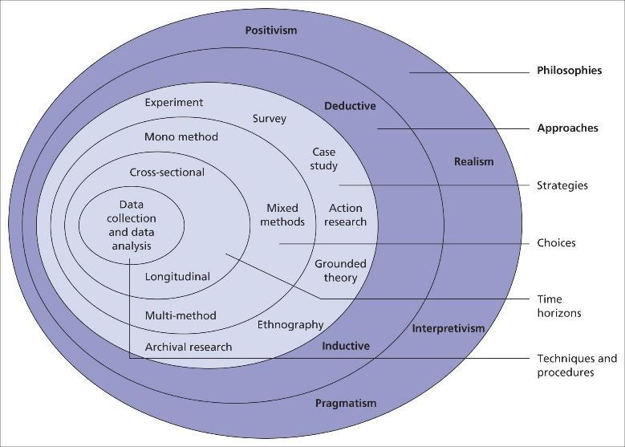
Figure 1: Saunders Research Onion
Source: (Melnikovas, 2018)

3.2.1 Research Design
The tactic or plan a researcher implements to create and carry out a research is referred to as research design. The right research methods, sample strategies, data gathering techniques, data analysis strategies, and other research process elements must be chosen. There are five kinds of research designs such as experimental, descriptive, explanatory, diagnostic and correlational. Among all the research designs, the researcher has chosen descriptive research design. This research design has been chosen by the researcher so that they can systematically accomplish the goal of understanding the impact of Samsung’s digital marketing on the consumer behaviour. Through using this the researcher has found the ‘what’, ‘where’ and ‘when’ questions about the research problems rather than why (Heath, 2023). The researcher has been helpful from this research design because from this the data on Samsung’s consumer behaviour can be gathered and analysed by focusing on the theoretical perspective. Thus, this has made the research more systematic which helped in getting a proper outcome.

3.2.2 Research Philosophy
Research philosophy is a bunch of beliefs with which the data about a certain phenomenon is gathered. Through following a proper research philosophy, a researcher can understand in which way they will gather the needed data, analyse it and ultimately use it. There are four kinds of research philosophies such as positivism, pragmatism, realism and interpretivism in which the researcher has chosen positivism philosophy to do the research. Using positivism philosophy, the researcher has been able to gather factual data about the impact of Samsung’s digital marketing on the consumer behaviour. The factual information has been obtained through observations which have been done in an objective manner. In this, the reality of the concept of the research problem is static which has helped the researcher to gather general information about the consumer behaviour. They have avoided any personal beliefs and views and only focused on the general concept. This study is quantifiable and also observable which made it easier for the researcher to understand the general views on the impact of digital marketing on the consumer behaviour (ResearchMethodolog, 2023).

3.2.3 Research Approach
Research approach is a process which shows based on which aspect the research data would be collected. This is the general plan and process in order to carry out the research. There are three types of research approaches such as abductive, inductive and deductive. Among these, the researcher has chosen the deductive approach in order to gather right information about the impact of Samsung’s digital marketing on their consumers’ behaviour. By following this approach,the researcher has firstly developed the objectives like whether the digital marketing in Samsung has been affecting positively or negatively, challenges faced by Smasung in implementing the digital marketing strategies and the strategies they are overcoming it with. These have been made with an existing concept about the digital marketing’s effect on Samsung’s consumers. Therefore, the whole strategy of the research has been made with the help of the objectives. This approach has been beneficial for the researcher to gather proper information as the objectives have been constructed based on an existing concept.Thus, it also helped in getting an appropriate outcome (ResearchMethodology, 2023a).

3.2.4 Research Strategy
Research strategy is referred to as the processes through which the required data or information about the research problem is obtained. This is a more practical stage in which the procedure of data collection is focused on. There are many strategies according to the onion model such as ethnography, survey, interview, case study research, experimental research etc. The researcher has used surveys as a research strategy in order to collect appropriate data. Survey is a data collection method through which the researcher has obtained real-time information about the impact of digital marketing on Samsung’s consumers and their buying behaviour. From the survey, the researcher has achieved raw data from the selected people for the survey through which the analysis of data regarding the research problem has been easier. Here, Google Forms have been used to do the survey. Likert scale, Yes-No quetsins and general questions related to the research topic have been included. Through this, a greater statistical depth has been added in the data and in a smaller amount of time which is maximum 5 minutes, large amounts of information has been obtained (Voxco, 2022).

3.2.5 Types of Investigations
The researchers prefer to use primary data collection to proceed in their experimental working process. There are two types of data collection methods which include the secondary and primary. The first one is dependent on the already available sources like - books, newspapers, journals etc and the latter one proposes to research the practical interaction of the sources (Simplilearn, 2023). Here the resercher has used primary data in order to get direct information about the digital marketing’s effect on Samsung’s consumers.

3.2.6 Research Choice
Research choice is known as the selection of types of data which are collected through a data collection process. There are three kinds of choices such as mono, multi and mixed. The researcher has chosen the mono method here to collect data. Quantitative data was obtained by the researcher about the impact of digital marketing on Samsung’s consumer behaviour. A survey has been conducted through which the researcher has obtained numerical data about the research problem. Quantitative data provides a range of benefits among which the researcher has mostly benefited by the fact that the data is easy to analyse. Thus, the numerical data about the impact of digital marketing on Samsung’s consumer behaviour has helped in finding the answers easily (Indeed, 2022).
Advantages and Disadvantages of Quantitative Method
Advantages:
1. The utilisation of quantitative data has helped the researcher to check and test the research outcome properly as it can be analysed easily.
2. Quantitative method does not need any direct observation of the participant that helped the researcher to get participants easily (DeVault, 2020).
Disadvantages:
1. Through quantitative methods, limited data or information is obtained.
2. These methods can be more expensive than others as it requires a large proportion of people, analysis of a huge amount of data (Radef, 2023).

3.2.7 Time Horizon
Activities | 1st Week | 2nd week | 3rd week | 4th week | 5th week | 6th week | 7th week | 8th week | 9th week | 10th week
Introduction
Literature review
Research methodology
Creating the questionnaire
Collection of data
Analysis of data
Discussion/Interpretation of data
Conclusion and recommendations

Table 1: Timetable
(Source: Created by the researcher)

3.2.7 Sampling
The sampling process is determined to collect data from various ranges of citizens who express their own opinions on the research topic. By following this process the researchers can get a scenario of the trends of the whole population.
Here, the researchers have conducted their research methodology by preferring simple random data collection from 30 employees of Samsung to recognise the impact of digital marketing on their customer behaviour. Out of the different types of sampling processes they have selected the simple random sampling process to gather different kinds of data from different points of view. Consequently, it becomes very much effective for them to understand the present situation of the effectiveness of digital marketing on customer behaviours (McCombes, 2019).
Advantages and Disadvantages of simple random sampling
Advantages
1. Biases decreased because the participants were chosen randomly.
2 This is one of the simplest methods of sampling where the researcher does not have to know the knowledge base of the participants (Gaille, 2019).
Disadvantages
1. The knowledge of the participants might not be similar or adequate which can impact on the research outcome
2.. There is an added expense of the cost to the overall research (Gaille, 2019).

3.2.8 Data Collection and Analysis
The process in which they have collected the primary data has helped them to derive real-time data on their projected research topic. The researchers have utilized their opportunities to make a direct connection with 30 employees of Samsung. They are earnestly welcome to give their open-minded opinion on the effectiveness of their digital marketing process on consumer behavior and how it has created a significant impact on their business (Simplilearn, 2023).

3.3 Ethical Considerations
The researchers have maintained the ethical consideration of their research methodology in the process of proceeding with their research centred around 30 employees of the leading electronics company Samsung. The researchers proceeded well with the prior consent and confirmation of the employees to participate in the process of research methodology spontaneously (Enago, 2022). They are assured to take part in the process of research by informing about their opinion openly as their names will not be disclosed and the confidentiality of their views will be strictly maintained by confirming their necessary measures of security. The research scholars are also well informed about the possible risks of their research process which they have considered to make the employees aware. It should also be mentioned that the research group has a direct inclination to pursue the Data Protection Act 2018 to conduct the whole research methodology in the correct order (Ico, 2018).

3.4 Summary
The research methodology chapter has summarized research to shape the research design. Through research design, the researcher has chosen descriptive design so that they can systematically accomplish the goal of understanding the impact of Samsung’s digital marketing on consumer behaviour. Positivism philosophy has been chosen as the research philosophy because the researcher can gather factual data about the impact of Samsung’s digital marketing on consumer behaviour. The deductive approach has been chosen as the research approach, survey strategy and mono method have been used as the research choice. Through simple random sampling and primary data collection methods, the researcher has completed the research. The researcher has also maintained an ethical approach to doing the research.

Chapter 4: Analysis and Discussion
A survey has been done to understand the impact of digital marketing on Samsung’s consumer behaviour. 30 employees have been selected for this to know how much it has affected the buying behaviour of consumers. Therefore the analysis of the survey results has been one below to come to a proper conclusion.
1. What age group do you fall in?
Aspects | Percentage
18 - 25 years | 26.7%
26 - 35 years | 46.7%
36 - 45 years | 16.7%
Over 46 years | 10%

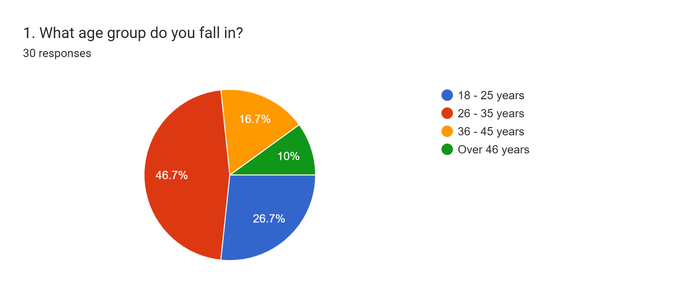
Figure 2: Survey result of Qestion 1

The survey was conducted among 30 employees of Samsung and when selecting the individuals it was necessary that they are of 18 or above. From the survey results it can be seen that 26.7% of the individuals are of 18 -25 years, 46.7% are between the ages of 26 to 35 years, 16.7% are between 36 to 45 years and 10% were of over 46 years. Thus, among the 30 respondents, 8 individuals are of 15 to 25 years, 14 were between 26 and 3 years, 5 were of 36 to 45 years of age and the rest of the 3 people were over 46 years.
2. How long have you been working at Samsung?
Aspects | Percentage
Less than a year | 26.7%
1 - 3 years | 40%
4 - 8 years | 30%
More than 9 years | 3.3%

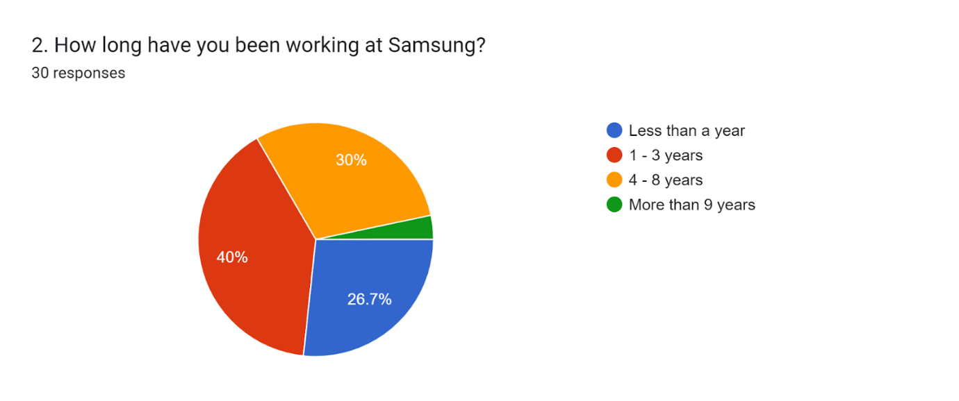
Figure 3: Survey result of Question 2

This is a demographic question and this one was introduced to find out for how long the respondents had been employed by the company. they were selected haphazardly by which people that were selected are with different levels of work experience within Samsung. This could include those who have been employed for a short period of time as well as those who have been employed for more than four or five years. Their experience also evolves with time, which may have an impact on their responses to further questions. This question was added in order to assess how appropriate their responses are in light of the above. It can be seen that 26.7% of the respondents were working for less than a year, 40% were working for 1 to 3 years, 30% were working for 4 to 8 years and 3.3% were working for more than 9 years. Therefore, it can be stated that 8 people who were selected were working for less than 1 year, 12 were working for 1 to 3 years, 9 were in the company for 4 to 8 years and 1 is for more than 9 years. As most of the people were working for over a year, it can be stated that the answers to the questions are appropriate.
3. In which department of Samsung you are working?
Aspects | Percentage
Marketing | 20%
Human Resources | 13.3%
Finance | 13.3%
Sales | 26.7%
General management | 13.3%
Operations | 13.3%

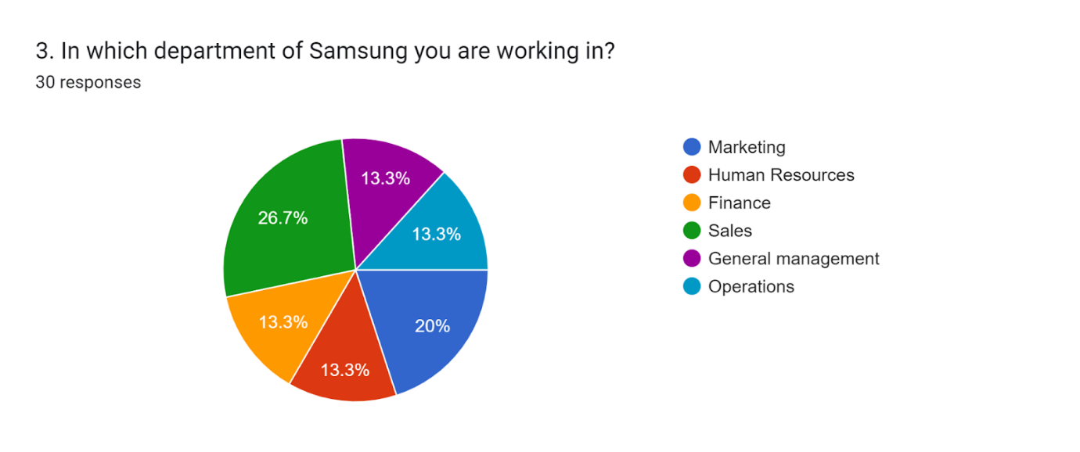
Figure 4: Survey result of Question 3

There were many people in the survey who are from different departments. From the survey, it is known that 20% were from marketing, human resources, finance, general management and operations departments there were 13.3% each and 26.7% were from the sales department. Thus, among the 30 people, 6 people were from marketing and 8 people were from sales. From the operations, human resources, general management and finance departments there were 4 people each.
4. What digital marketing strategies Samsung has been using? (Select all that apply)
Aspects | Percentage
Social media ads | 63.3%
Online marketing campaigns | 60%
SEO | 53.3%
Pay-Per-Click | 56.7%
Influencer marketing | 63.3%
Google ads | 43.3%

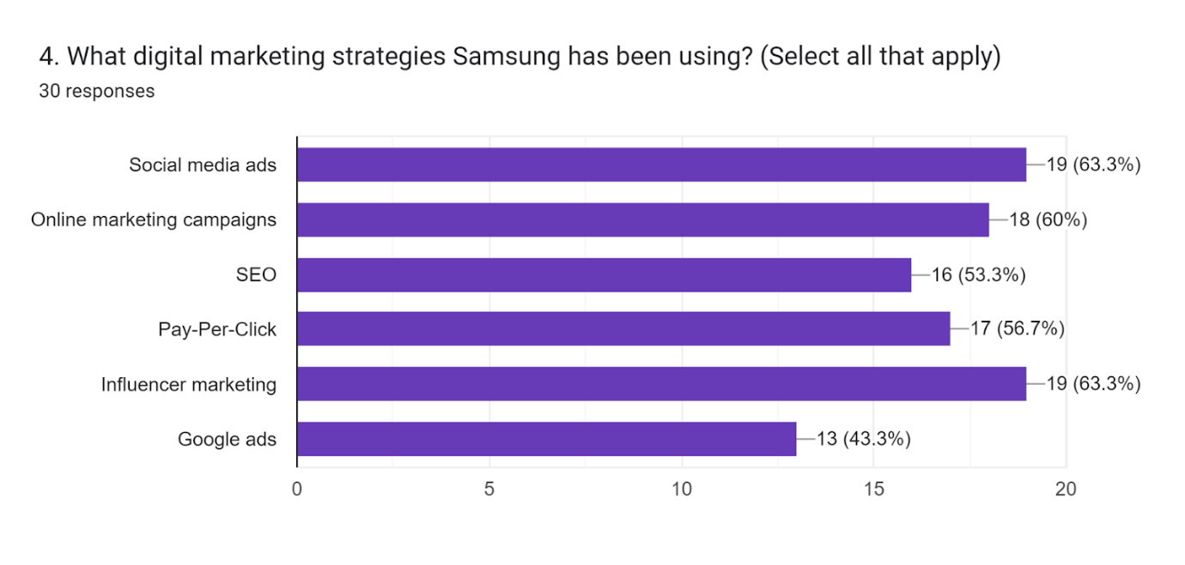
Figure 5: Survey result of Question 4

This question was added in order to understand the way Samsung has been using digital marketing. There was an option for the individuals to choose more than one option that they think is being used by the company. From the survey results it has been known that 63.3% have chosen Social media ads, 60% have chosen online marketing campaigns, 53.3% selected Search Engine Optimisation, 56.7% have chosen pay-Per-Click, another 63.3% have chosen influencer marketing and 43.3% chosen Google ads. Among the 30 respondents, Social media ads and influencer marketing were chosen by 19 people, 18 respondents chose online marketing campaigns, 16 have chosen SEO, 17 choose PPC and 13 individuals to choose Google ads. It can be seen that the distribution is quite equal. It has been known from the literature that Samsung has been focusing on its digital marketing strategies and also using social media the most for its benefit (Tringali, 2022).
5. Do you think the digital marketing strategies in Samsung are effective?
Aspects | Percentage
Yes | 90%
No | 6.7%
Do not know | 3.3%

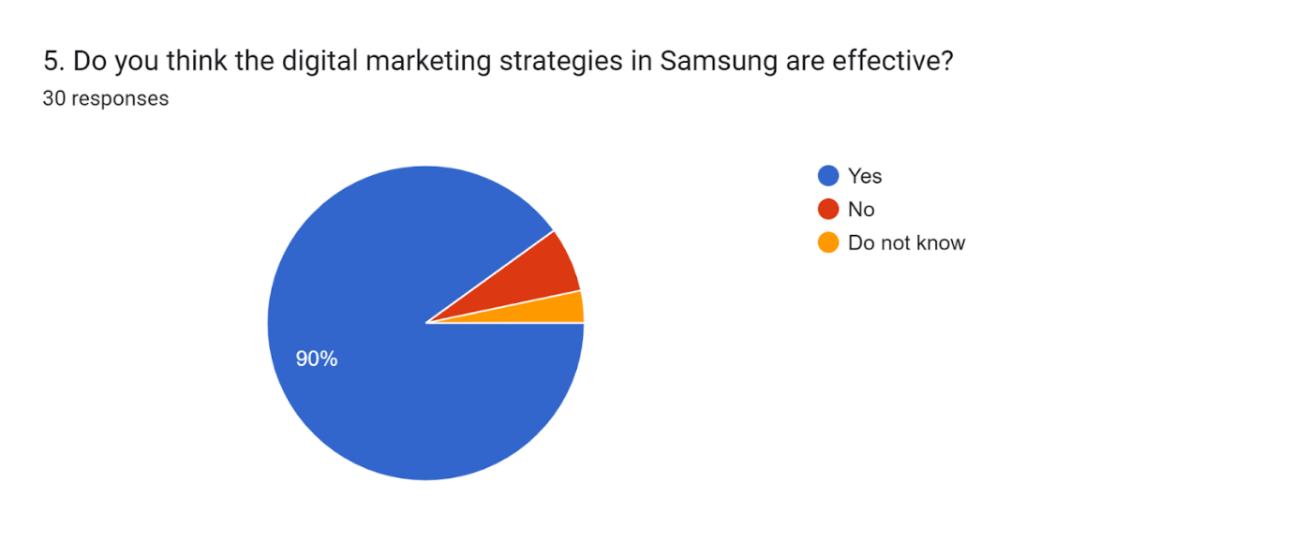
Figure 6: Survey result of Question 5
This question was added to know if digital marketing strategies have been useful for Samsung. By analysing these results, the researcher can understand whether the implementation of digital marketing has been helpful for the company or not. According to the survey results, it has been known that 90% of the employees provided a positive answer to the question, 6.7% provided a negative response and 3.3% selected do not know. Among the 30 individuals, 27 responded with a yes as they think that the digital marketing strategy of Samsung has been effective. On the other hand, only 2 people did not think it was effective and 1 person did not know about this. From the literature, it is known that digital marketing is a useful part of marketing processes in any company nowadays. It is known that there are different types of digital marketing strategies and these are providing benefits to Samsung to have the extra advantage of increasing acknowledgement in the market (Cardenal et al. 2019).
6. In what way has the enhancement of digital marketing affected Samsung’s customers?
Aspects | Percentage
Positively | 56.2
Negatively | 6.7%
Neutral | 6.7%

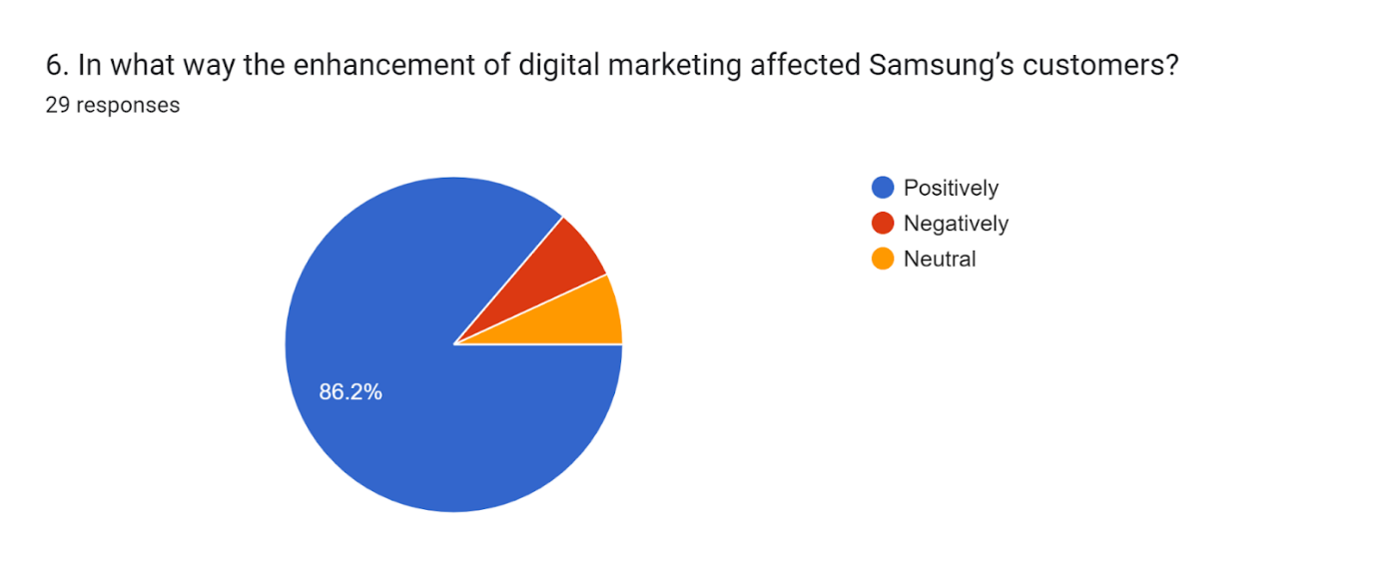
Figure 7: Survey result of Question 6

Digital marketing has been evolving the business processes in many companies. People have also been leaning towards online or digital platforms for which companies are being benefited from their promotions on digital platforms. This question was therefore added to know are the digital marketing strategies have been affecting Samsung positively. When analysing the question, it can be seen that 1 individual has not provided any answer to the question. Therefore, among the rest of the individuals, 56.2% provided a positive response. 6.7% of them provided a negative response and another 6.7% stated that they are neutral about this. Among the 29 responses, 25 were positive as they believe that the digital marketing strategies have affected their consumers positively. 2 people think it affected them negatively and the rest of the 2 people were neutral about this. It has been known from the literature that Samsung has been using a number of digital marketing strategies and these are helping them to enhance their sales. Therefore, it can be stated that the data collected for this question is appropriate.
7. What is the main reason for this change of marketing processes to digital ones?
Aspects | Percentage
It is more cost-effective than traditional marketing | 20%
Because of Covid-19 | 16.7%
To make the strategies more targeted | 40%
Having new platforms | 23.3%

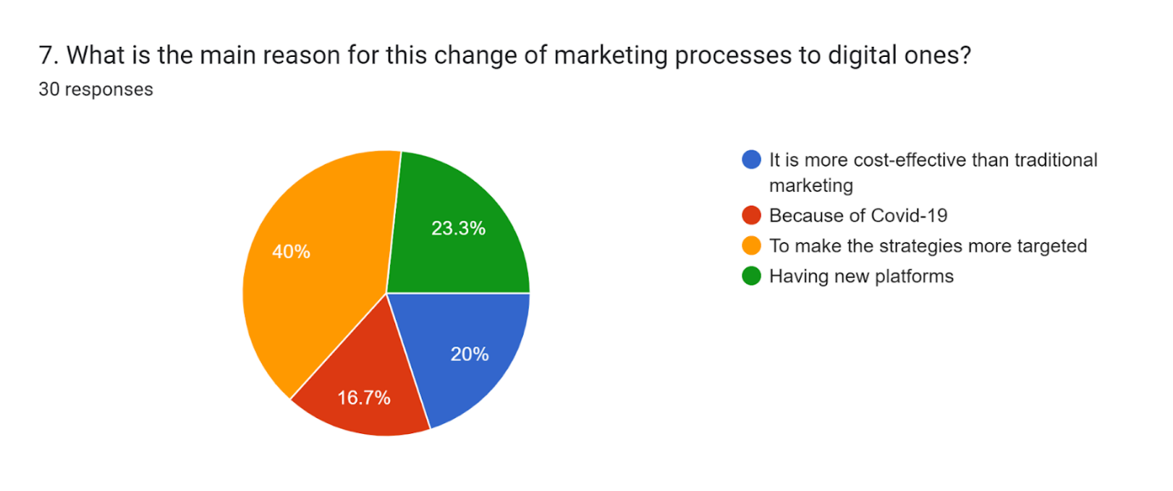
Figure 8: Survey result of Question 7

This question has therefore been added to analyse the reasons for which the company changed their marketing strategies to digital ones. It has been derived from the results that 20% of the employees stated digital marketing is more cost-effective, 16.7% stated Covid-19 was the reason, 40% selected having a more targeted strategy as the reason and 23.3% selected having new platforms as their reasons for Samsung's changes. Thus, among the 30 responses, 6 stated that digital marketing is more cost-effective which is the reason for changing from traditional to digital marketing. Among the rest, 5 stated the reason for the change was Covid-19, for 12 it was to make the strategies more targeted and for 7 individuals, it is having new platforms for marketing. Samsung has been offering various products and services to their customers over the years and these can evolve in recent years because of the enhancement of digitalisation. Therefore, when there have been any problems in the market in terms of marketing, Samsung has changed its strategies and looked for a better one to cater for its marketing needs.
8. Has people been more attracted towards the brand?
Aspects | Percentage
Yes | 80%
No | 10%
Do not know | 10%
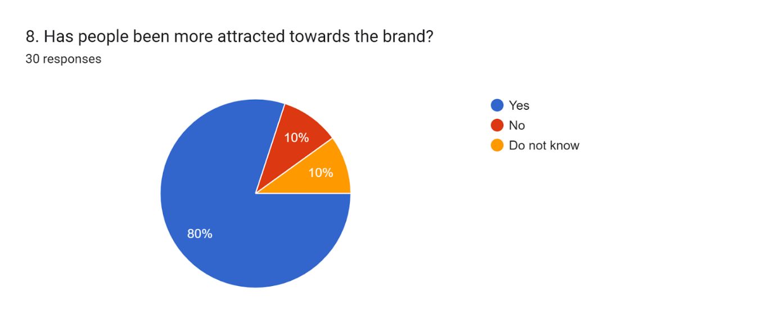
Figure 9: Survey result of Question 8

According to the survey results, it has been seen that 80% of the respondents have stated that people have been more attracted towards the brand. However, 10% have answered negatively and another 10% do not know about it. Among 30 employees, 24 individuals have stated that they have seen more people attracted towards Samsung, 3 people have denied the fact and another 3 people have said that they do not know. From the literature, it is known that, through digital marketing, a huge number of people can be attracted in less time. Therefore, Samsung has also been successful to do the same (Schutte and Chauke, 2022).
9. What changes have you noticed because of enhancing digital marketing in Samsung? (Select all that apply)
Aspects | Percentage
Faster decision-making | 26.7%
Becomes loyal customer | 36.7%
Increased impulse buying | 36.7%
More engaged towards website | 43.3%
Expectations are higher | 46.7%

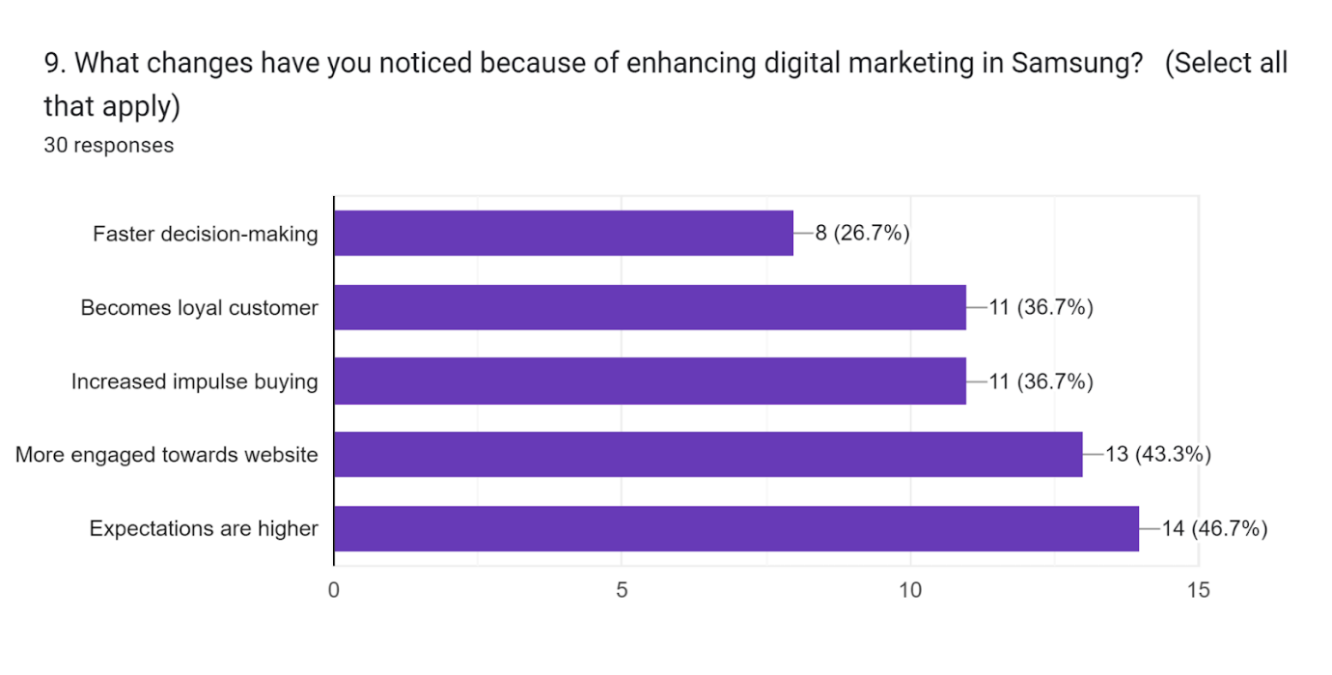
Figure 10: Survey result of Question 9

It is derived from the survey that there are many changes within Primark because of the changes to digital marketing. This question was added to know about the changes that happened because of digital marketing strategies. The employees could secret more than 1 option for this question. 26.7% have stated that faster decision-making is the change, 36.7% selected an increase in loyal customer base, another 36.7% stated increased impulse buying, 43.3% selected more engagement to Samsung's website and 46.7% selected consumer expectations became high. Thus, among the 30 responses, the options have been selected by 8, 11, 11, 13 and 14 individuals respectively. It is known from the literature that digital marketing strategies enhance the level of communication between the company and its consumers, therefore, Samsung has also seen some positive changes in its organisation (Alghizzawi, 2019).
10. What challenges have been faced by Samsung while implementing digital marketing strategies?
Aspects | Percentage
Security issues | 24.1%
Unpredictable buying behaviour | 13.8%
Creation of engaging content | 31%
Lack of knowledge | 27.6%
Others | 3.4%

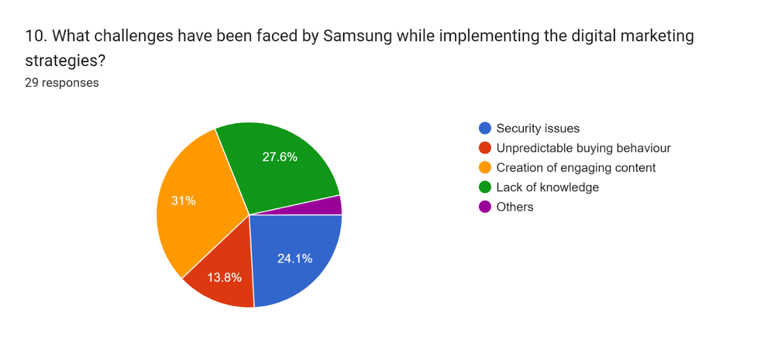
Figure 11: Survey result of Question 10

From the survey, it is derived that there are several challenges that Samsung faced while implementing its digital marketing strategies. 1 individual skipped this question. Thus among the rest, 24.1% of the employees stated security issues, 13.8% selected unpredictable buying behaviour, 31% selected problems in the creation of engaging content, 27.6% secreted lack of knowledge and 3.4% selected others. Therefore, among the 29 responses, security issues, unpredictable buying behaviour, creation of engaging content, lack of knowledge and other issues were selected by 7, 4, 9, 8 and 1 individuals respectively. From the literature, it has been known that there have been several challenges for Samsung like security issues, lack of technological knowledge etc (Iaetsdjaras, 2023).
11. What strategies have been adopted by Samsung to overcome the issues?
Aspects | Percentage
Market research to know consumers’ demands | 20%
Making external business communication better | 33.3%
The marketing networks should be monitored to avoid security problems | 20%
Employee training | 20%
Others | 6.7%

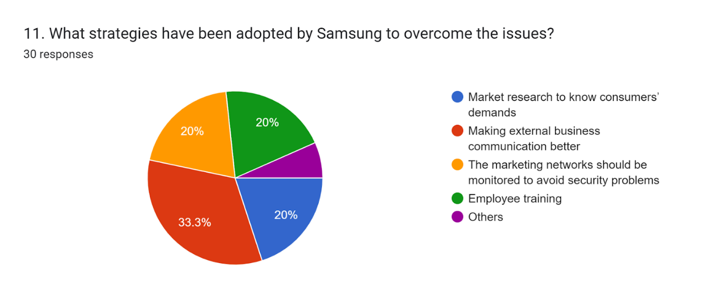
Figure 12: Survey result of Question 11

It can be retrieved from the survey that 20% of employees selected market research to know consumers’ demands, 33.3% selected making external business communication better, 20% sleeted the marketing networks should be monitored to avoid security problems, another 20% selected employee training and 6.7% selected others. Among 30 people, market research to know consumers' demands. making external business communication better, the marketing networks should be monitored to avoid security problems. employee training and others were selected by 6, 10 6, 6 and 2 employees respectively. From the literature, it has been known that the ROI of the company should be monitored, knowing buying personas through market research and making communication with consumers better have been found (Gregory, 2022).
12. How frequently consumers of Samsung are now buying their products over others?
Aspects | Percentage
Never | 0%
Rarely | 3.4%
Sometimes | 31%
Often | 31%
Always | 34.5%

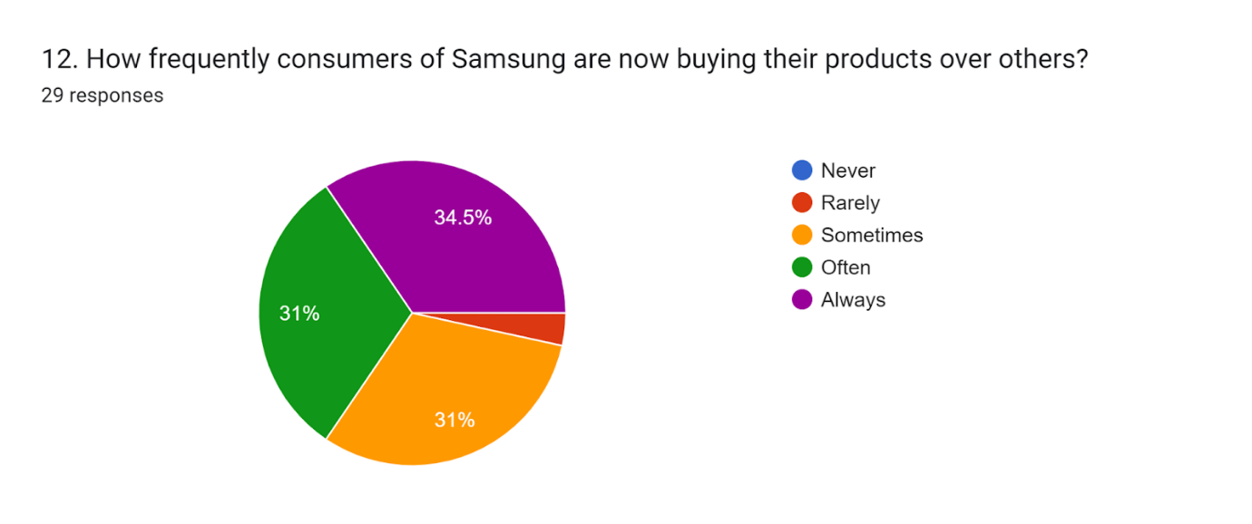
Figure 13: Survey result of Question 12

The question has not been answered by 1 individual. In accordance with the survey results it has been known that according to the employees, among the consumers of Samsung, 3.4% are rarely leaning towards their products over other companies, 31% selected sometimes, another 31% selected often and 34.5% selected always. Thus, of 29 employees, 1 selected rarely, 9 selected sometimes, another 9 individuals selected often and 10 selected consumers always buy their products. T has been known from the literature that people are grabbing opportunities by knowing about products and services from companies' digital promotions which also benefits Samsung to attract people (Schutte and Chauke, 2022).
13. Rate how the digital marketing strategies have affected the consumer behavior.
Aspects | Percentage
1 | 3.3%
2 | 0%
3 | 3.3%
4 | 3.3%
5 | 23.3%
6 | 13.3%
7 | 23.3%
8 | 16.7%
9 | 30%
10 | 3.3%

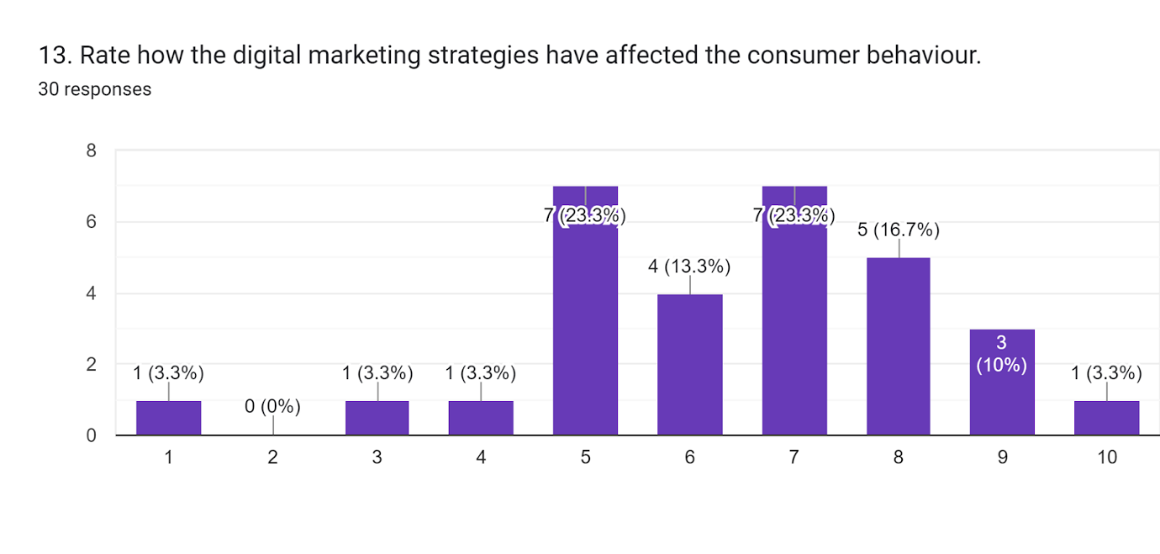
Figure 14: Survey result of Question 13

The survey has 30 responses within which 23.3% of employees have given 5 rates. Four responses have given 6 rates, and five responses have given 8 rates out of 10. Three responses which mean 10% have given a 9 rate. Seven responses have given 7 rates to digital marketing effect. There are four responses from whom the researcher has got 1, 3, 4, and 10 rates from each one respectively. No response has given 2 rates. Employees of Samsung have reported that digital marketing has affected their consumer behaviour. The majority of employees have detected that digital marketing has changed their consumer behaviour. According to Gregory (2022), Samsung has applied a new strategy to its social media marketing to control its online traffic. It is already a renowned electronic brand which does big data handling with a concentration to know about its customer demand. As it is responsible to understand a buyer persona to set any marketing strategy it is also true for digital business. They measure their ROI accuracy to avoid data security with data security issues.

4.1 Limitations of the survey
Through the process of accomplishing the research methodology, the researchers have understood that it was sometimes time-consuming to get trustworthy employees to understand the present situation related to the impact of digitized marketing on the behaviours of customers. The employees who can not provide real-time data have no understanding of the situation properly. It would make the research irrelevant and out of track. In this process, they would not be successful properly as there would be a deficit in collecting the real-time data for the successful progression of the research. This condition has led the researchers to spend more time collecting relevant data from authentic sources which will be fit for their sample questions. So, it is the limitation the researchers have during processing of the research (Abbadia, 2022).

Chapter 5: Conclusion and Recommendations

5.1 Conclusion
The research focuses on the impacts of digital marketing in terms of evaluating the behaviours of consumers. The 'YouMake' campaign for Samsung gets global recognition and helps to increase brand value. The primary method of data collecting has been used in this approach to gather relevant information. Honeycomb digital marketing theory has been used in this approach to get the proper values of technology in marketing. The research has gone through the realm of surveys and a deductive approach has been focused here. Though the research becomes time-consuming in terms of getting proper information about the digital aspects, with the help of the research questions it has been found that the impacts of digital marketing help Samsung to increase their business value in the competitive market. Therefore the research creates a positive overview for the readers to make out the facts of digital marketing of Samsung to go through consumer behaviour.
5.2 Limitations
In this research on the sources of primary data have been used. The secondary data sources can not be obtained in this research. For that reason, due to the lack of secondary information the credibility of the research gets mitigated. The limitation of the research can be put forward as the information of secondary sources is missing.

5.3 Linking with Objectives
Objective 1 To determine the impact of Samsung’s digital marketing strategies on consumer behaviour.
Question numbers 3, 4, 5, 6, 7, 8, 9, 12, and 13 are elaborately focused on the above objective. From question 3, it has been surveyed that the majority of the employees in Samsung are working in the sales department. Therefore the digital marketing strategy of Samsung helps all the employees to look into the basic changes in the market and buying behaviour of the customers and the digital marketing strategies are generalised properly. Thus the value of the objective has been met properly as digital marketing helps an organization to appeal to a much longer audience which cannot be achieved through the aspects of traditional marketing. From question 4, it has been observed that Samsung has been using social media ads and influencer marketing to strengthen the impacts of digital marketing on consumer behaviour. Social media ads help consumers to observe the products and services of the company more profoundly. Influencer marketing assists the company to attract a wide range of consumers to its brand. Therefore the behaviour of consumers is gone through properly with the help of digital marketing and the objective is fulfilled. From question 5, it has been seen that a wide range of people think that the strategies of Samsung’s digital marketing are effective. It can be said that consumer demand is elaborately done by fostering their behavioural aspects by the company with the help of digital marketing. For that reason, the real meaning of the objective is met. From question 6, the fact has been observed that digital marketing positively affects customers of Samsung. The customers can be satisfied effectively with the help of the digital mode of the company. Therefore the business value of the company enhances well and the objective is fulfilled. From question 7, the fact has been rendered that strategies of Samsung become more targeted with the help of digital mode. The customers are targeted well with the help of digital marketing. Therefore it focuses on the objective i.e. determining the impacts of digital marketing to focus on consumer behaviour. Question 8 focuses on the fact that a wide range of people is attracted to the brand as their demands and behaviours are generalised properly with the help of digital marketing. Therefore it also fulfills the view of the objective. Question 9 elaborates on the fact that digital marketing helps the company to be more engaged toward the website and the expectations of the consumers become higher. Therefore it rightfully fulfills the objective and the impacts of digital marketing are gone through properly. Search engine optimization, social media marketing, pay-per-click, mobile marketing etc are used by the company to enhance the digital marketing. In question 12, it has been found that due to the enhancement of digital marketing, the consumers become more satisfied and they often choose the brands to buy the products as their demands are fostered properly. For that reason, the objective is met properly. Question 13 provides the view that the consumers rate the digital marketing strategies of Samsung with quite a satisfaction. The impacts, therefore, become prevalent while getting positive feedback from the consumers as well. For that reason, the objective is generalised properly.
Objective 2 To analyse the challenges faced by Samsung when implementing its digital marketing strategies.
Question number 1, 2, and 10 are focused on the aspects of the objective properly. From question 1 it has been found that most of the employees at Samsung are from 18-25 years of age. For that reason, they are efficient enough to make out the facts of digitalisation in the business process as they are highly tech-savvy. Due to the efficiency in technology and coming from the younger generation, the digital marketing strategies of Samsung are fostered well by all the employees. But it becomes for such employees who are not from that age gap and can not see the technological development in the workplace. Therefore it fulfils the real value of the objective. In question 2, it has been said that most of the employees at Samsung are working for 1-3 years. Due to the lack of experience, it becomes an obstacle for the company to manage the workforce. Thus it creates a negative impact and fulfils the basic realm of the objective. Question 10 focuses on the challenges of the creation of engaging content and the lack of knowledge of the employees. Consumer behaviour focuses on five steps but due to the lack of ability, the employees are not able to manage it properly. Thus it creates a massive challenge and fulfils the objective.
Objective 3 To evaluate the overcoming strategies to eliminate the issues.
Question 1 focuses on the strategic development where it is found that it becomes very difficult for such employees who are not from the age gap of 18-25 and can not see the technological development in the workplace. Therefore Samsung focuses on teaching the employees who are not so efficient in the technological aspects. Question 11 focuses on this aspect where it has been found that Samsung is trying to make external business communication better to overcome the problem. Samsung uses digital marketing to improve its holiday sales by sharing the launch of the product news on social media to overcome the obstacle.

5.3 Recommendations
- Samsung needs to focus on the changing scenario of the market as well as the buying behaviours of the consumers according to their styles and choices.
- The company also needs to focus on creating the external values of business communication perfectly. When the external factors are accessed well, it can help the company to focus more on the market trends.
- It should also train the employees properly to get the real values of technological aspects in the business scenario (Forbes, 2022).
- The Human Resources department of the company also needs to be very uplifted in terms of recruiting proper employees who are efficient enough in technology and can be termed tech-savvy.
- A proper analysis of the behaviours in the workplace also needs to be done by the company. A proper approach of user-centric analysis of marketing perspective needs to be gone through by the managers and the leaders of the company to get a competitive advantage in the marketing scenario (Forbes, 2022).
- The company also needs to go through proper cross-channel marketing to enhance the business values in the market and enhance the digital channels properly (Forbes, 2022).

5.4 Future Scope
The research will become very fruitful for companies which want to increase their share by using digital marketing strategies. The research has been conducted through surveys. But in future, the research can also be conducted through interviews which is qualitative research. For that reason, the chances of getting more credible and relevant information become more prevalent in future.

References
Abbadia, J. (2022) What are the limitations in research and how to write them?, Mind The Graph. Available at: https://mindthegraph.com/blog/limitations-in-research/#:~:text=The%20limitations%20in%20research%20are,of%20your%20research's%20ultimate%20findings (Accessed: April 28, 2023).
Alghizzawi, M., (2019). The role of digital marketing in consumer behavior: A survey. Int. J. Inf. Technol. Lang. Stud, 3(1), pp.24-31.
Cardenal, A.S., Aguilar-Paredes, C., Galais, C. and Pérez-Montoro, M., (2019). Digital technologies and selective exposure: How choice and filter bubbles shape news media exposure. The international journal of press/politics, 24(4), pp.465-486.
Chaffey, D. and Ellis-Chadwick, F., (2019). Digital marketing. Pearson uk.
Enago (2022) What are the ethical considerations in research design?, Enago Academy. Available at: https://www.enago.com/academy/what-are-the-ethical-considerations-in-research-design/ (Accessed: April 28, 2023).
Forbes, (2022) Council post: 16 effective techniques to improve a company's digital marketing, Forbes. Forbes Magazine. Available at: https://www.forbes.com/sites/forbesagencycouncil/2020/06/22/16-effective-techniques-to-improve-a-companys-digital-marketing/?sh=78460aff3429 (Accessed: April 28, 2023).
Gillis, A.S. and Horwitz, L. (2023) What is Digital Marketing? everything you need to know: Definition from TechTarget, Customer Experience. TechTarget. Available at: https://www.techtarget.com/searchcustomerexperience/definition/digital-marketing (Accessed: April 28, 2023).
Gregory, E.T. (2022) Content marketing challenges and how to overcome them, FT Longitude. Available at: https://longitude.ft.com/10-content-marketing-challenges-and-how-to-overcome-them/ (Accessed: March 24, 2023).
Gustavsen, A. (2022) What are the 8 types of digital marketing? Southern New Hampshire University. Available at: https://www.snhu.edu/about-us/newsroom/business/types-of-digital-marketing#:~:text=Digital%20marketing%20can%20be%20broadly,Marketing%20Analytics%20and%20Affiliate%20Marketing%20. (Accessed: March 17, 2023).
Heath, C. (2023) Descriptive research: Design, methods, examples, and faqs, Descriptive Research: Design, Methods, Examples, and FAQs. Dovetail. Available at: https://dovetail.com/research/descriptive-research/ (Accessed: April 28, 2023).
Iaetsdjaras (2023) “challenges and opportunities in digital marketing” - iaetsdjaras.org. Available at: https://iaetsdjaras.org/gallery/23-january-402.pdf (Accessed: March 24, 2023).
Ico (2018) About the DPA 2018, ICO. Available at: https://ico.org.uk/for-organisations/guide-to-data-protection/introduction-to-dpa-2018/about-the-dpa-2018/ (Accessed: April 28, 2023).
Iide (2023) Detailed marketing strategy of TSMC - 2023 | IIDE. Available at: https://iide.co/case-studies/marketing-strategy-of-tsmc/ (Accessed: March 12, 2023).
Indeed (2022) What is quantitative data? (with methods, benefits and examples) - indeed, Indeed. Available at: https://www.indeed.com/career-advice/career-development/quantitative-data-definition (Accessed: April 28, 2023).
Lucidchart (2023) Definition and examples of the consumer decision-making process, Definition and Examples of the Consumer Decision-Making Process | Lucidchart Blog. Available at: https://www.lucidchart.com/blog/consumer-decision-making-process#:~:text=What%20is%20the%20consumer%20decision,decision%20and%20post%2Dpurchase%20evaluation. (Accessed: April 28, 2023).
Mailchimp (2023) What is Digital Marketing? A beginner's guide, Mailchimp. Available at: https://mailchimp.com/marketing-glossary/digital-marketing/#:~:text=Digital%20marketing%2C%20also%20called%20online,messages%20as%20a%20marketing%20channel. (Accessed: March 12, 2023).
McCombes, S. (2019) Sampling methods: Types, techniques & examples, Scribbr. Available at: https://www.scribbr.com/methodology/sampling-methods/ (Accessed: April 28, 2023).
Melnikovas, A., (2018). Towards an explicit research methodology: Adapting research onion model for futures studies. Journal of futures Studies, 23(2), pp.29-44.
Puthussery, A., (2020). Digital marketing: an overview.
Qazzafi, S.H.E.I.K.H., (2019). Consumer buying decision process toward products. International Journal of Scientific Research and Engineering Development, 2(5), pp.130-134.
ResearchMethodology (2023) Positivism - research methodology, Research-Methodology. Available at: https://research-methodology.net/research-philosophy/positivism/ (Accessed: April 28, 2023).
South Asia’s growth prospects have weakened due to tightening financial conditions available at : https://www.worldbank.org/en/region/sar/overview/

ResearchMethodology (2023a) Deductive approach (deductive reasoning) - research-methodology, Research. Available at: https://research-methodology.net/research-methodology/research-approach/deductive-approach-2/ (Accessed: April 28, 2023).
Saffordglobal (2023) The influence of digital marketing on Consumer Behavior, Stafford Global. Available at: https://www.staffordglobal.org/articles-and-blogs/marketing-articles-blogs/digital-marketing-behavior/ (Accessed: March 14, 2023).
Samsung (2023) Samsung Electronics launches #YouMake campaign, putting customization and connectivity in every day lives, – Samsung Global Newsroom. Available at: https://news.samsung.com/global/samsung-electronics-launches-youmake-campaign-putting-customization-and-connectivity-in-everyday-lives (Accessed: March 15, 2023).
Samsungsds (2023) Digital Marketing: DT service: Samsung SDS, DT Service | Samsung SDS. Available at: https://www.samsungsds.com/en/digital-marketing/digital-marketing.html (Accessed: March 15, 2023).
Samsungsds (2023) Digital Marketing: DT service: Samsung SDS, DT Service | Samsung SDS. Available at: https://www.samsungsds.com/en/digital-marketing/digital-marketing.html (Accessed: April 28, 2023).
Schutte, F. and Chauke, T., (2022). The impact of digital marketing on consumer behaviour: a case study of Millennials in South Africa.
Simplilearn (2023) What is collection of data? methods, types & everything you should know, Simplilearn.com. Simplilearn. Available at: https://www.simplilearn.com/what-is-data-collection-article (Accessed: April 28, 2023).
Slater, J. (2021) The honeycomb model of Social Media, The Marketing Sage. Available at: http://www.themarketingsage.com/the-honeycomb-model-of-social-media/ (Accessed: April 6, 2023).
Tringali, S. (2022) How Samsung's marketing strategy transformed them into a global brand, Proecho Solutions. Available at: https://proechosolutions.com/how-samsungs-marketing-strategy-turned-them-into-a-technological-powerhouse/ (Accessed: April 6, 2023).
Voxco (2022) Why are surveys important?, Voxco. Available at: https://www.voxco.com/blog/why-are-surveys-important/ (Accessed: April 28, 2023).
Webfx (2023) How does internet marketing benefit consumers?, WebFX. Available at: https://www.webfx.com/digital-marketing/learn/how-does-digital-marketing-benefit-consumers/ (Accessed: March 16, 2023).
Wsj (2023) Samsung's Big Marketing Challenge, The Wall Street Journal. Dow Jones & Company. Available at: https://www.wsj.com/articles/samsungs-big-marketing-challenge-1492807963 (Accessed: March 17, 2023).
Radef, A. (2023) 10 Quantitative Research Advantages & Disadvantages, Helpfull. Helpfull. Available at: https://helpfull.com/blog/10-advantages-disadvantages-of-quantitative-research (Accessed: May 4, 2023).
DeVault, G. (2020) Here are the advantages and disadvantages of Quantitative Research, LiveAbout. LiveAbout. Available at: https://www.liveabout.com/quantitative-research-advantages-and-disadvantages-2296728 (Accessed: May 4, 2023).
Digitalstrategyone (2023) Digital marketing models: The honeycomb model, Digital Strategy One. Available at: https://www.digitalstrategyone.com/digital-marketing-models-the-honeycomb-model/ (Accessed: May 4, 2023).
Shout (2023) Race model: Improve your digital marketing strategy, Shout.com. Available at: https://shout.com/digital-marketing/race-model-for-digital-marketing/ (Accessed: May 4, 2023).
Targetinternet (2023) The honeycomb model for Social Media Strategy, Target Internet. Available at: https://targetinternet.com/resources/the-honeycomb-model-for-social-media-strategy#:~:text=The%20key%20way%20the%20honeycomb,methodically%20during%20planning%20or%20evaluation. (Accessed: May 4, 2023).
Talwar, S., Dhir, A., Singh, D., Virk, G.S. and Salo, J., (2020). Sharing of fake news on social media: Application of the honeycomb framework and the third-person effect hypothesis. Journal of Retailing and Consumer Services, 57, p.102197.
Cherry, K. (2022) What is a cross-sectional study?, Verywell Mind. Verywell Mind. Available at: https://www.verywellmind.com/what-is-a-cross-sectional-study-2794978 (Accessed: May 4, 2023).
Gaille, L. (2019) 17 advantages and disadvantages of random sampling, Vittana.org. Available at: https://vittana.org/17-advantages-and-disadvantages-of-random-sampling (Accessed: May 4, 2023).

Appendix 1: Survey questions
1. What age group do you fall in?
18 - 25 years
26 - 35 years
36 - 45 years
Over 46 years
2. How long have you been working at Samsung?
Less than a year
1 - 3 years
4 - 8 years
More than 9 years
3. In which department of Samsung you are working in?
Marketing
Human Resources
Finance
Sales
General management
Operations
4. What digital marketing strategies Samsung has been using? (Select all that apply)
Social media ads
Online marketing campaigns
SEO
Pay-Per-Click
Influencer marketing
Google ads
5. Do you think the digital marketing strategies in Samsung are effective?
Yes
No
Do not know
6. In what way the enhancement of digital marketing affected Samsung’s customers?
Positively
Negatively
Neutral
7. What is the main reason for this change of marketing processes to digital ones?
It is more cost-effective than traditional marketing
Because of Covid-19
To make the strategies more targeted
Having new platforms
8. Has people been more attracted towards the brand?
Yes
No
Do not know
9. What changes have you noticed because of enhancing digital marketing in Samsung?
Faster decision-making
Becomes loyal customer
Increased impulse buying
More engaged towards website
Expectations are higher
10. What challenges have been faced by Samsung while implementing the digital marketing strategies?
Security issues
Unpredictable buying behaviour
Creation of engaging content
Lack of knowledge
Others
11. What strategies have been adopted by Samsung to overcome the issues?
Market research to know consumers’ demands
Making external business communication better
The marketing networks should be monitored to avoid security problems
Employee training
Others
12. How frequently consumers of Samsung are now buying their products over others?
Never
Rarely
Sometimes
Often
Always
13. Rate how the digital marketing strategies have affected the consumer behaviour.

