Timothy Lee
1901664
Engineering science 1

Energy in a Flywheel

When energy is stored it is often referred to as potential energy. Gravitational, electrical, chemical potential are all examples of this. The use of flywheels as a stored energy source has been used in some form for centuries. Commonly used in engines to smooth the stop start nature of pistons by storing and releasing rotational energy. Woodford, Chris. (2012/2020)

In this experiment, gravitational potential energy from a falling weight is used to power a flywheel. This flywheel the consequently is then used to lift the weight again. The inefficiency's in this conversion lead to a reduction of original height to the rerecorded height (after bounce).

The experiment is used for research the stored energy in a flywheel given an initial potential energy in a given weight. As a weight is lifted it stores potential energy which can be expressed as weight (kg)* height (m)* gravitational constant (9.81N/kg). This stored energy is then converted to rotational energy of the flywheel and then converted back to complete a cycle.

The experiment consisted of a weight attached to a string which was wound around a flywheel. The weight is lifted to constant 0.280m for every test. The string attached to the drive shaft id wrapped around it as the weight is lifted. Therefore, the weight is held by the string. One person then can hold the weight with on finger on the flywheel. The reduces the transference of energy when realised. The time taken for a full cycle top-bottom-top again and the height it reacts are recorded. In our experiment, a countdown for the release allowed each member to sync up. In addition, two people timed each run because when the weight reached peak height could be easily miss judged.
Using apparatus show bellow:

Working in a group each person had job. Releasing the weight, timing, measuring the return height and putting new weights on the holder. We used two timers because it was hard to see when the movement stopped . this is in an aim to reduce error by giving us an average. Furthermore, we repeated each test 5 times, taking an average from each. This reduces the impact animalise and outliers would have on our results as given other data they can be omitted.
In a perfect flywheel system, any potential energy is released and converted and then stored again. In our experiment this would mean that the weight would return to the same height when released. However, this is not the case due to energy losses. These include but not limited to friction on bearing, string flexing and unwanted weight movement. My results show a significate height loss of around 0.03m in every experiment. Using Potential energy loss, we can see that the PE loss in 0.1kg is 0.04j but at 0.5kg the PE loss is four times this at 0.16j. This difference is mainly due though the increased friction in bearing and the increased loss of energy when the holder moves violently when it hit the end of the strings. This movement is contrary to the vertical movement required and is a large ,loss of energy.
Using our results, we calculated PE loss, acceleration, downward time, etc.





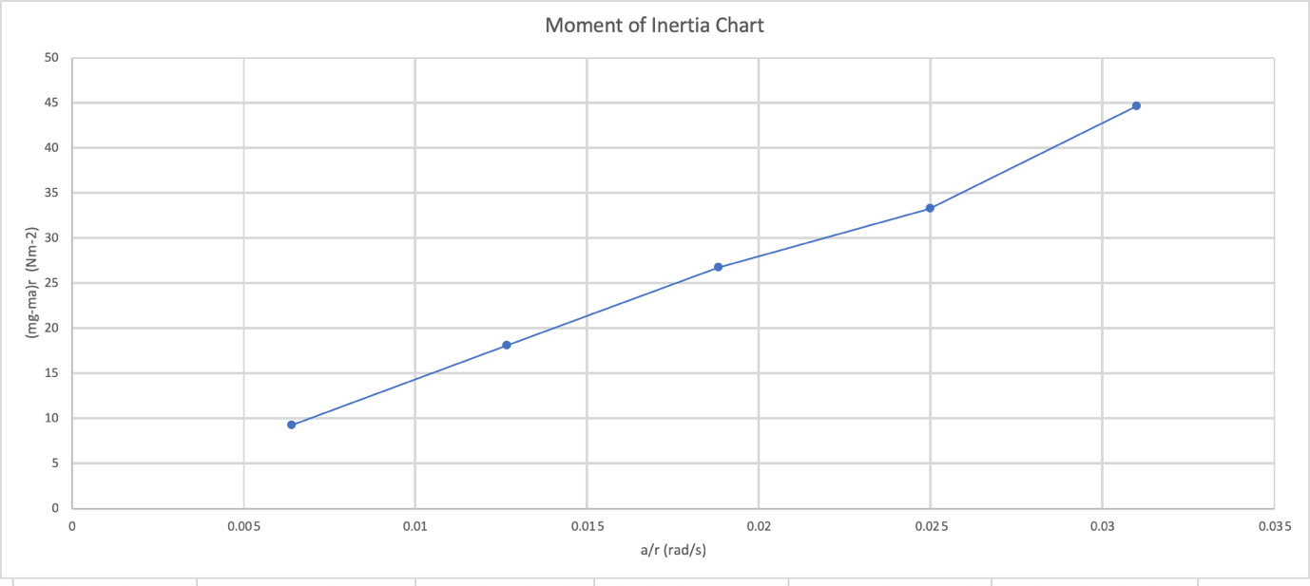

My value for I was 0.007. this is the average calculated gradient of their graph above. The gradient does fluctuate through the graph. However, this can be explained by human error and experimental error.

One way to reduce the impact of human error is to implement use of electronic and mechanical systems including a triggered release and laser rpm meter on the Flywheel allowing you to time when the rotation stops changes at the top and bottom of the range of movement.

Our experiment shows the overall correlation between of energy and losses in flywheel systems. However, due to the small scale and human error in our experiment, our data is not near reliable. Steps could be taken if this experiment is repeated to improve our results.

In Björn Bolund, Hans Bernoff and Mats Leijon (2005), they note that a flywheel can be used as an energy source and has been throughout history in mechanisms like steam engines. However, just like in our experiment they state that flywheels have large inefficiencies and suggest ways to reduce this. One possible solution is to use magnetic bearing which are virtually frictionless. This reduces the losses of enthalpy. This is shown in M. Ahrens, L. Kucera and R. Larsonneur(1996), "Performance of a magnetically suspended flywheel energy storage device," where mag-lev technology is used in conjunction with a 1kwh potential output system.
However, they are studying the use of flywheels in the stored of energy in slow, deep cycle powerplants. This doesn’t translate to the small scale of our experiment because our flywheel is not spinning for hours or even days as a power plant.
Another key area in which the use of flywheels is not only important but at the for front of design. Engine manufactures have used flywheels for many different reasons. In Alberto Boretti (2010), show hoe flywheels can be used to improve efficiency and reduce greenhouse emissions in diesel T1.2 engines.

References
Woodford, Chris. (2012/2020) Flywheels. Retrieved from https://www.explainthatstuff.com/flywheels.html. [Accessed (12/2020)]

Björn Bolund, Hans Bernoff and Mats Leijon (2005), Flywheel energy and power storage systems, Uppsala University.

M. Ahrens, L. Kucera and R. Larsonneur(1996), "Performance of a magnetically suspended flywheel energy storage device," in IEEE Transactions on Control Systems Technology, vol. 4, no. 5,

Alberto Boretti (2010), “Comparison of fuel economies of high efficiency diesel and hydrogen engines powering a compact car with a flywheel based kinetic energy recovery systems”

