

Effective TeamWork and Communication
Module code: BMSW4002
Student number: 2021166
Claudia Ancuta Dragan
Lecture: Chizoba Esio-Bassey
Table of Contents
Introduction 3
Task Analysis 4-5
Communication barriers and challenges faced by Barry 5
Solutions to barriers and challenges 5-6
Methods of effective communication 6-8

Advantage and disadvantage of technology in communication……………………………….9
Types of communication…………………………………………………………………..10
Conclusion 11
References: 12

Introduction
Communication plays a significant role in an organization as it increases the effectiveness of the work performance of the entire firm. The effective communication process leads to making a solid team (Kalogiannidis, 2020).
The present assignment is based on the case study of Barry and communication barriers. The report will illustrate the challenges and barriers to communication that are faced by Barry with the team. The study will describe the solutions considered by Barry in order to address all the barriers and challenges. Furthermore, it will discuss some techniques that Barry can adopt
in order to communicate with the employees and motivate the team to follow the practices for safe food handling.

Task Analysis

Communication barriers and challenges faced by Barry
Communication is the fundamental key to effective teamwork. There are different types of barriers that hinder the procedure of communication. These obstacles include perception, attitude, technological, psychological, emotional, organizational structure, linguistic, physical, and cultural other barriers (Varma, 2021).
Barry has faced cultural barriers as the people of the restaurant have cultural diversity.
The language is another challenge faced by Barry. This type of obstacle arises when the people come from different parts of the country or world. The variety of cultures has different points of view about everything. It interrupts the interaction between the team members and affects the whole teamwork. People face issues while talking to each other, and the information is misunderstood due to different meanings or customs of various cultures.

Organization structure
It is also a major concern in the effective communication process (Haiilo, 2022). The circumstances such as lack of training sessions have made the communication process worst. The high turnover forced the organization to hassle the training programs that deprived several numbers of people of getting trained. The training would help them to understand how to handle food safely and make them aware of the safety basics.

Cultural barriers
Diversified culture indicates that all have come from different regions, and English is not their first language. The language makes people unable to understand each other and affects the interaction between them. The information they have to send or receive from each other can impact the work.

Attitude barriers
Age is also a barrier that limits communication. Young and old age people have a different kind of attitudes toward their work that disrupts their interaction between them.

Lack of motivation barriers
Barry has faced the barriers that indicate that people of the restaurant don't have the motivation to work with enthusiasm. Motivation is vital for the workers at the organization. The unmotivated people don’t give desired outcomes. At the same time, motivated people are always eager to work, which increases their productivity, performance, and way of thinking or being creative.
Perceptual barriers
People from different types of cultures possess different perceptions. It influences other people in the organization as people tend to make a decision on the basis of their perceptions. The employees interpret the situation and come to a conclusion and make a quick decision.
People who have perceptual filters about their attitudes, life experiences, and values make them more vulnerable to getting affected by such factors. Sometimes employees get easily triggered by the facial gestures, body language, and cues that cost their mental peace (Kapur, 2018).

Psychological barriers
The variety of thoughts creates a psychological barrier for the entire firm. The people of the restaurant may have different beliefs or psychological issues that can affect the work to some extent.
Barry has come to know that the employees are not attentive to the efforts to make them understand the handling the food safety. The workers are not using the facilities they have been provided to maintain the temperature of food. The untrained employees are also one of the greatest challenges for Barry. The lack of motivation and training has made people carefree as they didn’t understand their individual or team responsibilities. The lack of proper planning and communication affected the people and their work abilities. The employees of the restaurant are lacking in having proper knowledge regarding food safety. The inadequate knowledge of using the equipment is also a challenge for Barry.

Solutions to barriers and challenges
The attitude barriers can be eliminated by training the staff members about having a positive attitude that can help them not only in life but also in professional progress. Barry can provide training to their employees to organize their thoughts. It will support them for future perspectives. It is required for people to pay attention to details. All the employees should be an active listener that shows people that they are listening to them.
Perceptual barriers can be removed by barking the mental blocks of people that limit their communication with effectiveness (Radovic , 2018). The workers must practice a positive physical appearance as the body languages influence the people. All employees must be transparent and help others to understand and create a favorable work setting for everyone.
Barry can implement motivational strategies to encourage its employees. For this purpose, Barry needs to formulate a proper strategic plan to persuade the people. The reward strategy can help Barry to inspire other people to work with full of enthusiasm. When people are recognized for their achievements, they feel more valued and respected, which makes them more focused on their work. These kinds of people work hard and also it increases their future development opportunities. Psychological barriers can be eradicated by making people manage their emotions. Emotional management is necessary to be present at the moment. The employee should use some mediation and stress releasing techniques to deal with their emotions band balance them. People must be aware of their emotions and beliefs. They should enhance their knowledge to remove their inappropriate behaviors.
Cultural barriers can be removed by embracing the diversity in culture and making all people comfortable with each other. A diverse culture can create an innovative team, and it supports all the people (Lopez, 2019). The entire team should encourage each other and provide them an open communication. The group discussion can improve the communication skills of all the people. It boosts the morale of the people and inspires them to involve themselves more. It will create a positive environment for everyone so that people don't get hesitated and easily share their views and problems they are facing. It will make it easy for Barry to understand their issues and solve them.
Language can be eliminated by avoiding jargon and slang words in communication that make the interaction more complex (Kapur, 2018). The listener should be active and attentive to understand the information and expression or gesture. The speaker should be clear and concise and use expressions and signs to make the employees understand the core of the message. A translation service can be provided to interpret the information. The visual techniques can help to remove the language obstacles in communication. The language sessions can help the employees to become familiar with a single langue which is English.
An organizational barrier has an essential place in communication. The employer and employees must be focused on making the work environment flexible for all the staff members. Barry must provide the employees a free space to the employees so that they can understand the opinions and ideas of the workers. It will add more innovation to the restaurant and encourage people to express their views and issues they are facing, and even they can take suggestions from staff members about finding solutions to the problems.
These kinds of strategies will help the restaurant to enhance its performance and make its people effective and efficient in handling food safety (Alyammahi, 2020). The company can invest more in providing training programs that don't have adequate knowledge about handling food safety.

Methods of effective communication
Barry can adopt different types of models to make the communication process more effective. These models include Berlo’s Model of Communication, Shannon and Weaver's Model of Communication, and Schramm's Model of Communication.
Barry can adopt the effective method of communication to make the team stronger and attentive. The digital technologies can help to interact with the employees such as online platforms zoom, Skype and other.

Shannon and Weaver Model of Communication
This model has developed by two-person Shannon and weaver, to make the communication process more straightforward. This concept aims at creating an effective interaction between the receiver and sender. According to this model, the factors that influence the communication procedure are referred to as noise (Kubota, 2019). The theory focuses on enhancing communication in a technical manner. It consists of a receiver, sender, channel, decoder, and encoder. The sender should have all the required information in a clear and concise way. The encoders transmit the message by transforming it into signals. The single is converted into binary data or waves that are compactable. It requires satellites or cables by which messages are transmitted; a telephone can be the best example to understand it.

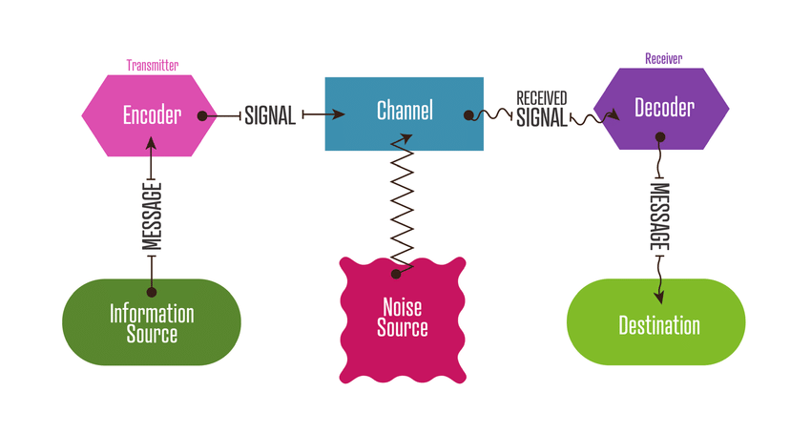
Figure 1: Shannon and Weaver Model of Communication
Source: (Researchgate, 2020)
A decoder is the place of reception where the signals are received, and after receiving, they are converted into messages again. It is the exact opposite process of the encoder. In case the receiver doesn't receive the exact message, then the information quality will be degraded or lost, which will affect the communication between the receiver and the sender. The receiver is the destination where the message is received from the source. The receiver provides feedback on the basis of decoded message (Researchgate, 2020). It should not be distracted by any kind of noise like the crowd, horn, thunderstorms, etc., or else it will impact the whole communication process. The external factors can affect the signal or message, so it should be free from the external factors in order to make the effective communication.

Schramm's Model of Communication
It is a straightforward method that is based on three critical elements of the communication process that includes the message, source, and destination. Communication is a two-way process that involves the sender and receivers (Kuznar, 2020). When the information is not put in the words cautiously, then it becomes useless. It may degrade the quality of the information. This theory states that communication procedure entails source, encoding message, decoding, and receiver. The source is the point from which information or message is sent to the receiver. The encoder is an individual who is responsible for converting the message into the codes. It is significant to use the appropriate word so that the correct information is received by the receivers.
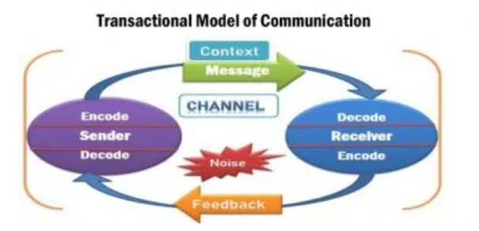
Figure 2: Schramm's Model of Communication
Source: (Newsmoor, 2021)
The decoders are the person who receives the encoded message and turns it into the language that is comprehensible to the receivers. The interpreter is defined as the person who understands and evaluates the information or message. It plays a significant role as it can affect the message if the interpretation may go wrong. The receiver is the end source of the communication process (Newsmoor, 2021). The information or data sent by the sender is called a message. The message is received by the receiver and accepted is known as the feedback procedure. Noise is the disruption while communicating. Medium is the channel through which the message is sent to the receiver.

Berlo’s Model of Communication
This model has certain steps that are as follows:
Sender
The source of the communication process is the individual who starts the process. There are several factors that can affect the procedure, including the communication skills of a person, the attitude of the person, knowledge, social system, and culture (Menor, 2021).
Message
It can be influenced through its structure, content, treatment, elements of the message, and code by which the message is sent.
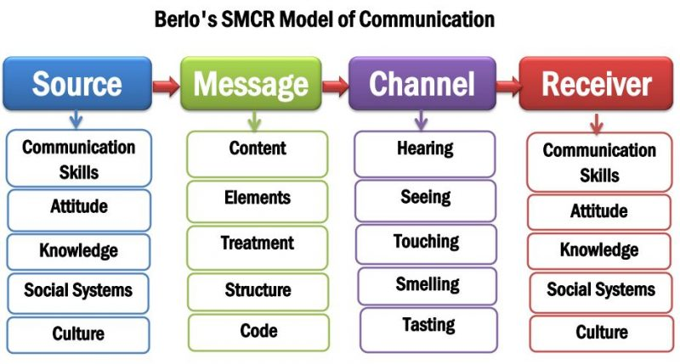
Figure 3: Berlo’s Model of Communication
Source: (Newsmoor, 2021)
Channel
Channels via a person get the message such as Hearing process, seeing, touching, smelling, tasting.
Receiver
The end source of the communication procedure is a person who is responsible for decoding and understanding the message (Newsmoor, 2021).

Advantage of technology in communication.
- Technologies make the communication easier.
- Anyone can communicate from anywhere with the help of technology
- it is efficient than other methods and long-distance communication gets easy and faster
Disadvantage of technology in communication.
- It is hard to use for many people.
- Proper knowledge is required to use it (Nayak, 2019).
- cyber-attack can affect it

Types of communication

Verbal
It is the process where people interact with each other by using pitch, tone, content.

Non verbal
In this process people don’t talk but communicate via facial expression, gestures, eye contact and posture.

Written
It is the way of communication which is done by sending information via message or in written form (Puscas, 2021).
Visual
In this communication method people interact by video such as YouTube, and other platforms.

#Conclusion
From the above report, it has been concluded that Barry has faced various challenges and barriers in relation to handling food safety. The report has described the various types of communication barriers such as psychological, perceptual, attitude barriers, and others. It has also demonstrated the communication models that will provide assistance to Barry to make the communication more effective and enhance the performance of the team. It will make the team more robust and improve coordination between the team members. Moreover, the study has explained the importance of communication and also the advantages and disadvantages of technology in communication. It will make the employee relation more healthy that will contribute to the employee motivation, and increase their participation.

References:
Alyammahi, A., Alshurideh, M., Kurdi, B.A. and Salloum, S.A., 2020, October. The impacts of communication ethics on workplace decision making and productivity. In International conference on advanced intelligent systems and informatics (pp. 488-500). Springer, Cham.
Haiilo, 2022. Barriers of communication [Online] Available through <https://blog.smarp.com/communication-barriers> [Accessed on 16th april,2022]
Kalogiannidis, S., 2020. Impact of effective business communication on employee performance. European Journal of Business and Management Research, 5(6).
Kapur, R., 2018. Barriers to effective communication. Delhi University.
Kubota, M., 2019. What is “Communication”?―Beyond the Shannon & Weaver’s Model―. International Journal, 13(1), pp.54-65.
Kuznar, L.A. and Yager, M., 2020. The Development of Communication Models, Quick Look. Joint Staff J39, Strategic Multi-layer Assessment Washington, DC United States.
Lopez, M.O. and Malabanan, M.R.L., 2019. Communication Barriers in the Workplace.
Menor, M.R., 2021. Improving the organizational communication of the management team.
Nayak, M.S.D.P. and Narayan, K.A., 2019. Strengths and weaknesses of online surveys. technology, 6, p.7.
Newsmoor, 2021. Berlo’s Model of Communication [Online] Available through <https://newsmoor.com/smcr-model-of-communication-david-berlos-smcr-model-of-communication-example/> [Accessed on 16th april,2022]
Newsmoor, 2021. Schramm's Model of Communication [Online] Available through <https://newsmoor.com/3-types-of-communication-models-linear-interactive-transactional/> [Accessed on 16th april,2022]
Puscas, L., Kogan, J.R. and Holmboe, E.S., 2021. Assessing interpersonal and communication skills. Journal of graduate medical education, 13(2s), pp.91-95.
Radovic Markovic, Mirjana, and Aidin Salamzadeh. "The importance of communication in business management." In Radovic Markovic, M., & Salamzadeh, A.2018. The Importance of Communication in Business Management, The 7th International Scientific Conference on Employment, Education and Entrepreneurship, Belgrade, Serbia. 2018.
Researchgate, 2020. Shannon and Weaver Model of Communication [Online] Available through <https://www.researchgate.net/figure/The-Shannon-and-Weaver-models-model-of-communication-reproduced-diagram_fig2_342523348> [Accessed on 16th april,2022]
Varma, S.B., Abidin, N.S.Z., Amir, N., Sukimin, I.S., Nadri, H.N. and Rahmat, N.H., 2021. Workplace Communication Hindrances: The Contextual, Structural and Behavioural Factors. Journal of Academic Research in Business and Social Sciences, 11(9), pp.1844-1855.

