
LCBB5000Data Handling and Business Intelligence
Lecturer:Amitave Banik
Name:Mihael Velikov
Student ID:2123841

Table of Contents

Introduction 3
Hotel Reservation Dataset Analysis 3
Data Charts 4
Observation 5
Evaluating the Use of Microsoft Excel 6
Using LOOKUP and PIVOT TABLE 7
LOOKUP 7
PIVOT TABLE 8
Students Score Dataset Analysis 10
Number of Male and Female Students 10
Students Qualifying for Reduced/Free Lunch 10
Mean and Median of Students 11
Differences in Students' Pre-Test And Post-Test Scores 11
K-Means Clustering in SPSS 12
Common Data Mining and Text Mining Methods 14
Advantages and Disadvantages of Using SPSS and Excel 15
References 17

Introduction
A common piece of software called Microsoft Excel is used for many things, including preparing data. Excel can be used to sanitise data by eliminating unused spaces, fixing typos, and eliminating redundancies (Alexander, 2010). It can also be used to swap out invalid or absent numbers with the proper ones. Data can be formatted into a particular style using Excel, such as dates or monetary values. This can be accomplished using a variety of built-in features or by adjusting cell layouts. By carrying out a number of processes like sorting, filtering, and combining data, Excel can be used to change data. Additionally, Excel offers pivot tables, which are an effective instrument for compiling and analysing data (Alexander et al., 2018). Overall, a strong collection of tools for data pre-processing are provided by Microsoft Excel. It is an approachable choice for users with a variety of technological skills thanks to its user-friendly UI and well-known spreadsheet structure.

Hotel Reservation Dataset Analysis
To determine the average value of a group of integers, use the AVERAGE function in Microsoft Excel. When calculating big quantities of data, it is a quick and efficient tool that can help you save a lot of time (Freund et al., 2013).
The user must choose the columns that hold the data they want to average before using the AVERAGE formula (Harvey, 2018). The user can then choose the columns they want to include in the computation by typing "=AVERAGE(" and selecting them. As an alternative, the user can enter the cell range by hand in the calculation. The formula "=AVERAGE(B2:B10)," for instance, would determine the average number of cells in the B2 to B10 region.

Data Charts
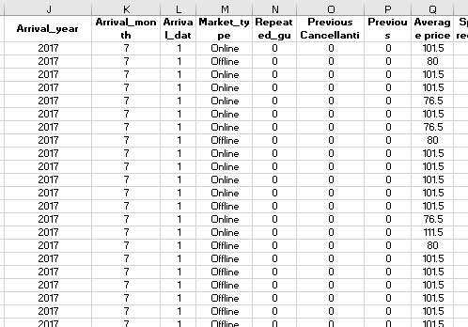
Figure: Finding the decline or increase in average price (Source: Author)
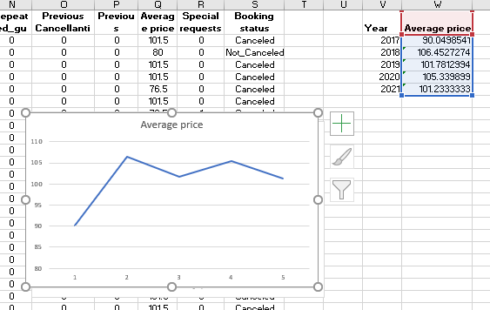
Figure: Finding the decline or increase in average price using the chart (Source: Author)

Figure: Finding the decline or increase in average price using all the values in a chart (Source: Author)

Figure: Chart of the decline or increase in average price (Source: Author)

Observation
It can be observed that the price has been on the decline in recent years (2021). The price started as quite low in the initial years and it slowly increased. Then, there has been a constant change in pricing as the values increased and decreased over time.

Evaluating the Use of Microsoft Excel
Data pre-processing, analysis, and visualisation can all be done with the help of Microsoft Excel, which is a strong instrument (Day, 2015). Due to its flexible features and user-friendly design, it is extensively used across sectors. This article will assess the pre-processing, analysis, and data visualisation capabilities of Microsoft Excel.
The simplicity of Microsoft Excel makes it a great choice for pre-processing data. Excel offers a user-friendly layout that makes it simple for users to organise and work with data (Harvey, 2018). Additionally, it has several built-in tools for organising and tidying up data. The text tools in Excel, for instance, can be used to glean information from unorganised data (Field, 2017). To get rid of duplicates, inaccurate data, or any other anomalies, users can sift and organise the data. The pivot table function in Excel is yet another effective instrument for pre-processing data. Utilizing pivot tables, users can categorise and summarise data to make it simpler to analyse. Filters can be applied by users to show particular data groups in pivot tables. Charts and additional layout options in pivot tables can be used to further customise the data's visual attractiveness (Harvey, 2018).
Excel's versatility is another benefit when pre-processing data. Text, numbers, dates, and times are just a few of the many kinds of data that Excel can manage. Excel is a flexible instrument for data analysis because it can manage both small and big datasets (Harvey, 2018). To guarantee that data is input accurately and regularly, use Excel's data validation function.
Excel's user-friendliness is a big benefit when it comes to data processing. Excel offers a user-friendly layout that makes it simple for users to organise and work with data. It also has several built-in features that can be used for data analysis. Basic statistics like mean, median, mode, and standard deviation can be calculated using Excel's built-in tools like SUM, AVERAGE, and COUNT (Day, 2015). Another effective instrument for analysing data is Excel's regression analysis function. It enables users to spot any trends or patterns in the data and analyse the connection between two or more factors. Data can be summarised and organised into groups using Excel's pivot table function, making analysis simpler (Day, 2015).
Sparklines, a component of Excel, is yet another useful instrument for data visualisation. Sparklines are tiny charts that can be put into a cell and show data patterns visually (Alexander, 2010). With the help of this function, users can rapidly spot trends and patterns in the data. Excel has some restrictions, despite all of its benefits for data visualisation. Excel, for instance, might not be the best choice for managing very big datasets because the charts and diagrams can get cluttered and challenging to comprehend. Furthermore, Excel might not be appropriate for developing extremely complicated visualisations that need specialised software tools.
In conclusion, Microsoft Excel is a useful tool for visualising data because it offers users a variety of pre-built chart and graph layouts that can be adjusted to suit their requirements. The pivot table and sparkline features in Excel also give users effective tools for compiling and analysing data (Alexander, 2010). Excel continues to be a common option for data visualisation due to its simplicity, adaptability, and variety of functionalities even though it may not be appropriate for making extremely complex visualisations.

Using LOOKUP and PIVOT TABLE

LOOKUP
The methods below can be used to use Excel's LOOKUP tool to ascertain whether the average price has decreased or increased:
The user must first launch Microsoft Excel and make a new spreadsheet. The data they want to analyse can then be entered into the spreadsheet. They could, for instance, input the values of a product for various periods in various compartments (Alexander, 2010).
The user must then figure out the product's typical price over the time span they are interested in. For this, they can make use of Excel's AVERAGE tool. To determine the average price, they must choose the cells that hold the values for that time frame and use the AVERAGE tool (Alexander, 2010). This process must be repeated by the individual for each time span they want to analyse.
The LOOKUP function can be used to compare the averages and determine whether there has been a rise or decrease in price after the user has determined the average price for each time frame (Alexander, 2010).
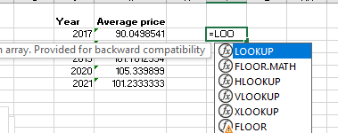
Figure: Performing task using LOOKUP (Source: Author)
The user must write "=LOOKUP(lookup_value, lookup_array)" in a cell to use the LOOKUP function. Lookup_value should be the average price they determined for the first quarter, and lookup_array should be the range of cells holding the average values for each quarter.
The average price has dropped if the outcome of the LOOKUP function is less than the average price for the second quarter. The average price has decreased if the output of the LOOKUP function is higher than the average price for the second quarter (Day, 2015). This process must be repeated by the individual for each time span they want to analyse. Microsoft Excel's LOOKUP function is a useful instrument for figuring out whether the typical price has decreased or increased (Day, 2015).

PIVOT TABLE
The methods listed below can be used to determine whether the typical price has decreased or increased using Pivot Tables in Microsoft Excel. The user must first launch Microsoft Excel and make a new spreadsheet. The data they want to analyse can then be entered into the spreadsheet (Day, 2015). For instance, they can input rates for a product for various time frames in various sections.
The user must then choose the data region and pick the "Insert" tab. They can then select the "Pivot Table" choice from there. The user must choose the data region they want to use for the pivot table from a dialogue window that will show.
The " Period" column can be moved to the "Rows" area and the "Price" column can be moved to the "Values" area after the pivot table has been made. The pivot chart will show the average price for each interval.
The "% Difference From" function in the pivot table can be used by the user to calculate the decrease or rise in the average price. They must perform a right-click and select the "Show Values As" choice on the column that contains the average price for the first time frame. The second period can then be chosen as the benchmark period by selecting "% Difference From" from that point on.
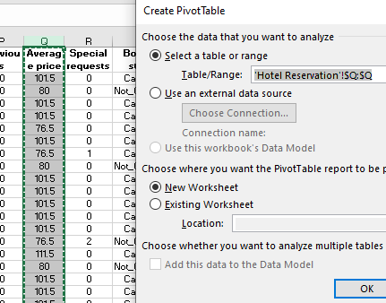
Figure: Performing task using PIVOT TABLE (Source: Author)
The percentage disparity between the two time periods will then be shown in the pivot chart. The usual price has risen if the percentage is positive (Day, 2015). The usual price has decreased if the proportion is negative.
For each period they are interested in analyzing, the user can continue this procedure. Overall, Pivot Tables in Microsoft Excel are an effective instrument for data analysis and visualization, and the "% Difference From" function is useful for calculating changes in average price.

Students Score Dataset Analysis

Number of Male and Female Students
To add the numbers in a set of cells that satisfy certain criteria, users can use Microsoft Excel's SUMIF function (Day, 2015). The user should carry out the following actions to use the SUMIF function:
First, the user needs to choose the column in which the user wishes to see the SUMIF function's output. In the column, enter "=SUMIF(." The user should choose the cell region to be evaluated. The condition will be evaluated within this region. Enter the prerequisite that the cells must satisfy. For instance, the user would write ">5" as the condition to sum the numbers in cells A1 to A10 that are higher than 5. The user should choose the number of pixels to sum. The numbers that fall within this range will be added together by the algorithm. The user needs to press Enter after securing the brackets.
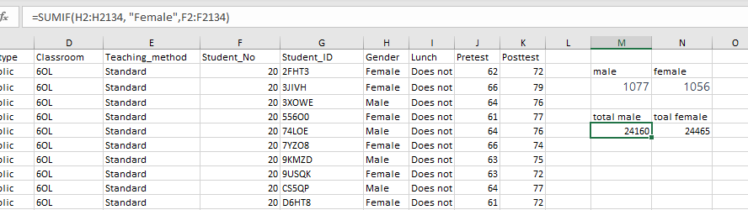
Figure: Number of male and female students (Source: Author)

Students Qualifying for Reduced/Free Lunch
Additionally, numerous conditions may be used with the SUMIF method. Instead, the user should make use of the SUMIFS method (Alexander et al., 2018). The SUMIFS function enables the user to define several requirements and aggregate the numbers that satisfy each requirement.
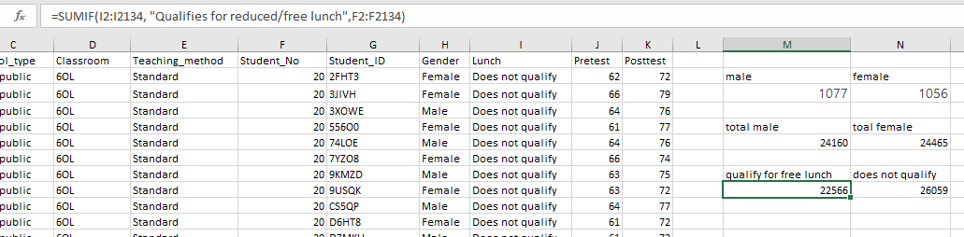
Figure: Number of students qualifying for reduced/free lunch (Source: Author)
It is significant to remember that the SUMIF function only adds up numbers in a range that satisfies a particular requirement. The SUM method should be used if the user wishes to add up all of the numbers in a range, whether or not they satisfy a requirement (Alexander et al., 2018). Overall, Microsoft Excel's SUMIF function is a strong instrument for analysing data sets and computing totals based on particular parameters. It can reduce time spent and offer insightful information about massive data collection.
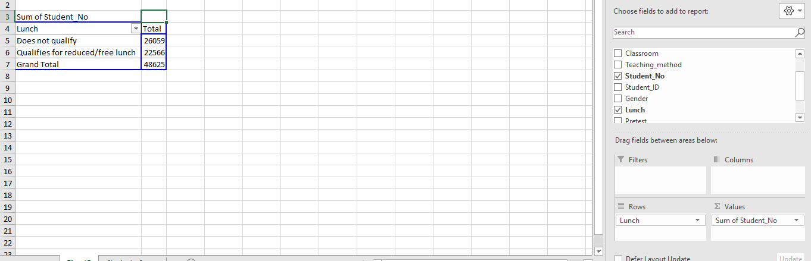
Figure: Number of students qualifying for reduced/free lunch using pivot table (Source: Author)
With the help of a pivot table in Microsoft Excel, a user can effectively summarise and analyse vast amounts of data in a table structure (Alexander et al., 2018). Finding the total amount of data in a table is one of the most frequent jobs that users carry out with pivot tables.

Mean and Median of Students
The pivot table, the MEAN and the MEDIAN function have been used to find the mean and median of the students.
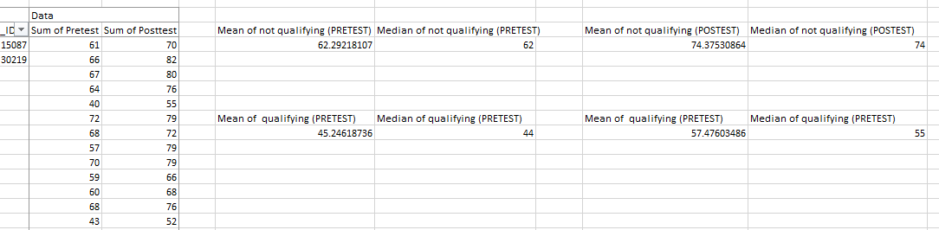
Figure: Mean and Median of Students (Source: Author)

Differences in Students' Pre-Test And Post-Test Scores
The pivot table, the MEAN, the MEDIAN and the subtraction function have been used to find the mean and median of the students.
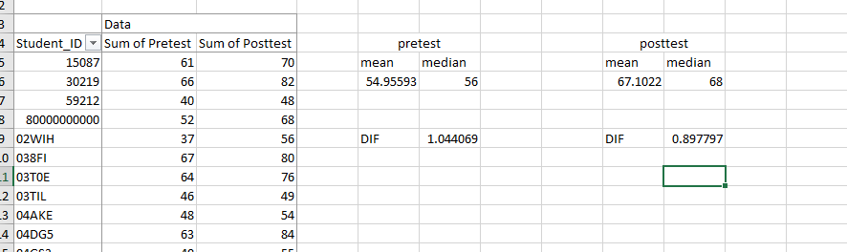
Figure: Differences in students' pre-test and post-test scores (Source: Author)

K-Means Clustering in SPSS
In SPSS, K-means clustering is a well-liked approach for cluster analysis. A dataset is divided into K groups by the K-means method, where K is the user-specified number of clusters (Cleophas and Zwinderman, 2014). The technique attempts to reduce the separation between the data elements and the cluster centroids. Data elements are divided into a predetermined number of groups using the K-means clustering technique based on how similar they are to one another (Aspelmeier and Pierce, 2009). Each data point is assigned to the closest cluster centre by the algorithm after the user specifies the number of clusters they want to construct. Once the clusters are steady, the programme repeats the process of updating the cluster centres. With the help of SPSS, you can perform k-means clustering and choose the number of groups, the spacing between them, and the initialization strategy (Cleophas and Zwinderman, 2014).
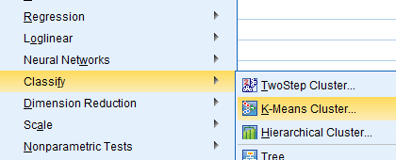
Figure: K-Means Clustering in SPSS (Source: Author)

Initial Cluster Centers
 | Cluster
 | 1 | 2
Student_No | 28 | 17
Pretest | 23 | 93
Posttest | 35 | 100

Iteration Historyª
Iteration | Change in Cluster Centers
Iteration | 1 | 2
1 | 30.372 | 33.776
2 | 1.005 | .898
3 | .570 | .494
4 | .280 | .242
5 | .183 | .158
6 | .066 | .057
7 | .018 | .016
8 | .000 | .000
a. Convergence achieved due to no or small change in cluster centers. The maximum absolute coordinate change for any center is .000. The current iteration is 8. The minimum distance between initial centers is 96.156.

Final Cluster Centers
 | Cluster
 | 1 | 2
Student_No | 25 | 21
Pretest | 43 | 65
Posttest | 55 | 78

Number of Cases in each Cluster
Cluster | 1 | 993.000
Cluster | 2 | 1140.000
Valid |  | 2133.000
Missing |  | .000

Table: K-Means Clustering of data of students’ school, pretest score and posttest score

Common Data Mining and Text Mining Methods
Text mining and data mining are effective methods for drawing conclusions and knowledge from massive amounts of unorganised text data. Here are five of the most popular data mining and text mining techniques, along with real-world applications for each in modern business:
Classification: A data mining method called classification classifies new data based on patterns in the training data (Cleophas and Zwinderman, 2014). A merchant, for instance, might use categorization to foretell a customer's likelihood of making a purchase based on the customer's characteristics, past purchases, and other information. This can increase consumer engagement and help the merchant focus promotions more effectively.
By examining trends in transaction data, banks can use categorization to find fraudulent transactions. Based on usage trends and other information, telecom firms can use classification to identify which clients are most likely to discontinue service (Cleophas and Zwinderman, 2014).
Clustering: Using the data mining method of clustering, comparable data points are grouped according to common traits. For instance, a financial services business might use clustering to divide up its clientele into different groups based on things like spending patterns and investment tastes (Field, 2017).
Clustering can be used by e-commerce businesses to suggest goods to customers based on their past purchases and the buying habits of other comparable customers. Clustering can be used by cybersecurity firms to find out-of-the-ordinary network traffic trends that might point to a cyberattack (Field, 2017).
Association rule mining: A data mining method known as "association rule mining" is used to find connections between factors in a dataset (Harvey, 2018). A merchant might, for instance, use association rule mining to find goods that are frequently bought in tandem.
Retailers can use association rule mining to pinpoint goods that are frequently bought together, and they can then make the most of this knowledge to fine-tune their cross-selling and product positioning tactics (Harvey, 2018). Telecom firms can use association rule mining to pinpoint utilisation trends connected to various customer groups.
Sentiment analysis: Sentiment analysis is a text-mining method that examines the emotional content of spoken or written words. For instance, a social media site might use sentiment analysis to track user attitudes towards a product or subject (Miller et al., 2009). This can assist the platform in spotting new patterns, picking up on negative feelings, and quickly reacting to user input.
Sentiment analysis can be used by businesses to track what the general public is saying about their brand on social media and other online forums (Miller et al., 2009). Organizations can use sentiment analysis to examine consumer evaluations and comments about their goods, then use the results to pinpoint areas in need of growth and create new products that more closely satisfy consumer demands (Reding and Wermers, 2013).
Text classification: Unstructured text data is categorised into predetermined groups using the text mining method known as text classification. Using text categorization, a news organisation could, for instance, automatically classify stories based on their subjects, sources, or other features (Reding and Wermers, 2013). This can assist the company in enhancing its content finding and suggestion systems and in giving users more individualised content.

Advantages and Disadvantages of Using SPSS and Excel
 | Advantages of SPSS | Disadvantages of SPSS | Advantages of Excel | Disadvantages of Excel
Data Analysis | Due to its statistical analysis focus, SPSS is better equipped to handle big datasets and challenging analysis jobs. Multivariate analysis, regression analysis, and factor analysis are just a few of the many statistical choices and tasks it provides. | The layout of SPSS can be overwhelming for novices, making it difficult to use (Miller et al., 2009). It can also be costly and might not be available to smaller businesses or people. | Excel is a versatile instrument that can be used for a variety of jobs, including financial modelling and data analysis. It is affordable and broadly approachable, making it usable by a variety of users. | For statistical analysis, SPSS might be more effective, and performing complicated analysis jobs in Excel can also be prone to mistakes when dealing with big databases or complicated formulas (Reding and Wermers, 2013).
Data Visualization | Charts, diagrams, and tables are just a few of the data visualisation choices provided by SPSS (Miller et al., 2009). The result can be readily exported to other tools or formats, and these can be tailored to suit particular requirements. | While SPSS may not provide as many visualisation choices as Excel, some users may find the UI to be less user-friendly (Morgan et al., 2012). | Charts, diagrams, and pivot tables are just a few of the many data visualisation choices that Excel provides. These are simple to edit and modify, making them simple to produce visualisations. | It may take more time to format and customise charts and graphs in Excel than it does in SPSS when making complicated visualisations.
Collaboration | The collaborative features of SPSS include assistance for team-based analysis and data sharing. It also provides workflow management and revision control utilities. | Because SPSS may not be as popular as Excel, working with users who are not acquainted with the programme can be more challenging. | Excel has many tools for teamwork, including co-authoring, feedback, and shared files. It is also widely used, which makes working with people who are acquainted with the application simple. | Some versions of Excel may have few tools for collaboration, and the programme might not be as effective as SPSS at managing workflow and team-based research (Reding and Wermers, 2013).

References
Alexander, M. (2010) Easy Microsoft Excel 2010. Que Corporation.
Alexander, M., Kusleika, R. and Walkenbach, J. (2018) Excel 2019 Bible. Nashville, TN, USA: John Wiley & Sons.
Aspelmeier, J. E. and Pierce, T. (2009) SPSS: A User Friendly Approach. New York, NY, USA: Worth.
Cleophas, T. J. and Zwinderman, A. H. (2014) SPSS for Starters. 2010th edn. Dordrecht, Netherlands: Springer.
Day, A. (2015) Mastering Financial Mathematics in Microsoft Excel: A practical guide to business calculations. 3rd edn. Harlow: FT Publishing International.
Field, A. (2017) Discovering statistics using IBM SPSS statistics. 5th edn. London: SAGE Publications.
Freund, S., Enger, R. and Jones, M. (2013) Microsoft Excel 2013: Complete. Florence, AL, USA: South-Western College Publishing.
Harvey, G. (2018) Excel 2019 all-in-one for dummies. Nashville, TN, USA: John Wiley & Sons.
Miller, R. et al. (2009) SPSS for Social Scientists. 2009th edn. Edited by J. Campling. London: Red Globe Press.
Morgan, G. A. et al. (2012) IBM SPSS for introductory statistics: Use and interpretation, fifth edition. 5th edn. London: Routledge.
Reding, E. E. and Wermers, L. (2013) Microsoft Excel 2013: Illustrated Complete. Florence, AL, USA: South-Western College Publishing.

