Reflective Account
Name of the Student: Andreea Zugravu 1604798
Lecturer name: Ze Zook

Introduction
The presentation done by our team members Patrick, Bulbul, Sayeed , Lina and me covered three topics. These are Sustainability and Globalization, Leadership and Entrepreneurship and Community participation. The three skills that I have developed from the commencement till the end of the project are Time Management, Delegation and Interpersonal Communication.
Discussion
Identification of personal skill set
The skill of time management adds value to an individual and development of this skill enables an individual to organize and plan the time which will be allotted to specific activities. There are many benefits associated with development of the skill of time management. These benefits are increased level of productivity and higher level of efficiency, ability to complete the assigned task within deadline, lesser stress and achievement of a good professional reputation (Rapp et al. 2013).During the project I developed three skills associated with time management. These skills are prioritization, scheduling and execution. Members of our presentation team divided the responsibility of research on the presentation topic. We have prepared a to-do-list everyday from the start till the end of the presentation.

Process undertaken
The to-do-list covered all the tasks that were required to be done on a particular day. I applied the ABCD rank method to prioritize our task for the day. A implied the activities of the presentation topic which was of high priority and was supposed to be done immediately. B and C implied the second-priority activities and D implied the low-priority tasks. I applied the scheduling technique for my tasks of the day. I divided each day into 5 parts like morning, noon, afternoon, evening and dinner hour. Then I made a note of significant tasks of the day and assigned a block of time for each tasks. I also applied the execution technique for my prioritized schedule. Along with my team members, I assigned a deadline for each topic of the presentation, broke down each topic of the presentation into smaller tasks and assigned a deadline for each task (Crane and Matten 2016). I also ensured to focus on one task at a time rather than multi-tasking. This method ensured that my research for each topic of the presentation was in-depth and adequate. I kept myself motivated by taking small breaks after completion of each task. I have gained several personal experiences while preparing and conducting our presentation. I learnt to collaborate with my team members and after the end of individual research on each topic we discussed about the results of our findings which enabled us to develop a holistic viewpoint towards each topic of the presentation which are Sustainability and Global Citizenship, Leadership and Entrepreneurship and Community Participation (Rapp et al. 2013).

Amalgamation of skills and tools
Interpersonal communication is a skill of paramount importance which I developed during the commencement of this project. Researchers have depicted that open communication model among team members increases the productivity and effectiveness of a team. The method of interpersonal communication which proved to be highly effective for our team members during the commencement of the presentation are face-to-face group meeting and Skype sessions. In each group meeting, I got an opportunity to discuss about the learning outcome of each topic of my presentation. The team leader of our team, Andreea communicated effectively during each group meeting (Crane and Matten 2016). Our presentation followed an action plan and a roadmap. After completion of research on each topic of presentation, the key findings were discussed among group members. We conducted secondary research for each topic of presentation from existing books, journals, social networking sites like Facebook and Twitter, magazines and company websites. The face-to-face team meetings helped us to clearly communicate with each other about the roles and responsibilities that each team member shared to prepare the presentation. Our team leader Andrea reviewed whether each sub-topic of the presentation was completed within the planned deadline. Interpersonal communication helped us to maintain transparency within our team member. Development of the skill of interpersonal communication also helped me to cultivate a positive outlook towards our project, acknowledge the expertise of our team members, practice active listening and be empathetic towards our team members (Fussell and Kreuz 2014 ).The interpersonal communication skill which I have learnt during the presentation also helped me to understand the viewpoint of my team members about the sub-topics of our presentation like environmental sustainability, sustainable projects in the sector of retail, leadership and entrepreneurship and the benefits of community participation.

Learning process
The discussion about these topics with our team members enabled me to understand the present research that have been conducted on these topics and the current trends, issues and challenges related to sustainability, globalization, leadership and entrepreneurship and that are faced by industries and society. I also got an opportunity to discuss about the solutions of the most challenging problems related to this topic. Networking is focused around developing and maintaining contacts with other people. I developed networking skill while working with my team members on this presentation. I developed networking skills with team members and the senior students of my educational institutions who worked on similar projects to draw external information about the project topic. I enhanced my networking skills by asking meaningful questions to my seniors and team members and tried to interpret their answers effectively (Beck 2015). I had to be active on social networking sites like Facebook, Twitter, Youtube and Instagram to conduct and prepare this presentation. Networking on social networking sites helped me to comprehend the trends, issues and challenges of sustainability, globalization, entrepreneurship and leadership and community participation (Rennie and Morrison 2013).Understanding of contemporary trends and issues which are prevalent among members of community and different industries was of paramount importance to analyze each sub-topic of the project. Networking on social media platforms provided me access to a substantial amount of meaningful information which was extremely effective for me to complete the project. Networking helped me to interpret the issues on the presentation topics which are prevalent in my country and across the globe. During my presentation I could contemplate that business organizations perform on an international scale in this modern era of globalization (Rapp et al. 2013). Enterprises could leverage on multiple benefits due to globalization. Some of these benefits are cost advantage, availability of resources in host countries and outsourcing business processes from developing countries by utilizing cost-effective labor. However, I learnt from my group discussions and research of my group members that globalization needs to address the issues of sustainability. Sustainability is satiating the needs of the present without hampering the ability of future generations to meet their needs. I also learnt that social, environmental and economic are the three pillars of sustainability. The environmental sustainability issues are a contemporary concern for many business organizations in this modern era of globalization (Moldan, Janoušková and Hák 2012). The global organizations publish annual reports of sustainability to gain credibility of the stakeholders. These reports discuss the initiatives and contribution towards sustainability undertaken by the global organizations. The sustainability reports of the organizations focus on the Triple Bottom Line of business which is people, planet and profit. The creating of long-term value is of prime importance for global organizations. I collaborated with my group members to research about the topic of sustainability and globalization on social media platform. I could comprehend from our face-to-face group discussions that environmental sustainability is a rising concern for various industries like tourism, retail and finance (Beck 2015).

Concept of global citizen
Global Organizations focus on reducing environmental footprints, making use of renewable energy sources, reducing the impact of environmental pollution and adopting safe procedures for handling of wastes. The face-to-face group meeting at the end of the completion of the topic of sustainability I learnt that global organizations also foster diverse work culture, open communication model, flexible structure and fair accounting practices indulges in corporate social responsibility to address the concerns of sustainability. Globalization has also led to the concept of global citizen where the world is considered as a community (Beck 2015). The retail sectors also adopt a sustainable supply chain management and implement modern technology in supply chain (Crane and Matten 2016 ). A global citizen is ready to cross the boundaries of his home country and travel to a foreign land for work and respect diversity related to language, ethnicity and culture.

Examples of sustainable projects and environment sustainability
I collaborated with my team members to develop powerful insights about entrepreneurship. Entrepreneurs are ready to take the risks and rewards of a business venture and serve the needs of the society with their powerful business ideas. From interpersonal communication and networking on digital platforms I learnt about the contributions of several entrepreneurs like Richard Branson of Virgin Group, Mark Zuckerberg of Facebook and Elon Musk of Tesla. The face-to-face discussion with my team members has helped me to understand the importance of leadership in global organizations. I learnt from the research of my project that previously business enterprises adopted models of transactional leadership where organizations had rigid structure to ensure strict control points (Nahavandi 2016). However, secondary research on the presentation has helped me understand that at present, business organizations have adopted transactional leadership which fosters innovation and creativity. Transactional leaders support employees of the organization and there is a flexible work structure and open communication model which are adopted by business enterprises in modern era (Drucker 2014).The presentation has helped me to understand that community participation is important to develop tolerance for linguistically and culturally diverse communities and encourages tolerance towards minor members of a community like people with disability. During the research of the project, I discovered that community participation is practiced in sports, for instance, the Paralympics sports organized by International Olympic Committee fosters participation of disabled athletes who have physical disabilities like limb deficiency and impaired muscle power(Brittain 2016 ).The presentation has helped me develop several skills of employability. Skills like time management, interpersonal communication and networking which I have gained during the presentation and by collaborating with my group members during the project will have several long-term benefits when I enter the corporate world(West 2012) .

Conclusion
Global enterprises have offices in different countries and foster work in cross-cultural team. I have learnt to appreciate opinion of my team members which will help me in working in corporate teams in future. Interpersonal communication plays a significant role in global teams of business enterprises. By completing this project I have learnt to overcome the barriers of communication which can adversely affect the work process of a team. A personal skill-set knowledge relevant to this project is that I have knowledge about the sustainability factors that are implemented by different industrial sectors like retail sector

Reference Lists
Beck, U., 2015. What is globalization?. John Wiley & Sons.
Brittain, I., 2016. The paralympic games explained. Routledge.
Crane, A. and Matten, D., 2016. Business ethics: Managing corporate citizenship and sustainability in the age of globalization. Oxford University Press.
Drucker, P., 2014. Innovation and entrepreneurship. Routledge.
Fussell, S.R. and Kreuz, R.J., 2014. Social and cognitive approaches to interpersonal communication. Psychology Press.
Moldan, B., Janoušková, S. and Hák, T., 2012. How to understand and measure environmental sustainability: Indicators and targets. Ecological Indicators, 17, pp.4-13.
Nahavandi, A., 2016. The Art and Science of Leadership -Global Edition. Pearson.
Rapp, A.A., Bachrach, D.G. and Rapp, T.L., 2013. The influence of time management skill on the curvilinear relationship between organizational citizenship behavior and task performance. Journal of Applied Psychology, 98(4), p.668.
Rennie, F. and Morrison, T., 2013. E-learning and social networking handbook: Resources for higher education. Routledge.
West, M.A., 2012. Effective teamwork: Practical lessons from organizational research. John Wiley & Sons.

Presentation Plan
Activity | Time of commencement
Individual Research on Sustainability and Globalization | Week One
Meeting with Team Members | At the end of week one
Understanding Learning outcomes of team members | Skype meetings and Face-to-Face meetings at the end of week one
Preparing the Slides of the presentation with general topics of Sustainability and Globalization | Week 2 –Beginning
Individual research on sub-topics of Entrepreneurship and Leadership | Week 2- End
Attending team meeting | Skype at the beginning of Week 3
Individual research on the topic of Community participation | Week 3-End
Attending team meeting | Week Four-Beginning
Preparation of the conclusion side | Week Four-End
Editing , referencing and in-texting my part of presentation | Week Four-End

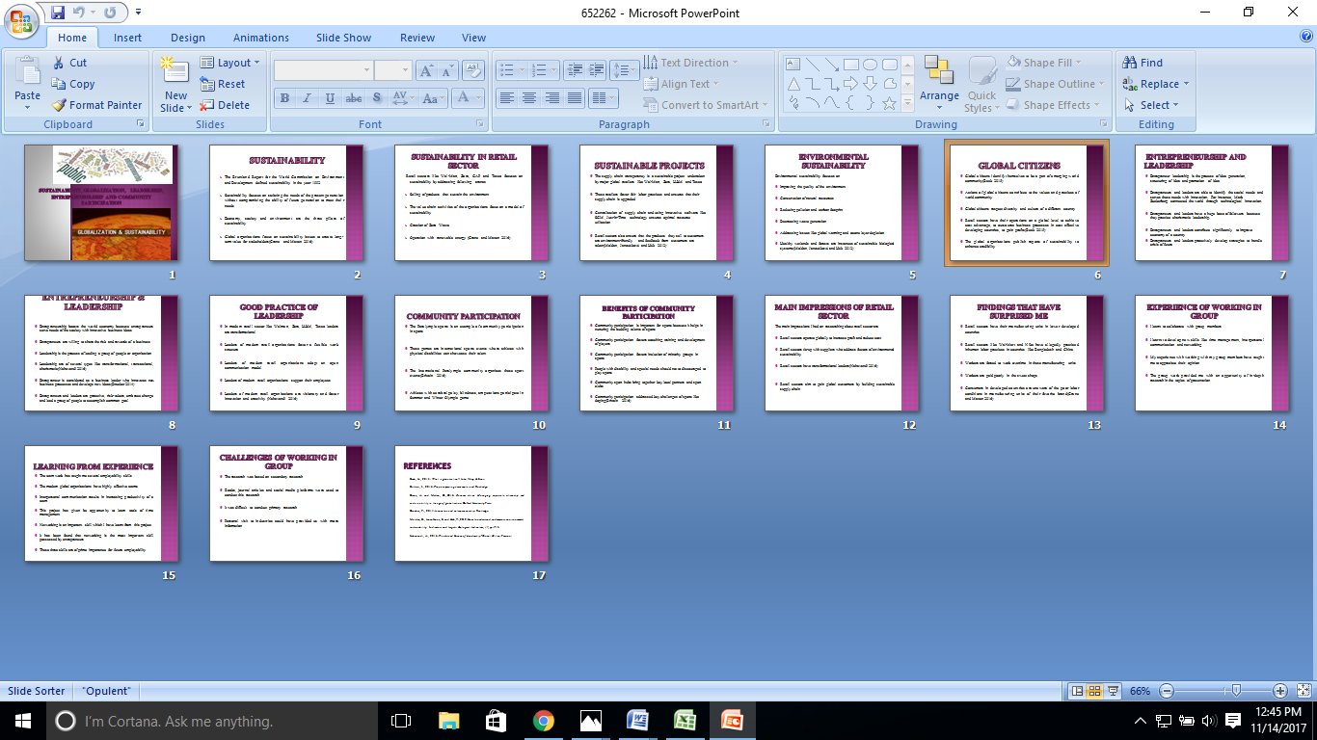
Screenshot of Presentation
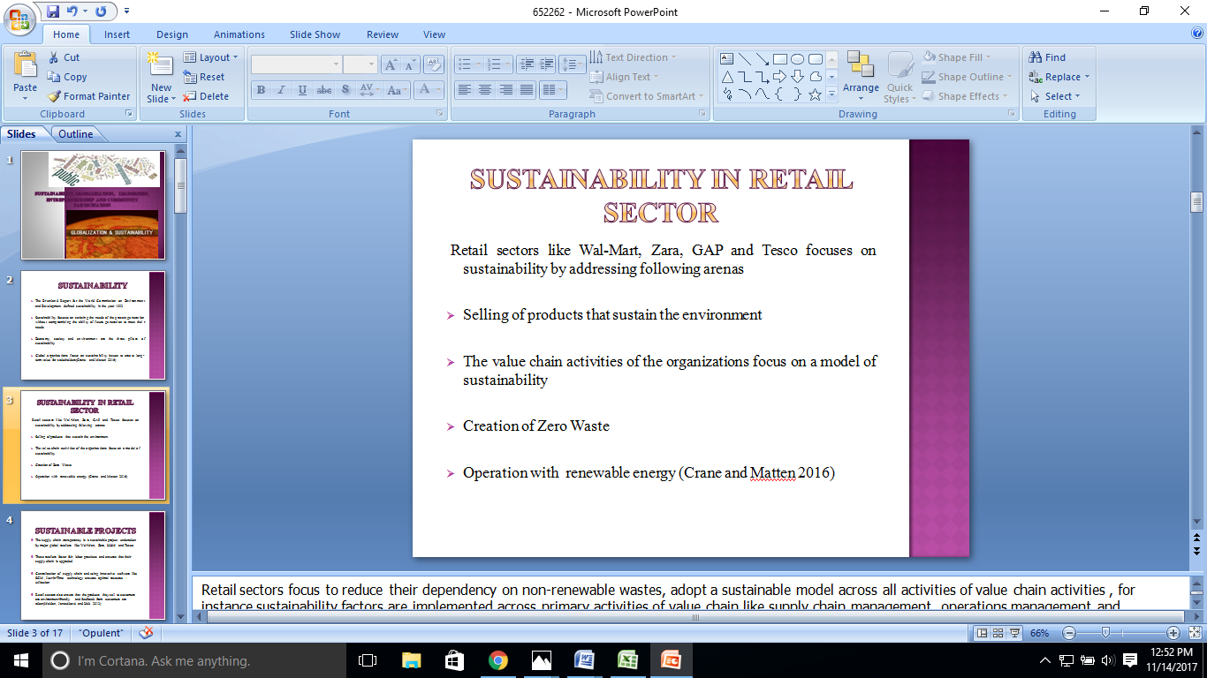
Screenshot of Presentation
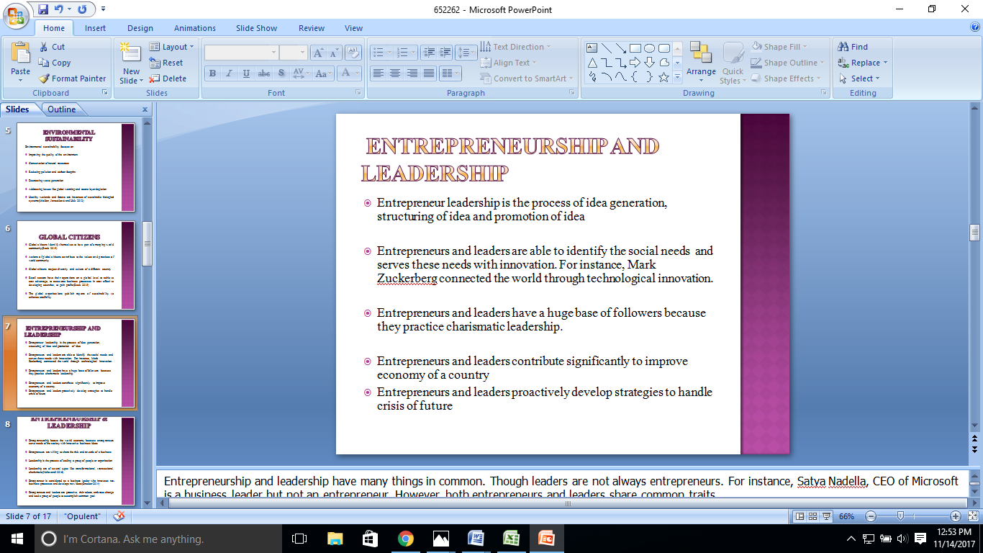
Screenshot of Presentation

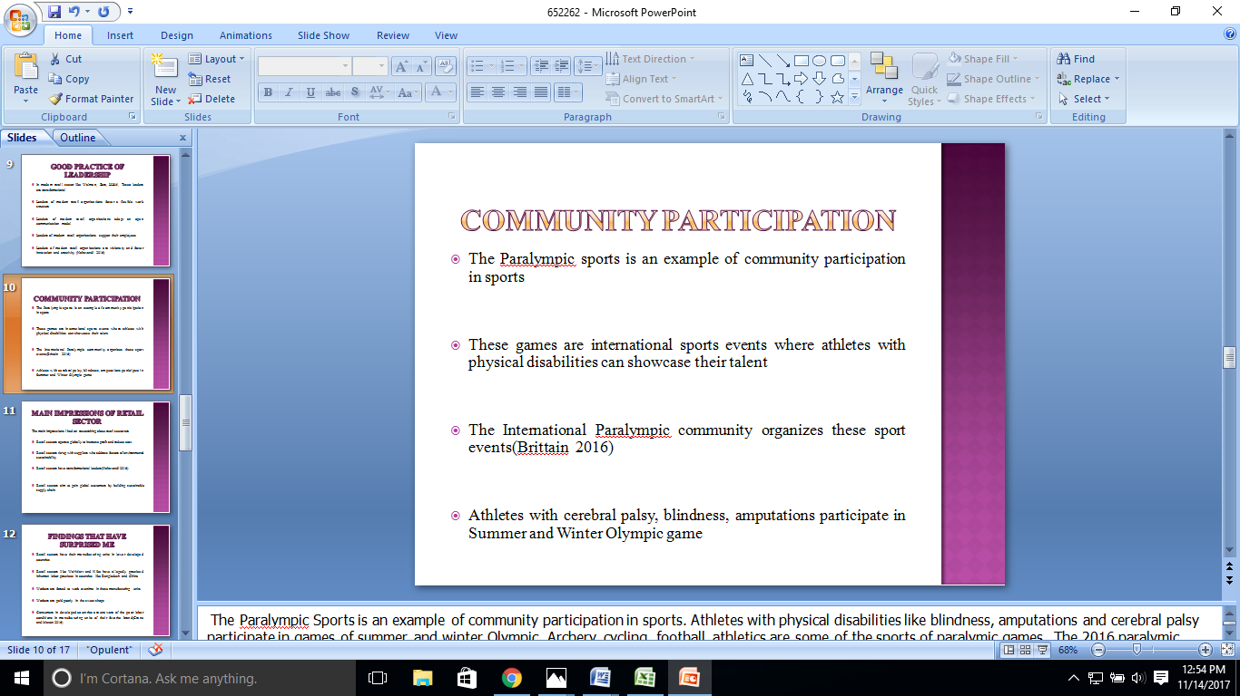
Screenshot of Presentation

