
Student name: |  | Volodymyr Kalhin | Student ID number: | 2514104
Programme: |  | Certificate of Higher Education Skills for the Workplace (Health & Social Care)
Module: |  | Introduction to Health and Social Care
Module code: |  | LCHS4003 | Contribution to Overall Module  Assessment (%): | 50%
Resit/Rework Lecturer: |  | Muhammad Aliyu | Internal Verifier: | Jolly Nwankwo
Assignment Title: |  | Portfolio – Two Tasks | Word count (or equivalent): | 1,500 words  Equivalent
Submission deadline: |  | To be submitted via Turnitin on Monday, 23rd March 2026, 10 am | Return date of provisional marks & written feedback: | 17th April 2026

Mental Health Services in Communities

Community Mental Health Services (CMHS) are specialised programs that are aimed at providing mental health care and treatment to people within the community, and not in institutions.
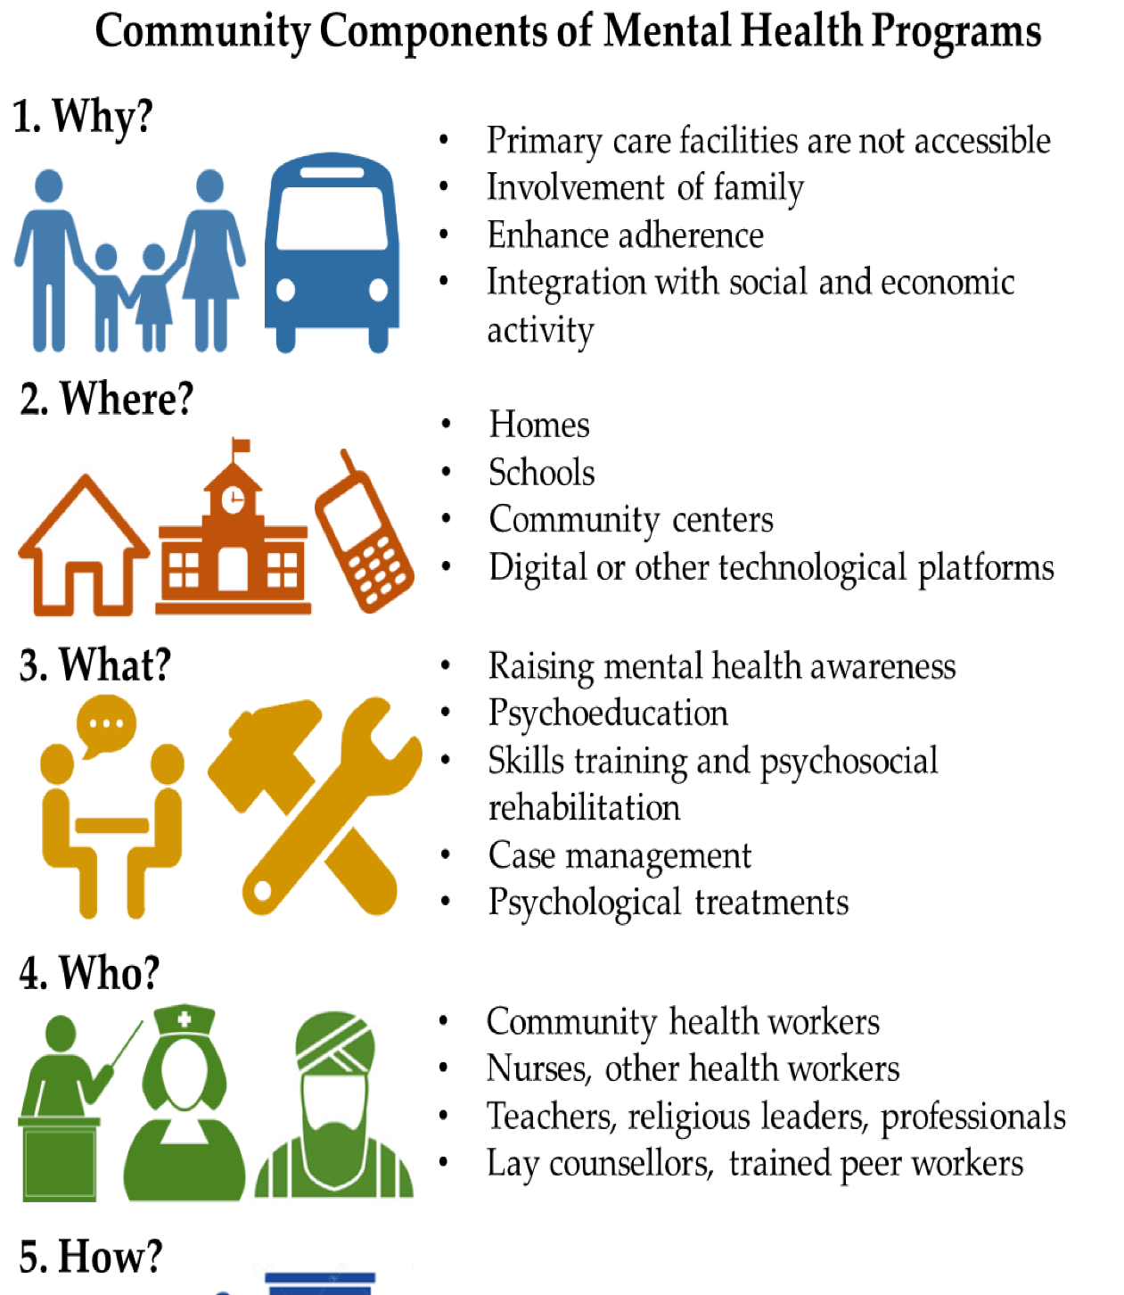
Figure 1: The Role of Communities in Mental Health Care in Low- and Middle-Income Countries: A Meta-Review of Components and Competencies. Retrieved from: https://www.mdpi.com/1660-4601/15/6/1279
- CMHS are broad and encompass therapy and counselling to crisis intervention and long-term care, among other forms of interventions aimed at enhancing the mental health of individuals situated in their immediate surroundings (NHS England, 2024).
- CMHS is concerned about delivering community-based, accessible care that supports recovery and reintegration into society and targets individuals of all ages and requirements (Bouras et al., 2018).
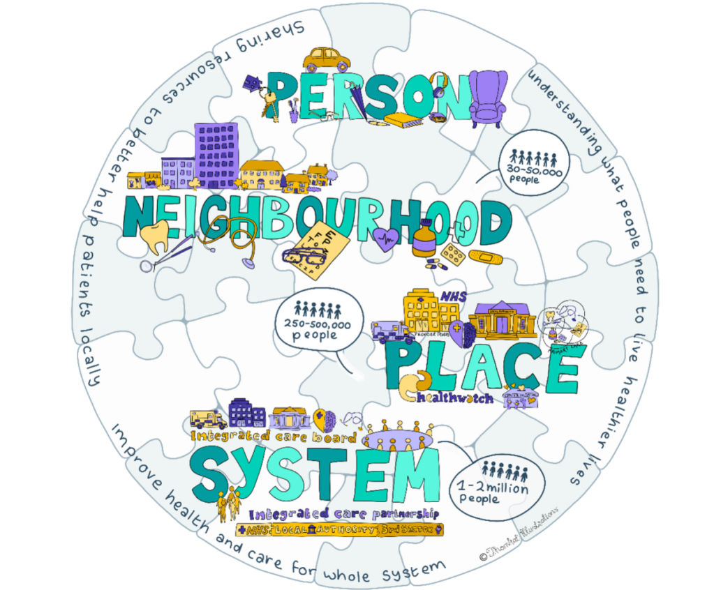
Figure 2: Integrated care systems (ICS) | NHS Confederation. Retrieved from: https://www.nhsconfed.org/publications/integrated-care-systems-ics
The three primary goals of CMHS include:
- Preventing hospitalisation
- Lowering the stigma of mental health
- Equipping patients with the means to cope with their ailments and live freely.
This is achieved using several community interventions, among them day centres, outreach programs, and home visits. It involves mental health professionals, i.e., psychiatrists, social workers, and psychologists working together to deliver an integrated care that is client-oriented (Vigo, 2017).

A Brief History of Community Mental Health Services
The transition of institutional to community-based care for persons with mental illnesses started in the latter half of the 20th century. In the past, patients with mental illnesses were usually placed in huge mental institutions, which were ineffective in numerous situations, and this resulted in negative health outcomes for patients (Turner et al., 2015). During the 1950s and 1960s, when people started to realise the drawbacks of institutionalisation, numerous Western nations started to transition to community care systems. This change was cemented in the UK by the National Health Service Act of 1946, which formed the beginnings of the expansion of access to mental health services. However, there was a tremendous shift in the de-institutionalisation movement of the 1980s, as long-term care became not the purview of psychiatric hospitals, but rather the services of community-based organisations. It was aimed at offering care in less restrictive and more integrated environments in society where people could recover (Bouras et al., 2018).
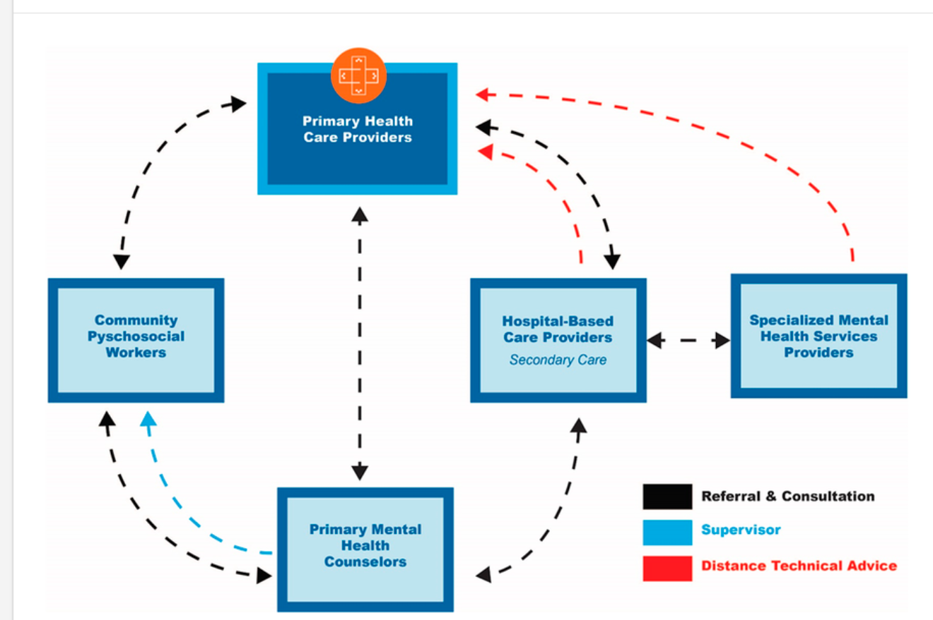
Figure 3: communiy-based Mental Health care framework. Retrieved from: https://www.researchgate.net/figure/Comprehensive-collaborative-and-community-based-care-C4-framework-for-LMICs_fig1_368857198
Community mental health care is still becoming increasingly developed, especially with the inclusion of new methods, such as recovery-oriented care and the increase in the number of multidisciplinary teams (Bemme et al., 2021). Nevertheless, the problems have not been eliminated, especially the ability to meet the increasing demand with the required resources to supply the services.

Current Functioning of Community Mental Health Services
Nowadays, CMHS in the UK are present on many levels, such as the early intervention and prevention up to the treatment of severe mental illnesses in the long-term. As NHS England (2024) states, contemporary CMHS provides an outreach service, counselling, social support, and psychiatric treatment. Such services usually act in liaison with local general practitioners (GPs), social services, and housing support organisations in order to provide holistic care to people.
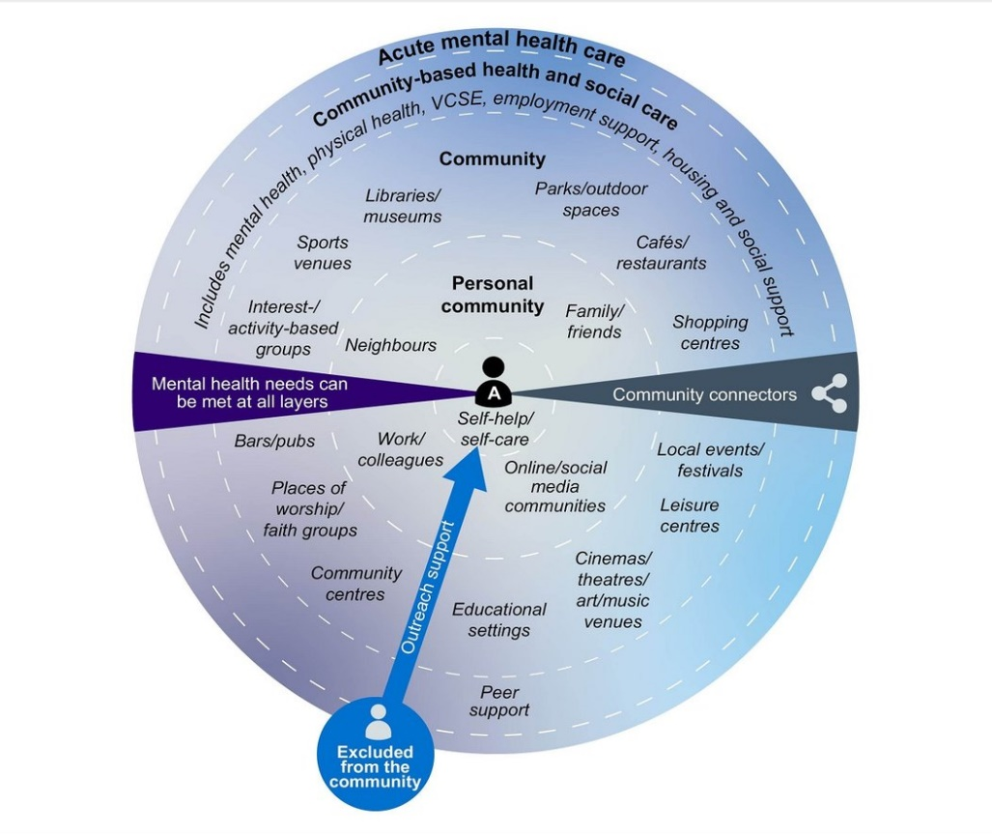
Figure 4: Current functioning of CMHS. Retrieved from: https://www.hssib.org.uk/patient-safety-investigations/care-delivery-within-community-mental-health-teams/investigation-report/
Among the biggest CMHS innovations, the shift towards integrated care systems (ICS), in which several services are synchronised to provide holistic care, should be mentioned. These systems enable quicker and more individual care since they offer accessibility to numerous professionals who collaborate.
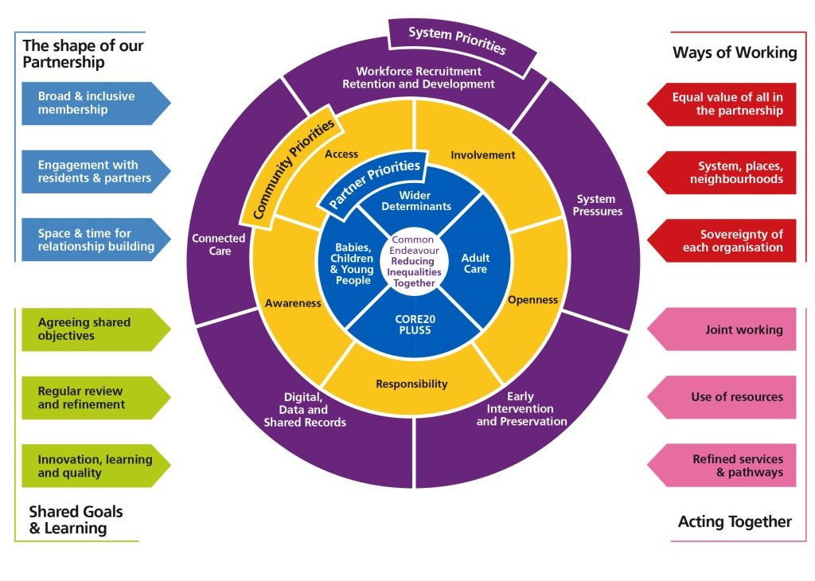
Figure 5: Integrated Care system. retrieved from: https://www.midandsouthessex.ics.nhs.uk/about/integrated-care-strategy-2023-33/what-is-important/
- CMHS also uses digital tools to keep track of its patients, enabling more effective and frequent communication between professionals and service users (Vigo, 2017).
- CMHS has become more interested in mental health crises, and some of them provide crisis intervention and mental health urgent care centres where people can obtain immediate care without having to visit a hospital (Bemme et al., 2021).
- The method can greatly alleviate the load in emergency departments and offer a more humane, specialised intervention to patients in acute distress.

Two Challenges Faced by Community Mental Health Services

Challenge 1: Inadequate Funding and Resource Shortages
Although there have been advances in the development of CMHS, one of the challenges has been underfunding and a shortage of resources that influence service delivery. There has been a huge rise in the demand for mental health services, particularly during the COVID-19 pandemic period, but the funding has not kept up (Ahmed et al., 2023).
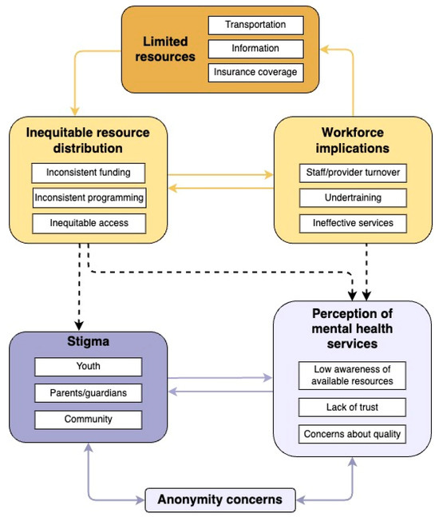
Figure 6: Effects of Limited Resources on CMHS. Retrieved from: https://www.mdpi.com/1660-4601/21/6/725
The community typically results in mental health services being cut, limiting them to staff hiring, the required training, or the adoption of modern treatments (Bouras et al., 2018). Due to that, patients can face delays in receiving treatment, limited access to services, and a greater risk of mental health emergencies (NHS England, 2024).

Challenge 2: The Impact of the COVID-19 Pandemic on Service Delivery
COVID-19 affected mental health services in the entire world, including community-based services. As the need for mental health care increased considerably, a lot of the services underwent minimisation or transitioned into the remote mode, including teletherapy. Despite the digital platforms being beneficial, they have formed obstacles to some groups of people, including those who lack access to the internet or lack technology proficiency (Bemme et al., 2021).
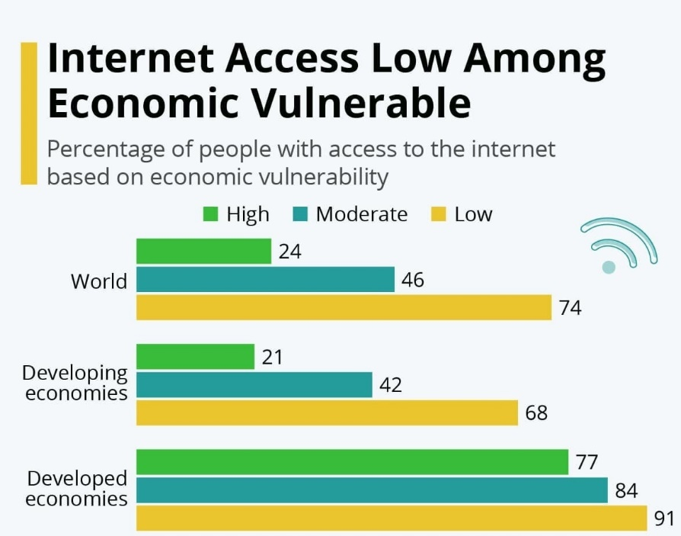
Figure 7: The digital divide exposed by COVID-19. Retrieved from: https://www.weforum.org/stories/2021/01/covid-digital-divide-learning-education/
Additionally, the pandemic aggravated mental health problems, which increased anxiety, depression, and post-traumatic stress disorder (PTSD) within communities (Ahmed et al., 2023). The long-term social consequences of the pandemic are the issue of restoring mental health services in the community, overwhelmed or paralysed in the midst of the crisis (Bemme et al., 2021). For example, whereas outreach services and face-to-face support have been of primary importance to the community mental health approach, they were limited considerably in times of lockdowns, which also affected access to vulnerable people (Vigo, 2017).

Conclusion
CMMHS is crucial to serving as an integrated, accessible care provider to people with mental illnesses. Community care is a significant step in the treatment of mental health and provides an opportunity to approach the treatment of a person as an individual, with care. However, the issues of inadequate funding and the effects of the COVID-19 pandemic still influence the effectiveness of such services. To make CMHS successful in the future, it is paramount that the governments and healthcare providers address these problems and ensure that funding and resources coincide with demand.

References
- Ahmed, N., Barnett, P., Greenburgh, A., Pemovska, T., Stefanidou, T., Lyons, N., Ikhtabi, S., Talwar, S., Francis, E.R., Harris, S.M., and Shah, P. (2023). Mental health in Europe during the COVID-19 pandemic: a systematic review. The Lancet Psychiatry, 10(7), pp.537-556.
- Bemme, D., Gayer-Anderson, C., Irvine, A., Strang, L. and Rose, N. (2021). Long-term societal implications of COVID-19: mental health.
- Bouras, N., Ikkos, G. and Craig, T. (2018). From community to meta-community mental health care. International journal of environmental research and public health, 15(4), p.806.
- NHS England (2024). Community mental health services. https://www.england.nhs.uk/mental-health/adults/cmhs/
- Turner, J., Hayward, R., Angel, K., Fulford, B., Hall, J., Millard, C., and Thomson, M. (2015). The history of mental health services in modern England: practitioner memories and the direction of future research. Medical history, 59(4), pp.599-624.
- Vigo, D.V. (2017). On burden: a study of the population-level health-effects of mental illness.

History, Present Operation, And Importance Of Ambulance Services
The ambulance service is a very important component of emergency medical care as it enables fast response to medical emergencies and enhances patient outcomes. These services were originally designed to facilitate transportation, but nowadays they have been integrated into complex systems that provide pre-hospital services. This essay delves into the history of ambulance services, their operation in the modern world, and their role in improving the living standards of the users of the services.
Ambulance services date back to the early 19th century when military forces utilised horse-drawn carriages to transport injured soldiers. In 1865, the initial civilian emergency medical transport was organised in London, which inaugurated the first modern ambulance service (Mort et al., 2015). At the beginning, ambulances were just employed in transportation. However, the growth of medical crises after World War II resulted in the professionalisation of ambulance services. The introduction of paramedics in the 1970s and 1980s was introduced to offer pre-hospital treatment, such as life-saving measures, such as CPR, airway care, and medications (Brady, 2020). These discoveries led to modern ambulance services that have become techno-paramedical.
Ambulance service of the modern time is a highly specialised organisation accompanied by the latest technologies and provided with trained paramedics. These services work under the system of triage and give priority to the most urgent emergencies (Brady, 2020). Telephone triage systems are very common, in which operators determine the severity of the condition of a patient and send an ambulance (Booker et al., 2019). Ambulances are nowadays more advanced with a GPS tracker and telemedicine, meaning that paramedics can contact hospital physicians in real-time (Pulsiri et al., 2019). Such technologies assist paramedics in giving prompt attention to the patient and relaying critical data about the patient, including heartbeat and oxygenation, before the patient even reaches the hospital. The ambulance services are also instrumental in solving the primary care problems. They are usually requested in non-emergency cases like chronic care of minor injuries, which can be treated by primary health care providers (Booker et al., 2019).
The services of an ambulance contribute greatly to the quality of life of people who are faced with medical emergencies. Fast response time may save lives in situations such as heart attacks, strokes, and trauma because the response is fast (Alnashwan et al., 2025). Patients can be stabilised with pre-hospital care, including the use of painkillers and oxygen, which enhance the effects of recovery. An additional benefit of technological advancements to patient care is such areas as telemedicine, which allows real-time consultations between paramedics and hospital physicians (Pulsiri et al., 2019). These technologies will make sure that patients receive the necessary care until they are at the hospital, which enhances the effectiveness of the treatment. Furthermore, the emergency ambulance services offer emotional assistance. Professionalism and empathy of paramedics are the source of anxiety relief to patients and families and provide reassurance in stressful times (Newton, 2014).
Ambulance services have participated in the development of the primitive modes of transport to the modern medical care teams, which offer life-saving interventions. They are needed today to handle medical emergencies, provide state-of-the-art care, and enhance patient outcomes. In spite of such setbacks as overloading with non-emergency patients, ambulance services remain critical in improving the quality of life of service users, saving lives, and offering the necessary treatment during critical situations.

References
Alnashwan, H.F., Almutairi, F.T., Almutairi, A.S., Alghuwainem, A.M., Aljuraybah, S.A., Almoijed, M.B., Almutairi, E.A., and Almutairi, H.L.H. (2025). Advancing Ambulance Services For Optimal Emergency Response: A Comprehensive Review Of Global Practices And Innovations. The Review of Diabetic Studies, pp.197-207.
Booker, M.J., Purdy, S., Barnes, R. and Shaw, A.R., (2019). Ambulance use for ‘primary care’ problems: an ethnographic study of seeking and providing help in a UK ambulance service. BMJ open, 9(10), p.e033037.
Brady, M. (2020). Patient experiences of UK ambulance service telephone triage: a review of the literature. International Journal of Emergency Services, 9(2), pp.89-108.
Mort, A.J., Fitzpatrick, D., Schneider, A., Wilson, P. and Mellish, C. (2015). Pre-hospital technology research: reflecting on a collaborative project between ambulance service and academia. Journal of Paramedic Practice, 7(4), pp.184-191.
Newton, A. (2014). Ambulance Service 2030: the future of paramedics.
Pulsiri, N., Vatananan-Thesenvitz, R., Sirisamutr, T., and Wachiradilok, P. (2019), August. Save lives: a review of ambulance technologies in pre-hospital emergency medical services. In 2019, Portland International Conference on Management of Engineering and Technology (PICMET) (pp. 1-10). IEEE.

