Gulab Uddin – 1708842
Assignment title: knowledge and information management skills for the workplace
Module code: BMSW5006
Lecturer’s name: Buddhi Pathak

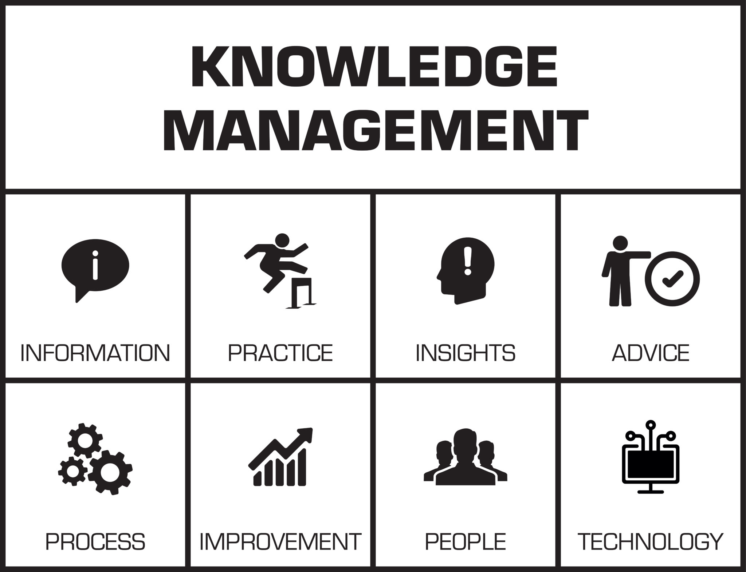

Contents:
Introduction………………………………………………………….………………….3
Why can the same set of data be used as knowledge?.................................3-4
Knowledge differs from data……………………………………..………………….4
Knowledge differs from information……………………………..…………………5
Is tacit knowledge used in a card game or explicit knowledge?...................5-6
Five decisions I have made today…………………………………………………6-7
How to use data and convert it into information………………………………….7
References……………………………………………………………………………….8-9

Introduction
The purpose of this task is for me answer the following the questions which have been set out to explain why the same sets of data can be used and considered as a useful piece of information by some and useless data by others and if this useful information be termed as knowledge and why? Using appropriate examples and theories/concepts which I have learnt during my first 4 weeks of study. Secondly, I will be describing such ways in which knowledge will differ from data and information as well so I will then be justifying my answer and explanation with the relevant diagrams and examples. Furthermore, a question is also given whether a player in a card game is using tacit or explicit knowledge? With a brief explanation towards the answer I provide. I will then be defining and giving a brief explanation towards the difference between both examples I will be using. Moreover, I will be considering five decisions which I have made which might be simple such as taking a turn whilst driving or even choosing a soda at a local convenience store. In each example I will be using I will determine the data, knowledge or information which have been involved in the decision in which I take. Lastly, I will be collecting demographic data from sample population, this is where I will be determining how I can be able to use this data to be able to convert it into information and possibly knowledge for promoting the product. The outcome for this task is to evaluate the key concepts as well as the importance of knowledge management based within the terms of an organization’s knowledge assets and the management systems and to understand knowledge management processes which is required within an organization development to develop a framework to establish a good knowledge management culture.
Why can the same set of data be used as knowledge?
The reason as to why data is useful is because transactional data is very important for many businesses and the reason to this is because it can help them to expose variability and to also optimize their operations for higher quality of results and this is by examining large sums of data so it is possible to uncover the different hidden patterns as well as the correlations according to (What is data, and why is it important? | Import.io, 2018). There are many potential benefits for the use of data collection and the main benefits to consider for data collection is that data helps everybody to analyse and make appropriate decisions so in other words is good for decision making techniques and the important decisions have to be made by every individual on a daily basis and transparent information and utilizing your analysis to make improvements and more room for improvement for a later stage if required and the use of the data towards your advantage is always important as well and very useful especially to improve a business or other working environments and an environment which has the use of storing and collecting data on a daily basis so this then involves all businesses which is important and enables any type of business to succeed and gather the important information in which they need to stay competitive and improve on all areas of other parts of a business according to (Benefits of Data Collection to Improve Business Workflow, 2020). Data itself is very important and it allows many organizations to determine more effectively the cause of the problem if there was any to make appropriate decision-making techniques and suitable recommendations for the type of issues which may be faced within the workplace environment. Data also allows many organizations to visualize the relationships between what’s about to happen or what is happening in the different locations, systems and departments according to (12 Reasons Why Data Is Important | The Council on Quality and Leadership, 2020). Collecting data also allows people and organizations to store and analyse the relevant information not only about your existing customers but the potential ones too so being able to collect this type of information can therefore save a company or business a lot of money and time to then prepare a plan to build a database of customers for the future marketing and retargeting efforts as well. Good data has the ability to reduce exposure to possible legal action as well as the human rights complaints procedures so being able to collect data on a daily basis and using the accepted data collection tools and procedures has the ability to help an organization show where it has met the targets and the duties to protect and therefore uphold human rights.
Knowledge differs from data
The reason as to how knowledge differs from data is that data itself is containing facts and messages for others which involves a set of discrete facts, not yet interpreted symbols or raw facts so in my point of view data can then be defined as a set of representation of the plain facts this is where knowledge then takes over and forms into personalised information which can then be gathered through studies as well as experiences too according to (What is the difference between data information and knowledge - Assignment Point, 2020). Knowledge itself refers to the awareness as well as the understanding based on the subject which may result to being education based or work based or may even be related to experiences of an individual. So, information is nothing but known as the refined form of data that is helpful to understand the meaning. Furthermore, to this report knowledge is a relevant and objective piece of information that has the ability to help in drawing to conclusions if necessary or required.

Knowledge differs from information
Information is data that has been processed whereas knowledge is just information that is moulded to be useful when needed or required. A person needs information to then have the ability to gain new knowledge and information deals with the way data is related and whilst knowledge would then examine different types of patterns which will be within a provided set of information. The difference between knowledge and understanding is that knowledge is something that you have ability to gain through learning and understanding can be something that you may know because you may have already experienced it or have experienced it a long time ago which you will still have understanding and knowledge about. The direct experience gives an individual the understanding so you should give more importance to the things you gain by learning experiences to experience them yourself rather than then attempting to learn such knowledge as experience can gain you automatic knowledge when you experience such situations by yourself according to (What is the difference between knowledge and understanding?, 2020). Knowledge is referred to the understanding on the matter which you get from education that is gained or experiences of a person. Information isnt anything but the refined form of data, which is useful to understand the meaning. On the other hand, knowledge is the relevant and objective information that helps to draw conclusions.
Is tacit knowledge used in a card game or explicit knowledge?
when it comes to a card game it is well-known that a card game would require a tacit knowledge based upon the players intuitions, insights and hunches that would be used by the player to then analyse the state of the game and then formulate a strategy. So, this would then result to the accuracy of the player who is playing the card game and how much experience and knowledge they have in order to be succeeding in winning the game according to (Does A player in a card game use tacit or explicit knowledge? Explain why. Define and explain the difference between the two, 2020). Tacit knowledge can be used for may purposes as a strategy such as socialization which is the sharing of tacit knowledge through social interactions like being face-to-face for instance. Externalization is a process which can be used to convert tacit knowledge in a more visible form but whereas explicit knowledge is concerned combination is the process through which discrete pieces of explicit knowledge are then recombined into a new form thereafter according to (Tounkara, 2020). Using tacit knowledge is known to be one’s personal, intuitive knowledge and experiential knowledge also as opposed to explicit knowledge and this can be codified easily and communicated easily too so being able to manage tacit knowledge is very important and is an important exercise where organizations should use to carry out every day to then promote the overall growth and performance as well whether being in an educational environment or a working environment. There are three ways on how a person is able to obtain tacit knowledge and gain tacit knowledge. 1) if an individual spread the important knowledge around to other individuals it helps to gain more knowledge and tacit knowledge. 2) to be able to gain tacit knowledge a person should also create such an environment where others are encouraged with their new ideas to share around towards other people which is also a good way to gain tacit knowledge. 3) a person should also provide a formal learning program which for example there should be a budget for such team developments and also training courses too which creates and provides the opportunities for other people as well as myself to gain tacit knowledge.
Five decisions I have made today
- The first decision that I have made today was to go to work on an alternative route and the reason why I have chosen this root is because it is a lot easier to get to work with the alternative route that I chose to avoid the traffic up ahead on my old route to avoid being late at work again. The type of knowledge that is involved taking this decision is due to the experience I’ve had in the past where I have been late to work on an occasion where I had been stuck in traffic for a very long time which caused this so I had tried an alternative route in the past where it had resulted to me getting to work much quicker even if there was a lot of traffic and this is the knowledge and experience I have which led to this decision being made.
- The second decision I have made today was wearing my favourite ring on my other hand and this is because it had become loose on one hand which is why I attempted to try it on my other hand as for the information I have gathered I had researched that sometimes there is a difference on a persons hands where your fingers have a difference in size and thickness which you cannot tell but scientists have gathered that this is true and the dominant hand is more likely to have a ring fit than a non-dominant hand so upon reading this I had decided to try this on my other hand upon gathering this piece of valuable knowledge from a valuable source according to (De Jager, 2018).
- Another decision I have made today was to use my favourite perfume today to smell good before going to work as my mind had told me due to the fact that I have had a shave and I am feeling a lot more smarter and wearing fresh clothes that its also best to wear my favourite perfume due to this and because of this occasion coming after while I chose to do this due to a lot of the compliments I also received from fellow colleagues at work to so it’s why I chose to do so according to (Editors, 2018).
- I also decided to make the decision to make myself breakfast today and the reason to this was that I know how I like my breakfast to be made and so to have somebody else to make this for me in the mornings just didn’t taste very good to me and didn’t taste right for me so I decided to make breakfast myself the way that I wanted it and feel better about having my breakfast in the morning which to me will feel a lot more better so my mind has given me the information that I have had the experience before where I didn’t like the breakfast made for me by somebody else which is best for me to make it myself the way that I like to have it to avoid such a problem in the future.
- Lastly, I decided to spend more time at home to avoid time consumption where I can use this valuable time at my workplace in the mornings to socialize more with my fellow colleagues and friends which makes me happy in the mornings as to sometimes I don’t be in the right state of mind and having a laugh and a joke with fellow colleagues and friends helps me to take my mind of things and makes me a lot more happier at times as well so my mind tells me on occasions to take this approach due to the fact that it keeps me in a happy mood and that is due to the fact that my experiences and knowledge has helped me to reach this conclusion as my past experience has given me all the knowledge to use at a later stage to avoid such issues again and to then take a different approach to reach a better solution towards the situation.
How to use data and convert it into information
The way data is turned into information is when the data has been taken and therefore been utilized and manipulated by combining it with other relevant data and trending it over time as well. Assessing or analysing the outliers that need to be dealt with and the most important as well applying your own experience and knowledge to therefore transform that particular data into something that can be used towards other related theories etc to reach an appropriate decision which is why problem solving and decision making techniques are very valuable within the educational and workplace environment according to (Theriault, 2020).

References
C-q-l.org. 2020. 12 Reasons Why Data Is Important | The Council on Quality and Leadership. [online] Available at: <https://c-q-l.org/resource-library/publications/cql-publications-for-free/12-reasons-why-data-is-important> [Accessed 16 March 2020].
Antares Technology Solutions. 2020. Benefits of Data Collection to Improve Business Workflow. [online] Available at: <https://www.antaresnet.com/data_collection/> [Accessed 16 March 2020].
de Jager, F., 2018. Finger Size Matters - How to Measure and Order the Perfect Size Ring. [online] The True Diamonds Blog. Available at: <https://www.trudiamonds.co.uk/blog/finger-size-guidelines/> [Accessed 17 March 2020].
Chegg Study. 2020. Does A Player in A Card Game Use Tacit or Explicit Knowledge? Explain Why. Define and Explain the Difference Between the two. [online] Available at: <https://www.chegg.com/homework-help/questions-and-answers/player-card-game-use-tacit-explicit-knowledge-explain--define-explain-difference-two-q13685527> [Accessed 17 March 2020].
Editors, F., 2018. How to Choose the Right Fragrance for The Occasion? [online] Fashion Beans. Available at: <https://www.fashionbeans.com/article/right-fragrance-for-occasion/> [Accessed 17 March 2020].
Theriault, M., 2020. 6 Ways to Transform Data into Information That Drives Decision Making | Allbusiness.Com. [online] AllBusiness.com. Available at: <https://www.allbusiness.com/transform-data-real-information-drives-decision-making-16096-1.html> [Accessed 14 March 2020].
Tounkara, T., 2020. [online] Available at: <http://file:///C:/Users/local%20user/Downloads/ejkm-volume11-issue3-article411.pdf> [Accessed 16 March 2020].
Import.io. 2018. What Is Data, And Why Is It Important? | Importin. [online] Available at: <https://www.import.io/post/what-is-data-and-why-is-it-important/> [Accessed 16 March 2020].
Assignment Point. 2020. What Is the Difference Between Data Information and Knowledge - Assignment Point. [online] Available at: <https://www.assignmentpoint.com/business/management/what-is-the-difference-between-data-information-and-knowledge.html#:~:text=For%20one%20data%20is%20%E2%80%9CFacts,of%20Representation%20of%20plain%20facts%E2%80%9D.&text=This%20knowledge%20is%20personalized%20information,gathered%20through%20experience%20or%20study.> [Accessed 14 March 2020].
Quora. 2020. What Is the Difference Between Knowledge and Understanding? [online] Available at: <https://www.quora.com/What-is-the-difference-between-knowledge-and-understanding> [Accessed 12 March 2020].

