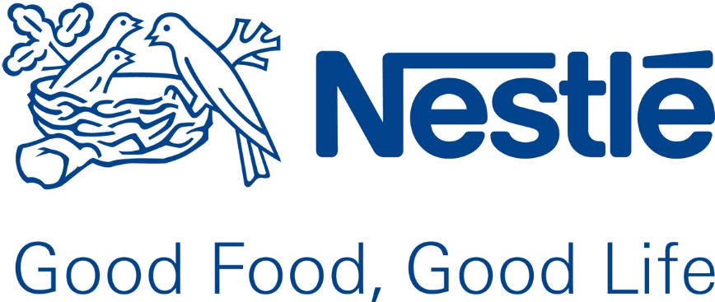

Structure and Culture of NESTLE

Student : Dimitar Gadov
Student Number : 1913486
Tutor’s Name : Dr. Gregory Cowan
Module : Introducing the Modern Workplace
Module Number : LCBB4003
2020

Introduction
Nestle, created in 1866 by Henri Nestle, is the giant food and beverage corporation in the world. (Nestle annual report, 2018) In the beginning, the company has sold children’s cereal, but rapidly diversified to include a varietation of items, such as: chocolate, coffee, water, soups, yogurt and frozen foods. (The History of Nestle, 2019)
The company’s founder, was innovator by nature. He produced a nourishing cereal at first, but quickly developed more products. Eight years afterwards, they can be already found throughout the world in countries in Asia, South America and United States.
The whole firm worked hard to enter in US market. That leaded to partnership with one of the biggest company in the world – Coca Cola.
At this time, the corporation has under control more than two thousand labels, based all over the world. They have a direct aim to be the leader in health and wellness.
(The History of Nestle, 2019)
Organisational Strategy
The strategy is the sum of the actions that a company aspires to get and achieve long-term aims. All of those actions make up a company’s strategic plan. (What Is the Meaning of Organizational Strategy?, Sophie Johnson, Updated March 08, 2019)
The organizational strategy of a company is based on its mission. It is the main regulation, which is lined with every job task in the company in making tactical decisions. (Organisational behaviour, Hellriegel. D. and Slocum. Jr, 2004)
Nestle aims to offer variety of products to satisfy customer needs, offer dietetics and delight the senses, which are giving healthier and more balanced live and also a cleaner planet. The company are achieved by:
- Meeting the needs of the modern consumer with healthy and convenient products for the busy daily lifestyles.
- Offering a broad range of organic plant foods for customers with special diet
- Bringing premium food innovations to market (Our strategy: The choices we make, Nestle’s website)
Structure
An organizational structure is a system that defines how necessary activities are administered in order to reach the goals of an organization. These can include: rules, roles, and responsibilities. Also it regulates how information moves between levels of the company. It can be presented as diagram or chart. (Organizational Structure, W.Kenton, Jul 1, 2020)
Structure can be created around functions, products, and geographic areas. (Cultural implications of business strategy-making, K. Fatehi, 2016)
Functional structure shows how each part of the corporation is grouped according to its purpose with different departments, such as: marketing, production, sales. (Different Types of Organizational Structure, Alexis Writing, Updated February 12, 2019)
Advantages of it are:
- Better productivity;
- Clarity and punctuality - each group of specialists know what to do
- Responsibility of each team member
Disadvantages are:
- Miscommunication- different functional groups may not communicate with each other;
- Susceptible to tunnel vision;
- Coordination between the departments may take too long.
(Models of Organizational Structure, Jim Woodruff, 2018)
Product structure is the most used and most effective model. It arranges tasks and leadership. Workers are categorized by product lines and types, by business characteristics, market and geographically.
Advantages are:
- Concentrating and gaining product knowledge;
- Divisions operate independently;
- Better respond and focus on faster changing market
Disadvantages are:
- It is more expensive for the company;
- Possible conflict;
- Lack of communications between departments.
(Models of Organizational Structure, Jim Woodruff, 2018)
Geographical structure groups employees according to the region in which they operate. It is common used in large, multinational firms.
Advantages are:
- Strong local base;
- Logistical efficiencies;
- Flexible market response;
- Good training ground for managers
Disadvantages:
- Potential conflict between local and central management
- Duplication of resources
- Problems in terms of company culture
(Geographic Organization Structure, Jayne Thompson, 2019)
Nestle operates in different zones (1. Europe, Middle East and North Africa; 2. South and North America; 3. Asia/Oceania/Africa) with the exceptions of the globally managed businesses. (Management, Nestle’s official website)
There are different types of organization charts that include hierarchical, matrix and flat.
Nestle Company is organized according to the matrix structure. Advantages of this structure are that employees can share their knowledge and understand their role in the company, leading to professional growth. (Nestle´s organization, Wordpress, 20 Jan, 2019)
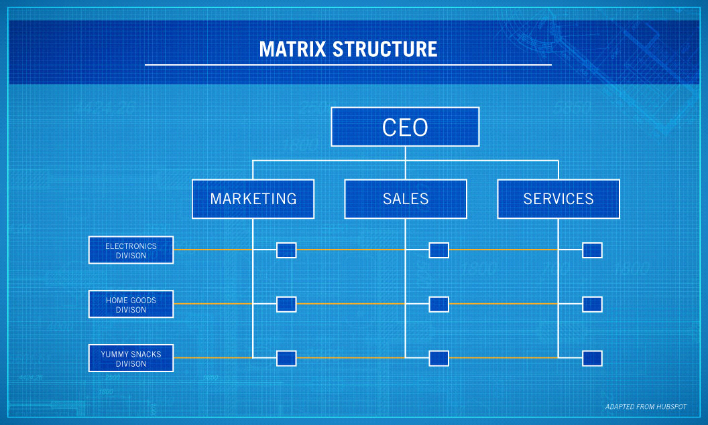
Source: 4 Types of Organizational Structures, Posted February 15, 2018 by admin, https://online.pointpark.edu/business/types-of-organizational-structures/

Chain of Command
According to Nestle website, the company has a board of directors, with chairman Paul Bulcke, who was the former CEO. Each Board member has high level of qualification, proven experience, skills and expertise that covers company’s business aims. (Board of directors, Nestle website)
Nestle chain of command consists of a Board of Directors of a total of 14 members and the Executive Board of 13 members, who manages the company daily in different areas of the global business. The Executive Board include two CEO, ten Vice Presidents and Secretary to the Board of Directors. This type of structure maintains the consistency and effectiveness of communication throughout the organization. (Nestle annual report, 2018)
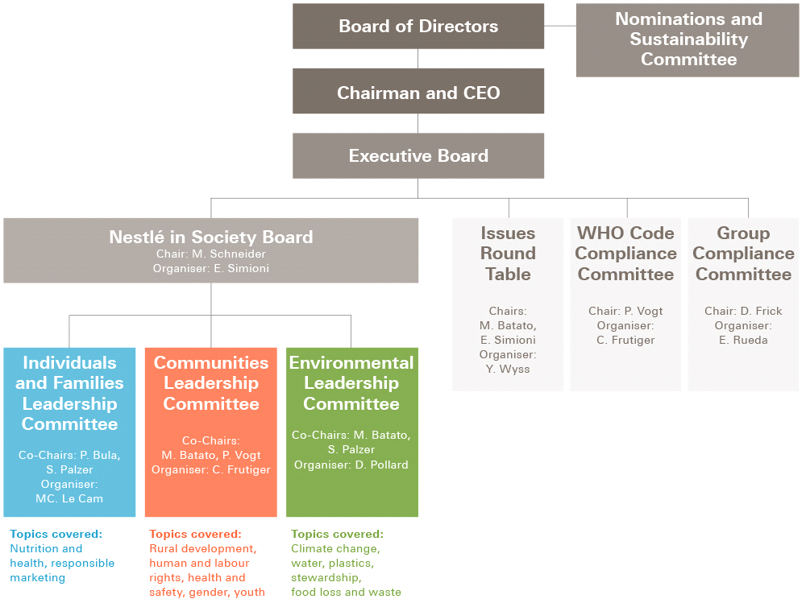
Source: Internal governance structure, Accountable and inclusive governance, https://www.nestle-cwa.com/en/csv/what-is-csv/accountable-and-inclusive-governance/

Span of Control is stated in maximal numbers of workers, that the supervisior can assure and monitor them for the realisation of all available duties and responsibilities. (Leadership, change and responsibility, by Remme Joop, 2008)
Nestle Company is a decentralized organization. Major decisions are made by the Board of directors, but daily operations are made by the other levels of the management.
By the matrix organisational chart, the company has:
- Top level of management
- Middle level of management
- Lower level of management, where each level does their own responsibilities.
(Nestle´s organization, Wordpress, 20 Jan, 2019)
Culture
Organizational culture relates to the beliefs, ideologies, principles of a selected corporation. The relevant one contains a deep impact of the staff and their relationship between themselves. It‘s extremely important for all co-workers to understand and accept the culture of their workplace. (Understanding organization and organization culture, What is organisation culture, by Prachi Juneja)
Hofstede's cultural dimensions’ theory shows the results of a society's culture, communication of the members and the way they relate to behaviour. (Effects of Information Capitalism and Globalization on Teaching and Learning, Hofstede’s cultural dimensions, p6 , by Adeoye, Blessing F.)
Based of his study, it identifies six major dimensions of national culture.
- Power distance
This dimension shows the degree to which the less powerful members of a society accept and expect that power is administrated unevanly.
- Individualism vs Collectivism
The high side of this dimension represents a social shut in which individuals are expected to take care of only themselves. On the opposite hand, collectivism, presents a society, where the in-group care and loyalty are prevailing.
- Masculinity vs Femininity
The Masculinity means a preference in society for achievement, bravery and substantial rewards for achievement. Its opposite, femininity, sits for a predisposition for cooperation, fairness, caring for the weak.
- Uncertainty avoidance
The Uncertainty avoidance dimension demonstrates how the the members of a society feel unpleasant with uncertainty. Weak avoidance society is assosiated with more relaxed persuasion.
- Long term orientation vs short term orientation
Societies, who score low, choose to maintain old-time traditions and norms. On the opposite hand, those with a culture which scores high, take a more pragmatic approach.
- Indulgence vs Restraint
Indulgence sits for a society that enables relatively free gratification. Restraint stands for a society that represses fulfilment of needs and regulates it as strict social norms.
(National culture, by Professor Geert Hofstede, Hofstede Insights)
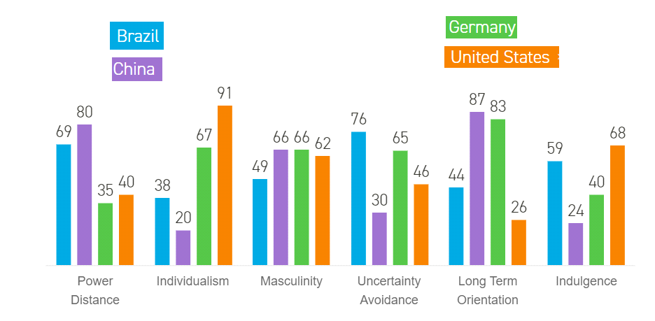
Source: Hofstede's Cultural Dimensions, Understanding Different Countries, https://www.mindtools.com/pages/article/newLDR_66.htm
Nestle operates in many countries and in many cultures throughout the planet.The corporate embraces cultural and social diversity and doesn‘t discriminate on the basis of origin, nationality, religion, race, age or gender. (The world of Nestle, Nestle Italy)
Nestle has unique collaborative culture where they expect employees to move, make decisions quickly and feel comfortable working beyond their recent team. (Transforming Nestle’s culture isn’t just inside our walls, it’s in how we hire, by Jon Salmons, 2018)
The firm has high performance culture, using rewards and development programs to make sure their individual and business objectives. They need a very awfully trade policy, where employees are encouraged to talk directly and honestly with the managers. (Performance culture, Nestle Canada’s website)
Leadership
Leadership is the art of motivating a gaggle of individuals to act toward achieving a standart goal. This could be directing employees and colleagues with a method to fulfil the company's needs. (What Is Leadership? by Susan Ward, 2020)
Effective leadership is on the point of inspiring and winning commitment. Leadership is more about personal authenticity and recognising personal fundamental flow, which limit the capacity. Leaders need strong sense of direction, energy and clear vision. (Educational leadership, by Harry Tomlinson)
Leadership devides from management. Managers have to plan, measure, monitor, coordinate, solve, hire, fire, and so on. Leaders concentrate on people and lead, inspire, innovate and develop the corporate. (What Is Leadership, by Kevin Kruse, Apr 9, 2013, Forbes)
Nestle leadership policy is concentrated on:
- Grow talent of its employees and build comfort working environment;
- Believes in achieving business objectives based in compliance and sustainable practices;
- Lead to win, think from different perspectives and to create modernism;
- Believes in open dialogue with stakeholders about future trends, technology, consumer habits and business opportunities.
(The Nestle Management and Leadership Principles, Sept 2011)

Conclusion
From its creation, Nestle company has built a fortunate business through understanding and predicting consumer wishes, and adapting to achieve in a developing marketplace. Through enhancing quality of life and contributing to a healthier future, they aim to deliver sustainable, industry‑leading financial performance and build trust. Nestle use the ability of their food and drinks to reinforce quality of life for everybody, for today and for future generations. (Strategy of Nestle, Nestle official website)

References
The History of Nestle, by Martin Luenendonk, September 20, 2019
Nestle Annual report 2018
What Is the Meaning of Organizational Strategy?, By Sophie Johnson, Updated March 08, 2019
“Organizational Behaviour”, by Hellriegel. D. and Slocum. Jr., J.W., 2004
Our strategy: The choices we make, https://www.nestle.com/aboutus/strategy
Organisational structure, By Will Kenton, Reviewed By Amy Drury, Updated Jul 1, 2020
Cultural implications of business strategy-making, by K. Fatehi, 2016
Different Types of Organizational Structure, By Alexis Writing, Updated February 12, 2019
Models of Organizational Structure, By Jim Woodruff, Updated December 13, 2018, Small Business
Geographic Organization Structure, By Jayne Thompson, Reviewed by: Michelle Seidel, Updated June 13, 2019
Nestle´s organization, Wordpress, 20 Jan, 2019, https://nestleanalysis2019.wordpress.com/2019/01/20/nestles-organization/
Management, Nestle’s official website, https://www.nestle.com/aboutus/management
Source: 4 Types of Organizational Structures, Posted February 15, 2018 by admin, https://online.pointpark.edu/business/types-of-organizational-structures/
Board of Directors, Nestle website, https://www.nestle.com/aboutus/management/boardofdirectors
Source diagram: Internal governance structure, Accountable and inclusive governance, https://www.nestle-cwa.com/en/csv/what-is-csv/accountable-and-inclusive-governance/
Remme Joop, Jones Stephanie, van der Heijden Beatrice, De Bono Silvio, “Leadership, Change and responsibility”, 2008
Understanding organization and organization culture, What is organisation culture, by Prachi Juneja, Reviewed by Management study guide content team
Effects of Information Capitalism and Globalization on Teaching and Learning, Hofstede’s cultural dimensions, p6 , by Adeoye, Blessing F.
National culture, by Professor Geert Hofstede, Hofstede Insights , https://hi.hofstede-insights.com/national-culture
Source: Hofstede's Cultural Dimensions, Understanding Different Countries, https://www.mindtools.com/pages/article/newLDR_66.htm
The world of Nestle, Nestle Italy, https://www.nestle.it/sites/g/files/pydnoa476/files/asset-library/documents/pdf_nostri_report/12_theworldofnestle.pdf
Transforming Nestle’s culture isn’t just inside our walls, it’s in how we hire, by Jon Salmons, Oct 16, 2018
Performance culture, Nestle Canada’s website, https://www.corporate.nestle.ca/en/careers/why-nestle/performance-culture
What Is Leadership? Definition & Examples of Leadership, by Susan Ward, Updated August 15, 2020)
Educational leadership, by Harry Tomlinson, p118
What Is Leadership?, by Kevin Kruse, Apr 9, 2013, Forbes
The Nestle Management and Leadership Principles, Sept 2011, https://www.nestle.com/sites/default/files/asset-library/documents/library/documents/people/management-leadership-principles-en.pdf
Strategy of Nestle, Nestle official website, https://www.nestle-cwa.com/en/aboutus/strategy

