
DATABASE APPLICATION DEVELOPMENT
Database Design & Implementation



Module Name: DATABASE APPLICATION DEVELOPMENT
Module Code: ACCA5026

Student Name: Beda Clement NDEPO
Student ID: 2411399

Lecturer’s Name: FAHA AHMED

14/08/2026

Table of Contents
PART A 2
Scenario: MedAssist Clinic 2
I. INTRDUCTION 2
II. DATABASE DESIGN 2
1. Entity Types 2
2. Attribute Types 2
3. Tables 2
4. RELATIONSHIP (EDR) 4
5. Normalisation of the design to Third Normal Form (3NF) 5
III. IMPLEMENTATION AND DOCUMENTATION 7
A. Table Creation 7
B. Constraint Implementation 9
C. Sample of Data Insertion 13
D. Examples Using SQL Aggregate Functions 14
E. Examples of UPDATE and DELETE 15
F. Validation Methodology 15
G. Med Assistant Clinic Auditing Implementation 16
H. How to Implement Auditing 16
IV. STORE PROCEDURE AND TRANSACTIONAL SCENARIO 17
A. Stored Procedure 17
B. Key Queries and Operations Critical to Business Performance (MedAssistant Clinic) 18
C. Transactional Scenario 20
V. PERFORMANCE TUNING ENHANCEMENT: QUERY OPTIMISATION 20
A. Indexing strategy 20
B. Indexing Benefits MedAssist Clinic’s Operational Data Handling. 24
C. Improvement in Query speed and efficiency 24
VI. CONCLUSION & REFLECTION 24
PART B 25
University Library (Books borrowing) 25
INTRODUCTION 25
A. Identification of SQL Injection Vulnerabilities on the Website 25
B. Demonstrating Attempted Injection 26
CONCLUSION & RECOMMENDATIONS 27
RECOMMENDATIONS 27
References 28

PART A

Scenario: MedAssist Clinic

INTRDUCTION
MedAssist Clinic is expanding its services and needs a modern, secure system to manage patient records, doctor schedules, appointments, treatments, and feedback. As the current processes are inefficient and prone to errors, the clinic requires a structured relational database to support reliable, multi-user access and maintain data integrity.
As the database consultant, your task is to analyse the clinic’s operations and design a relational database prototype that models key entities: Patient, Doctor, Department, Appointment, Treatment, and Feedback, while supporting core processes such as registration, booking, treatment recording, and feedback submission. The system must also include transaction-safe stored procedures using COMMIT and ROLLBACK to ensure consistent and secure handling of critical operations.

DATABASE DESIGN

Entity Types
An entity is a collection of objects that share common characteristics and are recognised by the organisation as having an independent and meaningful existence within the system [1].
According to the scenario the Entities are Patient, Department, Doctor, Appointment, Treatment, Feedback

Attribute Types
An attribute is a specific characteristic or property that describes an entity or a relationship within a database model [2].

Tables

Patient
Stores demographic and medical background information for individuals receiving care
Role: Individuals receiving medical care at the clinic. Key Attributes:
PATIENT
PatientID (PK)
FirstName
LastName
DateOfBirth
Gender
Phone
Email
Address
NHSNumber
Allergies
ChronicConditions

Department
Groups doctors by specialty (e.g., Cardiology, Dermatology)
Role: Organisational units grouping doctors by specialty. Key Attributes:

DEPARTMENT
DepartmentID (PK)
DepartmentName
Description

Doctor
Represents clinicians providing services, linked to a specific department.
Role: Medical professionals providing consultations and treatments. Key Attributes:
DOCTOR
DoctorID (PK)
FirstName
LastName
Specialty
Email
Phone
IsActive
DefaultSlotDurationMinutes
DepartmentID (FK)

Appointment
Captures scheduled consultations between patients and doctors.
Role: Scheduled consultation between a patient and a doctor. Key Attributes:
APPOINTMENT
AppointmentID (PK)
PatientID (FK)
DoctorID (FK)
AppointmentDate
AppointmentTime
ReasonForVisit
Status

Treatment
Records clinical outcomes, diagnoses, and prescriptions from each appointment.
Role: Records diagnosis, prescriptions, and notes after a consultation. Key Attributes:

TREATMENT
TreatmentID (PK)
AppointmentID (FK)
PatientID (FK)
DoctorID (FK)
Diagnosis
Prescriptions
Notes
CreatedAt

Feedback
Allows patients to submit ratings and comments about their appointment experience.
Role: Patient comments and ratings about their consultation experience. Key Attributes:
FEEDBACK
FeedbackID (PK)
AppointmentID (FK)
PatientID (FK)
Rating (1–5)
Comments
SubmittedAt

RELATIONSHIP (EDR)
The relational model was first proposed by E.F Codd in his seminal paper ‘A relational model of data for large share data bank’ (Codd, 1970) [3].
Relationships
- Department → Doctor: 1–M, one department is served by multiple doctors
- Patient → Appointment: 1–M, one patient can be appointed to multiple appointment
- Doctor → Appointment: 1–M, one Doctor can be appointed to multiple appointment
- Appointment → Treatment: 1–1, one appointment can be appointed to only one treatment
- Patient → Treatment: 1–M, one patient can be appointed to multiple treatment
- Doctor → Treatment: 1–M, one Doctor can be appointed to multiple treatment
- Appointment → Feedback: 1–M, one appointment can have multiple feedback
- Patient → Feedback: 1–M, one patient can drop multiple feedback

Normalisation of the design to Third Normal Form (3NF)
3NF normalisation removes redundancy by ensuring attributes fully depend on the primary key. Using methods based on Heath’s theorem, schemas are decomposed to eliminate partial and transitive dependencies while preserving integrity [4]
The MedAssist Clinic database was normalised to Third Normal Form (3NF) to remove redundancy and ensure consistent, reliable data storage. By enforcing atomic attributes in 1NF, eliminating partial dependencies in 2NF, and removing transitive dependencies in 3NF, such as separating department-related information from doctor records and preventing duplication of patient or doctor details in treatment and feedback tables. The final design improves data integrity, reduces update anomalies, and supports efficient multi-user access across all clinic operations.

Final 3NF-Compliant Table Structure
Patient (PatientID, FirstName, LastName, DateOfBirth, Gender, Phone, Email, Address, NHSNumber, Allergies, ChronicConditions)
Department (DepartmentID, DepartmentName, Description)
Doctor (DoctorID, FirstName, LastName, Specialty, Email, Phone, IsActive, DefaultSlotDurationMinutes, DepartmentID)
Appointment (AppointmentID, AppointmentDate, AppointmentTime, ReasonForVisit, Status, PatientID, DoctorID)
Treatment (TreatmentID, Diagnosis, Prescriptions, Notes, CreatedAt, AppointmentID, PatientID, DoctorID)
Feedback (FeedbackID, Rating, Comments, SubmittedAt, AppointmentID, PatientID)

1. ERD (Schema Prototype)
The proposed database schema captures the essential operational processes of the MedAssist Clinic, including patient registration, appointment scheduling, treatment documentation, and feedback management. The design adheres to Third Normal Form (3NF) principles, thereby minimising data redundancy and maintaining strong referential integrity across all entities.
The system consists of six core entities:
- Patient
- Doctor
- Department
- Appointment
- Treatment
- Feedback

2. ER Logical Diagram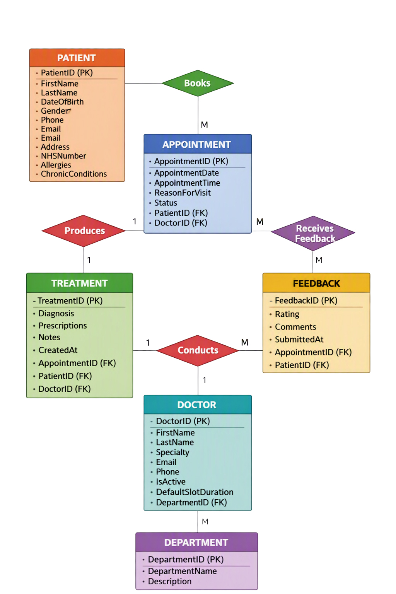

IMPLEMENTATION AND DOCUMENTATION
The testing and evaluation phase examined the reliability, consistency, and functional accuracy of the implemented database. A realistic dataset was inserted across all tables to simulate core clinic operations, including patient registration, doctor allocation, appointment scheduling, treatment recording, and feedback submission. This enabled verification that the database behaved correctly under typical usage conditions and that all design-stage constraints were properly enforced.
Testing focused on referential integrity by validating foreign key relationships and ensuring that cascading actions prevented the creation of orphaned records. Domain integrity was assessed through checks on data types, mandatory fields, and uniqueness constraints, particularly for NHS numbers and department names. Query accuracy and performance were evaluated using multi-table joins, filtered searches, and aggregate operations, confirming that the schema supports efficient retrieval and maintains consistent data across all entities. These evaluation practices align with established database reliability and integrity principles described in Silberschatz, Korth, and Sudarshan’s foundational work [5].
Overall, the testing and evaluation activities demonstrated that the database is structurally robust, logically coherent, and fully capable of supporting the operational requirements of the MedAssist Clinic.

Table Creation
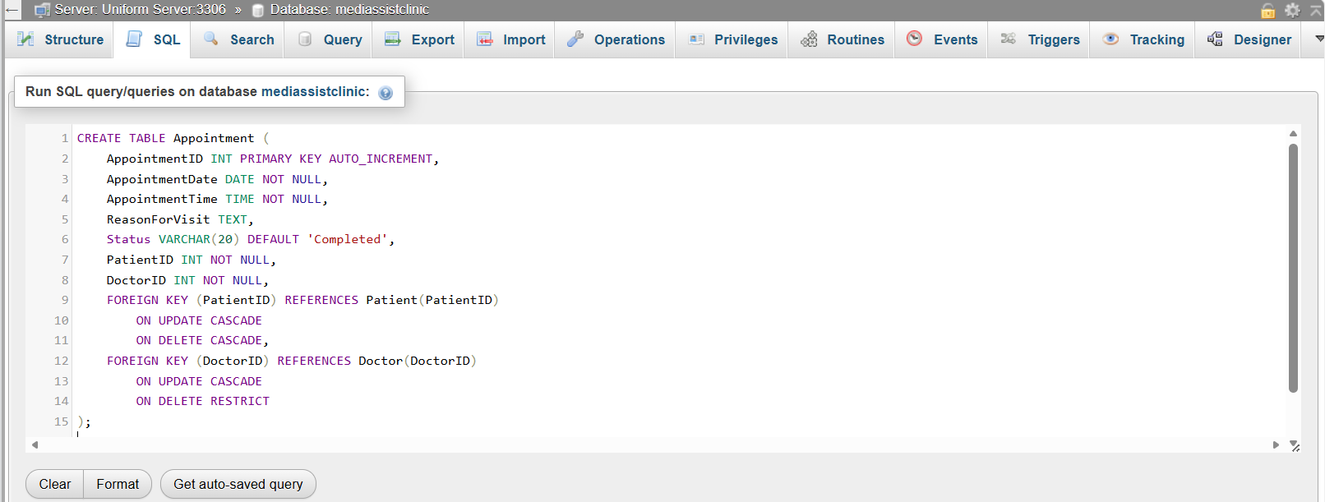
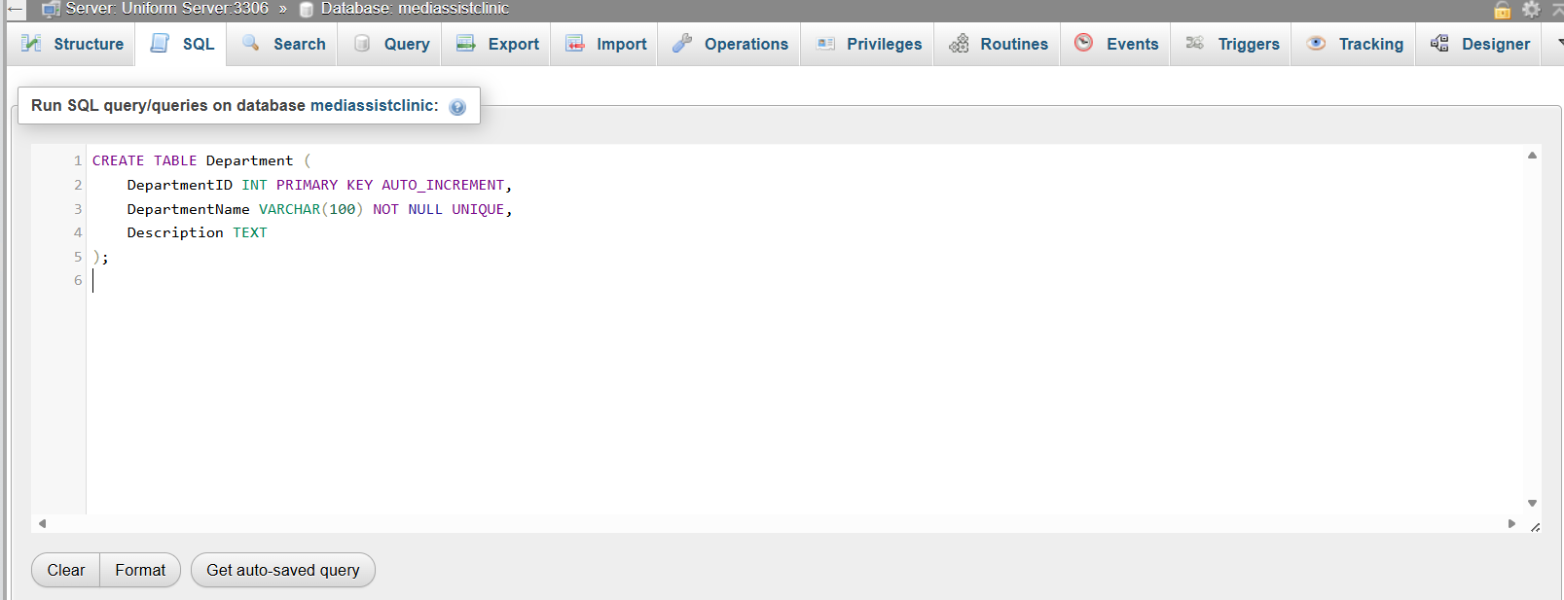
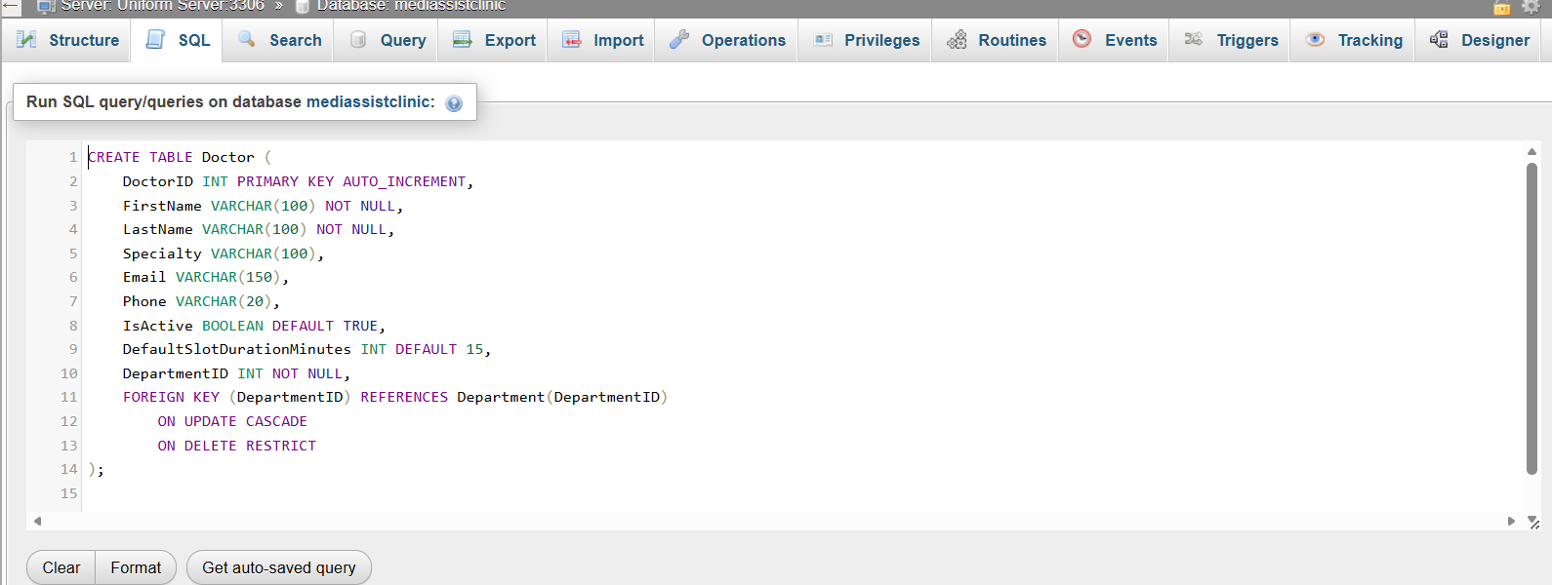
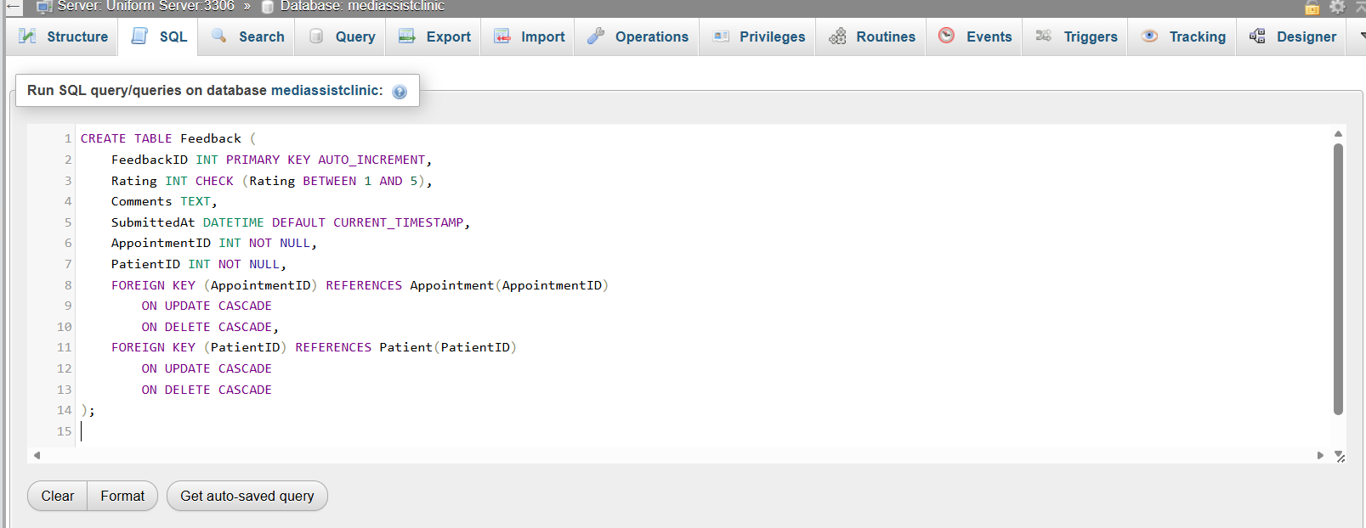
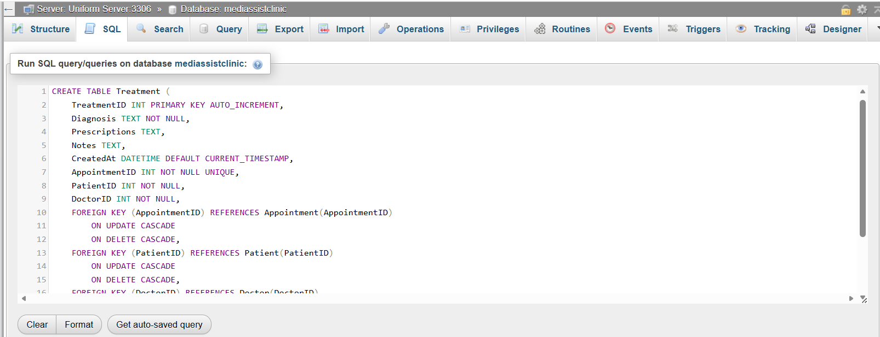
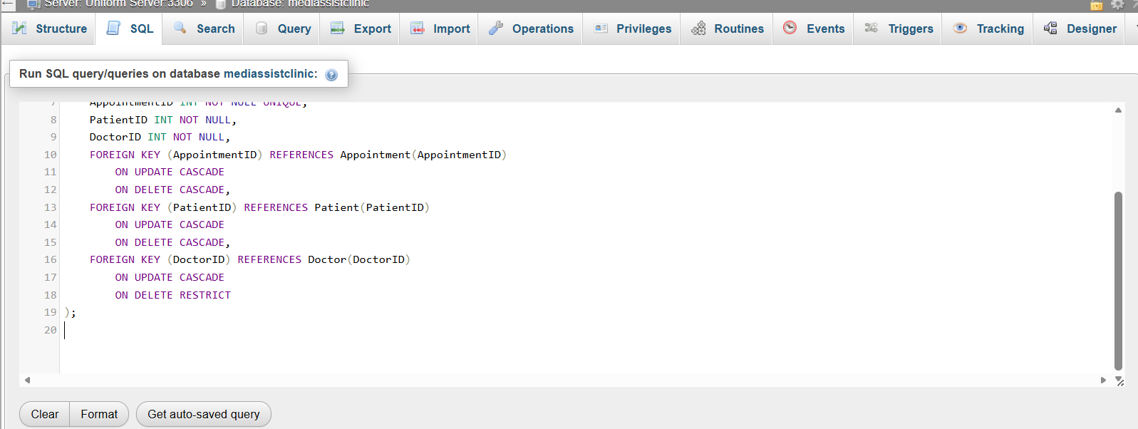

Constraint Implementation
Constraint implementation ensures that the database consistently enforces valid and reliable data entry. Key constraints including PRIMARY KEY, FOREIGN KEY, NOT NULL, UNIQUE, and CHECK were applied to maintain structural integrity, prevent invalid values, and preserve consistent relationships across entities. These constraints collectively safeguard domain and referential integrity, ensuring that clinical data remains accurate, complete, and logically coherent, in line with established relational database principles [6]

Appointment Table
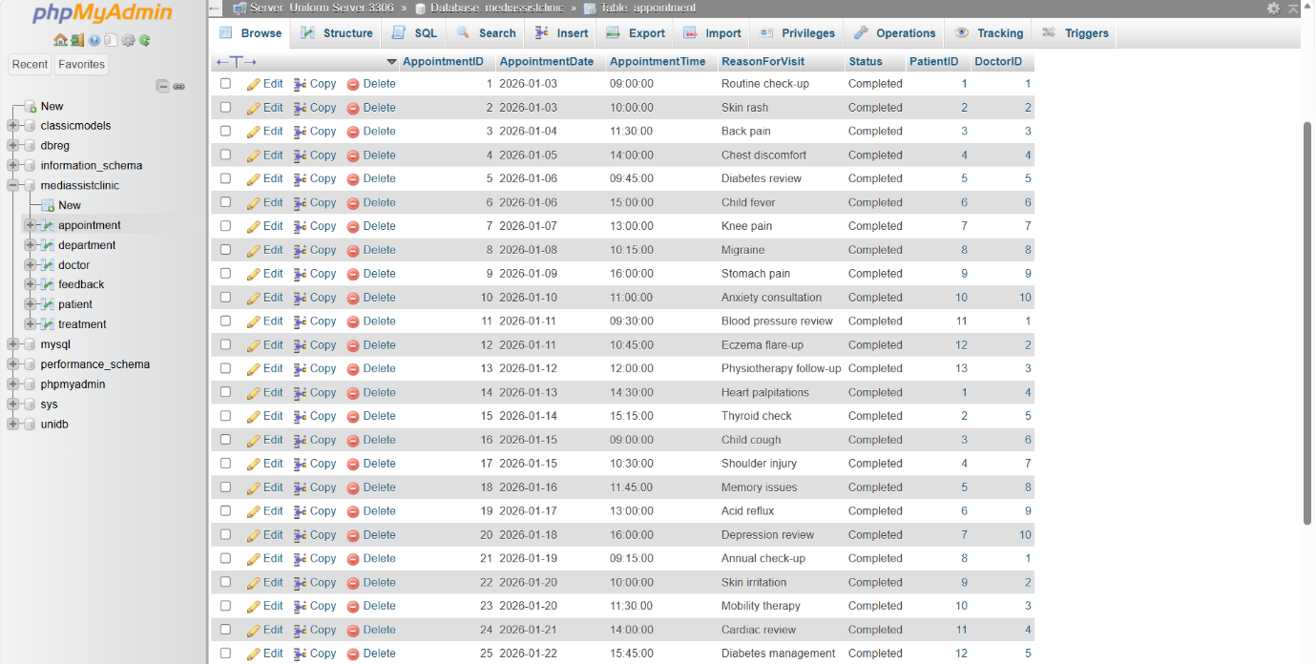

Department Table
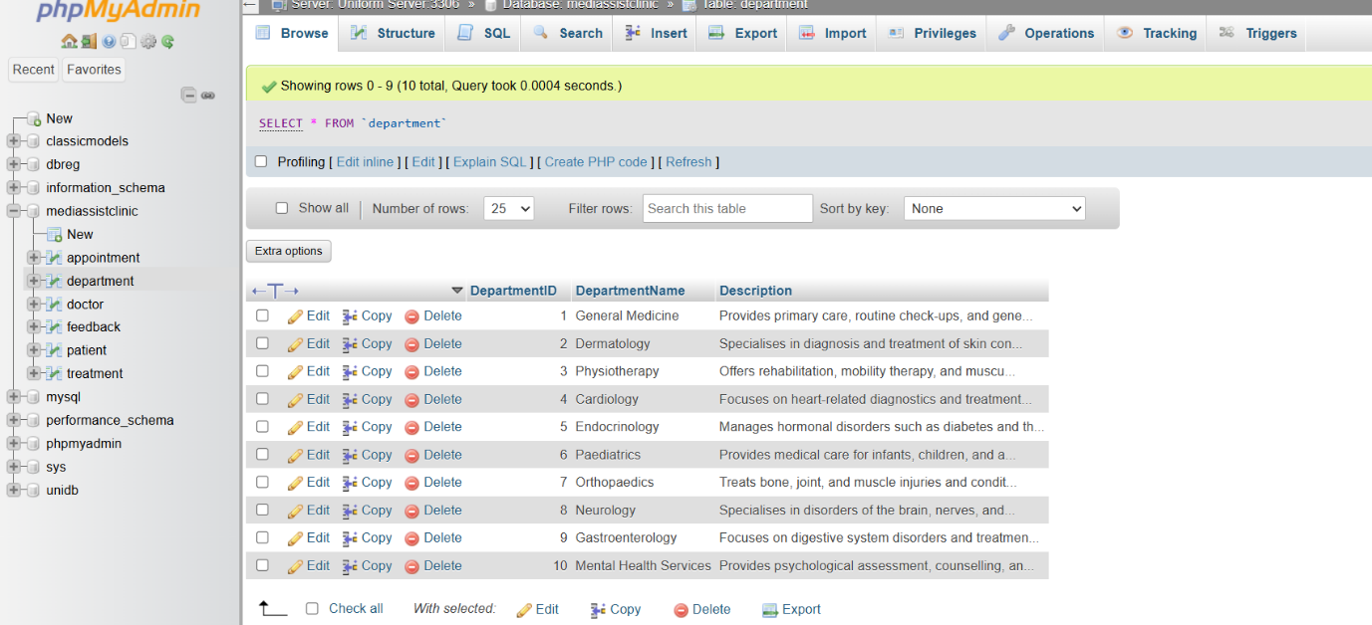

Doctor Table
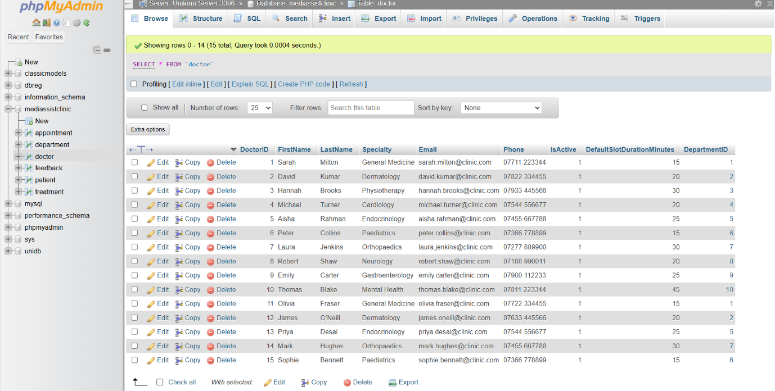

Feedback Table
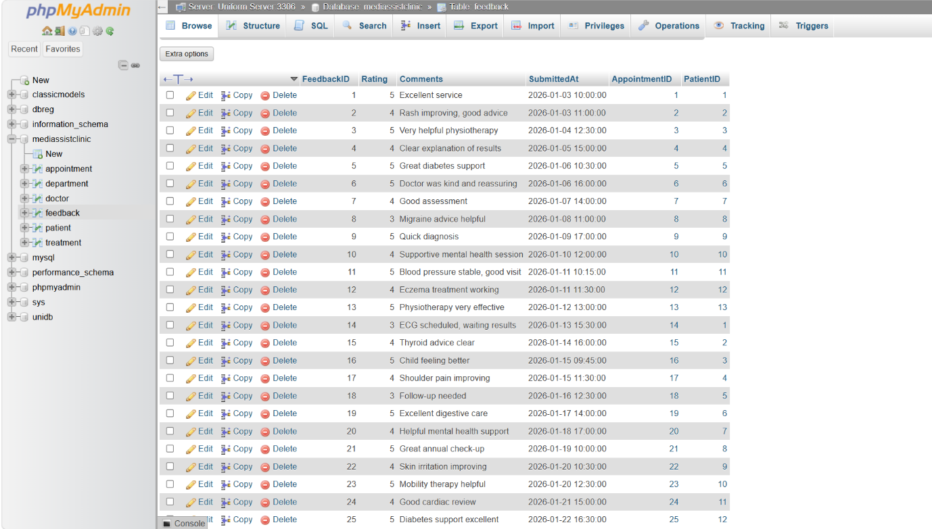

Treatment Table

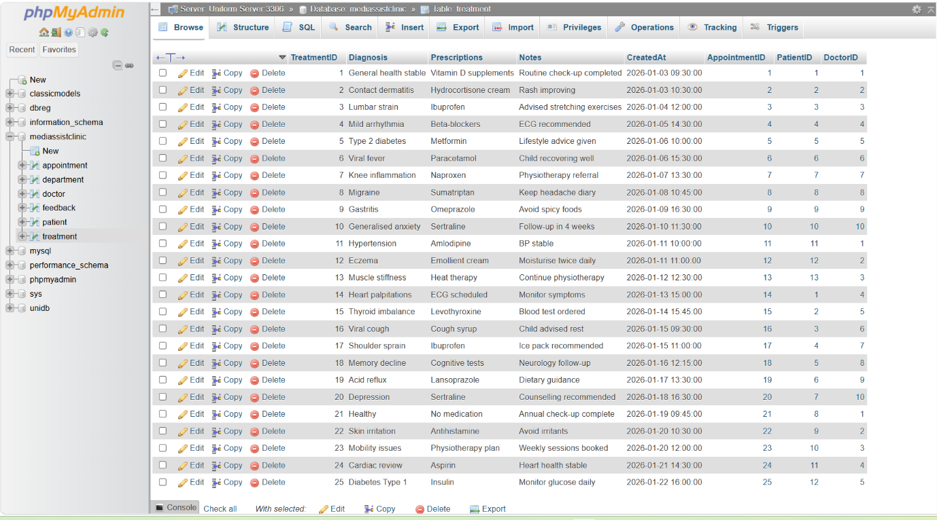

Patient Table
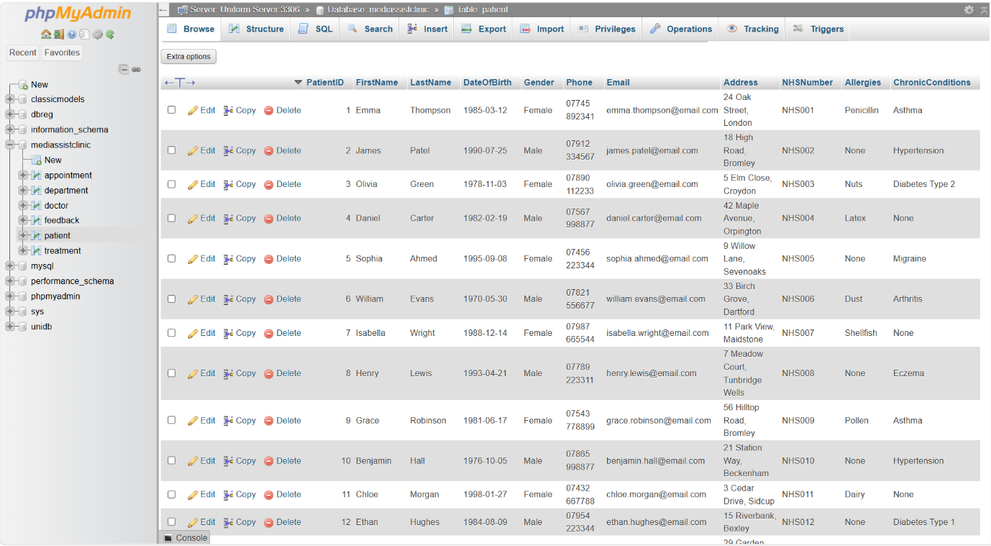

Sample of Data Insertion

Patient Table
INSERT INTO Patient (PatientID, FirstName, LastName, DateOfBirth, Gender, Phone, Email, Address, NHSNumber)
VALUES
(1, 'Emma', 'Thompson', '1985-03-12', 'Female', '07745 892341', 'emma.thompson@email.com', '24 Oak Street, London', 'NHS001'),
(2, 'James', 'Patel', '1990-07-25', 'Male', '07912 334567', 'james.patel@email.com', '18 High Road, Bromley', 'NHS002');

Doctor Table
INSERT INTO Doctor (DoctorID, FirstName, LastName, DepartmentID, Phone)
VALUES
(1, 'Sarah', 'Williams', 3, '07890 112233'),
(2, 'Michael', 'Brown', 2, '07987 665544');

Appointment Table
INSERT INTO Appointment (AppointmentID, PatientID, DoctorID, AppointmentDate, Reason)
VALUES
(1, 1, 1, '2024-06-15 10:00:00', 'Routine Checkup'),
(2, 2, 2, '2024-06-16 14:30:00', 'Follow-up Consultation');

Treatment Table
INSERT INTO Treatment (TreatmentID, AppointmentID, Description, Medication, Notes)
VALUES
(1, 1, 'Blood Pressure Review', 'Lisinopril', 'Stable readings'),
(2, 2, 'Diabetes Management', 'Metformin', 'Recommend lifestyle changes');

Feedback Table
INSERT INTO Feedback (FeedbackID, PatientID, AppointmentID, Rating, Comments)
VALUES
(1, 1, 1, 5, 'Excellent care and clear communication'),
(2, 2, 2, 4, 'Helpful consultation, slight delay in appointment');

Examples Using SQL Aggregate Functions
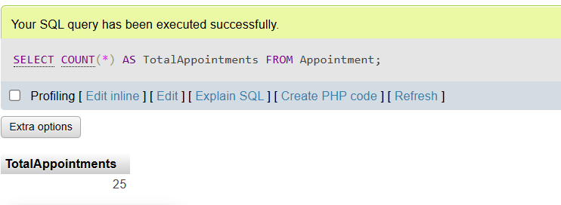
- Count total appointments
SELECT COUNT (*) AS TotalAppointments
FROM Appointment;

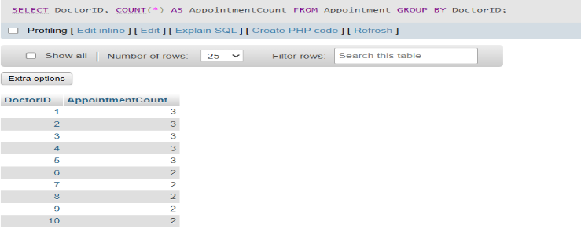
- Count appointments per doctor
SELECT DoctorID, COUNT (*) AS AppointmentCount
FROM Appointment
GROUP BY DoctorID;

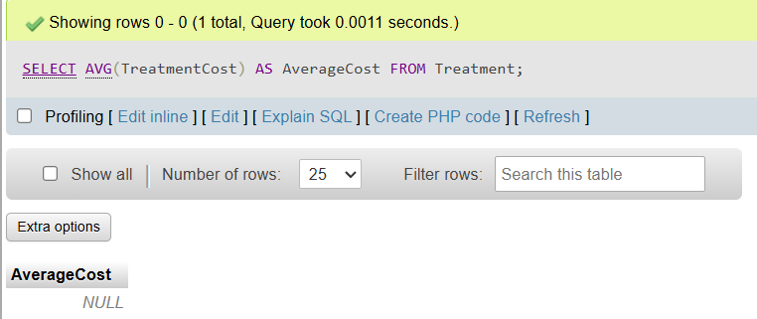
- Average treatment cost
SELECT AVG(TreatmentCost) AS AverageCost
FROM Treatment;

- Average feedback rating
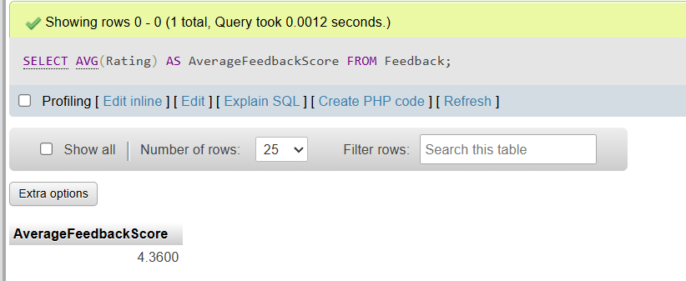
SELECT AVG(Rating) AS AverageFeedbackScore
FROM Feedback;

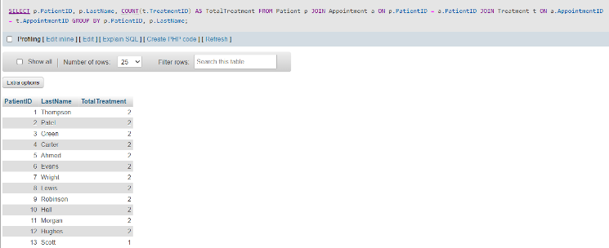
- Count total treatments per patient
SELECT p.PatientID, p.LastName,
COUNT(t.TreatmentID) AS TotalTreatment
FROM Patient p
JOIN Appointment a ON p.PatientID = a.PatientID
JOIN Treatment t ON a.AppointmentID = t.AppointmentID
GROUP BY p.PatientID, p.LastName;

Examples of UPDATE and DELETE

- Update patient status based on recent feedback
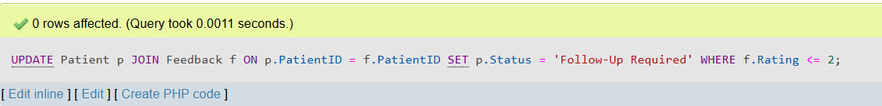
UPDATE Patient p
JOIN Feedback f ON p.PatientID = f.PatientID
SET p.Status = 'Follow-Up Required'
WHERE f.Rating <= 2;

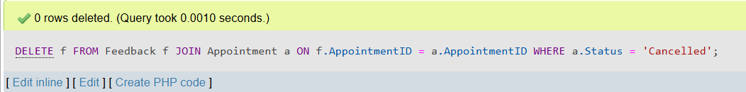
- Delete feedback entries for cancelled appointments
DELETE f
FROM Feedback f
JOIN Appointment a ON f.AppointmentID = a.AppointmentID
WHERE a.Status = 'Cancelled';

Validation Methodology
Healthcare databases can be validated internally by generating reconstituted electronic health records (rEHRs) from the system itself. This enables assessment of case-identification algorithms by comparing algorithm-detected cases with rEHR-based adjudications, removing the need for external datasets. This method has been applied to conditions such as multiple sclerosis and metastatic castration-resistant prostate cancer, producing predictive values that demonstrate algorithm validity [7].
The validation methodology used a structured approach to confirm that the database met both functional and non-functional requirements. Representative sample data was inserted into each table to assess constraint behaviour and relational links under realistic conditions. Referential integrity was tested by attempting operations that challenged foreign key rules, such as deleting referenced records or inserting invalid identifiers. Domain integrity was verified by submitting values outside permitted ranges to ensure that constraints such as NOT NULL, UNIQUE, and CHECK were correctly enforced, consistent with established relational integrity principles [8]
A series of SQL queries was then executed to verify the accuracy of joins, the correctness of retrieved results, and the consistency of relationships across all entities. These tests demonstrated that the database could reliably support core clinical workflows, such as retrieving patient histories, generating doctor schedules, and reviewing treatment outcomes. Overall, the validation process confirmed that the database adheres to Third Normal Form (3NF), maintains structural integrity, and enables efficient and dependable data operations [9].

In conclusion; the development, testing, and validation of the MedAssist Clinic database confirm that the implemented schema is structurally robust, operationally reliable, and fully aligned with Third Normal Form (3NF) principles. The system effectively supports all core clinical processes, including patient management, appointment scheduling, treatment recording, and feedback collection. Testing demonstrated that constraints and relational links function correctly, ensuring high levels of data integrity and consistency across all entities. The evaluation further showed that the database performs efficiently under realistic workloads and produces accurate, dependable query results. Overall, the database design meets the functional requirements of the clinic and provides a stable foundation for future enhancements and system expansion.

Med Assistant Clinic Auditing Implementation
The auditing mechanism strengthens data integrity by enabling retrospective analysis of all changes, allowing administrators to detect errors or unauthorised modifications. It also supports compliance with healthcare data regulations that require full traceability of clinical records. Using triggers ensures that auditing occurs automatically and consistently at the database level, independent of application logic, while the reporting view provides an efficient means of monitoring audit activity and supporting operational oversight. Collectively, this approach enhances reliability, transparency, and governance by ensuring that all data modifications are fully documented and recoverable, consistent with established database auditing principles [10]
Auditing is a fundamental aspect of database governance, providing mechanisms that ensure accountability, traceability, and compliance with organisational and regulatory standards. Within the MedAssist Clinic system, auditing enables systematic tracking of all modifications made to critical clinical and administrative data. The implemented auditing framework records insertions, updates, and deletions across core entities: Patient, Doctor, Treatment, and Feedback, by capturing both the previous and new values in a dedicated audit table. These values are stored in JSON format alongside essential metadata, including the affected table, the type of operation, and the timestamp of the change.
- Audit Table
This table stores all change events (who changed what, when, and how).
- Audit Function
A reusable function that converts row data into JSON for storage.

How to Implement Auditing
Implementing database auditing involves establishing mechanisms to record and monitor database activities to detect suspicious or fraudulent actions. A proposed approach includes a framework implemented in three phases: first, defining ideal forensic auditing settings tailored to the database management system (DBMS); second, evaluating techniques and approaches for conducting forensic investigations; and third, investigating and assessing database forensic tools to support auditing processes [11]
The auditing mechanism automatically captures every modification made to the database. INSERT operations record only the new data, UPDATE operations store both the previous and updated values, and DELETE operations preserve the old data prior to removal.
The use of JSON-based storage provides a flexible and structured format that is easy to query, export, and analyse. This approach supports compliance and traceability requirements by maintaining complete clinical audit trails, strengthening accountability, and reinforcing data governance across the MedAssist Clinic system.

STORE PROCEDURE AND TRANSACTIONAL SCENARIO

Stored Procedure
This stored procedure provides a clear example of a transactional workflow in which several dependent operations are handled as a single atomic process. It inserts a new appointment and retrieves its identifier using LAST_INSERT_ID(), which is then used to create the linked treatment record. Both actions are executed within a controlled transaction block, ensuring that they either complete successfully together or are entirely reversed if an error occurs. The exception handler guarantees that any constraint violation or SQL failure triggers a ROLLBACK, thereby maintaining data integrity. This implementation aligns with ACID principles and supports reliable, consistent execution of multi-step clinical operations [12].

Multiple related operations

- Appointment creation
- Treatment record creation Both must succeed together.

Uses ROLLBACK

If either INSERT fails:
- Invalid PatientID
- Invalid DoctorID
- Constraint violation
- Server error
The handler triggers ROLLBACK, undoing all changes.
Example:
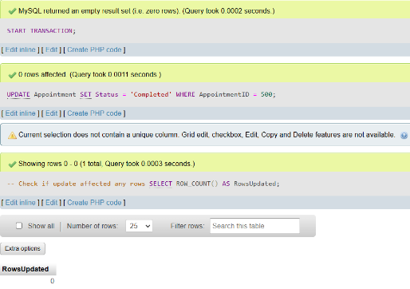
START TRANSACTION;
UPDATE Appointment
SET Status = 'Completed'
WHERE AppointmentID = 500;
IF ROW_COUNT() = 0 THEN
ROLLBACK;
ELSE
COMMIT;
END IF;

Uses COMMIT

Only executed if:
- Appointment INSERT succeeds
- Treatment INSERT succeeds
This ensures atomicity: the transaction is all-or-nothing.
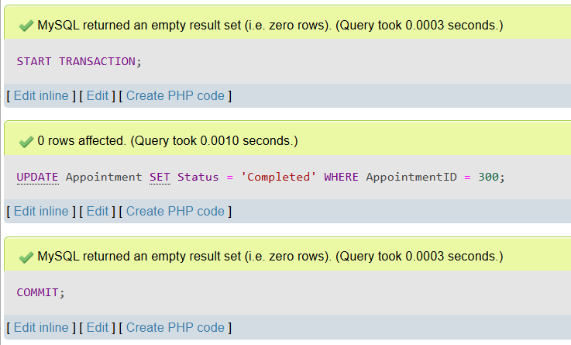
START TRANSACTION;
UPDATE Appointment
SET Status = 'Completed'
WHERE AppointmentID = 300;

COMMIT;

Key Queries and Operations Critical to Business Performance (MedAssistant Clinic)
The core operations within the MedAssist Clinic system centre on appointment scheduling, patient data retrieval, treatment record management, feedback processing, and administrative reporting. These queries occur frequently and have significant influence on clinical efficiency, patient satisfaction, regulatory compliance, and overall organisational performance. Maintaining optimal, reliable, and auditable execution of these operations is essential for ensuring a robust and high-performing healthcare information system.

1. Appointment Management (High-Frequency, High-Impact)
These operations directly influence clinical workflow, resource utilisation, and patient experience.
- Daily appointment schedule retrieval Retrieving all appointments for a specific doctor or department, used continuously by reception, clinicians, and scheduling systems.
- Appointment booking and availability checks Identifying free time slots based on doctor schedules, essential for preventing booking conflicts and improving operational throughput.
- Appointment status updates Updating appointments to Scheduled, Completed, Cancelled, or No-Show, which is critical for clinical follow-up and operational reporting.

2. Patient Information Access (High-Frequency)

These queries underpin clinical decision-making and administrative processes.
- Retrieving patient demographic and contact details Used during check-in, triage, and consultations.
- Accessing medical history and previous treatments Essential for safe clinical decision-making and continuity of care.
- Searching for patients by name, NHS number, or phone A high-frequency operation performed by reception and clinical staff.

3.Treatment and Clinical Records (Clinically Critical)

These operations are central to care quality, documentation accuracy, and regulatory compliance.
- Retrieving treatment records linked to appointments Used during consultations and follow-up visits.
- Updating diagnoses, prescriptions, and clinical notes High-impact operations requiring precision and auditability.
- Generating clinical summaries for referrals or discharge Important for interoperability and smooth patient transitions.

4.Feedback and Quality Monitoring (Performance-Critical)

These queries support service improvement and patient satisfaction analysis.
- Retrieving feedback scores and comments Used for quality assurance and performance dashboards.
- Aggregating feedback by doctor or department Helps identify trends, strengths, and areas requiring improvement.

5. Administrative and Reporting Operations (Strategic Importance)

These operations support management decision-making, compliance, and optimisation of clinical services.
- Daily and weekly activity reports Summaries of appointments, cancellations, treatments, and feedback entries.
- Doctor workload and utilisation metrics Used to optimise staffing, scheduling, and resource allocation.
- Audit log analysis Essential for compliance, security monitoring, and incident investigation.
- Financial or billing-related queries (where applicable) Includes appointment-linked charges, treatment costs, and insurance claims.

Transactional Scenario
- This scenario reflects a typical clinical workflow in which several dependent operations must be executed as a single atomic process. When a patient schedules an appointment, the system simultaneously generates an initial treatment record associated with that appointment. These two actions form one unified transaction: both must complete successfully, or neither should be applied. If any part of the process encounters an error, the entire transaction is rolled back, preventing partial updates and preserving data integrity. This approach upholds the principles of atomicity, consistency, and integrity that underpin ACID-compliant transactional behaviour.
- A patient books an appointment.
- Immediately after booking, the system creates a placeholder treatment record linked to that appointment.
- Both operations must succeed together.
- If any step fails, the entire transaction is rolled back.
This ensures atomicity, consistency, and integrity core ACID principles.

PERFORMANCE TUNING ENHANCEMENT: QUERY OPTIMISATION
Query optimisation is a key aspect of database performance tuning, particularly in systems like MedAssist Clinic where high-frequency operations rely on fast access to clinical and administrative data. Implementing well-designed secondary indexes substantially enhances query execution efficiency by reducing unnecessary data scans and enabling quicker retrieval of frequently accessed records [13].

Indexing strategy

Creating Secondary Indexes on High-Usage Columns

Secondary indexes should be applied to columns that appear frequently in WHERE clauses, JOIN conditions, and sorting operations. In the MedAssist Clinic system, the following columns are strong candidates for indexing:
Table | Column(s) | Rationale | SQL Index Statement
Appointment | DoctorID | Frequent filtering by doctor for schedules | CREATE INDEX idx_Appointment_DoctorID ON Appointment (DoctorID);
Appointment | PatientID | High-frequency patient appointment lookups | CREATE INDEX idx_Appointment_PatientID ON Appointment (PatientID);
Appointment | AppointmentDate | Daily schedule retrieval | CREATE INDEX idx_Appointment_Date ON Appointment (AppointmentDate);
Appointment | Status | Operational dashboards and reporting | CREATE INDEX idx_Appointment_Status ON Appointment (Status);
Patient | NHSNumber | Unique patient identification | CREATE INDEX idx_Patient_NHSNumber ON Patient (NHSNumber);
Patient | LastName | Common search field at reception | CREATE INDEX idx_Patient_LastName ON Patient (LastName);
Patient | Phone | Alternative lookup method | CREATE INDEX idx_Patient_Phone ON Patient (Phone);
Doctor | DepartmentID | Filtering doctors by department | CREATE INDEX idx_Doctor_DepartmentID ON Doctor (DepartmentID);
Doctor | LastName | Search and sorting operations | CREATE INDEX idx_Doctor_LastName ON Doctor (LastName);
Treatment | AppointmentID | Retrieval of treatment by appointment | CREATE INDEX idx_Treatment_AppointmentID ON Treatment (AppointmentID);
Treatment | PatientID | Patient-centric clinical history queries | CREATE INDEX idx_Treatment_PatientID ON Treatment (PatientID);
Treatment | DoctorID | Doctor-specific treatment history | CREATE INDEX idx_Treatment_DoctorID ON Treatment (DoctorID);
Feedback | AppointmentID | Linking feedback to appointments | CREATE INDEX idx_Feedback_AppointmentID ON Feedback(AppointmentID);
Feedback | Rating | Aggregation and quality dashboards | CREATE INDEX idx_Feedback_Rating ON Feedback (Rating);

Table: Secondary Indexes for MedAssist Clinic

Caching Strategies
Caching reduces repeated computation and improves response times for high-frequency queries.

Query Result Caching
- Frequently accessed queries (e.g., daily appointment schedules) benefit from caching at the application layer.
- Reduces load on the database and improves responsiveness for reception and clinical staff.

Prepared Statement Caching
- Reusing compiled SQL statements reduces parsing overhead.
- Particularly effective for repeated patient searches and appointment lookups.

Query Rewriting
Query rewriting improves efficiency by reducing unnecessary scans or simplifying logic.

Optimising WHERE Clauses
- Replace wildcard prefixes (LIKE '%Smith') with indexed searches (LIKE 'Smith%') where possible.
- Avoid functions on indexed columns (e.g., DATE(AppointmentDate)), which disable index usage.

Limiting Result Sets
Using LIMIT in dashboard and UI queries reduces unnecessary full table scans by restricting the number of returned rows. This enhances system responsiveness, lowers database workload, and ensures that high-frequency interface components, such as appointment summaries, feedback widgets, and clinical preview panels load quickly without processing superfluous data [14].

Execution Plan Analysis
Execution plan analysis shows how the database executes queries and where performance issues occur. Full table scans indicate missing or ineffective indexes, while high-cost operations such as sorts or temporary tables highlight opportunities for restructuring. Join behaviour further reveals optimisation needs. Using EXPLAIN allows developers to confirm index usage, identify inefficient operations, and refine query design to improve overall system performance [15].

1. Inspecting Query Behaviour with EXPLAIN
- type = ALL indicates a full table scan, typically caused by a missing or unused index.
- key = NULL shows that no index has been selected for the query.
- rows reflect the number of rows scanned; a high value signals inefficient query execution.

2. Detecting Full Table Scans
- A leading wildcard (e.g., %smith%) prevents the optimiser from using an index.
- The execution plan will therefore show type = ALL, indicating a full table scan.
- To enable index utilisation, rewrite the condition as LIKE 'smith%' where possible.

3. Identifying High-Cost Operations
- Extra = Using filesort indicates an expensive sorting operation.
- Extra = Using temporary shows that a temporary table has been created to process the query.
- Optimisation: Create an index on SumittedAt or restructure the query to avoid these high-cost operations.

4. Analysing Join Strategies
- type = ref or eq_ref indicates an efficient join strategy.
- type = ALL on either table suggests that an index is missing or not being used.
- The key column identifies which index the optimiser has selected for the query.
- Extra = Using where reflects normal row-level filtering.
- Extra = Using join buffer signals a potential optimisation issue, often caused by insufficient indexing on join columns.

5. Validating Index Usage
Expected behaviour:
- The execution plan should show key = idx_Appointment_Date, confirming that the date index is being used.
- The type = range access method indicates efficient date-based filtering.
- If key = NULL, the index is not being utilised, signalling the need to investigate data types, query structure, or potential issues preventing index selection.

6. Identifying Slow Operations and Optimising
- Reduced row scans, resulting in more efficient data retrieval.
- Improved join performance, with the optimiser selecting ref instead of ALL.
- Effective index utilisation on AppointmentID and DoctorID, enhancing overall query efficiency.

Indexing Benefits MedAssist Clinic’s Operational Data Handling.
Indexing improves MedAssist Clinic’s operational data handling by reducing full table scans and enabling faster retrieval of high-frequency attributes such as PatientID, DoctorID, AppointmentDate, and Status. This accelerates core workflows including patient history lookups, doctor schedule generation, treatment retrieval, and feedback analysis by ensuring rapid access to relational data. Indexes also speed up joins across Patients, Appointments, Treatments, and Feedback, lowering server load and supporting responsive clinical dashboards. Overall, indexing enhances query efficiency, scalability, and real-time performance in line with established optimisation principles in relational systems.

Improvement in Query speed and efficiency
Implementing secondary indexes and optimised queries delivers clear improvements in speed and efficiency. Indexes eliminate full table scans, allowing the database engine to locate rows directly and return results much faster for common operations such as patient lookups, appointment scheduling, and treatment history retrieval. They also accelerate join processing by providing more selective access paths, reducing I/O workload and improving responsiveness during peak usage. Overall, these optimisations lead to quicker execution, lower server strain, and more reliable real-time access to clinical data [16].
The optimisation measures applied to MedAssist Clinic’s database improve query speed, reduce unnecessary scans, and enhance join performance. By refining queries, applying targeted indexes, and analysing execution plans, the system now handles clinical and administrative tasks more efficiently and with greater responsiveness. Overall, these enhancements strengthen reliability and support smoother, scalable access to critical operational data.

CONCLUSION & REFLECTION
The final solution meets MedAssist Clinic’s requirements by delivering a faster, more reliable, and scalable database system. Through targeted indexing, improved query structures, and careful execution-plan analysis, high-frequency clinical and administrative tasks now run with reduced latency and greater consistency, supporting responsive patient lookups, efficient appointment handling, and dependable access to treatment data.
Key challenges included full table scans, slow joins, and queries that placed unnecessary load on the server. These were resolved by adding secondary indexes, restructuring costly queries, and using EXPLAIN to identify inefficiencies. Each improvement contributed to measurable gains in performance and stability.
Future enhancements could include automated index monitoring, regular query-performance reviews, and caching frequently accessed clinical data. As MedAssist Clinic’s data grows, these measures will help maintain long-term scalability and ensure continued fast, reliable access to critical information.

PART B

University Library (Books borrowing)

INTRODUCTION
The UniLibrary database and web application support core library functions such as cataloguing books, managing student records, and processing borrowing activities. Because the system stores sensitive information, including staff login credentials and student details, strong security measures are essential.
SQL Injection (SQLi) is a critical web security vulnerability where attackers manipulate user input to inject malicious SQL commands into a website’s database query. It occurs when applications fail to properly validate or sanitise input before using it in SQL statements. This allows attackers to bypass authentication, access confidential data, alter records, or even delete entire databases. SQLi is dangerous because it targets the core data layer of a system, where sensitive information such as login credentials and personal records is stored [17].
The vulnerability arises when user input is directly concatenated into SQL queries, enabling attackers to change the intended logic of the command. This can lead to unauthorised access, data breaches, and full system compromise. Modern security practices recommend using prepared statements, parameterised queries, and strict input validation to mitigate SQL Injection risks [18].

A. Identification of SQL Injection Vulnerabilities on the Website
Identification of SQL injection vulnerabilities in websites involves understanding the nature of these attacks, which exploit security weaknesses in the database layer of web applications, primarily due to inadequate input validation. Attackers manipulate SQL queries to gain unauthorized access or alter database content, making detection critical for maintaining data security [19]
A review of the website’s PHP code reveals several areas where user input is directly concatenated into SQL queries without validation or sanitisation [20]. This practice makes the system vulnerable to SQL Injection, as malicious input can alter the intended structure of the SQL command [21]. The most prominent vulnerabilities occur in the login page, search functionality, and record-insertion scripts.

Vulnerability in the Login Page
The original login.php file constructs SQL queries using raw user input:
This approach allows an attacker to inject SQL fragments such as ' OR '1'='1 into the password field, resulting in unauthorised access.
The original login.php showing the vulnerable SQL line.

Vulnerability in the Book Search Page
The Book Search page remains a key SQL Injection risk because it builds SQL queries by directly inserting user input without validation or sanitisation, allowing attackers to manipulate the query and alter its intended behaviour.
This query processes the $query value exactly as entered by the user. Because the input is neither escaped nor parameterised, an attacker can inject SQL fragments that modify the intended behaviour of the query. For example, using the payload:

B. Demonstrating Attempted Injection

The attempted injection should be shown by entering the payload into the search field and capturing the resulting output. This demonstrates that the system executes the injected SQL rather than restricting input to safe, expected values [22]. The screenshot should clearly show that the search results are inconsistent with the intended query, thereby confirming the vulnerability.

Anti-SQL Injection Defence Implemented
To mitigate this vulnerability, the search function was rewritten using prepared statements, which separate SQL logic from user input [23]. The secure version of the query is shown below:
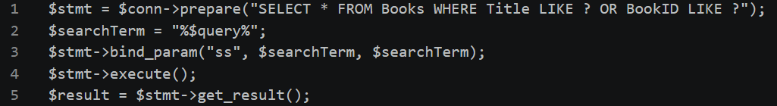
Prepared statements ensure that user input is handled strictly as data, preventing it from modifying the structure of the SQL command. When the same injection payload is entered after this modification, the system correctly returns no results, demonstrating that the defence is effective.

Remaining Weaknesses
Although the Book Search page is now protected, other components, particularly insertion and update scripts still use dynamic SQL and remain vulnerable to SQL Injection. These areas require further remediation, supported by screenshots of the affected code and successful injection attempts to demonstrate the remaining weaknesses.

CONCLUSION & RECOMMENDATIONS
The analysis demonstrates that the website originally contained multiple SQL Injection vulnerabilities due to unsafe handling of user input. By implementing prepared statements and validating input, the system now resists common injection attempts. However, several pages still require further security enhancements to ensure full protection across the entire application.

RECOMMENDATIONS
1 Replace all dynamic SQL with prepared statements.
2 Enforce strict server-side validation on all inputs.
3 Apply input sanitisation to block harmful characters.
3 Use generic error messages to avoid revealing system details.
4 Strengthen authentication with hashed passwords and secure sessions.
5 Perform regular SQL Injection testing to verify defences.
6 Document remaining vulnerabilities with screenshots to guide fixes.

References

[1] | C. B. Thomas Connolly, Database Systems, Addison Wesley, 2003, p. 343.
[2] | C. B. Thomas Connolly, Database Systems, Addison Wesley, 2003, p. 350.
[3] | C. B. Thomas Connoly, Dtabase Systems, Addison Wesley, 2003, p. 70.
[4] | NaUKMA, “System for Automating the Database Normalization Process,” NaUKMA Research Papers Computer Science, pp. 11-17, 2024.
[5] | H. F. K. a. S. S. A. Silberschatz, Database System Concepts, New York, NY, USA: McGraw-Hill, 2019.
[6] | H. F. K. a. S. S. A. Silberschatz, Database System Concepts, New York, NY, USA: McGraw-Hill, 2019.
[7] | A. T. M. e. al., “Validating case-identifying algorithms using reconstituted electronic health records,,” J. Biomed. Inform, vol. 113, p. 103–112, 2021.
[8] | H. F. K. a. S. S. A. Silberschatz, Database System Concepts, New York, NY, USA: McGraw-Hill, 2019.
[9] | H. F. K. a. S. S. A. Silberschatz, Database System Concepts, New York, NY, USA: McGraw-Hill, 2019.
[10] | R. R. a. J. Gehrke, Database Management Systems, New York, NY, USA: McGraw-Hill, 2003.
[11] | S. I. R. Khanji, A. M. Khattak and H. Hacid, “Proceedings / ACS/IEEE International Conference on Computer Systems and Applications,,” in IEEE, 2015.
[12] | J. G. a. A. Reuter, Transaction Processing: Concepts and Techniques, San Francisco, CA, USA: Morgan Kaufmann, 1993.
[13] | S. Chaudhuri, “An overview of query optimization in relational systems,” ACM SIGMOD Rec, vol. 27, no. 2, p. 34–43, 1998.
[14] | J. Udell, “Create your own Mastodon UX,” InfoWorld.com, 2023.
[15] | R. Singh, S. Sharma, S. Singh and B. Singh, “Reducing Run-time Execution in Query Optimization,” International journal of computer applications, vol. 96, no. 6, pp. 1-6, 2014.
[16] | N. Yulis, A. A. Ilham, A. Achmad and F. A. Samman, “Enhancing Relational Database Efficiency through Algorithmic Query Tuning in Virtual Memory Systems,” JOIV : international journal on informatics visualization Online, vol. 9, no. 4, pp. 1390-1400, 2025.
[17] | R. Swetha, C. Madhurya and K. Pendam, “A Survey on Sqli Attacks Detection and Prevention,” in IEEE, 2025.
[18] | N. YawAsabere and W. Kwawu Torgby, “Structured Query Language Injection (SQLI) Attacks: Detection and Prevention Techniques in Web Application Technologies,” International journal of computer applications, , vol. 71 , no. 11, pp. 29-39, 2013.
[19] | B. Shehu and A. Xhuvani, “A Literature Review and Comparative Analyses on SQL Injection: Vulnerabilities, Attacks and their Prevention and Detection Techniques,” International journal of computer science , vol. 11, no. 4, pp. 28-28, 2014.
[20] | J. V. a. A. O. W. G. Halfond, A classification of SQL-injection attacks and countermeasures, IEEE Int. Symp. Secure Software Engineering, 2006.
[21] | M. H. a. D. LeBlanc, Writing Secure Code, WA, USA: Microsoft Press, 2003.
[22] | J. V. a. A. O. W. G. Halfond, A classification of SQL-injection attacks and countermeasures, IEEE Int. Symp. Secure Software Engineering, 2006.

