2.C Energy

Usage/Efficiency
To reduce energy usage, automatic doors will be fitted, so that doors only open when required. Pairing this with triple glazed windows and an effective HVAC system will ensure that limited heating will be required once the building is up to temperature. During the summer, the air-conditioning fitted throughout the building will ensure that the temperature is regulated. Automatic doors will ensure that doors will only be open when required. Fire safety doors will also do a similar thing for both fire safety and air containment, which will improve the heat retention of rooms, as the doors are self-shutting, which stops heat from escaping down hallways etc. To ensure that there are healthy levels of oxygen within rooms, the quality air conditioning system will be present throughout the entire building. By having a high level of control of the buildings HVAC system, it mitigates the amount of heating required, as the building retains its temperature for longer.
Lighting will be managed using motion sensors to detect whether a space is being used and switch off the lights if not in use. These will be fitted on the first and second floor. The ground floor won’t require these features, as they will be in use throughout the day. This can save a significant amount of energy and money, as usually students don’t care about the energy they use, as their monthly payment is an all in cost for both the facilities and the bills. Appliances such as TVs, and computers will automatically switch off if unused for 2 hours. This will reduce the energy wasted by unnecessarily powering these.

Energy Production
To produce energy for the building we are going fitting 231 solar panels to the roof west building. These will be angled south facing and spread over a 14.5m x 30m (435$m^{2}$) area. This will produce 68,589$kWh$ for the building, and saves 16 tonnes of ${CO}^{2}$ per year. This significantly reduces the emissions of the building by fitting these panels. In terms of economics, by fitting the solar panels it would save £21,262 per year, which is money that can be spent on other elements of the building such as maintenance. This will be discussed further in whole life cycle costings.
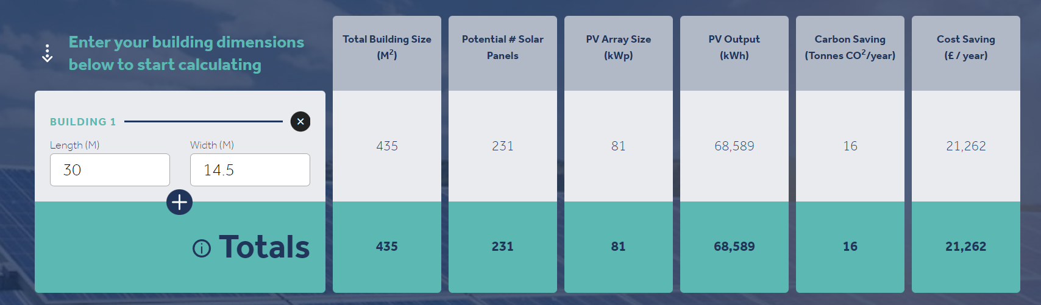

EPC Requirements
Better EPC facilities will be used where possible; however, with some appliances like TVs, there are very few highly efficient ones available and therefore, the LG Smart TV was selected as this had one of the higher EPC ratings of E. All cookers fitted in the kitchens will have an EPC rating of A. Fridge freezers will tend to have a lower energy rating because of the amount of energy required to freeze or refrigerate food. However, the appliances with the best energy ratings will be selected for the kitchens. Other appliances will be selected based on their energy efficiency rather than price, as the client does not mind paying extra for more efficient products. By doing this, it should reduce the overall energy consumption of the building. The aim is to achieve an overall EPC rating of C or above. With the use of efficient ventilation systems, heat proofing and air control, and energy efficient appliances this should be achievable.

Embodied Energy
The consumption of materials accounts for around 10% of UK carbon emissions. This around 400 million tonnes a year, and therefore it is important that we are considerate with the materials we use to construct the building. Careful consideration has been taken with the specifications used to reduce the embodied carbon in the materials. Additionally, materials have been selected that can be recycled or reused where possible, as this reduces the amount of waste that must be put into landfill once the building reaches the end of its functional lifespan. Other embodied energy considerations will be locally sourcing materials instead of transporting them hundreds of miles from England or Europe. This should reduce overall emissions significantly, as lorries won’t be using as much fuel for deliveries.

BREEAM
The plan for the project is to achieve a standard of ‘very good’. This is a reasonable figure to achieve considering the projects timeframe. To do this, we must achieve a score between 55% to 69%. If a higher rating is achieved, this is more beneficial; however, this is just a minimum. To maximise credits, we must include evidence of climate resilience and resource efficiency. Another thing is designing the building aiming to achieve an EPC level of A. On this specific project we’re aiming for a rating of C; however, the building might achieve a better rating of this, which would be beneficial.

Part L – Building Regulations
This document covers the conservation of fuel and power. This relates to the energy usage section previously completed above. The document has 12 sections to take into consideration. The student accommodation is a mixture of a residential and commercial building, as there is 2 floors of student and family accommodation, with the ground floor being predominantly retail units, facilities, and student hangout areas. This means compliance with building regulations will be different. Standard Assessment Procedure (SAP) will be used on the first and second floor, whereas Simplified Building Energy Model (SBEM) will be used for the ground floor. SAP is a simplified building energy model that calculates how much energy we use and converts that figure to a KGs or tonnes of carbon. The SBEM section is similar and calculates the energy required to heat, cool, ventilate, and light a non-dwelling, also providing a figure in KGs or tonnes of carbon. We have ensured that we adhere with this legislation by using many methods to limit our energy usage throughout.

