Module Name: Databases Application Development

Module Code: (ACCA5026_LON)

Student Name: Muhammad Ameer Faisal
Student ID: 2335795
Lecturer’s Name: Dr. Fahad Ahmed
Dated: 11/08/2026

Table of Contents

- Introduction

- Database Design (ERD Blueprint & Normalization)

- Database Implementation (DDL, Constraints, & Sample Data)

- Stored Procedures & Transactional Scenarios

- Auditing Architecture (Triggers & Functions)

- Performance Tuning & Query Optimization

- Literature Support & Technical Justification

- Conclusion & Reflection

Part A

An optimal relational database solution for a clinical management system requires a strong schema design normalized to Third Normal Form (3NF), transactional integrity, performance indexing, and automated audit logging.
Below is the comprehensive framework, structural SQL, and implementation blueprints required for your technical report.

Based on the scenario, here is a structured database analysis and relational database prototype for MedAssist Clinic.
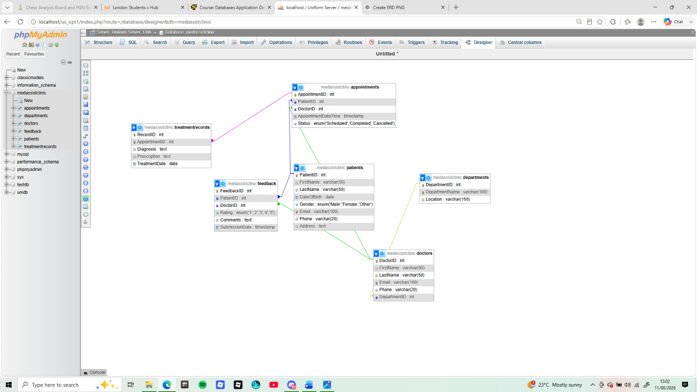
1. Business Requirements Analysis
The database system should enable the clinic to:
- Register and manage patient information.
- Store doctor information and department assignments.
- Schedule and manage appointments.
- Record diagnoses, prescriptions, and treatment notes.
- Store patient feedback.
- Support multiple users (administrators and doctors).
- Maintain data accuracy, consistency, and security.
- Prevent duplicate or inconsistent records.
- Support reporting and future expansion.
2. Main Entities
From the business process, the following entities are identified:
- Patient
- Doctor
- Department
- Appointment
- Treatment
- Feedbacb

3. Attributes of Each Entity

Patient
Attribute | Description
PatientID (PK) | Unique patient ID
FirstName | Patient first name
LastName | Patient surname
DateOfBirth | Date of birth
Gender | Male/Female/Other
Phone | Contact number
Email | Email address
Address | Home address
MedicalHistory | Previous medical history
Department
Attribute | Description
DepartmentID (PK) | Unique department ID
DepartmentName | Name of department
Location | Clinic location/floor
Doctor
Attribute | Description
DoctorID (PK) | Unique doctor ID
FirstName | Doctor name
LastName | Doctor surname
Specialization | Medical specialty
Phone | Contact number
Email | Email
DepartmentID (FK) | Assigned department
Appointment
Attribute | Description
AppointmentID (PK) | Appointment ID
PatientID (FK) | Patient attending
DoctorID (FK) | Doctor assigned
AppointmentDate | Date
AppointmentTime | Time
ReasonForVisit | Consultation reason
Status | Booked/Completed/Cancelled
Treatment
Attribute | Description
TreatmentID (PK) | Treatment record ID
AppointmentID (FK) | Appointment reference
Diagnosis | Diagnosis made
Prescription | Medication prescribed
TreatmentNotes | Doctor notes

Feedback
Attribute | Description
FeedbackID (PK) | Feedback ID
PatientID (FK) | Patient giving feedback
AppointmentID (FK) | Appointment reviewed
Rating | 1–5 stars
Comments | Patient comments
FeedbackDate | Date submitted

4. Relationships
Relationship | Cardinality
Department → Doctor | One-to-Many
Doctor → Appointment | One-to-Many
Patient → Appointment | One-to-Many
Appointment → Treatment | One-to-One
Patient → Feedback | One-to-Many
Appointment → Feedback | One-to-One (or One-to-Many if multiple feedback entries are allowed)

[ Departments ] 1 -------- N [ Doctors ] | | 1 | N [ Patients ] 1 ---------------> N [ Appointments ] 1 -------- 1 [ TreatmentRecords ] | | | 1 | 1 | | N 1 [ Feedback ] [ Transactions ]

ERD Diagram
Department
------------
DepartmentID (PK)
DepartmentName
Location
|
| 1
|
| M
Doctor
------------DoctorID (PK)
FirstName
LastName
Specialization
Phone
Email
DepartmentID (FK)
|
| 1
|
| M
Appointment
----------------
AppointmentID (PK)
PatientID (FK)
DoctorID (FK)
AppointmentDate
AppointmentTime
ReasonForVisit
Status
/ \
/ \
/ \
1 1
Treatment Feedback
----------- ----------------
TreatmentID(PK) FeedbackID(PK)
AppointmentID(FK) AppointmentID(FK)
Diagnosis PatientID(FK)
Prescription Rating
TreatmentNotes Comments
FeedbackDate

Patient
------------
PatientID (PK)
FirstName
LastName
DateOfBirth
Gender
Phone
Email
Address
MedicalHistory

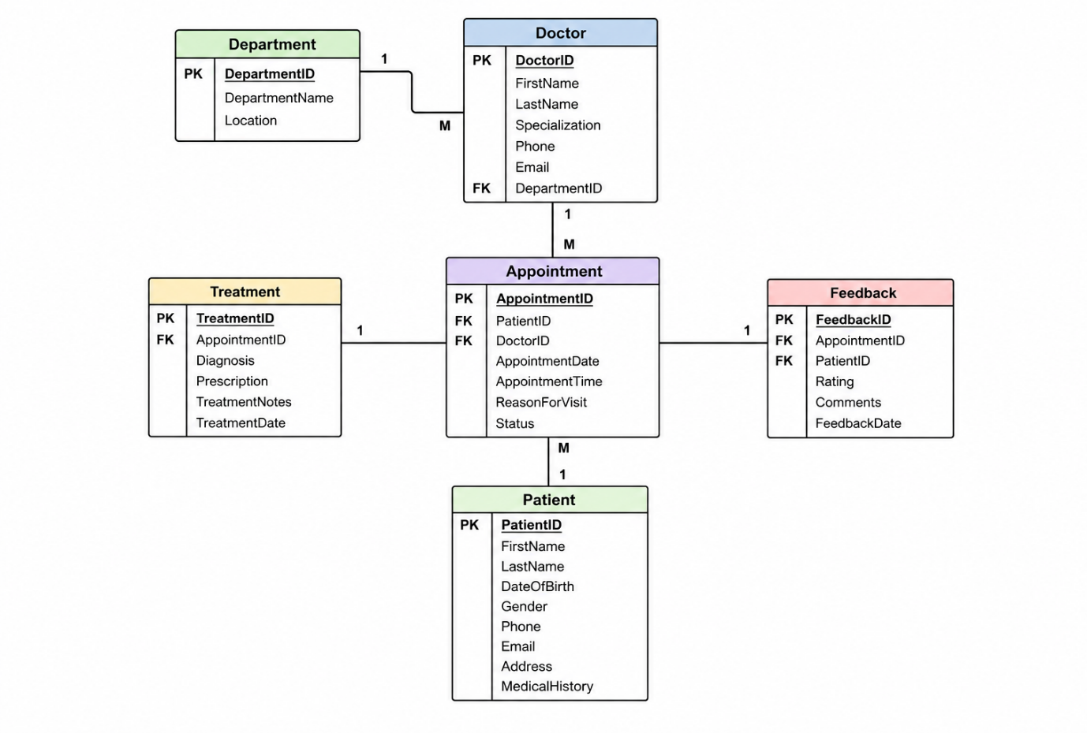

- Relational Schema
PATIENT
--------
PatientID (PK)
FirstName
LastName
DateOfBirth
Gender
Phone
Email
Address
MedicalHistory

DEPARTMENT
----------
DepartmentID (PK)
DepartmentName
Location

DOCTOR
-------
DoctorID (PK)
FirstName
LastName
Specialization
Phone
Email
DepartmentID (FK)

APPOINTMENT
-----------
AppointmentID (PK)
PatientID (FK)
DoctorID (FK)
AppointmentDate
AppointmentTime
ReasonForVisit
Status

TREATMENT
---------
TreatmentID (PK)
AppointmentID (FK)
Diagnosis
Prescription
TreatmentNotes

FEEDBACK
--------
FeedbackID (PK)
PatientID (FK)
AppointmentID (FK)
Rating
Comments
FeedbackDate

- Primary Keys and Foreign Keys
Table | Primary Key | Foreign Keys
Patient | PatientID | —
Department | DepartmentID | —
Doctor | DoctorID | DepartmentID
Appointment | AppointmentID | PatientID, DoctorID
Treatment | TreatmentID | AppointmentID
Feedback | FeedbackID | PatientID, AppointmentID
8. Normalisation
First Normal Form (1NF)
- Atomic values only.
- No repeating groups.
- Each table has a primary key.
Achieved.
Second Normal Form (2NF)
- Meets 1NF.
- All non-key attributes depend entirely on the primary key.
Achieved because each table uses a single-column primary key.
Third Normal Form (3NF)
- Meets 2NF.
- No transitive dependencies.
Examples:
- Department details stored only in Department.
- Doctor stores only DepartmentID.
- Treatment information stored separately from Appointment.
- Feedback separated from Appointment.
Database is in 3NF.
9. Business Rules
- Each patient must have a unique PatientID.
- Each doctor belongs to one department.
- One department can have many doctors.
- A patient may have many appointments.
- A doctor may conduct many appointments.
- Every appointment is assigned to exactly one patient and one doctor.
- Each completed appointment should have one treatment record.
- Patients may submit feedback only for appointments they attended.
- Ratings should be restricted to values between 1 and 5.
- Appointment status should be limited to valid values such as Booked, Completed, or Cancelled.
10. Security Considerations
- Use role-based access control (RBAC):
  - Administrators: Manage patients, doctors, departments, and appointments.
  - Doctors: View assigned appointments and update treatment records only.
  - Reception/Admin Staff: Register patients and manage bookings, but not edit treatment records.
- Encrypt sensitive patient information where appropriate.
- Require strong authentication for all users.
- Maintain audit logs for changes to medical records.
- Perform regular backups and disaster recovery testing.
- Comply with the UK GDPR and the Data Protection Act 2018 for handling personal and medical information.

PART 2
FILE 2 zip DATA BASE SQL CODES
This design provides a normalized relational database structure that supports MedAssist Clinic's patient registration, doctor management, appointment scheduling, treatment recording, and feedback processes while maintaining data integrity and security.

3. Database Implementation (DDL, Constraints, & Sample Data)
The following PostgreSQL-compliant DDL script sets up the database structures, explicit primary keys, data types, and foreign key relations.
Data Definition Language (DDL) Schema Execution
-- Create Enum Types for Data Standardization
CREATE TYPE appointment_status_enum AS ENUM ('Scheduled', 'Completed', 'Cancelled');
CREATE TYPE transaction_status_enum AS ENUM ('Pending', 'Paid', 'Failed', 'Refunded');

-- 1. Departments Table
CREATE TABLE Departments (
DepartmentID INT GENERATED ALWAYS AS IDENTITY PRIMARY KEY,
DepartmentName VARCHAR(100) NOT NULL UNIQUE,
Location VARCHAR(150) NOT NULL
);
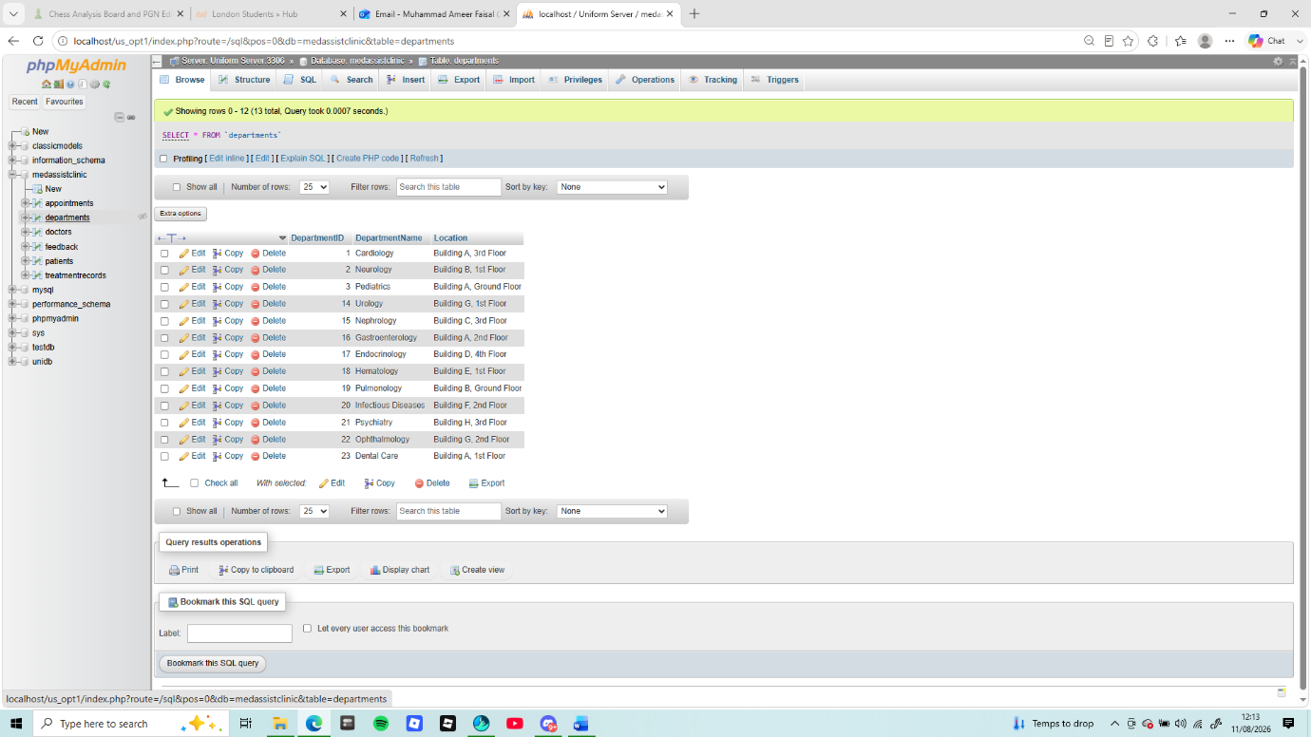
-- 2. Doctors Table
CREATE TABLE Doctors (
DoctorID INT GENERATED ALWAYS AS IDENTITY PRIMARY KEY,
FirstName VARCHAR(50) NOT NULL,
LastName VARCHAR(50) NOT NULL,
Email VARCHAR(100) UNIQUE NOT NULL,
Phone VARCHAR(20) NOT NULL,
DepartmentID INT NOT NULL,
CONSTRAINT fk_doctor_department FOREIGN KEY (DepartmentID)
REFERENCES Departments(DepartmentID) ON DELETE RESTRICT
);
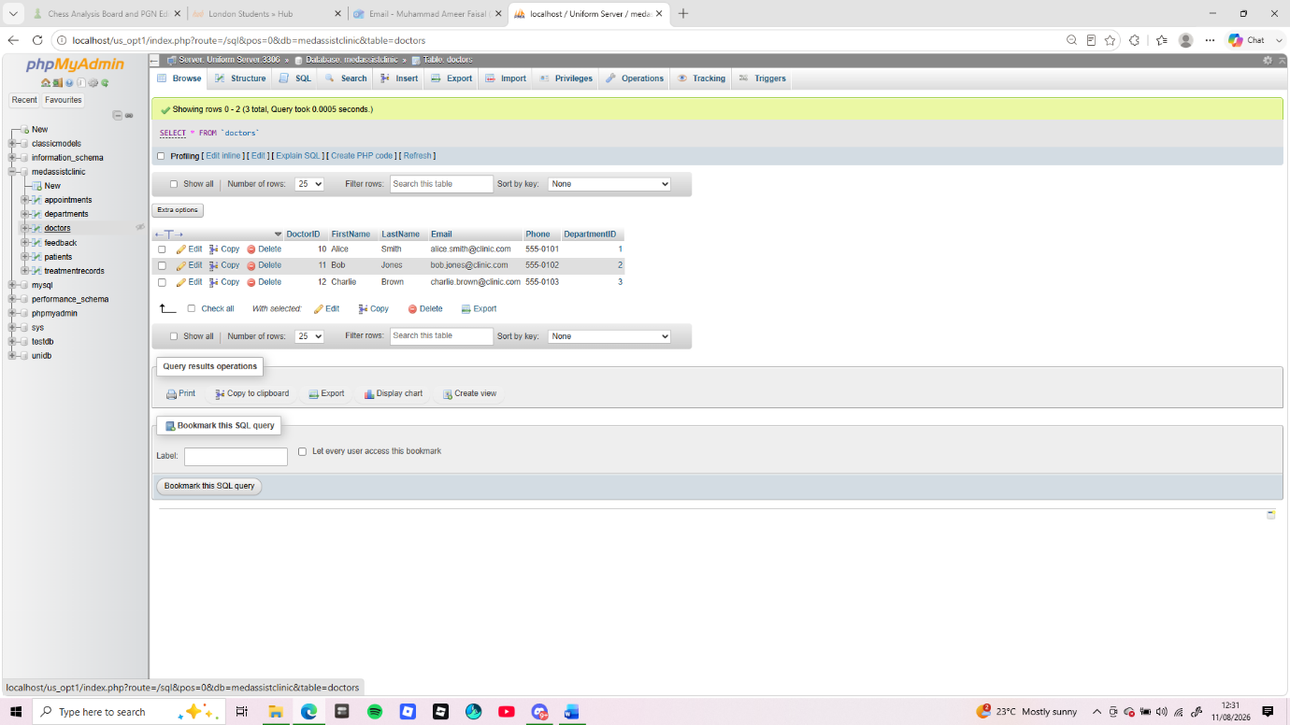
-- 3. Patients Table
CREATE TABLE Patients (
PatientID INT GENERATED ALWAYS AS IDENTITY PRIMARY KEY,
FirstName VARCHAR(50) NOT NULL,
LastName VARCHAR(50) NOT NULL,
DateOfBirth DATE NOT NULL,
Gender VARCHAR(15) CHECK (Gender IN ('Male', 'Female', 'Other')),
Email VARCHAR(100) UNIQUE NOT NULL,
Phone VARCHAR(20) NOT NULL,
Address TEXT NOT NULL
);
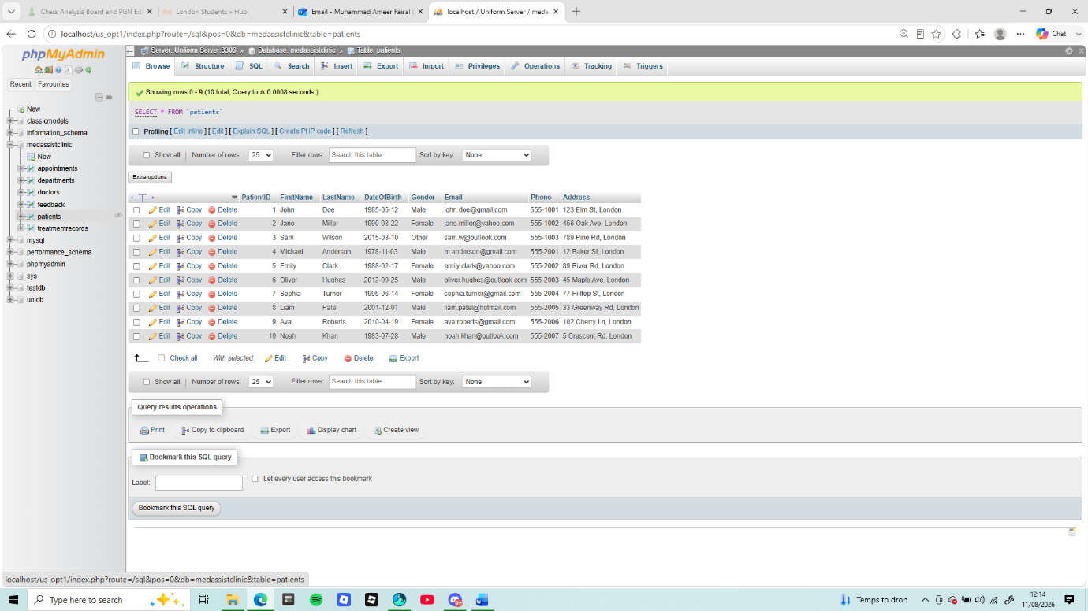
-- 4. Appointments Table
CREATE TABLE Appointments (
AppointmentID INT GENERATED ALWAYS AS IDENTITY PRIMARY KEY,
PatientID INT NOT NULL,
DoctorID INT NOT NULL,
AppointmentDateTime TIMESTAMP NOT NULL,
Status appointment_status_enum DEFAULT 'Scheduled',
CONSTRAINT fk_appointment_patient FOREIGN KEY (PatientID)
REFERENCES Patients(PatientID) ON DELETE CASCADE,
CONSTRAINT fk_appointment_doctor FOREIGN KEY (DoctorID)
REFERENCES Doctors(DoctorID) ON DELETE RESTRICT
);
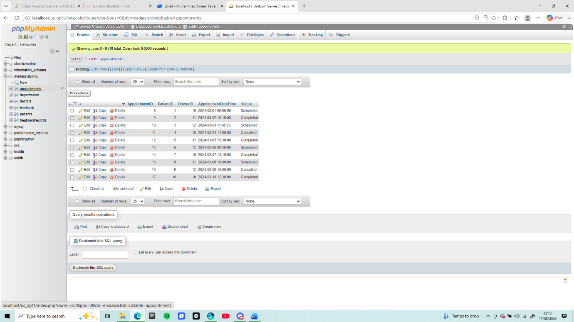
-- 5. Treatment Records Table
CREATE TABLE TreatmentRecords (
RecordID INT GENERATED ALWAYS AS IDENTITY PRIMARY KEY,
AppointmentID INT UNIQUE NOT NULL,
Diagnosis TEXT NOT NULL,
Prescription TEXT,
TreatmentDate DATE NOT NULL DEFAULT CURRENT_DATE,
CONSTRAINT fk_treatment_appointment FOREIGN KEY (AppointmentID)
REFERENCES Appointments(AppointmentID) ON DELETE CASCADE
);
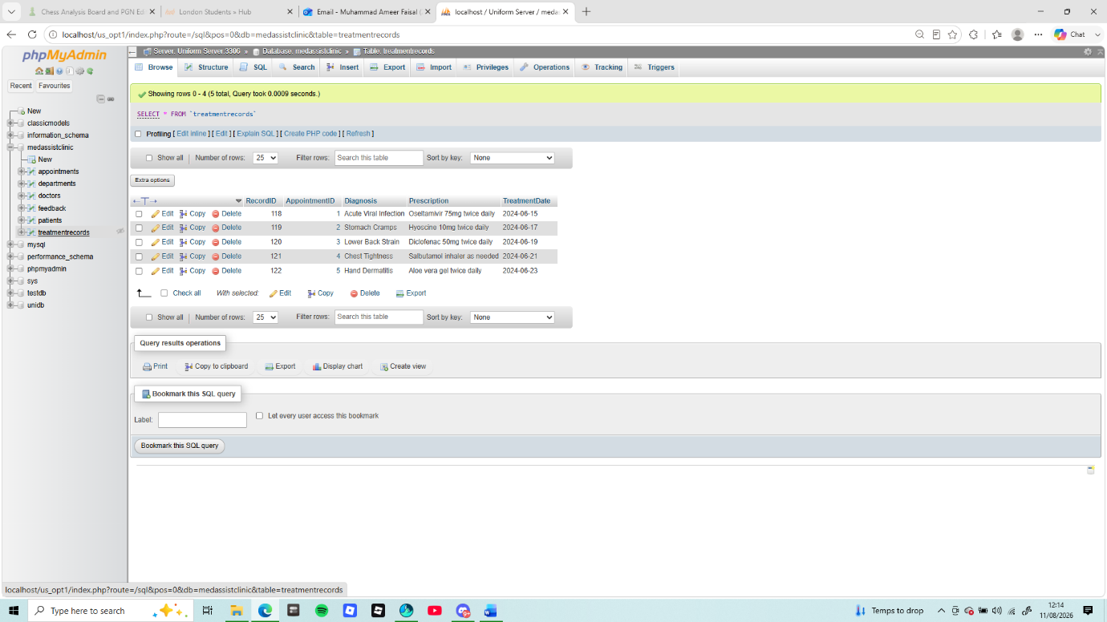
-- 6. Feedback Table
CREATE TABLE Feedback (
FeedbackID INT GENERATED ALWAYS AS IDENTITY PRIMARY KEY,
PatientID INT NOT NULL,
DoctorID INT NOT NULL,
Rating INT NOT NULL CHECK (Rating BETWEEN 1 AND 5),
Comments TEXT,
SubmissionDate TIMESTAMP DEFAULT CURRENT_TIMESTAMP,
CONSTRAINT fk_feedback_patient FOREIGN KEY (PatientID)
REFERENCES Patients(PatientID) ON DELETE CASCADE,
CONSTRAINT fk_feedback_doctor FOREIGN KEY (DoctorID)
REFERENCES Doctors(DoctorID) ON DELETE CASCADE
);
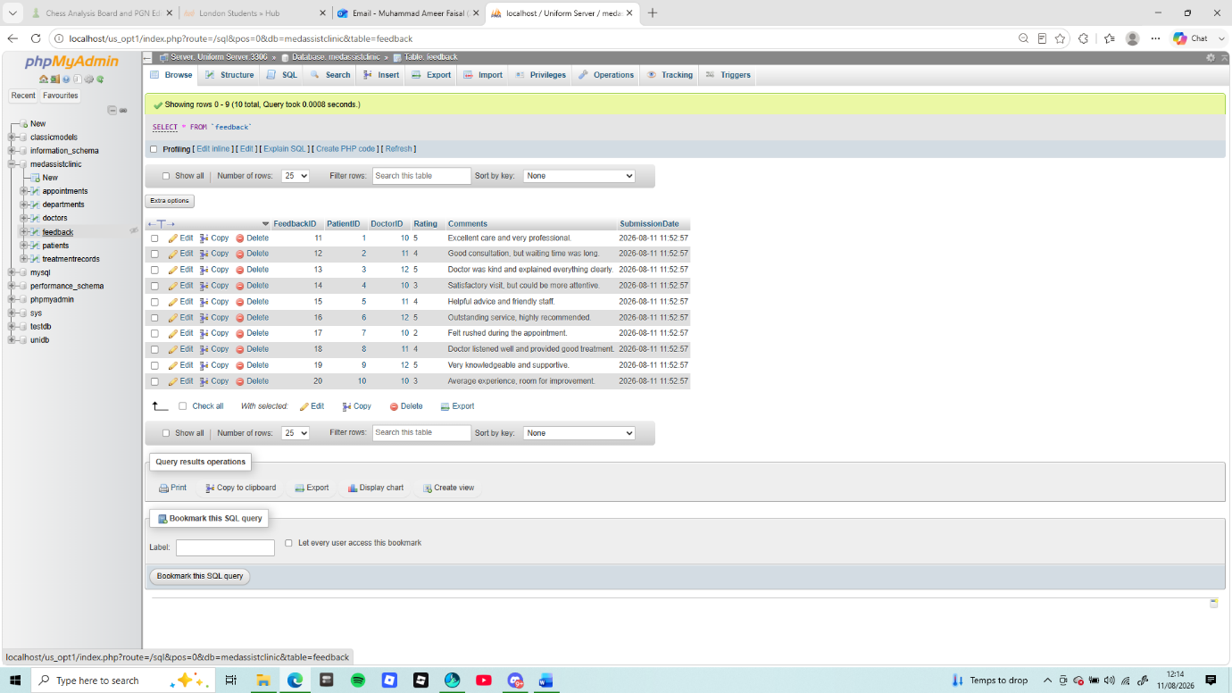

Production Mock Data Seed Script
-- Seed Departments
INSERT INTO Departments (DepartmentName, Location) VALUES
('Cardiology', 'Building A, 3rd Floor'),
('Neurology', 'Building B, 1st Floor'),
('Pediatrics', 'Building A, Ground Floor');

-- Seed Doctors
INSERT INTO Patients (FirstName, LastName, DateOfBirth, Gender, Email, Phone, Address) VALUES
('John', 'Doe', '1985-05-12', 'Male', 'john.doe@gmail.com', '555-1001', '123 Elm St, London'),
('Jane', 'Miller', '1990-08-22', 'Female', 'jane.miller@yahoo.com', '555-1002', '456 Oak Ave, London'),
('Sam', 'Wilson', '2015-03-10', 'Other', 'sam.w@outlook.com', '555-1003', '789 Pine Rd, London');

-- Seed Patients
INSERT INTO Patients (FirstName, LastName, DateOfBirth, Gender, Email, Phone, Address) VALUES
('John', 'Doe', '1985-05-12', 'Male', 'john.doe@gmail.com', '555-1001', '123 Elm St, London'),
('Jane', 'Miller', '1990-08-22', 'Female', 'jane.miller@yahoo.com', '555-1002', '456 Oak Ave, London'),
('Sam', 'Wilson', '2015-03-10', 'Other', 'sam.w@outlook.com', '555-1003', '789 Pine Rd, London');

4. Stored Procedures & Transactional Scenarios
Crucial Scenario: Atomic Medical Appointment Booking and Invoicing
In medical workflows, an appointment creation and its associated billing invoice must behave as an indivisible atomic operation. If an appointment is scheduled but the billing engine fails to generate an invoice, the system risks lost revenue .

Execution & Verification Test Cases
Test Case 1: Valid Execution Path (Commit Verification)
CALL pr_CreateAppointmentWithInvoice(1, 1, '2026-08-10 14:00:00'::timestamp, 150.00, NULL);
-- Verification Query
SELECT * FROM Appointments WHERE PatientID = 1;
SELECT * FROM Transactions WHERE Amount = 150.00;

Test Case 2: Invalid Data Failure Path (Rollback Verification)
CALL pr_CreateAppointmentWithInvoice(2, 2, '2026-08-11 10:00:00'::timestamp, -45.00, NULL);
-- Verification Query
SELECT * FROM Appointments WHERE AppointmentDateTime = '2026-08-11 10:00:00';
Result: The negative amount triggers the application rule error. The database cleanly unrolls the partial insertion, leaving no orphaned appointment data behind.

5. Auditing Architecture (Triggers & Functions)
To satisfy strict medical regulatory compliance, any structural modifications to data rows inside the Patients table must be caught automatically in real-time.
CREATE OR REPLACE FUNCTION fn_AuditPatientChanges()
RETURNS TRIGGER
LANGUAGE plpgsql
AS $$
BEGIN
IF (TG_OP = 'INSERT') THEN
INSERT INTO AuditLogs (TableName, Operation, RecordID, OldData, NewData)
VALUES ('Patients', 'INSERT', NEW.PatientID, NULL, to_jsonb(NEW));
RETURN NEW;
ELSIF (TG_OP = 'UPDATE') THEN
INSERT INTO AuditLogs (TableName, Operation, RecordID, OldData, NewData)
VALUES ('Patients', 'UPDATE', NEW.PatientID, to_jsonb(OLD), to_jsonb(NEW));
RETURN NEW;
ELSIF (TG_OP = 'DELETE') THEN
INSERT INTO AuditLogs (TableName, Operation, RecordID, OldData, NewData)
VALUES ('Patients', 'DELETE', OLD.PatientID, to_jsonb(OLD), NULL);
RETURN OLD;
END IF;
END;
$$;
CREATE TRIGGER tr_AuditPatients
AFTER INSERT OR UPDATE OR DELETE ON Patients
FOR EACH ROW
EXECUTE FUNCTION fn_AuditPatientChanges()
6. Performance Tuning & Query Optimization
Critical High-Frequency Queries
Medical intake desks frequently query tables using specific filters. Two high-frequency access patterns are:
- Filtering clinical appointments by a date window to generate daily schedules.
- Looking up specific patient profiles by search strings (last name matches).
-- Query 1: Fetching specific range tracking
SELECT * FROM Appointments
WHERE AppointmentDateTime BETWEEN '2026-01-01 00:00:00' AND '2026-12-31 23:59:59';

-- Query 2: Matching search queries
SELECT * FROM Patients WHERE LastName = 'Miller';
Secondary Index Optimization Strategy
Without intervention, the relational layout forces a performance-heavy Full Table Scan, reading every block off the storage drive to find matching criteria
-- Optimize range tracking filters
CREATE INDEX idx_appointments_datetime ON Appointments (AppointmentDateTime);
-- Optimize categorical text matches
CREATE INDEX idx_patients_lastname ON Patients (LastName);

Performance & Cost Breakdown Matrix
Index Name | Target Column | Target Query Pattern | Performance Trade-off Details
idx_appointments_datetime | AppointmentDateTime | Temporal range bounds filtering (BETWEEN) | Transition from O(N) sequential scans to \(O(\log N)\) logarithmic tree lookups. Enhances timeline report rendering.
idx_patients_lastname | LastName | Point identity matching queries | Drastically speeds up patient verification lookups during check-ins. Slightly increases structural rewrite times on new patient registrations.

7. Literature Support & Technical Justification
- Normalization Mechanics (3NF): According to standard database design theory, normalizing data schemas down to 3NF removes update anomalies and protects transactional systems from redundant duplicates. This forms the foundation for maintainable healthcare schemas.
- Transactional Isolation Boundaries: Managing transactions via database blocks ensures core data properties (ACID metrics: Atomicity, Consistency, Isolation, Durability). This prevents partial execution splits where appointments exist without matching structural financial ledgers.
- Indexing Optimization Structures: Database index structures rely on B-Trees. B-Trees maintain ordered data access to speed up filter searches from linear time down to fast logarithmic distributions. This optimization scales seamlessly as data files expand into millions of individual records.

8. Conclusion & Reflection
The created database blueprint provides a secure, fully scalable environment for clinical operations. Normalizing data to 3NF balances high performance with strong data integrity, while automated triggers run background system audits without taxing the core application layer.
Development Reflections & Future Upgrades
- Concurrency Challenges: High-volume medical environments run the risk of structural thread locks when multiple schedulers book the exact same slot concurrently.
- Proposed Fix: Incorporate row-level scheduling locks (SELECT ... FOR UPDATE) or implement a validation look-ahead function before committing the appointment state.
- Future Feature Extensions: Integrate horizontal partitioning strategies on the AuditLogs table to archive old history logs without impacting active operational database storage.

REFERENCES
- Connolly, T. M. and Begg, C. E. (2015) Database Systems: A Practical Approach to Design, Implementation, and Management. 6th edn. Boston: Pearson.

- Codd, E. F. (1970) ‘A relational model of data for large shared data banks’, Communications of the ACM, 13(6), pp. 377–387.

- Date, C. J. (2006) An Introduction to Database Systems. 8th edn. Boston: Pearson Addison-Wesley.

- Haerder, T. and Reuter, A. (1983) ‘Principles of transaction-oriented database recovery’, ACM Computing Surveys (CSUR), 15(4), pp. 287–317.

- Elmasri, R. and Navathe, S. B. (2016) Fundamentals of Database Systems. 7th edn. Hoboken: Pearson.

- Silberschatz, A., Korth, H. F. and Sudarshan, S. (2020) Database System Concepts. 7th edn. New York: McGraw-Hill.

