Assignment Title: System Improvement Programme
Programme Name: MSc Digital Skills for the Health and Care Professions
Academic Year: 2022/2023
Module Name: Digital Technology in Health and Social Care
Module Code: BMDS 7006
Student Name: Claire Jeanette Muxworthy
Student ID: 2212124
Total word count: 4679
Date of Submission: 15th December 2022

Table of Contents

 | Title | Page
1 | Introduction | 3
2 | Justification | 4
3 | Aim and Objectives | 6
4 | Literature Review | 6
5 | Methods | 11
6 | Discussion | 16

Introduction

As part of the wider National Health Service (NHS) in Wales; established in 1998, The Welsh Ambulance Services NHS Trust (WAST) merged with NHS Direct Wales in April 2007, to become, not only an emergency service to treat patients at the scene and transport them to a hospital, but also to provide telephone health-related guidance. WAST covers the whole of Wales and provides healthcare for more than three million people. There are over 250,000 calls to the emergency number each year (Welsh Ambulance Service NHS Trust, 2022).
For telephone advice, the patient telephones 111. The call is then answered, prioritised, and passed to the most appropriate person. If information is required, then a Health Information Advisor will signpost to the relevant information, either via a website, telephone number, or leaflet. If the patient has symptoms, a Nurse Advisor will provide advice about treatments or next steps, for example, to visit their pharmacy or doctor’s surgery. If the patient is deemed to have life-threatening symptoms, then the call is redirected to 999.
For emergencies, the patient telephones 999. The call is then answered and prioritised for urgency. Once prioritised, a suitable vehicle is located and dispatched. When the ambulance arrives on the scene, the Paramedic treats the patient. They then complete an electronic patient clinical record (ePCR).
The ePCR contains the patient’s personal details (name, date of birth, address, etc) in addition to the patient’s clinical observations and any medical treatment administered. These can be selected via either a dropdown box or a button with pre-defined answers. There is also a free text field where any additional comments relating to the patient can be recorded. Once the Paramedic has finished entering all the data onto the ePCR and the patient has been discharged from the care of the Paramedic, the record is closed, and all data is saved in a data warehouse.
On 25th May 2018, the General Data Protection Regulation (GDPR) replaced the Data Protection Act 1998. WAST must ensure that any information relating to a patient must be stored, accessed, and used appropriately. All aspects of patient privacy, rights, and protection are adhered to (Data Protection Act 2018).
In addition to the regulations relating to the patient and ePCR, WAST employs Clinical Audit Co-ordinators (CAC) who carry out clinical audits to ensure every patient receives effective and safe treatment. The treatment is measured against specific standards and guidelines as set out in the Joint Royal Colleges Ambulance Liaison Committee JRCALC Clinical Guidelines 2022 (AACE, JRCALC, 2022).

Justification
The author of this document, working as a WAST Clinical Audit Co-ordinator (CAC), is conscious that carrying out tasks as efficiently and effectively as possible is vital. Ways to improve the role must always be explored.
Current situation
Whilst carrying out clinical audits, the data required for each audit is currently manually downloaded from the ePCR system by the CAC. This is done via an SQL script which has to be written by the CAC.
The data is then copied from SQL and pasted into a Microsoft Excel spreadsheet which must be physically formatted by the CAC to include complex formulas. The formulas help to define which things need to be audited.
The CAC must then manually search the ePCR database for the relevant patient record to audit against.
Issues Arising
Writing the SQL query, formatting the excel spreadsheet, then manually searching for each ePCR is a very timely process. From the author of this document’s experience of performing these tasks, it is evident that writing the SQL script plus entering the formulas into the excel spreadsheet can take several days (between two and five) depending upon the complexity of the data required. As there are usually approximately twelve audits carried out per year, this means a minimum of twenty-four working days are lost to performing these tasks. This could be greatly reduced if a new, more automated system were introduced.
Associated Risks
There is a risk that if there is an error in either the SQL of excel formulas (Glass, Ford, and Dewhurst, 2009). some of the data to be audited will be missed, and results will be incomplete or inaccurate.
Carrying out intricate functions in Microsoft excel, in addition to being time-consuming, carries the risk of the formula being incorrect (Powell, Baker, and Lawson, 2008, pp.128 - 138).
If using large amounts of data, there is also a risk that the excel spreadsheet will reach its maximum workbook row limit of 65,536, (xls) and 1,048,576 (xlsx) (Alam, Islam, and Alam, 2019).
Manually finding each patient record on the ePCR database also carries a risk. If the incorrect ePCR number is accidentally entered, the record shown will be for the wrong patient, thus breaching patient confidentiality (Wales, N.H.S., 2015, pp.7-20) .
Suggested Solution
A more efficient system would enable the auditor to select the required fields via a tick box on a pre-created form. The relevant scripting would run in the background.
Then, once the data is downloaded, a mouse click would open the relevant ePCR.
Anticipated Improvements
It is anticipated that the newly improved system would enable a more seamless process that would be able to provide accuracy in data selection and acquisition, whilst also saving a large amount of time. Both staff and management would be able to gain the information, in the best format for them. There would also be an audit trail of all data requested
The CAC would be able to work more accurately and effectively as the new design would enable more in-depth data to be extracted from the ePCR database.
WAST managers would be able to access the data they need to use for research, performance management, and service improvement purposes.
Also, if the reports were saved as templates, multiple people could make use of them. This would prevent duplication of effort and ensure reproducibility and accuracy.
Going forward, the data could be used to further enhance performance and provide much-needed information to forecast future requirements. An example of this is medication management, whereby the usage of a specific drug can be logged to help predict its future requirements, and whether an alternative drug with a longer shelf life could be used instead. Within WAST, in June 2021, due to the usage and short expiry date, the drug Glycopyrronium was replaced with Hyoscine Hydrobromide on all WAST emergency ambulances. (WAST, 2021).
Considerations
Getting the design of the database right is essential. Careful planning that takes into account all aspects of the design is crucial. Additionally, during the entire development process, the client who will be using the database must be consulted.
For the project to be successful, the client must understand exactly what they require, and the creator must be made aware of what is expected of them.
The creator must work in conjunction with the customer to ensure that the requirements are clearly understood, and both are aware of what is attainable.
If the customer is presented with something inferior, then the entire project has not been a success (Kendall et al. 2020, p.40).

Aim
The aim of the project is to implement an automated system to collect all the required data from the ePCR database and display it in a user-friendly way by 1st September 2023.

Objectives
To decide upon software that is suitable to collect the required data.
To test whether the software is compatible with current WAST systems (ePCR and CAD).
To find out if the software adheres to WAST policies and guidance in relation to data acquisition.
To design a wireframe diagram for the user interface that can be used by the Clinical Audit Co-ordinator.
To be designed by the Health Informatics Team within WAST to ensure cost-effectiveness and stakeholder engagement throughout.
To test the software and install it by 1st September 2023.

Literature Review
The following table was designed to ensure that the author of this document considered everything that needed to be included in the literature review. The author of this document entered various words with similar meanings to aid the search:
Table 1: Initial Search Criteria
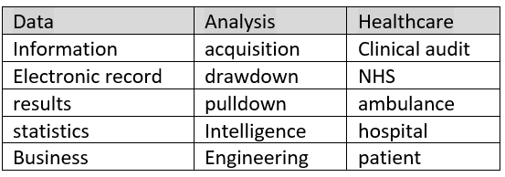
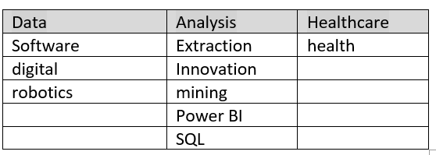
To use the best information, the author of this document launched the Google Scholar search engine within the web browser. This allowed her to search for the information and cite the appropriate reference. To ensure only current information was displayed, the author of this document set the search timescale to the previous five years. Initially, the words searched for were “data analysis tools in healthcare” which returned 17,800 searches (25th October 2022). From this, the author of this document searched on more explicit words to return fewer searches, however, searching "Clinical Audit Systems within the ambulance Service" returned no results. The author of this document then broadened the search to “Clinical Audit Systems” which provided 24 results. To ascertain whether these documents were from a credible source, the author of this document looked at references used within the literature and what source they were from. For example, if the author of this document was a lecturer within a university, then this was deemed acceptable from the author of this document’s perspective.
The auditor then looked for the most relevant documents and initially discarded documents, for example, documents relating to European radiology, and concentrated on the ones which were more generalised.
Document 1 used Activity Theory and referred to an electronic clinical audit tool (eCAT). This system initially seemed to be a viable method, as was linked to the patient administration system (PAS), however, the document contained technical information which proved confusing to the author of this document (Wickramasinghe, Haddad, 2017).
Document 2 was a trial of different ways to conduct a clinical audit rather than a tool to aid with data acquisition. Although the search requested English, this document was not written in English, however, there was an option to translate the document which the author of this document did (Gavrilyuk et al. 2020, pp.27-31).
Document 3 was discarded as, although it discussed healthcare systems, the content was based on political views rather than a clinical audit system (Triantafillou , 2022, pp.199-208).
Document 4 was discarded as it was a survey regarding patient safety, and not a clinical audit system (Yeboah et al. 2007, pp. 34-45)
Document 4 was discarded as the author of this document was unable to view the document due to it being an academic piece of literature (Lacey, 2019).
The author of this document then searched using Boolean operators the key words “data analysis” and “ambulance” and “clinical audit”. This returned 305 results. By altering “ambulance” to “ambulance service” and “UK”, the results were cut to 304. The “uk” element seemed to have little impact as studies from Southern Australia were visible.
The author of this document scanned the information available before opening documents deemed relevant.
The following document was regarding a dementia audit of patient data captured on electronic record, similarly to WAST. The data for this audit was extracted via SQL, then there was extra data accessed via Qlikview. This application is like similar to (Qlik sense) which is currently used to provide operational information from the CAD system within WAST. The Clinical Audit and Effectiveness Department (CAED) is familiar with how this data is presented. The data was then transferred to a Microsoft excel document. This is similar to how WAST currently does its audits (Pocock et al., 2018, p10).
The author of this document searched on "analysing data" and "electronic healthcare records" and "NHS" forwarded 14 results, however, all documents were discarded.
Following a search of health information management systems, and the author of this document discovering the wording FHIR (Fast Healthcare Interoperability Resources), the author of this document searched the internet for documents containing the specific words of FHIR.
This led the author of this document to research FHIR. Once the pertinent documents had been read, to ensure that the most relevant information was not overlooked, the author of this document searched for specific words like “ambulance” within the documents. This enabled her to ascertain whether there were any sections relevant to the ambulance service. Although some health records may have been designed through the FHIR HL7 project (the Health Level 7 standards organisation), it was not the system that was used for WAST (HL7 International (n.d)).
The WAST database was designed and managed via a company called Terrafix Ltd. The system used for WAST in addition to the Scottish Ambulance Service and is called Terrapace (Terrafix Ltd., 2019). Whilst the Terrapace system has some similarities, for example, the ability for the user to add photographs to the ePCR, or electrocardiograms (ECG) to further enhance the patient record, there are differences. WAST uses a computer-aided dispatch (CAD) system to prioritise the patients who ring 999. This is a totally separate system from the ePCR, however, the two can be linked.
Whilst researching FHIR, the author of this document was signposted to NHS terminology codes, which are often used in hospitals and doctor’s surgeries. SNOMED CT is advertised as the most thorough and accurate terminology product. It is a mandate that all NHS Trusts in England must use it (NHS Digital, 2022).
Computers can be programmed to interpret the SNOMED CT coding. The codes can then be used to form part of the patient record. To ensure accuracy the coded information can be passed between healthcare professionals, across multiple countries (SNOMED International, 2022).
Although SNOMED CT must be used across England, WAST does not use this for coding. Instead, WAST uses a “closure code” which is assigned to meet the patient’s condition.
The author of this document found that searching words such as “data analysis”, “ambulance” and “NHS” provided information that referred to the automatic capture of information, rather than the automated withdrawal of the data from the patient record system. The author of this document then searched using "health information" and "digital innovation" "NHS". This proved more beneficial. The document spoke about artificial intelligence and robotics which could further enhance the data being extracted (Sheikh et al., 2021 pp. e383-e396).
A search of "medical data systems" and "robotics" saw 39 results. After reading the abstracts of relevant articles, the author of this document then concentrated on industry 4.0. and the digitisation of the NHS. The document discussed the internet of things (IOT) which is being rapidly implemented across the NHS. Devices can be used which transmit data from patients to doctors. This document also discusses the retrieval of records and information using blockchain technology. This is described as a secure system and would therefore be beneficial to the NHS to help patient confidentiality (Paul et al., 2021, p43).

Following this document, the author of this document then searched "blockchain technology" and "ambulance service" and “UK”. Despite twenty results being found (19th November 2022) and the detailed search criteria, the information was not relevant to the author of this document’s requirements.
The author of this document found difficulty in locating evidence of success or failure using different project management style, despite carrying out multiple searches using different search criteria e.g. “information systems implementation and "project success" and "ambulance", "data acquisition projects" and "healthcare", information system projects for automated data drawdown, project ,management and “automated information systems” and “ambulance”, sourcing and installing information systems projects, project management and “automated information systems” and “ambulance”.
Whilst there were multiple research documents which suggested which project methodology to use for which project, there was little evidence surrounding the actual systems implemented and the project success and failure aspects. The studies generally used questionnaires and surveys to ascertain effectiveness.
From looking specifically at "data extraction" and "health records" and "tool" the author of this document found information relating to Medrave 4 which was tested for accuracy in a study carried out in Norway in 2019 (Holte and Holmen 2020, pp. 1–5) which was constructed to drawdown the data which had been saved in healthcare records. The tool was tested against other tools and was found to be the most accurate of those tested. The system is not absolutely accurate, however has been adapted in almost 850 health centres and general practices throughout Scandinavia.
From searching using Boolean operators "Power BI" and "ambulance service" and "UK", (8 results) the author of this document found evidence of where Power BI had been used to draw down information from electronic patient records. By using Power BI, the operator was able to produce a visual display which clearly showed the required data in a user-friendly way. This was deemed helpful by the viewers (Fleming, 2019, p 99).
To aid with the project management aspect, the author of this document searched specifically on Boolean operators “software project management” and “ambulance”.

Methods
Project Methodologies Available
For projects to be successful, the most appropriate method of project management needs to be used. There are a lot of project management methodologies currently available. These include but are not exhaustive of PMBoK , ISO 21500 standard, P2M, PRINCE2, Agile, and RUP (Kononenko and Kharazii, 2014).
Whilst comparing Prince 2 Methodology to PMBOK, Wideman found that Prince 2 methodology, whilst having its flaws, was an easy process to follow. In software design, as there needs to be frequent testing, this method was deemed suitable (Wideman, 2002, pp.13-16).
Prince 2 is a project methodology commonly used within WAST (Harris, 2021). Due to this, the author of this document, whilst working for WAST has achieved a foundation certificate in Prince 2 Project Management. therefore the preferred project methodology will be Prince 2.
There are several different approaches which can be used whilst carrying out a project. These include but are not exhaustive of: Agile, Waterfall.
Whilst researching software project management, although, (Day, 2011) did not specifically mention Prince 2 project methodology, it directed the author of this document to another document (Ahmed, 2011).
Whilst Ahmed ‘s preferred approach is a process aligned to the systems development life cycle (SDLC) (Kendall, 2020, pp. 42-47); as there are multiple strands to this project, it would be beneficial to test and amend after each section. Due to this, the Agile approach, where testing occurs at the end of each section, not each project, is deemed more suitable in this instance.
Also, according to Prince 2 methodology, for use with information systems, the best project management approach is Agile. This will be the management approach carried out in this report (Axelos, 2017, p.15).
Prince 2 Project Methodology:
According to Prince 2 methodology (Axelos, 2017), a project should always have a start and end date with several stages in-between. It is not a permanent process. A team should be set up to achieve the project goals and is then disbanded once the project has been completed. There should always be lessons learned from both things that went and things that didn’t.
The team should be led from the highest standing in rank, and the project begins with an idea (vision) of the Chief Executive Office (or similar position) of a company.
There is a Project Board appointed to control the project. This is usually made up of departmental heads, the Project Board should consist of people with the authority to make the important decisions and authorise any actions taken by the Project Manager. The success of the project is usually attributed to the decisions made by the Project Board.
The Project Manager is usually a junior manager. They are appointed to keep the project on track. It is their job to act as a link between the team members. They must feed any important information upwards to senior management as well as sideways to the Team Manager.
The Team Manager is usually the software creator or seller. They must be provided with the product specification. They must liaise with the Project Manager regarding timescales, cost etc.
For the project to be successful, firstly it needs the following aspects to be identified:
What is the budget and expected price? What timetable is allocated to the project? To what standards will it be completed? (Often quality is affected by budget). What will actually be done in the project? What are the threats associated with the project? What are the advantages of completing the project? The Project Board must agree these, and always be kept up to date on how each is progressing at the end of each stage of the project.
Prince 2 methodology follows seven processes.
Table 2: The seven processes outlined in Prince 2:
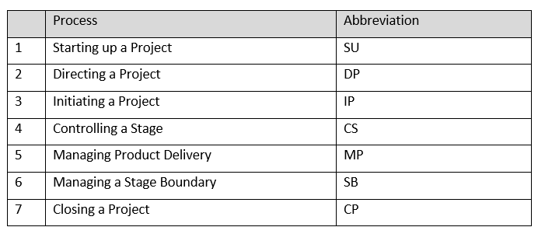

Prior to any process, the idea has already been discussed and approved at Senior level.
In the SU process stage, the Project Brief is written. This is a document which will describe the project. It will have clearly defined aims, objectives, and project scope. Alongside this will be a daily log to capture all daily occurrences, and another log created to capture any lessons learned during the process. These documents will then be passed to the Project Board who will start the DP process stage. Once it is agreed that the project will go ahead, it is moved to the IP process stage.
In the IP process stage, the Project Initiation Document (PID) will be written. This will contain all aspects of the project. It will include risks and benefits, plus specify both individual and group responsibilities.
As the name suggests, each individual stage is managed by a CS process where individual pieces of work are completed. During this, the Team Manager, in the MPD process stage, manages the production of the goods.
At the end of each stage completed, (except the last) there is an SB process stage. This is where the Project Manager completes a document that updates everyone on actions, progress, risks, threats, etc.
The stage processes are replicated until the project is finally completed when the CP stage is implemented.
Project Implementation
During the SU phase, the author of this document (customer) will ensure that she has the most appropriate team of people from multiple disciplines. These will include a very senior manager, a senior specialist in computers (hardware, software, and programming), a senior financial specialist, a project manager, and a senior procurement specialist.
The customer and computer specialist will meet to discuss exactly what is needed, how it is intended to work etc. The computer specialist will then scope different options, showing the customer demonstrations of each so that the customer can decide which best meets what is needed and whether the programming will be more cost-effective to be carried out in-house or bought in from a supplier.
Once the customer and computer specialist have agreed upon the hardware, software etc. required, the computer specialist will then meet with the procurement specialist to provide costings for each item required and name the corresponding suppliers for each.
With costing for everything provided (including the cost of the time required for the WAST programmer of applicable), the customer will write the project brief and submit it to senior management for approval. This will contain all aspects of the project; the problem, the intended benefits, the possible risks, the timescales, and the cost.
Once approved, the specialists will then form the project board and the project can enter IS phase. The project manager will write the PID and create a Gantt chart (Gantt, 2015) to show specific timescales for each aspect of the project.
Image 1: Example of a Gantt Chart:
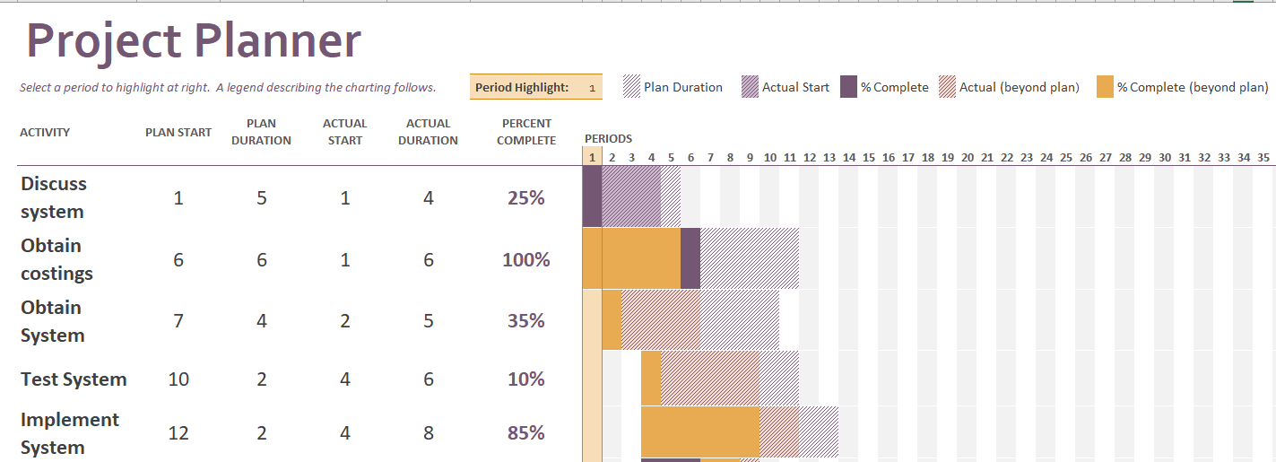

In line with the Agile process, the focus will be on the customer requirements and will keep adapting with testing carried out throughout (NILC, 2020).
Table 3: Prince 2 vs Prince 2 Agile:
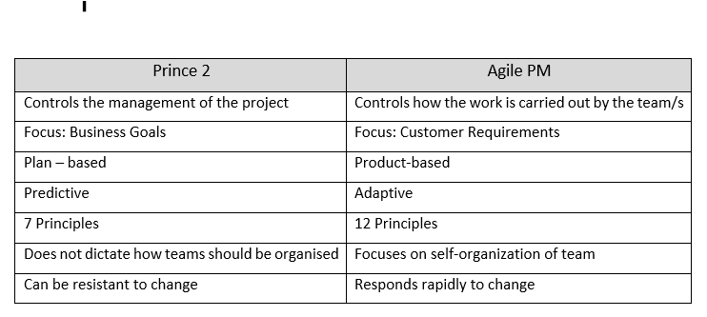
At the end of each stage, once the testing for that element has been completed satisfactorily, the project manager will feed back the progress to the project board. This process will continue at the end of each stage until the final stage of the project has been completed. A closure report will then be written by the project manager. This will include the impact of the project, the benefits, costings, any issues arising with the project, and risks and how these were managed.
Project Evaluation
To determine whether the project has been deemed a success or not and whether it has made a positive impact on the customer, the customer, in conjunction with the project manager will evaluate the project using an evaluation tool.
A suitable tool which can be used to help the project manager to assess all aspects of the project is the D & M IS Success Model (DeLone, McLean, 2003):
Image 2: D & M IS Success Model:
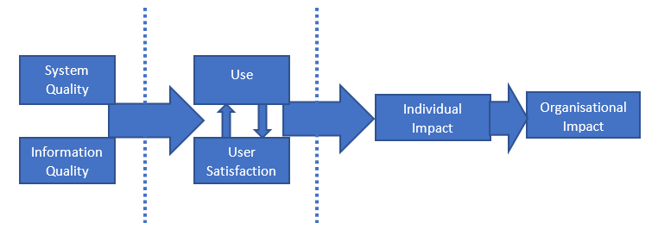
As displayed in the tool, for the project to be deemed successful, the following criteria would be met in line with the project objectives:
System Quality: The system would be compatible with all WAST systems required.
Information Quality: The data provided would be accurate.
Use: The software would be suitable to collect the data with the required ease.
User Satisfaction: The expectations of the CAC would be either met or exceeded.
Individual Impact: The CAC would save time whilst carrying out her role and be able to promote the system for use with senior managers within WAST.
Organisational Impact: The project would be delivered within timescales and budget. The efficiency and effectiveness of the system would save WAST resources and reduce risk and organisational reputation.

Discussion:
Benefits of the new system
The main aim of the Clinical Audit Co-ordinator’s role within WAST is to ensure patient safety, ensure quality, and make suggestions for improvement following any issues identified during the clinical audit process (Welsh Ambulance Services NHS Trust, 2020, unpublished).
This system will enable more clinical audits to be carried out by the CAC and other members of the Clinical Intelligence and Assurance Team (CIAT). Also, due to the ease of using the new system, more people in different teams across the Trust can carry out clinical audits.
From the clinical audits, recommendations can be made to aid clinical performance.
From the literature, due to less human interaction, there is less risk of producing inaccurate data while using the new system compared to the old way of working (Glass, Ford, and Dewhurst, 2009). As WAST reports on monthly clinical performance indicators which are publicised, the reputation of WAST will be less likely to be harmed (Emergency Ambulance Services Committee, 2022).
Influence wider system improvements
As the author of this document could not find any literature to support this project being implemented previously (either successfully or unsuccessfully), she can assume that this is the first of its kind.
Due to this, there are possibilities that the same process can be followed to enable the data extraction and display from various other systems both within WAST and other NHS Trusts.
If there were elements of programming within the project that were carried out by a programmer working within WAST, the programmer will have gained valuable knowledge which can then be used in the future if similar systems are required. Also, there is a possibility that in the future, the programmes can then be sold to other non-NHS organisations that need to use a similar approach to gain revenue for WAST. Other NHS Trusts can also benefit from the tool, as it can be used in different NHS Trusts for zero cost, particularly in Scotland where the same TerraPACE ePCR system is used.
There is also scope for the WAST programmer to explore the possibility of the system working with the Clinical Aided Dispatch (CAD) system to enable WAST senior managers to provide more intricate reports, which can be obtained simply and quickly. This will enable the possibility to improve CAD usage.
The system can also be used to gain information from past data to enable better predictions in the future. As previously demonstrated, this can be seen with the use of medications to improve drug dates. If programmed, this system could also be used to identify different types of patients, different conditions etc. This could prove very useful when identifying staff and vehicles to roster onto a shift, and medical equipment to order at specific times of year.
In conclusion
The system could enhance the performance, not only of the CIAT, but also of the whole of WAST. By being able to successfully draw down the required data with minimum human interaction, this will lessen the risk of inaccuracy. Due to this, it can be positively used to treat patients, which is at the heart of the Welsh Ambulance Service.

References

Ahmed, A., (2011). Software project management: A process-driven approach. CRC Press.

Alam, M.M., Islam, S., and Alam, M.J., (2019). The efficient way of crossing the row limit, while exporting big SAS® data to Excel. Data Science and SDGs: Challenges, Opportunities and Realities.

Axelos, (2017) Managing Successful Projects with PRINCE2®.6th Edition. Norwich: TSO

Data Protection Act 2018, Available at: Data Protection Act 2018 (legislation.gov.uk) (Accessed: 2 December 2022)

Day, L.E., (2011). The integration of software quality into software project management (Doctoral dissertation, Walden University).

DeLone, W.H. and McLean, E.R., (2003). The DeLone and McLean model of information systems success: a ten-year update. Journal of management information systems, 19(4), pp.9-30.

Emergency Ambulance Services (2022), Ambulance Service Indicators. Available at: Ambulance Service Indicators - Emergency Ambulance Services Committee (nhs.wales) (Accessed: 9th December 2022).

Gantt, H., 2015. Gantt chart.

(Gavrilyuk et al. 2020 pp.27-31) Available at: Improving the patient care process based on the principles of clinical audit (cyberleninka.ru) (Accessed: 10 November 2022)

Glass, M., Ford, D. and Dewhurst, S., (2009). Reducing the Risk of Spreadsheet Usage-a Case Study. arXiv preprint arXiv:0908.1584.

Harris, S., (2021) “TerraPACE Project, Project Initiation Document” Welsh Ambulance Services NHS Trust. Unpublished.

HL7 International. (n.d.). FHIR Overview – Clinicians Available at: Overview-clinical - FHIR v4.3.0 (hl7.org) (Accessed: 25 October 2022)

Holte, M. and Holmen, J., (2020). Program for data extraction in primary health records: a valid tool for knowledge production in general practice? BMC Research Notes, 13(1), pp.1-5.

Joint Royal Colleges Ambulance Liaison Committee, (2022.) JRCALC clinical guidelines 2022. Class Professional Publishing.

Kendall, K.E., Kendall, J.E., Kendall, E.J. and Kendall, J.A., (2002). Systems analysis and design (Vol. 4). Upper Saddle River, NJ: Prentice Hall.

Kendall. (2020). Systems analysis and design [electronic resource] (J. E. Kendall, Ed.; Tenth edition, Global edition., p. 1 online resource (578 pages)). Pearson

Kononenko, I. and Kharazii, A., (2014). The methods of selection of the project management methodology.

Lacey, A., (2019). Using Novel Data Types for Big Data Research in Epilepsy: Patient Records, Clinic Letters and Genetic Mutation (Doctoral dissertation, Swansea University).

NHS Digital (2022) Available at: SNOMED CT - NHS Digital (Accessed: 25 October 2022)

NILC., (2020) Prince 2 vs Prince2 Agile: What are the differences? Available at:
PRINCE2® vs PRINCE2 Agile®: What are the differences? - NILC (Accessed 4 December 2022).

Paul, S., Riffat, M., Yasir, A., Mahim, M.N., Sharnali, B.Y., Naheen, I.T., Rahman, A. and Kulkarni, A., (2021). Industry 4.0 applications for medical/healthcare services. Journal of Sensor and Actuator Networks, 10(3), p.43.

Pocock, H., Jadzinski, P., Taylor-Jones, C., King, P., England, E. and Fogg, C., (2018). A clinical audit of the electronic data capture of dementia in ambulance service patient records. British Paramedic Journal, 2(4), p.10.

Powell, S.G., Baker, K.R. and Lawson, B., (2008). A critical review of the literature on spreadsheet errors. Decision Support Systems, 46(1), pp.128-138.

Sharman, J., (2019). P-99 Driving by the dashboard lights. Available at: http://dx.doi.org/10.1136/bmjspcare-2019-HUKNC.122 (Accessed: 3 December 2022)

Sheikh, A., Anderson, M., Albala, S., Casadei, B., Franklin, B.D., Richards, M., Taylor, D., Tibble, H. and Mossialos, E., (2021). Health information technology and digital innovation for national learning health and care systems. The Lancet Digital Health, 3(6), pp.e383-e396. (Accessed: 13 November 2022)

SNOMED International (2022) available at: https://www.snomed.org/snomed-ct/five-step-briefing. (Accessed: 25 October 2022)

Terrafix Ltd (2019) Available at: About| Terrafix Limited| Mobile Data Systems (Accessed: 25 October 2022)

Triantafillou, P., (2022). Accounting for value-based management of healthcare services: challenging neoliberal government from within?. Public Money & Management, 42(3), pp.199-208. Available at: Accounting for value-based management of healthcare services: challenging neoliberal government from within?: Public Money & Management: Vol 42, No 3 (tandfonline.com) (Accessed 3 December 2022)

Wales, N.H.S., (2015). Informed health and care: a digital health and social care strategy for Wales. Cardiff: Welsh Government pp. 17-20.

Welsh Ambulance Service NHS Trust - About Us (wales.nhs.uk) (Accessed: 6 October 2022)

Welsh Ambulance Services NHS Trust, Medical Directorate, “Vehicle Based Just in Case Medication. Glycopyrronium to be replaced with Hyoscine Hydrobromide” (2021) Welsh Ambulance Services NHS Trust. Unpublished.

Welsh Ambulance Services NHS Trust, “Clinical Audit Coordinator Job Description” (2020), Welsh Ambulance Services NHS Trust. Unpublished.

Wickramasinghe, Haddad, (2017) Assessing Electronic Clinical Audit information Systems Using Activity Theory (core.ac.uk) (Accessed: 1 November 2022)

Wideman, R.M., (2002). Comparing PRINCE2® with PMBoK®. AEW Services, Vancouver, BC, Canada, pp.13-16.
Yeboah, B., Mensah, E., Letsa, T., Owusu –Dabo, E. (2017) Assessment of Patient Safety Systems Structures and Practices in Sunyani Municipal Hospital Ghana, pp. 34-45. Available at: (researchgate.net) (Accessed: 3 December 2022)

