3/24/2025
University of Wales Trinity Saint David
London campus
E-Portfolio Link: https://sites.google.com/view/eduardfabianpasareacca4025/introduction-page
Module Name: Learning In the Digital Era
Module Code: ACCA 4025

Student Name: Eduard Fabian Pasare
Student ID:2518439
Group: 2

Lecturer’s Name: Koushik Modak

LDE Assignment 1
E-Portfolio
Table of Contents
Introduction 2
Main Body 2
Task 1: Essential Academic and Employment Skills for the future career Path 2
Task 1 (a): Report on Essential Academic and Employment Skills 2
Task 1 (b): Evaluation of Task 1 (a) based on Similarity report 2
Task 2: Collaborative Mind Map and Individual Poster 2
Mind Map (Collaborative) 2
Poster (Individual) 2
Task 3: Virtual Collaboration and RefWorks 2
Report on Virtual Collaboration 2
Step-by-step process of using RefWorks with visuals 2
Task 4: E-Portfolio Creation and Evaluation 2
Task 4 (a): E-Portfolio Creation 2
Task 4 (b): Illustrative Review of E-Portfolio tool Selection 2
Conclusion 2
References 2
Task 1 References: 2
Task 3 References: 2

Introduction

Main Body

Task 1: Essential Academic and Employment Skills for the future career Path

Task 1 (a): Report on Essential Academic and Employment Skills
Good academic and employment skills are very important for becoming a successful software engineer. The essential skills for this role consist of communication abilities and teamwork skills and time management skills and critical thinking abilities and problem-solving competencies [1]. I apply communication skills to share my ideas with my team through report creation and by transforming technical information into simple language. Software engineers need to work together as a team because they handle large projects which require strong teamwork and mutual understanding between team members. [2]
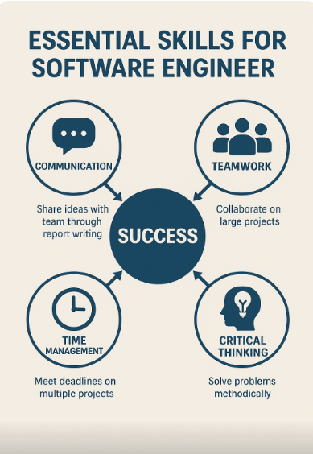
Figure 1: Essential Skills for Software Engineers
Time management enables me to complete all my work assignments before their due dates when I work on multiple projects simultaneously. Through critical thinking I can detect programming mistakes and enhance my coding solutions and problem-solving enables me to handle technical issues with composure and methodical thinking. Academic success requires me to learn proper research methods with reliable sources because this skill enables me to track down new technological developments. [3]
A basic diagram which demonstrates the relationship between communication and teamwork and time management skills for achieving professional success would serve as an effective visual representation. The skills I have developed will benefit my professional career because they enable me to work more efficiently while delivering reliable results with increased confidence. The program will assist my development into a skilled developer who possesses teamwork abilities and technological flexibility. [4]

Task 1 (b): Evaluation of Task 1 (a) based on Similarity report
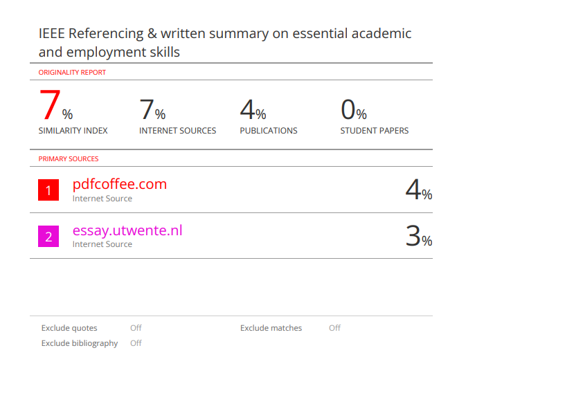
My Turnitin similarity score was 7%, which shows that most of my writing was original. I will enhance my work through better paraphrasing skills and by reducing direct online source quotations in my assignments.
I would give myself 78% using the Generic Assessment Criteria. The summary follows a clear structure, yet I should have added visual components and particular examples to enhance comprehension. The referencing in my work followed the correct format yet I require additional experience with IEEE citation style. I demonstrated my understanding of these skills through most of the requirements which showed their connection to my software engineering work.

Task 2: Collaborative Mind Map and Individual Poster

Mind Map (Collaborative)
Mind Map Link: https://mm.tt/map/3845109934?t=JaHoBdrrhm

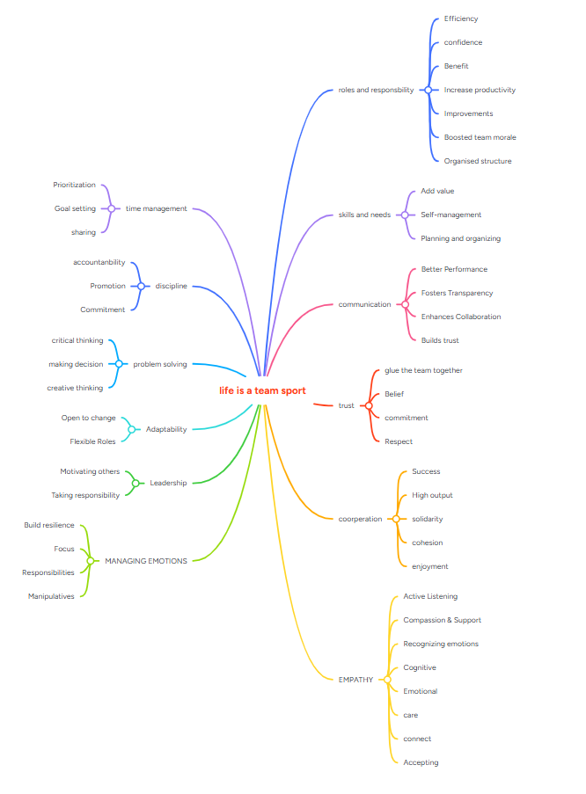

Poster (Individual)
References:
[1] M. Hoegl and K. P. Parboteeah, “Creativity in innovative projects: How teamwork matters,” J. Eng. Technol. Manag., vol. 24, no. 1–2, pp. 148–166, 2007, doi: 10.1016/j.jengtecman.2007.01.008.
[2] F. Ximenes, “Strategic Teamwork,” in Strategic Software Engineering: Software Engineering Beyond the Code, Apress, Berkeley, CA, 2024, pp. 171–200, doi: 10.1007/979-8-8688-0995-8_4.
[3] M. St.Pierre, G. Hofinger, and R. Simon, “The Key to Success: Teamwork,” in Crisis Management in Acute Care Settings, Cham, Switzerland: Springer, 2016, pp. 233–252, doi: 10.1007/978-3-319-41427-0_11.
[4] S. Tannenbaum, “How to overcome the nine most common teamwork barriers,” Organ. Dyn., vol. 52, no. 4, p. 101006, 2023, doi: 10.1016/j.orgdyn.2023.101006.
Poster Link:
https://www.canva.com/design/DAG4-YZmRl4/_JkKyU-yjioJ82jADa6mtQ/edit?utm_content=DAG4-YZmRl4&utm_campaign=designshare&utm_medium=link2&utm_source=sharebutton

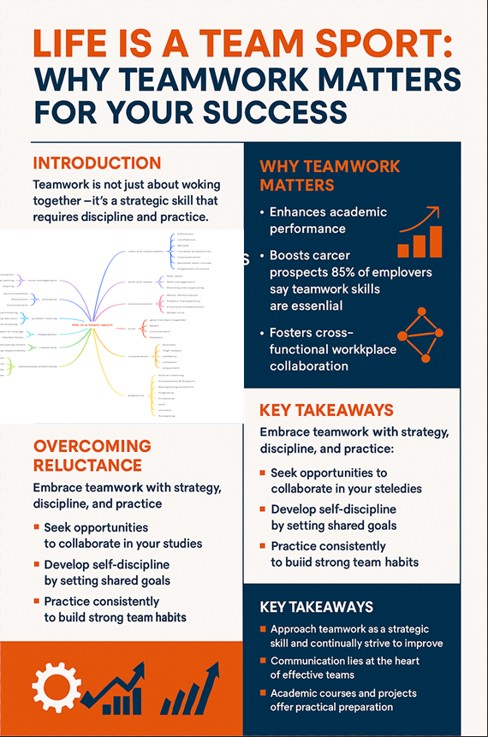

Task 3: Virtual Collaboration and RefWorks

Report on Virtual Collaboration
Modern workplaces now use virtual and hybrid team environments to replace traditional face-to-face teamwork methods. Employers actively seek professionals who can work together effectively because this skill enables organizations to achieve innovation and higher productivity and success [1]. Building an effective virtual team demands organizations to adopt innovative methods for team communication and trust development and coordination [2].

Virtual teams achieve success through defined roles and common organizational targets. Team leaders need to create organized communication systems for digital communication because virtual teams lack face-to-face contact [3]. Virtual collaboration success depends on creating feelings of belonging among team members who should experience value and connection despite physical separation. Research indicates that scheduled team meetings combined with social activities lead to better team unity and higher job satisfaction among workers who work from different locations [4].

Virtual teamwork success depends on two essential elements which are trust and accountability. The absence of non-verbal signals during online communication requires team members to develop trust through their dependable work performance. Team members can maintain visibility and accountability through the use of Trello and Asana for task management and Google Drive and SharePoint for document storage [5]. Virtual team leaders need to show emotional intelligence and cultural understanding because their teams span different time zones and cultural backgrounds [6].

Virtual collaboration success depends on continuous assessment and enhancement activities. The team uses scheduled feedback meetings to assess their progress while solving communication problems and strengthening their common goals. Virtual teams that receive proper management can match or surpass traditional teams in performance while providing flexible work arrangements and inclusive environments and access to worldwide talent [7].

Virtual team success depends on strategic planning and excellent communication methods and team members who maintain trust and inclusiveness. The ability to work digitally will define future work environments so people need to develop these competencies to succeed in their academic and professional careers.

RefWorks Usage Evidence (100 words)
The automatic referencing tool RefWorks helped users organize and cite academic sources for this assignment.

The RefWorks tool helped users create properly formatted citations while simplifying their reference management work.

Step-by-step process of using RefWorks with visuals
Step 1: First Search RefWorks on google and create a account.
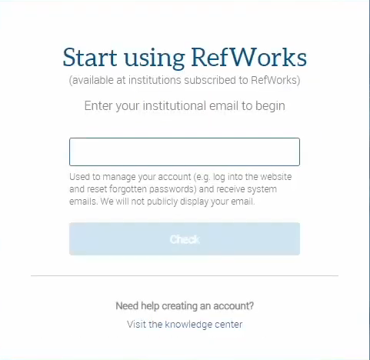

Step 2: Create a folder and name it whatever you like from the left hand side menu.
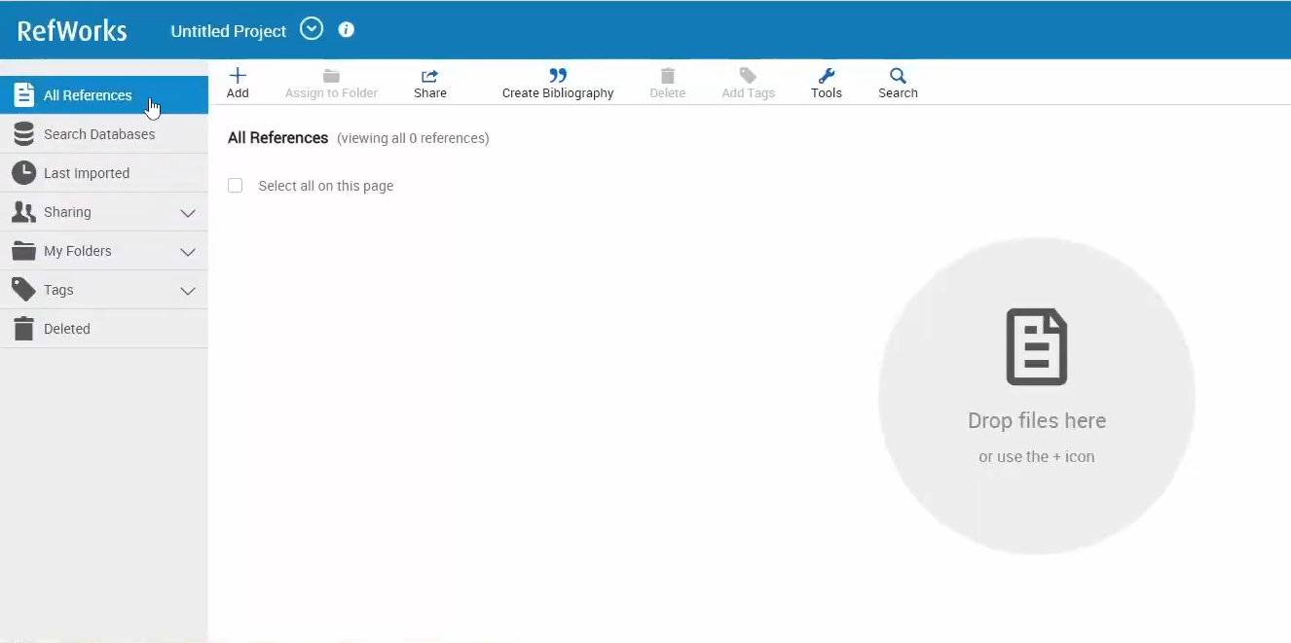
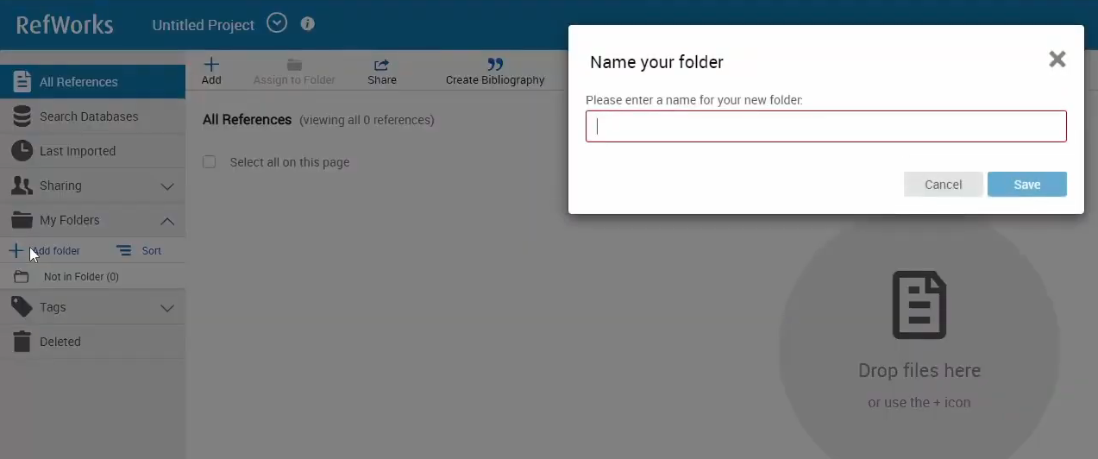
Step 3: Press on the add button from the top menu and select one of the 3 options (which one is suitable for you)
Step 4: Select the “Create bibliography” button and create a citation by selecting one of the 3 options (which one is suitable for you)
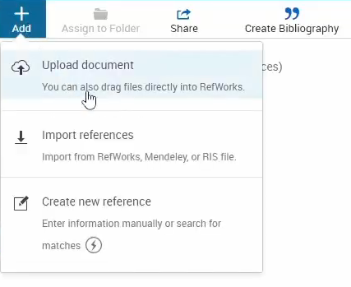
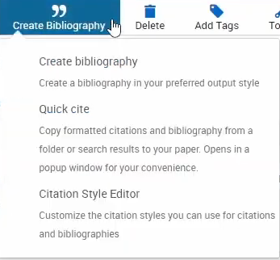
Step 5: Go on the Word app and select the “Get Add-Ins” button and search up “RefWorks”
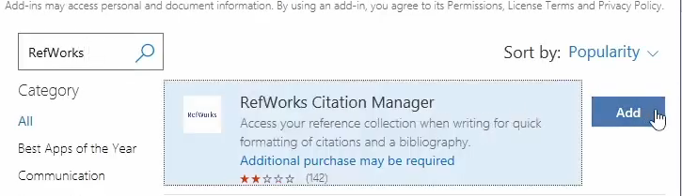
Step 6: You should now see a new button next to “Help” called “RCM” , click on it and log in with the account that you have created in Step 1
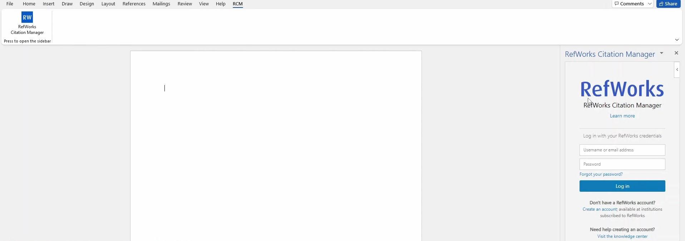
Step 7: After you logged in you should be redirected to the ref works main page, make sure the Bibliography setting is on, and after you should be able to import your citations from RefWorks into your word document
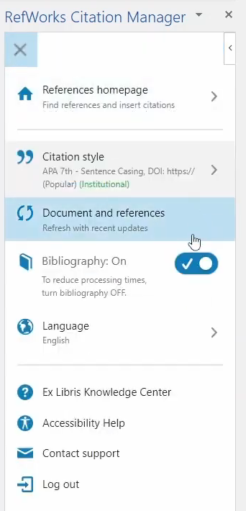
Step 8: After you have completed every step, your citations should look like this.
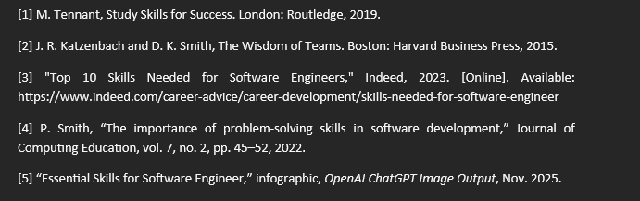
The automatic referencing tool RefWorks helped users organize and cite academic sources for this assignment.
The RefWorks tool helped users create properly formatted citations while simplifying their reference management work.

Task 4: E-Portfolio Creation and Evaluation

Task 4 (a): E-Portfolio Creation
E-Portfolio Link: https://sites.google.com/view/eduardfabianpasareacca4025?usp=sharing
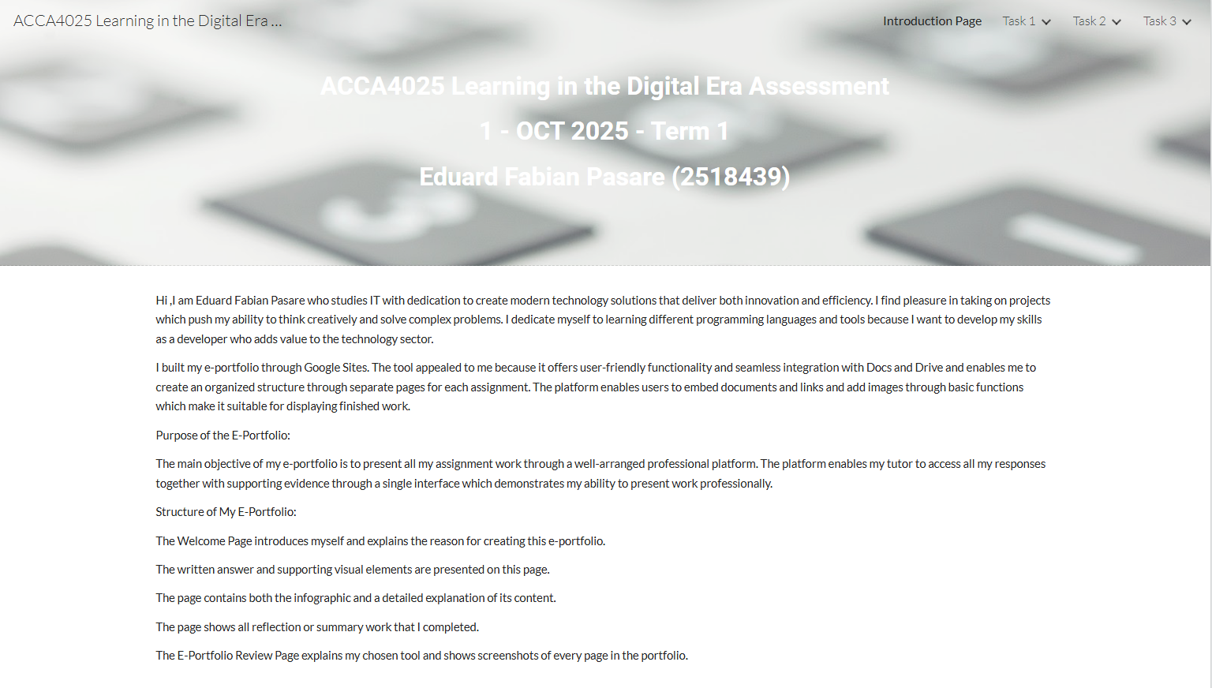
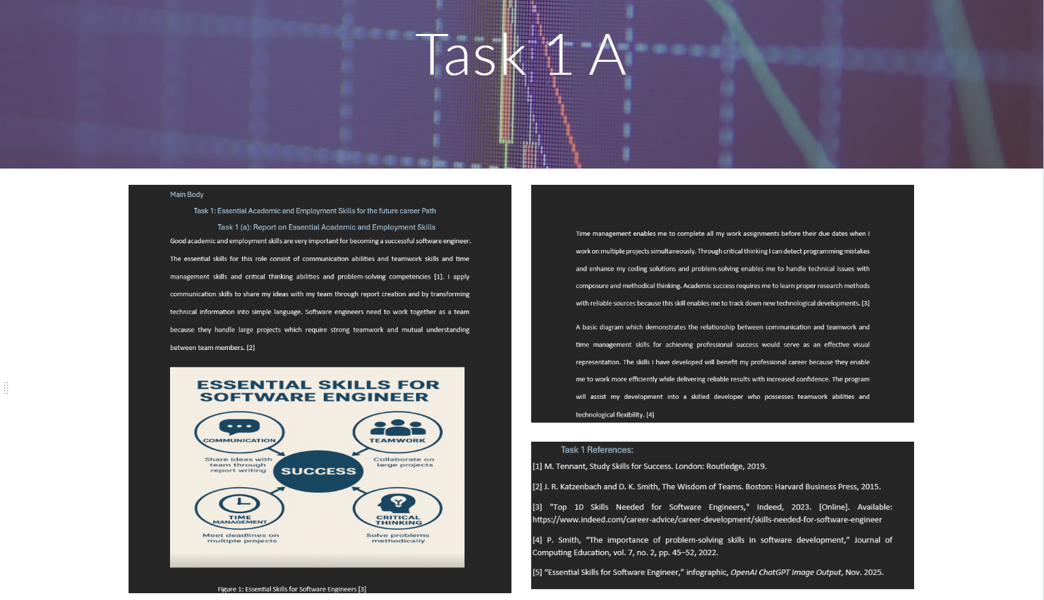
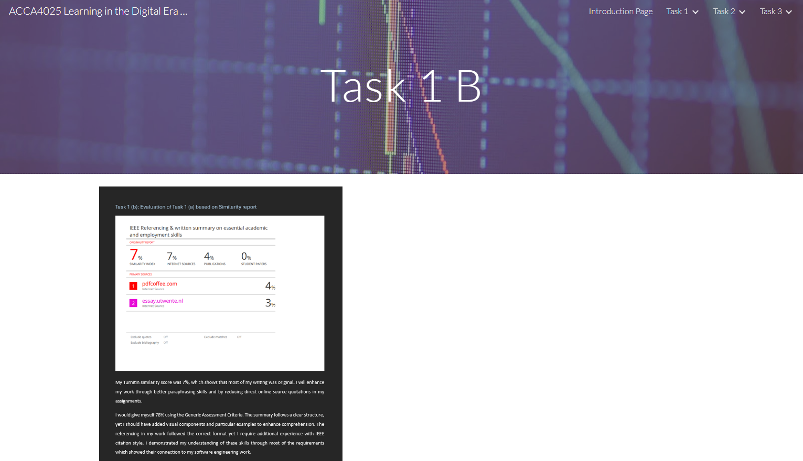
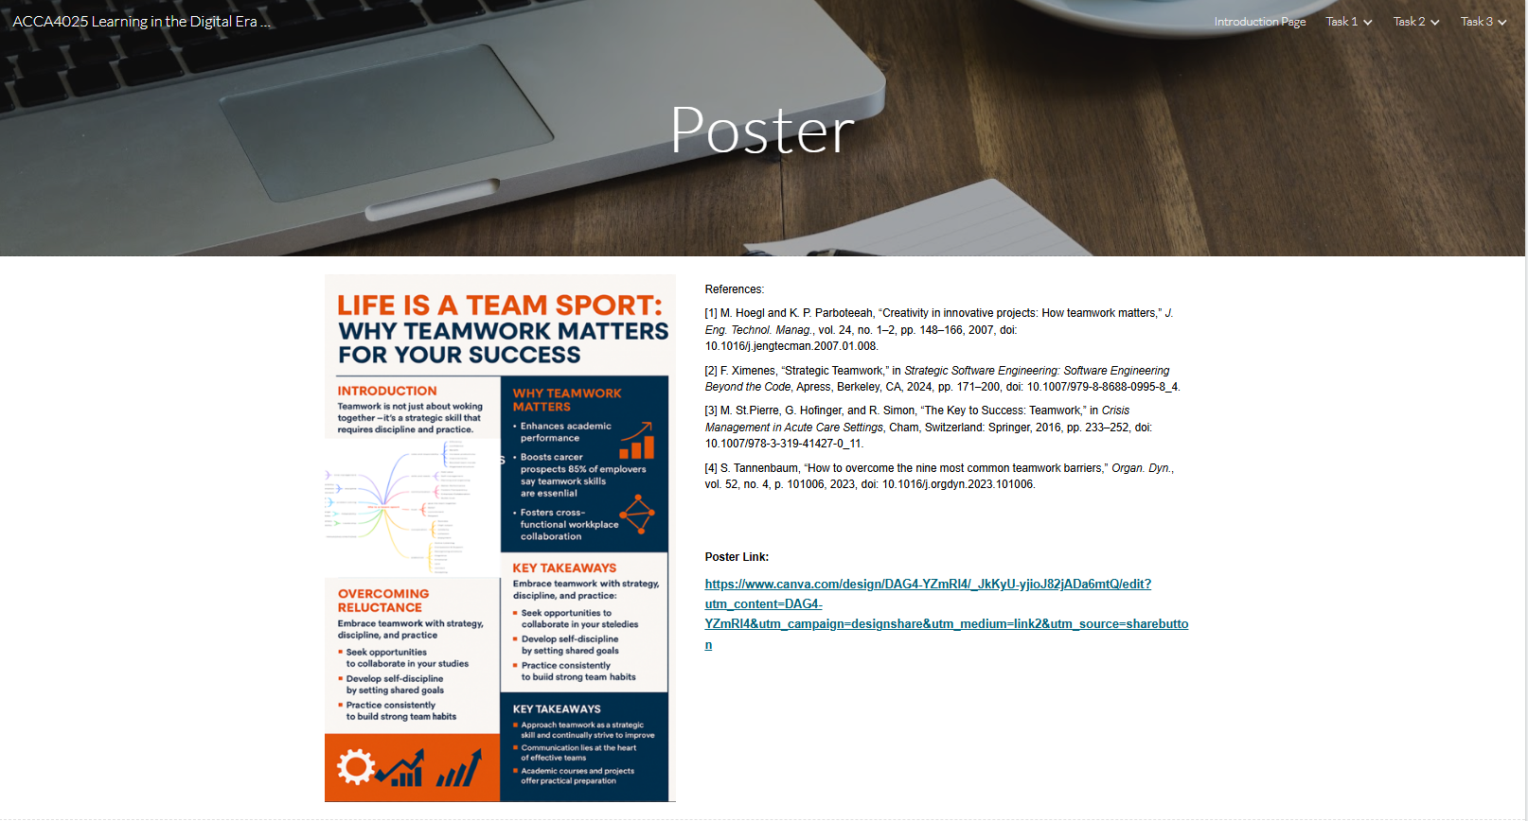
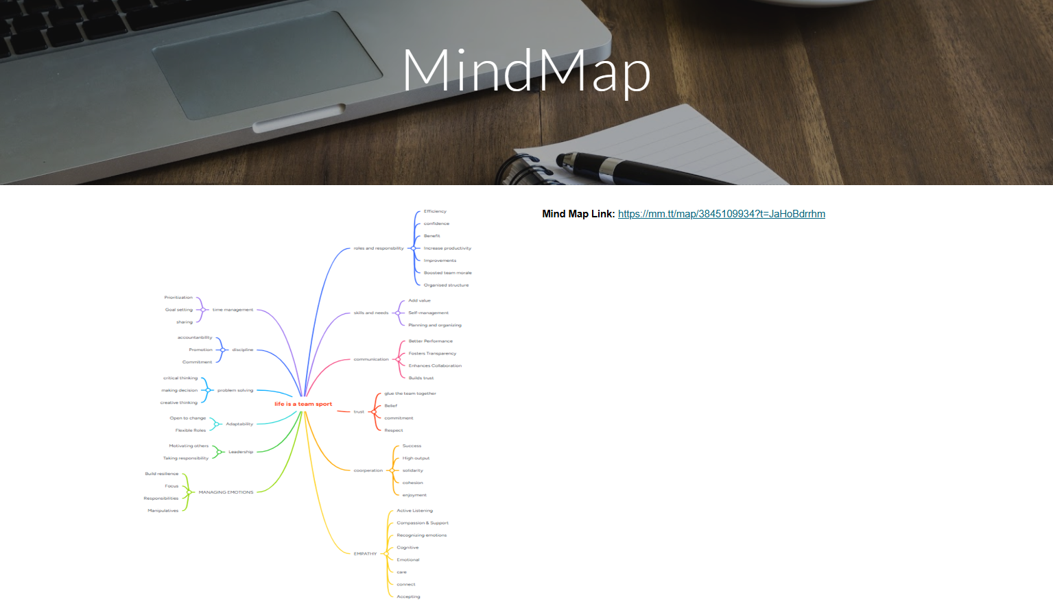
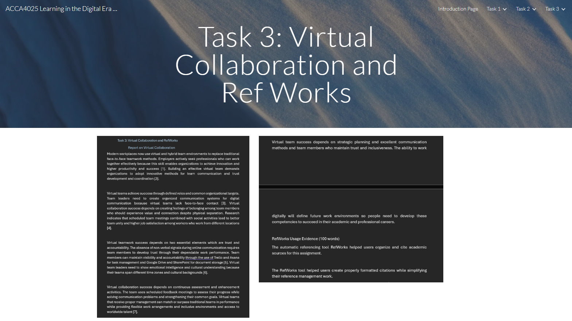
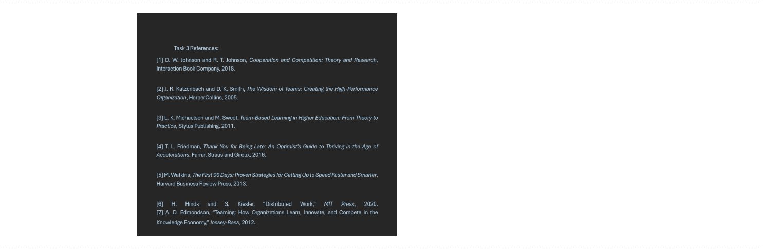
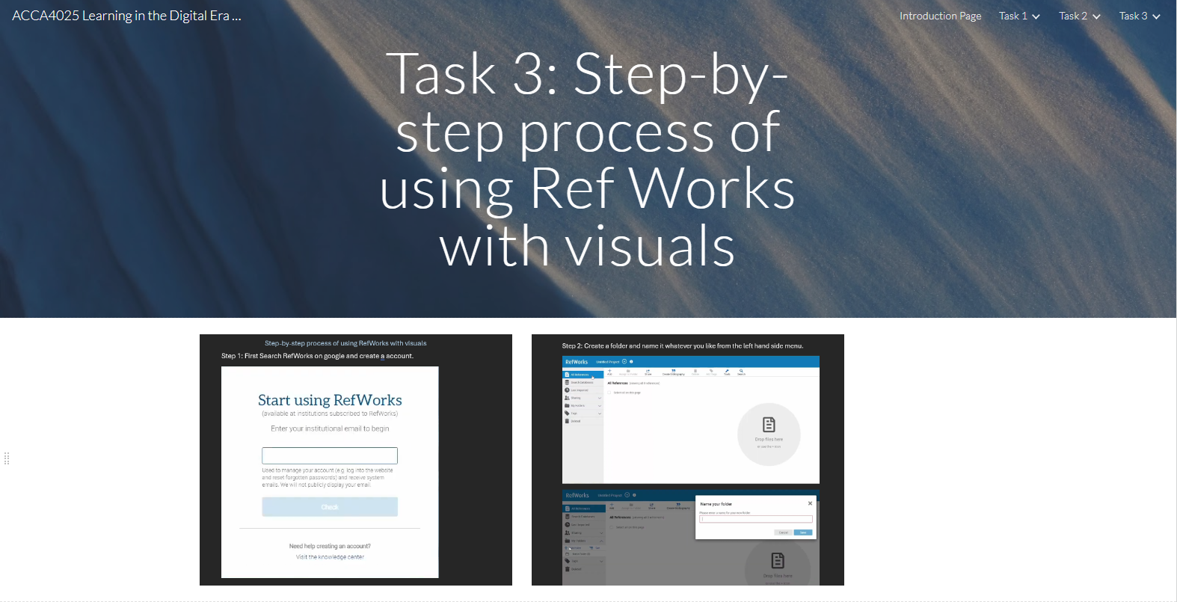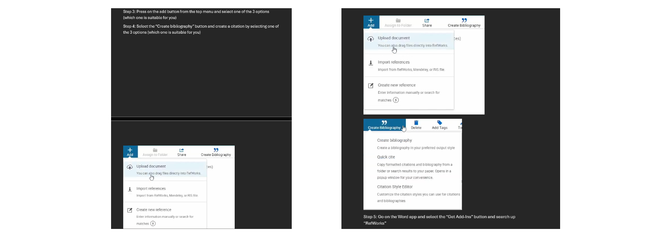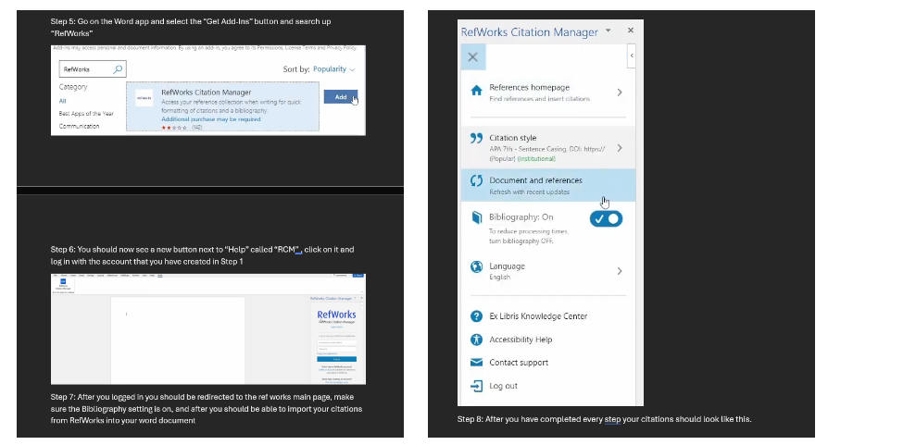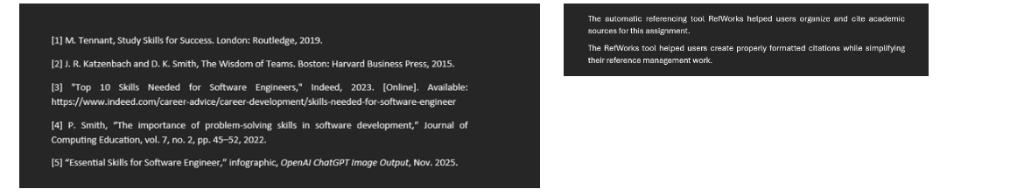

Task 4 (b): Illustrative Review of E-Portfolio tool Selection
Discussion (Review)
Pros
1. Easy to Use
Google Sites provides users with a simple interface that allows them to create content addition through drag-and-drop functionality and image and text and video and document insertion without requiring any programming knowledge.
2. Free and Included with Your University Google Account

Users who have Google Workspace through their university can start using Google Sites right away because it comes at no additional cost and requires no installation process.
3. Seamless Integration with Google Tools
Users can embed Google Docs and Slides and Sheets and Forms and Drive files and YouTube videos into their content through a straightforward process.
The platform works best for displaying academic work including assignments and presentations and project results.
4. Simple Sharing and Privacy Control
The platform enables users to determine access levels for their portfolio content through three available options.
Public
Link-only
University-restricted
The platform provides adaptable access options which suit different professional needs and academic requirements.
5. Responsive Design
The platform automatically adjusts its layout to match different screen sizes including mobile devices and tablets and desktop computers without requiring additional design work.
6. Collaboration
The platform enables team members to work together on site content at the same time which proves useful for collaborative projects and group portfolio development.

Cons
1. Limited Customization
Google Sites provides users with restricted design template options and limited font choices and layout customization compared to Wix and WordPress and Canva Websites.
2. Not Ideal for Highly Professional/Advanced Portfolios

Users who work in design or media or art fields that require powerful visual effects will find Google Sites insufficient for their needs.
3. Limited Advanced Features
The platform restricts users from performing the following actions:
Users cannot add custom HTML/CSS or plugins to their site.
The platform does not provide advanced analytics capabilities beyond its basic features.
The platform does not support interactive or dynamic content elements.
4. Basic Storage Layout
Users who store their files in Google Drive need to maintain proper organization because otherwise their site will experience performance issues and become difficult to handle.
5. Dependent on Google Ecosystem
Your access to the Google Sites platform will end when your university restricts your Google account access or removes your account after graduation unless you transfer the site to another platform.
6. SEO and Custom Domains Are Limited
Users who need to maintain a professional portfolio through their website will find Google Sites insufficient because it lacks essential features including:
The platform lacks effective SEO tools for optimization.
Users cannot add custom domains to their sites unless they use external solutions.
Users cannot modify metadata settings.
Summary
Google Sites serves as an excellent platform for creating basic university portfolios which showcase projects and reports and presentations and videos and coursework.

Conclusion
The assessment process helped me identify all necessary academic and professional and digital competencies which will support my software engineering career path. The evaluation of fundamental academic and work-related competencies revealed that communication skills and teamwork abilities and time management skills and critical thinking and problem-solving competencies serve as essential requirements for university assignments and industrial work environments. The similarity report process enabled me to understand better the value of proper paraphrasing and referencing techniques and I gained better skills in using the IEEE citation style.

The collaborative mind map work and individual poster creation process showed me effective team-based idea sharing methods which allowed me to maintain my personal understanding. The virtual collaboration experience demonstrated to me how contemporary workplaces depend on digital teamwork systems and I discovered that remote team success depends on trust and accountability and structured communication approaches. The RefWorks tool enhanced my ability to handle academic sources and generate proper references became more efficient.

The e-portfolio creation process proved to be the most beneficial part of this assessment. The platform enabled me to assess my professional abilities and presentation skills for online work display. The Google Sites evaluation process revealed to me the benefits and drawbacks of using digital tools for academic work and career development.

The assessment process enhanced my academic performance while teaching me better digital skills and making me more proficient with collaborative tools. The assessment provided me with essential knowledge about employer requirements for software engineers and it showed me which skills to focus on for university success and professional advancement.

References

Task 1 References:
[1] M. Tennant, Study Skills for Success. London: Routledge, 2019.
[2] J. R. Katzenbach and D. K. Smith, The Wisdom of Teams. Boston: Harvard Business Press, 2015.
[3] "Top 10 Skills Needed for Software Engineers," Indeed, 2023. [Online]. Available: https://www.indeed.com/career-advice/career-development/skills-needed-for-software-engineer
[4] P. Smith, “The importance of problem-solving skills in software development,” Journal of Computing Education, vol. 7, no. 2, pp. 45–52, 2022.

Task 3 References:

[1] D. W. Johnson and R. T. Johnson, Cooperation and Competition: Theory and Research, Interaction Book Company, 2018.

[2] J. R. Katzenbach and D. K. Smith, The Wisdom of Teams: Creating the High-Performance Organization, HarperCollins, 2005.

[3] L. K. Michaelsen and M. Sweet, Team-Based Learning in Higher Education: From Theory to Practice, Stylus Publishing, 2011.

[4] T. L. Friedman, Thank You for Being Late: An Optimist’s Guide to Thriving in the Age of Accelerations, Farrar, Straus and Giroux, 2016.

[5] M. Watkins, The First 90 Days: Proven Strategies for Getting Up to Speed Faster and Smarter, Harvard Business Review Press, 2013.

[6] H. Hinds and S. Kiesler, “Distributed Work,” MIT Press, 2020.
[7] A. D. Edmondson, “Teaming: How Organizations Learn, Innovate, and Compete in the Knowledge Economy,” Jossey-Bass, 2012.

