Program: BA Business Management

Module: International Business Communication

Module Code: LCBB6001

Assignment Title: Essay

Lecturer: Riaz Bhatti
Student: Sandrina Rangelova
Student number: 1917133

Contents
Introduction to the context of British business communications 3
A brief introduction of the selected company 3
Application of theories of international and intercultural communication 4
Critically evaluate cultural sensitivity when doing business in the UK 5
Different communication barriers experienced by a diverse workforce 7
Appropriate communication strategies and relevant recommendations 7
Conclusion 8
Reference 9

Introduction to the context of British business communications
Business communication (BC) refers to the exchange of ideas, feelings, emotions, experiences, problems, and resources by internal individuals within a business environment. Different nations in different countries possess different business communications such as the communications of British are quite different from other countries in Asia, Australia, Europe, and America (World Business Culture, 2019). Rather than directness, British business managers use diplomatic language and words to avoid directness in communicating negative words and feelings. For example, rather than saying “I disagree’ they may say’ this is good enough. You have made several good points. But have you ever considered this option? I think it would be very good alongside your opinion and points.” The British tend to be friendly and positive-minded at their workplace. They use humor in critical and stressful work and business situations for decision-making (Gudykunst & Mody, 2002). They are satisfied with their native language, English and they give little focus on other languages, though at present students are taught various foreign languages.
They use a handshake when meeting any new member or business professional for the t time. They state it as a part of their communication etiquette. After the first time, they tend to avoid hand shaking for beginning a conversation. Rather than direct questions or recommendations, they tend to be happy with open-minded questions as they love the environment of free thinking (Shukla, 2021). In most business situations, they use emotionless words and language to ask for the actual results. They tend to underestimate facts which vary based on the original meaning. For example, ‘little expensive’ in British communications indicates ‘highly expensive’. For business relationships and sustainability such as mergers & acquisitions, and joint ventures, they don’t believe in oral contracts and demand written contracts with solid papers and documentation including all conditions (Gudykunst & Mody, 2002). They show an adequate level of sincerity in negotiations, build long-term agreements, and use non-verbal communication such as personal space management, gestures, eye contact and facial expression. They use moderate facial expressions and give personal space to others to share their needs, feelings, and requirements. They use less frequent eye contact because overuse of eye contact is seemed impolite and makes others feel uncomfortable (Gudykunst & Mody, 2002).

A brief introduction of the selected company
The 5%ers is an Online Funding & Growth Program developed and run by Five Percent Online Ltd in the UK. It is also stated as a fully funded forex trading platform giving trading facilities to skilled and dedicated traders. Being a private ltd company, it does mainly the Nostro-investment activities located in Enstar House 168, Pared Street, London, UK (The5ers, 2022). A few essential principles that the company follows to operate effectively are that it does not accept any investors and their funds as well as the clients' or traders’ funds. Rather the program provides its funds to the traders and makes money. It considers various currency trading including USD, EUR, GBP JPY, CHF, NZD, and CAD. For safer and easier trading, it suggests risk management discipline to the potential and existing traders. The vision of The 5%ers is ‘to create an open career building platform for forex traders by suggesting risks guidance, profit and investment plans (The5ers, 2022). Gil Ben Hur is the founder of the program of Five Percent Online Ltd where Yaniz Elbaz is acting as the chief operations officer (CFO), Saul Lokier is the CEO, and Alexander Kriss is the Trader Success.
Other members of the management team include Ruben Abitbol, Tomer Dubrov, O Abadi, Ophira Top, Valery Kuznetsov, Tal Weiss, and Andrei Blusher. The company is operated via different functional areas such as trading success agency, full stack development, operations management, video content creation for marketing, and social media communications (The5ers, 2022). It helps international traders build and sustain effective trading skills and knowledge on multiple currency trading. This site provides a range of benefits to the traders such as offering fully funded accounts, no risk no charges facility and an excellent trading growth scheme. This funding program aims to increase its internal funds rather than depending on investors or clients funds which indicates a strong source of competitive advantage (The5ers, 2022). The company runs various programs to satisfy the needs of traders such as hyper-growth investment plans, Bootcamp and its related terms and conditions along with high stakes and related conditions.

Application of theories of international and intercultural communication
Hofstede’s Cultural Dimensions is a popular intercultural and international communication theory talking about four types of cultures of a country or business firm. As per the theory, the power distance culture informs that less powerful staff in an organisation such as The 5%ers are controlled and dominated by the highly powerful in top positions (Hofstede, 2001). The company uses high power distance because the low-level staff are under top officials. The company applies a collectivist culture because it allows skilled and highly dedicated members to form effective teams to deal with trading activities and issues of diverse traders from international locations (Peterson and Mikael Søndergaard, 2008). As per uncertainty avoidance culture, the employees of The 5%ers are in a better position because their employees are stable, highly committed to risk acceptance and deal with market uncertainties to increase the number of traders, manage their trading needs and issues and make more earnings through internal fund generation. The company focuses on masculinity culture because it allows both male and female staff to work together, be friendly, foster good manners with potential traders, and work collaboratively to accomplish goals. The employees of the company hold long-term orientation in operations and decision-making (Dewiyanti, 2021).
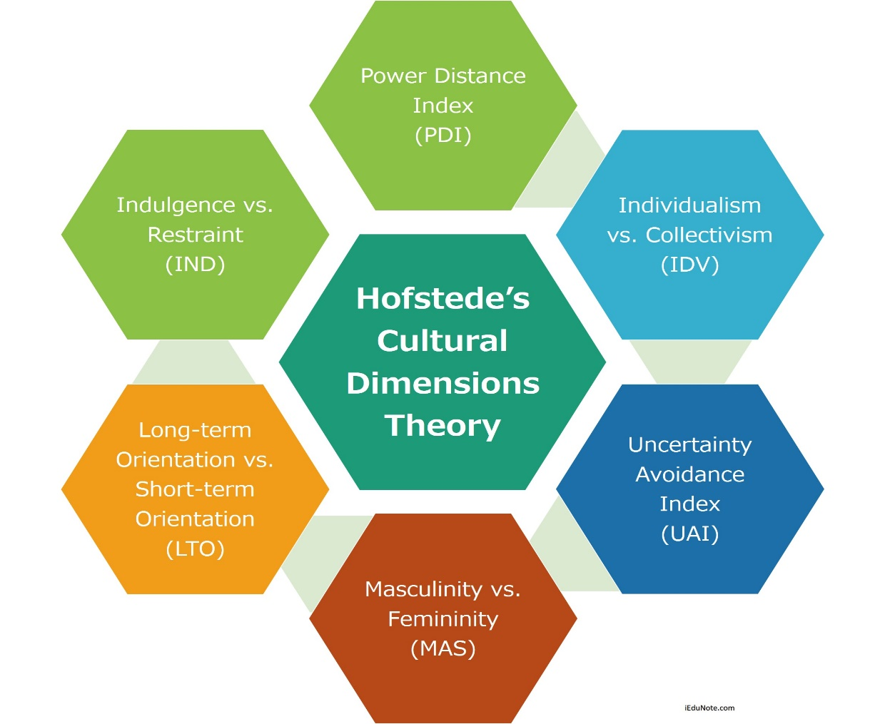
Figure 1: Hofstede's Cultural Dimensions Source: (Hofstede, 2001)
Samovar’s Theory of intercultural & international communication states communication is ‘the interaction between diverse groups of people having distinct perceptions and symbol systems. This theory indicates the exchange of languages, cultures, values, social beliefs, working systems, and ethical standards within an international business environment (Samovar, Porter and Mcdaniel, 2012). According to this theory, when doing business in an international environment having diverse workforces, The 5%ers Company must respond to foreign languages, cultures, values, systems, behaviours and ethical concerns. Jandt Fred’s Theory of Culture also gives meaningful insights into intercultural & international communication. Jandt’s theory states intercultural communication s ‘the face-to-face interaction between employees or people from diverse language and cultural backgrounds, different norms, and values. This theory informs The 5 %ers respect and accept people with diverse cultures as a valuable source of innovations and new product development ideas (Fred Edmund Jandt, 2010).

Critically evaluate cultural sensitivity when doing business in the UK
According to Hofstede’s Intercultural Dimensions, the UK focuses on low power distance culture which is 35 represented by Hofstede Insights. The index below 50 indicates that employees in UK business firms don’t focus on unequal power distribution and follow too much hierarchy in assigning roles and positions. Whereas countries like Israel are in a better position with an index of 13 but Bangladesh and Pakistan in Asia focus on high power distance culture. Senior to low-level staff in the UK tend to work together to accomplish unique goals, mission, and vision. The individualism culture index of Israel and the UK are 54 and 89 whereas Bangladesh and Pakistan hold 20 and 14 (Hofstede Insights, 2021). This parameter indicates people in UK business firms love to work singly rather than forming teams and working with teams or group members.
Business firms in the UK support masculinity culture represented by 66 of the indices. It means they are focused on achievements and success. The uncertainty avoidance index according to Hofstede Insights is only 35 indicating a positive sign of high risk and uncertainty acceptance. People in the UK business firms love to accept challenging roles, and trace risks as potential sources of innovation, creative product, or service ideas whereas people in Israel, Pakistan and Bangladesh are more uncertainty avoidance minded and avoid risks and challenges (Hofstede Insights, 2021).
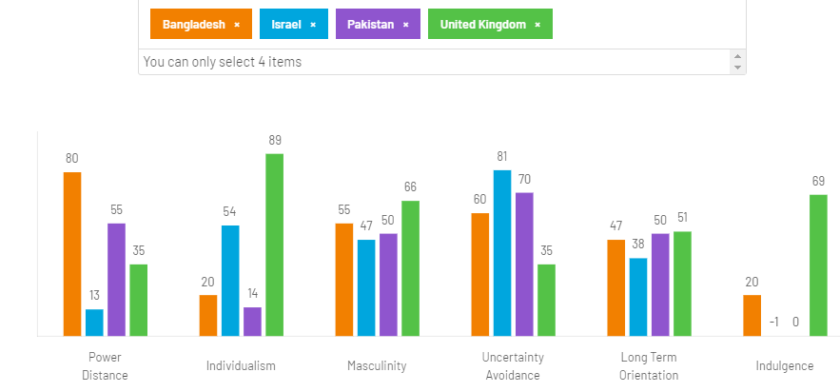
Figure 2: Comparison of Country Culture, Source: (Hofstede Insights, 2021)
The origin of Five Percent Online Ltd is in Israel but it started this program in the UK and targeted many other countries. When doing business, the diverse workforce of The 5%ers must follow the national culture of the UK. For example, the company must avoid too much hierarchy in forming teams, allocating tasks, and submitting reports (Hofstede Insights, 2021). Diverse employees hired from diverse nations and countries must be inspired to have equal power and authority and respect the cultural values, thoughts, and beliefs of each member. The company has to inspire and direct its leaders and top managers to distribute resources equally and roles and responsibilities singly because the British love to work based on their skills, knowledge and experiences. they consider teamwork or collectivism as a source of wasting time and resources by unnecessary gossiping (Dewiyanti, 2021).
Leaders should be effective in learning their followers how to handle haunting potential traders, work with them, meet their issues, and raise financial performance. As the UK people focus female workers more on high positions, the company must hire skilled and dedicated male staff for senior management positions. Besides, the company should inspire a diverse workforce to respect female staff and work with them friendly and efficient by sharing resources, ideas, knowledge, positive feelings and a supportive mindset (Dewiyanti, 2021). Employees are to be inspired to involve in accepting risks and challenging job roles to foster innovation and creativity, a major source of competitive advantage. The company needs to arrange effective meetings and seminars to train employees on how to accept risks, deal with diverse risk management strategies, and turn uncertainty into potential products or services.

Different communication barriers experienced by a diverse workforce
One of the major communication barriers is the language barrier because the native British workforces use English only and they have very little knowledge of other foreign languages. Foreigners such as Bangladeshi, Pakistani, and Indians may find it difficult to cope with English all the time. Even the workforce in the UK may find communication difficulties when talking with Indians, Bangladeshi, Nigerians, and Brazilian in their local language (World Business Culture, 2019). The second is the emotional barrier because they seem emotionless when discussing any issue. In business conversations such as potential funding or investment meeting, professionals tend to go to direct points and ask for straightforward results or information to make appropriate decisions. Besides, underestimation is another big communication barrier. They tend to use understatement to express issues which create serious issues for a diverse workforce.
For example, when the team leader of the UK state that there is a little bit of risk in this job role. It means that the job role has a higher risk (Business Culture, 2013). So, a little bit of risk means huge risk which may not be understandable by the workforces coming outside the UK such as Argentina, Canada, Pakistan, China etc. It creates serious decision-making issues for the diverse workforce. The British people do not use direct communication which most of the time results in decision-making delay and selection of the right options. It seems quite difficult for diverse workforces hired from diverse locations to adjust to native UK employee’s and people. To overcome this issue, organizations such as The 5%ers have to arrange direct communication training and learning programs. This barrier sometimes forces them to criticize themselves to make the external users, customers, and parties happy and satisfied. British people do not use facial expressions as an effective method of non-verbal communication because they seem impolite.

Appropriate communication strategies and relevant recommendations
The 5 %ers is operating well in the national environment but the company needs to develop a lot of effective strategies to communicate internationally and interculturally. For example, the company should focus on effective non-verbal communication strategies. As the British people don’t like facial expressions always as a give way to exchange information, the company should discourage diverse people from minimising the use of facial expressions when working with UK people or traders (Byram, Stevens and Nichols, 2001). When communicating with customers and third parties, employees are encouraged to provide personal space to them for judgment and proper decision-making and enhancement of relevant information. Employees should not stand too close and talk because it seemed impolite in the business environment. Excessive eye contact is considered impolite and misbehavior. For this, when using eye contact, employees should use it at a minimum or equal level because it may make others feel uncomfortable in the workplace (Evason, 2016). As per gestures in British communications, the 5%ers should inspire a diverse workforce to be reserved, polite and honest in exchanging information.
They should be supported and should not disclose the secrets of others without permission within a team or group. The Equality Act 2010 would be an effective strategy for communication. this tool inspires employees not to make any type of discrimination among the employees or teams based on race, sex, ethnicity, power and control (Evason, 2016). It inspires respecting cultures and values differences to strengthen learning, updating professional ethics and behaviours, and formal and informal communication skills. The employees of the 5%ers should be trained to utilise humor because it helps them adjust to stressful situations and critical business environments. humor will assist them easily overcoming risks and challenges in terms of enhancing their self-confidence level. rather than using direct negative responses, employees should be inspired to use self-criticism and diplomatic language to express negative sides positively (Evason, 2016). The British are active listeners, and they tend to give more importance when listening to someone or something. For this, the 5%ers must improve the active listening skills of its employees because these will assist them clarify facts to colleagues and partners.

Conclusion
Managing business internationally is not simple at all because it includes international culture and communication complexities. Communication systems in each country differ from other countries such as the British systems vary from Israel and Bangladeshi communication systems. When doing business in a target market, the organisation must evaluate intercultural and communication issues and related theories. The 5%ers is a successful online trading platform that works with diver traders internationally. It offers its funds to clients rather than asking for funds from investors. For this, it evaluates the traders effectively including mission, vision, trading options, characteristics, and risk-taking capability, and suggests potential strategies for risk management. When doing business in the UK, it thinks about cultural dimensions. for example, it applies Hofstede Insights to compare UK culture with others to inform how the diverse workforce will adjust to the UK business environment. Major communication barriers faced by the diverse workforce of the company include underestimation, too much politeness and indirectness, lack of direct communication, and little amount of facial expression and handshaking. To tie long-term relationships with British employees and partners along with traders, the company must follow the determined communication strategies including personal space management, an adequate level of gestures and facial expressions, avoidance of direct communication, adjustment with humor, self-deprecation, and indirect communication.

Reference
Business Culture (2013). Business communication. [online] Business Culture. Available at: https://businessculture.org/northern-europe/united-kingdom-business-culture/business-communication/.
Byram, M., Stevens, D. and Nichols, A. (2001). Developing Intercultural Competence in Practice. Clevedon: Multilingual Matters.
Dewiyanti, S. (2021). Hofstede’s Cultural Dimensions Theory. [online] Accounting. Available at: https://accounting.binus.ac.id/2021/11/15/hofstedes-cultural-dimensions-theory/.
Evason, N. (2016). British Culture - Communication. [online] Cultural Atlas. Available at: https://culturalatlas.sbs.com.au/british-culture/british-culture-communication.
Fred Edmund Jandt (2010). An introduction to intercultural communication: identities in a global community. Los Angeles: Sage.
Hofstede Insights (2021). Country comparison tool. [online] www.hofstede-insights.com. Availableat:https://www.hofstede-insights.com/country-comparison-tool?countries=bangladesh%2Cisrael%2Cpakistan%2Cunited+kingdom [Accessed 14 Aug. 2024].
Hofstede, G. (2001). Cultures and Organizations: Comparing Values, Behaviors, Institutions, and Organizations across Nations. 2nd ed. Thousand Oaks: Sage Publications.
Peterson, M.F. and Mikael Søndergaard (2008). Foundations of cross-cultural management. Thousand Oaks, Ca: Sage Publications.
Samovar, L.A., Porter, R.E. and Mcdaniel, E.R. (2012). Intercultural communication: a reader. Boston, Mass.: Wadsworth Cengage Learning.
The5ers (2022). Proprietary Trading Fund | The5%ers forex proprietary fund. [online] [Accessed 14 Aug. 2023].
World Business Culture (2019). British Communication Styles. [online] World Business Culture. Available at: https://www.worldbusinessculture.com/country-profiles/great-britain/business-communication-style/#:~:text=Being%20very%20non%2Dconfrontational%20in [Accessed 14 Aug. 2023].

