BMDS7010-04 Self-study issued 19 March 2026

The sync session run-through and last week’s self-study were about “learning to drive” – as for those steps, the only way to gain SPSS skills is practice. The objective here is still to gradually increase confidence. This also is step-by-step but not too difficult. It assumes you’ve seen the walk-through in the sync session and also done up to BMDS7010-03. Within the broad plan for BMDS7010 self-studies, this part comprises:

Introduction to SPSS: Descriptive Statistics and Data Visualisation

This handout will guide you through the basics of using SPSS for descriptive statistics and data visualisation. We'll be working with a synthetic UK NHS health-related population dataset to explore various analytical techniques. This handout assumes basic familiarity with the SPSS interface. The dataset, NHS_synthetic_data.csv, contains over 300 records representing a sample of the UK population. It includes variables related to health outcomes, demographics, and hospital utilisation.

1. Opening the Dataset in SPSS
- Open SPSS.
- Go to File → Open → Data.
- Locate and select the file Extended_SPSS_Dataset.sav.
- Click Open.
- In the Import Wizard:
  - Check Read variable names from the first row of data.
  - Click Next and then Finish.
- Verify that the data appears in the Data View tab, with the variable names correctly displayed.
This is a bigger dataset with 500 records (rows) and 13 columns. As always, first check in Variable tab view that that the SPSS Types and Measure columns are correctly set. If not, change them. Here is a cross-check with reasoning:

SPSS Data Types and Measure Types
Variable Name | SPSS Data Type | SPSS Measure | Reasoning
PatientID | String | Nominal | Alphanumeric identifiers (e.g., PT0001) that serve as unique labels
AppointmentDate | Date | Scale | Calendar dates in YYYY-MM-DD format that can be ordered chronologically
SurveyResponse | String | Ordinal | Categorical responses with inherent order (Very Dissatisfied to Very Satisfied)
ClinicianFeedback | String | Ordinal | Categorical assessments with inherent order (Very Poor to Excellent)
Age | Numeric | Scale | Continuous numerical values representing patient ages
Gender | String | Nominal | Categorical with no inherent order (Male, Female, Other)
Ethnicity | String | Nominal | Categorical demographic data with no inherent ordering
LengthOfStay | Numeric | Scale | Count data representing days, can be treated as continuous
Readmitted | Numeric | Nominal | Binary data (0/1) representing yes/no status
AdmissionMonth | Date | Nominal | Names of months with no statistical ordering
AdmissionYear | Numeric | Scale | Year values that can be ordered chronologically
SatisfactionScore | Numeric | Ordinal | Rating scale (1-5) with inherent ordering
FeedbackScore | Numeric | Ordinal | Rating scale (1-5) with inherent ordering
Note, these settings can be difficult to remember until you have used them so much you get used to them - so do persist.

2. Creating Basic Charts

A strength of SPSS is how quick you can do a large number of charts; here we use the menu system but as you will remember it is probably easier to do these by SPSS syntax (see last self-study). Know how to do it both ways, but here its mostly menus. Generally, one can do a Google search to find correct SPSS syntax.

Also remember to save frequently in case you make mistakes – just go back to saved version get in the habit of using “Save Restore Point” in the File menu before every new step.

2.1. Histogram
- Go to Graphs → Histogram.
- Select a continuous variable (e.g., Age) and move it into the Variable box.
- Check Display normal curve.
- Click OK.
- Interpretation: The histogram displays the frequency distribution of the selected variable. The normal curve allows you to assess whether the data approximates a normal distribution.
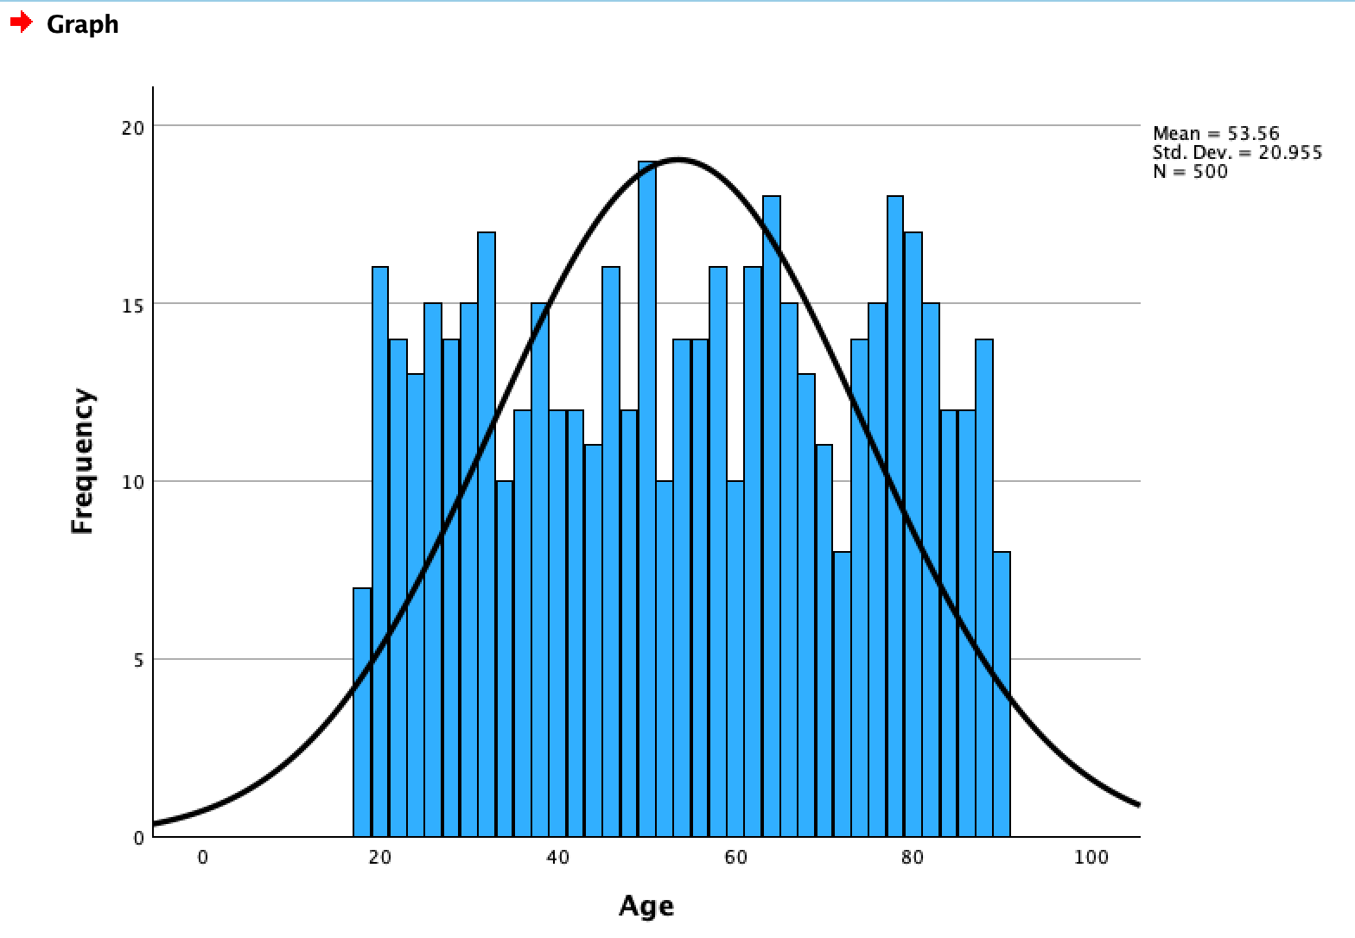

2.2. Bar Chart
- Go to Graphs → Bar.
- Choose Simple and select Summaries for groups of cases.
- Click Define.
- Select a variable (e.g., Gender) and move it into the Category Axis box.
- Select a variable (e.g., Age) for the Bars Represent section.
- Click OK.
- Interpretation: The bar chart shows the distribution of the continuous variable across the categories.
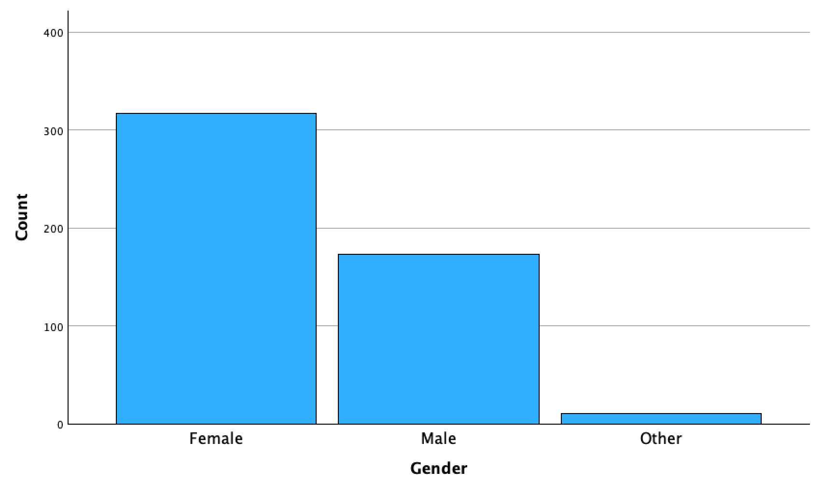

2.3. Scatterplot
- Go to Graphs → Scatter/Dot.
- Choose Simple Scatter and click Define.
- Select one continuous variable (e.g., Satisfaction Score) for the X-Axis and another (e.g., Age) for the Y-Axis.
- Click OK.
- Interpretation: The scatterplot reveals there isn’t any clear relationship between patient satisfaction and age as a similar score pattern exists across all ages in the dataset.
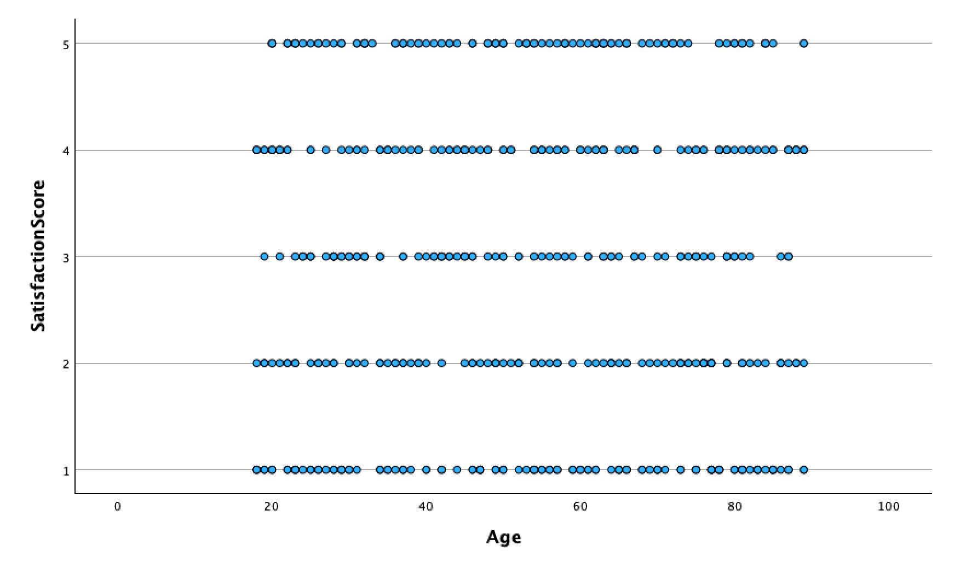

3. Analysis of Patient Demographics

This type of query will depend what variables you have to work with in your dataset, so this is just an example,

3.1. Frequency Table
- Go to Analyze → Descriptive Statistics → Frequencies.
- Select categorical variables (e.g., Gender, Ethnicity) and move them to the Variables box.
- Click OK.
- Interpretation: Review the frequency distribution of demographic variables. Identify the proportions of gender, ethnicity, etc.
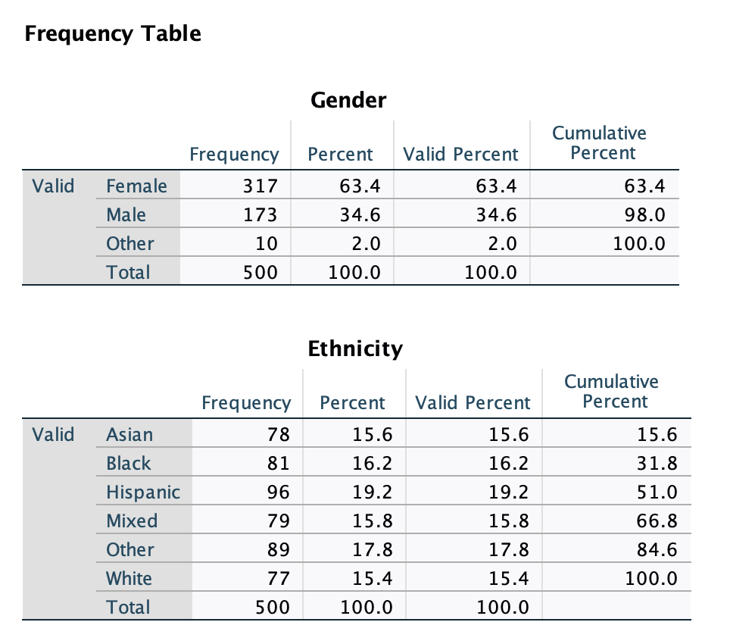

4. Analysis of Length of Stay

4.1. Descriptive Statistics
- Go to Analyze → Descriptive Statistics → Explore.
- Select Length of Stay for the Dependent List.
- Click OK.
- Interpretation: Identify the mean, median, and standard deviation. Review the boxplot to identify outliers and spread of stay duration.
Now try seeding the data changing “28” to “280” for length of stay and repeat 4.1
Note how this outlier you have entered are handled in the leaf plot and boxplot …note how you could use this for a “first look” at real world data to see how it shapes up.
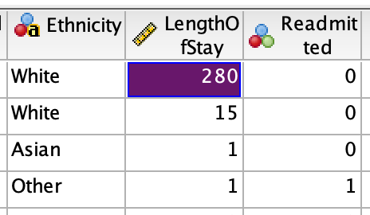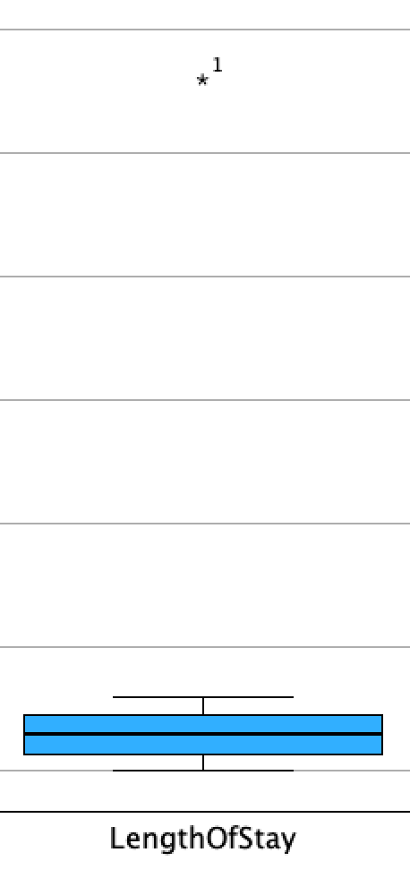
Now change the “280” back to “28” before continuing.

4.2. Compare Length of Stay by Category
- Go to Analyze → Compare Means → Means.
- Select Length of Stay for the Dependent List.
- Select a categorical variable (e.g., Gender) for the Independent List.
- Click OK.
- Interpretation: Compare the average length of stay by gender. All results (below) look similar
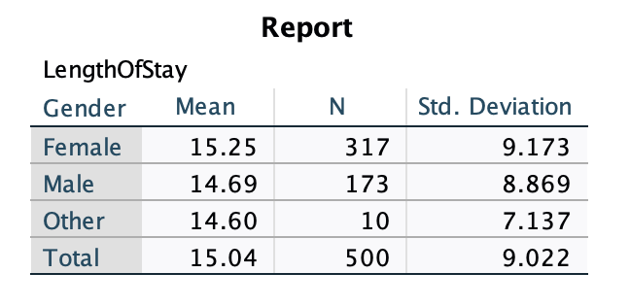
Here’s how to interpret each row of the SPSS result table in common-sense terms:
Remember standard deviation (SD) always indicates the degree of "spread" (or variability) of the data around the mean. In practical terms a small SD means that most values are close to the mean, indicating low variability. A large SD means the values are more spread out from the mean, indicating high variability.
For Female: The mean score for female participants is 15.25, based on 317 individuals. The standard deviation (SD) is 9.173, which means that the scores vary quite a bit around the mean. In practical terms, most female participants scored within roughly 9 points above or below the average (around 6 to 24). The relatively high SD indicates a wide spread of scores.
Male: The mean score for male participants is 14.69, slightly lower than the female mean, with 173 participants. The SD of 8.869 shows that their scores also vary significantly but slightly less than the female group. Most male scores fall around 6 to 23.
Other: This group has 10 participants with a mean score of 14.60. The SD is 7.137, meaning the scores are more tightly clustered compared to the female and male groups. Most scores for this group range between 7 and 22, indicating slightly less variability.
Total: The overall mean for all 500 participants is 15.04. The SD of 9.022 reflects the overall variability of the scores across all gender groups, with most scores falling between roughly 6 and 24. The relatively high standard deviations across all groups indicate a wide range of scores, meaning that while the average score is around 15, individual scores often vary significantly from this average. The smaller SD for the “Other” group suggests that their scores are more consistent, whereas the larger SDs for the male and female groups indicate greater variability. The SD always indicated the degree of “spread” about the mean.
Note while SD shows the extent of spread, it doesn’t reveal whether the data is symmetrically distributed or skewed. For that, you would need to look at measures like skewness or a visual representation (e.g., histogram).

5. Visualisation of Trends (seeing if they exist)

5.1. Line Chart
- Go to Graphs → Line.
- Choose Simple and select Summaries for groups of cases.
- Click Define.
- Select a Time-related variable (e.g., Admission Date) for the Category Axis.
- Select a continuous variable (e.g., Length of Stay) for the Bars Represent.
- Click OK.
- Interpretation: The line chart shows how the metric changes over time, highlighting trends.
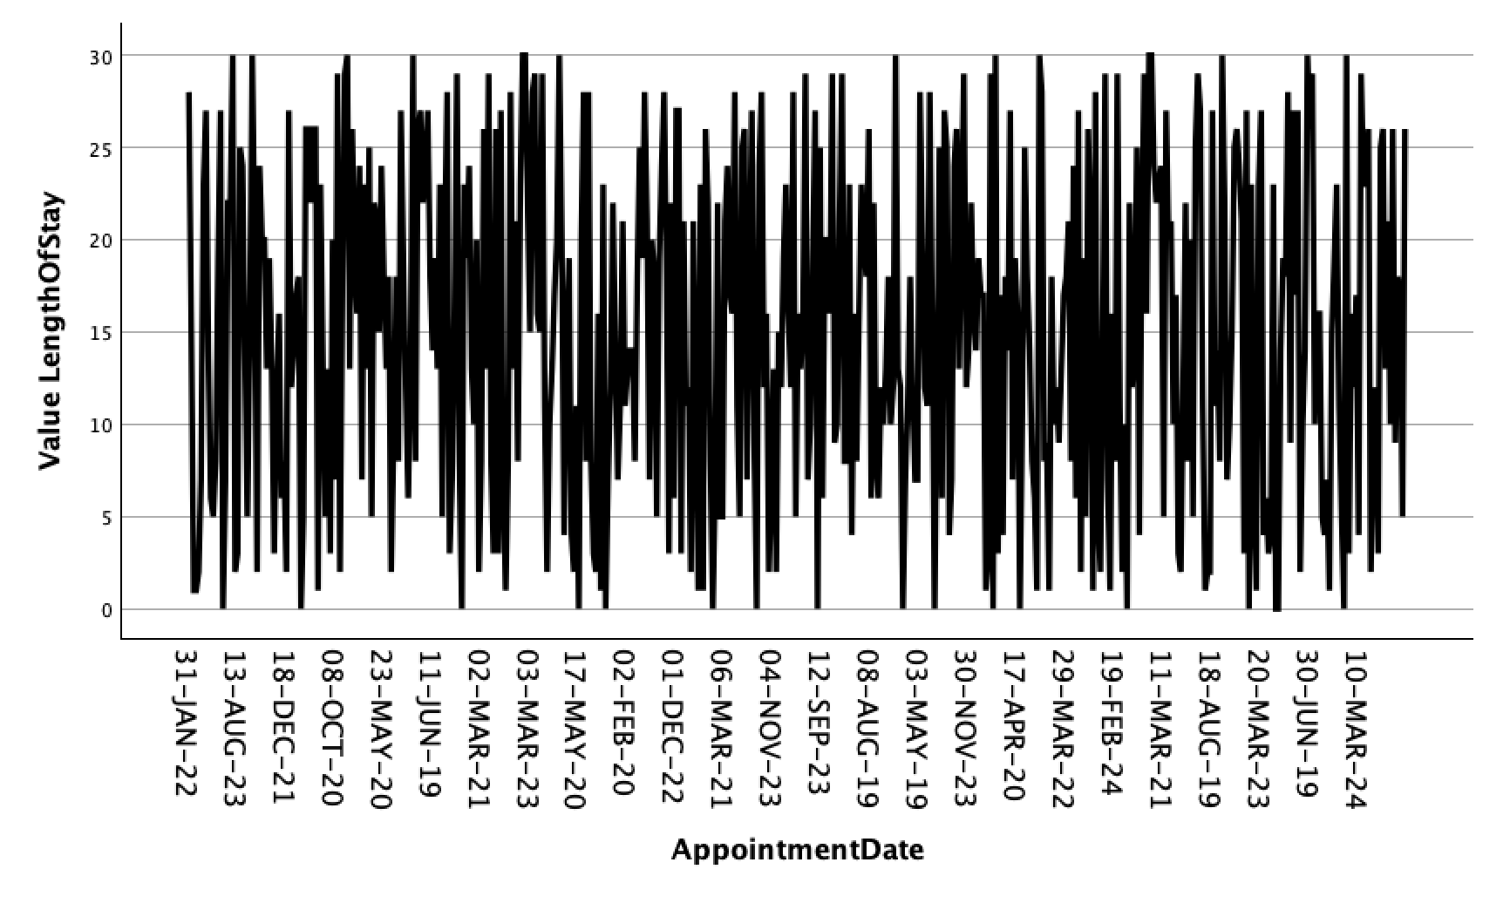
Evidently although there is large variation in length of stay ranges over time, there is no clear trend. If there was, you’d tend to see a pattern in this type of plot.

6. Visualisation of Distributions in Key Performance Indicators (KPIs)

7.1. Boxplot
- Go to Graphs → Legacy Dialogs → Boxplot.
- Choose Simple and select Summaries of separate variables.
- Click Define.
- Select KPI variables (e.g., Cost, Length of Stay) for the Variables box.
- Click OK.
- Interpretation:
  - The boxplot displays the distribution, median, and potential outliers of the KPIs.

7.2. Multiple Bar Chart for KPIs
- Go to Graphs → Bar.
- Choose Clustered and select Summaries for groups of cases.
- Click Define.
- Put the variable AdmissionMonth into the Category Axis box.
- Put the variable SatisfactionScore into the Define Clusters by box.
- Click OK.
- Interpretation: Compare satisfaction distributions clustered by month across a number of years.
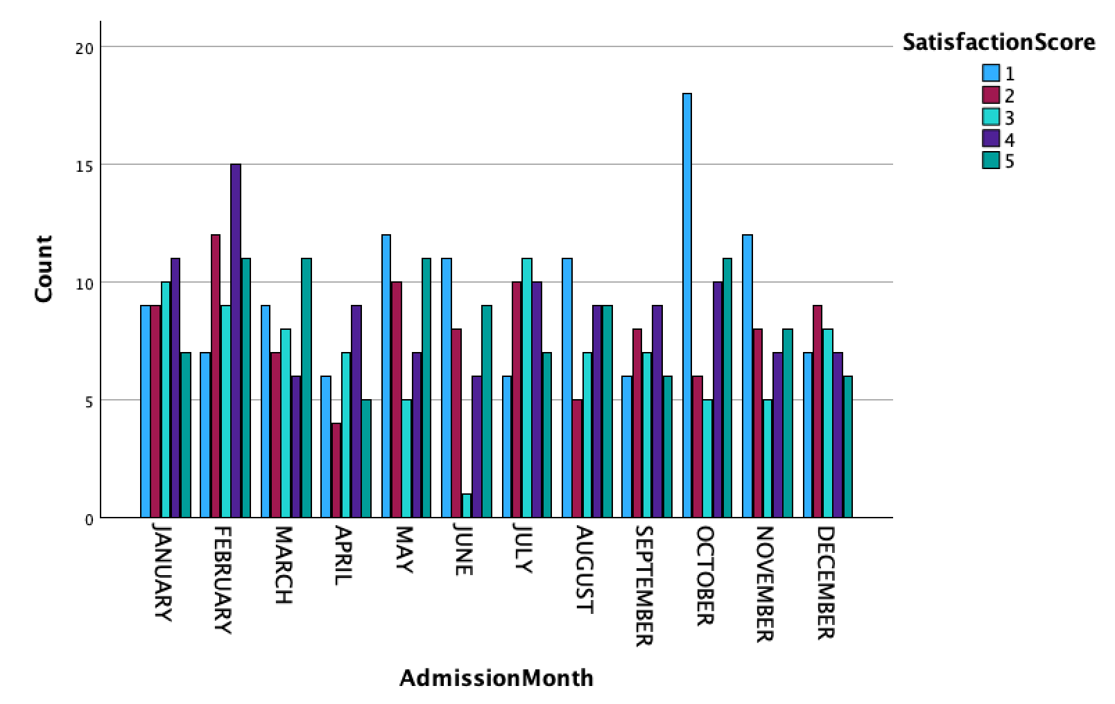
Obviously all of these demonstrations are just examples of what can be analysed. The idea is you seek out SPSS functions might illustrate the data relationships you are interested in seeing.

- Recoding variables

In the last self-study we touched upon recoding variables. This is extremely useful and often needed because the original data is not in exactly the right format as what is needed to do the analysis. For example, you may have Male, Female and Other in the Gender variable, but you may need numeric variables to process.

Naturally there is a way to do this through the menus, but as seen last week its often much easier to use SPSS syntax. For example, try transforming all occurrences of the dataset “female” 0, “male”1 and “other” 2. That can be accomplished by opening a new syntax window and pasting in this code:
RECODE Gender ('Female'=0) ('Male'=1) ('Other'=2) INTO Gender_Code.
VARIABLE LABELS Gender_Code 'Gender (0=Female, 1=Male, 2=Other)'.
VALUE LABELS Gender_Code 0 'Female' 1 'Male' 2 'Other'.
FORMATS Gender_Code (F1.0).
EXECUTE.

If you have problems opening the syntax window, save everything and re-open the data and try new syntax window again.

Remember you highlight the syntax to run and then click the green triangle arrow. This should execute the selected code:

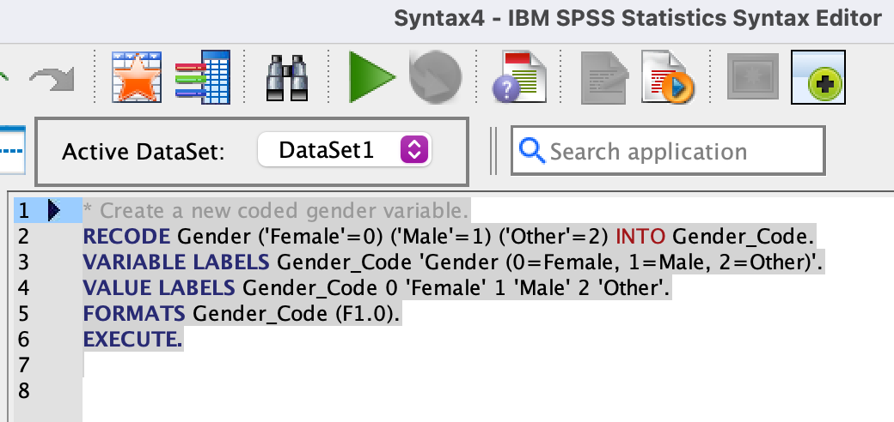

If you do this, you should see a new column with the transformed values as integers. You could delete the original data once transformed and checked for accuracy.

Naturally you can manipulate the syntax (code) to do exactly what you want or do a calculation as part of the transforming process (this is actually part of the assignment part 1, which you have a step-by-step instruction for).

