University of Wales Trinity Saint David



CLCS4007
Athens and Rome: Life and Culture in Classical Antiquity
(Module Syllabus)
Module Code: CLCS4007
Credit points: 20
Pre-requisites/restrictions: None
Taught: Semester 1 and 2
Lecturer: Dr Matthew Cobb

GENERAL INFORMATION
This module provides a wide-ranging discussion of the social, cultural and economic aspects of the Greco-Roman world by concentrating on the two great periods in ancient history: classical Athens and imperial Rome. The module will provide students with the opportunity to learn about the culture and life in these two diverse societies and compare the lives of Greeks and Romans of different social strata. The module will cover topics such as democracy, domestic life and sanitation, medicine, food and diet, work and leisure, games, theatre and shows, death and burial, cults and rituals, philosophy and art, slavery and the relations between classes. The module will cover important social structures such as the family, marriage and education, and it will also pay particular attention to trade, business and professional activities both in classical Athens and imperial Rome.

AIM(S)
- to introduce students to the society, culture and economy of the Athenians in the classical period and the Romans during the imperial period;
- to introduce students to key literary, documentary and archaeological evidence for Greek and Roman culture and society, and to modern scholarship on life in the Graeco-Roman world.

LEARNING OUTCOMES
By the end of this module all students should be able to:
- Demonstrate an elementary understanding and knowledge of the main aspects of culture and social history of classical Athens, for example democratic institutions, theatre, religion, slavery and philosophy.
- Demonstrate a basic knowledge of social and cultural traits and developments in imperial Rome.
- Demonstrate a basic knowledge of the ancient sources and evidence relating to the society and culture of classical Athens and imperial Rome and an understanding of their problems and limitations
- Demonstrate a fundamental understanding of the modern scholarship on the main aspects of culture and social history of classical Athens and imperial Rome.
- Present written and oral work in a manner appropriate for a relevant/professional audience

OFFICE HOURS/HOW TO CONTACT ME
Please feel free to come and see me if you would like to discuss any problems you may have concerning this module. Try, if at all possible, to come during my office hours. If you come to see me at another time and I am not in because of teaching or other commitments, please email me (m.cobb@uwtsd.ac.uk). You can also ask questions (not confidential) in the discussion board available in the Moodle space for this course.

STRUCTURE AND ORGANISATION
This 20-credit module has 20 contact hours, per semester. Attendance is compulsory for ALL lectures, workshops and seminars. If you cannot make a class because of illness or other good reason, you need to inform me (m.cobb@uwtsd.ac.uk) and your personal tutor about this.

Organising your work schedule is your own responsibility. As this module is a 20-credit module taught over two semesters, you should complete at least 200 hours of work for this module, including time spent in class. A suggested weekly work schedule for this module is the following: 2 hours in class, 4 hours preparation and follow-up for lectures/workshops/seminars, and 4 hours preparation for the coursework assessments.

Course Outline:
Potentially subject to change should circumstances require it.

Lecture/Workshops (Semester 1) | Topic
Week 1 - Lecture/workshop | Introduction
- Lecture/workshop | Home is where the hearth is
Week 2 - Lecture/workshop | The “Ordinary man”
- Lecture/workshop | Slavery and freedom
Week 3 - Lecture/workshop | Women in Athens and Rome a comparison
- Lecture/workshop | (Lysias 1)
Week 4 - Lecture/workshop | Childhood and education
- Lecture/workshop | Ancient Science and Technology
Week 5 - Lecture/workshop | Bathing in Antiquity
- Lecture/workshop | Aquae Sulis
Week 6 - Reading week | No lectures this week
Week 7 - Lecture/workshop | Monumental buildings in context
- Lecture/workshop | Social History and Epigraphy (deciphering inscriptions)
Week 8 - Lecture/workshop | Death and Burial
- Lecture/workshop | (exploring the afterlife)
Week 9 - Lecture/workshop | Symposia and Convivia
- Lecture/workshop | (reconstructing Roman cooking)
Week 10 - Lecture/workshop | Greek Athletics
- Lecture/workshop | Roman Spectacles
Week 11 - Lecture/workshop | The Saturnalia
- Lecture/workshop | (Ancient Board Games)
Christmas Break
Exam Period | There are no exams for Athens and Rome

Lecture/Workshops (Semester 2) | Topic
Week 1 - Lecture/workshop | Disease
- Lecture/workshop | (Rome – A City of Filth?)
Week 2 - Lecture/workshop | Medical Practice in the Ancient World
- Lecture/workshop | (Retrospective Psychoanalysis – Caligula as a case study)
Week 3 - Lecture/workshop | Greek and Roman Warfare
- Lecture/workshop | (life under siege)
Week 4 - Lecture/workshop | Greek and Roman political systems
- Lecture/workshop | (the mixed constitutions)
Week 5 - Reading week | No Lecture this Week
Week 6 - Lecture/workshop | Law in Athens and Rome
- Lecture/workshop | (Lysias 3 - Against Simon)
Week 7 - Lecture/workshop | Reception
- Lecture/workshop | (Reception – Classics and the Screen)
Week 8 - Lecture/workshop | Visual Arts
- Lecture/workshop | (Roman Portraiture)
Week 9 - Lecture/workshop | Myth and Religion in Athens
- Lecture/workshop | Myth and Religion in Rome
Easter Break
Week 10 - Lecture/workshop | Sexuality
- Lecture/workshop | Sexuality
Week 11 - Lecture/workshop | Quiz
- Lecture/workshop | Quiz

ASSESSMENT

Coursework assignment 1: Gobbet Exercise
Deadline for submission is 28th November 2017 (must be uploaded on turn-it-in by 23:59 at the latest)

Pick one of the following passages or images and write an essay of 1,000 words (this is worth 50% of your mark). For the passages comment upon the context, content, and any relevant parallels that can be drawn from other historical sources; for the images comment upon their nature, imagery and political, social or economic significance.

1) “Hearing that the boy was at my house, he came there at night in a drunken state, broke down the doors, and entered the women's rooms: within were my sister and my nieces, whose lives have been so well-ordered that they are ashamed to be seen even by their kinsmen” – Lysias Against Simon 3.6 – trans. by W. R. M. Lamb (1930).

2) “Soon afterwards one of his own slaves murdered the city-prefect, Pedanius Secundus, either because he had been refused his freedom, for which he had made a bargain, or in the jealousy of a love in which he could not tolerate his master's rivalry. Ancient custom required that the whole slave-establishment which had dwelt under the same roof should be dragged to execution, when a sudden gathering of the populace, which was for saving so many innocent lives, brought matters to actual insurrection… Still, the party which voted for their execution prevailed.” – Tacitus Annals 14.42 – trans. by J. Jackson (1937).

3) “But on the contrary, in the days of our ancestors, it was these that were to be seen in their halls, and not statues made by foreign artists, or works in bronze or marble: portraits modelled in wax were arranged, each in its separate niche, to be always in readiness to accompany the funeral processions of the family; occasions on which every member of the family that had ever existed was always present. The pedigree, too, of the individual was traced in lines upon each of these coloured portraits. Their muniment-rooms, too, were filled with archives and memoirs, stating what each had done when holding the magistracy.” – Pliny NH 35.2.4-6 – trans. by J. Bostock and H. T. Riley (1855).

4)
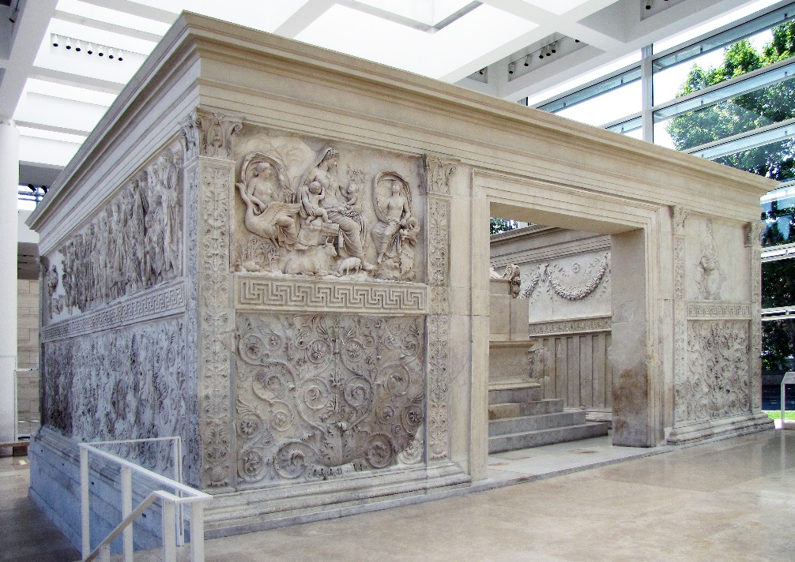
Ara Pacis

5)
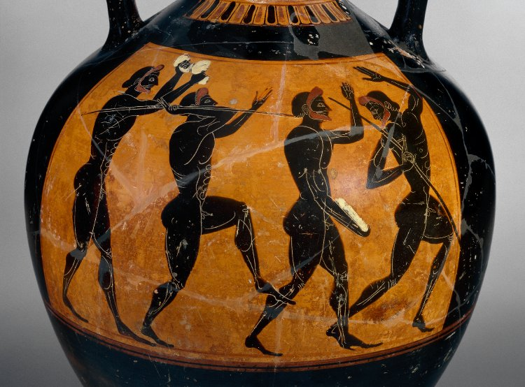
Panathenaic amphora – c. 530-520 BC

Coursework assignment 2: Essay
You should choose ONE of the following questions and write essay of 1,500 words (worth 50% of your final mark).
Deadline for submission is 1st of May 2018 (must be uploaded on turn-it-in by 23:59 at the latest)
1) Critically discuss the important role that banquets played with regard to status and social relationships in the Roman world.

2) Critically discuss the types of evidence we have available for understanding hoplite warfare in the Archaic and Classical Greek world [engage with any controversies in interpretation].

3) What problems are posed by using the texts of the logographers to understand Classical Athenian society?

4) Critically discuss the importance of gender and status, as well as the concepts of dominance and passivity in relation to Roman sexuality.

General assessment information: coursework
Coursework submission for this module will be through Moodle. Please follow the instructions on the module’s Moodle page for how to submit your work. The deadline for submission will be at 3 pm on the day given above. You will also need to retain a second electronic copy of your work to be submitted, if deemed appropriate, to the module convenor.

Word count
Please be aware that if you go significantly over or under the word limit (i.e. more than 10%), you may be penalised.

REMEMBER that the word count includes everything apart from the bibliography, titles or captions. You must provide the word count clearly on the cover sheet.

Welsh First language
If your first language is Welsh and you would like to submit any assessed coursework in Welsh, please see the School Office as soon as possible to make arrangements for this.

Special needs / requirements
If you have any special needs (e.g. dyslexia, visual impairment) that need to be taken into account for the teaching of this module, please make sure that our sure that our Student Support Liaison Officer, Dr Ruth Parkes (R.Parkes@uwtsd.ac.uk), is made aware of this so that we can make sure that we fully support you in your studies.

Returning of work
Your coursework will be returned electronically through Moodle. Detailed feedback is given on the essay cover sheet but if you would like to discuss your work in more detail, do come and see me during one of my office hours (see times given above).

Some extra assignment/essay guidelines
Help for the writing of coursework is available in the TSD and School of Classics Reference Guides, as well as through the Student Support Moodle page. You are advised to read the relevant sections carefully.

Marks will be deducted if your piece of coursework is not presented properly (e.g. double-spacing, font 12 is needed). Note that all coursework needs to be word-processed; hand-written work will not be accepted. Assessment criteria can be found in the Programme of Study Handbook and at the back of this Module Syllabus.

*** You need to watch plagiarism whenever you use secondary literature (ALL suspect coursework will be submitted to a Turn-It-In analysis). Please consult the Classics Reference Guide for advice on how to reference secondary literature.

In case of problems….
Do come and see me during office hours if you have any problems with the writing or planning of your piece of coursework. You are also welcome to see your personal tutor for advice.

Bibliography
A bibliography is provided in the Moodle space for this course. Please note that the books mentioned there are only recommendations. You should also make use of the relevant lecture notes and handouts and do some independent research.

Unless they are available in electronic format, all items for the reading list have been placed on library-only or short loan and are kept behind the library counter. Note that all these items can be reserved via the computerised catalogue – a very useful device that allows you to plan ahead with your reading for the essay.

