Manifesto Writing
1) Anyone should be allowed to express themselves.
2) There should be such a thing as a knife license in the UK, as there is in the USA but with guns.
3) Guns should only be used for military purposes.
4) All school meals should be free with better standards of cooking.
5) All education below college level should be free inc. private establishments.
6) Nurses should be earning a more significant wage.
7) EA Sports FIFA should be a PEGI 18 for the gambling reasons. It is currently a PEGI 3.
8) Never use more than 3 fonts on a piece unless it is something that is made up of a lot of fonts purposely.

“There should be such a thing as a knife license in the UK, as there is in the USA but with guns”
I believe that there should be a system where all knives have a serial number that can be tracked to a license that could lead to an owner, in cases of knife crime. “Stabbings were the largest single cause of death, totalling 40 fatalities out of 100, with the remaining 60 resulting from other causes such as assault or fire” (https://www.bbc.co.uk/news/uk-47476217, 2019) proving that this is a serious problem in the UK.

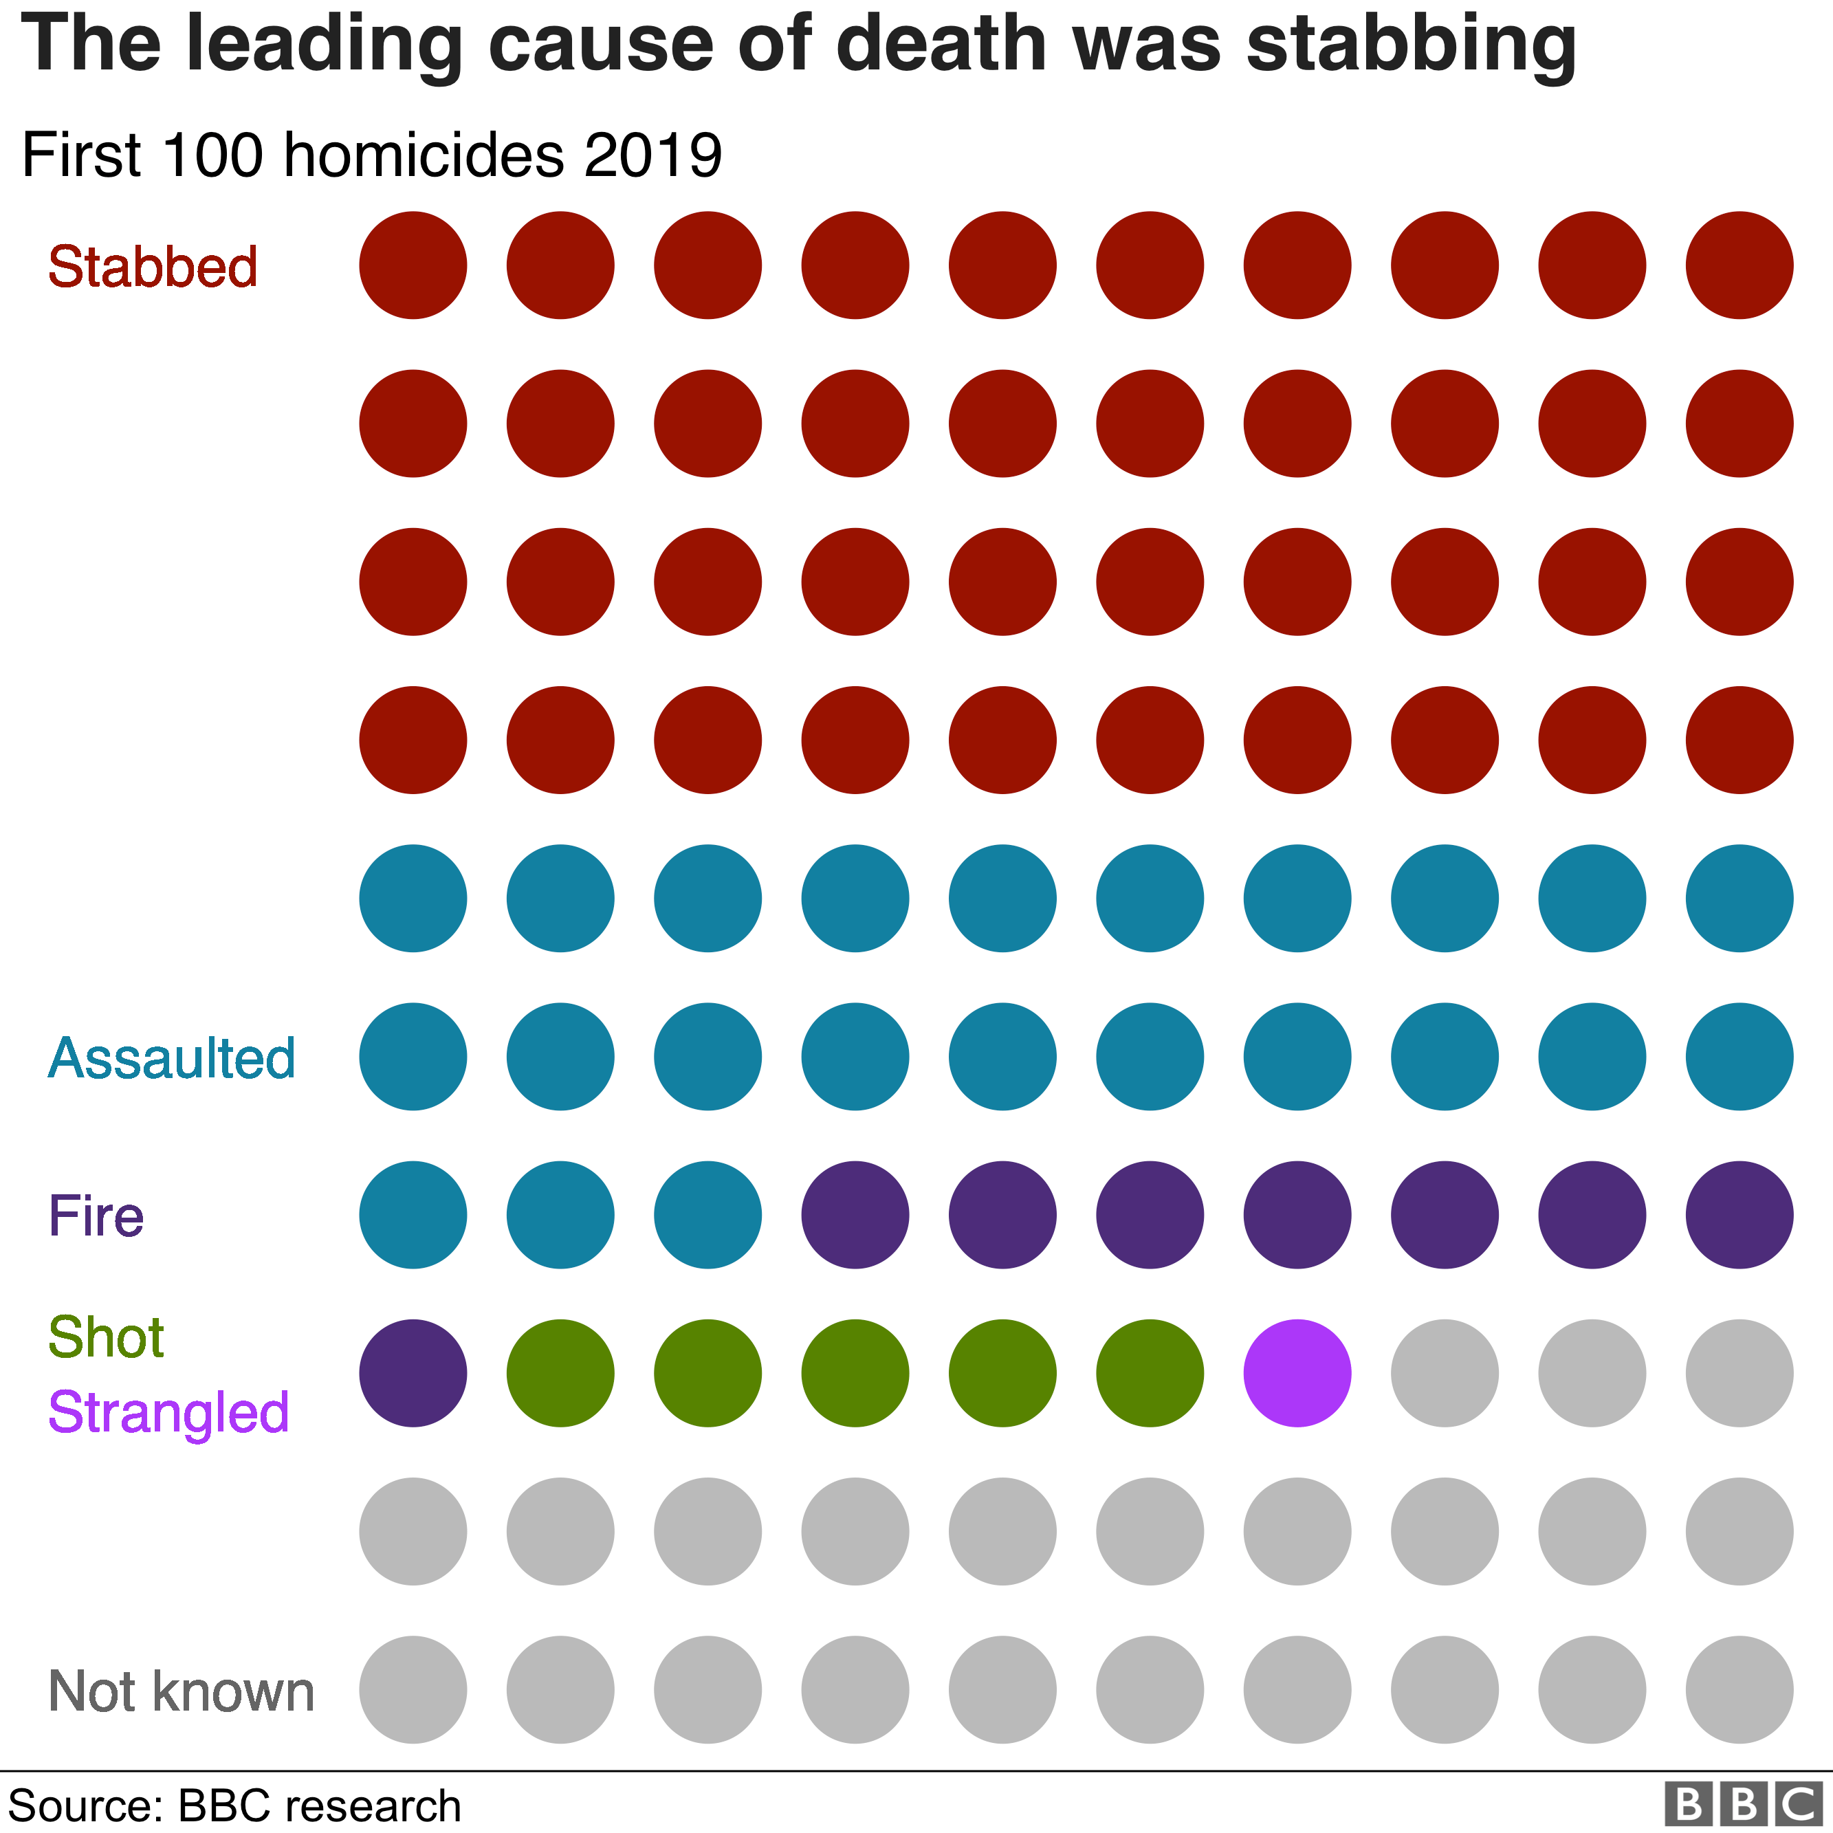

(https://www.bbc.co.uk/news/uk-47476217, 2019)
“Figures obtained through freedom of information requests show the overall number of knife incidents against victims under the age of 25 surged from 3,857 in 2013-14 to 6,503 in the year to March 2018. The number of knife-related incidents involving youth that led to no further action by police increased in the past four years from 33 per cent to 63 per cent” (https://www.independent.co.uk/news/uk/home-news/knife-crime-young-people-unsolved-stabbings-soar-police-figures-a8410491.html, 2019). The low solve rate of knife crime in this era proves that there needs to be a way of tracking who is responsible or who potentially could be linked to the crime. The license system could be a way of preventing this as having a more reliable and efficient way to trace the offender to the crime via the bladed article used, could deter people from using knives a lot more. This could then make less room for knife crime.
“All school meals should be free with better standards of cooking”
School meals should be free for all children or at least significantly cheaper, as the costs for food are troubling families across the UK. As around 18% of children are eligible for free school meals as they would need the support due to their income.
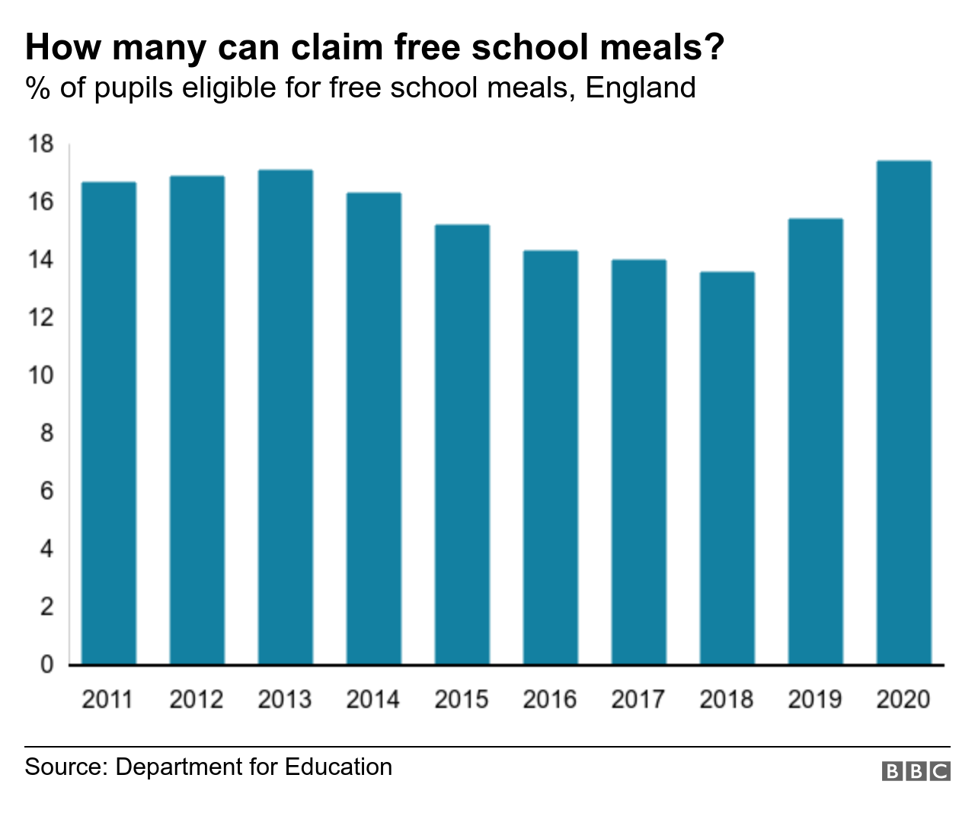
(https://www.bbc.co.uk/news/54693906, 2020)
But this also brings inequality within schools as some children have to pay and some do not. Making all meals free or significantly cheaper will give more children access to food and encourage them to eat at school more as there will be little-to-no financial issues. Having good nutrition at school also improves morale and mood according to some studies such as “Innovative research by Tamlin Conner and collaborators[14] has found—using data on daily food diaries on 281 students tracked over a 3-week period—that a high level of fruit and vegetable consumption appears to be predictive of greater emotional well-being on the following day. Various cross-sectional papers have also pointed to the possible existence of a statistical connection between psychological well-being and the amount of fruits and vegetables eaten, and have shown that this correlation survives the inclusion of a large number of covariates.[15]” (https://ajph.aphapublications.org/doi/pdfplus/10.2105/AJPH.2016.303260, 2016)

“Guns should only be used for military purposes”
The dramatic rise in gun violence causes for immediate change with gun laws especially in America, as innocent people are getting shot and killed by people who have been given the license to possess a firearm – “about one in five American adults own one of more guns” (Hunting and Gun Ownership, 2019). As US citizens have the right to handle a gun, and the introduction of SYG laws brought a rise of firearm abuse. “McClellan and Tekin (2012) found that SYG laws resulted in an increase of homicides. Using state-level data from the U.S. Vital Statistics for the period 2000-2010, the authors found that SYG laws were associated with a significant increase in the homicide rate of white males” (‘Guns and Crime – The Data Don’t Lie’ Mark Gius, 2016)
Observational Writing

This Christmas advert from Cola-Cola glorifies dominance and being outstanding through many different aspects of its design. The most obvious being its use of their trademark red. Red is the signifier of power and dominance – “just as red signifies anger” (Jonathan Bignell, 2002). This makes the advert as a whole stand out more due to its role in dominance. This also promotes power, as anger and dominance are the most powerful set of emotions. Having a powerful image can communicate with audiences better than any other type of message, and in this context, the powerful message is that Coca Cola is an elite, or if not one of the most elite brands in the world, due to its powerful use of colour. It also displays use of hierarchy, with the white on red again promotes dominance and the logo rightly conveying the elite brand message as it is the largest feature on the design. It is also placed in the top left of the design, so the eye connects with that first as people are naturally drawn towards the left of a graphic or the largest element. The logo is both of these, resulting in the powerful and eye-catching connection it has with the audience.
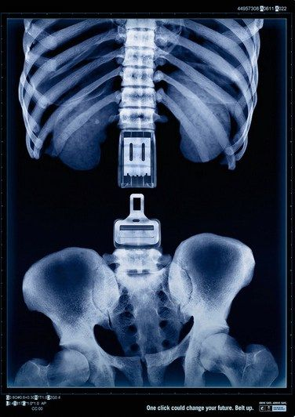
This advert’s intentions of communication intend to come across as firm and direct, as the main focus point of the image is directly in the centre. This being the main point of focus, then they want this point to stand out and make the most connection with the audience. This is a picture of the spine being signified by a seatbelt. The meaning being that wearing a seatbelt could mean life or death, as the seatbelt being detached represents a broken spine, that would cause death or severe paralysis, and a fastened seatbelt signifying no injury at all, meaning you’ll be much better off fastening your seatbelt. The centre focus of the image is surrounded by black empty space which can attract the viewer’s attention even more, especially when the point of focus is quite large; “The relationship between positive and negative space, the strength of horizontal or vertical forms, the dominance of variations in scale and value and the space between the objects will all work together to attract and direct the viewer’s attention” (“Graphic Design School”, p.33, 2017).
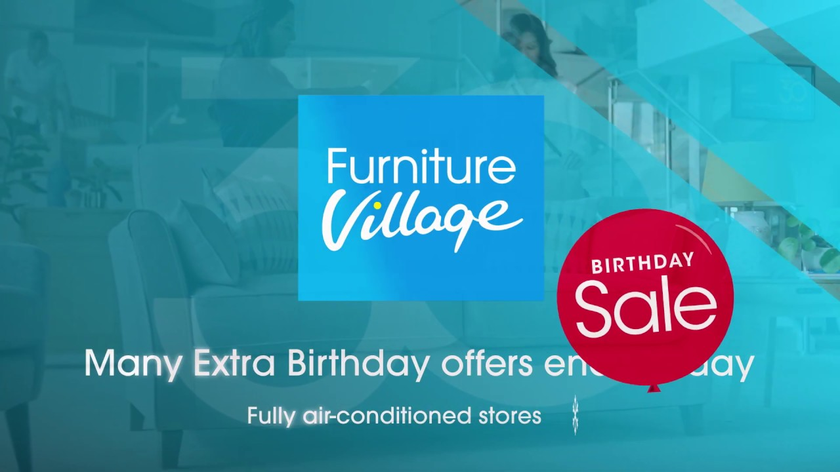
The blue used in this entails that it is trustworthy, loyal and quite a rare occurrence – “blue; once in a blue moon (rarely), true blue (loyalty)” (Messages, Signs, and Meanings, 2004.). The red also promotes attention and concentration, as not only is red a colour of danger and alarms, but it perfectly contrasts with the blue, so it stands out and immediately is the first thing you are drawn to when looking at this piece.
Practice-Based Writing
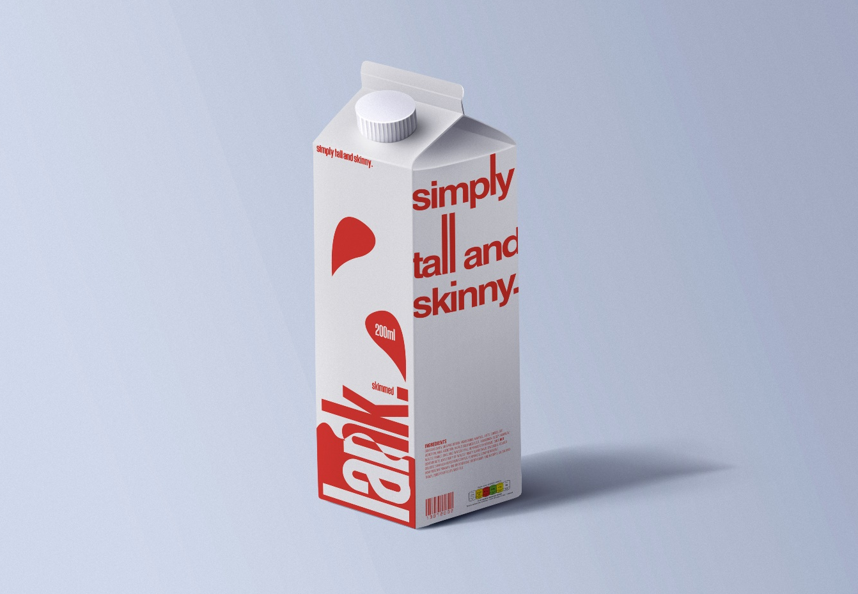
The above photo is the final design of my milk carton packaging design. To which, the brief stated that it had to be designed based on your own personal characteristics.
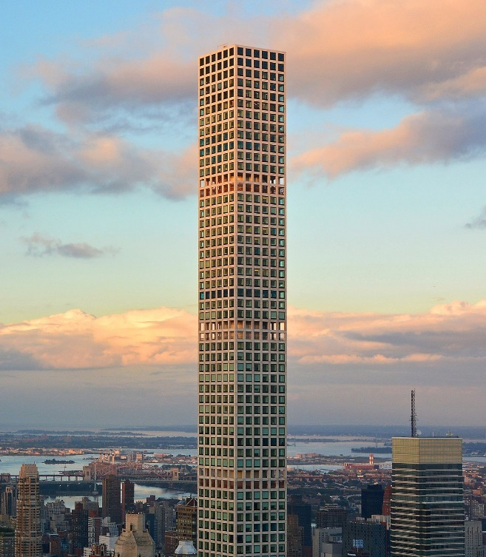
This particular object/artifact reminded me of tall lettering, and tall typefaces in general. Particularly the letter ‘l’ as it towers over others in most typefaces, just like this building is towering over the building to the right in the image. This gave me the idea to use a tall typeface for a logo.
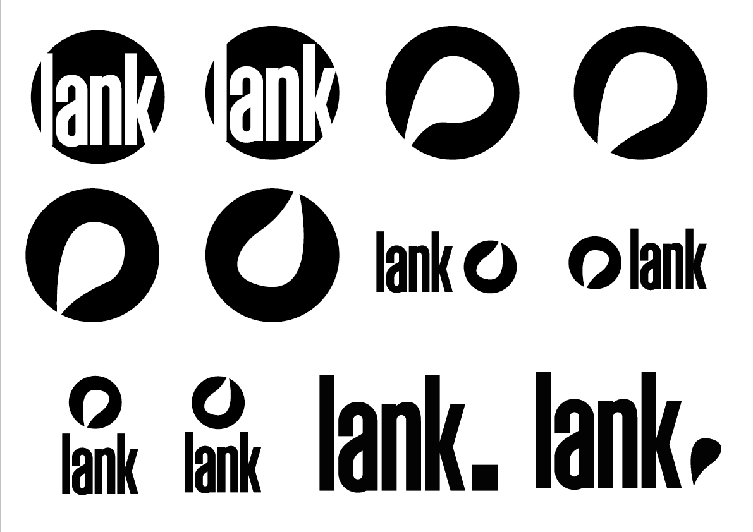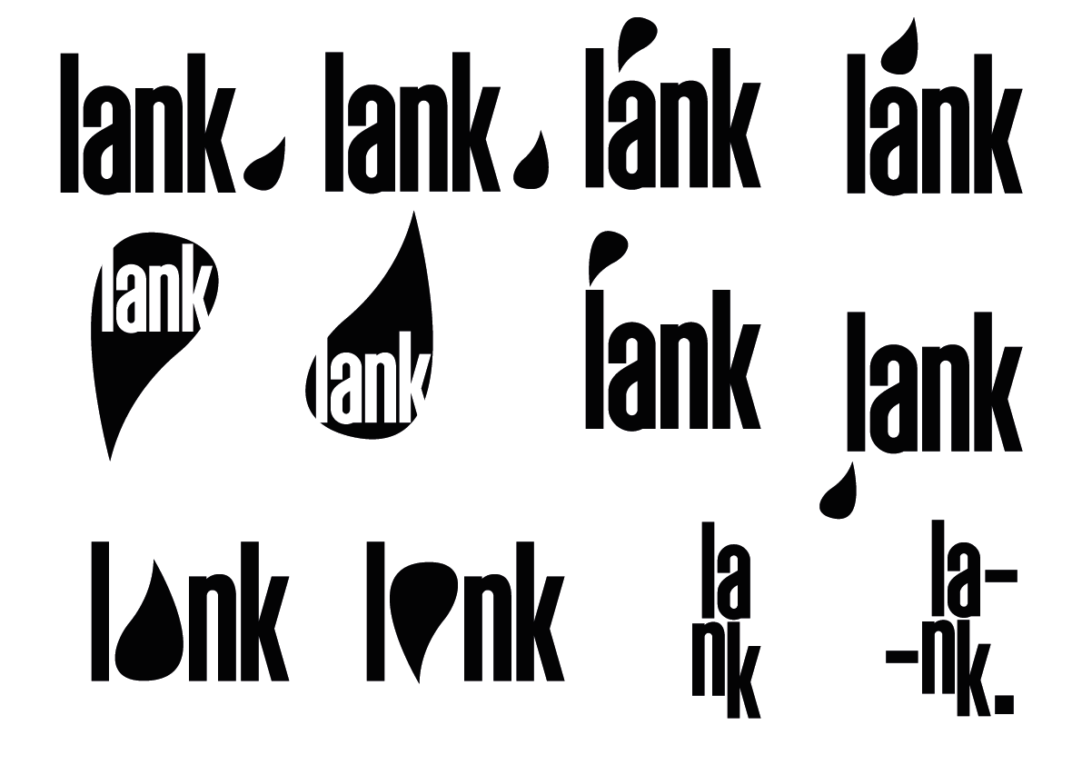
These are the logos I had come up with after realising that the type is suited to one of my projects for a milk carton packaging design. Tall typefaces reminded me of the building, and how it is prominent and stands out above a crowd.
I found ‘Deutschland’, the font shown above. The lettering met the criteria and was perfect for such a project. The simple shapes of the letters allowed them to be manipulated easily, allowing me to make my project more unique to me.
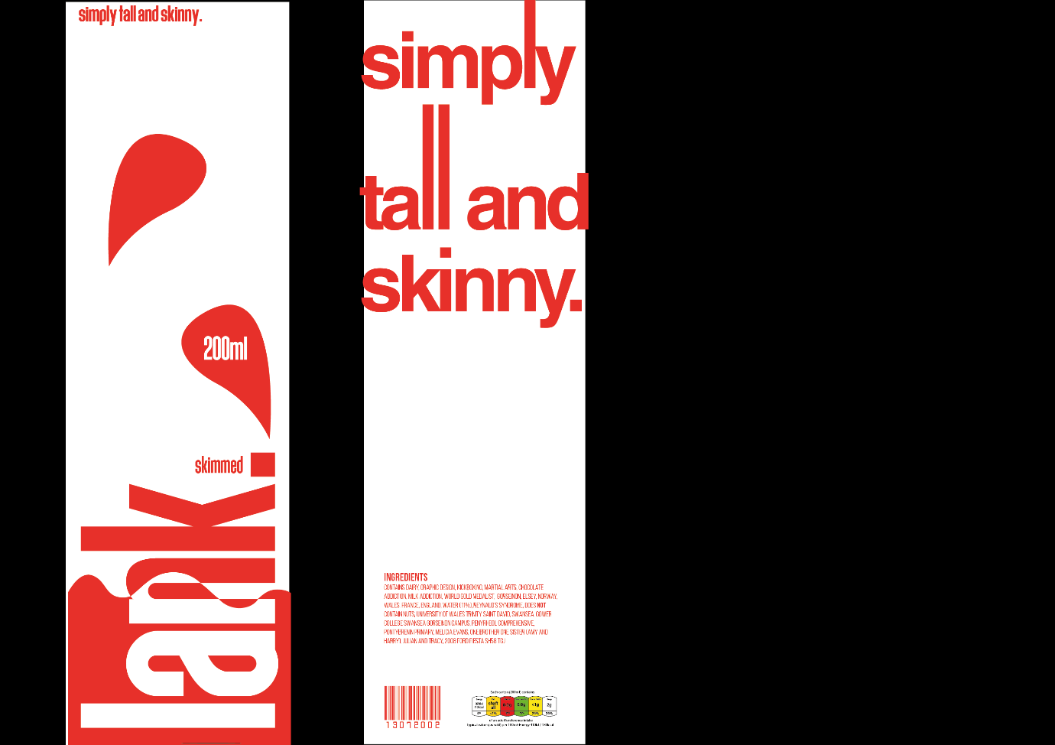
One of my main objectives was to achieve salience – for one of the elements to stand out more than any others. In the front of the carton it is the logo, and the side profile it will be the red large text. “Salience can be achieved through color, size, or location within the composition space.” “Their dominance is derived from their size because they all occupy 50% of the composition space” (Kenneth L. Smith, ‎Sandra Moriarty, ‎Keith Kenney, 2020). This is what I think I have achieved in both of my designs above.
To resemble the artefact that inspired these designs in the first place, I increased the height of the letter ‘l’s’. This made them stand out more to the eye, and adjusted lettering is modern and more suited to up to date design styles which was one the main reasons as to why I chose this. They have their own negative space around them it makes them far more noticeable to the audience. In terms of signs, “because of their size, colour, and simplicity, ads may be most likely to attract your attention,” (Media Semiotics, 2002) which is why I went for a more minimalistic design when going about this project. 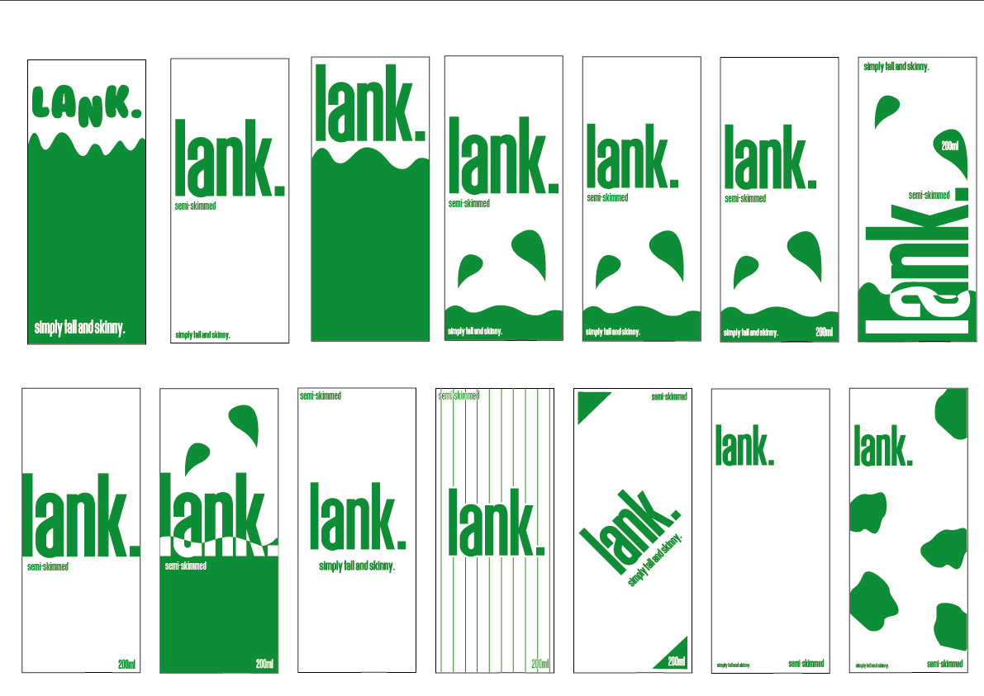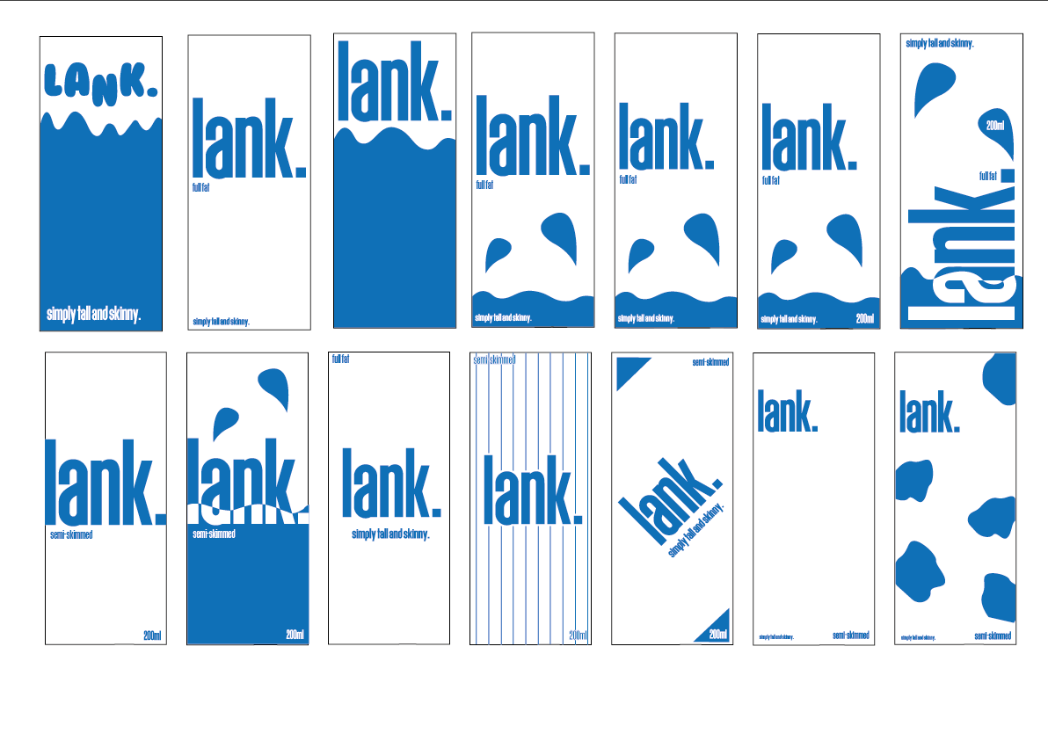

When thinking about the colours, I had thought about green and blue, and did designs for them as you can see above. But overall, they didn’t stand out as much as they did when I used red, so for that reason I chose red. Red is naturally more appealing to the eye – “a child picks a red ball because it looks more active and it promises more fun than a gray one” (Handbook of Visual Communication: Theory, Methods and Media. 2004)
By experimenting with multiple different designs as see above, it has allowed to me to have a wide variety of different styles and that allowed to me to assess which one would visually apply the best to my project. The processes I used allowed me to design and work to my full potential, as I constantly had options if I thought something did not fit or look right. My project would not have been the quality it was if I did not use this method of experimentation that I used to develop it.

