Research Methods-M7X01371

University of Wales Trinity Saint David
School of Engineering

Title: Hydrotreater Shutdown/Turnaround

Assignment 1: Research Proposal

MSc Engineering Project Management

Name: Stephen Thomas

Student Number: P150906

Student Email: SThomas.150906@student.uwtsd.ac.uk

Contents
Introduction 2
Project Aim 3
Background and Rationale 4
Permits 4
Safe Isolation to Plant and Equipment 5
Methodology/Objectives 5
Literature Review 5
Figure 1: Hydrotreater Process Diagram (DELTA V) 6
Resource Requirements and Constraints 7
Manpower 7
Departments 7
Equipment 7
Standard Operating Procedures 7
Operations constraints 8
Resource constraints 8
Deadlines 9
Cost implications 9
Drain on resources 9
Potential safety hazard 10
Ethical considerations 10
Consent form 10
Privacy of information 10
References 11
Bibliography 13
Appendix 14
Figure 1: Hydrotreater Process Diagram (DELTA V). 14

Introduction
A six week hydrotreater planned maintenance shutdown is due to take place at Valero in 2019. The operations department takes responsibility for the operational activities in a planned shutdown, this ensures that the process is shutdown safely and efficiently. These operational activities consist of the creation and issuing of permits, safe isolation of plant and equipment and the implementation of safety safeguarding procedures. This research proposal will identify how the operational department conducts the shutdown, how data is collected and interpreted, how procedures are implemented to ensure safe isolation of plant and equipment is achieved and finally, how the process could be improved for future use. Studies conducted by (Dedopoulos and Shah, 1995), (Megow, Möhring and Schulz, 2011) on the short term planning, (Amaran et al., 2015) Midterm planning, (Amaran et al., 2016) long term shutdown scheduling and studies such as (Jahangiri et al., 2016) illustration of the human errors associated with permits and (Megow, Möhring and Schulz, 2011) Decision Support and Optimization in Shutdown and Turnaround Scheduling, all identify key milestones and characteristics which are incorporated into the operational departments shutdown responsibilities. These milestones will help with the implementation of a planned shutdown and ensure the correct precautions are in place following the result of these published studies.

Project Aim

The reliability and structural integrity of equipment deteriorates overtime and a planned shutdown must take place to rectify these identified faults thus, improving efficiency and reliability of the process unit. Maintenance activities are essential to ensure there is a high level of productivity through the process. However, these activities cannot be carried out until operations have completed the necessary work scope. The aim of this project is to research and carry out a planned shutdown from an operations perspective, implement the shutdown and recommission the process unit within a six week deadline set by Valero. Operations are tasked with safe isolations of plant and equipment, the issuing of permits, gas testing and purging, coordinating with maintenance department to plan the shutdown accordingly and the continuous monitoring of the planned work scope. Studies by (Amaran et al., 2016) and (Amaran et al., 2015), discuss the importance of early shutdown planning and argue the need to eliminate the uncertainty over a midterm or longterm time periods. Although this information provided identifies key aspects of planning, shutdowns cannot always be planned early due to excessive workload and manpower availability, this is currently the situation at Valero. Health and safety executive guidance publications are a reliable source of information to help implement a planned shutdown such as safe isolation of plant and equipment. Isolation and reinstatement of process plant failures are one of the main causes of loss of containment incidents which have the potential to lead to major incidents. Rigorous management control and high standard isolations are required for plant isolation and reinstatement. (Hse.gov.uk, 2018) therefore, it is essential that the tasks associated with the planned shutdown are scheduled and carried out correctly.

Background and Rationale
Refineries and chemical process plants operate continuously during normal operations. Therefore, periodic maintenance and major overhauls are required to improve and maintain good operational process conditions. (Sahoo, 2017). The period of maintenance and major overhaul activities can only be carried out through a planned shutdown. A shutdown is defined as planned, periodic shutdown of a refinery’s process unit or in some cases the entire refinery to perform maintenance, inspection and carry out repairs of equipment that have failed or been damaged (Sahoo, 2017). A study conducted by (Amaran et al., 2015) addresses the effects of increasing the maintenance workscope due to inaccessibility of plant equipment. While a study by (Khatab et al., 2018) discusses selective maintenance implications by identifying issues in maintenance optimisation. These issues consist of budget, resources, and limited time. Therefore, the completion of the shutdown and recommission of the process unit could potentially go over the six week deadline set by Valero pending the need to carry out further maintenance activities. Through a shutdown, operations are required to organise jobs that enable maintenance activities to be carried out safely and effectively. These activities consist of the following,

Permits
A specialised type of safe system of work, under which certain groups of high risk potential work may only be done with the specific permission of authorised personnel is known as the permit to work procedure (Hughes and Ferrett, 2016). Permits vary depending on the maintenance activity and are classified as a hot work or cold work permits. These permits are constructed by maintenance and issued by operations to ensure that safe systems of work is achieved. These permits will consist of isolations, location, hazards, risk assessment, method statements and process & instrumentation drawings. RAPnet software is used to construct and issue electronic permits on a daily basis. This data is easily accessible through Valero and will be used through this shutdown.

Safe Isolation to Plant and Equipment
Isolation of plant and equipment is achieved by carrying out a positive isolations. Positive isolations are accomplished by isolating the equipment from the process by closing valves, purging the equipment and ensuring that the equipment and area is safe from hydrocarbons. (Bahadori, 2017). On a shutdown regular isolations take place to allow maintenance activities to commence. Once the work is completed and the permit is handed back, operations will reinstate the equipment and ensure it is ready for process recommission. The shutdown plan will then be updated accordingly and continuously monitored through the process. Procedures are obtained through Valero’s Pembroke Refinery Management System software and these procedures specify how isolations are carried out and gives instructions and guidance to complete the task correctly and safely.

Methodology/Objectives

Literature Review
Although several papers illustrate activities associated with a planned shutdown such as short term scheduling of production and maintenance (Dedopoulos and Shah, 1995), (Megow, Möhring and Schulz, 2011). Midterm (Amaran et al., 2015), and long term (Amaran et al., 2016) and studies such as (Jahangiri et al., 2016) illustration of the humans errors associated with permits and (Megow, Möhring and Schulz, 2011) Decision Support and Optimization in Shutdown and Turnaround Scheduling. No prior work appearing in the literature appears to address how operations shutdown units, carryout tasks and recommission the unit following a successful planned shutdown. Therefore, the objectives for this project proposal is to:
- Implement a hydrotreater shutdown and recommission the process.
- Complete a planned shutdown within a six week period
- Create and issue permits for the shutdown
- Carryout safe isolation of plant and equipment
- Respond to any abnormalities that may occur
These objectives can only be achieved by carrying out research methods, these methods consist of data collection, statistical considerations and quantitative research. Research development involves the selection of research methods, data collecting methods, sampling methods and the development of instruments, data collection, and analysis. Pawar, M. (2004) Quantitative data will be obtained from Valero’s database to help create work packs and indicate process characteristics which will specify process faults and conditions. (O'Dwyer and Bernauer, 2014) states that, ‘by retaining problems as they exist in natural settings, qualitative research seeks to discover new knowledge, whereas quantitative research seeks to discover new knowledge by simplifying complexities in setting that tend to be more contrived’. Therefor, Data such as Process & Instrumentation Drawings, work order numbers, trends, flows, temperatures, pressures and process conditions will all be obtained through Pembroke Refinery Management Systems, TDC and DELTA V software to help illustrate and demonstrate the current process conditions as the process progresses through the planned shutdown.

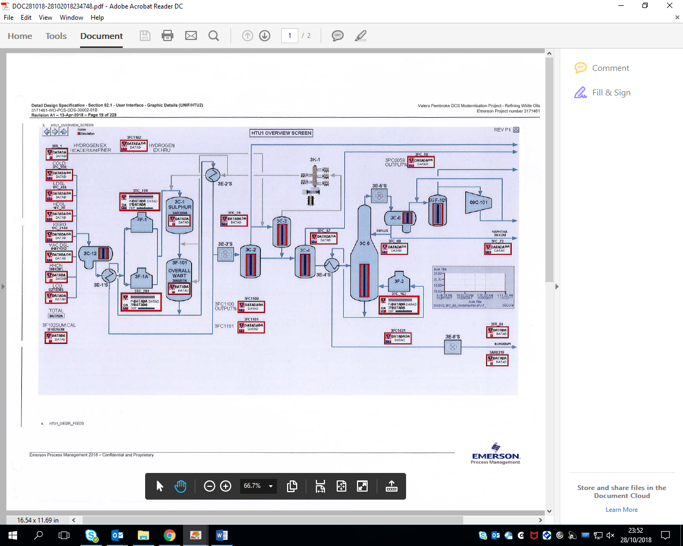
Figure 1: Hydrotreater Process Diagram (DELTA V)
Hydrotreating removes impurities from the feed to produce a low sulfur high quality diesel. Impurities in the feed consist of sulfur, nitrogen, metals and oxygen all of which are removed by the use of catalysts, high pressure hydrogen and heat. The environmental and economic nature of hydrotreating is why refineries are swayed towards their use. (Dugulan, 2008). As seen in figure 1, Hydrotreaters consist of splitters, strippers, heat exchnagres, heaters, separators, fin fans and various centrifugal pumps all of which will be inspected through the planned shutdown. The process unit will be out of operation for a six week period and this will have a knock on effect to the other refinery process units. Certain units on the refinery will need to increase process rate to compensate for the hydrotreater being out of service. Eventually this can be very costly to a company such as Valero.

Resource Requirements and Constraints

Manpower
(Amaran et al., 2016) and (Amaran et al., 2015) study of midterm and longterm maintenance turnaround planning raises the issues of man power on a planned shutdown. The study discusses the matter of a need to hire personnel in advance before carrying out the shutdown. In addition, it discusses the effects of insufficient manpower by insisting that if maintenance activities exceed the normal duration and maintenance personnel are not available, maintenance activities could be postponed to future shutdowns. This would clearly affect the deadline of the shutdown and implement more costs towards Valero

Departments
Maintenance departments consisting of mechanical, electrical, and instruments, planning department and operation departments are all required to conduct this planned shutdown effective. During major shutdown to an existing process plant, operations and maintenance departments can be extensive. The operations and maintenance departments can play a vital role in ensuring that equipment integrity is properly maintained during a shutdown. (CCPS, 1995)

Equipment
Operational equipment will be required to ensure safe isolations of plant and equipment is achieved. This is accomplished by using gas testers to confirm there is no traces of hydrocarbon before maintenance activities begin. Commonly new equipment is stored and waiting on site prior to the planned shutdown. Initial work for the equipment can still be carried out while the unit is still in operation therefore, all that remains for the turnaround work is the final connections of the equipment to the process unit (Speegle, 2016). Steam, water and nitrogen hoses are all required to successful purge equipment prior to testing and breaking of containment. This equipment is at the facility and is easily assessable to operations when required.

Standard Operating Procedures
A type of standing plan is known as a standard operating procedure or SOP. A SOP is more precise than policy, in that it outlines the steps to be followed in particular circumstances. (Griffin, 2013). Procedures are obtained through Valero’s PRMS software, each job has a specific procedure associated with it. The procedure gives step by step instructions on how to carry out the task correctly. These procedures are regularly reviewed to ensure they are competent and illustrate correct information related with the task.

Operations constraints
(Amaran et al., 2015) long term shutdown planning study, discusses the effects on operations while a shutdown is being carried out. The study declares that blocking of upstream operations or restricting downstream operations can occur when performing a shutdown on a process unit, this is due to the complexity relationship between the process units. While the hydrotreater is out of service, other process units will alter their production rate to meet the customer demand. Storage facilities located on site enable enough products to be stored to sustain the demand while the process unit is offline.

Resource constraints
Part of the study conducted by (Amaran et al., 2015) goes on to address the issue of requiring a large workforce with a wide range of skills to conduct the shutdown maintenance. Efficient planning and coordination is required to ensure management and allocation of maintenance personnel is conducted correctly and to a high standard. As the work scope of the planned shutdown is conducted, a greater work force is required to carry out the work, this workforce is typically contractors.

Potential Problems
An opportunity to identify and address major potential problems or failures in a timely manner, to improve plant safety and efficiency in the maintenance organisation is achieved through a planned shutdown (Gulati, 2013). Through the planned shutdown, there will be potential problems that could occur. Any task produces a potential hazard associated with the planned shutdown. The high profile potential problems are as follows,

Deadlines
A study by (Pinto, Joly and Moro, 2000) discuss the planning and scheduling models for refinery operations. The research identifies the main obstacle for the integration of production objectives and process operations lack of technology for production scheduling. The six week shutdown deadline will be achieved pending that no issues arise, these issues could consist of further maintenance activities, lack of resources, man power availability and operational abnormalities such as leaks and emergencies.

Cost implications
A shutdown impacts the business in a particular way by financially incorporating company profits to conduct the work. It is typically an expensive event that can have major impacts on profits in the year in which it is performed (Lenahan, 2004). The operations department have no control of cost while conducting a shutdown. However, more operational staff such as process operators are required through the shutdown due the increased workload.

Drain on resources
Shutdowns are a drain on company resources and personnel are diverted away from other crucial work. Shutdowns typically require more workers than the company normally employs and external resources have to be brought in to conduct the increased workload (Lenahan, 2004). Resource scheduling is a complex activity for a maintenance turnaround, shutdown or outage. Not only must this task be properly estimated, planned and code all equipment and work orders but the availability of the resources may only be accessible at certain quantities and times during outage (SAHOO, 2017).

Potential safety hazard
The potential for harm to property, environment and people increases through a shutdown. A comparison between normal routines and a situation which exists on the shutdown, the shutdown tends to reverse almost every characteristic of normal routine. Large numbers of personnel are using unfamiliar and inherently hazardous procedures and equipment (Lenahan, 2004). This potential problem can escalate to a major incident if it is not properly controlled therefor, operations conduct routine isolations and inspection with maintenance workforce to identify and confirm the equipment has been prepared for maintenance and this helps reduce the uncertainty of unfamiliar procedures and equipment.

Ethical considerations
Standards that distinguish between right and wrong are known as ethics. Ethics help define the difference between unacceptable and acceptable behaviours. Prevention against the falsifying data and therefore, promoting the pursuit of knowledge is achieved through ethical standards (Cirt.gcu.edu, 2018).

Consent form
Through this planned shutdown a variety of staff will all be working towards the successful implementation of the hydrotreater maintenance shutdown. Information gathered by contributors that take part in this planned shutdown will be recognised pending a consent form has been approved and information has been obtained from that personnel. Senior management and experienced process operators will provide information from the process panel and Valero’s network and this will be recognised through the shutdown implementation project

Privacy of information
Valero’s data protection act prevents confidential information from being published. Any information gathered from this company and used through this project will be subject to screening and authorisation.

References
- Amaran, S., Zhang, T., Sahinidis, N., Sharda, B. and Bury, S. (2016). Medium-term maintenance turnaround planning under uncertainty for integrated chemical sites. Computers & Chemical Engineering, 84, pp.1-4.
- Amaran, S., Sahinidis, N., Sharda, B., Morrison, M., Bury, S., Miller, S. and Wassick, J. (2015). Long-term turnaround planning for integrated chemical sites. Computers & Chemical Engineering, 72, pp.1-10.
- Bahadori, A. (2017). Oil and gas pipelines and piping systems. 2nd ed. Lismore, NSW, Australia: Gulf Professional Publishing, pp.349-360
- CCPS, C. (1995). Guidelines for safe process operations and maintenance. 1st ed. New York, NY: Center for Chemical Process Safety of the American Institute of Chemical Engineers, p.59.
- Cirt.gcu.edu. (2018). Ethical Considerations - Center for Innovation in Research and Teaching. [online] Available at: https://cirt.gcu.edu/research/developmentresources/tutorials/ethics [Accessed 28 Oct. 2018].
- Dugulan, A. (2008). High-pressure sulfidation of hydrotreating catalysts. 2nd ed. Amsterdam: IOS Press/Delft University Press, pp.4-5.
- Griffin, R. (2013). Management. 1st ed. Australia: South-Western Cengage Learning, p.190.
- Gulati, R. (2013). Maintenance and reliability best practices. 1st ed. New York, NY: Industrial Press, p.91.
- Hse.gov.uk. (2018). The Safe Isolation of Plant and Equipment. [online] Available at: http://www.hse.gov.uk/pUbns/priced/hsg253.pdf [Accessed 25 Oct. 2018].
- Hughes, P. and Ferrett, E. (2016). Introduction to health and safety at work. 1st ed. Abingdon, Oxon: Routledge, pp.120-129.
- Khatab, A., Diallo, C., Venkatadri, U., Liu, Z. and Aghezzaf, E. (2018). Optimization of the joint selective maintenance and repairperson assignment problem under imperfect maintenance. Computers & Industrial Engineering, 125, pp.413-422.
- Lenahan, T. (2004). Turnaround management. 2nd ed. Oxford: Butterworth Heinemann, pp.3-20.
- O'Dwyer, L. and Bernauer, J. (2014). Quantitative research for the qualitative researcher. 1st ed. London: SAGE Publications,
- Pawar, M. (2004). Data collecting methods and experiences. 1st ed. Elgin, IL: New Dawn Press, pp. 5
- Pinto, J., Joly, M. and Moro, L. (2000). Planning and scheduling models for refinery operations. Computers & Chemical Engineering, 24(9-10), pp.2259-2276.
- Sahoo, T. (2017). Process Plants. 1st ed. [S.L.]: CRC Press, pp.1-49
- Speegle, M. (2016). Process technology plant operations. 2nd ed. Boston, USA: Cangage Learning, pp.290-300.

Bibliography
- Abs.gov.au. (2018). Statistical Language - Quantitative and Qualitative Data. [online] Available at: http://www.abs.gov.au/websitedbs/a3121120.nsf/home/statistical+language+-+quantitative+and+qualitative+data [Accessed 25 Oct. 2018].
- Dedopoulos, I. and Shah, N. (1995). Preventive maintenance policy optimization for multipurpose plant equipment. Computers & Chemical Engineering, 19, pp.693-698.
- Jahangiri, M., Hoboubi, N., Rostamabadi, A., Keshavarzi, S. and Hosseini, A. (2016). Human Error Analysis in a Permit to Work System: A Case Study in a Chemical Plant. Safety and Health at Work, 7(1), pp.1-10.
- Margolis, E. and Pauwels, L. (2011). The SAGE handbook of visual research methods. 2nd ed. Los Angeles: SAGE, pp.10-32.
- Megow, N., Möhring, R. and Schulz, J. (2011). Decision Support and Optimization in Shutdown and Turnaround Scheduling. INFORMS Journal on Computing, 23(2), pp.189-204.
- Pawar, M. (2004). Data collecting methods and experiences. 1st ed. Elgin, IL: New Dawn Press, pp.1-30
- Treese, S., Pujadó, P. and Jones, D. (2008). Handbook of Petroleum Processing. 2nd ed. Dordrecht, The Netherlands, p.32

Appendix

Figure 1: Hydrotreater Process Diagram (DELTA V).

