PROJECT MANAGEMENT

Introduction
As asserted by Kerzner, (2019), project management is identified as the integration of adequate knowledge, tools, skills, and techniques for sequentially achieving pre-defined objectives. The project management concept is generally required for delivering a successful project by covering its aims, objectives, capital, stakeholders, possible risk & mitigation plans, communication style, timescale, key milestones, and estimated outcomes. The recent essay-based study is going to illustrate the initial project plan, budget structure, timeframe, stakeholder involvement level, and risk factors of the selected “Hinkley Point C” project. The study is going to determine whether the selected project has experienced an issue of cost overrun and time delay or not. The selected project is recognised as an expensive project with a budget range of £25 - £26 billion to form a Nuclear Power Plant across the globe.
The root cause of creating a cost overrun scenario of Hinkley Point C was entitled to the sudden appearance of inflation due to the emergence of the SARS-CoV-2 virus. In this aspect, the estimated project cost would On the other hand; the project would likely cost more than its pre-designed budget rate. Subsequently, the project is going to be delayed by another year as the cost of the project has gone up to around £3 billion. As a result, the project would be able to take more time to develop 25,000 employment opportunities and apprenticeship scope for the regional talents (Butcher et al., 2021, p. 509. Also, the cost overrun and time delay issues of the Hinkley Project would have an impact on the slow national economic progression of the country.

The Body

Initial project plan
Project Overview
Hinkley Point C is a popular nuclear plant infrastructure set-up-based project in the United Kingdom and it is situated in Somerset. The main motto of this project was to reduce the carbon emission rate and develop a low-carbon electricity programme for nearly 6 million houses and also consider a wide range of employment opportunities for the local talents in the United Kingdom. Focusing on the low-carbon electricity channel, this nuclear power plant's two ERP reactors would offset around 9 million tonnes of CO2 or more than 600 million tonnes in its 60 year of span (edfenergy.com, 2015).
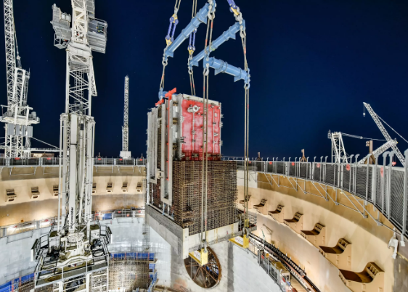
Figure 1: Image of Hinkley Point C
(Source: edfenergy.com, 2015)
This power plant was also planned to defeat the climate alteration concept to make the project remarkable. In this aspect, the British Government approved and announced the “Subsidised Feed-in Pricing Strategy” to produce a low-carbon electricity concept.
Aim
The Hinkley Point C project aims to lower the carbon emission level in the United Kingdom up to 2050 and improve overall employment & national economic prospects of the United Kingdom.
Objectives
The key objectives of the project are associated below,
- To develop approximately 3,260 MW of low-carbon and safe electricity for the next 60 years
- To generate an employment opportunity of nearly 25,000 jobs and 1,000 apprenticeships
- To evaluate a long-term benefit to the national economy of the United Kingdom by offering thousands of job scopes and lone-carbon electricity in 6 million homes

Core elements of the project
Budget
Hinkley Point C project has experienced a huge degree of “cost levelling up” type issue and henceforth, the project has automatically experienced a huge degree of time delay. In this aspect, the original budget of the project was estimated to be £20.5 billion by EDF and eventually, the cost confirmation in the autumn of 2016 was up-scaled up to £24.8 billion. Gradually, the cost was heightened up to an additional £3.6 billion at the end of 2022. As of the 2016 assessment and interpretation, it has been disclosed that the UK Government stated that the total lifetime costs of the Hinkley Point C project could be as high as £46.5 billion, compared to the previous cost estimation of £17.7 billion (power-technology.com, 2023).
The project cost was eventually heightened day by day for this nuclear power plant-based project and henceforth, the executives of EDF outlined that the infrastructure cost could be projected up to £32.7 billion. The reason behind the cost overrun is the presence of the “inflation indices” based on 30th June 2022. This statistical information indicates an increase from May 2022 with an estimation of £26 billion to £27 billion of additional costs while adjusting the inflation degree in 2023. In order to get additional funding for the Hinkley Point C project, the EDF has created a significant level of partnership with CGNP (China General Nuclear Power) and henceforth, the price tag for two reactors is entitled to £25 billion and £26 billion respectively. EDF has increased this nuclear power plant-based project's budget figure multiple times from an initial estimation of £18 billion when the contract was first signed with the United Kingdom in 2016 (scmp.com, 2023).
Time
The initiation of electricity generation for unit 1 of the Hinkley Point C project in the United Kingdom has an estimated deadline of June 2027. In this aspect, the project completion cost is entitled to £26 billion to complete the project within the scheduled time scale.
Activity phases | 2007 | 2008 | 2009 | 2010 | 2011 | 2012 | 2013 | 2014 | 2015 | 2016 | 2017 | 2018 | 2019-continue
Making Announcement
Designing for Deployment
Government Development and Approval of Consent Order
Strategic Collaborative investment
Contract for Electrical Package
Transmission cables for power plant
Installation and completion of the project

On November 2015, the UK-based Entergy Policy review is launched by Tony Blair and after that, he declared that the failure in taking action against the UK’s nuclear plants would be considered a “Dereliction of Duty” on May 2006.
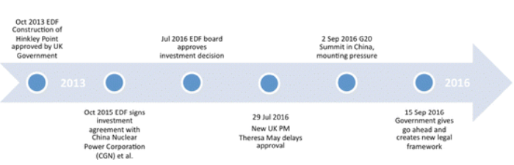
Figure 3: Timescale-based roadmap of the Hinkley Point C project
(Source: Rabe and Gippner, 2017, p. 472)
On August 2007, it has been reviewed by the EDF that reactor safety is required for creating an infrastructure of low-carbon electricity (theguardian.com, 2016). In October 2013, the UK Government announced a “Subsidy Deal” for Hinkley Point t produce power. In 2016, the executives of EDF decided to make a final investment at the board meeting on 28th July. due to the cost overrun, the selected project will experience a time delay of more than 15 months and henceforth, the estimated time for completion of the project would be September 2023.
Quality stakeholders
The respective Project Manager of the Hinkley Point C project is using the “Stakeholder Grid Model” to distribute the scheduled activities among the stakeholders based on their power and level of interest. The key stakeholder reference group of this project are “Material Suppliers”, “Main Contractors”, “Safety Officers”, “UK Government”, “UK Community”, and “Main Investors”. Considering the “Main Suppliers” of Hinkley Project C, it has been disclosed that the required materials such as “welding substances”, “structural steels”, “non-metallic materials and composite substances”, and “copper alloys”.
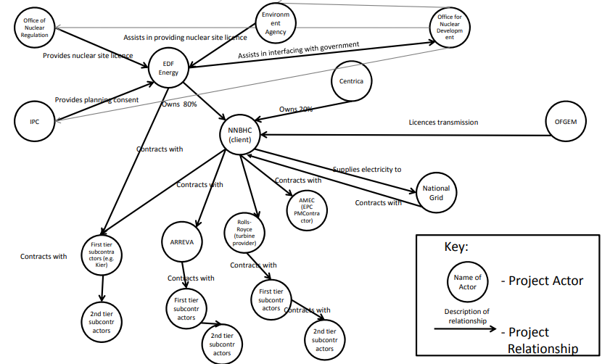
Figure 4: Stakeholder’s Mapping Approach of Hinkley Point C Project
(Source: silo.tips, 2021)
The reactor supplier of the Hinkley Point C project is “Framatone” while the cooling source of Point C is coming from seawater from Seven Estuary. In order to deliver the erection sequence of the Point C nuclear plant-based construction site in Somerset, England, the respective Project Manager has already created a “MEH Joint Venture” by connecting with the companies such as “Doosan Babcock”, “Cavendish Nuclear”, “Altrad”, and “Balfour Beatty Baily” (Daniel and Daniel, 2019, p. 1020).
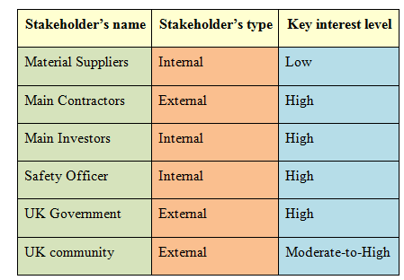
Figure 5: Stakeholder’s type and interest level
(Source: Developed by the learner)
By creating a 50/50 joint venture-based partnership between Kier and Baam Nuttall, the delivery of the OH2001 enabling tasks on behalf of EDF (kier.co.uk, 2022). In this aspect, the Main Contractor of the Hinkley Point project s recognised as “EDF Energy” while the core customer of this project is entitled to “CNNC (China National Nuclear Corporation)”. In this aspect, the project manager is also using Trello and Slack-based virtual platforms to connect with its enlisted internal and external stakeholders for making flawless connectivity and tracking the project progress rate.
Risk factors
The key risk factors of the Hinkley Point C project are associated with the consideration of “Delay in Delivery” and “Cost Overrun”. By reviewing the statistical information, it has been disclosed that the “design of reactors” was completely unproven as there was no evidence of reactor technology application across the globe (nao.org.uk, 2017). In addition, other projects contributed to developing nuclear power stations with the usage of ERP technology in China, Finland, and France. On the other hand, the EDF’s fiscal status has been eventually poor since 2013 due to the consistent generation of negative cash flows with a high degree of capital expenditure. In order to overcome these issues, the respective Project Manager would hire efficient Nuclear Power-plant Designers, Architects, along with the consideration of the BIM (Business-Intelligence-Modelling) for making an error-free design. As a result, the overall chances of cost overrun or additional investment in rectifying the error would be in a control mode and the delivery time would be slightly shorted.
The project has experienced a budget shortage scenario due to the appearance of Covid-19 and the inflation scenario. As a result, the cost of the materials has been up-scaled, resulting in the generation of a capital shortage scenario during the mid-evaluation phase of this nuclear project. Subsequently, the severity degree of this risk is “high” as it would have a direct impact on delaying the completion of the infrastructure within the scheduled deadline. In order to mitigate this risk aversion, the respective Project Manager of Hinkley has tried to take monetary help from the UK government. This kind of assistance would be effective for this project to again face the cash flow shortage scenario and sudden stoppage of the infrastructure activities.

What went wrong?
The selected Hinkley Point C project experienced a high severity of risks in “cost overrun” and “time delay in delivery”. The project would be delayed until at least 2026 due to the presence of the pandemic situation, a high degree of unemployment, and an inflation scenario. These crucial factors have a direct contribution in increasing the cost of the project up to 500 million GBP to 23 billion GBP. Due to Covid, the project manager suddenly stopped the project activities to avoid the chances of being affected. Throughout the pandemic phase, the project manager and the involved teammates are carefully monitored for tracking the project progress rate. As the Covid outbreak has created a staff shortage scenario onsite, the project completion timeframe is in delayed mode. The project has lost around 3 months of scheduled time and is also estimated to lose additional 3 months in 2021 (world-nuclear-news.org, 2021).
According to the newspaper report analysis, it has been disclosed that the selected nuclear project has experienced a huge level of time overrun issue and that is why the revised operating date for the project completion is entitled to June 2027. According to the statement of EDF, it has also been revealed that there would have zero level of cost-effectiveness for British taxpayers and customers. The Covid emergence has had a dramatic influence on the supply chain disruption of Hinkley Point C and henceforth, the upper management of Hinkley was forced to cut down their onsite employees from over 5,000 to 1,500. As of April 2020, around 180 suppliers had completely a zero level of work throughout the pandemic session and as of February of that year; more than 60 suppliers were involved in the operational zone with lower productivity (bbc.com, 2022). Henceforth, it has been also revealed that the Hinkley Point C project has experienced a huge level of labour shortage and inflation scenario as an “extremely high” severity degree.
The project’s cost would be increased up to £33 billion while building the nuclear power plant in the South-West section of England. In order to mitigate the cost overrun issues, the respective Project Manager of Hinkley is eventually trying to get financial assistance from not only the UK government but also from CGNP by holding around 33% of the stake in this project. In this aspect, the probability of fund offerings for the Hinkley project has already achieved its committed equity cap to a high degree. Therefore, this project has experienced a lot of controversies from its first announcement phase and overall worries eventually reached "high prices" of electricity implemented at the plant, national security, financial difficulty, and environmental safety both from the taxpayers' and investors' end has been plagued this nuclear project (power-technology.com, 2023). Due to the consideration of these issues, the project is entitled to an original opening date of 2017 and it was gradually pushed back to 2025 as per the 2015's analysis. The date was again in delay and the completion date is entitled to 2027 due to the presence of an efficient labour force and unavailability of proper capital due to the presence of inflation scenarios across the world.

Conclusion
Finally, it can be concluded that the Hinkley Point C project went wrong due to the sudden emergence of the Covid-19 scenario and the strict global lockdown phase. As a result, the project has experienced a high degree of unavailability of efficient labour, an inflation index, and an absence of proper investment in developing onsite Covid-safety protocols. As of 2022, the first reactor set-up process of Hinkley Point C was completed after the spending of innovative and intellectual planning techniques, capital, and dedication of involved stakeholders around 80,000 hours spent. Henceforth, the project has taken initiatives to move forward towards the carbon-neutral and low-carbon electricity concept of 2050. The overall analysis has also outlined the key aims, objectives, budget, timescale, ongoing cire risk factors, and the wrong parameters of Hinkley. It has been also disclosed how Covid has created dramatic changes in its infrastructure development process and generated a scenario of cost overrun and time delay in completing the reactor build-up session.
Recommendations
The key recommendations for mitigating the project’s issues are as follows,
R1: Consideration of the “Supplier Diversification Strategy” for reducing the time delay issue
Through the consideration of this approach, the respective Project Manager of Hinkley Point C is going to create a MEH Joint Venture and a 50/50 joint venture with the material suppliers. In this aspect, the company is trying to revive its local partnership with more than 4,000 local businesses. As a result, the supplier connectivity rate is increased and the supplier's cost-based negotiation rate is comparatively low due to their availability.
R2: Consideration of collaboration with the enterprise such as GIS
Through the development of collaborative connectivity with the GIS portal, the respective Project Manager and the involved stakeholders would be able to get a clear picture of the construction on-site. It allows the internal stakeholders to share construction-relevant on-site information with each and it is hosted by EDFs Microsoft Azure Cloud (bimplus.co.uk, 2023). In this aspect, the CAD data, BIM model, Revit Models, and all the emergency & logistics operations of the on-site will be visible. As a result, the respective Project Manager would be able to make immediate ramifications to avoid the chances of delivery delay and cost overrun issues of the Hinkley Project.

References
Books
Kerzner, H., 2019. Using the project management maturity model: strategic planning for project management. John Wiley & Sons. https://books.google.com/books?hl=en&lr=&id=4vyGDwAAQBAJ&oi=fnd&pg=PR11&dq=project+management&ots=UbEfG1b2qQ&sig=hvjp2vXiovJPqUjUtwlzEO5EiOw
Websites
silo.tips, 2021. “[PDF] Hinkley Point Nuclear Power Point - Free Download PDF.” Silo.tips, 25 Apr.
2021, silo.tips/download/hinkley-point-nuclear-power-point. Accessed 5 Apr. 2023
power-technology.com, 2023. Cossins-Smith, Annabel. “Cost of EDF’s Hinkley Point c Nuclear Project Rises to $40bn.” Power Technology, 21 Feb. 2023, www.power-technology.com/news/hinkley-point-c-project-costs-rise-again/#:~:text=Since%20its%20initial%20announcement%2C%20the. Accessed 5 Apr. 2023.
scmp.com, 2023. “Cost of French, Chinese-Backed Hinkley Point Nuclear Plant Soars to US$38.5 Billion.” South China Morning Post, 18 Feb. 2023, Accessed 5 Apr. 2023
theguardian.com, 2016. “Hinkley Point c Timeline: All the Key Moments.” The Guardian, 28 July 2016, www.theguardian.com/environment/2016/jul/28/hinkley-point-c-timeline-all-the-key-moments. Accessed 5 Apr. 2023
nao.org.uk, 2017. Hinkley Point C (summary) - national audit office (2017). Available at:https://www.nao.org.uk/wp-content/uploads/2017/06/Hinkley-Point-summary.pdf Accessed 5 Apr. 2023
world-nuclear-news.org, 2021. "Hinkley Point c Delayed until at least 2026: Corporate - World Nuclear News." World-Nuclear-News.org, 27 Jan. 2021, world-nuclear-news.org/Articles/Hinkley-Point-C-delayed-until-at-least-2026. Accessed 5 Apr. 2023.
bbc.com, 2022. BBC. “Hinkley Point c Delayed by a Year as Cost Goes up by £3bn.” BBC News, 20 May 2022, www.bbc.com/news/uk-england-somerset-61519609. Accessed 5 Apr. 2023.
power-technology.com, 2023. Cossins-Smith, Annabel. “Cost of EDF’s Hinkley Point c Nuclear Project Rises to $40bn.” Power Technology, 21 Feb. 2023, www.power-technology.com/news/hinkley-point-c-project-costs-rise-again/#:~:text=The%20Hinkley%20Point%20C%20project. Accessed 5 Apr. 2023.
bimplus.co.uk, 2023. Stanton, Justin. “Hinkley Point c Improves Collaboration with GIS Portal.” BIM+, 9 Feb. 2023, www.bimplus.co.uk/hinkley-point-c-improves-collaboration-with-gis-portal/. Accessed 5 Apr. 2023.
edfenergy.com, 2015. “Latest Images.” EDF Energy, 17 Mar. 2015, www.edfenergy.com/energy/nuclear-new-build-projects/hinkley-point-c/latest-updates. Accessed 5 Apr. 2023.
kier.co.uk, 2022. “Hinkley Point C.” Www.kier.co.uk, 10 Apr. 2022,www.kier.co.uk/our-projects/hinkley-point-c/#:~:text=Kier%20and%20BAM%20Nuttall%2C%20with. Accessed 5 Apr. 2023
edfenergy.com, 2015. “About Hinkley Point C.” EDF Energy, 16 Feb. 2015,www.edfenergy.com/energy/nuclear-new-build-projects/hinkley-point-c/about. Accessed 5 Apr. 2023
Journals & PDFs
Butcher, A., Stork, A.L., Verdon, J.P., Kendall, J.M., Plenkers, K., Booth, F., Boneham, M. and Koe, A., 2021. Evaluating rock mass disturbance within open-pit excavations using seismic methods: A case study from the Hinkley Point C nuclear power station. Journal of Rock Mechanics and Geotechnical Engineering, 13(3), pp.500-512. https://www.sciencedirect.com/science/article/pii/S1674775521000056
Daniel, E. and Daniel, P.A., 2019. Megaprojects as complex adaptive systems: The Hinkley point C case. International Journal of Project Management, 37(8), pp.1017-1033.https://www.sciencedirect.com/science/article/am/pii/S0263786317313297
Rabe, W. and Gippner, O., 2017. Perceptions of China’s outward foreign direct investment in European critical infrastructure and strategic industries. International politics, 54, pp.468-486.https://link.springer.com/article/10.1057/s41311-017-0044-x

