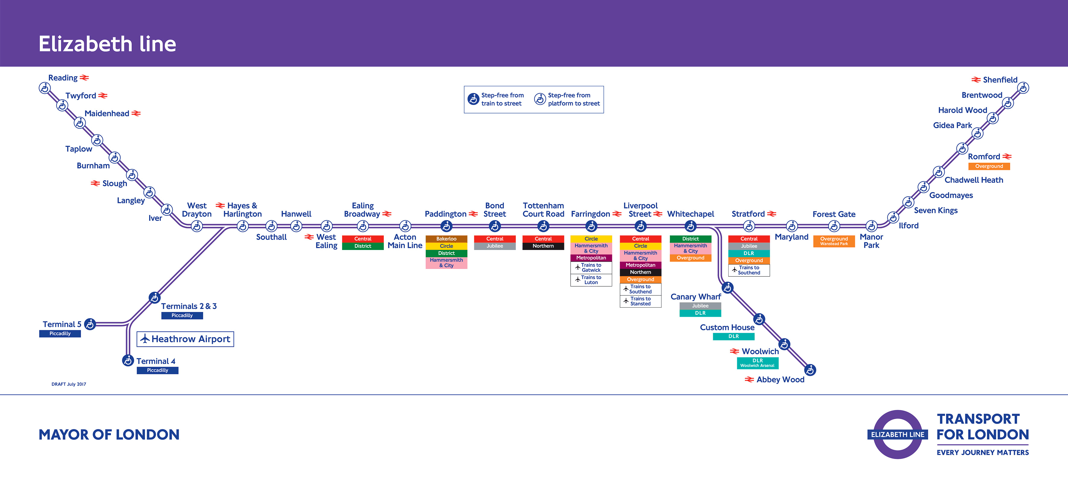
The Impact of Crossrail on the Travel and Tourism Industry in London

Ffion Merrick - P144697

Executive Summary

This report is an assessment on the likely impact of Crossrail on travel and tourism in London, with a case study of Emirates Airline cable car, using 2 strategic management models to provide a more in depth insight into investigation. Research and analysis was made through sources like books and government official websites.

The findings presented show that Crossrail, despite being such a big and time consuming project for London, will provide more benefits that drawbacks, by providing a more quicker, efficient, available service along side the current Underground system, as well as providing more business spaces for new businesses to grow into, or current businesses to expand into. Crossrail allows tourists to visit more places with more stations added onto the line along with the current 40 stations in place, plus renovations made to the current stations, the whole project appears to regenerate London as a more efficient and modern travel and tourism destination. As a result, it is expected that Crossrail will help alleviate the current transport strains placed on London, and provide a better, faster service.

Contents Page

1.0 Introduction Pg4

2.0 Findings Pg5
2.1 Transport and Tourism in London with Crossrail Pg5
2.2 Transport and Tourism - Models Pg6
2.3 Case Study - Emirates Airline Cable Car Pg9
2.4 Case Study - Models Pg9

3.0 Conclusion Pg12

4.0 References Pg13

1.0 Introduction

This report has been conducted to assess the likely impact of Crossrail on travel and tourism in London and Emirates Airline cable car, using 2 strategic management models for a more in depth assessment. Crossrail is a new rail system running from Reading to Shenfield through London, and will be called the Elizabeth Line. It was built to increase capacity to the City’s transport system. Research made in this investigation came from a variety of sources, including books and official government websites. This report looks into Crossrail, travel and transport in London, tourism in London and Emirates Airline cable cars based in North Greenwich, with also a look into 2 strategic management models for a more in depth look into how Crossrail affects travel and tourism in London, and Emirates Airline cable cars. These models are Porter’s 5 Forces model and VRIO model.

2.0 Findings

2.1 Transport and Tourism in London with Crossrail

London is becoming a booming tourism destination. In 2016, around 4 million inbound overseas visitors came to London, holiday and visiting friends and relatives visits rose to 1.8 million and 1.3 million visits, with over 2.4 million EU visitors, 480,000 visitors from North America, and 770,000 visitors from the rest of Europe. Fluctuation of exchange rates due to political uncertainty could have affected both tourism numbers and the production of the new Crossrail line over the past year, however, tourism still continues to increase despite this (visitbritain.org, 2017). With these kinds of statistics it is clear that as London’s tourism grows, so does it’s transport infrastructure, which is where Crossrail comes in.

Cross rail is a new rail system running from Reading to Shenfield, which was designed to increase the capacity of London’s transport system. This new line will be called the Elizabeth Line, on behalf of the Queen (Eleftherious-Smith, 2016). The new line will provide a direct route between all the main employment areas in London, from Heathrow to Paddington, to the West End, the City and Canary Wharf, with the aim to relieve congestion, reduce journey times and support jobs. Construction on the project starting in 2009, with major upgrades of stations and tunnels, plus the existing rail network between 2015 and 2017. The first service is aim to run in late 2018, and by late 2019 the whole line is due to be fully operational.

Farringdon station has become on of the busiest stations in Britain, with the potential to reach demand of 27 million passengers a year. It is because of statistics like this that fuelled the production of a project like Crossrail, to simply relieve the pressure of the current transport system. It is predicted that going from Heathrow airport to City of London on Liverpool Street will go from taking 55 minutes to 35 minutes and by making London more accessible, they are opening London up to many more employment opportunities for people. (City of London, 2015)

A lot of the short term economic impacts of Crossrail are the increased number of jobs that it will provide the city, but also the jobs provided for the project itself. This boosts the economy for Britain which as a result will positively affect the tourism industry. With the aim to improve transport links between employment area like Heathrow and The City, the West End and Canary Wharf, its not just for business people, these improvements made will also boost transport links between tourism attractions in and around London, meaning places will become more accessible for tourists to travel around and potentially go to new places they haven’t been able to go to or access before, but also allows new tourism businesses to open up around the new crossrail line to boost tourism in London.

The additional transport service crossrail provides will help relieve some of the pressures London’s current transport system has with the increase in tourism and business visitors. Without the crossrail system in place to help, the potential impact that the current transport could have on day-to-day life in London could be major for example, Oxford Economics Forecasting estimate that by 2016 the transport constraint would have reduced employment within the West End, the City of London and the Isle of Dogs by 10,000, and by 2027 central area employment would be reduced by 23,000 without crossrail. (City of London, 2015)

2.2 Travel and Tourism in London with Crossrail - with Strategic Management Models.

Porter’s 5 Forces model

Porter’s 5 Forces Model investigates the competitive environment in a particular industry. It relates a company to it’s environment, and depending on the strength of each force, determines the profit potential of each sub-industry for example tour operator, theme park and so on. (Vanhove, 2010). Porter’s model consists of 5 forces;

Competitive Rivalry

Threat of Entry

Threat of Substitutes

Bargaining Power of Buyers

Bargaining Power of Suppliers

Competitive Rivalry

London is a very large tourism industry, meaning supply power may be low, and the presence of crossrail may change that. Because of crossrail, any property’s close to a station connected to crossrail route, the cost of purchasing and maintaining it will be high, so if an already present business is there, it all depends on if the cost affects them, as it may be a driver to a reduction of competitors. But then again, the opening of the crossrail route may bring in more competitors if it allows them to be more accessible to customers. Plus, for the tourism industry, a lot of things can be purchased online.

Threat of Entry

With crossrail, the threat of new businesses in the tourism industry in London is high, as more business space will be opened up for new businesses to come into the market. However the estate price and general prices in London will be high, giving any new business a difficult entry barrier to move past, so starting up the business from the beginning may be difficult for some, although, if the business is fully established and is simply expanding into a new area it may be more sustainable for them to start in London along the crossrail route, as crossrail will bring more people, which in itself is good brand recognition for a new business in the tourism industry.

Threat of Substitutes

There is a high threat of substitutes in the tourism industry in London, especially when a new transport system is close to being opened which will bring in more potential customers/businesses to provide an alternative service in the industry.

Bargaining Power of Buyers

Buyers are a lot more independent when they purchase a product or service, they seek out the information and the service or product themselves, instead of waiting for an advertisement to attract them to it. So bargaining power in London in regards to tourism is high, because they can research prior and if needs be visit a specific place in London - via crossrail - and not have to visit a number of places by a variety of modes of transport.

Bargaining Power of Suppliers

Due to London being such an integral part of the tourism industry of Britain, there are many suppliers in and outside London. As a result there is low bargaining power from the suppliers, because quiet often there are other suppliers who can provide the same service for a potentially cheaper price. The effect crossrail has on this is providing more connection between business and supplier, with quick and more accessible links.

VRIO

VRIO stands for Value, Rarity, Inimitability and Organisational support. Barney and Hesterly (2006) as cited in O’Meara et al (2013) proposed the VRIO model as a means of analysing the usefulness of an asset or part of a business.

Value - its a valuable system that will be used by many people in London, to ease congestion on the London Underground and on other modes of transport. They have seen the opportunity for a better and another transport link for people to get around London. They have been clever by using current open stations and as a result do not have to build many new ones. It is a value to customers because it is a quicker service than the current underground system, and it may also mean more travel space in the carriages, because not everyone will be rushing to use one underground system. Despite the large cost to make crossrail happen, it will most likely make a return and some for the British economy.

Rarity - Its a fast service, which is rare for transport in London, as most journeys, regardless of the mode of transport, seem to be time consuming. It is uncertain how much more efficient the service will be until it opens.

Inimitability - Will be difficult to imitate because of the cost of the project and how big the project is, how much space and resources is required in order for it to be imitated.

Organisational support - A lot of organisational support from the government, Transport for London, the partners whom helped create crossrail, the public (the people who will benefit from the project).

Case Study - Emirates Airline Cable Car

Based in North Greenwich, Emirates Airline Cable Car is London’s only cable car service. It’s unique location is a ‘bustling tourist spot’ along the Thames, with its nearest tube station being North Greenwich / Royal Victoria (DLR), and its closest crossrail stop being Canary Wharf, it won’t take long to travel to. Emirates cable car have done a deal with the Underground system, that if tourists purchase a visitor oyster card, they can get up to 26% discount on their ride.

Porter’s 5 Force

Threat of new entry - It is the only cable car system in London. There is a potential threat of newcomers because there are so few services like Emirates Airline cable car. It would be a relatively difficult market to enter and compete in because of the difficulty of acquiring the space, regulations, government approval, plus then building such a thing requires a lot of time and resources.

Buyer Power - There is power in a sense that tourists are the key market for the cable car service, so if people have had a bad experience of service, its more likely to affect other people and if they turn up or not because word of mouth and social media have a major impact on other people.

Threat of substitution - Some substitutes could be other modes of transport, for example buses, trains, the underground, bike, car, and including the new crossrail. The one unique aspect the cable car has is the views over the Thames, whereas any other mode of transport around London would just have views of traffic.

Supplier power - There are few suppliers that could provide materials required for the cable car service because it is the only one in London. Because of this supplier power will be high, meaning whatever they do will have a huge influence on the cable car service, how it works, and if it would work. This may also mean because there are few suppliers, the cost of resources will be high.

Competitive rivalry - There are few cable car specific competitors in London, being emirates the only cable car company working the service in London. But in general transport terms, there is a lot of competitors to transport people from one area of London to another, including crossrail. Crossrail's’ expected quicker travel times compete with the cable car in that aspect, however the experience, although faster, may not be the same because of other factors like views of London, because Crossrail is underground.

VRIO

Value - The service is valuable to London’s transport and tourism industry because it is the only one of its kind in London, so it is a unique mode of transport for tourists and businesses/everyday people to use. However in comparison to crossrail, crossrail is also unique in that it has or promises quick travel times, and nice carriages (because of how new the service is), but there are not many other services that can provide the same kind of service as the cable car does.

Rare - It is rare because it is the only cable car company in London, but it isn’t a temporary service, so there is a chance of another company doing a similar service in the future.

Inimitability - This cable car service is hard to imitate because of the nature of the service, being that it is suspended up above the Thames.

Organisational support - The cable car company would have support from many people, including the government, transport for London, the O2 arena in Greenwich.

3.0 Conclusion

This report aimed to assess the likely impact Crossrail will have on the travel and tourism industry in London, with a case study of Emirates Air Line Cable Car. Crossrail is most likely to have a positive impact on London’s travel and tourism industry due to the reduction in travel times and the increased number of services available. By building 10 more stations, this allows for more stops and places to go for tourists, plus more business opportunities.

4.0 References

Eleftherious-Smith, L. 2016. Independent. ‘Elizabeth Line: When will the new Crossrail line open, where does it stop and how many passengers will it take?’. Online. Accessed: 21.11.17. http://www.independent.co.uk/news/uk/home-news/elizabeth-line-when-will-the-new-crossrail-line-open-where-does-it-run-and-how-many-passengers-will-a6891406.html

Fenech C, Perkins B. 2014. A Deloitte insight report. Published - Deloitte LLP - London. Online. Accessed: 18.11.17 https://www2.deloitte.com/content/dam/Deloitte/uk/Documents/consumer-business/consumer-review-8-the-growing-power-of-consumers.pdf

Horsfield, G, 2017. Office for National Statistics. ‘Travel Trends’. London, England article - Travel Trends 2016. Publisher - London Stationary Office.

No Author. City of London - April 2015. ‘The Impact of Crossrail - Secondary research briefing paper’. Online. Accessed 18.11.17. https://www.cityoflondon.gov.uk/business/economic-research-and-information/research-publications/Documents/research-2015/Impact-of-Crossrail-briefing-paper.pdf

No Author. 2017. Online. Acc: 21.11.17 Transport for London. ’The Emirates Air Line Experience’. https://tfl.gov.uk/modes/emirates-air-line/the-emirates-air-line-experience?intcmp=1445

O’Ceallaigh, J. 2017. ‘London’s tourism industry counts cost of latest terrorist attack’. The Telegraph - Travel. http://www.telegraph.co.uk/travel/destinations/europe/united-kingdom/england/london/articles/london-terrorist-attack-city-travel-tourism-industry/ Online. Accessed: 11.11.17

O’Meara B, Petzall S. 2013. ‘The handbook of strategic recruitment and selection a systems approach’. Publisher: Bradford: Emerald Group Publishing Limited.

Vanhove N. 2010. ‘The Economics of Tourism Destinations’. Publisher: Hoboken: Taylor and Francis.

No Author. 2017. Visit Britain. Online. Accessed:17.11.17 https://www.visitbritain.org/sites/default/files/vb-corporate/Documents-Library/documents/august_2017_ips_summary.pdf

No Author, November 2017. ’Latest Monthly Data’. Visit Britain. Online. Accessed : 17.11.17. https://www.visitbritain.org/latest-monthly-data

