Contents
Introduction 2
E-Commerce Infrastructure 2
Hardware 2
Software 2
Recommendation 3
Technologies used for E-Commerce Solutions 3
Software Suites 3
Online E-Commerce Builder 3
Methods of E-Commerce Transactions – Electronic Payment Systems 4
Credit Card 4
Cryptocurrency 5
PayPal 5
Marketing Metrics 5
Unique Visitors 5
Webpage Views 6
Appendix 7
Bibliography 11

Introduction
Plumrite is a small plumbing company that focusses on working on plumbing problems at the customers’ house. The information was all kept in a paper format and therefore was prone to losing some pieces of work. So, the purpose of creating an e-commerce solution is to allow the company to take online transactions, i.e. selling services, and to allow the company to make appointments without losing the information. The main point being the selling of a service; which works with the overall definition of e-commerce [1] as there will be the selling of an item; a plumber going to a customer’s house.
The purpose of an e-commerce solution is to buy and/or sell goods and/or services over the internet/network [2]. The consumers of the services and/or goods will either be businesses or people; this will make the website change the way in which the information for each product will be represented [3]. In the case of Plumrite there will be the selling of goods and/or services to both customers and business; this will mean that the e-commerce solution will have to have both aspects of B2C and B2B e-commerce. These will, of course, share the same principles; monetary transactions, product catalogue, product descriptions, product prices and product images but they will be presented differently depending on a B2C or B2B.

E-Commerce Infrastructure
An e-commerce infrastructure will share the same two main pillars, no matter what the e-commerce solution is showing. These two main points are a hardware component [4] and a software component; these are all the items needed for an infrastructure but will differ depending on the scale and overall cost of the e-commerce solution – there will be the same core pieces of hardware and software for any e-commerce infrastructure. These three points all provide a much needed task for the e-commerce solution and will, in turn, run the e-commerce solution.

Hardware
The hardware of an e-commerce solution will be the same when it comes to any form of e-commerce. These hardware solutions are mainly going to be a server(s), encryption device(s) and a physical firewall(s). These pieces of hardware will be used to make sure that the information, i.e. stored credit card details and/or customer information, on the e-commerce solution is kept safe and secure; the encryption devices and firewall will stop any unauthorised access to the information and the servers will allow the information to be stored in a more secure manner than if the e-commerce solution were to be held on a USB drive [5].

Software
The software of an e-commerce solution will be different depending on the type of e-commerce solution. An example of some of the software that will be used in an e-commerce infrastructure would be a content management system, database servers and web analytics. The content management system is a piece of software that shows what the user can access on the e-commerce solution, i.e. what products can be bought and hide the products that are out of stock. The database server will hold the customer information within [6], i.e. the customer information would be credit card details (if the client chose to save them on the site), the name and address of the user. The web analytical software will allow the creator to see how the website is performing on the web, i.e. how many hits the website is getting and how it compares to other solutions.

Recommendation
Depending on if the user wants to physically create their e-commerce solution, this being with code and not an online builder, then the recommended e-commerce infrastructure would generally be to buy a server, PCs, Monitors, Keyboards, Mice, Encryption and Firewalls. This is because they will have to physically contain all the information from the e-commerce solution. This is also the same with the software; the user will have to physically purchase all the software and utilise it within the e-commerce solution – this does make this option more expensive and therefore not the best for an SME.
On the other hand, if the user wants to take the easier route and build the e-commerce solution on an online e-commerce builder then all the hardware and software will be provided for them. This means that this option is a lot cheaper and will take less time to make and implement the e-commerce solution; this option is arguably better for an SME.

Technologies used for E-Commerce Solutions
There are a multitude of technologies for building an e-commerce solution [7]. These technologies generally involve pieces of hardware and software, as have been mentioned previously. There are suites available that allow the user to create an e-commerce solution. A different method would be to use an online e-commerce builder, such as SquareSpace. Software suites and an online e-commerce builder can co-exist; an example of this would be Shopify. Shopify sells a package of software to help monitor the e-commerce store.

Software Suites
An e-commerce software suite is a package of software based around the analytical side of the e-commerce store. This would generally include software to help track of the store, and would include analytical features such as a way of measuring the amount of profit gained or the amount of hits that the e-commerce store has had.
One type of suite would be the Shopify suite. This suite has most of the tools needed by someone with an e-commerce solution [8]. This includes features such as measuring the profits of the store, the amount of hits that the store has had, where the customers are from and an interface for updating the e-commerce store. A different type of software suite would be a package like Adobe Dreamweaver [9]; this package deal allows the user to create a website from scratch with the use of HTML and CSS. There are also options for monitoring the performance of the website, i.e. load times, amount of hits and overall speed of the website etc.
The advantages of using a suite over an e-commerce builder is that all the features will be told before you purchase the suite [10]. Comparing this to the e-commerce builder where the user does not know what tools, if any, are available – this also factors in if the e-commerce builder is free or not, as the user would more than likely have to pay for these types of tools at a more expensive rate than compared to just purchasing the suite.

Online E-Commerce Builder
An online e-commerce builder is a piece of software that has the capabilities of a content management system, which means that it basically has a product page and it also holds a hosting service. This means that the e-commerce solution will be hosted by the company and not the user [11].
There are different types of e-commerce builder; most of them double up as a website builder as well. The variations would include SquareSpace, Weebly, Amazon Store Front and many more. There are different types like cloud based, open source and fully hosted.
An online e-commerce solution, like SquareSpace will have all the capabilities of showing a product, the details of the product; including the price, name and stock, while still maintaining the hosting side. There are advantages and disadvantages to this type of technology. An example of an advantage would be that there is little, to no, coding knowledge required but a simple drag and drop mechanic is used instead. This being an advantage because it allows the user to create a professional looking e-commerce store with little to no effort and no coding knowledge is going to be needed. The disadvantages to this type of e-commerce builder would be that they can be pricey and SquareSpace is a good example of this. SquareSpace when compared to other options, such as Wix or Weebly, is rather expensive and that does not help an SME. The prices can range from around £20/month to £200/month depending on the type of facilities the user would want on the e-commerce store.

Methods of E-Commerce Transactions – Electronic Payment Systems
An electronic payment is defined as “The definition of an electronic payment system is a way of paying for a goods or services electronically, instead of using cash or a check, in person or by mail.” [12] by yourdictionary.com.
There are different methods of payment when it comes to an e-commerce store. There are the more common variants, i.e. using a credit card and/or PayPal and then there are the less common variants, i.e. the use of cryptocurrency; for example the use of Bitcoin or Etherium [13]. Also the use of cheques can be used and gift cards can also be used – but this depends on the e-commerce store.

Credit Card
The use of credit cards on an e-commerce store is the most common form of payment. This is because it is really simplistic to implement in most stores and is simple for the customer to pay. All banks allow the use of their clients to use their credit cards on an e-commerce solution, so this means that anyone with a credit card can pay for something online [14].
This works by the customer entering in their credit card information and then the information gets encrypted by 40bit SSL via the browser and then 128bit SSL by the banks – the customer will then be informed of the purchase and then the purchase is completed [15].
The use of credit cards can have a downside, as if there is a stolen credit card being used then there is no way of knowing and the thief will not be prompted to use a PIN number. This being a disadvantage because the thief will only need the CC details and they are readily available on the card.

Cryptocurrency
Cryptocurrency is a recent phenomenon when it comes to e-payement. E-commerce sites are only recently allowing the use of payment via cryptocurrency, mainly Bitcoin. This is mainly to do with the fact that most people do not own any cryptocurrency, as most people do not really have a firm understanding of how it works. Cryptocurrency works by cryptography to exchange amount of the currency to real currency [16].
Using Bitcoin as an example to show how Cryptocurrency works; one bitcoin is worth approximately £6700, but these changes all the time [17]. As Bitcoin is expensive most e-commerce sites will elect to use 0.001 Bitcoin instead of a whole one.
The advantage of using any form of cryptocurrency is that it cannot be stolen by any conventional means. This means that a thief cannot break into a house and steal one bitcoin. This being an advantage because it makes the cryptocurrency a more secure form of currency, cryptocurrency does, however, has drawbacks. A drawback being that it cannot be used in physical stores and/or the owner cannot withdraw cryptocurrency from the bank [18].

PayPal
The use of PayPal is a fairly new method of e-Payment, but is widely used around the world. PayPal is mostly included as a payment option with most e-commerce stores as it is a secure way of the customer entering their details onto the internet, as there is a lot of encryption for the user [19].
The use of PayPal is generally the same as using a credit card, as the customer’s credit card information will still be encrypted during the purchase, but by using PayPal there is another level of security. This level of security is another 128bit SSL encryption by PayPal.
If a person were to steal the credit card off someone then they would not be able to get into the PayPal account and therefore adds a layer of security in the physical sense. Most people will, however, use their Facebook profile or will keep their details saved; this means that if someone were to gain access to a victim Facebook account then there is chance of the PayPal account being accessed.

Marketing Metrics
Marketing Metrics are the features that allow the owner of an e-commerce store to see how progress is being made. This can be in the form of various graphs and statistics or in the form of a report [20].
The main types of marketing metrics are going to be how many unique visitors have visited the website and how many views a web page has had [21]. All of these need to be analysed to see how well the website has been doing.

Unique Visitors
The amount of unique visitors is important for the e-commerce store for a multitude of reasons. An example of one reason would be to see how well the store is doing in terms of attracting new people. This being an advantage because new people coming in can mean that the store will need to expand the overall bandwidth of the site, so the store does not slow down with more traffic [22].
Having more unique visitors is a main staple of any e-commerce store as a store always needs new people to come and visit. This also helps to understand the customer and what they want on the store. This, therefore, allows the changing of the products, if needed [23].

Webpage Views
The amount of webpage views correlates with the amount of unique and non-unique visitors there are coming to the webpage. This shows how many people are visiting the website in total; not just the amount of new visitors. Webpage views generally have the same actions that the unique visitors would, i.e. increasing bandwidth where needed.

Appendix
Appendix Number | Image
1 | 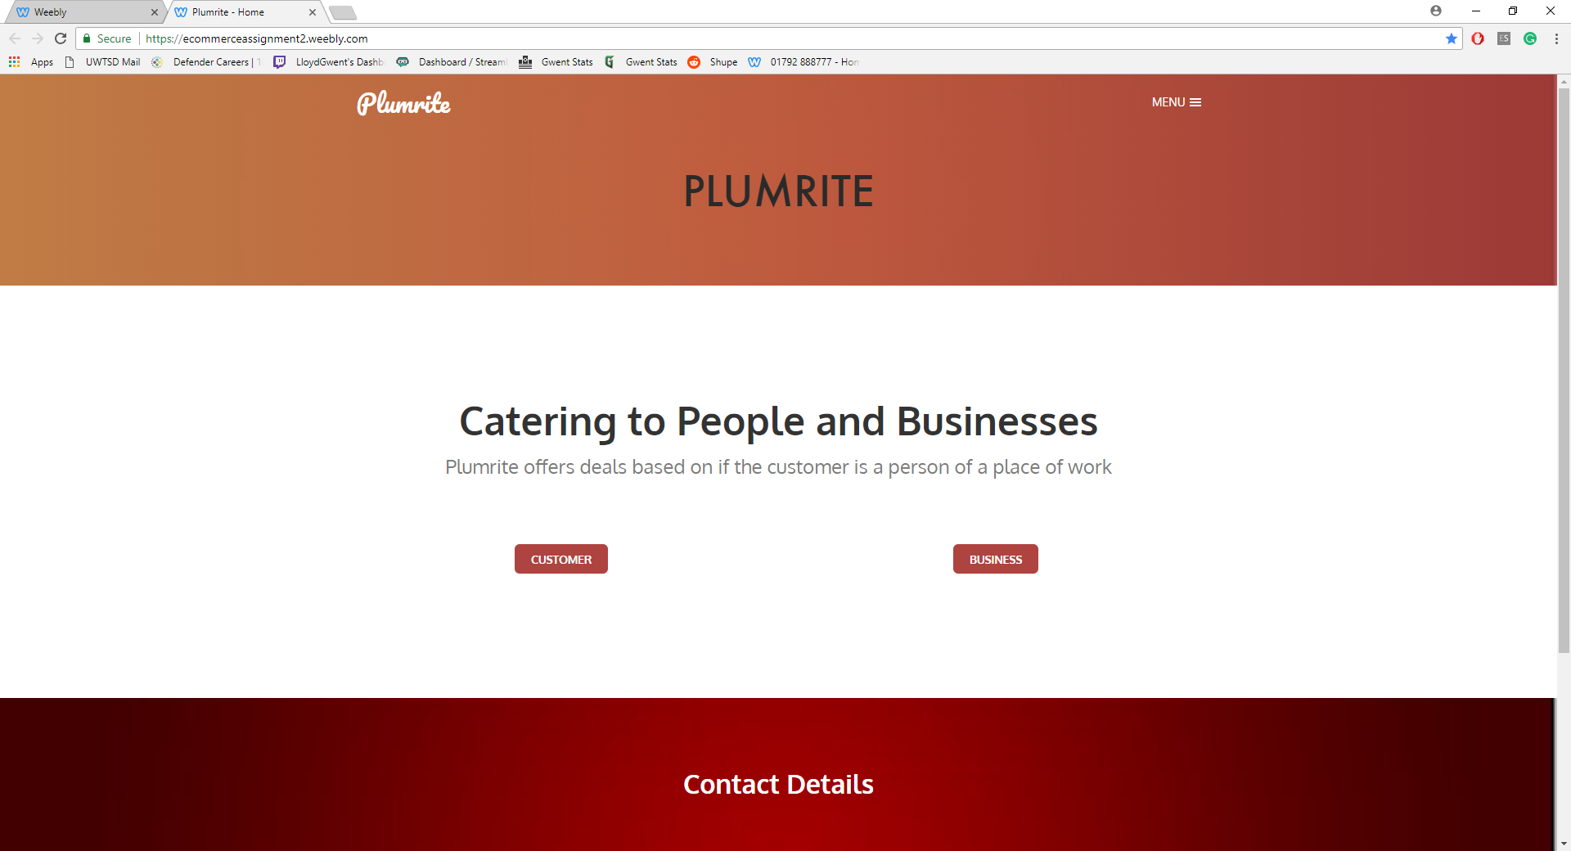
2 | 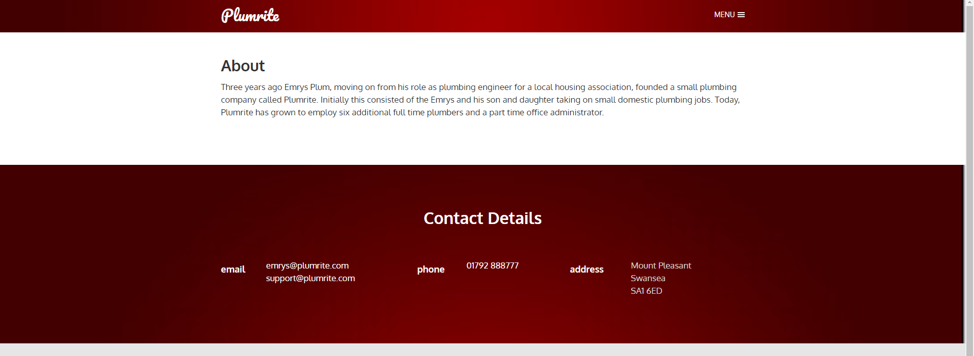
3 | 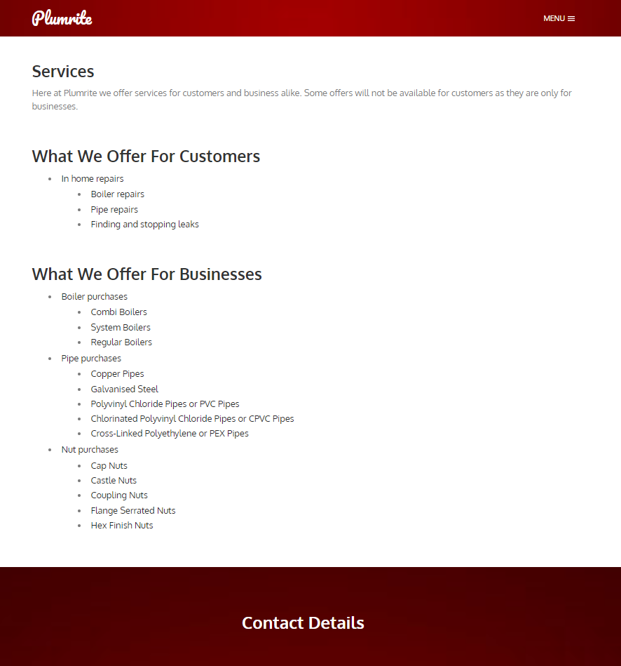
4 | 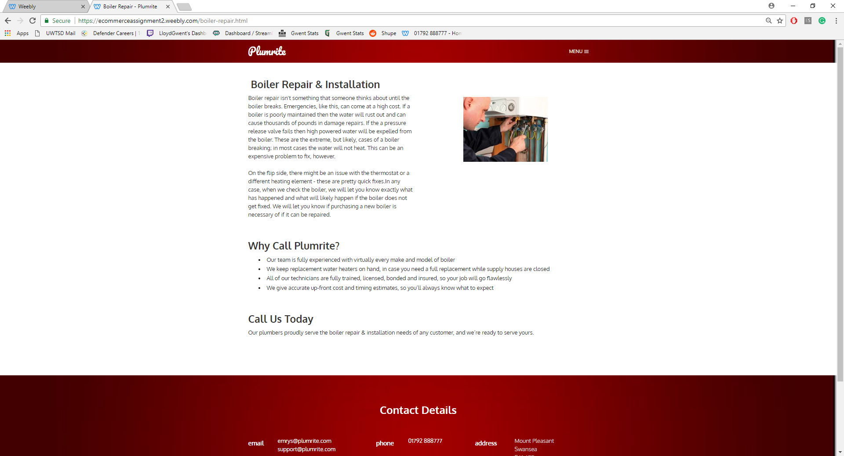
5 | 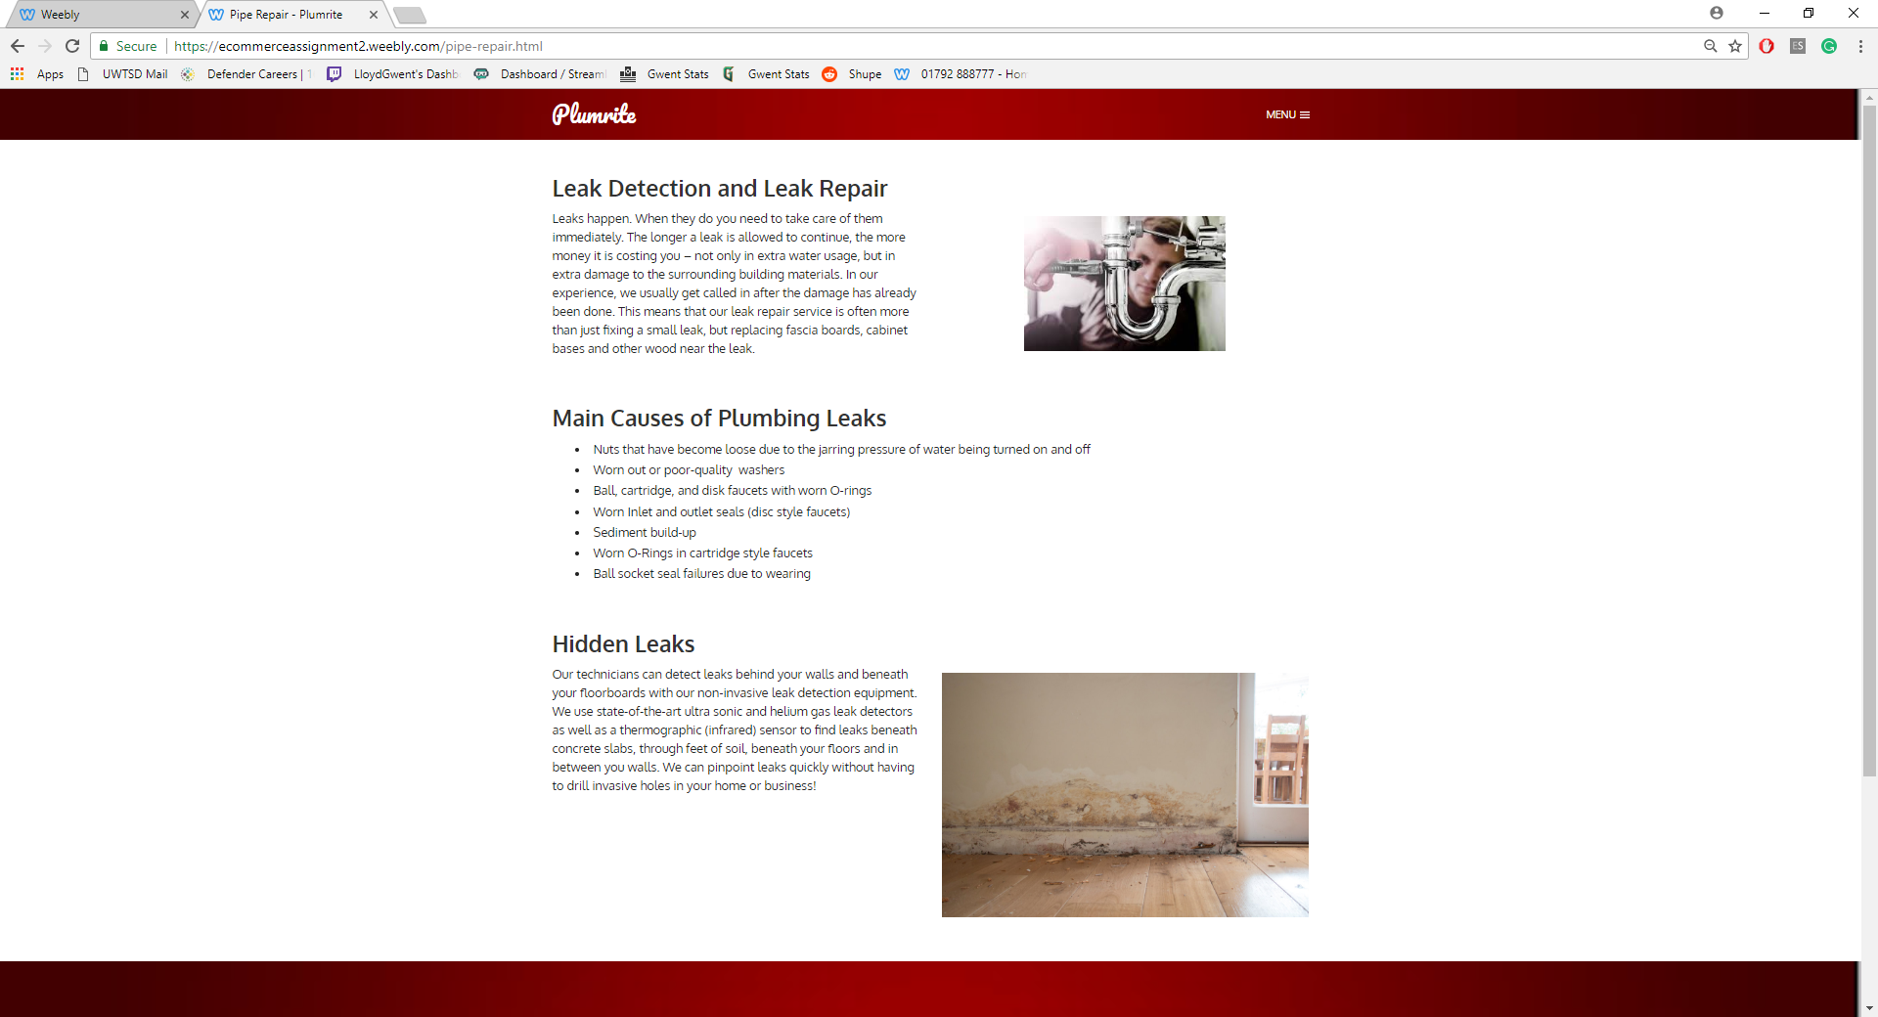
6 | 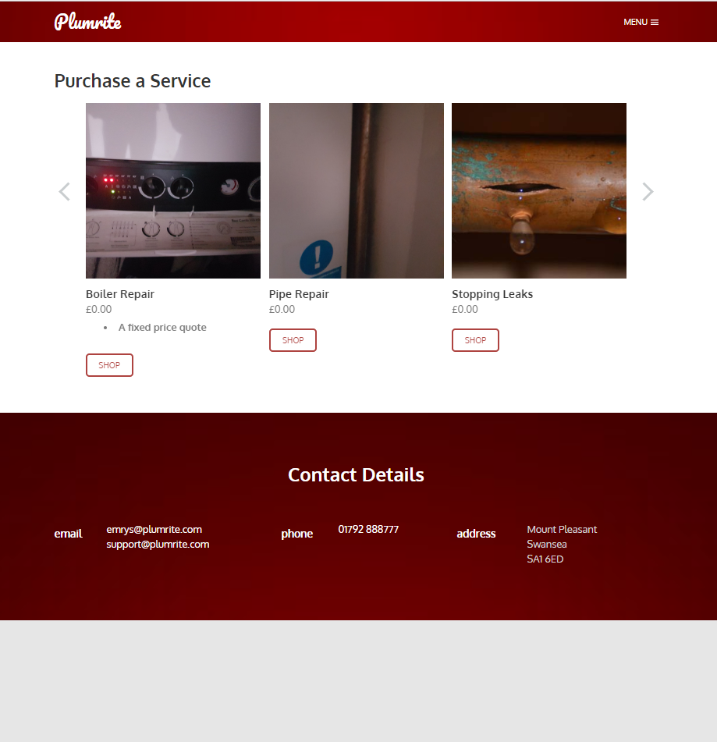
7 | 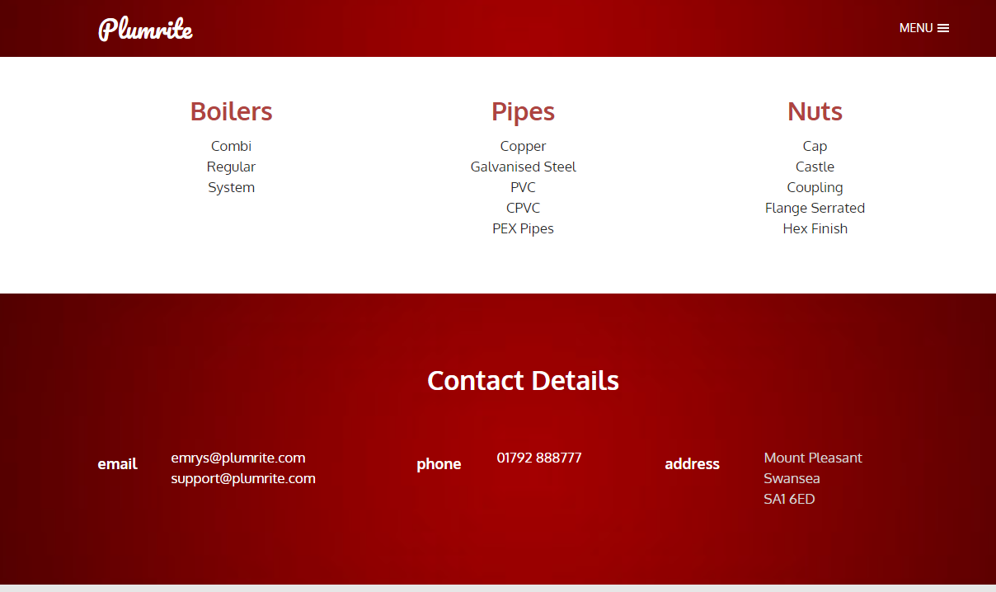
8 | 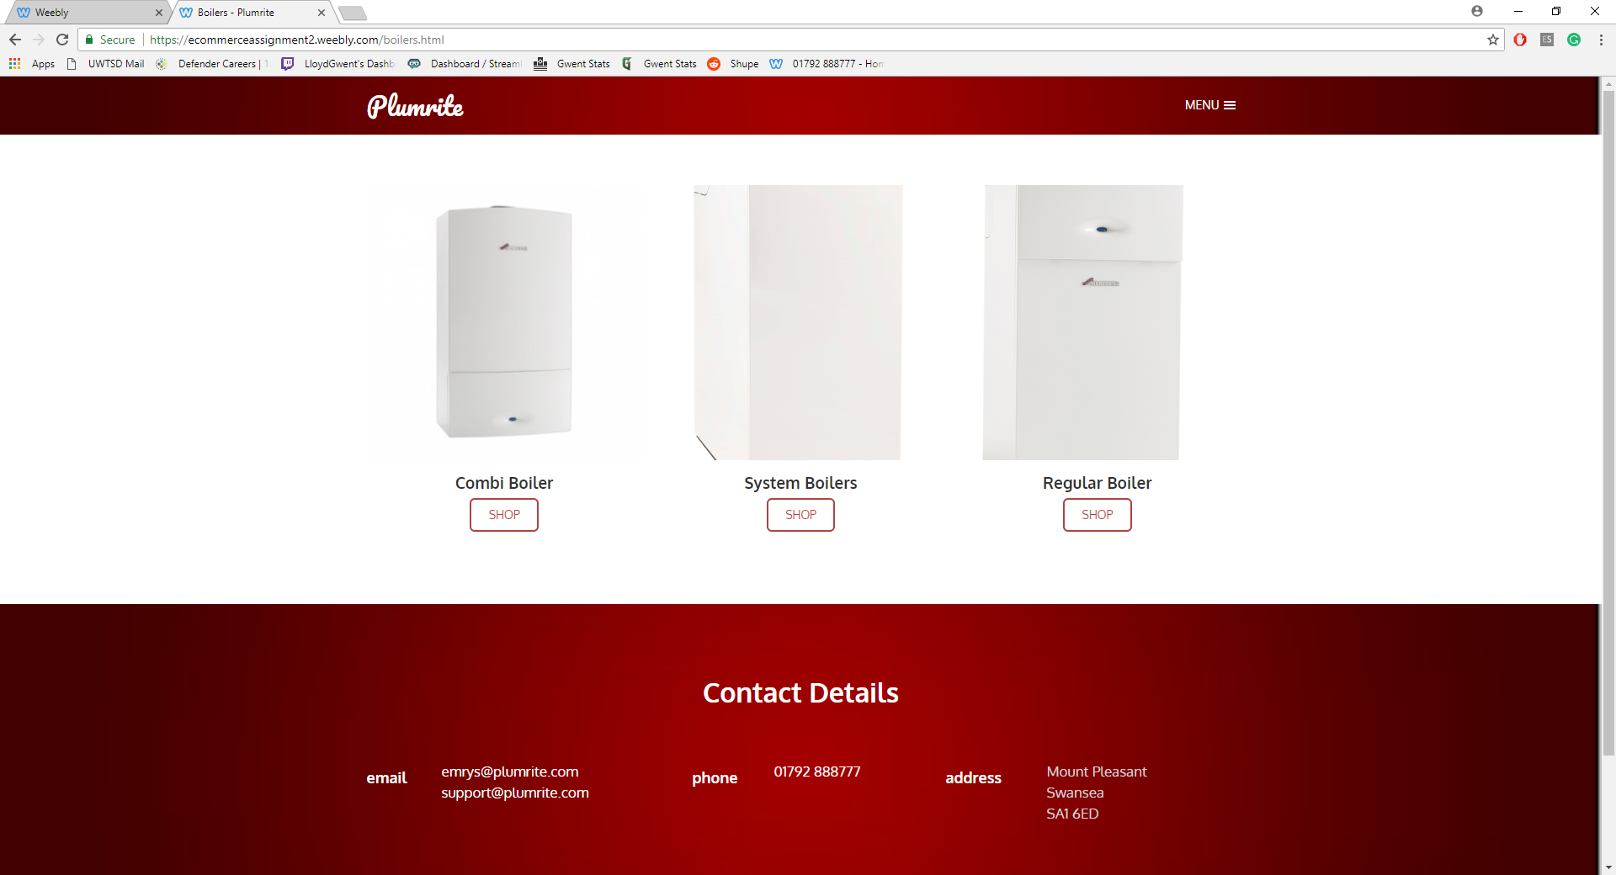
9 | 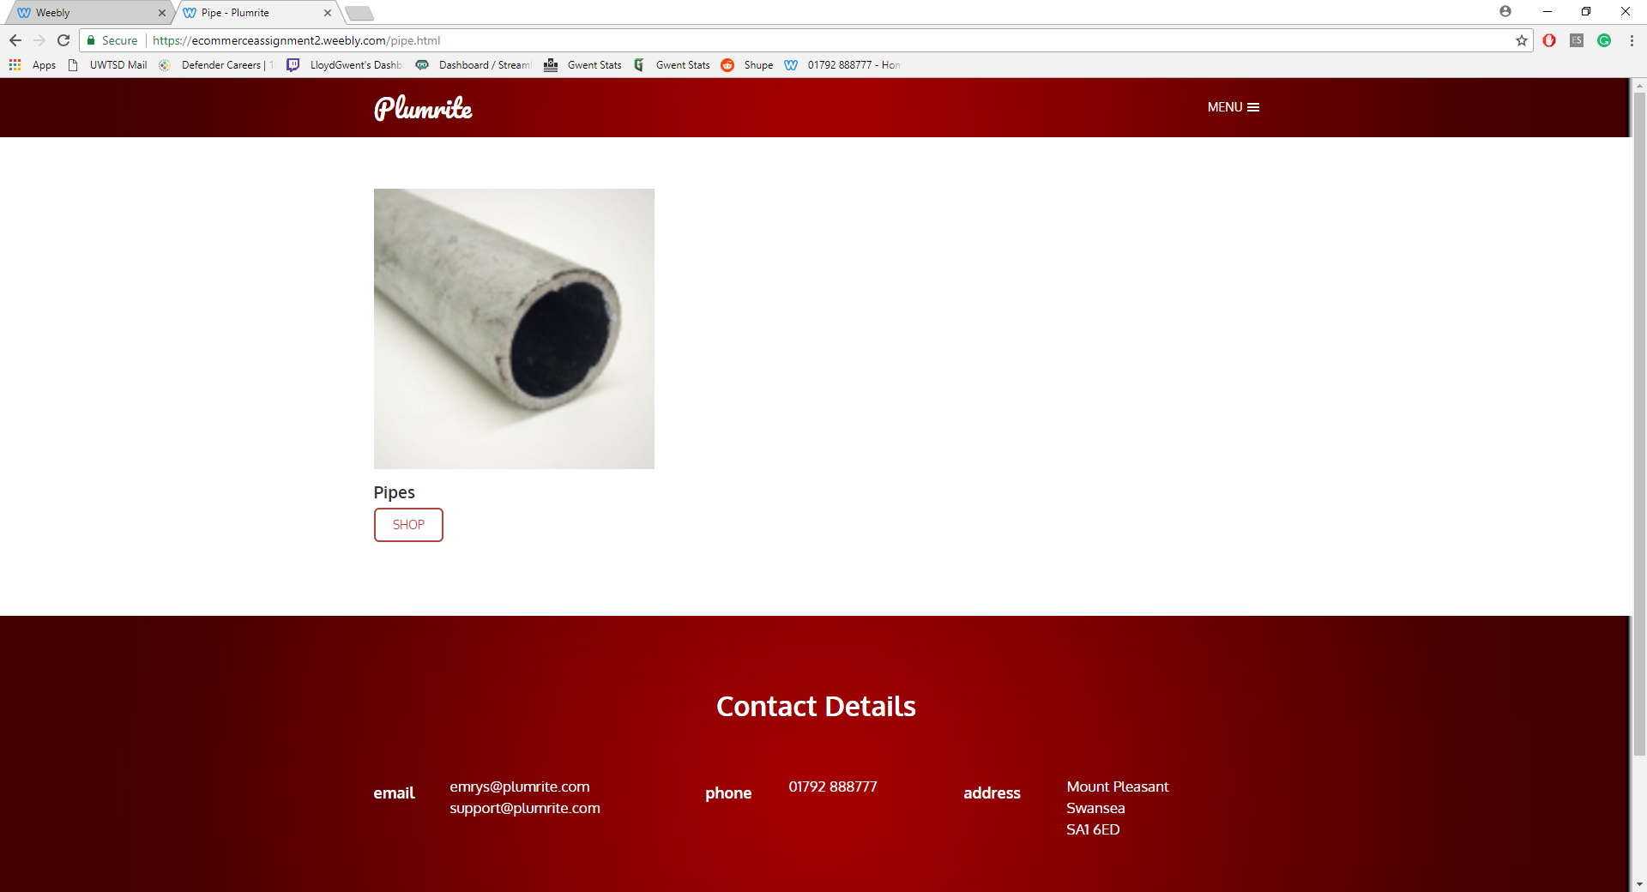
10 | 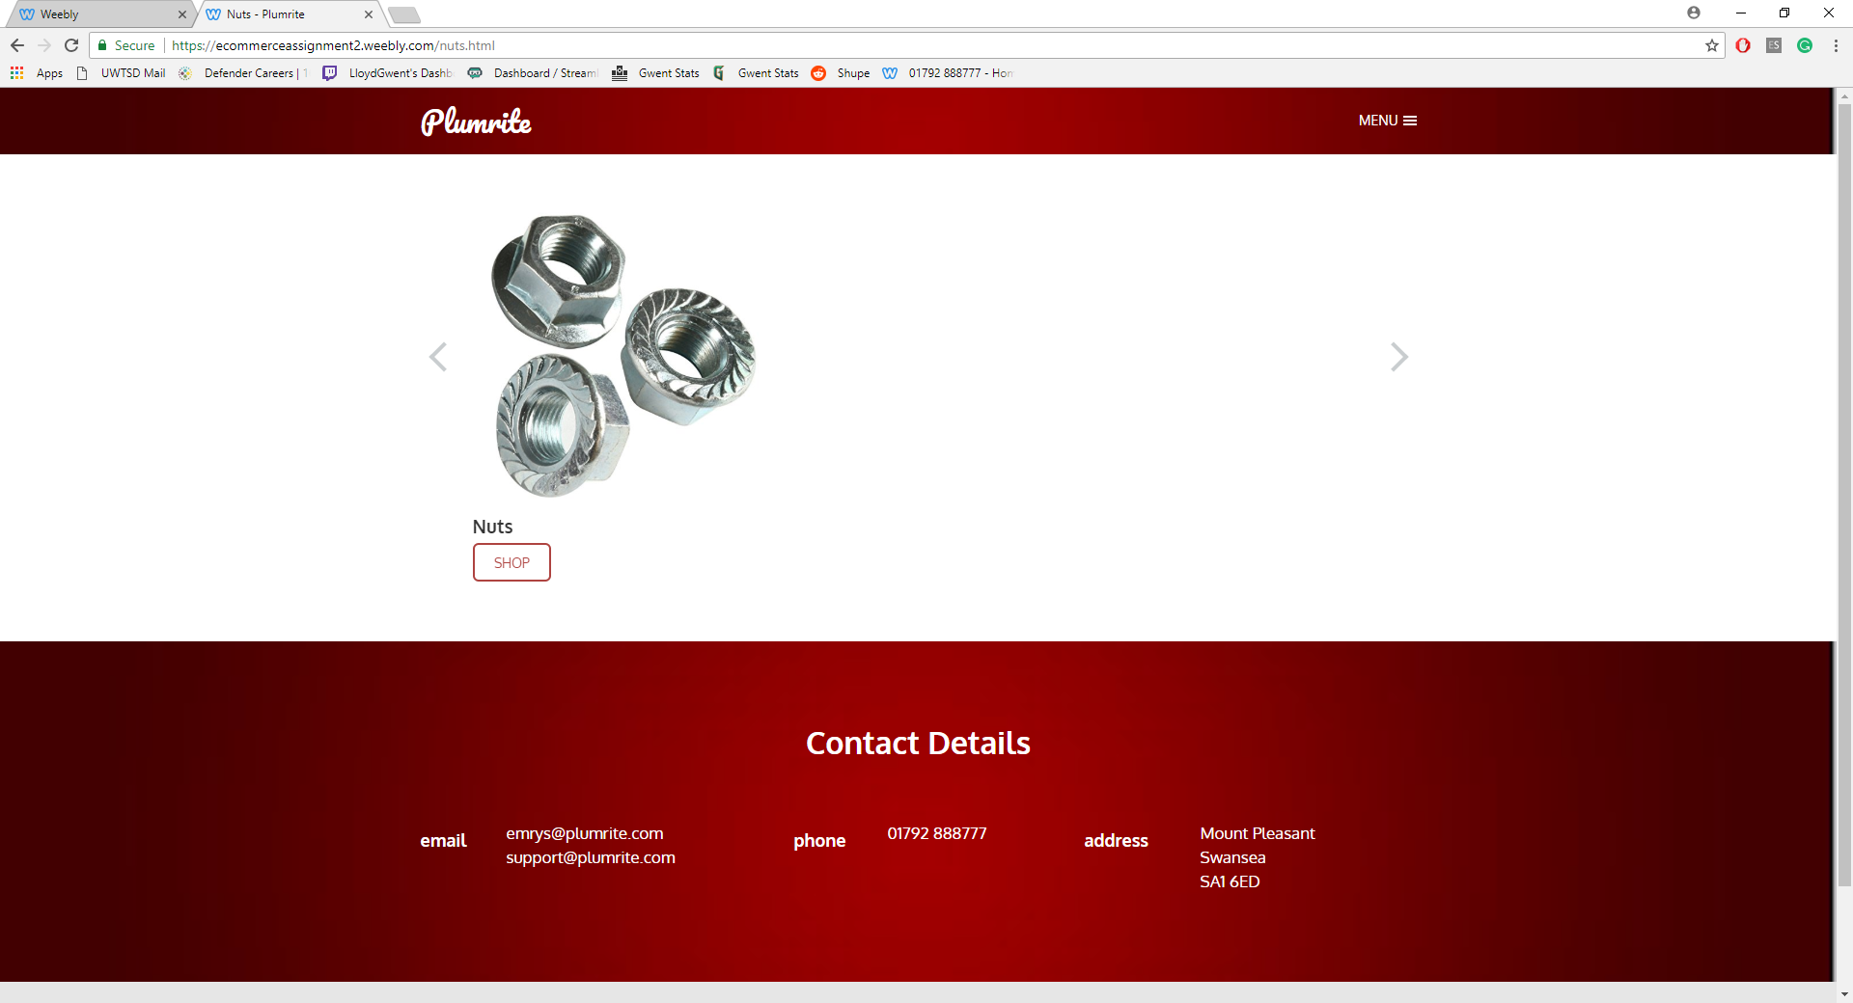
11 | 

Bibliography

[1] | R. A. K. P. Srini S.Srinivasan, “Customer loyalty in e-commerce: an exploration of its antecedents and consequences,” Journal of Retailing, vol. LXXVIII, no. 1, pp. 41-50, 2002.
[2] | quora, “What is the purpose of e-commerce websites?,” quora, [Online]. Available: https://www.quora.com/What-is-the-purpose-of-e-commerce-websites. [Accessed 10 March 2018].
[3] | I. Linton, “Differences Between B2C & B2B in Business Systems,” Chron, 26 March 2018. [Online]. Available: http://smallbusiness.chron.com/differences-between-b2c-b2b-business-systems-39922.html. [Accessed 27 March 2018].
[4] | quora, “What is E-Commerce Infrastructure,” quora, [Online]. Available: https://www.quora.com/What-is-the-E-commerce-infrastructure. [Accessed 20 March 2018].
[5] | W. H. D. a. E. R. McLean, “Measuring e-commerce success: applying the DeLone & McLean information systems success model”.
[6] | D. Gloag, “E-Commerce Infrastructure: Planning & Management,” study.com, [Online]. Available: https://study.com/academy/lesson/e-commerce-infrastructure-planning-management.html. [Accessed 20 March 2018].
[7] | corbus, “E-COMMERCE TECHNOLOGY SOLUTIONS,” corbus, [Online]. Available: http://www.corbus.com/ecommerce-technology-solutions. [Accessed 22 March 2018].
[8] | financesonline, “What is E-commerce Software? Analysis of Features, Benefits and Pricing,” financesonline, [Online]. Available: https://financesonline.com/e-commerce-software-analysis-features-benefits-pricing/. [Accessed 24 March 2018].
[9] | Fueled, “Is Dreamweaver a serious web design tool?,” creativebloq, 18 December 2015. [Online]. Available: https://www.creativebloq.com/adobe/dreamweaver-web-design-tool-121518352. [Accessed 20 March 2018].
[10] | business-software, “Benefits of Ecommerce Software,” business-software, [Online]. Available: https://www.business-software.com/article/benefits-of-ecommerce-software/. [Accessed 22 March 2018].
[11] | M. Macdonald, “How to Start An Ecommerce Business Without Spending Any Money,” shopify, [Online]. Available: https://www.shopify.com/blog/10580693-how-to-start-an-ecommerce-business-without-spending-any-money. [Accessed 28 March 2018].
[12] | yourdictionary, “electronic payment systems,” yourdictionary, [Online]. Available: http://www.yourdictionary.com/electronic-payment-systems. [Accessed 20 March 2018].
[13] | investopedia, “Cryptocurrency,” investopedia, [Online]. Available: https://www.investopedia.com/terms/c/cryptocurrency.asp. [Accessed 24 March 2018].
[14] | oxforddictionaries, “cryptocurrency,” oxforddictionaries, [Online]. Available: https://en.oxforddictionaries.com/definition/cryptocurrency. [Accessed 25 March 2018].
[15] | moneysupermarket, “Understanding Credit Card,” moneysupermarket, 22 February 2018. [Online]. Available: https://www.moneysupermarket.com/credit-cards/credit-card-guide/. [Accessed 27 March 2018].
[16] | A. Rosic, “What is Cryptocurrency: Everything You Need To Know [Ultimate Guide],” blockgeeks, 20 February 2017. [Online]. Available: https://blockgeeks.com/guides/what-is-cryptocurrency/. [Accessed 20 March 2018].
[17] | wikipedia, “Page semi-protected,” wikipedia, [Online]. Available: https://en.wikipedia.org/wiki/Bitcoin. [Accessed 28 March 2018].
[18] | A. Rosic, “7 Incredible Benefits Of Cryptocurrency,” huffingtonpost, 6 December 2017. [Online]. Available: https://www.huffingtonpost.com/ameer-rosic-/7-incredible-benefits-of-_1_b_13160110.html. [Accessed 29 March 2018].
[19] | paypal, “What is PayPal?,” Paypal, [Online]. Available: https://www.paypal.com/us/webapps/mpp/how-paypal-works/overview. [Accessed 29 March 2018].
[20] | klipfolio, “Marketing Metrics and KPIs,” klipfolio, [Online]. Available: https://www.klipfolio.com/resources/kpi-examples/marketing. [Accessed 29 March 2018].
[21] | K. Cain, “Measuring Marketing Effectiveness: 6 Metrics You Need to Track,” http://contentmarketinginstitute.com, 29 October 2012. [Online]. Available: http://contentmarketinginstitute.com/2012/10/measuring-marketing-effectiveness-metrics/. [Accessed 24 March 2018].
[22] | klipfolio, “Unique Visitors,” klipfolio, [Online]. Available: https://www.klipfolio.com/resources/kpi-examples/digital-marketing/unique-visitors. [Accessed 30 March 2018].
[23] | A. Summerall, “Marketing 101: What is a unique visitor?,” sherpablog.marketingsherpa.com, 27 October 2017. [Online]. Available: https://sherpablog.marketingsherpa.com/search-marketing/marketing-101-what-is-unique-visitor/. [Accessed 23 March 2018].

