DS Task 1
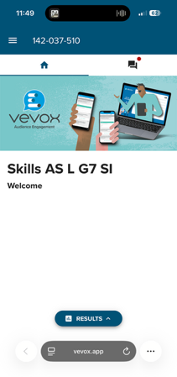

Vevox – used for educational purposes to engage students in a group discussion
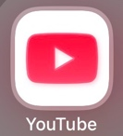
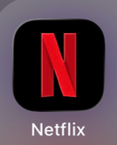
YouTube – watching educational videos and short clips

Netflix – watching movies and episodes
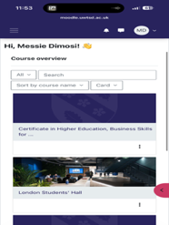
Moodle – helps you locate your timetable and able to pull up information about your task or assessment you’re doing.

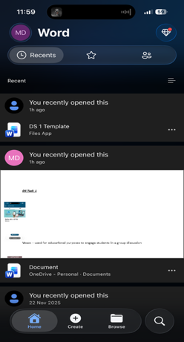
Microsoft word – used to complete my task and assessment

I would say my digital life is pretty standard. It has been a part of my everyday life for as long as I can remember, and I use technology in almost everything I do. Whether it’s communicating with friends through Snapchat or keeping up with what’s happening around the world on Instagram, digital technology plays a big role in my daily routine. I believe that without it, life would be much more difficult, as many important activities depend on technology, such as traveling, shopping, and staying connected with others. Overall, my digital life helps make everyday tasks easier and more convenient

