GIS Data Analysis

Contents
Table of Figures 1
Table of Tables 1
Introduction 2
Identification of Area of Interest 2
Data added to QGIS 3
Factors Affecting Machine Vision Processes 5

Table of Figures
Figure 1 - Google Streetview of Area of Interest 2
Figure 2 - Aerial Image of Area of Interest 2
Figure 3 - Photograph of Area of Interest 3
Figure 4 - Initial Layers 4
Figure 5 - LiDAR Colour Ramp 4
Figure 6 - Mine Images 4

Table of Tables
Table 1 - Mine Latitudes and Longitudes 4

Introduction
This report covers the creation of the GIS made following the practical assessment element of the Remote Sensing and Imaging module of the OME: Test & Evaluation course. The first part of the report details how the area of interest was identified. Next the evolution of the GIS is discussed and shown. The third section covers factors affecting the accuracy of the machine vision process.

Identification of Area of Interest
The first step was to enter the base layer of google street map onto the QGIS system (Figure 1). Once that was done, the area that the practical assessment was found, this was more easily visualised on google earth (Figure 2) as the imagery from google earth matched the imagery taken of the area during the experiment (Figure 3).

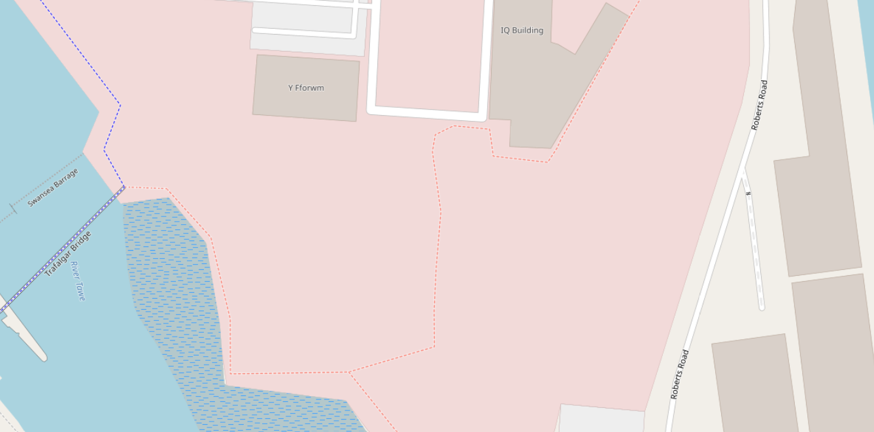
Figure 1 - Google Streetview of Area of Interest
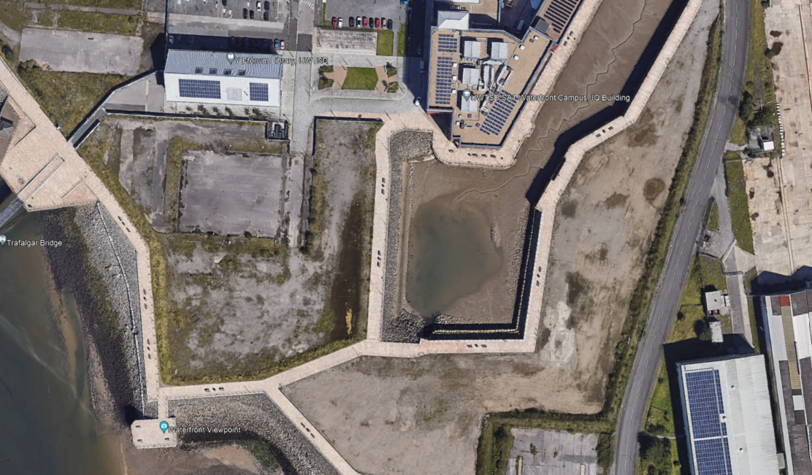
Figure 2 - Aerial Image of Area of Interest
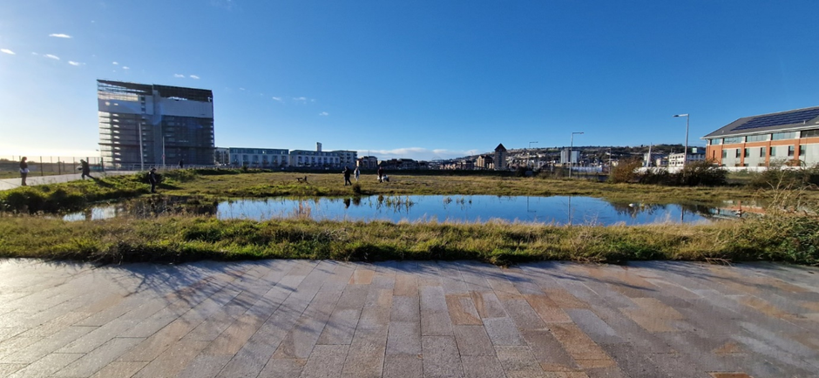
Figure 3 - Photograph of Area of Interest

Data added to QGIS
After the area of interest was identified, subsequent layers were then added on top of the google maps layer. All data entered onto QGIS had to have standard Co-ordinate Reference System (CRS) assigned to it, so that each layer would sit perfectly on top of the layer below it. The standard CRS chosen was EPSG:27770 – OSGB36 / British National Grid.

The initial layers chosen are shown in Figure 4. The first layer was a data set which outlines buildings, the library and IQ building are shown in figure 4 as item 1 and 2 respectively. The next layer added shows the roads and footpaths around the area as red lines on the map.
The last of the initial layers was a topographical layer captured using LiDAR. This layer does an excellent job of showing elevation changes, where they exist. Sea level is shown as a grey colour, further elevations are shown by a colour ramp in Figure 5.
The topographical layer shows a number of things, firstly that the LiDAR data is older than the building outline data, as Figure 4 shows the outline of the library and IQ buildings but shows no elevation above ground level, showing that the buildings had not been constructed when the LiDAR data was captured. This brings into question how accurate how accurate to the modern time the LiDAR data is, as the university buildings were constructed in August 2018, meaning the LiDAR data is at least 5 years old.
Nevertheless, this data is all that is available, and matches with what was experienced in the real world, that is a flat piece of land with a few buildings and paths round it and the sea nearby. This provides a good base to add more data too.
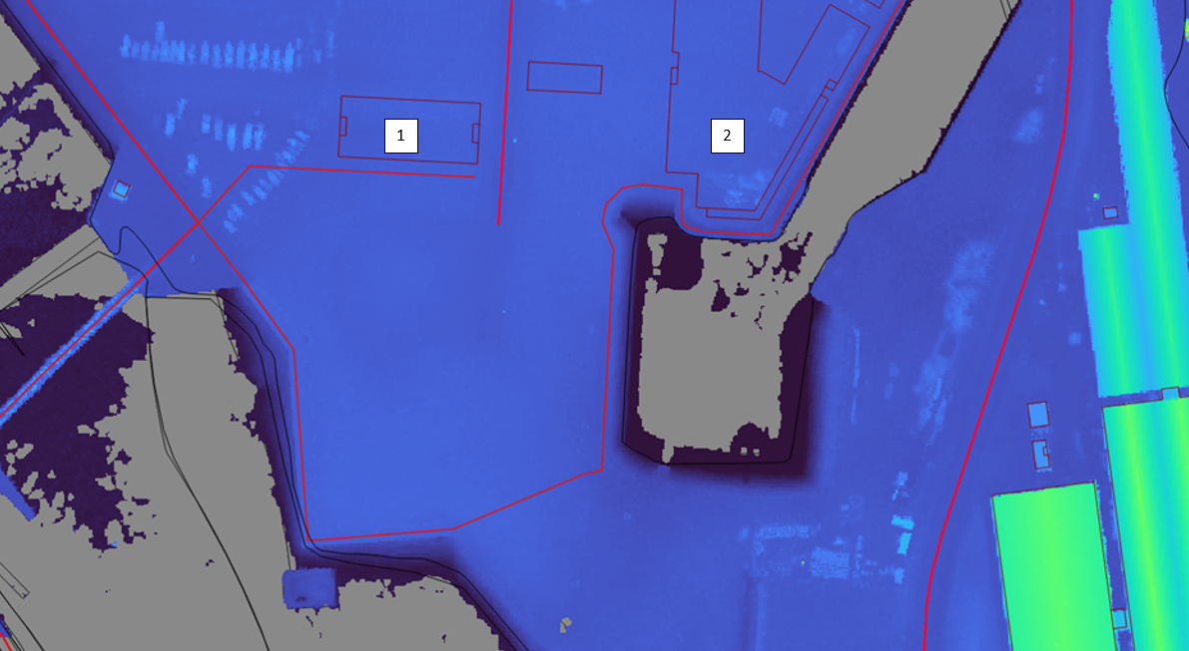
Figure 4 - Initial Layers
Figure 5 - LiDAR Colour Ramp
The next layer added was some point data of the mines that were found. The data from this was captured from the geotagging photograph function on a phone. Table 1 shows the latitudes and longitudes of each image and Figure 6 shows them plotted on the GIS.

Table 1 - Mine Latitudes and Longitudes
Image description | Latitude | Longitude
Mine under tennis ball | 51°37'1.06"N | 3°55'39.96"W
Mine under woodpile | 51°37'1.16"N | 3°55'39.24"W
Mine in shrub | 51°37'1.00"N | 3°55'39.01"W
Mine in field | 51°36'59.36"N | 3°55'39.48"W
Mine under rock | 51°36'58.17"N | 3°55'39.01"W

The issue with this method is that the spots on the GIS are not indicative of where the mines were actually found. For example, the mine under the woodpile was not found within the boundaries of the library building. This is an issue with the accuracy of the phone used to capture the data, as the CRS for each data point was set to the same as the rest of the layers. An improved method would be to use an accurate GPS system or a phone application such as what3words, as that is accurate to 3m, much better than the latitudes and longitudes given by the photo data.

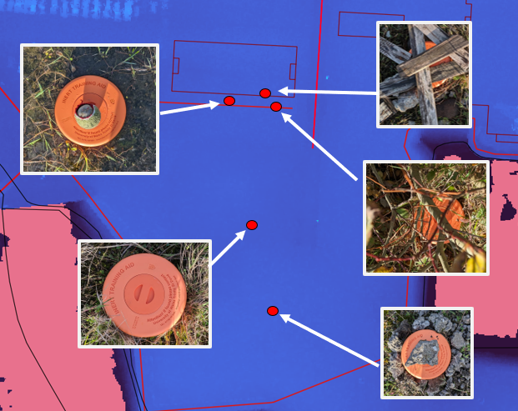
Figure 6 - Mine Images
The final layer to be added to the GIS was a background layer which, when interrogated, described what the bedrock was. The area of interest is described as being formed of sedimentary rocks including, mudstone, siltstone and sandstone, see figure 7. This layer was kept as a background layer rather than being prominent, as it obliterated the rest of the visual data behind an opaque colour.

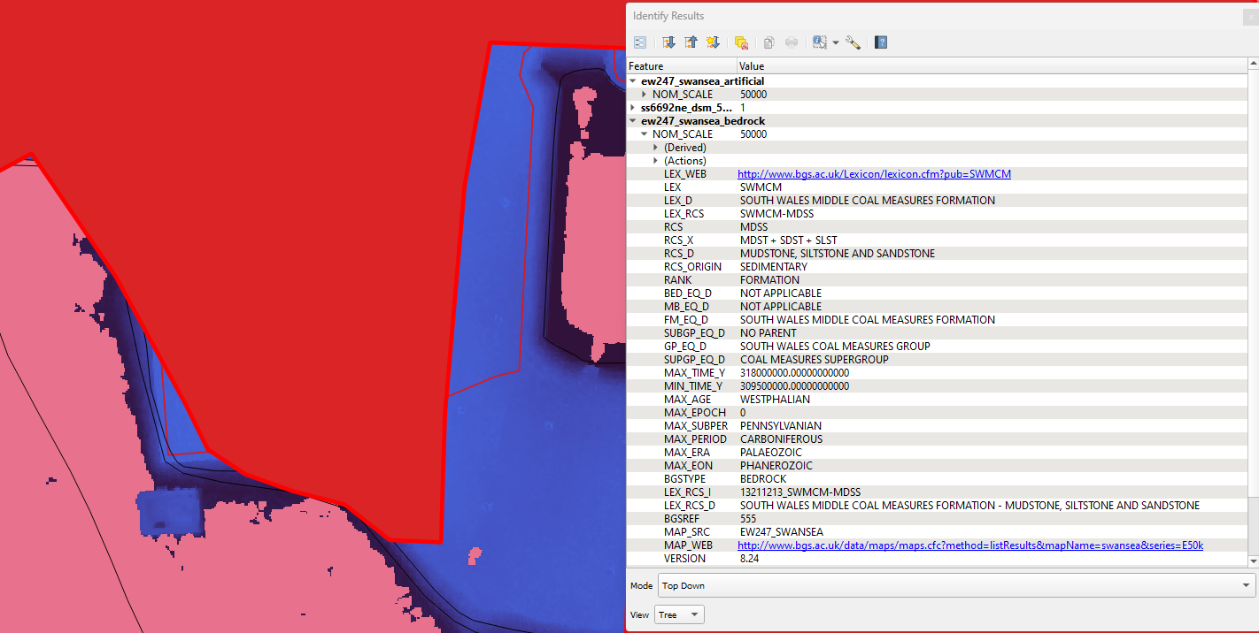
Figure 7 - Bedrock Layer

Factors Affecting Machine Vision Processes
Machine vision processes play a vital role in GIS creation by enabling the extraction, analysis, and interpretation of data from visual sources like satellite imagery, aerial photography, LiDAR scans, or ground level photographs such as used in the GIS attached to this report. The accuracy of machine vision processes within GIS applications depends on several factors.

Firstly the quality of the visual sources is important, higher resolution images will give better details and therefore be easier to analyse and interpret. Higher resolution images can be obtained by using better quality sensing equipment.

Secondly, georeferencing all the data is essential. As proven in figure 6, if all the data is not georeferenced correctly then the displayed GIS can be misleading.

Thirdly, the involvement of a human being in the process. Reconnaissance is never wasted and it is always worth checking a site in person if able to. As shown in this report, the LiDAR data did show the IQ and library buildings, but they are there, a fact which could only be verified by a human observer, or more recent LiDAR scan.

