Beloved Imagination: “If ever one art movement consumed the entire illustration genre, it was Surrealism”
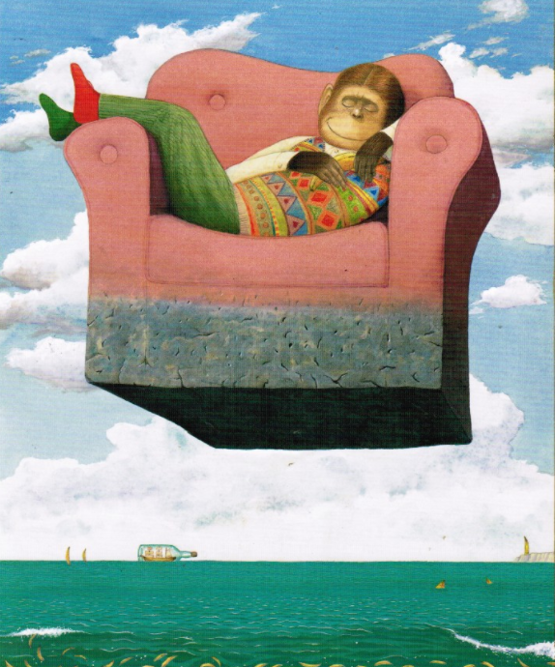
(Heller and Chwast, 2008, p.70).

Arianne Nicholas
1802809
Illustration: Image, Book, Text
Word Count:
Tutor: Delyth Lloyd-Evans
In this essay I will examine the fundamental importance provided by the Surrealist movement to contemporary illustration. By exploring examples from the founding practitioners established themes’ reilluminated in the light shone by illustrators today to the visual alphabet we use in modern technology, a significant wave of influence and awakening is evident across literature, art, society, and essentially our own psychology. When dissecting illustration, each of these factor causes effect on the next. By offering an appealing avenue of daydreams, in which other ethos can one disappear to a world where “the roses are blue; the wood is of glass. The earth, draped in its verdant cloak, makes as little impression upon me as a ghost.” (Breton, 1924, p.47), or a realm in which “Total possibility and total obliteration coexist, and disorientation prevails” (Stich, 1990, p. 84)
Argued by Andre Breton discordantly to Freud’s theories regarding subconscious desires and psychiatric diagnosis for treatment, it was emphasised that the subconscious existed independently as its own creative outlet, and rather than alter or unravel the abnormal desires, we are to simply make reality with them (Cramer and Grant, 2020). In the 1924 Manifesto of Surrealism, Breton distinguishes the process as pure psychic automatism free of any reason and liberated from all aesthetic or moral concern (Breton, 1924). It is important to note these developments as the artistic awakening that the Surrealist movement stirred would be one to have a domino effect across all visual stimuli, unravelled from both fruitful and barren attempts to define exactly what it is that provides each individual with their unique awareness.

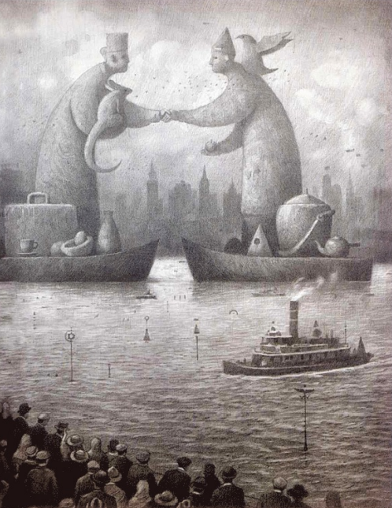
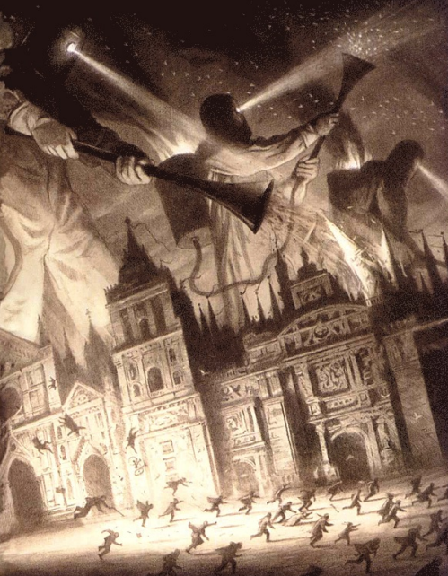
Born from wartime, Surreal ideations have often posed as more appealing than our waking life.
Never before had man’s submission to the world seemed so unendurable, that submission of which an intense awareness and a desire to bring it to an end are precisely what makes the artist (Nadeau, 1989, p236)
A collection of work that demonstrates this beautifully is Shaun Tan’s The Arrival. Through the towering threats and creatures of all sizes and demeanours, each reader can find a journey that resonates with them be it a physical or psychological shift in their personal travel through life. One can communicate triumph or trauma through symbolism and semiosis, as explained by the illustrator himself:
It is open to the individual reader to decide whether this might be political, economic, personal or something else, depending on what ideas or feelings the picture may inspire. (Tan, 2006)
Illustration is the easiest practice of manifesting visualisation, enabling the creator to take hold of it, bestowing power or revoking it from the brain in which it was conceived.
No other medium can communicate surrealism so intensely. Surrealism has always been an emotionally gripping and powerful vehicle for emotional expression, As demonstrated gracefully by surrealist artist, celebrity and cultural icon Frida Kahlo. An example of this organic mentality as a means of therapeutic communication to oneself and others can be observed in the piece Henry Ford Hospital (1932). It has been interpreted to illustrate Kahlo’s anguish. “Kahlo depicted herself surrounded by "symbols of maternal failure" representing her "knowledge that she would never be able to bear a child." (Lindauer, 1999, pg. 21)
In contemporary illustration Kahlo herself has become a symbol with the rise in female empowerment, depicted through surrealist application. (fig)
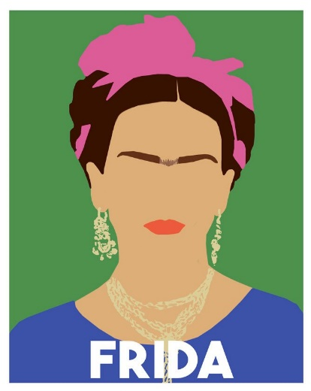
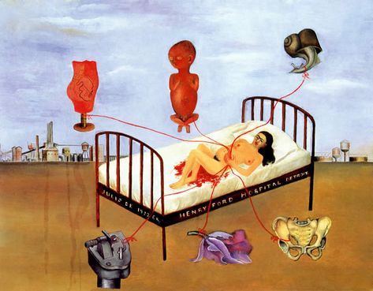
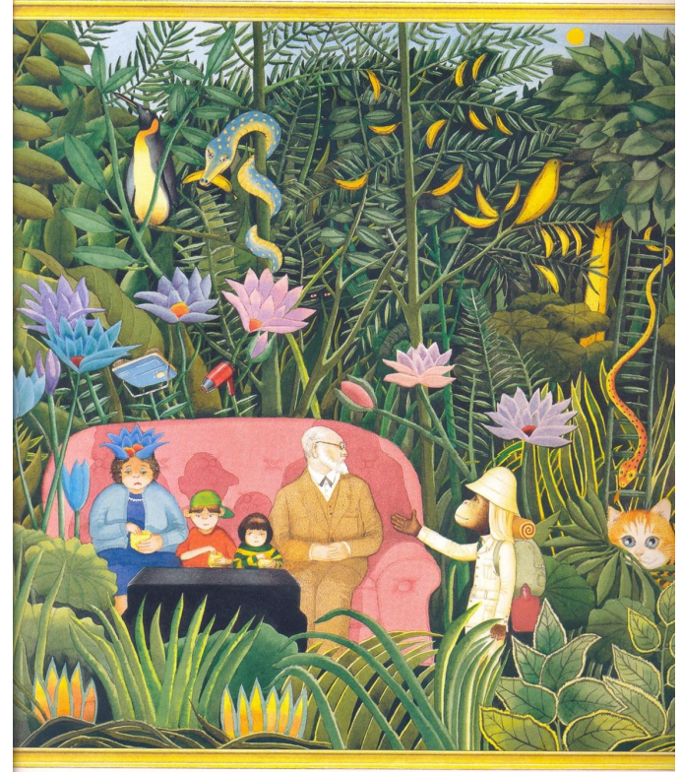
Providing the perfect channel from which to provide multiple stimuli for younger readers, picture books contribute another observation window to view the impact the Surrealist movement had on literature and is continuing to cast upon the younger generations. It is observed that “children favour styles of art that amuse, delight and challenge them” (Arizipe and Styles, 2003, pg. 50) and further study into the exciting works of Anthony Browne exemplify the success of surrealism not only with those charmed by the classic artifacts, but their children too. Paying homage to the iconography and juxtapositions themes that the movements founders established through intertextuality, the silent tributes prove to be an educational stimulus. "Another common view is that pictures are a means to an end - an aid to literacy and language development " (Doonan, 1993, pg. 7)
Fig. 5.
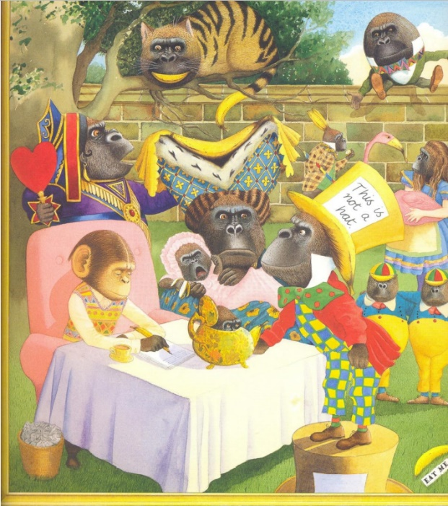
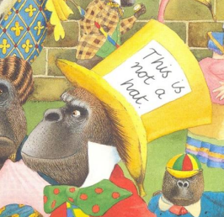
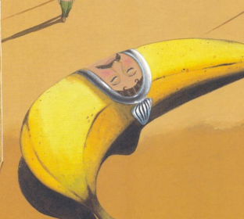
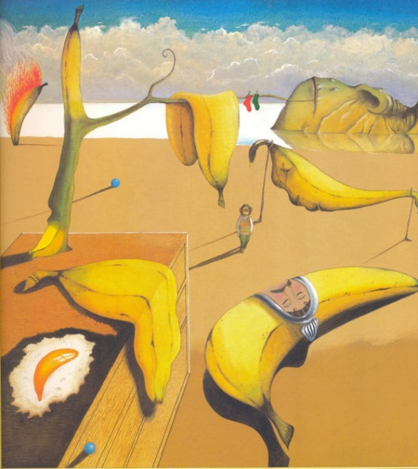
Browne’s artwork, particularly in Willy the Dreamer (1998) encapsulates the atmospheres and nostalgia that lies dormant after viewing Surreal and uncanny paradigms for the first time. for many this will conjure an image from the mind of Dali or Magritte. Referencing both indirect and specifically ‘’ and ‘’. opportunities arise where the unaware ‘backseat reader’ will query these cultural references, passing the warped and weird baton to the next generation of potential artists introduced to an entire movement through a vivid recollection of images in a postmodern picture book in childhood.
However, a notable factor in the successful outcome, not limited to commercial illustration, can be described as what was established by Freud to be the Uncanny. Labelled as “unheimlich” the opposite of the German “Heimlich” - belonging to the home, familiar - (1919, pg.2), Freud outlines the fundamental emotional presences which contribute to how one may feel when viewing a surrealist artwork, the unease and anxiousness of an unpleasant dream.
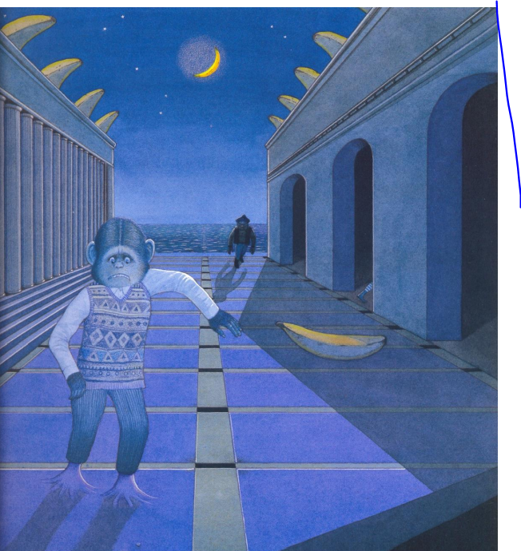

Illustration has held an effective role in commerce and advertisement, and so too would it be swept by the wave of the surrealist trend much to the dismay of those who supported the moral over the matter. “It is clear to anyone who has given surrealism serious consideration that it stands essentially opposed to capitalism and commerce” (Fijalkowski, 2007, pg. 101).

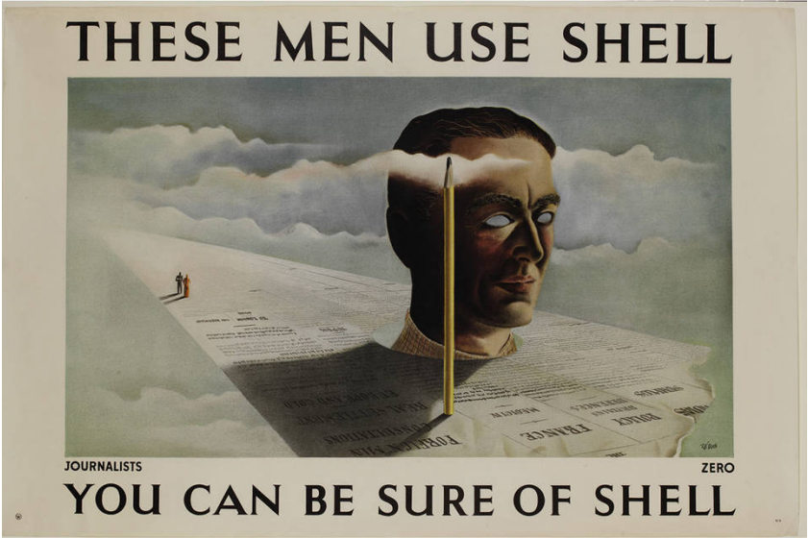

It is believed that the age of illustration in advertisement media has passed by, with photography replacing figurative realism and dominating the pages of magazines and roadside billboards (Male, 2007, p.54) Which provides us with a crossover of mediums. Photography can try but can only go so far using existing creations whilst illustration can move mountains before they are even formed.

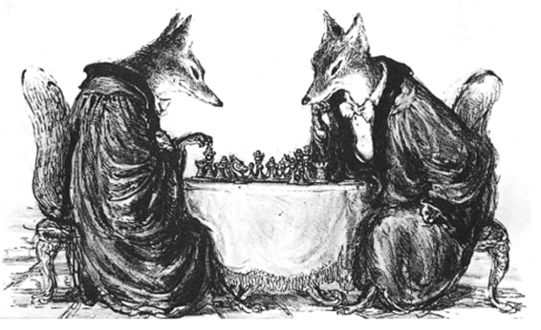
Yet again observing semiotics at work, example (fig) of an editorial illustration by Paul Weber communicates a sly, tactical battle of mental will through the notoriously sly fox synonymous with the human capabilities of wickedness derived from Aesop’s’ Fables. (Kraust, 2007, pg. 86)
The work of the founders bleed into everyday life and language. The clocks and apples of Dali and Magritte occur when one wants to create an eerie and unearthly atmosphere in popular culture. In practice, Surrealism induces physical and mental vertigo that distorts viewer perception. No psychology behind any topic is off limits for exploration through surreal juxtapositions (Heller and Chwast, 2008, pg. 148)
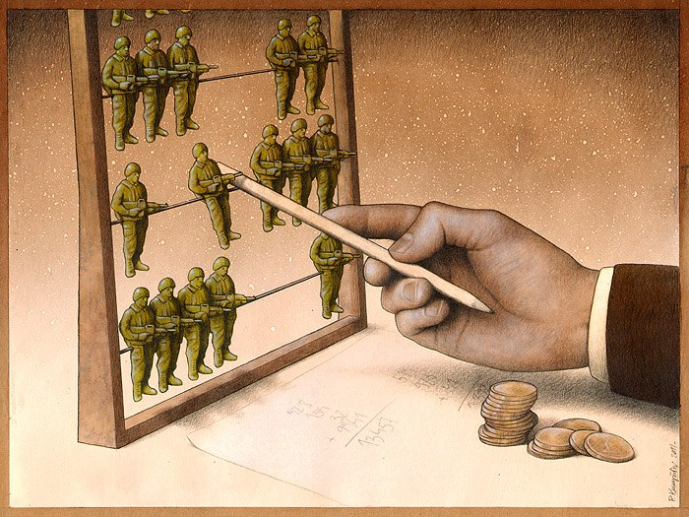
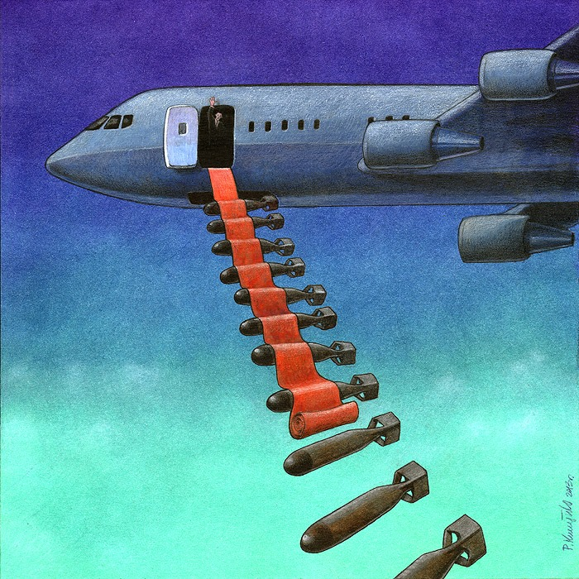
As the revolution of technological advancement and neo surrealism unfolded, art and illustration were arguably amongst the main areas to benefit and thrive. Due to the gift of freedom of interpretation and the blatancy when complete lack thereof, metaphor can be unrepentantly expressed as diffuse or explicitly as the artist wishes.
An illustration can also shock a newspaper reader into taking notice of a contentious argument, it can give a bland, faceless company a new identity and it can send any product into a fantasy world that might appeal to a potential buyer (Male, 2007, pg. 10)
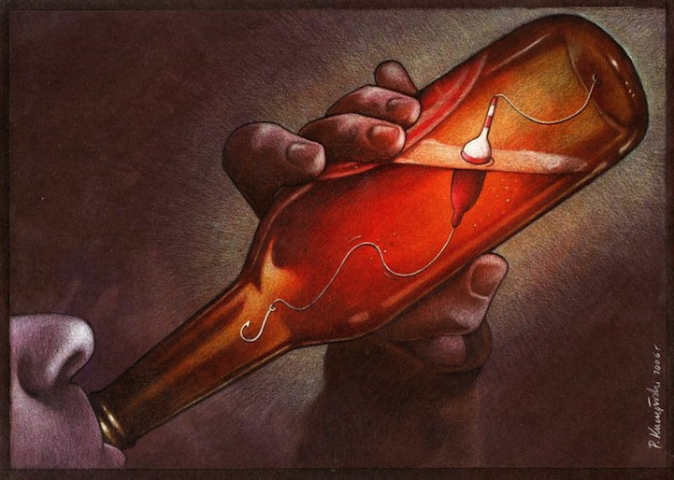
In true lawlessness the movement shook all outlets in media from editorials to cinema, imagination materialised in eye catching, controversial, satirical, and influential products.
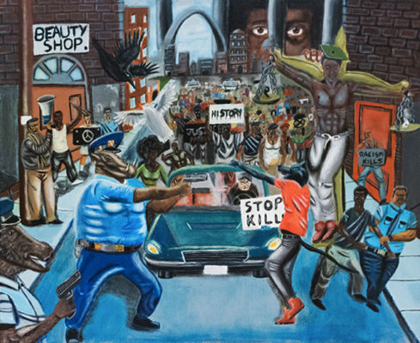
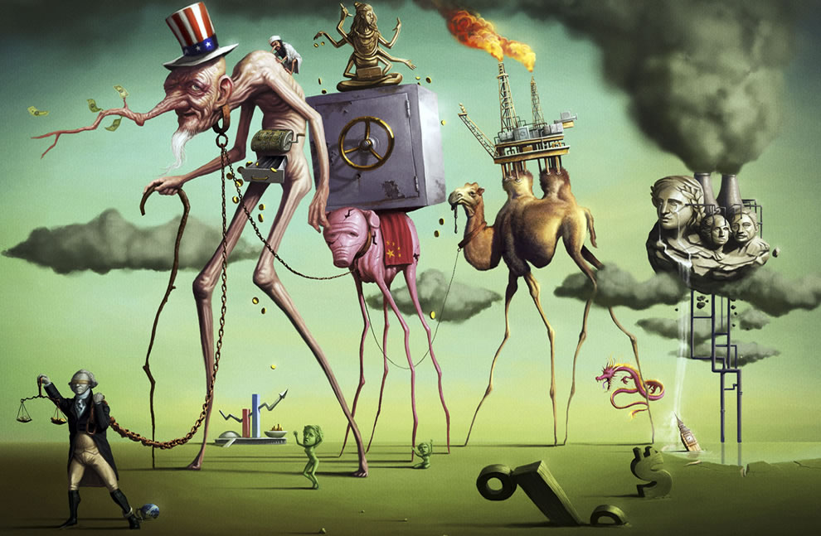
"It could be used to sell any product and depict any idea... it was an effective way to confuse censors, so they used it to make controversial and graphic statements" (Heller and Schwast, 2008, pg. 148)
The outline of the movement almost cried out to creatives and activists, with shock value and controversy proving itself a valuable move when the surrealist loophole provided a scapegoat. Artists could employ a surrealist approach to frequently exaggerate or understate the relative sizes of objects in the composition, thus symbolising power or weakness, importance or insignificance, and threat or helplessness of some person, group, or social force. (Fetsko, 2001, pg. 10)

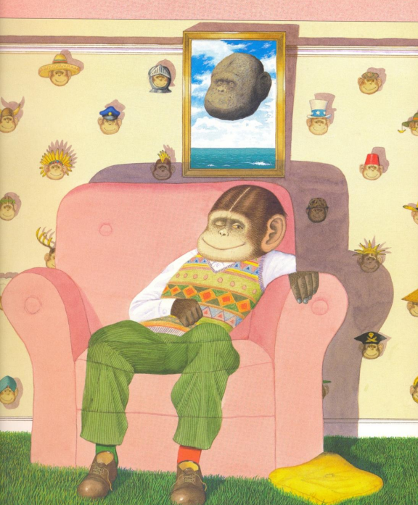
Everything in our media today has been touched by surrealist themes. Staying current and reflecting waking life like a funhouse mirror and offering comprehension and accessibility to all looking upon our history as experiential beings. education and historic significance current events, political satire seemed to mimic that of the surrealist nature of the unexpected and absurd. They have asserted most loudly in our century man's ability to change himself, and the extra- ordinary, almost magical, role that literature can play in effecting that change. (Peyre, 1948, pg. 49) Establishing itself by evolving the universal language art provides, It is only natural that the conscious, subconscious, weird and wonderful would collide and burst into the colourful world we know, where it is uncertain where the boundary lies between waking and dreaming.

