Using novel methods, is it possible to achieve 2530 m/s muzzle velocity as detailed in AOP-4496 from a 30mm RARDEN Gun Barrel?

Research Proposal
Samuel Page

Contents
Figures 3
Tables 3
Abbreviations 3
Annexes 3
1. Introduction 4
2. Background to the Proposed Research 5
3. Aims & Objectives 6
3.1. Aim 6
3.2. Objectives 6
4. Experimental Design 7
4.1 Outline of Experimental Procedure 7
4.1.1. Control Variable(s) 7
4.1.2. Dependant Variable(s) 7
4.1.3. Independent Variable(s) 7
4.2 Data Collection 7
4.3 Data Evaluation 8
4.4 Risks & Limitations 8
4.5 Ethical Issues 8
5. Resources & Planning 9
5.1 Resources Required 9
5.1.1 Physical Resources 9
5.1.2 Human Resources 9
5.1.3 Other Resources 9
5.2 Gantt Chart 9
References 10
Bibliography 11
Annex A 12
Annex B 20

Figures
Figure 1 – Gantt Chart

Tables
Table 1 - Data Table

Abbreviations
EMTAP – Energetic Materials Testing and Analysis Programme
TCO – Trials Conducting Officer
NATO – North Atlantic Treaty Organization
RARDEN – Royal Armament, Research and Development Establishment

Annexes
Annex A – Ethics Form
Annex B – Blank Data Table

1. Introduction
This research project is to find a new and novel way to increase the muzzle velocity of a 30mm RARDEN barrel to 2530 m/s. This is to bring the capability of the test site in line with the test standard set out in AOP-4496. Previously, work has been conducted internally to modify the internal ballistics of the gun barrel by changing the propellant burn time and the volume of gas produced by the composition. This meant that the Vihtavuori N500 series of propellants were decided upon as it gave the greatest increase of muzzle velocity. However, the muzzle velocity is still short of the 2530 m/s required in AOP-4496.
It is believed that creating a vacuum within the gun barrel will reduce the air resistance on the round that is being fired and therefore, increasing the muzzle velocity to that required. This would allow the company to be able to perform the full suite of IM tests which would provide a financial boost to the company, and it would also bolster the reputation of the company.

2. Background to the Proposed Research
Currently the ability to perform EMTAP tests to current NATO standards such as AOP-4496 is limited. Due to current access the largest calibre weapon system that can be used is a 30mm RARDEN gun barrel. This is more than sufficient for the slow velocity of 1850 m/s but so far has been incapable of reaching the high impact velocity of 2530 m/s [1]. When it comes to weapon design and modifications, there are two things to consider, the first is internal ballistics and the second are the exterior ballistics [2]. It has long been known that standardised approaches to IM testing is an accurate way to directly compare the different responses of munitions especially during threat conditions such as war or peace time [3]. Different approaches to maximising the muzzle velocity could be taken and have been studied previously by subject matter experts within the company. One variable that could be changed is the propellant type [4]. This does have limitations though as the strength and length of the barrel affect both the brisance that can be withstood and the burn time required to ensure maximum muzzle velocity in the weapon system [4]. For example, the longer the barrel, the longer the burn time of the propellant will need to be [4]. A fast-burning propellant would be less advantageous in this case as the propellant will be all burnt long before the round exited the barrel which would allow the resistive forces such as engagement with the rifling and air resistance to slow the bullet down [4]. This has been assessed before by internal experimentation within the company and the propellant that provided the best performance was the N500 series Vihtavuori propellants due to their high energy density as detailed in reference [5]. It is possible to achieve the required velocity with a rifled 30mm RARDEN Barrel though as QinetiQ have achieved it [6]. The effects of air resistance were discussed before so this research will focus on reducing this effect to achieve the 2530 m/s [1]. Other test sites within the UK are using similar methods to this to achieve the higher velocities but are still using larger bore weapon systems. Other methods could be to lengthen the barrel or even to go to a larger bore barrel or even smooth bore barrels [6].

3. Aims & Objectives

3.1. Aim
Creating lower pressures in the barrel of a 30mm RARDEN gun will mean that a muzzle velocity of 2530 m/s can be achieved giving the company the capability to perform the high velocity fragment impact test as detailed in AOP-4496.

3.2. Objectives
- To design and develop a suitable test regime using the 30mm RARDEN vacuum attachment to achieve a higher muzzle velocity than was previously possible out of a 30mm RARDEN Barrel.
- To critically evaluate a vacuum attachment for the muzzle of a 30mm RARDEN gun and its ability to hold a vacuum within the barrel.
- To analyse the muzzle velocity of projectiles using this vacuum attachment to evaluate the proximity to 2530 m/s that can be achieved using a 30mm RARDEN Barrel.
- To critically evaluate the accuracy and repeatability of firings to develop a tolerance band that the muzzle velocity can be achieved with.

4. Experimental Design
A comparative approach will be employed for this research. This allows us to assess the difference in performance between the old method of fragmentation impact and the proposed new method for fragmentation impact. Below the experimental method is outlined.

4.1 Outline of Experimental Procedure
- The 30mm RARDEN barrel will be placed in the gun mount to simulate the current ability for the EMTAP Fragment Impact test detailed in AOP-4496.
- Five initial firings of 18.6g metallic fragments contained in a plastic discarding sabot will be fired into a strawboard medium. The depth of penetration, muzzle velocity through doppler radar and a confirmation through High-Speed Digital Video and the initial barrel pressure before firing will be recorded.
- A newly designed vacuum attachment for the 30mm RARDEN gun barrel will be attached to the current set-up and five pressures with an increasingly higher vacuum will be created. At each of these pressures, five firings using the same propellant load, the same propellant type, the same RARDEN Barrel, the same sabot design and the same fragment shape and mass will be conducted into strawboard packs and repeated five times.
- The Muzzle velocity from Doppler Radar and the High-Speed Digital Video will be recorded and an average muzzle velocity per pressure will be calculated along with a tolerance that this velocity can be achieved.
- The depth of penetration into the strawboard pack will also be recorded as the energy of impact can be calculated and therefore, the velocity of impact can be calculated.
- The muzzle velocities will be compared, and a tolerance calculated to ensure it fits within the tolerance specified in AOP-4496 of $±90 m/s$.

4.1.1. Control Variable(s)
- Propellant load
- Propellant type
- Sabot design
- Fragment mass
- Fragment shape
- 30mm RARDEN Barrel

4.1.2. Dependant Variable(s)
- Muzzle velocity

4.1.3. Independent Variable(s)
- Initial barrel pressure

4.2 Data Collection
- Internal pressure (Pressure Transducers)
- Muzzle velocity (Doppler Radar/High Speed Digital Video Camera)
- Depth of penetration (Strawboard)
Internal pressure data will be used to analyse the optimal pressure to achieve the muzzle velocity required for AOP-4496. The direct measurement of muzzle velocity from the Doppler Radar will give an immediate confirmation of muzzle velocity and then using a scaling within the High-Speed Digital Image, the Digital Video will be used as a confirmation. The depth of penetration will be used to determine how much the fragment slows down during flight to assess the effects of the fragment hitting the air after exiting a barrel holding a vacuum. This ensures that the velocity stays within tolerance.

4.3 Data Evaluation
A t-test will be performed to test whether the new method creates a reliably higher velocity and if it is to a greater accuracy that the previous method. The mean will be calculated along with the standard deviation to determine the velocity variations.

4.4 Risks & Limitations
- Data Loss – All data will be backed up in at least three places and will be password protected. Data transfer between different media devices will be minimised to reduce the risk of data corruption.
- Cost Creep – Each item and process will be estimated below in section 5 and costs will be communicated to all involved personnel to ensure over-spending is mitigated
- Human error leading to data loss or failure to capture data – All personnel required are trained on the operation of all data capture. One final check that all instrumentation is armed and ready to capture will be made just before firing.
- Health and Safety risk – All tasks will be conducted in accordance with the Range Orders and Procedures, including having a 1-man risk at the last point of safety. Trauma trained personnel will be available in the event of an accident and a safety brief will be conducted for all unfamiliar personnel. All staff required will be trained in the area of work for example, the TCO must have a certificate of competency issued to them and have full range authorisation.
- Scope Creep – Clear aims detailed in this proposal will be followed and communicated to all involved personnel and a fully scoped out project Gantt Chart will be provided and disseminated to all involved personnel.

4.5 Ethical Issues
This task is deemed as ethically negligible risk. No living test subjects will be required and whilst the research being conducted is to improve a capability to test explosive devices, it is to remove as much risk as possible until they are needed for their design purpose. That is the whole reason behind IM testing and AOP-4496.

5. Resources & Planning

5.1 Resources Required

5.1.1 Physical Resources
- 1 no. 30mm RARDEN Gun Barrel (£0)
- 1 no. Gun mount w/ correct housing (£0)
- 20 no. 18.6g metallic fragments (£30 ea.)
- 20 no. discarding sabots (£5 ea.)
- 5 no. 30mm cartridge cases (£0)
- Propellant (Based on cost of black powder £200)

5.1.2 Human Resources
- 1 no. TCO (£120/hr)
- 1 no. Ammunition worker (£50/hr)
- 1 no. Supervisor
- Researcher to collect and analyse data, write report and describe and explain the outcome of their theory. Ensure trial is conducted to a standard where they obtain all data required and to the standard required. Recommend any further work and potentially propose and conduct the further work.

5.1.3 Other Resources
- Range hire: 1 Day (£7000)


5.2 Gantt Chart
Figure 1 - Gantt Chart

References

[1] | North Atlantic Treaty Organization, Fragment Impact Test Procedures For Munitions, A ed., vol. 1, Brussels: NATO Standardization Office (NSO), 2019.
[2] | Y. Wang, Y. Ma, R. Wang, L. Zhao, F. Nan and W. He, “Design optimization and simulation of interior ballistic measurement technology based on paramenters od large-caliber launch fuel,” Measurement, vol. 189, no. 1, 2022.
[3] | J. Isler, “The Transition to Insensitive Munitions (IM),” Propellants, Explosives, Pyrotechnics, vol. 23, no. 1, pp. 283-291, 1998.
[4] | Banaras Hindu University, “Internal Ballistics,” Banaras Hindu University, Varanasi, 2020.
[5] | Nammo - Vihtavuori, “VIHTAVUORI N500 HIGH ENERGY RIFLE POWDERS,” Nammo - Vihtavuori, 2022. [Online]. Available: https://www.vihtavuori.com/powders/n500-powders/. [Accessed 22 May 2022].
[6] | E. Schultz, “An international review of the STANAG 4496, Frangment Impact Test,” in 2015 Insensitive Munitions & Energetic Materials Technology Symposium (IMEMTS), Brussels, 2015.

Bibliography

[1] | North Atlantic Treaty Organization, Fragment Impact Test Procedures For Munitions, A ed., vol. 1, Brussels: NATO Standardization Office (NSO), 2019.
[2] | Y. Wang, Y. Ma, R. Wang, L. Zhao, F. Nan and W. He, “Design optimization and simulation of interior ballistic measurement technology based on paramenters od large-caliber launch fuel,” Measurement, vol. 189, no. 1, 2022.
[3] | J. Isler, “The Transition to Insensitive Munitions (IM),” Propellants, Explosives, Pyrotechnics, vol. 23, no. 1, pp. 283-291, 1998.
[4] | Banaras Hindu University, “Internal Ballistics,” Banaras Hindu University, Varanasi, 2020.
[5] | Nammo - Vihtavuori, “VIHTAVUORI N500 HIGH ENERGY RIFLE POWDERS,” Nammo - Vihtavuori, 2022. [Online]. Available: https://www.vihtavuori.com/powders/n500-powders/. [Accessed 22 May 2022].
[6] | E. Schultz, “An international review of the STANAG 4496, Frangment Impact Test,” in 2015 Insensitive Munitions & Energetic Materials Technology Symposium (IMEMTS), Brussels, 2015.
[7] | North Atlantic Treaty Orgnization, Policy for Introduction and Assessment of Insensitive Munitions (IM), D ed., vol. 1, Brussels: NATO Standardization Office (NSO), 2018.
[8] | L. E. Baker, N. Al-Shebab, K. Miers and D. Pudlak, “Insensitive Munitions Fragment Impact Gun Testing Technology Challenges,” Propellants, Explosives, Pyrotechnics, vol. 41, no. 1, pp. 572-579, 2016.
[9] | G. Stevens, STANAG 4496 Sabot A, West Lavington: Cranfield Universiy COTEC, 2007.
[10] | N. White, P. Cheese, P. Stuberfield and M. Cook, “Heavy Fragment Impact Testing of Large General Purpose Bombs Filled with Cast Cured PBX Formulations,” Uk Ministry of Defence, Bristol.
[11] | E. Degirmenci, “Effects of grain size and temperature of double base solid propellants on internal ballistics performance,” Fuel, vol. 146, no. 1, pp. 95-102, 2015.
[12] | Indeed Editorial Team, “10 Common Project Risks (Plus How To Analyze and Solve Them),” Indeed, 01 April 2021. [Online]. Available: https://www.indeed.com/career-advice/career-development/project-risks. [Accessed 15 May 2022].
[13] | Team Asana, “7 common project risks and how to prevent them,” Asana, 18 August 2021. [Online]. Available: https://asana.com/resources/project-risks. [Accessed 15 May 2022].

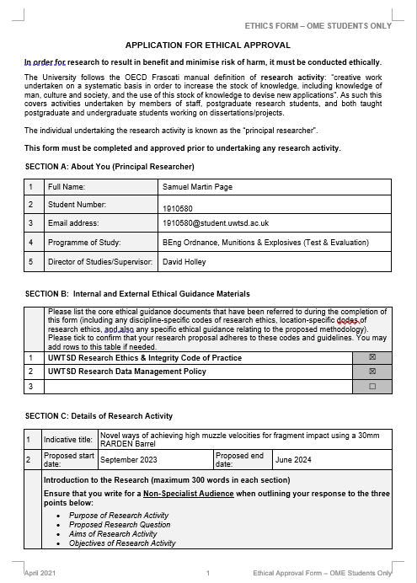
Annex A
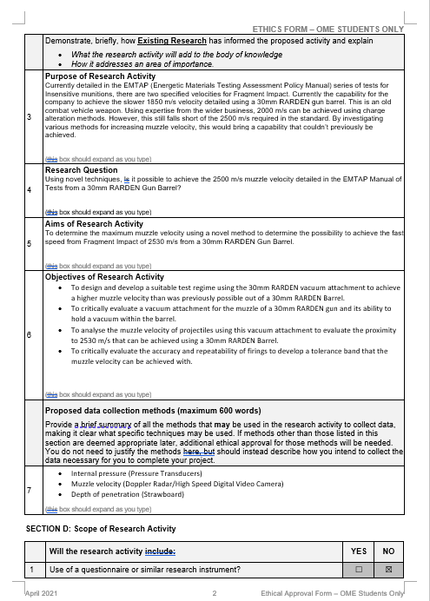
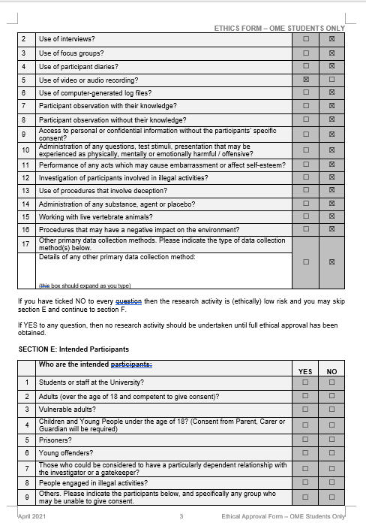
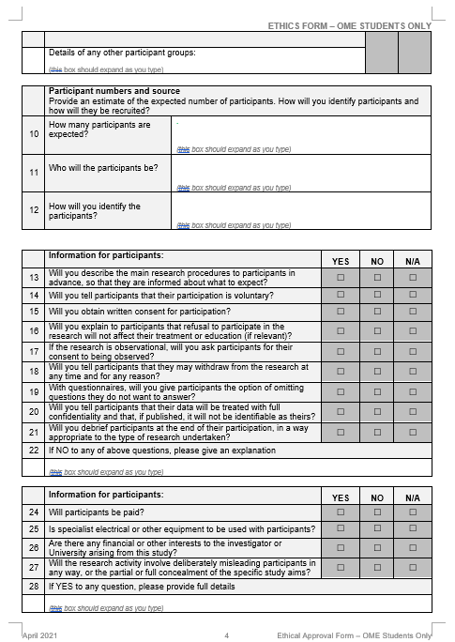

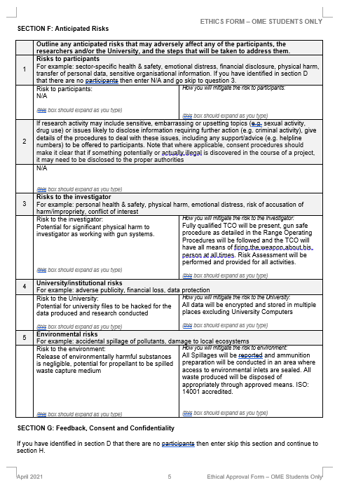

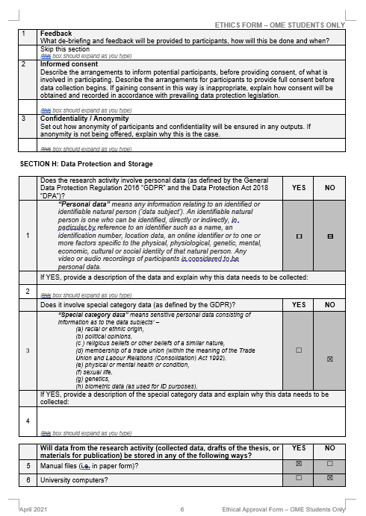

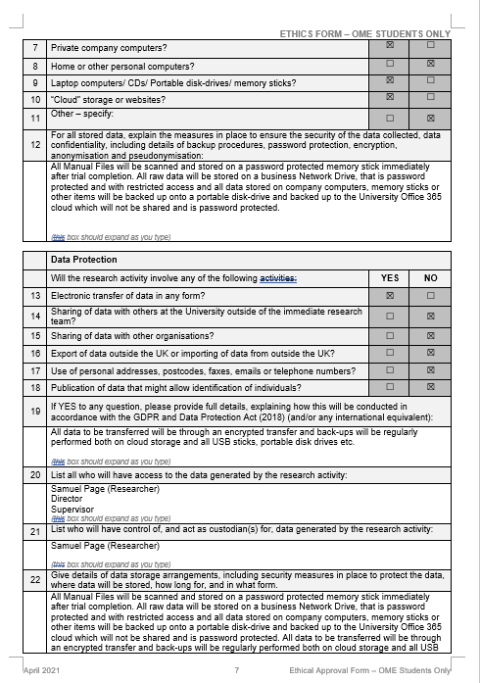

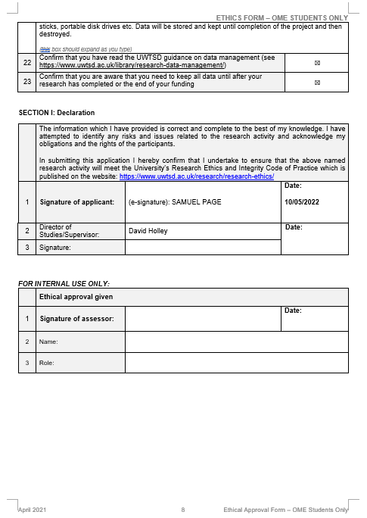

Annex B

Table 1 - Data Table
 | Doppler Radar |  |  |  |  |  | High-Speed Digital Video |  |  |  |  |  | Strawboard
Internal Barrel Pressure (kPa) | Muzzle Velocity (m/s) |  |  |  |  |  | Muzzle Velocity (m/s) |  |  |  |  |  | Depth of penetration (mm)
Internal Barrel Pressure (kPa) | 1 | 2 | 3 | 4 | 5 | Avg | 1 | 2 | 3 | 4 | 5 | Avg | 1 | 2 | 3 | 4 | 5 | Avg

