Financial Management and Planning
Assignment
MSc Industry 4.0 – Advanced Manufacturing
Module Code: ACPA7002
Supervisor: Howard Davies

Business and Financial review of Aston Martin Lagonda to assess suitability for consideration of joint venture in the development of electrical vehicles.

30th January 2023
Student: Christopher O’Connor 1351620
Email: christopher.oconnor@hanson.biz





Executive Summary
O’Connor Capital (OC) is an emerging EV parts manufacturing company that has made significant product development gains year on year since its start up in 2018. Since the beginning of 2021 it has been in close discussions with Aston Martin Lagonda (AML) around a potential joint venture (JV) into the manufacturing of EV parts for AML’s new breed of electrified vehicles.
In line with due diligence, the author of this report was asked by OC to carry out a financial assessment of AML over the last two years to understand its financial health, concluding with a recommendation as to whether OC should take up the JV opportunity.
To do the assessment, the author has used standard financial tools such as statements and ratios to analyse the data and draw conclusions. Within the report, the author discusses the tools used, their purpose but also their limitations. The author has supported this information and evidence with relevant reference to financial and non-financial information and sources. There is a great emphasis throughout that these tools must be used in line with wider reading and analysis of non-financial information to make sound, thought through recommendations.
Some financial indicators raised concerns during the analysis, particularly surrounding the leveraged position of AML. However, on balance the strong revenue growth, improved operational costs and clear roadmap to a sustainable business, when considered with other non-financial supporting information, led to the recommendation by the author that the JV between OC and AML should proceed.

Contents
Executive Summary 2
Introduction 5
Aston Martin Lagonda 5
Financial Statements 5
Aston Martin Lagonda: Ratio Analysis – Two Year Comparison 6
2020-21 Comparison 6
Financial Ratio Analysis 6
Financial Ratio Limitations 6
Profitability Ratios 7
Liquidity Ratios 7
Activity Ratios 8
Leverage Ratios 8
Investor Ratios 9
Other ratios that can be used: 10
Conclusion 10
Conclusion on Financial Analysis 10
Non-financial Supporting Information 11
Sustainability 11
Social Value 12
Industry 12
Brand Recognition 12
2022 and beyond; Targets and outlook 12
Recommendations 12
Bibliography 14
Table of figures 17
Appendices 18
2021 Financial Statements for Aston Martin Lagonda 18
Income Statement 18
Balance Sheet 19
Cash Flow Statement 20
Financial Statement Types 20
Balance Sheet 20
Profit and Loss Statement (Income Statement) 21
Cash Flow Statement 21
Ratio Calculations 22

Introduction
It is the intention of this report to carry out a detailed business and financial review of Aston Martin Lagonda (AML) and its financial statements to critically assess its worthiness for consideration in a joint venture with O’Connor Capital into the research and development of electric powered motor vehicles.

Aston Martin Lagonda
Now considered one of the worlds most luxuries car manufacturers, Aston Martin Lagonda’s began its journey in a far more modest setting thanks to the collaboration of Lionel Martin and Robert Bamford in 1913 (OSV.Ltd, 2023).
Despite suffering many financial difficulties over its lifetime, it remains a brand that is seen by many as one that optimises luxury and performance. A 2019 takeover by Lawrence Stroll and a 2021 rebranding of the Formula 1 team Racing Point to Aston Martin sees the dawn of a new era for this classic British car manufacturer, one which both its fans and investors will hope can be successful one.

Financial Statements
Financial statements are reports that indicate a business’s performance and financial activities over a period in time (Xero, 2022). They are most frequently prepared at the end of each month, quarter or yearend depending on requirement.
The accuracy and honesty in the reports are vital, particularly to large organisations, due to the effect they may have on its shareholders and investors. Therefore, the Companies Act 2006 requires that submitted accounts must give a true and fair reflection of the business performance (ICASEW, 2023) and be completed by a chartered individual.
At this point it is prudent of the author to highlight some of the limitations of the financial statements reviewed in this report. (Stittle & Wearing, 2008) in the book “Financial Accounting” states that a limitation of such statements is that at the time of reading, the detail within will be out of date by nature of it being an historical account of a company’s finances. These concerns are built upon further by (Srivastav, A K, 2023) who goes on to add further limitations such as:
- There is often personal judgement involved when valuing assets, this can differ depending on who it is carrying out valuation.
- Despite legislation in place for the production and management of such statements, they are still open to fraudulent practices.
- They do not consider non-financial implications such as social, government or environmental factors that may be affecting current or future business performance.
- Assets and liabilities within the statement are not inflation-adjusted, therefore any significant swings in either direction will mean an inaccurate account of costing within the reports.
There are three common statements used in accounting, Income Statement, Balance Sheet and Cash Flow Statement. Financial ratios are used to analyse the data contained within each statement to show the business’s position quickly and easily. Read with previous years (or other companies for that matter) ratios they can be useful in juxtaposing data to rationalise decision making processes.
A more detailed explanation of the statement types can be found in the appendices of this report.

Aston Martin Lagonda: Ratio Analysis – Two Year Comparison

2020-21 Comparison
 | 2020 | 2021 | Variance
Profitability Ratios
Gross profit Margin | 18% | 31% | 13%
Operating Profit Margin | -53% | -7% | 46%
Net profit Margin | -51% | -29% | 22%
Return on Assets | -15% | -7% | 8%
Return on Equity | -51% | -29% | 22%
Liquidity Ratios
Current ratio | 1.10 | 0.96 | -14%
Quick Ratios (or Acid Test Ratio) | 0.84 | 0.74 | -10%
Cash Ratio | 0.61 | 0.46 | -14%
Activity Ratios
Day’s sales outstanding | 106 | 81 | 26%
Inventory turnover | 2.42 | 3.82 | 92%
Days payable outstanding | 422 | 350 | 17%
Leverage Ratios
Gearing Ratio | 60% | 37% | -23%
Debt/Equity Ratio | 83% | 61% | -21%
Long term debt/equity ratio | 121% | 163% | 42%
Interest Coverage | -394% | -42% | 352%
Investor Ratios
Earnings per ordinary share | -3.57 | -1.63 | 55%
Dividend Cover | N/A | N/A | N/A
Price per Earnings ratio | -208 | -307 | 47%
Dividend yield ratio | N/A | N/A | N/A

Figure 1 - Two-year ratio review of AML, 2020-21

Financial Ratio Analysis

Financial Ratio Limitations
An analysis by (Gadoiu, 2013) highlights several reasons why financial ratios must be scrutinised carefully with consideration to the wider context of the business and subsequent industry, such as:
- Inflation may distort reported financial data.
- The information is historic in nature that it is a review of past financial activity, therefore may not reflect a current or future state.
- They are subject to manipulation.
- They can contain data that is often subjective in nature and may differ depending on who is utilising them and for what purpose.
- There may be different standards on what “good” and “bad” look like across companies and industries, therefore a high ratio for one may be positive indicator and a negative indicator for another.
- They cannot account for intangible assets such as brand strength or intellectual properties.
Nevertheless, they can be used as a powerful tool when combined with wider knowledge and understanding of a business and the industry in which it operates.
Profitability Ratios
Described by (Atrill & McLaney, 2017) as a good tool to give an indication of a company’s ability to create wealth for its owners/investors, they are made up of two types of ratio, “margin” and return”, and are used to show whether a company is effective at converting sales into profitability whilst displaying its value to its shareholders, respectively. AML saw strong 2021 results across all metrics in comparison with 2020, with each ratio showing a positive variance increase.
The increased gross profit margin of 13%, as per the annual report can be somewhat attributed to the increased efficiencies in operational activities that led to a c.20% reduction in manufacturing costs through Project Horizon. This coupled with improved sales revenue from £600m to £1.1b that was driven by an 82% increase in wholesales from 2020 following the return to normal operations from Covid -19 (12% growth on pre-covid sales in 2019) and increased core ASP of £150,000 (£136k 2020, £133k 2019) (Aston Martin Lagonda, 2021).
A net profit margin increase of 22% is an excellent indicator of the company’s annual performance as it considers all income and expenses associated with the business (Treece, D, 2022). However, as this metric encompasses associated costs, that means it considers one-time occurrences, for example the £14m benefit from exchange rate movements in 2021, that are not necessarily reflective of the company’s performance (Aston Martin Lagonda, 2021).
Liquidity Ratios
These ratios are used as an indicator for a business’s ability to be able to pay off short term debt (Novuna, 2023). They show a balance between a company’s assets and liabilities and are derived from the information contained within the balance sheet. There are several different liquidity ratios that can be used during analysis, for this report however we will focus on Current Ratio, Quick (or Acid Test Ratio) and Cash ratio. Each can be considered a more conservative representation than its predecessor, and this is due to the information they each consider. For example, Current ratio looks at all current assets and liabilities, even those that may be difficult or slow to turn into cash if needed to pay off debtors. A typical good score for a current ratio is 1.3-1.4. Quick or Acid test ratio consider all assets less stock, as it is reasonable to say that stock is not an asset until it is sold. A good score would typically lower, between 0.8 and 0.9. Finally, the Cash Ratio is the more stringent of the three as it purely considered the availability of cash or cash equivalents to cover current liabilities. A good Cash Ratio score could range between 0.5 and 0.8. There are benefits and limitations to each, for example Current Ratios consider assets that may be difficult to liquidate whilst Cash ratios may neglect most of the companies’ current assets. The type of analysis required is very much subjective to those carrying out the analysis and for what reasons.
The 14% decrease in the Current Ratio to 0.96 is a result of reduced inventories and cash/cash equivalents and an increase of trade and other payables.
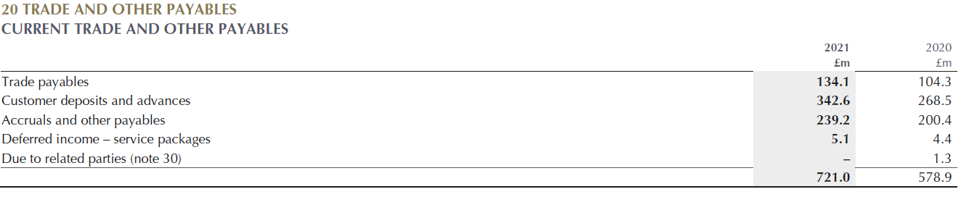
Figure 2 - Composite of trade and Other Payables (Aston Martin Lagonda, 2021)
Activity Ratios
These ratios are used to help evaluate the rate at which a company is turning over its assets and liabilities, to essentially showcase its ability to generate revenue through its current assets over a period (Brashear, 2023).
The percentage increase in the DSO, Inventory turnover and DPO by 26%, 92% and 17% respectively, tells us that not only is the business collecting its cash from sales more quickly, but it is also paying its debt in a prompter fashion. (Dwyer, G, 2018) would suggest an improvement in these results (DSO 81 days, DPO 350 days) indicate a good level of cash flow, which could be a result contributed to by the increased inventory turnover rate (81 days). It is worth noting however that with reference to inventory turnover, it is likely there would be a significant increase in this figure compared to 2020 when you consider the effect of Covid-19 on sales and distribution.
Leverage Ratios
When reviewing a business’ financial health, it is important to understand its ability to manage, cover and leverage debt. Debt in many cases is considered a positive strategy for generating funds to use for its operations and for business investment and expansion through capital. There are two important considerations a company must make however before taking on debt as discussed by (Fields, 2016), it is able to cover the interest payments and that it starts generating cash flow from the investment before the repayment is due. That is why a debt repayment term is equally as important as the interest rate payable. Failure to consider these points can lead to financial hardships if for example, revenue falls, or the asset purchased by capital depreciates significantly in value.
Gearing ratios use several financial metrics to assess a company’s leveraging and financial stability by looking at its shareholder equity vs its debt. High gearing (>50% typically) indicates a high degree of borrowing within a company whilst anything lower than <25% indicates a low reliance on borrowing. Gearing can be used to compare the performance of companies compared to industry competitors but are far less effective when comparing companies across industries.
Analysis of the Aston Martin leverage ratios shows an improvement in gearing, debt/equity, and interest coverage in comparison to 2020 by -23% (down to 37%), -37% (down to 74%) and +352% (up to -42%) respectively. For the same period long term debt/equity increased by 42% (up to 163%). These results were driven by Aston Martins increase in equity, of which is a contribution of improved revenue and reduced operational costs, and a reduction in non-current liabilities. The long-term debt/equity rise is a result of an increased interested bearing debt of £100m for the financial period and a £140m reduction in shareholders equity. The increased debt may sound alarm bells to those considering Aston Martin as an investment option/partner.
Investor Ratios
This group of ratios are used to understand the returns and performance from the position of a shareholder of a business’s shares who are not associated with the management of the business in question (Atrill & McLaney, 2017).
Earning per ordinary share give a quick representation on what an investor could expect to earn/lose if they were to decide to invest in a business. Typically, a positive return would naturally indicate a good result on their investment. In the context of Aston Martin, a 55% change in the EPS from -£3.57p to -£1.63, although remains negative is a significant improvement on the 2020 result and would indicate that the company is trending in the right direction. The dramatic increase can be attributed to the drastic improvement in the year-on-year net loss which has climbed from -£411m to -£189m, supported by the increased revenue and reduced operational costs. Caution should be considered when using this metric as a stand-alone assessment tool as the impact of Covid-19 would have obviously skewed the year performance when you consider lack of demand and distribution challenges. In comparison to 2019 results the EPS decreased from -£0.50p per share to -£1.60p per share, mainly down to an almost 50% reduction in shareholding from 228m in 2019 to 116m in 2021.
A decrease in market value per share to £501 (£744, 2020) seen a 47% reduction in the Price per Earnings Ratio, despite an improved EPS result, from -208 to -307. This ratio gives investors an indication on how much common stock would pay per £1 of earnings. Typically, in reporting, if its value is negative it is displayed as N/A. A negative PE ratio does not always mean a business should not be invested in, as they can also be negative as a result of; a company has just started, it has changed its accounting methods or there have been significant changes in depreciation or amortisation (Public, 2023). The ratio should be used as indicator for an investor to dig deeper into the company’s position and weigh up the risk rather than exclude it completely from possible investment.
Both the dividend cover and divided yield ratios are recorded as N/A as no dividends were paid out by Aston Martin in 2020 or 2021. Immediately this may deter some investors, however once again the author would implore that context must be given when analysing these ratios. For example, a reason a company may not pay out dividends is because it is reinvesting the money in the business instead (CFI Team, 2022).
This statement is supported by the information in the 2021 annual report where the company indicates a significant investment of £191m in Research and Design and a £14.1m Capex commitment, for example (Aston Martin Lagonda, 2021).

Other ratios that can be used:
There are several other ratios that could have been used either instead of or alongside the ones that have been analysed in this report, such as expense ratios, Return on Investment and Solvency Ratios. However, the author feels that those used here, supported by wider reading and information, are sufficient to make sensible recommendations regarding the JV between the company and O’Connor Capital.
Conclusion

Conclusion on Financial Analysis
A strong year performance in relation to the profitability ratio metrics indicates that 2021 was a good year for the business, driven by improved sale volumes and increased average ASP, both contributing to a significant year on year increase in revenue. Revenue increase has also improved as a ratio to cost of sales by 12%, indicating a reduction in manufacturing and operating costs in line with Project Horizon. The 46% increase in operating profit, although still negative, suggests to investors the company is trending well to be positioned to cover any fixed costs and interest obligations. This allows AML to be more agile when pricing their product which can be advantageous in aggressive markets emerging from a post Covid-19 environment. This increase came despite an increase in depreciation and amortisation, which shows a two-fold benefit that the company is experiencing strong revenue whilst also paying off its debts more quickly.
The liquidity ratio scores of 0.9 (Current), 0.74 (Quick) and 0.46 (Cash) have seen a decline when compared to 2020 data. The decline now means that the results have fallen out of the “acceptable” ratio limits, (Walls Street Prep, 2023) , and typically indicate that the company has insufficient assets to cover its short-term debt. Therefore, it usually would require further analysis to understand how much of an issue they represent for the company. A significant increase in borrowings (>£140m) is cause for concern, meaning extra financial commitments for the business, but it could be argued that with increased revenue and order these concerns are somewhat dampened, risk dependent of course. A reduction in inventories is a positive story from the review of these ratios as it supports the companies claim of increased sales and efficiencies.
Activity ratio analysis indicates an all-round improvement of supplier and customer commitments and improved sales through a 92% increase in inventory turnover. The impact of Covid-19 on sales and distribution must be considered when looking at this metric, although when compared with 2019 data there is still an improvement of 39%. This suggests that the business is trending in the right direction in terms of being able to collect money from its customers whilst maintaining reasonable breathing space before it must pay its debt commitments.
The positive leverage ratio metrics indicate that the business has more debt than equity supporting it. This holds up further the conclusions made around the activity ratio information. It must be said however that high gearing within a company does not necessarily mean there’s a problem. This is because some industries are far more capital intensive than others to produce a product, for example a steel company in comparison with an online marketing business. (Cattlin, R, 2022). When compared to other industry competitors, if a company had a significantly higher gearing ratio than the other then it would be reasonable to suggest that it could be under threat of failure and insolvency. However, a 2014 article in the Business Systems Research Journal by (Situm, 2014) suggests that gearing ratios do not consider enough information to be used as an indicator for business failure, and that debt/equity ratio were a better metric for this assessment purpose. The conclusion from these conflicting hypothesises support the reports early suggestion that whilst financial statements and the ratios used to analyse them are useful, it is essential to consider wider information and reasoning when assessing a company’s financial strength.
Since no dividends have been paid out by the company for the past several years, the data provided by the investor ratios was somewhat limited. On the contrary, the fact that no dividend was paid is information in itself and directed the author down the road of understanding why. It’s reasonable to suggest that, particularly since the 2019 take over by Lawrence Stroll there has been significant reinvestment into the business, which may be a contributory indicator as to why no dividends have been paid. A 55% increase in EPS suggests the company is trending upwards. This considered in addition with the point made in the report about negative PE not necessarily meaning a bad investment when you consider how low the share price is currently, it may suggest that now is an excellent time to invest/collaborate with Aston Martin as the price/value is low, yet the outlook and forecasts suggested by both the financial and non-financial indicators is very promising.

Non-financial Supporting Information

Sustainability
Aston Martin are showing clear ambition to drive sustainability throughout their organisation and product range. As per the Annual Report, Tobias Moaers, AML CEO, outlines some ambitious targets such as net zero manufacturing emissions by 2023, a 30% reduction in supply chain emissions by 2030, zero waste for landfill by 2022 (delivered) and a 15% reduction in water consumption (Aston Martin Lagonda, 2021). The operational goals are supported with targets to release a PHEV by 2023 and a full electrical vehicle by 2024/25.
(Ambaka, P, 2022) raises a very valid point around the pace in which Aston Martin has entered the renewable engine market, and that it is already significantly behind competitors such as Porsche and Rolls-Royce who already have cars on the road.

Social Value
Social Value appears to remain a core focus of the Aston Martin brand, as for the third year in a row they have attained the Sword of Honour health and safety award whilst maintain a 1% accident rate amongst staff. There is work to do around diversity and inclusion however, which the company recognises itself, having zero to date female representation at board level and only a 19% representation at senior leadership levels.

Industry
Brexit, Covid-19 and now the Russia-Ukraine war present significant challenges to operations, distribution, and customer networks globally. In spite of the current challenges, a McKinsey report by (Guan, M; et al, 2022) in July 2022 suggests that the luxury car market is significantly outstripping the mainstream market, with forecasted growth of between 8 and 14% annually up to 2031, when compared to an expectation of little to no growth for the standard market.
Further to this, Aston Martins Strategic Cooperation Agreement with Mercedes-Benz further strengthens is product with the integration of Mercedes technologies.

Brand Recognition
The introduction of the Aston Martin F1 team, appearance of several models in the recent James Bond movie and music video by pop culture icons such as Stormzy has seen a surge in online traffic directed towards the brand over the year, supported by c70,000,000 average global TV viewers during F1 race weekends (Aston Martin Lagonda, 2021).

2022 and beyond; Targets and outlook
A brief outline of some promising future targets and outlook outlining the companies ambitions and future position (Aston Martin Lagonda, 2021):
- Wholesales growth to 6,600 units (6,178 2021)
- Capex and R&D increase to £300m (£119m 2021)
- Depreciation and amortisation increase to c£315-£330m (£212, 2021)
- 10,000 wholesale, £2bn revenue and £500m EBITDA target 2024/25
Recommendations
Based on the information gathered in relation to the financial statements and subsequent ratio analysis, supported by the wider reading and considerations into the business’s future ambitions and targets, it is reasonable to recommend that a joint venture into the electrical vehicle market between Aston Martin Lagonda and O’Connor Capital would be beneficial to O’Connor Capital. Whilst Aston Martin still have internal and external challenges, their ability to make significant operational and financial improvements since the 2019 takeover and the post Covid-19 environment we currently reside in, suggests they would be a suitable partner to enter a joint venture with.
As suggested in the conclusion, the fact that the share and business value remain relatively low, it may be an ideal time to collaborate with the company and capitalise on the expected growth that is forecasted not only by the business, but by the wider industrial experts as well.
The substantial revenue result powered by increased wholesales and improved operational expenditure indicates a strong foundation for successful company growth.
Aston Martin introduction to F1, along with its product placement in movies and music would be an excellent opportunity to increase the exposure of O’Connor Capitals and its ideas and ambitions for EV vehicles.
The debt concern is a valid one, however with an increase in depreciation and amortisation forecasted for 2022 it suggests that the company is trending towards reducing its leveraged position somewhat.
The company’s commitment to a sustainable future is already gaining moment with the 2022 zero waste to landfill being achieved, and although they remain somewhat behind the curve for EV vehicles, it is the authors belief supported by industrial opinion contained within this report that there is still enough of a market share and demand for the product for the collaboration to become a successful one.

Bibliography
Ambaka, P, 2022. Could I double my money if I buy at this Aston Martin share price?. [Online]
Available at: https://themoneycog.com/articles/could-i-double-my-money-if-i-buy-at-this-aston-martin-share-price#:~:text=As%20a%20potential%20future%20shareholder,significant%20customer%20and%20media%20excitement.
[Accessed 27 January 2023].
Aston Martin Lagonda, 2021. Aston Martin Lagonda FY 2021 Results - Press Release , s.l.: AML.
Aston Martin Lagonda, 2021. Aston Martin Lagonda Global Holdings plc Annal Report 2021, s.l.: AML.
Atrill, P. & McLaney, E., 2017. Accounting and Finance for Non-specialists. In: London: Pearsons Education Ltd, p. 197.
Atrill, P. & McLaney, E., 2017. Accounting and Finance for Non-Specialists. 10th ed. London: Pearson Education Ltd.
Brashear, J., 2023. What Are Activity Ratios?. [Online]
Available at: https://www.aaii.com/education/article/17336-what-are-activity-ratios
[Accessed 24th January 2023].
Cattlin, R, 2022. A Guide To The Gearing Ratio. [Online]
Available at: https://www.cityindex.com/en-uk/news-and-analysis/gearing-ratios-explained/#:~:text=A%20good%20gearing%20ratio%20will,and%20stocks%20in%20other%20sectors.
[Accessed 26 January 2023].
CFI Team, 2022. Cash Flow Statement. [Online]
Available at: https://corporatefinanceinstitute.com/resources/accounting/cash-flow-statement%E2%80%8B/
[Accessed 15 January 2023].
CFI Team, 2022. Cash Flow Statement. [Online]
Available at: https://corporatefinanceinstitute.com/resources/accounting/cash-flow-statement%E2%80%8B/
[Accessed 15 January 2023].
CFI Team, 2022. Investing in Stocks With Dividends vs Stocks Without Dividends. [Online]
Available at: https://corporatefinanceinstitute.com/resources/equities/investing-in-stocks-with-dividends-vs-stocks-without-dividends/
[Accessed 26 January 2023].
Dhanashire, R, 2023. Balance Sheet Exmaples. [Online]
Available at: https://www.wallstreetmojo.com/balance-sheet-examples/
[Accessed 15 January 2023].
Dwyer, G, 2018. DSO & DPO; What's the difference?. [Online]
Available at: https://bstglobal.com/blog/dso-and-dpo-whats-the-difference/
[Accessed 24th January 2023].
Fields, E., 2016. The Essentials of Finanance and Accounting for Non-financial Managers. In: 3rd ed. New York: AMA, p. 147.
Fields, E., 2016. The Essentials of Finance and Accounting for Nonfinancial Managers. In: New York: AMA, p. 321.
Gadoiu, M., 2013. ADVANTAGES AND LIMITATIONS OF THE FINANCIAL RATIOS USED IN THE FINANCIAL DIAGNOSIS OF THE ENTERPRISE. Scientifc Bulletin - Ecomnomic Sciences, 13(2).
Guan, M; et al, 2022. 5 Trends Shaping tomorrow's luxury car market. [Online]
Available at: https://www.mckinsey.com/industries/automotive-and-assembly/our-insights/five-trends-shaping-tomorrows-luxury-car-market
[Accessed 27 January 2023].
Guan, M; et al, 2022. 5 Trends Shaping tomorrow's luxury car market. [Online]
Available at: https://www.mckinsey.com/industries/automotive-and-assembly/our-insights/five-trends-shaping-tomorrows-luxury-car-market
[Accessed 27 January 2023].
ICASEW, 2023. UK Regulation for Company Accounts - Overview. [Online]
Available at: https://www.icaew.com/technical/financial-reporting/uk-regulation-for-company-accounts/overview
[Accessed 15 January 2023].
Maverick, JB, 2021. What Is an example of a Profit and Loss Statement. [Online]
Available at: https://www.investopedia.com/ask/answers/122314/whats-example-pl-statement.asp
[Accessed 15 January 2023].
Novuna, 2023. Liquidity Ratio: What is it and how does it work?. [Online]
Available at: https://www.novuna.co.uk/business-cash-flow/cash-flow-finance-resource-hub/finance-terms/liquidity-ratio/#:~:text=Liquidity%20ratios%20are%20types%20of,coverage%20of%20short%2Dterm%20debts.
[Accessed 24th January 2023].
OSV.Ltd, 2023. A Briedf History of Aston Martin. [Online]
Available at: https://www.osv.ltd.uk/brief-history-of-aston-martin/
[Accessed 15 January 2023].
Public, 2023. What is a negative PE ratio? Are these worth your investment?. [Online]
Available at: https://public.com/learn/negative-pe-ratio#:~:text=What%20does%20negative%20pe%20ratio,over%20the%20last%2012%20months.
[Accessed 26 January 2023].
Situm, M., 2014. Inability of Gearing-Ratio as Predictor for Early Warning Systems. Business Systems Research, 5(2), pp. 23-45.
Srivastav, A K, 2023. Financial Statement Limitations. [Online]
Available at: https://www.wallstreetmojo.com/financial-statement-limitations/
[Accessed 22 January 2023].
Srivastav, A K, 2023. Profit and Loss Statement Exmaples. [Online]
Available at: https://www.wallstreetmojo.com/profit-and-loss-statement-examples/
[Accessed 15 January 2023].
Stittle, J. & Wearing, R., 2008. Financial Accounting. LA: SAGE Publications.
Treece, D, 2022. Business News Daily. [Online]
Available at: https://www.businessnewsdaily.com/11096-determining-profit-margins.html
[Accessed 22 January 2023].
Walls Street Prep, 2023. What is Liquidity Ratio?. [Online]
Available at: https://www.wallstreetprep.com/knowledge/liquidity-ratio/
[Accessed 27 Janaury 2023].
Xero, 2022. What is a Financial Statement?. [Online]
Available at: https://www.xero.com/uk/glossary/financial-statement/
[Accessed 15 January 2023].

Table of figures
Figure 1 - Two-year ratio review of AML, 2020-21 6
Figure 2 - Composite of trade and Other Payables (Aston Martin Lagonda, 2021) 8
Figure 3 - Balance Sheet Example (Dhanashire, R, 2023) 21
Figure 4 - P&L Example (Srivastav, A K, 2023) 21
Figure 5 - Cash Flow Statement Example (CFI Team, 2022) 22

Appendices

2021 Financial Statements for Aston Martin Lagonda

Income Statement
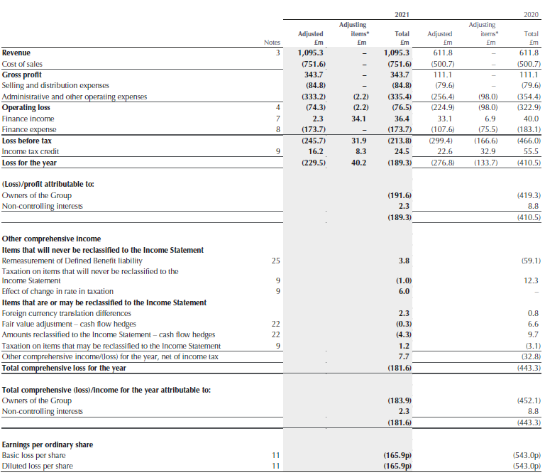

Balance Sheet
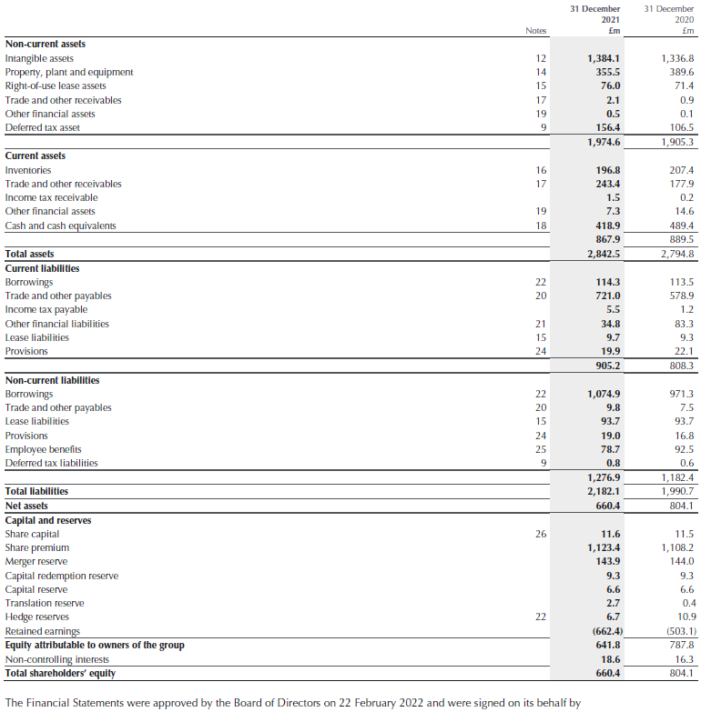

Cash Flow Statement
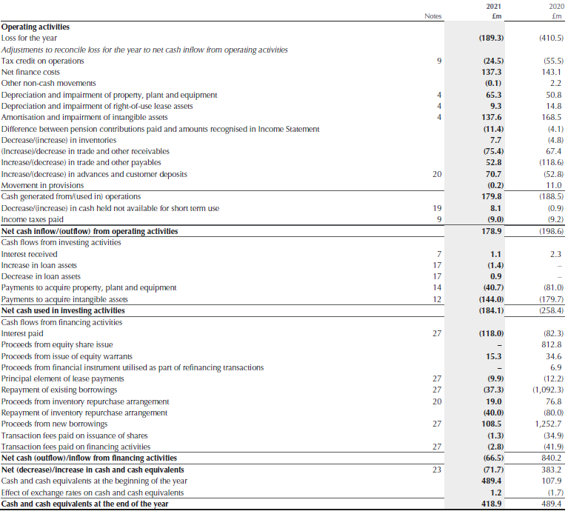

Financial Statement Types
Below are the common financial statements that are used in accounting, each own their own tell a story on the company’s performance and together provide an excellent tool to understand its overall financial health.

Balance Sheet
A balance sheet gives a snapshot of a business’s financial position by comparing its assets (what it owns) against its liabilities (what it owes) and stockholders’ equity at a point in time (Fields, 2016).
Assets – Liabilities = Equity
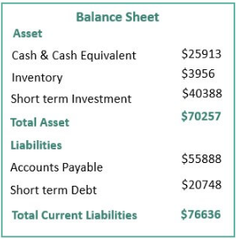
Figure 3 - Balance Sheet Example (Dhanashire, R, 2023)

Profit and Loss Statement (Income Statement)
The Profit and Loss Statement (P&L) is a report that shows the revenue and expenses within a business during a fiscal period. It is a useful tool that can be used by internal financial and nonfinancial people alike that is often reviewed monthly to try and control business spending with the aim of maintaining a positive net income position (Maverick, JB, 2021). They are also helpful to business’s when forecasting performance over a period. A company’s revenue can come from products or services sold, while expenses are often split in to two types, fixed and variable, for example licence fees or consumables respectively.
Revenue – Expenses = Net Income
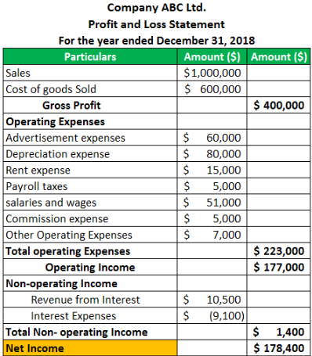
Figure 4 - P&L Example (Srivastav, A K, 2023)

Cash Flow Statement
A Cash Flow Statement is a tool used to display how much cash is generated and then how it is used over a given period within a business (CFI Team, 2022). This statement allows management, analysts, and investors to assess how much money it receives from company operations. The cash flow differs from the P&L statement as it only considers cash that has been either received or paid, rather than that which has not yet been collected.
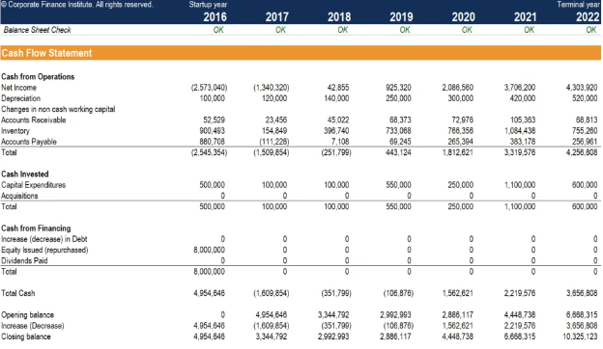
Figure 5 - Cash Flow Statement Example (CFI Team, 2022)

Ratio Calculations


