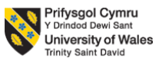

Student’s Name: Mohammed Azharuddin

Student ID: 2105239

Module Name: INTERNATIONAL MARKETING

Module Code: LCMB7006

Lecturer’s Name: Tushara Balendran
Executive Summary
This report has critically analysed the different aspects of the business environment of the automobile industry in the UK and the USA focusing on the Company Toyota. Furthermore, the SWOT analysis, the STP model, and the 7Ps marketing mix have also been carried out on Toyota. Finally, the strategy of Toyota has been analysed using Ansoff’s matrix. It has been seen that the overall situation of the business environment of Toyota is positive in both the UK and the USA, but the research facilities and pricing is better in the USA. Furthermore, the major strengths of Toyota are found to be brand image in both the UK and the USA, and their main business strategies involve market penetration and product development.

Table of Contents
1. Introduction 4
2. Background information about Toyota 4
3. The macro environment – PESTLE Model 5
3.1 Political 5
3.2 Economic 6
3.4 Technological 6
3.3 Social 6
3.5 Legal 7
3.6 Environmental 7
3.7 Comparative critical analysis of the above PESTLE model 7
4. The microenvironment – Porter's Five Forces model 9
4.1 Threat of existing rivals 9
4.2 Threat of new entrants 10
4.3 Threat of substitute products 10
4.4 Threat of buyer's power 10
4.5 Threat of supplier's power 10
4.6 Comparative critical analysis of above Porter's Five Forces model 11
5. SWOT analysis 12
5.1 SWOT analysis of Toyota in the UK 12
5.2 SWOT analysis of Toyota in the USA 13
5.3 Comparative critical analysis of the above SWOT models 14
6. Segmentation, targeting and positioning of Toyota 15
6.1 Segmentation 15
6.2 Targeting 15
6.3 Positioning 16
6.4 Comparative critical analysis of the above STP model 16
7. 7Ps marketing mix 17
7.1 Product 17
7.2 Price 17
7.3 Place and comparison on market entry methods used by Toyota 18
7.4 Promotion 18
7.5 People 18
7.6 Process 19
7.7 Physical evidence 19
7.8 Critical analysis of the above 7Ps marketing mix model 19
8. Ansoff’s matrix of Toyota 21
8.1 Market penetration 21
8.2 Market development 21
8.3 Product development 22
8.4 Diversification 22
8.5 Critical analysis of the above Ansoff’s matrix model 22
9. Conclusion 24
10. Recommendations for Toyota 24
10.1 Recommendations for Toyota in the UK 24
10.2 Recommendations for Toyota in the USA 25
References 26

1. Introduction
This assessment will analyse the internal and external factors of Toyota and their impacts on the Company’s overall success in future. All these factors will be discussed based on PESTLE analysis, Porter's Five Forces model, SWOT analysis, 7Ps marketing mix, and Ansoff matrix. The business scenario around the world has been significantly transforming around the world. This makes it necessary for companies such as Toyota to make necessary changes in their business function and operation. In context to this, the following assessment will outline various factors of the Company that are likely to challenge them in future while being able to identify essential solutions for mitigating or avoiding them from hampering their overall business.

2. Background information about Toyota
Toyota is considered as one of the largest automobile manufacturers across the globe. The headquarters of Toyota is in Toyota City in Aichi at Japan, and it was founded by Kiichiro Toyoda in 1937 (Toyota, 2022). The product range of Toyota includes different automobile products, including cars and vehicles, parts and repair services. Their product range includes some of the best-selling automobiles such as Toyota Corolla, or the modern hybrid engine vehicles such as Toyota Prius (Toyota, 2022). The five brands under the umbrella of Toyota brand are Daihatsu, Hino, Lexus, Ranz and Toyota. The number of employees working in Toyota is 366,283, and the annual revenue of Toyota is US$256.7 billion as of the fiscal year 2020-21 (Toyota, 2022).

3. The macro environment – PESTLE Model
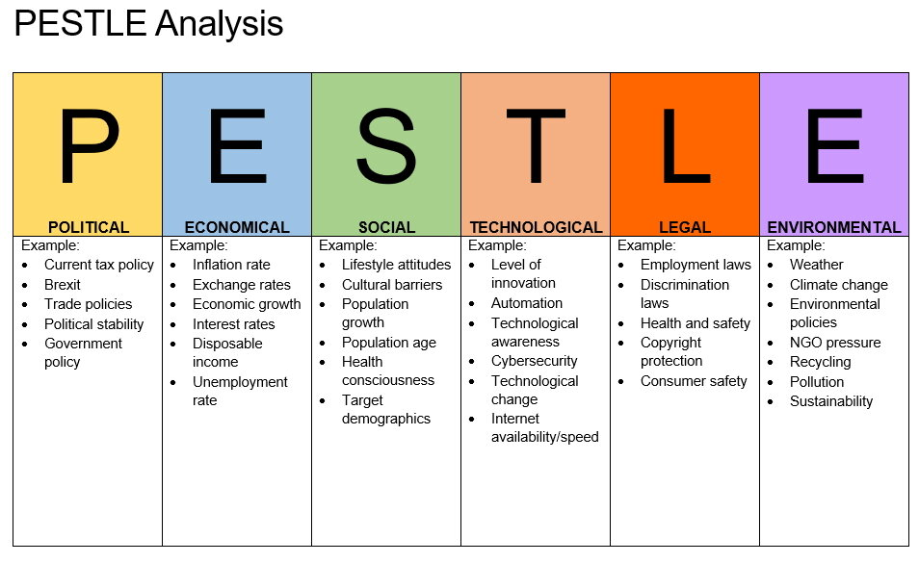
Figure 1: PESTLE Analysis
(Source: Ali et al., 2022)

3.1 Political
The political situation in the UK has reached stability after brexit, and the Company laws and low corporate tax laws (about 19%) in the UK has been optimised for acceleration of industrialisation and ease of entry for new companies (Ali et al., 2022). Permissions for license of new automobile are easy to get in the UK. Toyota is also getting benefits in land acquisition for automobile factory establishments and infrastructural developments. Basic amenities for business have also available easily in the UK.
According to Ali et al. (2022), this is highly similar to the situation in the USA, where their overall corporate taxation rate is slightly higher than that the UK (about 21%). Furthermore, the various facilities for business are also available abundantly for Toyota in the USA, such as water, electricity and transportation infrastructure. The Company laws are beneficial for Toyota in the USA, along with land acquisition laws. The permission for license of automobiles is available more easily in the USA, compared to UK (Thomsen and Kavadis, 2022). Thus, it can be argued that overall, the political situation of the UK and the USA are quite similar regarding automobile business, and political environment is a high opportunity for Toyota for both the countries.

3.2 Economic
The GDP per capita of the UK is about US$ 40,284.64, which is higher than the market average. Furthermore, the inflation rate of the UK is 7% per annum in 2022, which is mainly resulted from the increasing cost of motor fuels (Portes, 2022). This increases the capacity of Toyota to develop profitable pricing strategies, but this upwards pricing for fuels is hampering their sales. On the contrary, the GDP per capita of the USA is US$69,231, which is even higher than that of the UK, and the inflation rate of the USA is 4.7%, which is lower than that of the UK (Blecker et al., 2022). Thus, for Toyota, the economic situation of the USA is a greater opportunity than that of the UK.

3.4 Technological
The technological developments of the UK are great in terms of automobile technologies. Due to the presence of strong academic and research infrastructure, automobile technology within the UK is developed heavily, especially in terms of latest electric and hybrid engines. However, Kim et al. (2022) stated that the development in the USA is even greater, as they have excellent facilities for research and development in highly advanced automobile technologies, such as turbo-charge. Thus, the UK provides a great opportunity and the USA provides an even greater opportunity for Toyota in terms of technological development.

3.3 Social
To operate the business in the UK and USA Toyota motor has suffered the social issues associated with the languages and cultural differences of the countries with Japan. According to the article published in Corporate Finance Institute (2022), Toyota has focused on the significant strategies of Hofstede's model that describes reducing the social issues of UK and US, the Company using individualism culture, setting long-term orientation goals and masculinity processes in their business. Therefore, as there are differences found between the USA and UK culture and social factors the Company used the different strategies such as hierarchy and bureaucracy strategy for the UK and using the well-structured process in the USA to handle the social issues that they faced regarding the different culture of UK and USA (Corporate Finance Institute, 2022). The Company used the higher power distance index for leading their business in the UK and used the lower power distance index for leading their business in the USA.

3.5 Legal
Thomas et al. (2021) point out that Toyota has faced some similar and some different legal issues in the UK and USA regarding the customers' safety, pollutants, environmental impact laws and other legal problems. The UK government is charging the customers' safety laws on the Company and the Company is spending 1.7 million dollars in the UK in 2019 for providing the best security to the consumers (Thomas et al., 2021). However, in the USA the Company is spending 1.2 billion dollars in 2019 on settlement of the disputes and leading the auto industry that increasing the legal dependence of the firm (Team, 2022). The car Company chose the different strategies to reduce the similar high legal issues and enhance their business in the two different countries such as UK and USA.

3.6 Environmental
The US government is providing the environmental regulations on Toyota such as reducing the emission of CO2, minimising the environmental impact, recycling the products, planting zero CO2 emission and so many other factors that are making an impact on the business of the Toyota in USA (Team, 2022). Therefore, the UK government has provided similar kinds of environmental regulations on Toyota regarding reducing the use of hazardous chemicals in the business, improving the contribution to the environment and zero CO2 emission mission within 2050 (Team, 2022). The UK government give better support than the USA government, and it is helping the firm to achieve all of the environmental factors that they need to develop for increasing their business in those two countries' markets.

3.7 Comparative critical analysis of the above PESTLE model
From the above analysis, the comparison among the different factors of PESTLE of Toyota in the UK and USA that they faced during operating their business in those two countries are discussed here. The political stable conditions in the UK are providing support to leading the business of Toyota whereas the politically unstable position in the US is creating barriers for Toyota to generate their business in this country. Capobianco et al. (2021) stated that the different governments are providing different kinds of rules and regulations on the Company regarding the environmental factors, legal factors, pollution, and customer safety creating the problems in front of the Company to lead their business in the country. Moreover, the UK government is also creating high risks that are coming from the legal, technological and economic factors and creating moderate pressure that are coming from environmental factors. The economic issues of the USA and UK such as inflation, the changing rate of stock exchanges, the downward of the dollar rate and certain economic changes are creating big issues in front of Toyota to generate their business in these two significant global countries. Thomas et al. (2021) reported that the USA and UK environmental laws and legal laws are creating some positive impacts on the Company and they started to lead their business based on the advanced technological process. However, the social factors of the UK are more hierarchical and the people of the UK have followed the more traditional culture in their business where the USA people like to change and adapting mentality and focused on structured strategies that focused on the quality of the organisation (Sari et al., 2021). Thus, the languages, culture and different factors are also creating some new challenges in front Toyota to operate their business in the USA and UK the two major countries that are leading the most of the world economy.

4. The microenvironment – Porter's Five Forces model
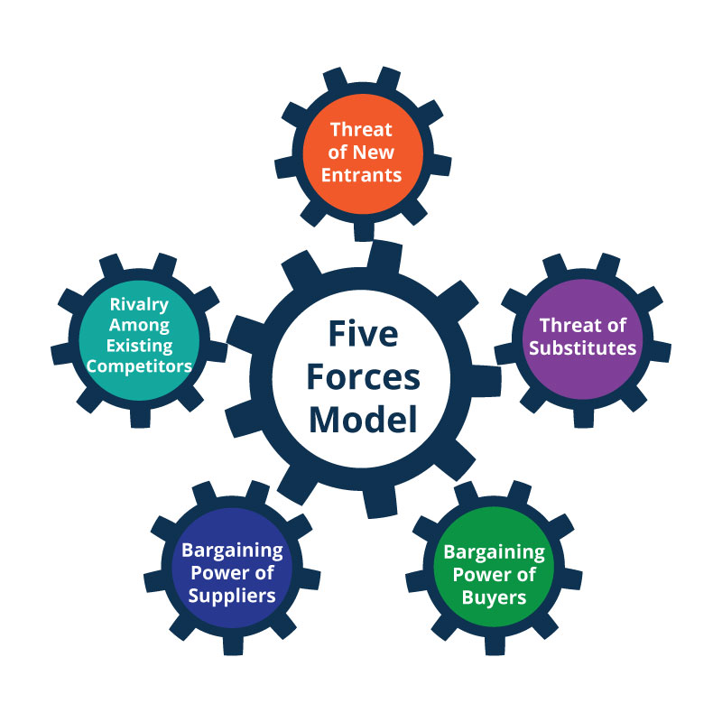
Figure 2: Porter's Five Forces Model
(Source: Ilyas and Irawan, 2021)

4.1 Threat of existing rivals
According to Ma et al. (2021), Toyota has faced strong forces from their competitive rival Companies as there are a lot of competitor car Companies available in the USA and UK market. The Company faced very strong competition in the USA, as the country is the top most preference of the other big vehicles Companies such as Tesla, Volkswagens, BMW and Mercedes. Those are the significant rivals of Toyota, who are providing more compatible products and well-featured products to the customers. The high market competition is creating new challenges in front of the Company. Ilyas and Irawan (2021) stated that in the UK market the Company has also faced strong competition but that has rather than the US market.

4.2 Threat of new entrants
The new entrants are working as the weak forces of Toyota as the Company has made a strong international image and well-marketed revenue in the international market. Appiah et al. (2021) point out that at the time of entering the USA market the Company has used the differentiation process and targeting the middle-aged people that is to help them to increase their effectiveness and develop their business in the US market. Therefore, at the time of entering the UK market the Company is using the positions and targeting the 25-55 years age group people to gain the attention of the consumers. The different entry modes of Toyota define the success of the new entrant of the firm.

4.3 Threat of substitute products
Toyota has faced moderate threats or moderate forces from the threats of the substitute product to lead their business in the USA and UK market. The low setting cost and moderate availability of the substitutes in the market are leading the moderate forces of substitutes on the Toyota business. Suwelack et al. (2022) stated that Toyota not only provided luxurious cars but also provided public transportation, and bicycle products to the consumers that could help them to hold the market presence and reduce the threats of the substitute product.

4.4 Threat of buyer's power
There are many competitors Companies available in the market. Toyota has faced high forces and threats from the buyers and the customers enjoyed the power of bargaining. It is the opinion of Appiah et al. (2021) that the customers can get the high-quality information about the competitors, find the better product features and quality from the competitors and can find the better prices strategy from the competitors Companies that is creating a big problem in front of the Company. Furthermore, the preferences and expectations of the USA and UK customers are holding the high bargaining power of them.

4.5 Threat of supplier's power
According to an article published in Panmore Institute (2022), the moderate populations of the suppliers, high quality and quantity of the supply and low forward integration of the suppliers are creating weak forces and weak bargaining power of the suppliers of Toyota to lead their business in the USA and UK market. In both those two countries, Toyota has found many suppliers that lead to the low bargaining power of the suppliers and could not make an impact on the prices strategy of the firm.

4.6 Comparative critical analysis of above Porter's Five Forces model
From the above analysis of Porter's Five Forces of Toyota, it could be found that the presence and brand images in the international market are helping them to enter the USA and UK markets and the huge number of competitors are creating new challenges in front of the Company after entering the new market. Ma et al. (2021) stated that the presence of a good number of suppliers is working as the weak forces on Toyota business in the USA and UK and as the Company provides various kinds of products to them, they reduce the threats of substitute products in the USA and UK market. It also found that the US market is much more competitive than the UK market.

5. SWOT analysis

5.1 SWOT analysis of Toyota in the UK
Strengths | Weaknesses
- Toyota holds around 5,680 hydrogen fuel cell patents worldwide including in the UK market (Profiroiu et al., 2020).  - In 2021, Toyota revealed its groundbreaking solid-state battery as a major achievement in its UK operations (Toyota, 2022).  - Despite the enormous hurdles posed by the Covid-19 epidemic, Toyota achieved performance in the UK by breaking all the records for the new car market in 2020 (Toyota, 2022). | - Toyota also set new market share records in the fleet and commercial car sales, with 5.5% for passenger cars, 5.01% for all Toyota brand vehicles, and 5.51% for all Toyota (GB) sales (Profiroiu et al., 2020).  - However, this record has been set before the Covid-19 pandemic, while following the observations have changed after the pandemic in the UK business market.  - As per following new regulations, Toyota's store network had to adjust its ways of operating because of the health emergency (Profiroiu et al., 2020).  - Toyota faced the complexities while failing to accomplish its amazing achievements in the rapid and effective response expected in the UK market.
Opportunities | Threats
- Toyota, UK is following the usage of user-friendly online video consultations and buying tools (Toyota, 2022).  - Even though no one could have predicted how difficult the trade circumstances would be, the retail partners of Toyota, UK have done an outstanding job of keeping consumers and their workers safe (Profiroiu et al., 2020).  - This initiative enhanced the opportunities while keeping the process of Toyota, the UK running with expected revenue earning.  - The good achievements are owed in large part to their devotion and, with the help of Toyota (GB) its swift and effective response (Zhang et al., 2021). | - Dependence on the hybrids of self-charging components could be a barrier while UK operations in Toyota are dependent on importing the SUV segments (Zhang et al., 2021).
Table 1: SWOT analysis of Toyota in the UK

5.2 SWOT analysis of Toyota in the USA
Strengths | Weaknesses
- In the current business of Toyota, $30.6 billion of direct investment has been done in the U.S. operations (Toyota, 2022).  - More than 2,112,941 Toyota vehicles were sold in Toyota US in 2021 (Toyota, 2022). | - Toyota recalls could not manage the quality standards for flawless production in the US operations (Weng, 2021).
Opportunities | Threats
- The high investment enhances the opportunity in Toyota US for continuing production of more than 29.9 million vehicles (Toyota, 2022). | - Despite the fact that sales volume fell, Toyota’s drop of -12.6% was the least among the major car manufacturers, and it was substantially less than the -29.4% drop in the US market (Weng, 2021).
Table 2: SWOT analysis of Toyota in the USA

5.3 Comparative critical analysis of the above SWOT models
As per following the observations of Weng (2021), the competitive strength in the operations of Toyota US is higher than its UK division by considering the current investment received by the US division to support the post-pandemic revival strategy. Meanwhile, the opportunities are not equal as compared in the current business context of both the UK and US segments of Toyota. However, Zhang et al. (2021) identified the concern for weak customer service in Toyota should be resolved for enhancing the expected opportunities in the services.

6. Segmentation, targeting and positioning of Toyota
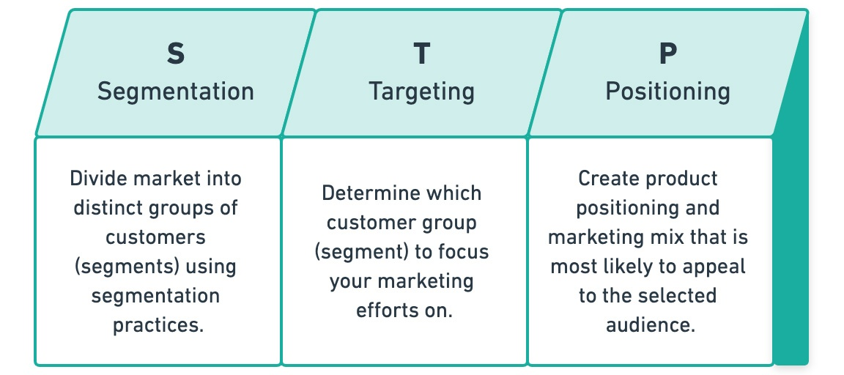
Figure 3: STP Model
(Source: Huang and Rust, 2021)

6.1 Segmentation
According to Huang and Rust (2021), Toyota has used a mixture of psychographic, geographic and demographic Segmentation strategies in their business to extend their market in the UK and USA. Moreover, after measuring the income of a particular group of society or the people and using the behavioural segmentation process the Company leads their business across the world. For the different marketing cultures of the USA and the UK Toyota has used a different segmentation process in their marketing.

6.2 Targeting
By targeting the middle-aged male people, who are part of the 35 age groups people and the US-born citizens, the Company leads their business in the USA. Gautam and Kumar (2022) point out that to grab the US market and get a huge amount of revenue from the USA market the Company focused on providing the differentiation strategy and products to their customers and try to provide the best features products to their customers that lead to the success of the firm. Therefore, to lead the business in the UK the Company targeted people in the 30-50 years age group and focused on the idle income group of people, producing value for money.

6.3 Positioning
The positioning is associated with the Company's marketing activities and perception of the customers' demons regarding the marketing strategies that are used by the competitors. Gautam and Kumar (2022) points out that positioning is the key to the success of Toyota in creating a good brand image in the USA and UK, both the countries by serving the unique and better quality services to their customers. To hold the market position in the USA and UK both of the countries Toyota used the differentiation and low-cost generic model that developed its business of them and improved its positioning in the global market.

6.4 Comparative critical analysis of the above STP model
From the above analysis, it could be criticised for the competitive nature and by using the physiographic, demographic and geographical segmentation approaches and targeting the 35 to 55 age group people, Toyota ensure their market establishment and enhancement in the USA and UK market. Therefore, according to Huang and Rust (2021), it also could be argued that Toyota used the different strategies such as targeting different kinds of audiences in the USA and UK, after measuring the purchasing nature of the two countries' customers. This was done by focusing on creating their market position by applying differentiation and low costing marketing strategy in the USA and UK market.

7. 7Ps marketing mix
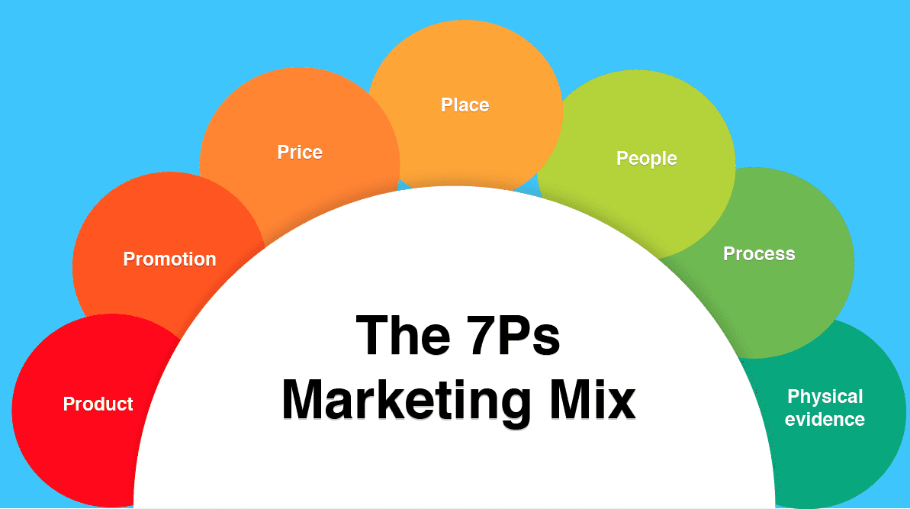
Figure 4: 7Ps Marketing Mix
(Source: Tanjung, 2021)

7.1 Product
From the various sources, it could be found that Toyota has followed almost the same marketing strategies to lead their business in the USA and UK both of the countries. According to Das et al. (2021), the main strategy and features of the product marketing strategy of Toyota are the Company provides the exclusive appealing design, luxurious cars with the unique models and offering the fuel-efficiency to the customers. By providing safety to the consumers, the Company tries to develop the features and by using the automation process, the Company enhances the competitive nature of their product in the market. Das et al. (2021) suggest that by providing the advanced features the Company increase their car demand in the USA and generate success in the USA, which is better than in the UK.

7.2 Price
Tanjung (2021) reported that Toyota has set their proportional prices strategies based on the income of their consumers and the income of the different parts of the world. By producing the high and low-income cars for the different consumers and determining the various offers strategies, the Company increases their competitive advantages in the market and develops its business in the USA and UK. Therefore, by providing high-quality products and consumer-friendly services that represent good value for consumers the Company operating their business in the market. Plarisan (2021) points out that Toyota fails to offer the second category's pricing strategies to the customers. They offer their product to the social classes A to A+ group people that are not suitable for each kind of customer.

7.3 Place and comparison on market entry methods used by Toyota
It is the opinion of Tongphet et al. (2021) that Toyota has applied the two different market entry methods and different strategies to choosing the place for the market expansion in the UK and USA. By using the differentiation targeting market strategy, Toyota entered the USA market. Moreover, to enter the UK market the Company has focused on the traditional process, which is the significant key to the UK market places. By choosing the correct marketplaces, Toyota has successfully enhanced its business in the two different countries and established its good position in the UK and USA markets.

7.4 Promotion
According to Ryńca and Ziaeian (2021), Toyota has focused on using the direct selling, public relations, ads, sales promotion and personal selling process in their business rather than the using of the digital process. By providing the Television advertisement, print campaigns and newspaper advertisement process Toyota led their promotional strategy in the UK. This is a very effective process for the UK to extend the market and make awareness among the people. However, Ryńca and Ziaeian (2021) reported that Toyota has used the digital and newsprint advertising process in the USA, which is also a significant step for the Company to extend their market and business and effective promotional strategy in the USA. By applying the different marketing promotional approaches the Company makes a good image in two countries.

7.5 People
The different kinds of stakeholders, shareholders, customers and employees of the Company are taking an important part of people to achieve the success of the firm. As opined by Siripipatthanakul et al. (2021), Toyota hires the solutions-oriented people, operational staff who are ready to face any kind of challenges, higher experts for the research about the innovation product and provide the open learning opportunity to their employees. All of the steps are significant steps for Toyota that they are helping them to leading their business in the UK and USA and to manage and handle the people and customers of those two countries. () argue that focused on the 30 to 55 years age group people, the Company leading their car business across the world and specifically in the USA and UK.

7.6 Process
In the process segment, the manufacturing process of Toyota, the different promotional processes that they followed leading their business in the UK and USA, the product development process and operational process are recorded (Siripipatthanakul et al., 2021). By focusing on providing eco-friendly manufacturing and reduction, focusing on the product efficiency process and focusing on the management process Toyota leads the different businesses in USA and UK the two famous countries. In the porches strategy, the Company faced similar kinds of factors in those two countries and they led a similar kind of processing to appreciate the customers of those two countries.

7.7 Physical evidence
According to Plarisan (2021), the physical evidence of Toyota in the UK and USA are associated with getting the fundamental identity, making the good images by providing the best strategy and by providing the unique logo, they represented their presence in the market. Therefore, by representing the sincerity of the brand and ensuring the consumers by setting the services and raising the confidence of the firm in the international market. The good market presences and well brand images are the significant physical evidence of Toyota that helping them to lead their business in the USA and UK.

7.8 Critical analysis of the above 7Ps marketing mix model
From the above analysis, it could be criticised that Toyota used the same product quality to lead their business in both the USA and UK markets. However, the Company provides the different prices strategy to the different kinds of customers of those two countries and after doing the market research about the UK and USA, the Company follows the different promotional strategies in those two countries. Ryńca and Ziaeian (2021) point out that by choosing the different target market and using personal selling, advertisement and public relations process the Company tries to gain the attention of the UK and USA people. As in the USA, most of the rich people are living, the Company offering the higher standard car product to them and the USA customers are focusing more on their safety than the money. By using it, the Company makes a huge profit from the USA and provides the advanced technological cars products Toyota leading a great number of revenues from the USA market (Tongphet et al., 2021). Therefore, by providing excellent customer services and unification among the customers, the Company led their business image in those two counties and by adopting the traditional advertising or promotional strategy, the Company developed their business in the UK market. From this comparison, this study is focused on all of the core marketing features and different strategies Toyota used to generate its business in the different countries across the world.

8. Ansoff’s matrix of Toyota
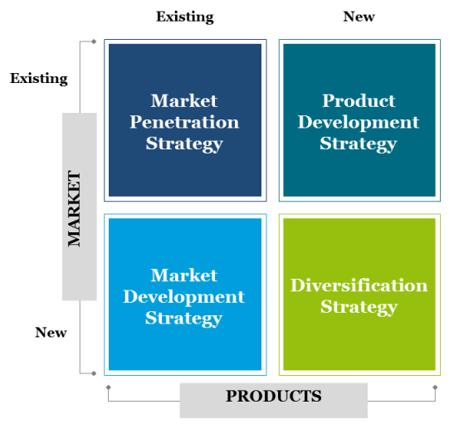
Figure 5: Ansoff’s Matrix
(Source: Business analysis, 2022)

8.1 Market penetration
According to an article published in Business analysis (2022), to operate the business in the USA and UK markets Toyota followed similar market penetration strategies that include suitability, acceptability and feasibility factors. Developing the marketing management activities, improving the product quality and the quality of services and considering the fair amount of cost of implementing the particular and specific strategies are helping the firm to find and get the attention of targeting customers and becoming the largest range of automotive industry in the USA and UK. The market penetration strategy is focused on the strategy that Toyota used to increase production capacity, increase marketing investment, develop the design engaging communication and enhance the distribution.

8.2 Market development
For developing the market Toyota is more involved with the innovative research and development programs such as the Company investing in more for making new research, identifying the different market and customer behaviours in the USA and UK and focusing on the regional expansion (Helmold, 2021). By expanding its market in the different cities and regions in the USA and UK the Company developed their market. Therefore, by focusing on the new customer segments, identifying the new product users and making the brand aware Toyota expanding its market and developing its position in the UK and USA.

8.3 Product development
It is the opinion of Chaturvedi et al. (2022) that by developing the quality of the product after measuring and making the research about the other automotive competitive industry and spending a huge amount to developing the manufacturing by using the advanced technology Toyota associated with the product development strategy in the USA and UK. By continuing building the technology the Company offers the 'new fuel' alternatives, providing the Prius model that is known as the eco-friendly vehicle and associated with the rapid progress of developing the new product marketing and improving the business in the USA and UK. The US government was also satisfied with the Toyota decision regarding the environmentally friendly prediction.

8.4 Diversification
To develop the diversification strategy Toyota used the vertical diversification and horizontal diversification in their business associated with launching the new product and product development, looking for the growth and introducing the new product under the existing product line in the USA and UK markets (Shalender and Sharma, 2022). By developing the new business and using the mergers and acquisitions process, the Company provides the different kinds of products to the customers that develop the business of the firm in the international market.

8.5 Critical analysis of the above Ansoff’s matrix model
From The above analysis, it could be criticised that Toyota is investing more to enhance their research and product development and raise the market in the international position. By applying the same kinds of activities and market strategies, the firm established its business and images in the USA and UK markets. Schlegelmilch (2022) stated that launching the new eco-friendly products, modifications of the existing products and making strategic partnerships with the other local brands are developing the market of the firm. Moreover, by developing the product quality and focusing on the new customer segment in the USA and UK market the brand is developing its business and level of the profit margin.

9. Conclusion
From the above analysis, it could be found that Toyota used some similar and some different strategies of marketing to lead their business in the USA and UK markets. As the USA and UK have led the different approaches, cultures and traditions, the Company uses the different 7Ps marketing strategies, promotional strategies, Ansoff’s matrix and different STP strategies to establish their position in the market. In the end, it could be concluded that by using the different strategies and political, economical and technological factors the Company improves their strengths and opportunities in the global market.

10. Recommendations for Toyota

10.1 Recommendations for Toyota in the UK
- Mandalka et al. (2022) suggest that to develop the market and increase their business in the UK market Toyota need to develop their supply chain management activities and manufacturing activities in the UK. Therefore, after understanding the needs of the customers of the different age groups, people in the Company can provide better products and services to their customers. Being more involved with the market research and development strategy can provide the success of the firm. By developing and being more involved with innovation, the Company can achieve the demand of the customers, which is one of the threats of the Company (Shah and White, 2021).
- Shah and White (2021) reported that using the key milestone and important development such as investing more using the advanced technology and offering a reasonable prices strategy are the significant factors for the Company to achieve the success and gain the well-positioned UK market. By developing their competitive advantages and making alliances with the local vehicle companies Toyota can be much more aware of the market and demand of the customers and can grab the attention of the consumers. Holding the reasonable prices strategy is a significant feature of success in the UK market.
- Mandalka et al. (2022) stated that after the Covid-19 pandemic, the Company must focus more on the health and safety of their employees and customers and by providing the eco-friendly product, the Company can make a good brand image in the international position. The Company needs to operate much better customer services and train their employees to provide the best support to their customers.

10.2 Recommendations for Toyota in the USA
- Li et al. (2021) point out that to achieve more success in the US market Toyota needs to focus on its promotional strategy. In this digital era, the Company still focused on the traditional advertising process that could not grab the attention of the customers. The other comets brands are providing digital advertisement and using social media platforms to provide the promotional strategies. By using the different digital advertising tools, the Company can increase its business in the USA market.
- Hafidz and Soediantono (2022) suggest that by using the different digital platforms Toyota can maintain and manage a better quality relationship with their customers that the other competitors' brands are followed to achieve their business in the USA market. By sending the regular messages in the different digital media, mail to inform the customers about the new offers and making the live product launching programmes the Company can have success and hold a better position in the USA competitive market. Moreover, by making effective communications the Company can build a good relationship with the customers, which is the key to the success of the organisation.
- Qi et al. (2022) argue that by knowing and understanding the demand of the different age groups people and their income Toyota can offer a different variety of products that develop their market position and increase the business effectiveness in the USA market. However, by making the brand awareness and inspiring the shareholders for the more investment to make more researches the Company can improve their marketing strategies, develop their product and develop products and services that are the key to the success and stand the well positioned in the USA competitive market of the Company. According to Fricke (2022), by taking the new features and strategies, the Company can overcome the Covid-19 situations that they faced in the USA to lead the market and hold the health of employees that are developing the overall business of the organisation.

References
Ali, S., Rangone, A. and Farooq, M. (2022). Corporate Taxation and Firm-Specific Determinants of Capital Structure: Evidence from the UK and US Multinational Firms. Journal of Risk and Financial Management, 15(2), p.55.
Appiah, M.K., Sedegah, D.D. and Akolaa, R.A. (2021). The implications of macroenvironmental forces and SMEs investment behaviour in the energy sector: the role of supply chain resilience. Heliyon, 7(11), p.e08426.
Blecker, R.A., Cauvel, M. and Kim, Y.K. (2022). Systems estimation of a structural model of distribution and demand in the US economy. Cambridge Journal of Economics, 46(2), pp.391-420.
Business analysis (2022). [online] Available at: <https://www.mbaknol.com/business-analysis/ansoff-matrix-analysis-of-toyota/> [Accessed 29 April 2022].
Capobianco, N., Basile, V., Loia, F. and Vona, R. (2021). Toward a Sustainable Decommissioning of Offshore Platforms in the Oil and Gas Industry: A PESTLE Analysis. Sustainability, 13(11), p.6266.
Chaturvedi, S., Verma, M., Purohit, S. and Varaprasad, R.R. (2022). Digital Value Innovation and Strategic Management Practices of Adyar Ananda Bhavan. In Cases on Digital Strategies and Management Issues in Modern Organizations (pp. 51-76). IGI Global.
Corporate Finance Institute (2022). Hofstede’s Cultural Dimensions Theory. [online] Corporate Finance Institute. Available at: <https://corporatefinanceinstitute.com/resources/knowledge/other/hofstedes-cultural-dimensions-theory/> [Accessed 28 April 2022].
Das, G., Jain, S.P., Maheswaran, D., Slotegraaf, R.J. and Srinivasan, R. (2021). Pandemics and marketing: insights, impacts, and research opportunities. Journal of the Academy of Marketing Science, 49(5), pp.835-854.
Fricke, L. (2022). The Long-term Problem with Electric Vehicle Batteries: A Policy Recommendation to Encourage Advancement for Scalable Recycling Practices. Seattle Journal of Technology, Environmental & Innovation Law, 12(1), p.2.
Gautam, N. and Kumar, N. (2022). Customer segmentation using k-means clustering for developing sustainable marketing strategies. Бизнес-информатика, 16(1 (eng)), pp.72-82.
Hafidz, A. and Soediantono, D. (2022). Benefits of 5S Implementation and recommendation in the Defense Industry: A Literature Review. International Journal of Social and Management Studies, 3(3), pp.13-26.
Helmold, M. (2021). Glossary of Management Terms. In Successful Management Strategies and Tools (pp. 213-219). Springer, Cham.
Huang, M.H. and Rust, R.T. (2021). A strategic framework for artificial intelligence in marketing. Journal of the Academy of Marketing Science, 49(1), pp.30-50.
Ilyas, N.F. and Irawan, A. (2021). Business Feasibility Towards Clothing Convection: A Case Study of Raiment. Malaysian Journal of Social Sciences and Humanities (MJSSH), 6(9), pp.545-560.
Kim, J., Paek, B. and Lee, H. (2022). Exploring Innovation Ecosystem of Incumbents in the Face of Technological Discontinuities: Automobile Firms. Sustainability, 14(3), p.1606.
Li, K., Yen, K., Misra, S., Hu, Y., Hu, C. and Verma, M. (2021). BAN: Large Scale Brand ANonymization for Creative Recommendation via Label Light Adaptation. In 2021 IEEE International Conference on Big Data (Big Data) (pp. 5950-5952). IEEE.
Ma, S., Mai, J., Wang, W., Yao, K. and Li, D. (2021). Development Status and Trend of New Energy Vehicles in China: Consumer Data Analysis Based on Internet. International Journal of Education and Humanities, 1(1), pp.10-15.
Mandalka, A., Cavalcanti, M.I.L.G., Harb, T.B., Toyota Fujii, M., Eisner, P., Schweiggert-Weisz, U. and Chow, F. (2022). Nutritional Composition of Beach-Cast Marine Algae from the Brazilian Coast: Added Value for Algal Biomass Considered as Waste. Foods, 11(9), p.1201.
Panmore Institute (2022). Toyota’s Five Forces Analysis (Porter’s Model) - Panmore Institute. [online] Panmore Institute. Available at: <http://panmore.com/toyota-five-forces-analysis-porters-model#:~:text=Synopsis%3A%20Toyota's%20Five%20Forces%20Analysis&text=Competitive%20rivalry%20or%20competition%20(strong,substitutes%20or%20substitution%20(moderate%20force)> [Accessed 28 April 2022].
Plarisan, G.M.G. (2021). MARKETING MIX IMPLEMENTATION AND STUDENTS’MOTIVATION IN ABC COLLEGE: BASIS FOR MARKETING PROGRAM. MARKETING MIX IMPLEMENTATION AND STUDENTS’MOTIVATION IN ABC COLLEGE: BASIS FOR MARKETING PROGRAM, 80(1), pp.22-22.
Portes, J. (2022). Immigration and the UK Economy after Brexit. Oxford Review of Economic Policy, 38(1), pp.82-96.
Profiroiu, M., Kaneko, H., Vlad, C., Dutescu, A. and Ishida, H. (2020). Toyota Motor Corporation's Culture Strategy. Revista de Management Comparat International, 21(4), pp.458-489.
Qi, K., Wang, R., Lu, Q., Wang, X., Jing, N., Niu, D. and Chen, H. (2021) Dual Learning for Query Generation and Query Selection in Query Feeds Recommendation. In Proceedings of the 30th ACM International Conference on Information & Knowledge Management (pp. 4065-4074).
Ryńca, R. and Ziaeian, Y. (2021). Applying the goal programming in the management of the 7P marketing mix model at universities-case study. Plos one, 16(11), p.e0260067.
Sari, P.N., Gusti, A., Suci, I. and Pratama, M. (2021) Sustainability of the climate village program to prevent the impact of climate change on water supply and sanitation: a perspective from the PESTLE analysis. In IOP Conference Series: Earth and Environmental Science (Vol. 708, No. 1, p. 012086). IOP Publishing.
Schlegelmilch, B.B. (2022). Selecting and Entering Global Markets. In Global Marketing Strategy (pp. 51-81). Springer, Cham.
Shah, C. and White, R.W. (2021). Task intelligence for search and recommendation. Synthesis Lectures onSynthesis Lectures on Information Concepts, Retrieval, and Services, 13(3), pp.1-160.
Shalender, K. and Sharma, N. (2022). Integrating strategic flexibility and marketing system to achieve sustainable competitive advantage: conceptual refinement and framework. World Review of Entrepreneurship, Management and Sustainable Development, 18(1-2), pp.175-194.
Siripipatthanakul, S., Phayaphrom, B., Nurittamont, W. and Chana, P. (2021). Effect of the service marketing mix (7Ps) on patient satisfaction for clinic services in Thailand. International Journal of Business, Marketing and Communication, 1(2), pp.1-12.
Suwelack, T., Stegemann, M. and Ang, F.X. (2022). Understanding the Outside World: Customers and the Surrounding Environment. In Creating a Customer Experience-Centric Startup (pp. 53-84). Springer, Cham.
Tanjung, I. (2021). Analysis of the Effect of Marketing Mix 7P on Purchase Decisions at Sentra Snack Stores. International Journal of Review Management Business and Entrepreneurship (RMBE), 1(2), pp.125-133.
Team, M. (2022). Toyota PESTLE Analysis | MBA Skool. [online] MBA Skool. Available at: <https://www.mbaskool.com/pestle-analysis/companies/17959-toyota.html> [Accessed 28 April 2022].
Thomas, P.J.M., Sandwell, P., Williamson, S.J. and Harper, P.W. (2021). A PESTLE analysis of solar home systems in refugee camps in Rwanda. Renewable and Sustainable Energy Reviews, 143, p.110872.
Thomsen, S. and Kavadis, N. (2022). Enterprise Foundations: Law, Taxation, Governance, and Performance. Annals of Corporate Governance, 6(4), pp.227-333.
Tongphet, S., Yaibuates, M., Bhrommalee, P. and Kantawong, K. (2021). A Study of Supply Chain and the Marketing Mix of Tai Lue Woven Fabric in Phayao Province, Thailand. In 2021 Joint International Conference on Digital Arts, Media and Technology with ECTI Northern Section Conference on Electrical, Electronics, Computer and Telecommunication Engineering (pp. 257-260). IEEE.
Toyota (2022). Profile | Company | Toyota Motor Corporation Official Global Website. [online] Toyota Motor Corporation Official Global Website. Available at: <https://global.toyota/en/Company/profile/?padid=ag478_from_header_menu> [Accessed 28 April 2022].
Toyota (2022). Toyota USA | Operations | Design, Engineering & Marketing. [online] Toyota.com. Available at: <https://www.toyota.com/usa/operations/> [Accessed 28 April 2022].
Weng, X. (2021). Towards Business Resilience against Business Crisis in China, Japan, and South Korea by Stage Model Comparative Case Study on Sanlu, Toyota, and Samsung. Journal of Japan Society for Business Ethics Study, 28, pp.209-224.
Zhang, H., Liu, X., Li, H., Hasa, I. and Passerini, S. (2021). Challenges and strategies for high‐energy aqueous electrolyte rechargeable batteries. Angewandte Chemie International Edition, 60(2), pp.598-616.

