
Skills for the Workplace
Module Assignment Submission
Student Name: | Elton Rees
Student Number: | 2022162
Module No: | BMSK4008
Module Title: | Academic and Research Skills - Managing Remotely

Statement of Confirmation of Authenticity
By the act of making this submission, the student declares that this is the work of the student named above. The work has not, in whole or in part, been knowingly presented elsewhere for assessment, or where assessment has been built on a previous assessment, this has been identified. Where materials have been used from other sources it has been properly acknowledged. If this statement is untrue, the student acknowledges that an assessment offence has been committed.
Attention is drawn to the plagiarism and unfair practice policies of both the University and of ILM.
Permission for ILM to use this script
ILM uses learners’ submissions – on an anonymous basis – for assessment standardisation. By submitting, both the centre and the learner agree that ILM may use this script on condition that identifying information is removed. However, if you are unwilling to allow ILM use this script, please refuse by ticking the box: □

Table of Contents
Introduction………………………………………………………………………………………………………………………………………….2
Pros……………………………………………………………………………………………………………………………………………..……..….4
Cons 5
References 14
Anon 14
Report: Remote work in the age of Covid-19 14
Appendix 1 15
Appendix 2 16

Introduction

During the 2020/2021 global pandemic all businesses and workplaces, schools and colleges etc have had to adapt to a new way of working.
Companies etc have had to undertake more business online and and learn to manage employees remotely.

Part 1

In order for employees to work remotely successfully, employees must have the technology they need to be successful, which may be more than just a mobile phone and laptop. For example, if you expect employees to attend virtual meetings, do they have adequate cameras?

Even if you do not have an extensive set of technology and tools available, you may have to equip employees to function effectively when remote. Managers cannot assume that their employees know how to operate with virtual communication or remain comfortable in that environment.
Acknowledge that virtual communications are different, and will not be perfect, but should still be professional and respectful of others. Managers must also be mindful that virtual communications may be less comfortable and effective for some. For example, if you have not settled an issue in six emails, the conversation may need to be elevated to a virtual meeting to get closure, via Teams, Skype or other online applications.

There are many advantages and disadvantages of remote working and managing remote working.

Pros
Higher productivity
People who are working remotely tend to be more productive as compared to their in-office counterparts. Several reasons for the enhanced productivity of remote workers.
Lesser distractions - When working remotely, no one is going to show up on your work desk to discuss trivial matters and have a discussion that is of no interest to you.
Many remote jobs allow you to work outside the regular 9-5 office hours. You can work at different times of the day when you are more productive. A lot of employers do not mind your flexible work schedule as long as you are completing your tasks on time.

Better work-life balance

Working remotely means that you can spend more time with your family. Additionally, it is possible to create a schedule that can help you achieve the perfect balance between work and personal life.
Not commuting to work means that you can save a significant amount of time. Therefore employees can utilise these saved hours to have some quality time with their family.

By getting some extra time daily to manage personal life, remote workers are more satisfied in their jobs.
Also, this is beneficial to organisations in the sense that it’s easy to retain employees and thus, maintain a high employee retention rate.

More savings and lesser carbon footprint
Another key advantage of working remotely is that you can save more money each year.
Just imagine, all the bills that you pay for your transportation, parking tickets, vehicle maintenance, paying for lunch, etc. cease to exist. All these savings become a reality when you are working remotely.
By not commuting to work, you also reduce your carbon footprint as you will not be taking your vehicle out. Additionally, it will not only help you do your bit to save the environment but also save fuel for the future.

Cons

Communication Gaps

One of the most important things that are often missing in a remote work arrangement is proper communication among colleagues, management and employees.
In the office, it is so easy to approach any colleague whenever you want to discuss something in person.
However, remote workers have to rely on instant messaging and video calls to communicate with team members.
While video conferencing can be a solution, it can never be as effective as talking to someone who is sitting right next to you.
The absence of proper communication among remote teams is likely to act as a roadblock for effective team collaboration.

Lack of motivation

As there is no active supervision and your colleagues are not working around you, it can be difficult to stay motivated and meet specific targets and deadlines.
This has always been one of the biggest challenges associated with remote working.
As a remote worker, you can easily become prone to a laid back attitude, and a habit of procrastinating. Once that starts to happen, it is certainly going to be a downfall in your professional life.

Lack of Social Interaction

It is obvious that you are going to miss social interaction with the people in your organisation.
The lack of social interaction will affect remote workers if they are an extrovert or a social butterfly. Also, when employees who work the whole day without talking to anyone, they are most likely to feel lonely.
Management will need to put more effort to interact with people in their team and even have to take part in remote team building activities.

Management challenges

While remote working may sound interesting, one thing that most people fail to notice is that most of them have to manage everything ranging from their workstation to internet connection all by themselves.
Working remotely means that you have to learn and use various technologies, including apps like to-do lists, project management software, etc. to stay productive.
Furthermore, it is also your responsibility to keep yourself organised and make sure that you have everything that you need to properly manage your work and oversee your employees.

Proofhub.com. (2021)

According to slack report - remote work in the age of covid 19.(2021)
An estimated 16 million U.S. knowledge workers started working remotely due to the Covid-19 as of March 27; that number is likely much higher now.
Remote work in the age of covid 19.(2021)

78% of new remote workers feel that their workplace is organised in a way that helps them communicate and collaborate efficiency while the figure for experienced remote workers.
83% of new remote workers feel that they can easily get in touch and engage with the people they need to collaborate with while the figure for experienced remote workers is 89%.
Also only 89% of new remote workers know where to find documentation or resources they need to do their work, while experienced remote workers average at 91%. ( See Appendix 3).
However the overall job satisfaction between new remote workers and experienced remote workers is very different, with only 10% of experienced remote workers experiencing satisfaction with their working arrangement while new remote workers is 23%.
Productivity between new remote workers and experienced remote workers illustrate a large gap. At 31% productivity for new remote workers and only 13% for experienced remote workers.
Also, when measure on a “Sense of belonging at work” 48% of new remote workers felt they had a sense of belonging while only 25% of experienced remote workers felt they had a sense of belonging at work.
(See Appendix 4).

Conclusion
With such a large difference between the figures of new remote workers and experienced remote workers, Does this highlight in a lack of management awareness of problems that experienced remote workers are experiencing, with a lack of the “sense of belonging” or productivity? Management will need to address why the experienced remote workers feel like this. If management are aware of any such problems, maybe some remote team building exercises need to be implemented. Are they feeling isolated? Maybe introducing a mental health and wellbeing programme? Management will need to address these areas to ensure increased productivity, staff retention, and wellbeing among their staff.

According to the Gartner poll, (See Appendix 1) Out of the Changes that have been made because of Covid, which do you expect to keep in place after the vaccines are widely adopted?

Allowing employees to work remotely at least part of the time 90%
Flexibility on when people work 65%
Additional employee benefits (mental health benefits, child care leave, etc) 44%
Changes to productivity monitoring for remote employees 26%
Flexibility on how much people work (allowing less hours for less pay) 17%
Changes to compensation for remote employees 7%
Other 5%
None of the above 1%

With such a high number of employers willing to continue for their employees to work from home illustrates that it must be working successfully without any major issues affecting productivity.

Conclusion

Hybrid workforce

Several companies have already announced plans to shift to a hybrid or completely remote working model after the pandemic. Asking these three questions will support success when considering this alternative working model.

July 10, 2020 - According to Gartner, 74% of surveyed CFOs plan to keep part of their workforce permanently remote after the COVID-19 crisis. Both organizations and employees see opportunities and benefits from remote working including flexibility, increased productivity and employee satisfaction. Several companies have already announced plans to shift to a hybrid or completely remote working model after the pandemic.
In this post, we explore three important questions to ask that will support success as companies consider a hybrid path.
Every employee responds to circumstances differently. Some thrive in an office setting. Others are better able to focus in a remote environment. Additionally, employees have likely adjusted to their new ways of working; for example, many have embraced a new-found flexibility in working hours. Consider all employee needs and preferences – existing and new – when revising policies toward remote and onsite work.
Employers should anticipate a further socialization process as employees acclimate to further changes associated with the move to a hybrid model. A McKinsey survey observed a dip in energy levels among Chinese workers at the start of the pandemic. However, energy returned to normal levels once people adapted to remote working.
Lastly, consider new management skills that arise as some employees return onsite while others remain remote. Remote employees may fear disadvantages, such as a lack of visibility for promotions. Leaders will be required to manage remote-first and spend a significant share of time in remote work. It is important to devise solutions that eliminate any potential for exclusion. McKinsey.com 2020

Improvements for Remote Managers
In order to be a successful manager of a remote workforce, the manager will have to be on the lookout for signs of distress in your employees.

They must use both direct conversations and indirect observations to get visibility into employees’ challenges and concerns. Use every opportunity to make clear to employees that you support and care for them. To facilitate regular conversations between managers and employees, provide managers with guidance on how best to broach sensitive subjects arising from the COVID-19 pandemic, including alternative work models, job security and prospects, impact on staffing and tension in the workplace.

Promote dialogue between managers and employees ensures that communication efforts help, rather than hurt, engagement. Keep employees’ understanding of organisations’ decisions and their implications during change is far more important for the success of a change initiative than employees “liking” the change.

Managers must trust in their employees, they may be concerned and even frustrated to lose the constant visibility they once had into their employees, but do not respond by micromanaging. That will only disengage and fatigue already stressed employees. Do not fixate on perceived performance problems; you will have plenty of time to lean on established performance management systems once the height of the crisis abates.

Many companies have spent the past couple of years building a set of values that describe how much they care about their employees, and how it is important for them to create great lives and experiences for their employees. Make sure to reinforce these values with employees.
Also continue to model the right behaviours and encourage employees to call out unethical conduct.

Use objectives to create clarity as role definitions may start to fall apart during the disruption, leaving employees unsure of where to focus. Focus on what employees should be accomplishing. Emphasise objectives over processes to create greater clarity for employees and drive greater engagement levels.

Managers may have to focus on outputs and not processes with many people juggling work and family commitments in their own homes, enable employees to complete their work in ways that are easiest and most productive for them. Schedule collaboration at a mutually agreeable time and lean on virtual tools wherever possible. Providing flexibility empowers teams to complete their assignments in their own way.

Effective recognition not only motivates the recipient but serves as a strong signal to other employees of behaviours they should emulate. Recognition does not need to be monetary; consider public acknowledgment, tokens of appreciation, development opportunities and low-cost perks. Managers at organisations facing a slowdown can take this opportunity to provide development opportunities to employees who normally do not have capacity.

Given the lack of visibility in a remote environment, managers must try to improve your monitoring techniques and relationships with direct reports. Use simple pulse surveys to ask specific questions or track output to collect data and find areas of recognition. By meeting with employees virtually and asking what barriers they have overcome or ways peers have helped them, you can identify elements to recognise, thank and share the accomplishments of teams and their members. Baker, M. (2021)

Part 2

Using Gibbs Reflective Cycle Model (see Appendix 2) Gibbs 1988
I can reflect on my own research skills as well as the findings of “managing remotely”.

Reflection - A managers perspective

Description

Covid-19 pandemic happened and the employees had to start working from home.

Feelings

As a manager, at the beginning of the pandemic, I felt anticipation, dread, anxiety relating to all aspects of managing a remote workforce, I was questioning everything. Would the staff have all the technology? Would the work get done? Technological problems? Logging in, remote access to the system, sorting IT issues out, deadlines being met, low staff morale, arranging meetings via Teams etc. but as time went on I felt less stressed and anxious as it seemed to be going fairly smoothly.

Evaluation

There have been mixed reviews about the whole experience, over time staff tend to feel isolated and lonely. On a positive, employees do enjoy a better work/life balance. No parking costs or fuel costs etc.

Analysis

As a manager, I regular speak to the staff, arrange meetings via Teams, try and communicate as regularly as possible and engage with all staff. If any staff are struggling, ensure there is an adequate support network in place.

Conclusion

I could have arranged more team building exercises, praised the staff for their work and boost employee morale a lot more.

Action Plan

As we are easing out of the current pandemic situation, I could offer staff the opportunity to continue to work from home or come into the office flexibly whenever it suited each employee. As long as work was getting done and targets were being achieved it could prove beneficial for staff.

Reflection – Personal perspective

By researching “Managing Remotely” I have engaged in sourcing credible articles, data and websites to obtain necessary information in order to compile a report which illustrates pros and cons of a remote workforce, plus adjustments managers need to make in order to manage a remote workforce successfully.
I have learned to manage my time effectively, and not procrastinate, by doing a little bit of research regularly, therefore gaining more knowledge and information. Planning and scheduling time to study and research. My note-taking skills have increased by listening to the recordings and attending teams meetings I can take notes more effectively by actively listening and discussing any queries with my fellow students and tutor.

Description

My first assignment, studying and researching the topic in order to complete my assignment.

Feelings

Anxious, nervous and extremely apprehensive. Am I doing this right? What if I get it wrong? Will It be good enough? Etc.

Evaluation

Researching and studying has been an enjoyable experience, it has been quite a long time since I have undertaken anything educational and academic. I have learned a lot about myself and my own learning styles.

Analysis

Conclusion

Ensure I attend all the teams meetings, take more notes and listen actively, participate in homework tasks and ask more questions if I am not sure of anything.

Action Plan

Ensure I attend all the teams meetings, take more notes and listen actively, participate in homework tasks and ask more questions if Im not sure of anything.

References

Anon

(2021) Images-cdn.newscred.com. Available at: https://images-cdn.newscred.com/Zz0yMTRlY2EwYzNiZGMxMWViOThkMjBhOTc1MWU1MWM4MQ== (Accessed: 21 March 2021).

Baker, M. (2021) 9 Tips for Managing Remote Employees, Gartner.com. Available at: https://www.gartner.com/smarterwithgartner/9-tips-for-managing-remote-employees/ (Accessed: 21 March 2021).

Gibbs (1988) Reflective Cycle.

(2021) Proofhub.com. Available at: https://www.proofhub.com/articles/pros-and-cons-of-working-remotely (Accessed: 21 March 2021).

Report: Remote work in the age of Covid-19

Report: Remote work in the age of Covid-19 (2021). Available at: https://slack.com/intl/en-gb/blog/collaboration/report-remote-work-during-coronavirus (Accessed: 22 March 2021).

Three important questions for the future of remote work, McKinsey.com Available at: https://www.mckinsey.com/business-functions/organization/our-insights/the-organization-blog/three-important-questions-for-the-future-of-remote-work (Accessed: 22 March 2021).

Appendix 1
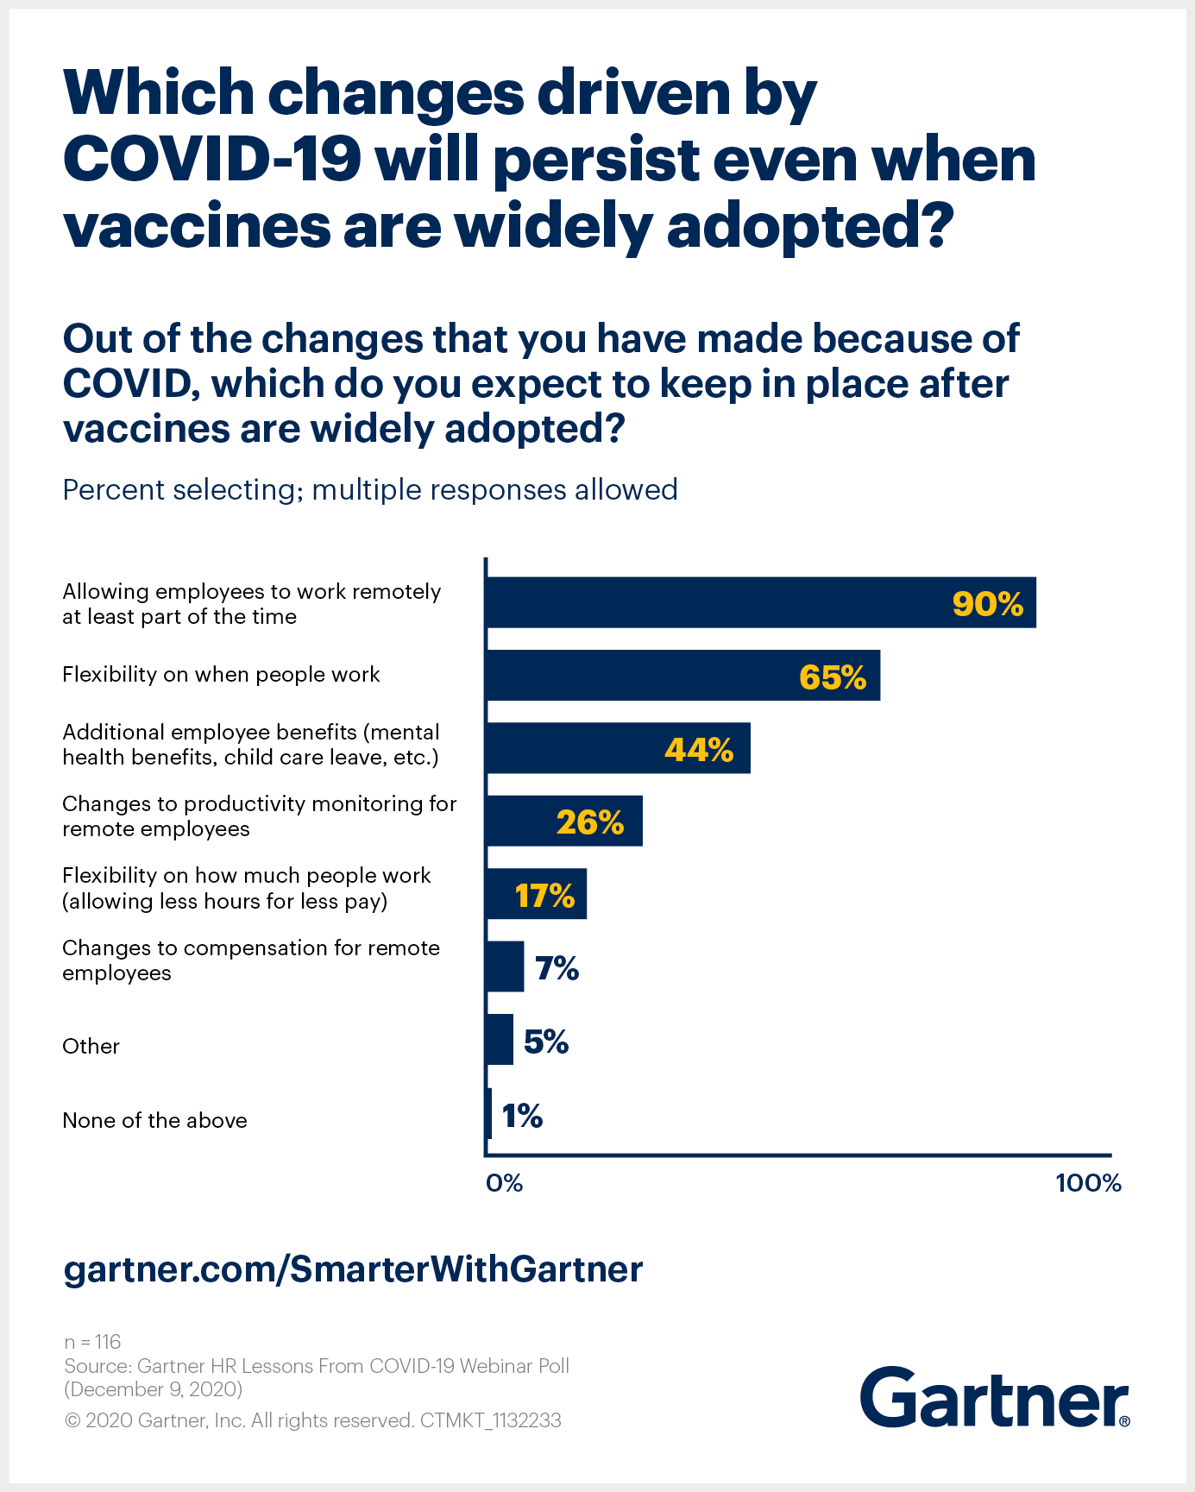

Baker, M. Gartner (2020)

Appendix 2



Gibbs 1988

Appendix 3

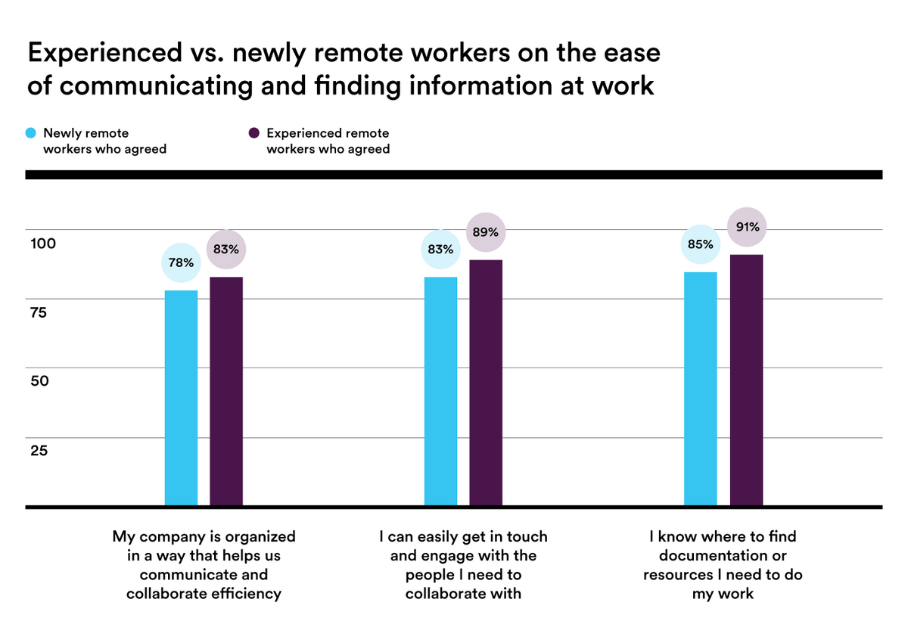

Appendix 4



