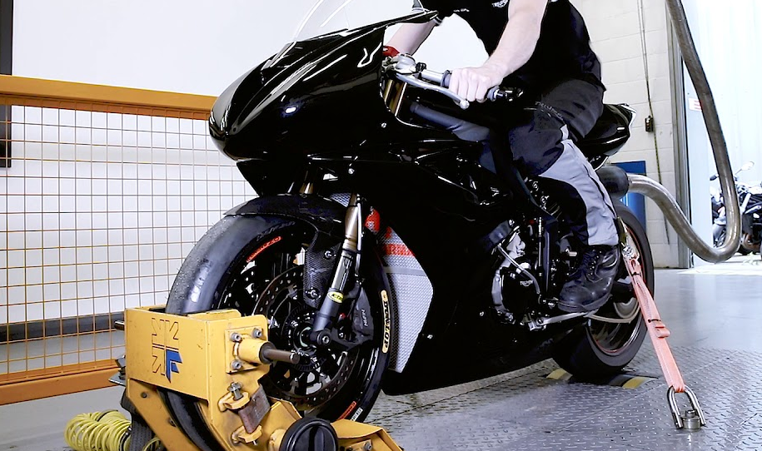

Transmission Matching BMW S1000RR
07/04/20
─
Asad Naqvi
1907788

Contents

Figures……………………………………………………………………………………………………………………………...………..2

Introduction………………………………………………………………………………………………..……………………..……….3
Research………………………………………………………………………………………………………………………………..…...3
- BMW S1000RR Specification
- Gear Ratios

Analysis………..…….……………………………………………………………………………………………………………….………4
Calculating - Transmission efficiency η………………………………………………………………………….………4
Calculating - Torque at Wheels T……………………………………………………………………………………….…….4

Calculating - Tractive Effort, TE……………………………………………………………………………………………….5

Air density ρ………………………………………………………….……………………………………………………………………..6
Calculating - (confirming) the differential ratio.……………………………………………………………………..6
Calculating - maximum tractive effort in each gear……………………………………………………………...6

Calculating - Speed ratio…………………………………………………………………………………………………….……..7
Calculating - Theoretical gear ratios……………………………………………………………………………….……….7
Calculating - Max road speed achievable……………………………………………………………………….……...7

Calculating - Max road speed in each gear……………………………………………………………………..……..8

Conclusion………………………………………………………………………………………………………………………………….8
Appendices………………………………………………………………………………………………………………………………...9

References………………………………………………………………………………………………………………………………..10

Figures

Figure 1 - Torque vs. RPM………………………………………………………………………………..………………….……4
Figure 2 - tractive effort…………………………………………………………………………….………………………………5
Figure 3 - Pdrag vs. velocity…………………………………...………………………………………………………………………….7

Introduction

This is a report on a transmission analysis of a BMW S1000RR motorbike. As part of a team tasked to collect performance data of the bike, the bike was hooked up to a motorbike dyno also known as a rolling road. A sweep test at the 5th gear of the bike was carried out to collect relevant data.

A rolling road is an automotive piece of equipment meant to test cars and bikes. It allows the user to apply increased load to a vehicle engine and observe how the vehicle performs under various conditions. Power, Torque, fuel efficiency can all be measured through the use of a rolling road.

Data such as Transmission efficiency, torque, tractive effort and maximum road speed achievable amongst other variables were measured.

Research

BMW S1000 RR Specifications
Mass 208kg
Engine 999cc
Cd 0.75
Frontal Area, A 0.7m²
Max engine power 152kW @ 13500rpm
Max engine torque 113Nm @ 10500rpm
Max engine speed 14200rpm

Gear Ratios
Primary 1.652
1st gear 2.647
2nd 2.091
3rd 1.727
4th 1.500
5th 1.360
6th 1.261
Final Drive (Sprocket) 2.647

- Lecture notes

Analysis

The collected data was then put into excel where it was manipulated to attain different variables.
- Calculating - Transmission efficiency η
- η = Power @ Wheels
Power @ Engine

η = 139.1 kW / 155 kW = 0.897419kW
This value (0.897kW) is the efficiency that the bike is running at. The answer indicates that the bike operates around 90% efficiency which indicates the age of the bike being relatively new coupled with a small drive train, the bike is able to achieve such efficiency.

- Calculating - Torque at Wheels
- T = T @ Engine x p x f x n x η

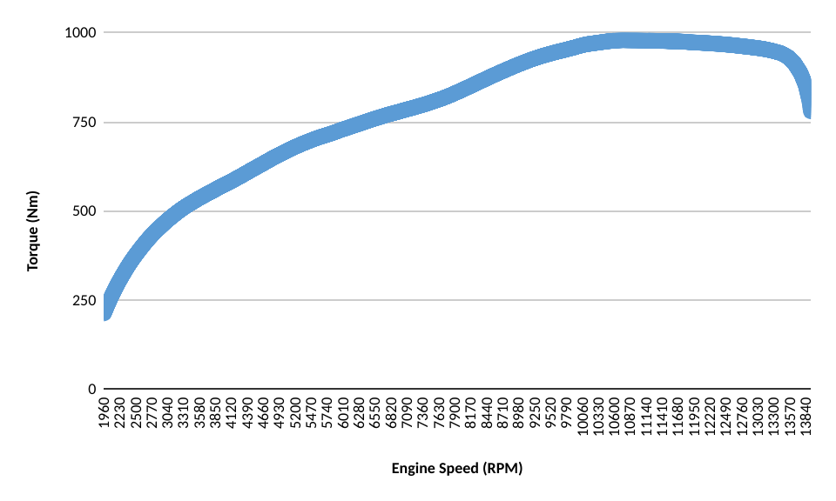
T = 24.83Nm x 2.65 x 2.65 x 1.36 x 0.897219kW = 212.8152804 Nm

Figure 1 Torque vs. RPM

As can be seen in figure 1, the line shows that as the RPM of the bike increases the amount of torque being developed at the wheels. The BMW S1000RR experiences its highest torque being developed around the 10330-11680 rev range. Around the 13300 rev range, the amount of torque being developed drops. This could either be the bike braking, or the bike achieving such velocity that its own momentum is propelling it forward or the rider has come off the gas.

- Calculating - Tractive Effort - TE = Torque @ the wheels
Rolling Radius, R
TE = 212.8152804 Nm / 0.315 m = 675.6057

Tractive effort is the force the bike must produce in order to overcome aspects like rolling resistance, gradient resistance and aero resistance.

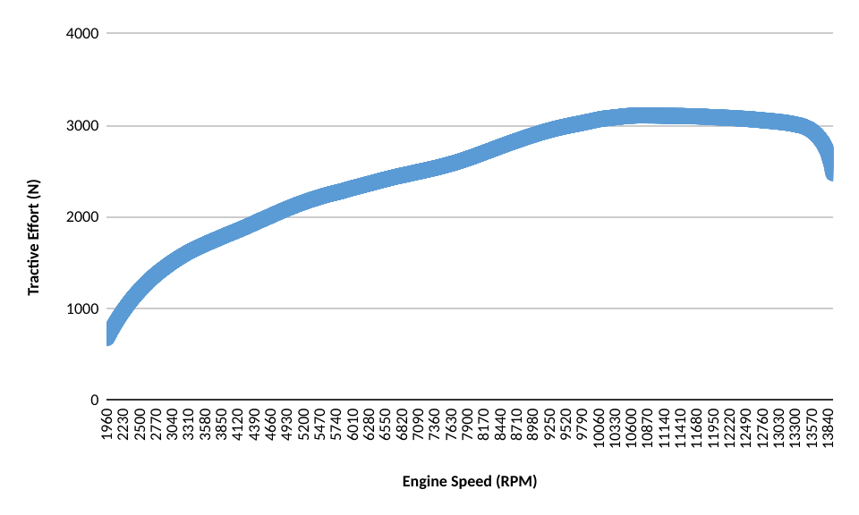

Figure 2 tractive effort

As can be seen from the graph, the bike requires around 700N of force at 1960rpm to overcome all the resistances in-order to start moving. The bike experiences the highest amount of resistance at 10330-10600rpm range and again sees a sharp decline at the end signaling the bike has been turned off.

Rolling resistance is caused by the weight of the car acting on the wheels. The size and type of wheel will have an impact on rolling resistance as a bigger wheel will need more power per rotation. Gradient resistance refers to the ‘gradient’ of the surface that the vehicle is on. Gradient has instant effect on the vehicle, i.e. reaching the ‘biting’ point of a vehicle on a hill is harder than if the road is flat, this is because the vehicle has to produce even more power in order to prevent rolling backwards due to the weight of the vehicle acting on the wheels will cause the vehicle to roll down. Aero resistance also known as ‘drag’ can cause a vehicle to slow down as the vehicle has to produce enough force to overcome the resistance.

It is one thing to drive a car that has great aerodynamics however even the slenderest of bikes can cause lots of drag, simply as a result of the rider sitting straight up on a bike while leaning over the tank reduces drag. A practical example of this would be ‘Grand Prix’ racers hunkering down to reduce surface area in straights in order to achieve higher speeds.

Air Density, ρ, has a huge effect on how fast a vehicle can travel without feeling air resistance. On one hand, lower air resistance will allow a vehicle to use all its power in propelling itself forward and less on overcoming aero-resistance. However, If the BMW bike were at a higher altitude, the bike would lose power due to decreased oxygen for the engine to breath. A bike is expected to lose 3% of power/efficiency per 1000 feet of elevation. In order to make sure that correct power and torque data is collected, all tests were done at sea-level where the air density is 1.225 kg/m3.

- Calculating - (confirming) the differential ratio as 2.65:1 - f = 2 π R N
60 V n p
f = 2π x 0.315m x 1960rpm / 60 x 10.70833m/s x 1.36 x 1.65 = 2.6873511
Average = 2.69824783

As can be seen from the result of the equation, the answer is 2.687. This is close to the factory differential ratio however, there is a slight discrepancy which could be the result of manufacturing tolerances.

- Calculating - maximum tractive effort in each gear - TE = T x p x f x n x η
R
TE = 114.3Nm x 1.652 x 1.65 x 2.65 x .897419 / 0.315m :
= 3777.74726Nm - 1st gear
= 2979.430858Nm - 2nd gear
= 2466.227457Nm - 3rd gear
= 2138.347506Nm - 4th gear
= 1938.768405Nm - 5th gear
= 1796.211905Nm - 6th gear

The figures above show the maximum tractive effort the bike can achieve in each gear. As can be seen, the first gear of the bike has the highest amount of tractive effort which is expected, this is because the bike needs to be able to be able to achieve such power to make start on steep hills with heavy loads and for initial start to overcome resistances as mentioned above. The 6th gear has the lowest amount of force as the bike’s built up momentum would be propelling it forward allowing for lower tractive effort.
- Calculating - Speed ratio = Max Torque engine speed
Max Power engine speed
Ratio = 10565rpm/13190rpm = 0.800986

- Calculating - Theoretical gear ratios

Gear 1 | 2.647
Gear 2 | 2.122611827
Gear 3 | 1.700181498
Gear 4 | 1.361820889
Gear 5 | 1.090798915
Gear 6 | 0.8737142182

The data set above shows the theoretical gear ratios of the bike. When the bike is in 2nd gear shows a nearly 2 to 1 gear ratio, this is also where the bike is producing a higher amount of torque as well. The 5th gear indicates a nearly one-to-one gear ratio which is consistent as the bike will need less torque at higher gears as higher velocities are achieved. The one-to-one gear ratio is found at the 4th gear on most cars and many bikes but as the BMW S1000RR has 6 gears, the 1-to-1 gear ratio operates at the 5th gear.

- Calculating - Max road speed achievable
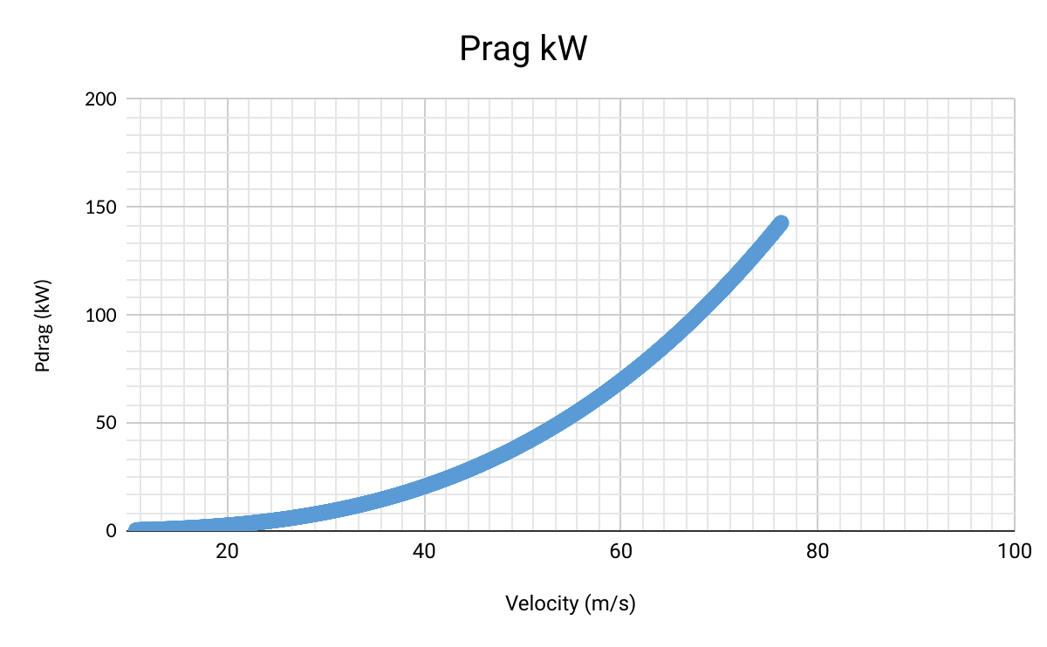

Figure 3
Pdrag vs. velocity

The graph shows that the bike can develop a maximum of 142.78kW at which the bike is travelling at a maximum velocity of 76.29m/s.

- Calculating - Max road speed in all gears

Max Road Speed | km/h
1st | 145.3544145
2nd | 184.3010519
3rd | 222.6527158
4th | 256.7927989
5th | 283.2273518
6th | 305.705713

The data set above shows the speeds the bike is able to achieve given all parameters be perfect like road surface, wheel inflation, driver skill and factors like condition of the bike being either new or well-maintained will all impact the road speed the bike is able to achieve in each gear. Between gears 1 and 3, roughly a 40km/h jump can be observed and when the bike reaches higher speeds the acceleration decreases and from gears 4 to 6, the bike roughly needs 28km/h to switch gears properly.

Conclusion

As part of the transmission team, all tests that were necessary to complete this report on the BMW S100RR have been carried out. This report has covered the tractive effort values of the bike, the amount of torque being developed at each wheel, maximum speed achievable in each gear along with the speed ration. Graphs have been produced and evaluated for necessary parts of the report. The data suggests that the bike is in great condition and operating as it should.

Appendices

Excel Data

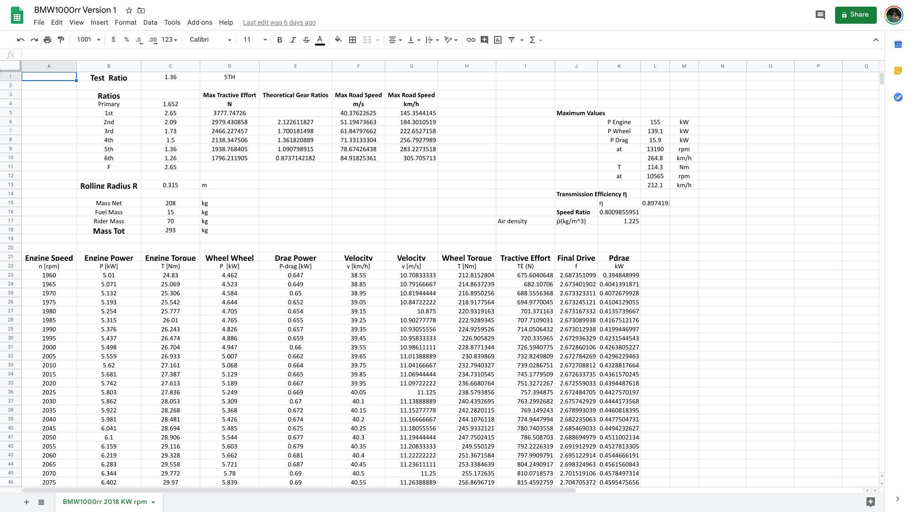

Bibliography

Lecture Notes

Jiffy Lube of Southern California. 2020. The Effects Of Altitude On Your Vehicle - Jiffy Lube Of Southern California. [online] Available at: <https://www.jiffylubesocal.com/jiffy-lube-blog/2015/09/the-effects-of-altitude-on-your-vehicle/> [Accessed 1 April 2020].

V A W Hillier and Calex Uk (2014). Hillier’s fundamentals of motor vehicle technology. Book 1. Oxford: Oxford University Press

Zammit, S. (1987). Motor vehicle engineering science for technicians, level 2. London: Harlow: Longman Scientific & Technical.

Formula1-istanbul.com. 2020. How Do These Three Forces Affect A Formula One Racing Car? | Formula One Racing. [online] Available at: <http://www.formula1-istanbul.com/7/how-do-these-three-forces-affect-a-formula-one-racing-car> [Accessed 11 April 2020].

