Angharad Davies – 1800866

Swansea Foreshore Ice-Cream Parlor

  - Introduction.
With an agreement established between the City and Council of Swansea, and the Marriot Hotel, there will be a new restaurant, ice cream parlour and managers apartment constructed on a site that is between County Hall and the Marriot Hotel. The ground floor of the building will have a GIA of 300 square metres. This ground floor will house the new restaurant and ice cream parlour, as well as a new café bar, kitchen and food stores. The first and second levels will each be approximately 150 square meters, with the first floor containing staff welfare facilities such as a break room and toilets. The second floor is to be a self-contained managers apartment.
While carrying out this project there will be a desk top study carried out as well as a site walk over. These will help to determine the conditions of the site as well as suitable procedures that will need to be carried out before and during the construction process.

  - Desk top study.
History of site:
There is no information regarding the previous history of the proposed site itself, however “Copper smelting had become a major activity in the lower Tawe Valley in the 18th century” (History points - Swansea Marina, n.d.). As this copper smelting had previously been carried out near our site, there could be potential contamination in the ground soil as copper doesn’t breakdown in the natural environment. The proposed site is also located close to Swansea’s South Docks, and “in 2006 the marina was extended into the dock’s western end, near the Marriott Hotel.” (History points - Swansea Marina, n.d.) meaning there could be potential contamination also coming from the docks. Since there is no history for the actual site, soil tests will need to be carried out in order to determine whether the soil is contaminated as suspected.

Site walk over:

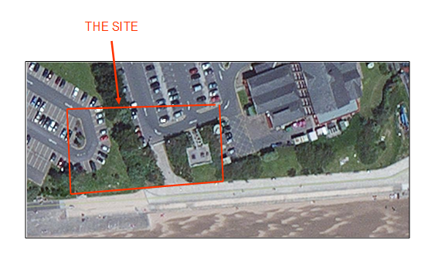
The above image shows the boundaries of the given site, extending onto the carparks of the City and Council of Swansea building, and the Marriott hotel.
This image was provided in the assignment brief.
From carrying out a site walk over several issues have been brought to light. Located in the area of the proposed site there are services running underground, a large amount of vegetation, as well as a private right of way located in the centre of the site, and a public cycle path.
Having services running under the site can cause issues during the construction process as if any of the said services are damaged it can cause disruption to the buildings that are connected to them and could also cause possible injuries to workers. To avoid causing any damage it is recommended to get a hold of the utility plans. These plans will highlight where utilities are located so you are either able to build around them or relocate them to a different position.

The vegetation on the site can also cause issues as there are several large trees as well as uneven ground levels. Trees can cause major issues when it comes to building foundations of a structure as the roots can absorb moisture from the soil causing subsidence. The roots can also rot, leaving voids underneath the foundations. To avoid these issues the trees will need to be removed in their entirety, however this may cause problems, “The expansion, known as ‘heave’, is unstoppable and strong enough to break foundations.” (Snell, 2012). This means when trees are removed, they are no longer there to absorb moisture in the soil leading to a possible build up, causing the ground to swell. To counteract this, foundations must be built taking this into consideration, the suitable depth will need to be calculated and this will allow you to determine what type of foundation will be the best. “For example, for depths up to 1.5m, trench fill foundations may be the most economic but for those in excess of 2m, pile foundations with ground beams would be recommended.” (Symington, n.d.). The uneven ground will need to be levelled before any construction can take place.

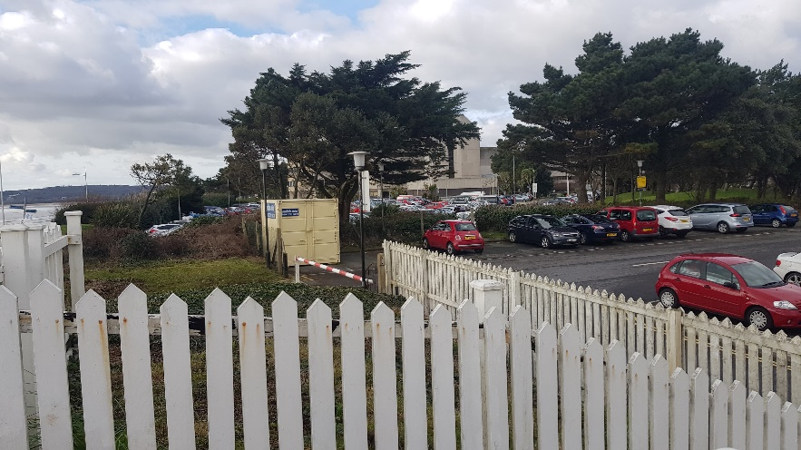

This image shows some of the vegetation on the site, including large trees.
This image was taken when I completed the site walkover.

There is a short private right of way in the centre of the plot. It is a private right of way under the Highways Act 1980, meaning it cannot be demolished or moved. To avoid any issues regarding this, the best option would be to build around the right of way to ensure it stays where it is currently located. As there is also a pubic cycle path going through the site, permission must be granted from the council to divert or relocate the route. “A path cannot be legally diverted or closed unless the council has made an order to divert or close it to allow the development to go ahead.” (Rights of way, n.d.).
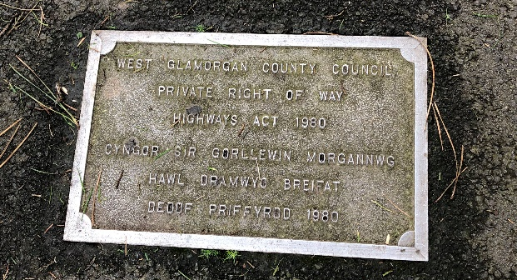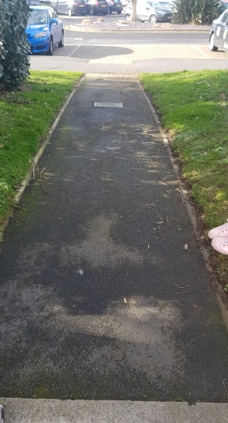

The above images show the plaque located on the private right of way in the middle of our site, as well as the full length of the path.
The images were taken when I carried out a site walkover.

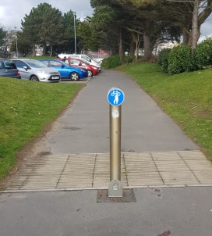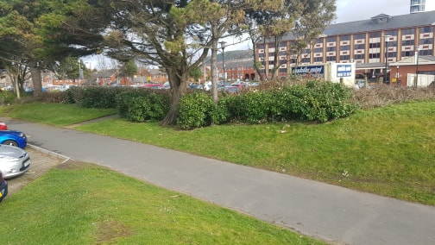

These images show the public cycle path that runs through the proposed site.
They were taken when I carried out a site walkover.

Since the site is located across the carparks of the City and Council of Swansea building, and the Marriott hotel, it needs to be taken into consideration that there will be less parking available for staff and the public. The could mean possible expansions of the existing carparks in the future.

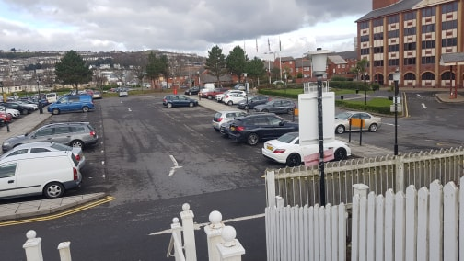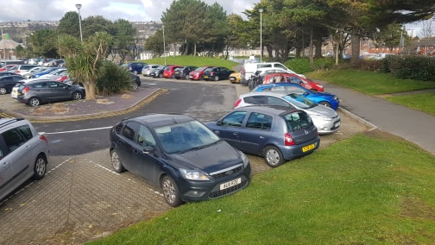
These images show the car park of the Marriott Hotel (right) and of the City and Council of Swansea (left)
The images were taken when I carried out a site walkover.

Where will the building be located?
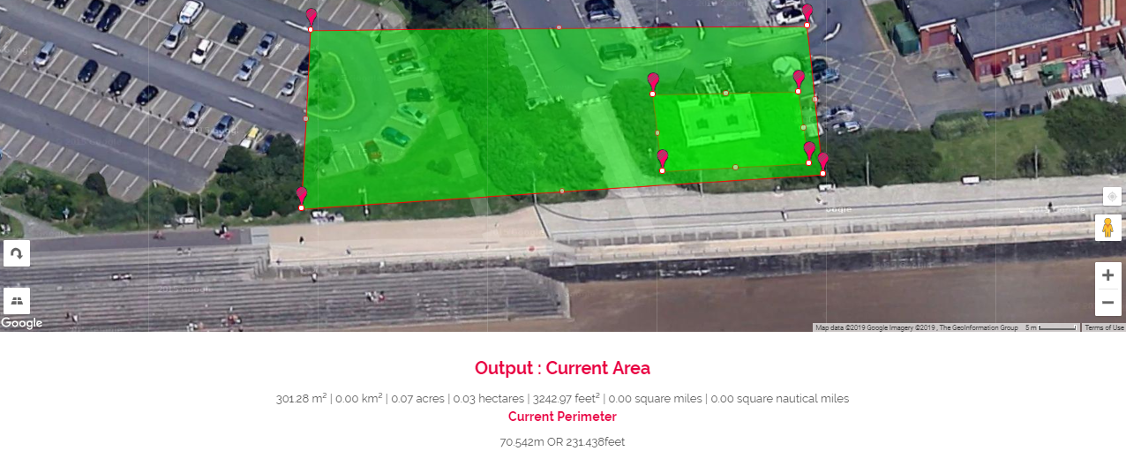
https://www.daftlogic.com/projects-google-maps-area-calculator-tool.htm#
The above image shows a larger area which is the site we have been provided with, there is also a smaller area highlighted that indicates where the building will be located. The area is approximately 300 squared meters meaning it is suitable for the construction. I have chosen this area as it means the private right of way and the public cycle paths will go undisturbed. It will also mean the carparks of both the City and Council of Swansea building and the Marriott hotel will remain as they are.

  - Recommendations for a more detailed site investigation.
I would recommend ground investigations to be carried out due to the unknown history of the site. A trial pit will be dug to determine whether the ground is suitable for foundations.
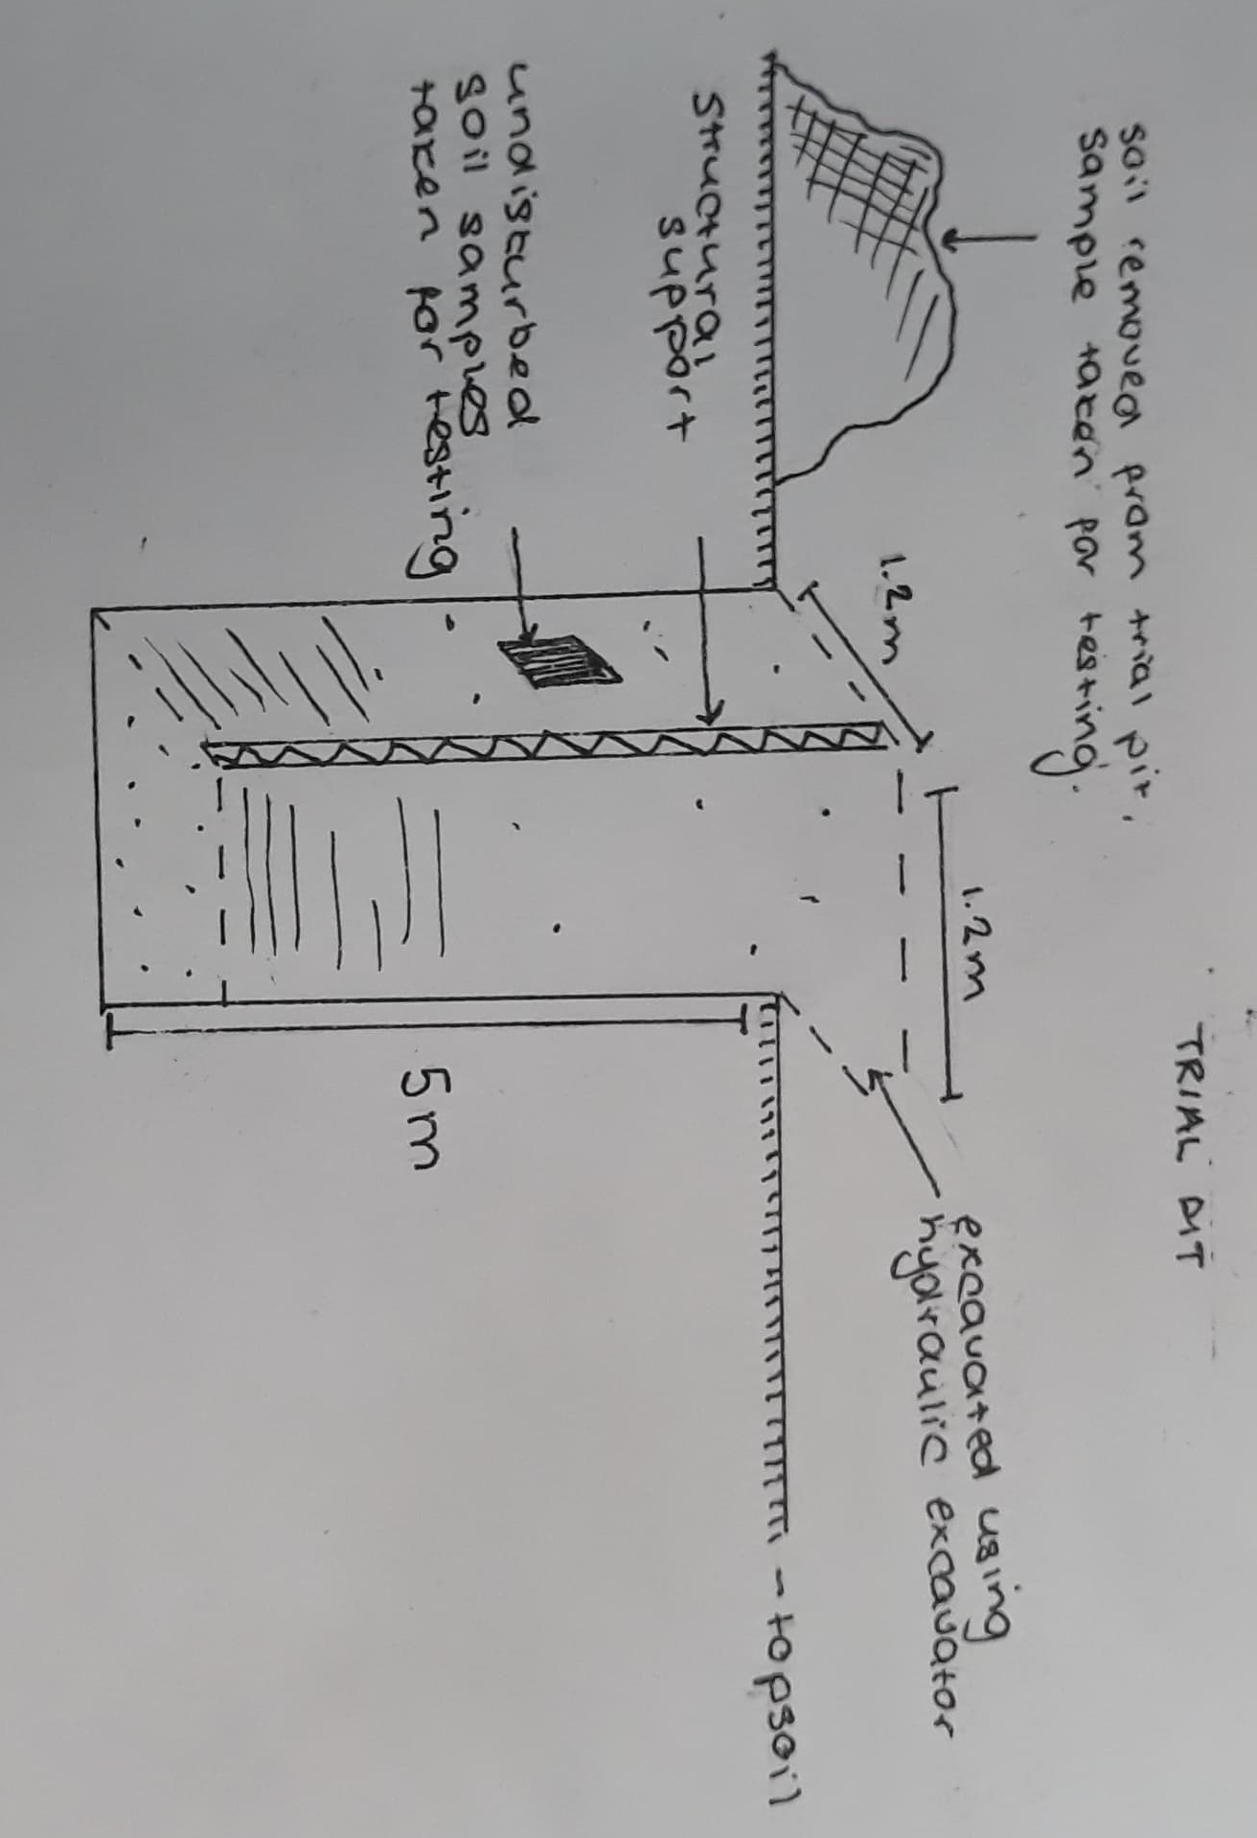
This image shows a sketch of a trial pit to be dug on the site.
Trial pits can help to locate services before boreholes are dug. They also allow subsoil to be “visually examined in-situ – both disturbed and undisturbed samples can be obtained” (Chudley & Greeno, 2010). This means the soil in the trial pit can be assessed visually, and both the undisturbed and disturbed soil can be sent for testing. Testing the disturbed soil can show the moisture content, whereas testing the undisturbed soil can show “the compressibility, shear strength, and permeability of the soil.” (Undisturbed soil sample, n.d.). Several trial pits will need to be dug in order to collect a substantial amount of data.
I would also recommend boreholes to be dug at the site for further investigation.
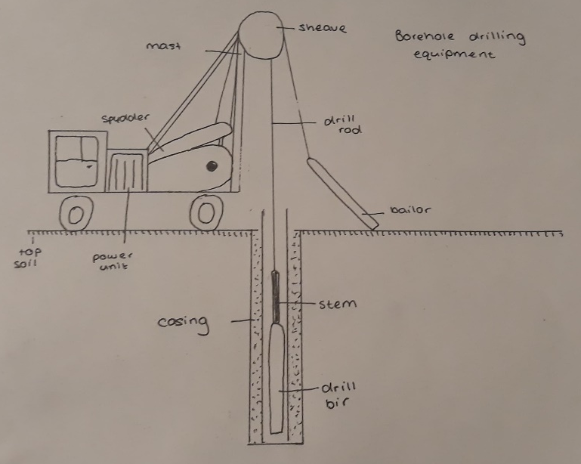
This image shows a sketch of a borehole to be carried out on site.
Boreholes are created by raising and dropping heavy tools to breakdown the material so it can be removed, until a hole is formed. This form of bore holing is suitable for all types of soils and rock, and since it is unknown what the conditions of the site are, I think this would be the most suitable. However, it’s “not economical for boreholes of diameter less than 100 mm.” (B, n.d.). To comply with this, a borehole would have to be dug with a diameter larger than 100mm.

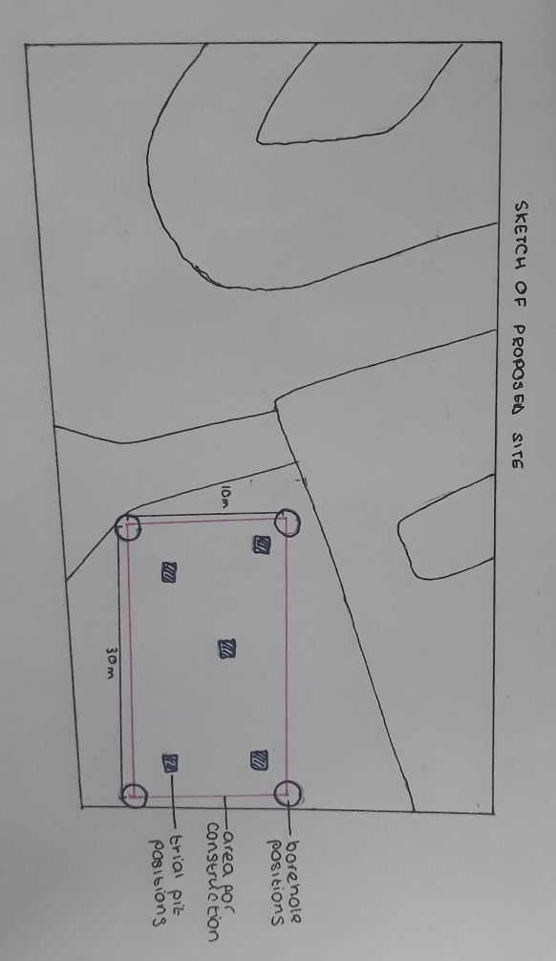
Sketch of site showing positions of boreholes and trial pits.
The above image shows where the boreholes and trial pits should be carried out. I would recommend that the bore holes are dug at the corners of the foundation as these will tell us whether the soil is suitable in that area. The trial pits will be dug in the centre of the area to help determine if there are any mains underground in that area and what the conditions in the centre are.
Finally, I would recommend that several soil tests are carried out. Laboratory testing will identify and classify the soil in relation to its moisture content, plastic limit and particle size distribution. Bulk density testing will tell us “the mass per unit volume which includes air or water in the voids” (Chudley & Greeno, 2010). The results will reflect the soils ability to support structures. Vane testing involves pushing a steel vane into the soil at the base of a borehole. It is then rotated, and this will give us the shear strength of the soil.

  - Suitable foundation and substructure details.
Pad foundations are suitable for most subsoils; therefore, it would be a good option for this construction project as we are unaware of the conditions of the soil.
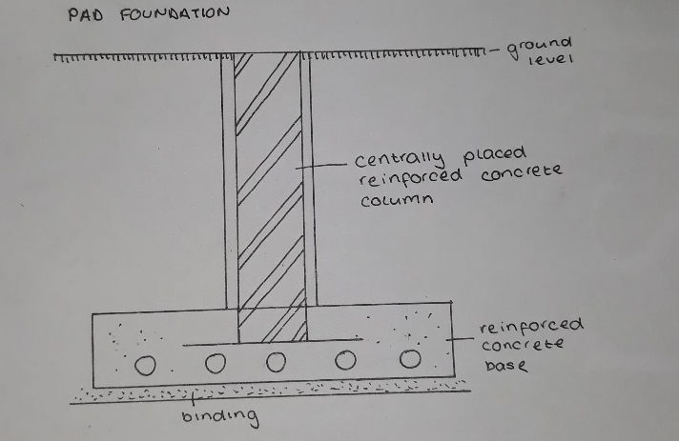
The image above shows a sketch of a pad foundation. “Pad foundations are generally shallow foundations” (Pad Foundations, 2018), meaning foundations less than 3m deep, however they can be deeper if the ground conditions call for it.

However, due to the nature of the project, I feel that pile foundations would be more suitable. Pile foundations are often deeper structures, going into tougher soil beneath the ground. This will provide more stability for the foundations and the building overall.
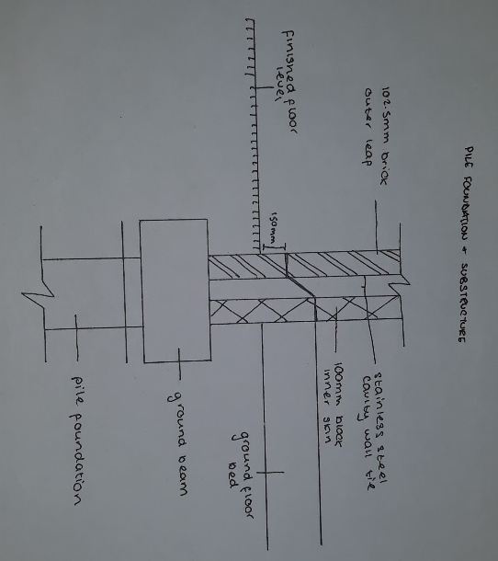
The sketch above illustrates my design for the pile foundation and the substructure that I would suggest using on this build.

  - Design Sketches
  - 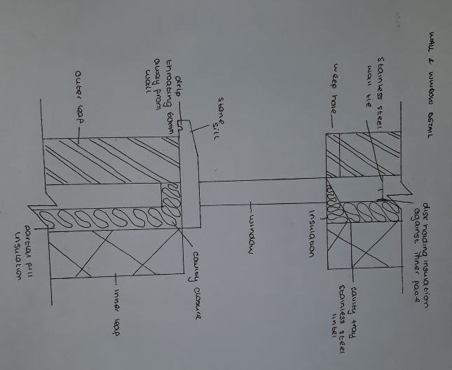
The image above shows the sketch of the intersection between the windows and the walls.
  - 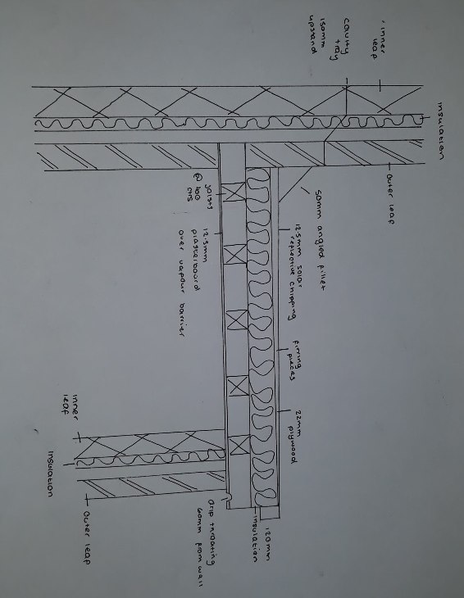
This image shows the rood structure. I would expect this building to have a flat roof as it would make the most sense aesthetically. It will have solar reflective chipping as the covering.
  - 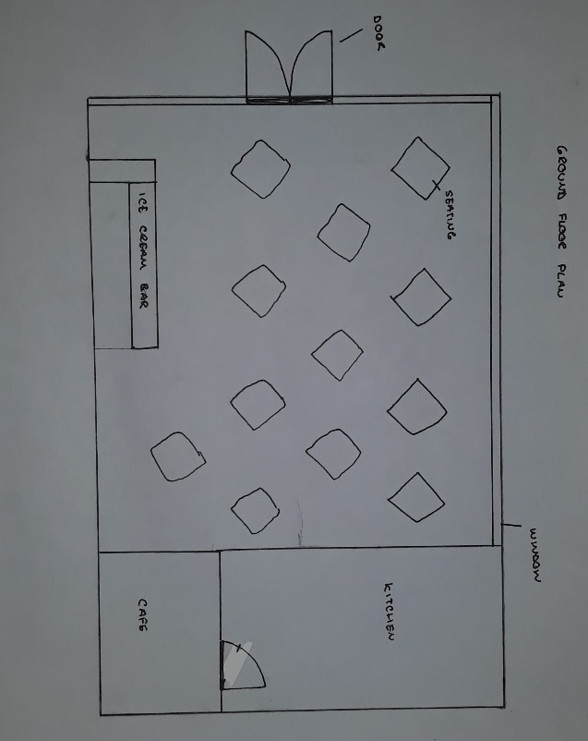
This image shows the ground floor plans. The kitchen will be located at the rear of the building, joining onto the café. The majority of the space will be open plan, with plenty of room for seating.

  - Site set up and plant required
In order to carry out this construction process safely there are a few measures that need to be taken. The whole site will need to have fencing around the perimeter. This will prevent unauthorised access and will help to keep the public safe from any of the hazards on site. All the access points need to be kept safe as well to ensure pedestrians are out of harm’s way. Although the fencing is temporary, it must be constructed correctly to make sure it doesn’t fall over, for example, when there are strong winds. The bases must be weighed down, helping the fencing to stay upright.
The traffic leaving and entering the site must be managed efficiently. Workers and pedestrians must be kept separate. There will need to be cleared points for deliveries, turning, and emergency access. To ensure no injuries are caused when heavy machinery is being operated, banksmen will need to instruct the drivers.
It is vital that the work site is kept tidy, and a level of order is maintained. This will help prevent any unnecessary accidents from happening, such as falling over equipment.
During this project I would expect several pieces of heavy machinery to be used, such as excavators, bulldozers, trenchers, cranes, boring machines, and graders. All these pieces of machinery must be operated only by people who have sufficient training and knowledge in the area.

References
B, T. (n.d.). Methods used in soil exploration. Retrieved from Soil Management: http://www.soilmanagementindia.com/soil-exploration/top-5-methods-used-in-soil-exploration-soil-engineering/13877
Chudley, R., & Greeno, R. (2010, February 5). Building Construction Handbook. Taylor & Francis Ltd - M.U.A.
History points - Swansea Marina. (n.d.). Retrieved February 18, 2019, from History points: http://historypoints.org/index.php?page=swansea-marina
Rights of way. (n.d.). Retrieved from Planning Portal: https://www.planningportal.co.uk/wales_en/info/4/your_responsibilities/50/other_permissions_you_may_require/9
Snell, D. (2012, November 20). Plots: When nature gets in the way. Retrieved from Homebuilding & Renovation: https://www.homebuilding.co.uk/plots-when-nature-gets-in-the-way/
Symington, A. (n.d.). How to reduce the effects of ground heave following tree removal. Retrieved from LABC Warranty: https://www.labcwarranty.co.uk/blog/how-to-reduce-the-effects-of-ground-heave-following-tree-removal/
Undisturbed soil sample. (n.d.). Retrieved from Chegg Study: https://www.chegg.com/homework-help/definitions/undisturbed-soil-sample-8

