Cloud Computing Technologies – Tutorial 11/8/16 – Part 1
Setting up a VPC, remote access, basic server settings and hosting a website.
Requirements – Internet connection, SSH Client (Putty.exe will be provided)

1. Setting up the Virtual Private Cloud instance.
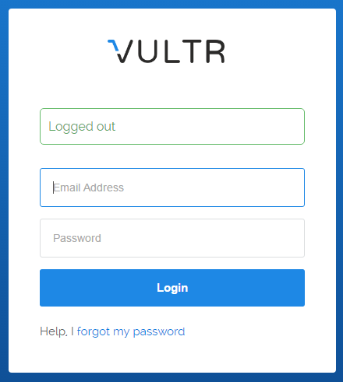
1. Go to - https://my.vultr.com/
2. Login using credentials
ID – ethan.court@gmail.com
PW – uwtsdlondon

** Note the Password will change after today’s tutorial **

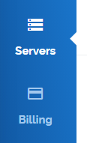

3. Navigate to the Servers pane on the left-hand menu.
4. Under instances you will find the list of servers linked to the account.
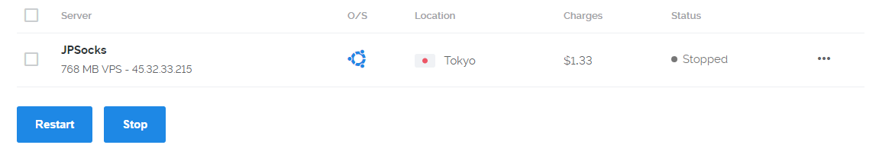

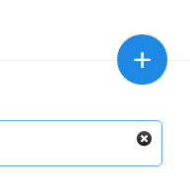
5. Click the plus button located in the top right to navigate to the deployment menu.

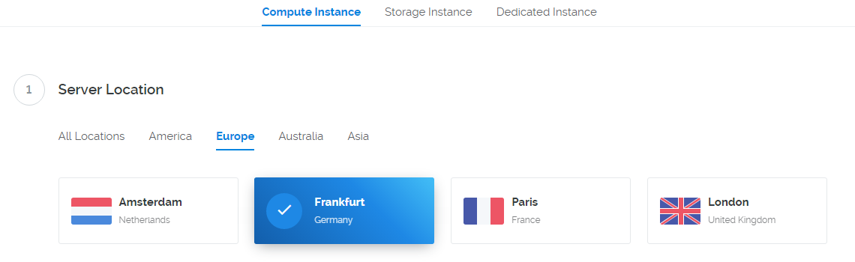
6. Under Compute Instance, select a location to deploy your instance – NOTE, the closer the location is to your own proximity the less delay you will have when remotely accessing the server.

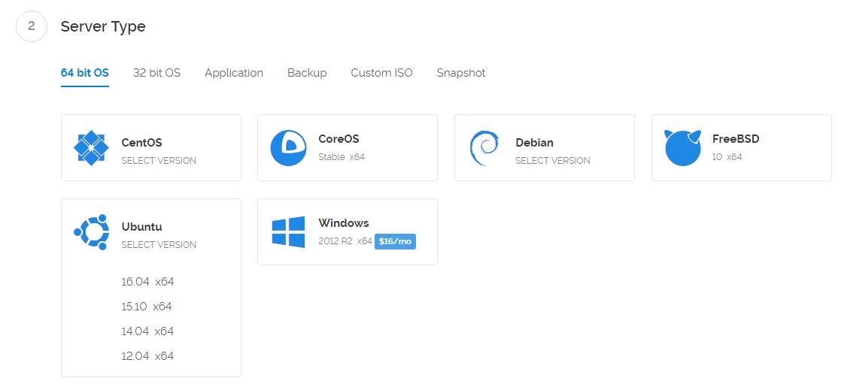
7. Under server type select 64-bit OS and Ubunutu version 16.04 x64
8. Under server size – select the lowest available option $5 month
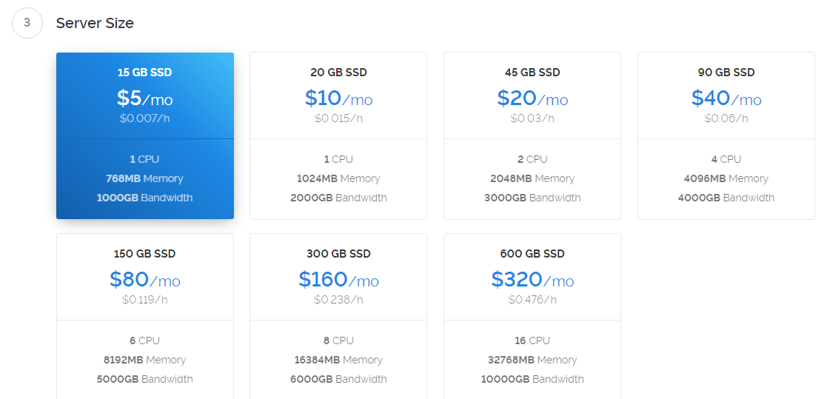

9. Check IPv6 in additional features, leave the startup script empty, and do not add any SSH keys.
10. Name the server your finish name combined with your student number. Ie john1234567
11. Click deploy server to deploy now to start the instance.

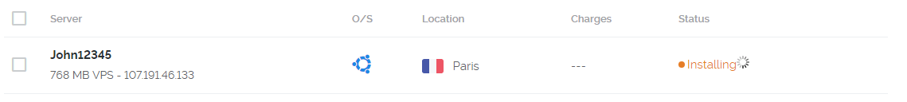
12. Wait until the server changes it status in the instance menu from installing, to running
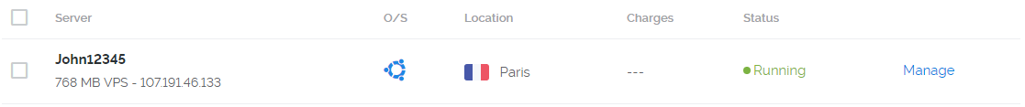

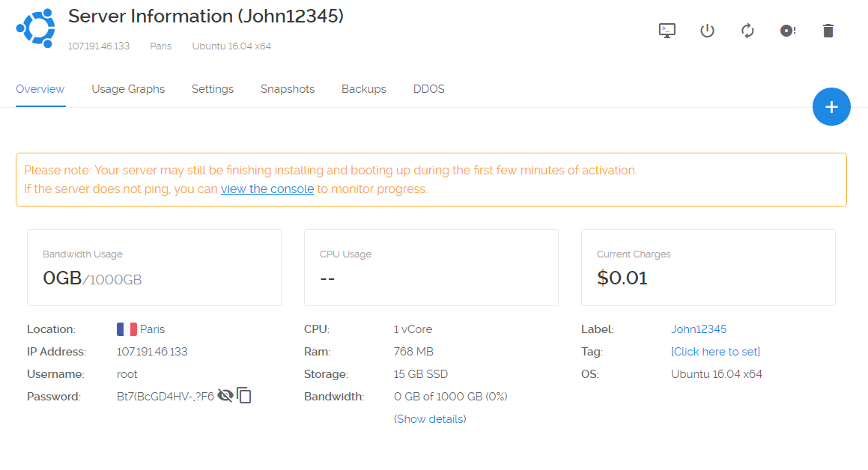
12. Click on the server name to bring up more information about the instance.
13. Familiarise yourself with the menus and the information available here, most public cloud providers have a similar setup – especially smaller providers such as Vultr.
14. TAKE NOTE OF THE SERVER IP ADDRESS AND PASSWORD
In this example the IP address is: 107.191.46.133 and the password is: Bt7(BcGD4HV-,?F6) This will vary in your own server.
Before you start you should test your server by pinging its IP address
2. Remote access
1. In order to access and configure our server we will need to remotely access it. The most common method is Secure Shell (SSH), although other methods such Remote Desktop Protocol (RDP) and Virtual Network Computing (VNC) exist.
2. Open Putty.exe – a copy of the .exe will be provided, if not then download and run at http://www.putty.org/
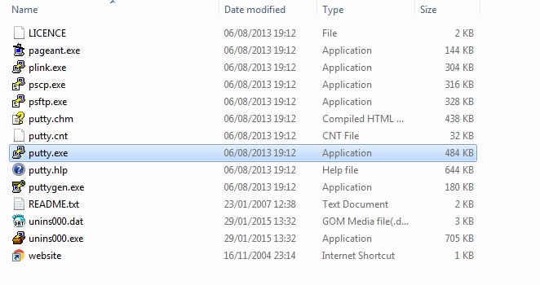
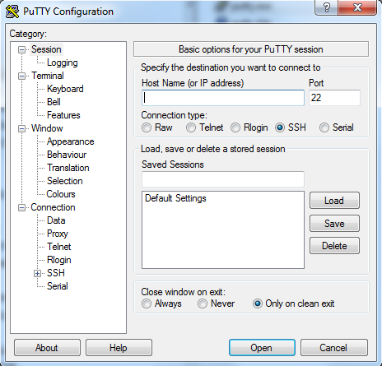
3. PuTTy is a tool used to remote access and supports other remote connection methods such as telnet. SSH also supports the use of “Keys” that a server uses as a secondary authentication. method, these keys would be configured on the physical server or, in a Cloud computing environment using their online web console - as you saw earlier.
4. The default port for SSH is port 22, input the IP address of the server into the PuTTy window and click Open. If you can connect, login to the server using the user name: root and the password provided in the server instance menu (you should have noted this earlier).
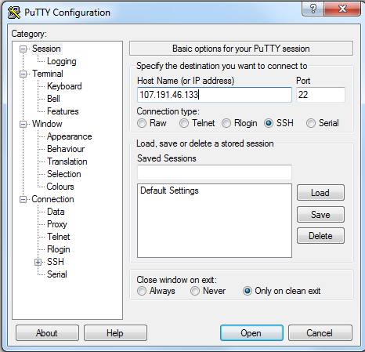

** Port 22 is often blocked on administrated networks, such as the Universities. If this is the case access the server console via the button in the instance menu.**


Changing the SSH listening port.
The server console window will now appear, login using the username root and password you noted previously – in the server instance menu on the cloud providers website.
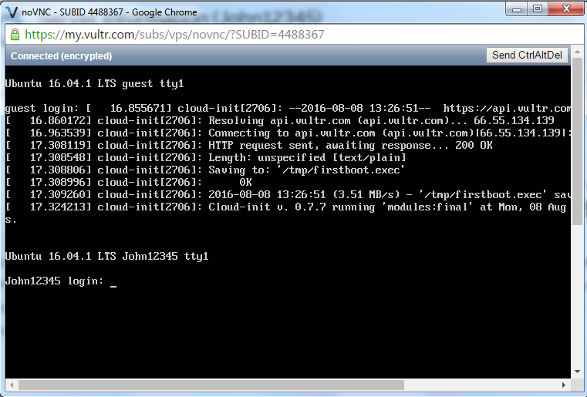
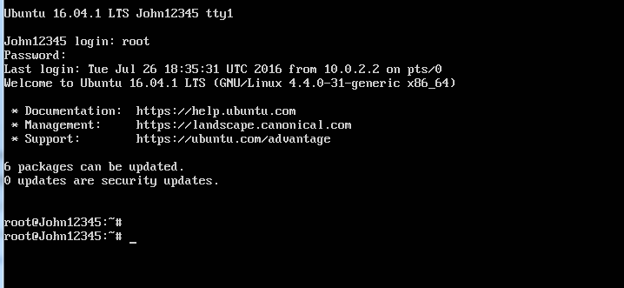
In order to make SSH work/secure it abit better we can change the port it listens to on the server, to do this we have to open the corresponding config file.
Type nano /etc/ssh/sshd_config
This will open the SSH config file.
NOTE – nano is one of the basic tools in Linux distributions that can be used to edit text files.
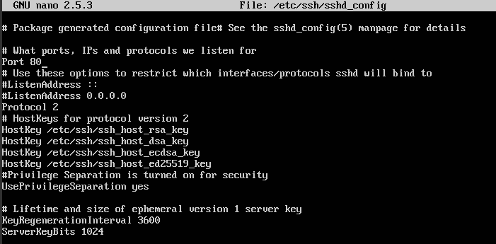
Under what ports to listen for, change the default port to 80 instead of 22.
Once this is done use Ctrl + x to exit the file and, press Y to save changes and confirm the location with enter.
Attempt to reconnect using the PuTTy client, but this time using port 80.
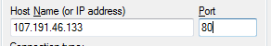

If you fail to connect using SSH due to the University’s network, continue using the online Console provided by vultr.
Try different port numbers here, did you find anything noticeable?

Before carrying out this step you should confirm the instance connectivity by pinging and tracerting various common websites, ping google.com, tracrt bbc.co.uk .. etc
3. Basic Server Settings
Once we have accessed the server remotely we should configure basic server settings.
- Changing the root password
  - To do this type “passwd”
  - Enter the new password
  - Write it down
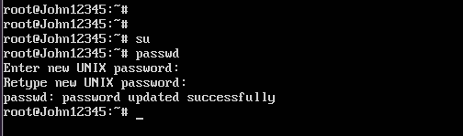
In this case the password was changed to uwtsdlondon
Note – as we already have root privileges and have access to sudo (secure privileges) we can change the password easily. Sudo allows us to run privileged commands under root user.
- Change the timezone
  - Enter – sudo dpkg-reconfigure tzdata
  - 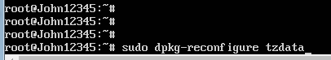
  - Follow the prompt and select a region
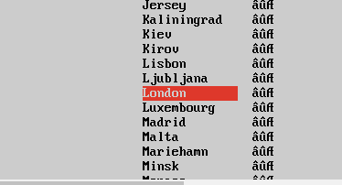


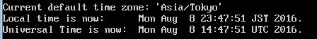

NOTE – You should set the timezone to the physical location you previously chose in the Cloud Providers web interface.
- Check and create the server dependency tree
  - Enter: sudo apt-get check
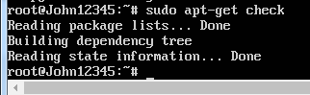
- Install Network Time Protocol (This may already be installed, but it is vital we check)
  - Enter: sudo apt-get install ntp
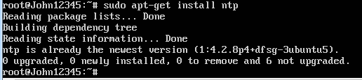
  - Confirm the date, by entering: date
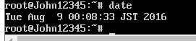
- Update the system
  - Enter: sudo apt-get update
  - NOTE – If the server does not update it will most likely be due to an IPv6 error, in order to solve this ---->
Open /etc/gai.conf
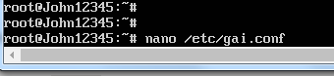

Uncomment the config --
#precedence ::ffff:0:0/96 100 (note – uncomment by taking away the #)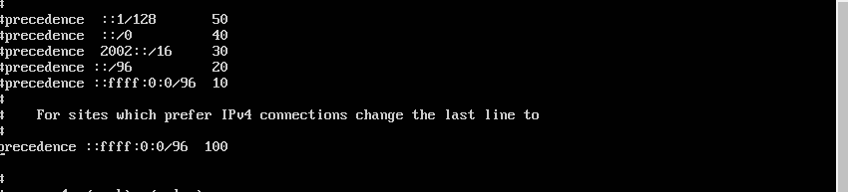
Save the file using ctrl + x,
This will give priority to using IPv4 addresses in the server.

  - Reattempt the update using; sudo apt-get update
  - The update should start
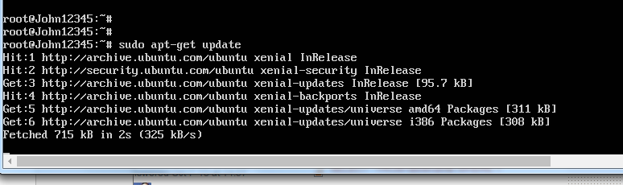
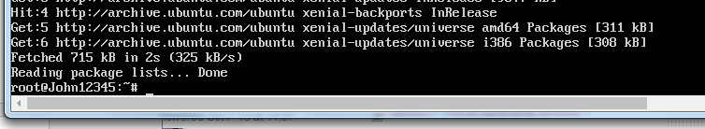
Installed packages are now up to date.
Basic things you should check include
- Use the command: free –m to check the memory allocation of the machine
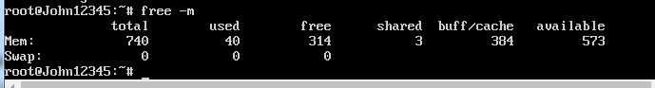

- Monitor processes using hTop system monitor
Installing hTop
- Apt-get install htop
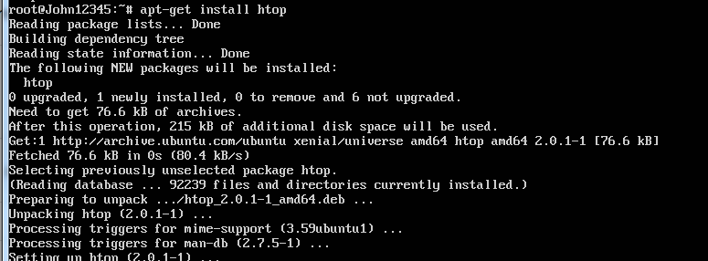
- Enter: htop
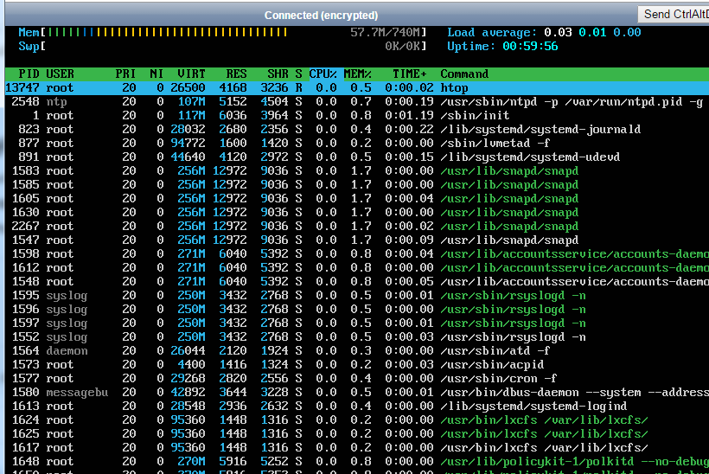
- F10 to quit.
4. See installed packages: apt list
Note this may give a lot of outputs, alternatively use
Apt list –installed

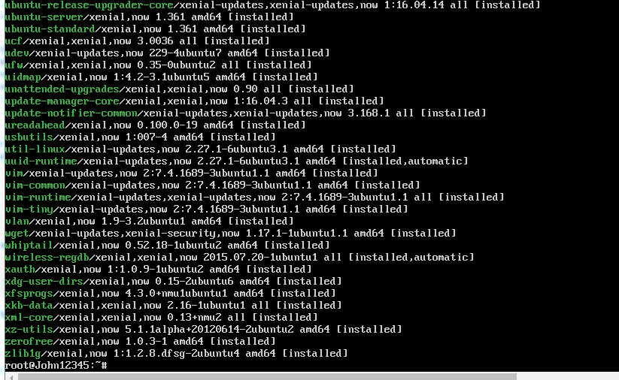
Above: Installed packages.

5. Set up the default Ubuntu firewall – sudo ufw enable
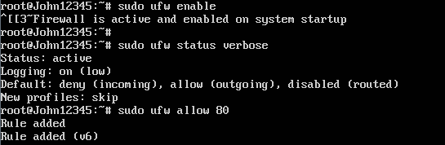
Allow traffic in and out of port 80 (http) using: sudo ufw allow 80
Check the status of the firewall rules using: sudo ufw status
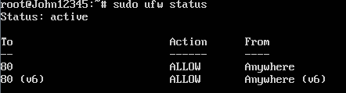
https://help.ubuntu.com/community/UFW << for further information and firewall config
Snapshot the server.
The server is now up and running and we can consider it stable. In order to utilise Cloud functions we should take a snapshot of the server.
- Power off the remote instance using: poweroff
- Go to the Cloud Providers (vultr) web interface and to your server instance.
- Click the snap shots tab.
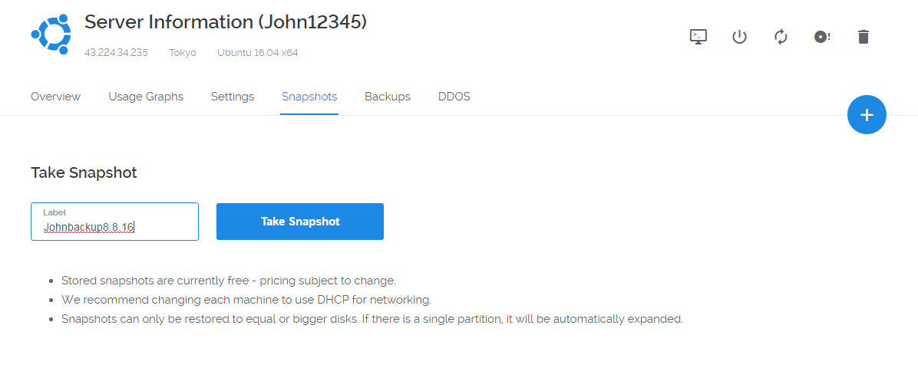
- Name the instance and click – Take snapshot
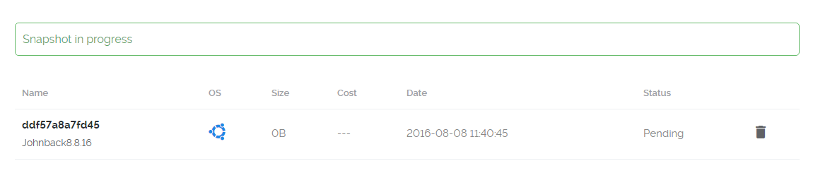
- Wait until the snapshot has been taken and reaccess your server, note – you may need to restart the server in web interface
- Confirm the server is running as expected by logging into it and issuing the date command.
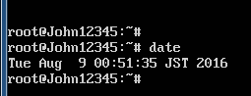
What we do with the server from this point onwards is based on our own skills, in part 2 of the tutorial we will install a Linux Apache MySql PhP (LAMP) stack and various packages that compliment it.

