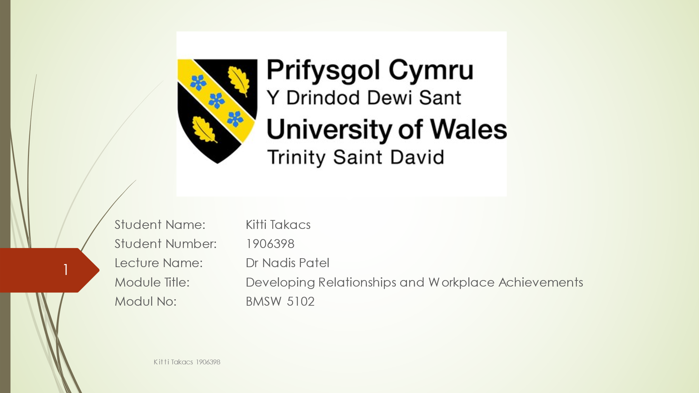

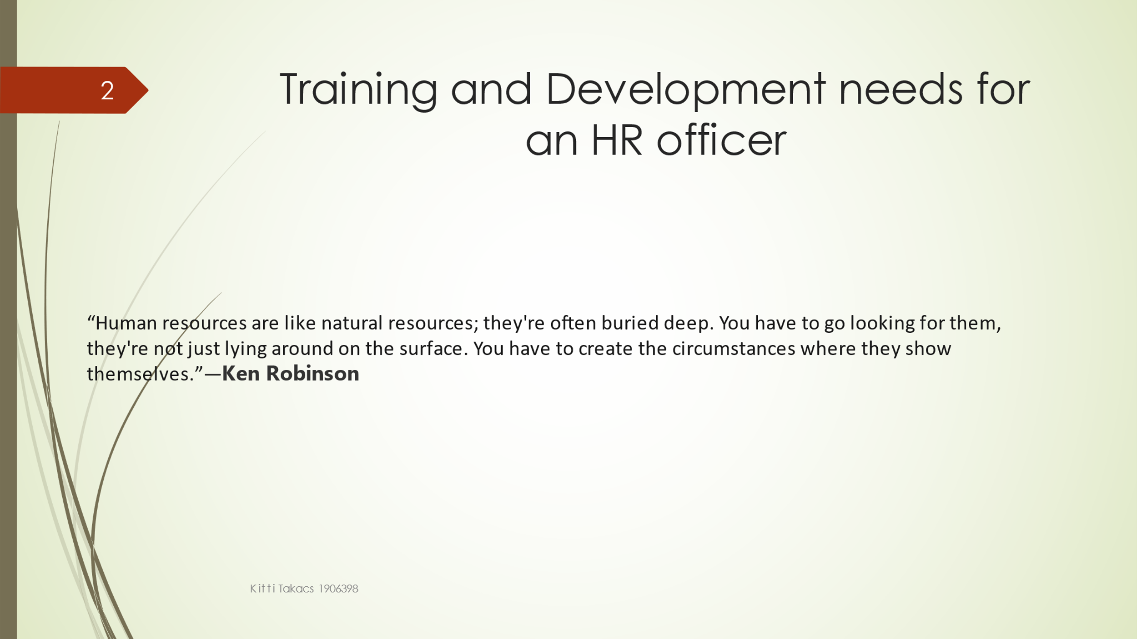
What are Human Resources or HR. HR is one of the departments in the organization. HR in charged of recruiting, training and finding employees. HR has many different responsibilities.
“I believe the real difference between success and failure in a corporation can be very often traced to the question of how well the organization brings out the great energies and talents of its people.” — Thomas J. Watson, Jr.
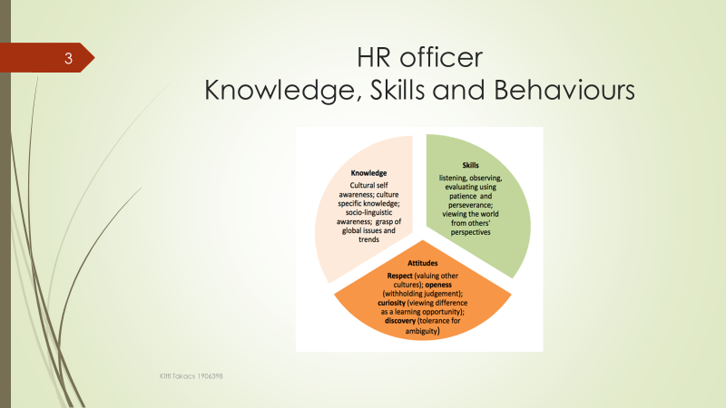
The 12 human resources skills what every HR officer must has. First is Communication skills. Communication skills is one of the most important skills in HR department as the HR professional will be linked with other departments and businesses. The second is administration expert. Administrative responsibilities continue a main part of the HR role. Proactivity is frequently measured more of a character as a person than a skill. The key HR skills is advising different investors. As a HR officer need to be able to advise any problems, issues to the management, employees and also to the senior management. Coaching skills are useful when the HR officer has a group and need to inspire and lead them. Another regularly said HR skill is recruitment and selection. To find the best employee who will fit in the position in the organization and match with the organization culture, behaviour and goals are the most important task as a HR professional. Teamwork is the kind of skills what every HR professional has. Working in a team is help the organization to grow. Each team member can focus on different task and added them together in the end.

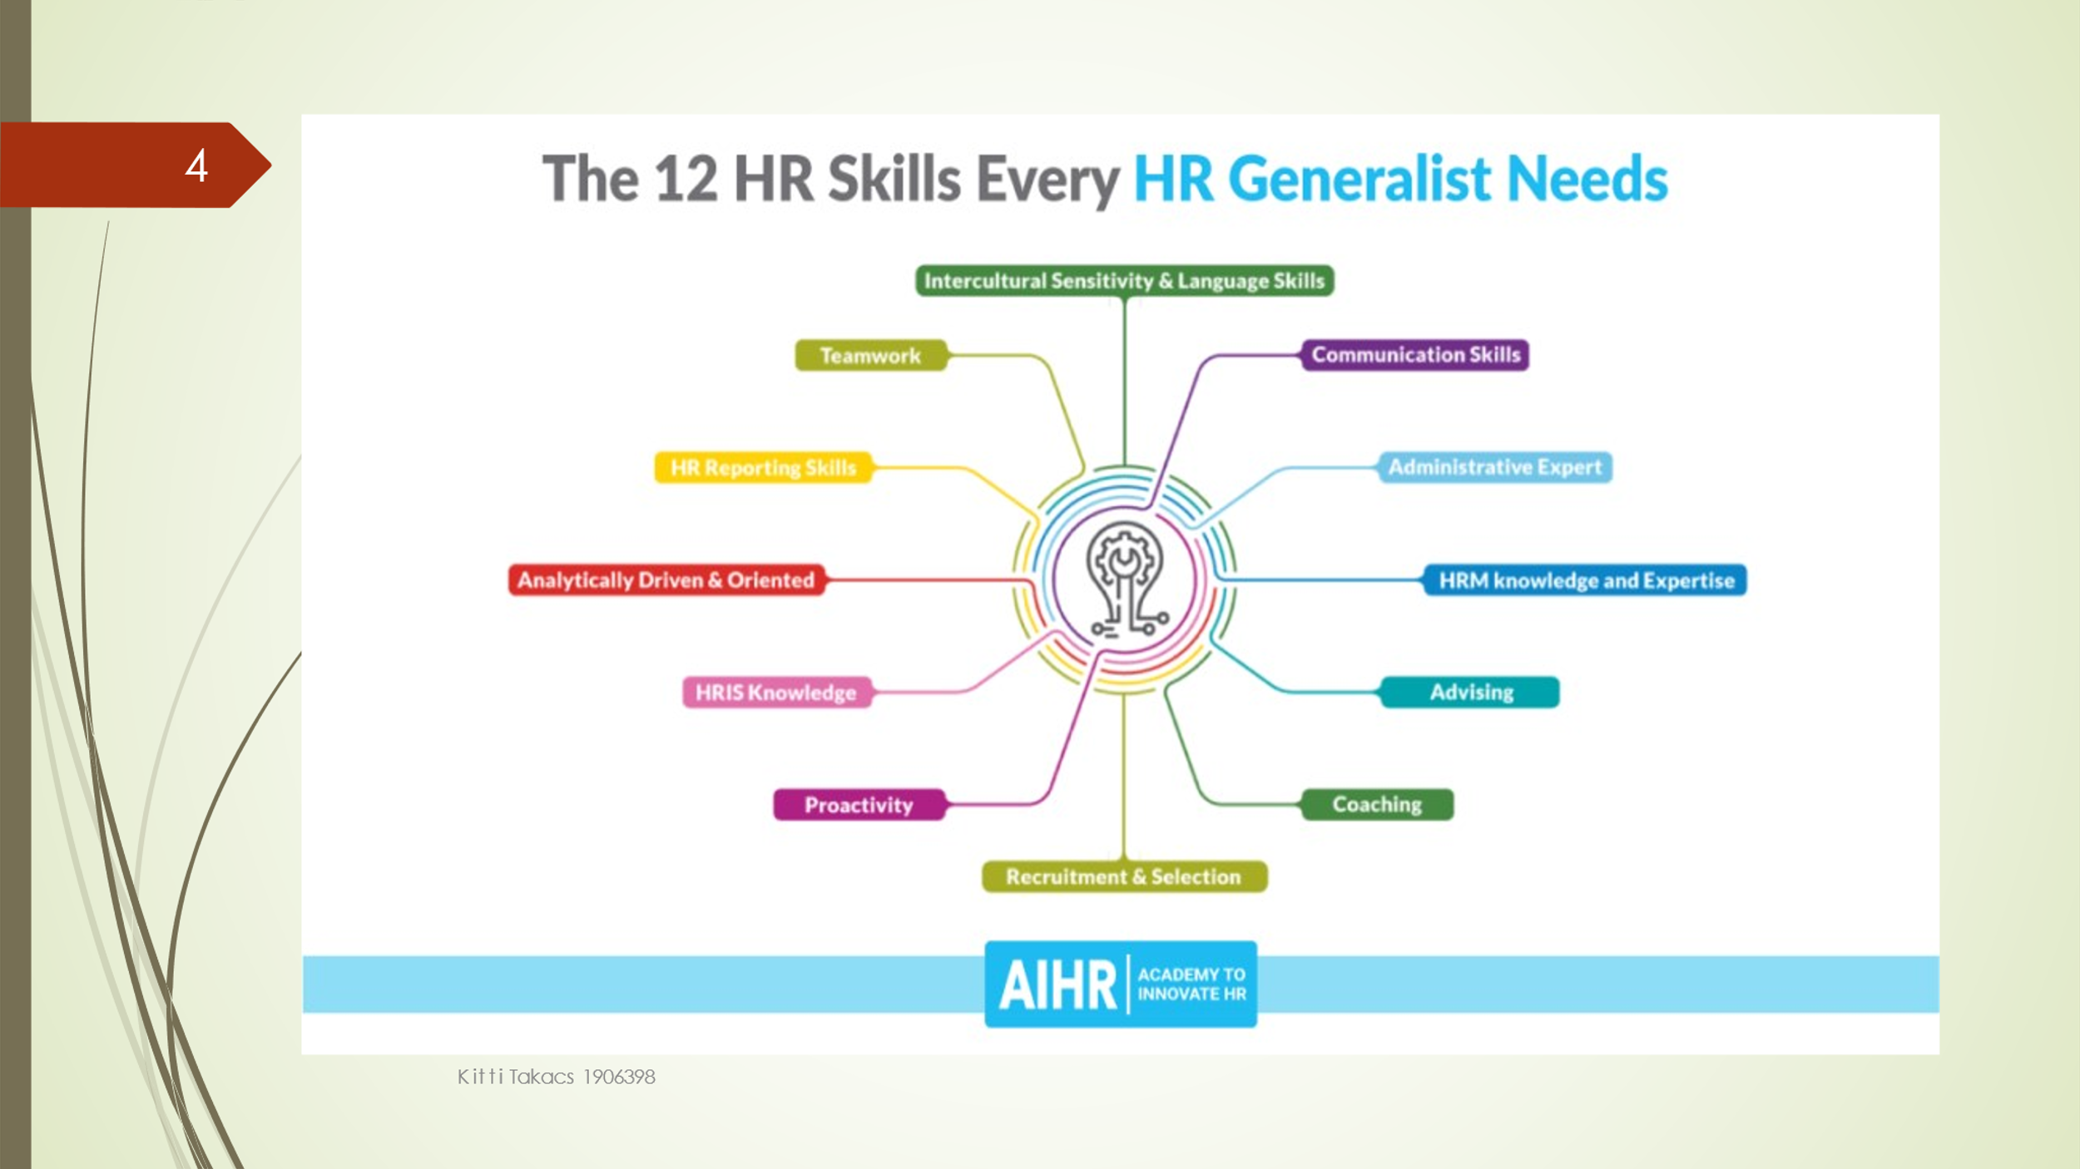
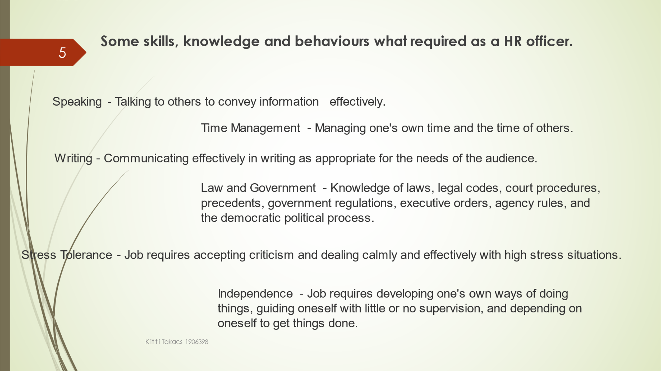
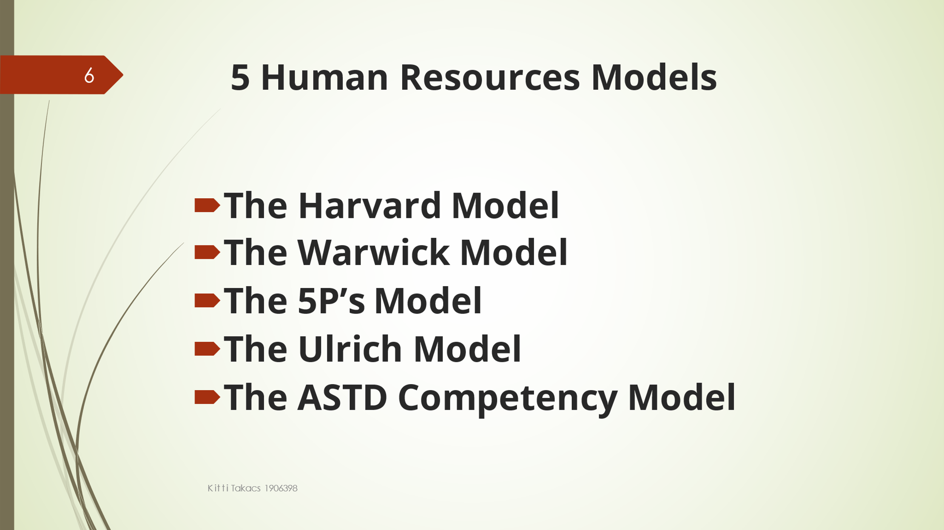
There are five different Human Resources models we can see on the picture. The HR models like an agreement between the management how they will manage any human resources strategies. The human resources models are able to divide roles and responsibilities.
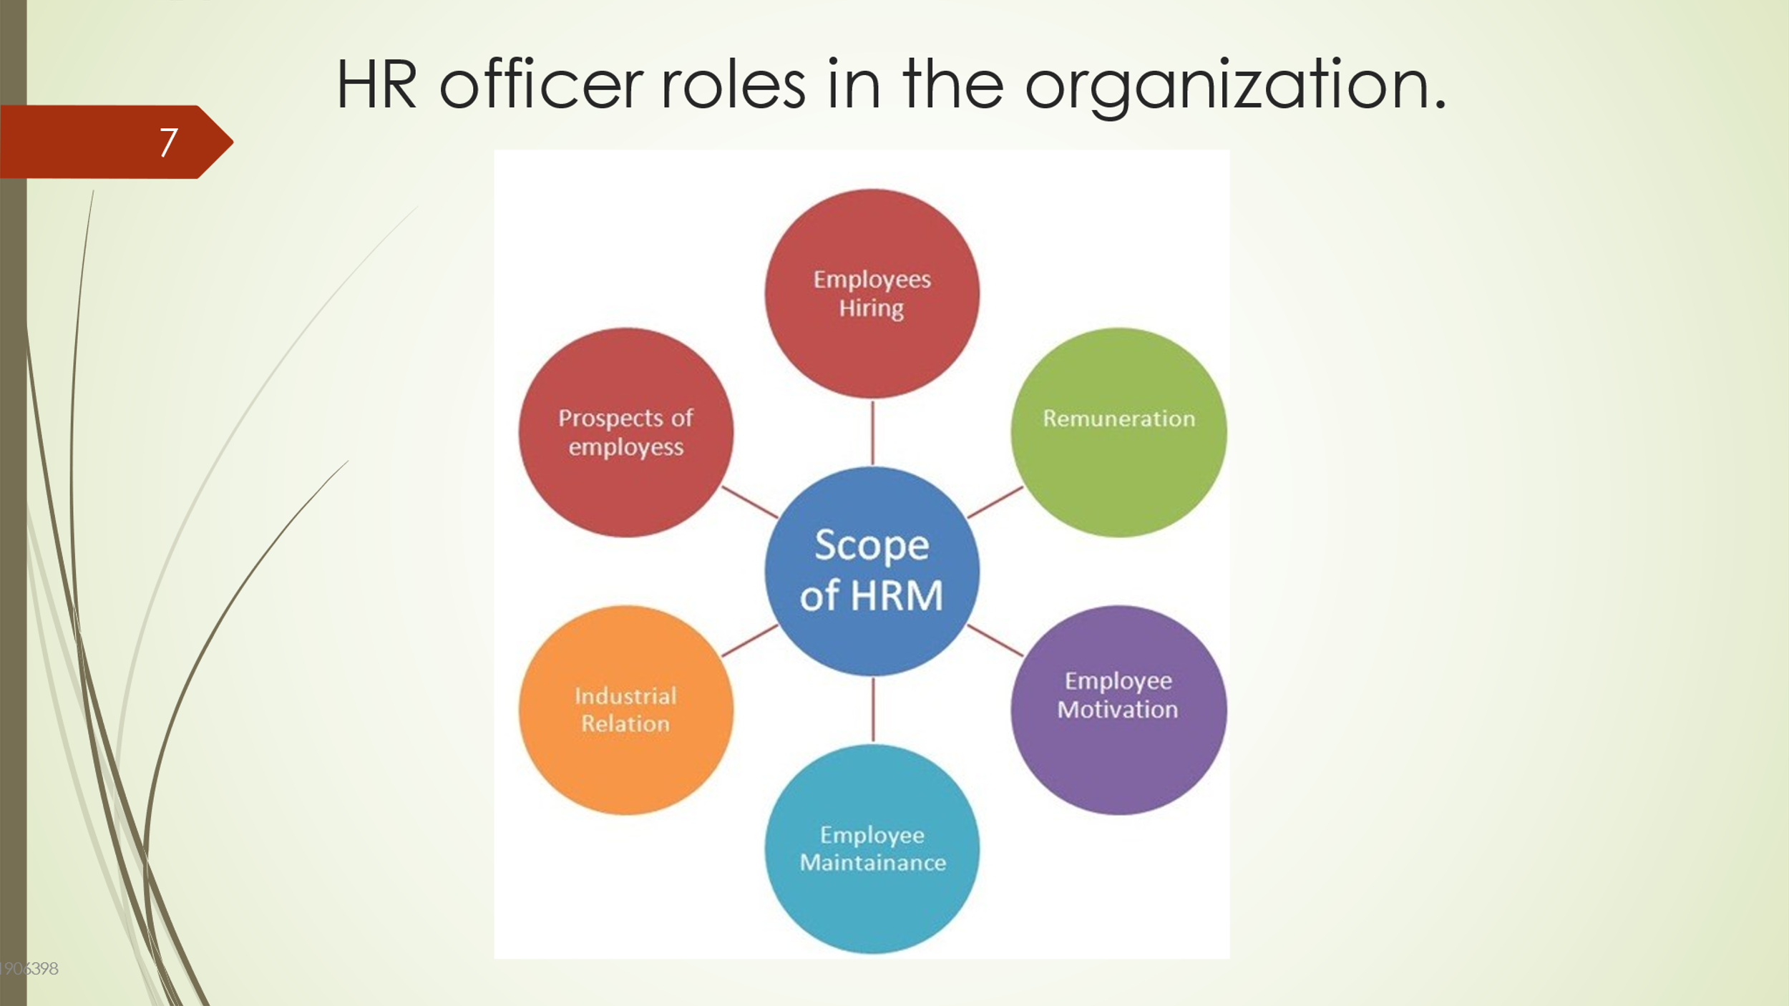
As a human resource officer job role are attracting candidates and Selecting Candidates. Selecting Candidates means the HR officer needs to make sure the selected candidates will be suitable for the position. Hiring candidates is not just outside of the organization HR professionals has to decide that the candidate will suitable from inside the organization or they need to hire from outside. Performance Appraisals is of the role in HR department where the management and employees set a day and talk about the employee performance and also let the employee to talk about his view of the work in a daily basis. “Hire people who are better than you are, then leave them to get on with it. Look for people who will aim for the remarkable, who will not settle for the routine.” — David Ogilvy

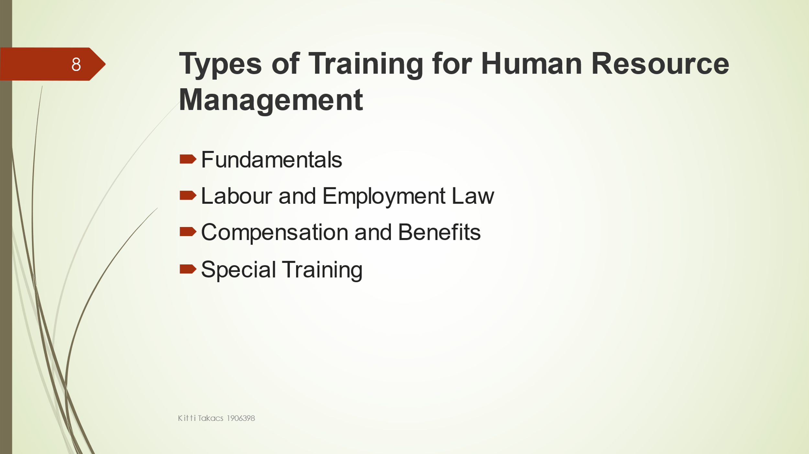
Human Resource management has to have four different type of HR management training such as Fundamental, Labou and employment lay, compensation and benefits and also special training.
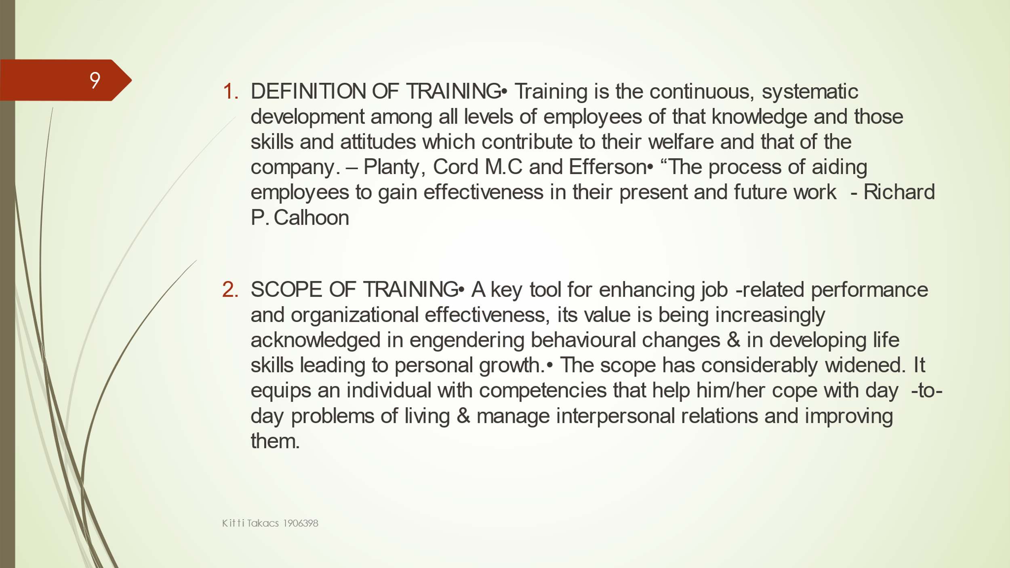
Training in HR department is very important. HR officer need to recruit candidate to a certain position. To be able to provide the best performance. HR professionals need to attend a scope training. Scope Training covers HR planning, hiring, training and development, payroll management, rewards and recognitions, Industrial relations, grievance handling, legal procedures etc. This type of training helps the HR department to deliver a good performance and do the roles in a high level.

Regarding Appendix B
As a graduate trainee Human Resource officer, I believe I still need to go through some training to provide the best performance for the organization. As you see on the appendix B shows that the specialist HR software skills will require more training. Communication skills and training is of the most important skills at this profession. Communication training is important to manage and perfume the department. Problem solving will need to require more training as not many problems I have faced since. All training if will provided through the trainee position, I believe, I can achieve and develop in the organization efficiently.

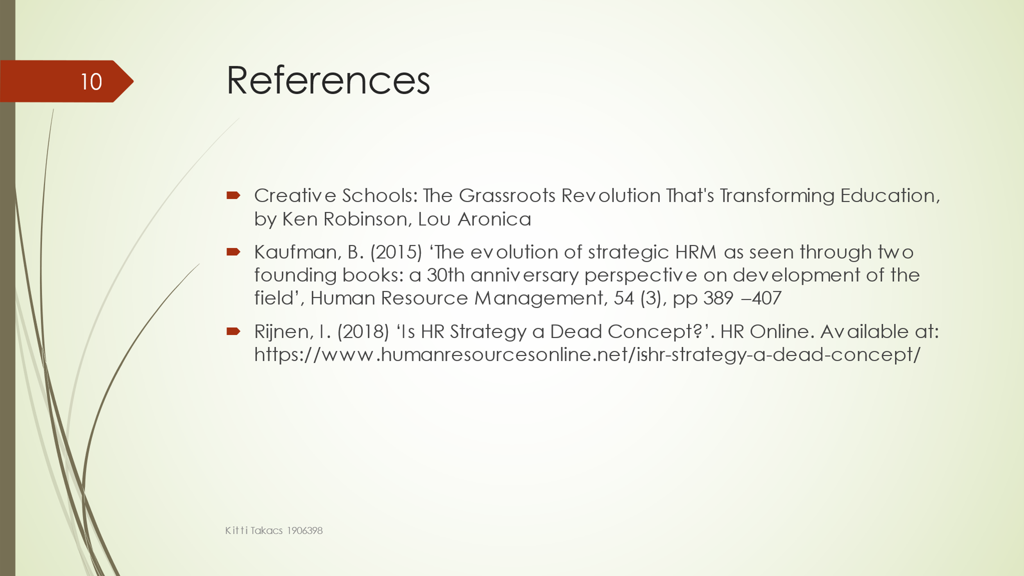

Appendix B

Personal Skills Audit

Name Kitti Takacs
Job role: Human Resource Officer

Please tick as appropriate to indicate how you would rate your skills in relation to the following work / functional areas.
 | Very good | Good | Adequate | Little or no experience
Information Technology
Use Microsoft Office Word |  | ✔️
Use Excel spreadsheet |  | ✔️
Use a Database |  | ✔️
Use specialist HR software |  |  | ✔️
Use the internet | ✔️
Use e-mail | ✔️
Use PowerPoint | ✔️
 | Very good | Good | Adequate | Little or no experience
Communication Skills
Drafting contracts of employment | ✔️
Taking notes of disciplinary |  | ✔️
hearingsWrite reports |  | ✔️
Produce material to support presentations |  | ✔️
Delivering a training session |  | ✔️
Resolving disputes/complaints | ✔️
Interviewing | ✔️
Advising on HR issues |  | ✔️

 | Very good | Good | Adequate | Little or no experience
Problem solving skills
Make good use of verbal reasoning skills, able to handle complex data and make selective use of information |  | ✔️
Explore more than one solution in order to solve a problem |  | ✔️
Consider the ideas of others to help solve problems |  | ✔️

Supervisory Management
How much experience have you had in your role? |  | ✔️ | < 1 month | 1-3 months | > 3 months
How many people have you managed at any one time? | None |  |  | 1-5 | Above 5 ✔️

I declare that the information given in this form is true
Signed | Kitti Takacs
Date | 04/05/2021

