Research In Practice Proposal Essay

Student Name: Morgan Edward Tomos Ash.
Student Number: 2104232.
Programme of Study: BA Hons Illustration.
Module: ADAD5004 Research in Practice.
Tutor: Delyth Lloyd-Evans
Total Word Count-
Three Key Words: Evolution, Animals and mythology

Context
The purpose of this project is to explore the three key words: evolution, animals and mythology, and their influence on the processes used to design creatures in video games. Examining the science and design thinking, alongside perspectives from practitioners in the industry and theorists.
Evolution
“It is not the strongest species that survives, nor the most intelligent but the ones most adaptable to change.” - Charles Darwin (1809–1882)
The process of evolution is how organisms change over time in response to their environment (Barton, 2007); one of the strongest forms of evidence for evolution is fossils. Since the early discovery of fossils, the public has looked to artists to help them envisage what these prehistoric creatures may have looked like. The earliest illustration of a scene from prehistoric life, based on information from fossil reconstructions, was Duria Antiquior; a lithographic print created in the 1830s by Henry Thomas De la Beche alongside William Buckland. De la Beche based his interpretations on fossils that had been recently discovered on the southern coast of England, in Lower Jurassic rocks (Sharpe & Clary, 2022). Many credit Duria Antiquior with the later creation of Paleoart, a term coined in the late 1980s by Mark Hallett, referring to his illustrations of extinct animals. Paleoart is any artistic creation that aims to depict prehistoric life based on scientific information.
Prehistoric life is the “archive of evolution preserved in the fossil record” (Lieberman and Kaesler, 2010). In an interview conducted by Natasha Umer (2015), paleoartists John Conoway and C.M. Kosemen discuss the ways dinosaur art in Hollywood can be flawed. One of the main ways Hollywood inaccurately portrays prehistoric creatures is by ignoring the fundamental laws of anatomy, such as accounting for muscle and fat deposits, and “shrink wrapping the skin” onto the fossil's skeleton.
In contrast to Hollywood and their inaccurate depictions of prehistoric life, some video games have proven successful. In an interview with palaeontologist Dr David Button, he credits the creature design in Horizon Zero Dawn as accurately depicting the behaviour and look of prehistoric animals, whilst still staying true to the games dystopian setting (Avard, 2017). Horizon Zero Dawn imagines a post-apocalyptic Earth so far in the future that it's “practically prehistoric” (Travis, 2017), providing the artists with a task to design creatures that have evolved both progressively and regressively. The way in which the artists created creatures that were in keeping with the game's unique environment and also true to science, was by taking reference from extinct animals, and adapting their behaviours and looks. This resulted in what Dr David Button calls “mechanistic critters” that “look like they behave much like dinosaurs would have done”.
An example of one of their creature designs is the Thunderjaw. The biggest creature you can come across, the Thunderjaw, is the king of the machines. Its creature design is heavily influenced by theropods, a collection of the largest carnivorous dinosaurs, such as the Tyrannosaurus Rex. The inspiration can be seen in the physical and behavioural design of the creature; the first similarity can be seen in the bipedal body structure of the Thunderjaw. This is a physical characteristic which theropods used to allow them to run faster and be more agile, this behaviour is replicated in the Thunderjaw who, in the game, is able to run at high speeds and use its agility to hunt prey (Henderson and Snively, 2004). When examining the Thunderjaw’s feet we can see another correlation, which is “claws on the ends of all of toes” (Smith, 2019). Similar to theropods (Kitchener, 1987), the claws are used by the Thuderjaw to harm the player and any enemy that poses a threat to the local fauna.
Another video game that utilises the concept of evolution in its creature designs is The Last Of Us. The Last Of Us is a franchise of games that has recently been adapted to a TV production. The game's story focuses on a zombie outbreak caused by a fungus called Cordyceps (Ophiocordyceps unilateralis): this fungus exists in the real world, infecting ants and spiders with spores. Fungi have "ancient origins”, with evidence from fungal hyphae illustrating that they initially formed some one billion years ago (Moore and Ahmadjian, 2019).
The Last Of Us illustrates the evolution of the fungus infection within the game by creating several terrifying variations of zombies that evolve with the game's own timeline. The resulting monsters are violent and will attack any uninfected human or animal that comes into contact with them. According to research into the processes of the zombie-ant fungus, the organism activates and inhibits certain ant genes throughout the infection to “alter and control its behaviour” (Petruzzello, 2023). This mechanism is replicated in the creature design of the zombies in The Last of Us, who undergo severe behavioural changes in response to the fungus infection. The first stage of the infection’s character is named the runner, followed by stalker, clicker, bloater, shambler and finally the rat king.
The best example of the utilisation of evolution in the creature design in The Last of Us is the rat king; a distinct stage of infection, born of multiple infected uniting into one, that evolved in a Seattle hospital after more than two decades of disease. Because of the amount of infected creatures in the design, the artists had to consider carefully how all the infected evolved together, making the concept of evolution, and subsequently natural selection, the focus of this design. The notion of natural selection is central to the creature design of the rat king, which has selected the best characteristics from each stage of the zombies' evolution, resulting in a creature who is immense in power and stature. Natural selection is a “mechanism of evolution”, where organisms which are better adapted to their environment are “more likely to survive”, causing the “species to change and diverge over time” (Osterloff, 2019). Additionally, the creature design team took influences from “Alien, The Thing and the work of Zsidslaw Bekinski” whilst designing this creature (IGN Games, 2021).
In my project, I hope to take inspiration from the creature designs of both prehistoric life and evolved characters in video games, such as the rat king, to portray evolution in a manner that is true to science.
Animals
Animals are biologically defined as multicellular, eukaryotic organisms that “survive through feeding on organic matter” using “specialised organs alongside a nervous system that responds rapidly to stimuli”. Animals are crucial to the process of creature design, providing endless references for anatomy. Anatomy is the “cornerstone of successful creature design, whether the creature is real or imaginary”; allowing you to design fictional creatures that viewers are inclined to believe in (Whitlatch, 2019). Many artists make use of the diverse animal classifications and functionality to create designs that are focused on capturing specific traits, such as strong claws and forward facing eyes to depict predators and slender frames and outward facing eyes to depict prey.
Spanning across all their titles, the Monster Hunter franchise has some of the best examples of creature designs which take inspiration from animal behaviours and anatomy. The Monster Hunter series designs monsters very carefully, giving them enough traits from animals to share a slight resemblance whilst avoiding an appearance that is too realistic. This is because they do not want their audience to feel unethical trying to hunt these monsters; to achieve this the artists “design the game so the setting is telling you this is the life of a hunter”, therefore, “it's not just a massacre of things minding their own business in the world” (Fujioka, 2019).
Monster Hunter creature designs are all made with shared fundamental rules. The reason behind these design rules is due to the use of the skeletons. Skeletons are created as the base for monsters and their movements, costing a lot of time and resources to create them to a high quality. As a result of this the artists have to “limit themselves to a number of base skeletal structures”. This means that certain animals that have unique body structures cannot be used for reference, such as spiders who have a “unique way of moving all the legs” that could not be replicated for any other creature (Fujioka, 2019).
The Dodogama is a crocodile-like creature, who is categorised as a fanged wyvern within the series; a classification of creatures that share a host of physical characteristics. Some of these characteristics include being quadrupedal, occasionally dragging their bodies with limbs spread to the sides, agility and speed. All of these physical traits are replicated in real crocodiles, who are also quadrupedal invertebrates and known as quick and agile hunters (Hutchinson et al., 2019). Additionally, the main attack of the Dodogama in the game is to eat rocks, then spit them out at you. This is comparable to real crocodiles, who frequently swallow stones to get rid of parasites, or to digest their food (Uriona, Lyon and Farmer, 2019).
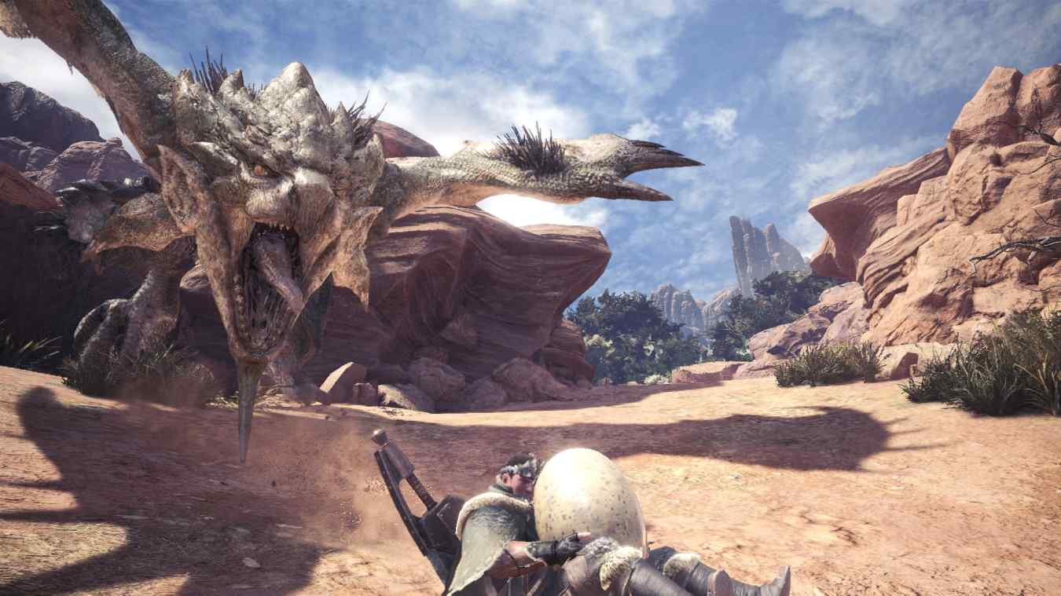
Figure 1. Rathalos egg protector.
Another example of the Monster Hunter series using animals as reference can be seen in the behaviours exhibited by Rathalos, a bird-like creature (See Figure 1). In this scene, Rathalos has had their eggs stolen from them by the player, this triggers a frantic response of chasing after the character. This is a behaviour mirrored in real birds, who are instinctively protective over their eggs since “the stakes for species survival are so high” (Wood, 2022). Zoologist, Zhanna Reznikova, also found that when predators are in the presence of an animal's nests, it is common for animals such as birds to respond by behaving in a chaotic manner, to try and deter the threat. This is an example of how successful creature design can be achieved through the utilisation of animals as references; by delving into both the physical and behavioural traits of animals (Holmes, 2016).
Being the most successful video game franchise, it’s no surprise that Pokémon are masters at using animals as inspirations for their creature designs. Pokémon approach their designs in a different way to Monster Hunter. Whilst Monster Hunter takes multiple references from different animals creating an entirely new monster, Pokemon’s design process is composed of two influences, animals and their habitats.

Figure 2. Poliwag.
An example can be seen in the design of Poliwag. This Pokémon is based on the Transparent Glass-Frog Tadpole, sharing both its distinctive physical features and behavioural traits. In the pokedex, the similarity is confirmed, with the species being named by the artists as a “tadpole” who, much like real tadpoles, evolves into a frog and lives in water. Physically, both the Poliwag and Transparent Tadpole have “a spiral on their stomach that resembles the intestines” on their underbelly, creating the iconic swirl that stands out in the creature's design (Carnegie Museum of Natural History , 2020). Furthermore, the Poliwags number one ability is speed, a behaviour trait replicated in tadpoles who “have long muscular tails, indicating an ability to move rapidly” (Downie, 2020).
Behind all great creature designs and the utilisation of animal traits and behaviours comes the understanding of semiotics. Within nature semiotics are everywhere, “including the organisation of insect nests” and the ”repetitive patterns of fractal geometry evident everywhere in nature’s branching structures” (Wheeler, 2006). Since semiotics are the foundation for visual communication in creature design, a theory that focuses on the presence of semiotics in nature alone was needed. The notion of biosemiotics was founded in 1962 by theorist Friedrich Rothschild; biosemiotics is “concerned with the study of signs and meaning in living organisms and systems” (Hendon and Sharov, 2022). In 2021, a paper analysing the semiotics behind the creature design of a reptile was published by Karta Atmaja (Atmaja, 2021). In this paper, she speaks about how she utilised biosemiotics to construct the reptile's “enthusiastic” personality and how subsequently the reptile was able to overcome “all obstacles, to complete the mission”. This highlights the importance semiotics play in designing a creature; the slightest trait can affect its character and visual communication drastically.
Mythology
The Oxford Dictionary defines mythology as “a collection of myths, especially one belonging to a particular religion or cultural tradition” (The Oxford Dictionary , n.d.). The word mythology is derived from the Greek words mythos (story) and logos (speech) and has held great significance since Plato coined the term “mythologia” (Kraemer, 1997). Creature design draws heavily from mythology, as mythology is prevalent in every culture throughout the world. Mythology in video games creates excitement and intrigue, presenting an opportunity to learn more about different cultures and different religions. The use of mythology in creature design immerses the players in the experience as all the themes build a believable world rooted in culture.
The Witcher is a video game series that embraced the use of mythology to build an immersive story, whose creature design has many parallels with Slavic and Celtic myths. The term "Witcher" itself alludes to a Slavic sorcerer with hidden knowledge. Folktales from the Slavic nations consist of some of the world's richest and most diversified mythologies. Whilst traditional Western European fairy tales have been diluted and sanitised via numerous retellings and interpretations, “Slavic mythology keeps its bite” (Allison, 2018). This can be seen in the game's creature design of the spirits that are bound to specific locations in the game, and have tragic backstories, such as the Botchlings; these creatures are based on the Slavic Bannik, “the spirit of the bathhouse” (Unclean Spirits, 2017). Botchlings are little creatures that resemble a severely deformed foetus, originating from the burial of unwanted, stillborn children; the backstory and behaviours of this creature match that of the Bannick. The similarities lie in the fact that they are also born of tragedy, and therefore seek revenge on the ones who hurt them, in the form of preying on pregnant women.
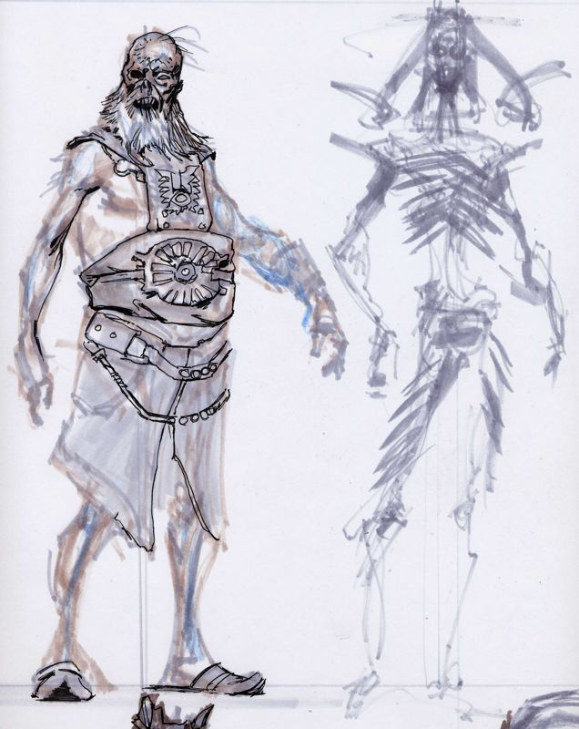
Figure 3. Draugr.

Skyrim is a game featured in the Elder Scrolls series that has kept a thriving community engaged for over 12 years, through detailed lore and creature design originating from Norse mythology (Gopaladesikan, 2013). One creature design featured in Skyrim is a zombie archetype named the Draugr. This inspiration for the creature design originated from Iceland and is further elaborated upon in the book The Playful Undead and Video Games. There are many myths similar to the Norse Draugr and they are all told as warnings to keep people from desecrating graves, creating a great opportunity for gameplay. Draugr represents the undead that guard ancient tombs and warriors who had died with glory. Draugr are dead warriors themselves, so their creature design incorporates many elements that tell the stories of these ancient characters, including ancient armour and weapons that have been worn down and buried with the dead.

Conclusion
Through exploring the subject of creature design, I have learnt about the amount of research and development that goes into the process. From looking at real life references, studying anatomy and how it could change and evolve through its narrative and then to pull influences from cultures all over the world. The process of creature design is a process that encumbers all aspects of life to create a truly effective design that creates engagement between the target audience and the work itself. For my proposed dissertation question, I would like to delve deeper into creature design and to create my own established world that these creatures could exist in. Elaborating on creatures that have been exposed to a virus perhaps over time and how it would affect the biology of the animals and their ecology. The title of the project would be How Nature and Culture influences Creature Design in Video Games.

Reference list
Allison, P. (2018). How video games like The Witcher are saving Slavic folklore. [online] Alphr. Available at: https://www.alphr.com/games/1008348/video-games-witcher-3-slavic-folklore/.
Atmaja, K. (2021). THE ANALYSIS OF SEMIOTICS IN ‘THE MAIN CHARACTER OF RAYA AND THE LAST DRAGON FILM’. LINGUA : JURNAL ILMIAH, 17(2), pp.45–64. doi:https://doi.org/10.35962/lingua.v17i2.87.
Avard, A. (2017). What Paleontologists Think About the Dinosaurs In ‘Horizon Zero Dawn’. [online] www.vice.com. Available at: https://www.vice.com/en/article/nz9zzm/what-paleontologists-think-about-the-dinosaurs-in-horizon-zero-dawn.
Barton, N.H. (2007). Evolution. Cold Spring Harbor, N.Y.: Cold Spring Harbor Laboratory Press.
Carnegie Museum of Natural History (2020). Pokémon Inspired by Animals. [online] carnegiemnh.org. Available at: https://carnegiemnh.org/pokemon-inspired-by-animals/#:~:text=Poliwag%2C%20Poliwhirl%2C%20and%20Poliwrath%20are [Accessed 25 Apr. 2023].
Downie, R. (2020). Croaking Science: See-through frogs are worth a look. [online] www.froglife.org. Available at: https://www.froglife.org/2020/06/30/croaking-science-see-through-frogs-are-worth-a-look/ [Accessed 25 Apr. 2023].
Fujioka, K. (2019). The Developers of Monster Hunter Explain What It’s Like to Build Monsters. [online] VICE . 18 Jun. Available at: https://www.vice.com/en/article/gy4ke4/the-developers-of-monster-hunter-explain-what-its-like-to-build-monsters.
Gopaladesikan, S. (2013). Rice University Explores Norse Mythology with a Skyrim Class - GCo. [online] Gamification Co. Available at: https://www.gamification.co/2013/02/05/rice-university-norse-mythology-skyrim-class/ [Accessed 25 Apr. 2023].
Henderson, D.M. and Snively, E. (2004). Tyrannosaurus en pointe: allometry minimized rotational inertia of large carnivorous dinosaurs. Proceedings of the Royal Society of London. Series B: Biological Sciences, 271(suppl_3). doi:https://doi.org/10.1098/rsbl.2003.0097.
Hendon, Y. and Sharov, A. (2022). Biosemiotics | Volume 15, issue 3. [online] SpringerLink. Available at: https://link.springer.com/journal/12304/volumes-and-issues/15-3 [Accessed 25 Apr. 2023].
Hutchinson, J.R., Felkler, D., Houston, K., Chang, Y.-M., Brueggen, J., Kledzik, D. and Vliet, K.A. (2019). Divergent evolution of terrestrial locomotor abilities in extant Crocodylia. Scientific Reports, 9(1). doi:https://doi.org/10.1038/s41598-019-55768-6.
IGN Games (2021). The Last of Us Part 2: How Naughty Dog Created Its Most Terrifying Monster | Art of the Level. [online] www.youtube.com. Available at: https://www.youtube.com/watch?v=zbJ8a1X5Paw [Accessed 5 Mar. 2023].
Kitchener, A., 1987. Function of Claws' claws. Nature, 325, pp.114-114.
Kraemer, E.W. (1997). An Etymological Dictionary of Classical Mythology. [online] library.oakland.edu. Available at: https://library.oakland.edu/people/personal/kraemer/edcm/preface.html#:~:text=The%20word%20mythology%20%5BF%20or.
Lieberman, B.S. and Kaesler, R.L. (2010). Prehistoric life : evolution and the fossil record. Hoboken, N.J.: Wiley-Blackwell.
Marc Taro Holmes (2016). Designing creatures & characters : how to build an artist’s portfolio for video games, film, animation, and more. Cincinnati, Ohio: Impact Books.
Moore, D. and Ahmadjian, V. (2019). fungus | Definition, Characteristics, Types, & Facts. In: Encyclopædia Britannica. [online] Available at: https://www.britannica.com/science/fungus.
Osterloff, E. (2019). What is natural selection? [online] Natural History Museum. Available at: https://www.nhm.ac.uk/discover/what-is-natural-selection.html.
Petruzzello, M. (2023). Zombie-ant fungus | Description, Infection, Life Cycle, Humans, & Facts | Britannica. [online] www.britannica.com. Available at: https://www.britannica.com/science/zombie-ant-fungus.
Smith, D. (2019). Theropod Dinosaurs. [online] ucmp.berkeley.edu. Available at: https://ucmp.berkeley.edu/diapsids/saurischia/theropoda.html.
The Oxford Dictionary (n.d.). Mythology . In: The Oxford Dictionary .
Travis, B. (2017). How Horizon Zero Dawn’s stunning game world was inspired by Planet Earth. [online] Evening Standard. Available at: https://www.standard.co.uk/tech/how-horizon-zero-dawn-s-stunning-game-world-was-inspired-by-planet-earth-tribal-culture-and-a-dutch-actress-a3478901.html [Accessed 5 Mar. 2023].
Unclean Spirits, (2017). [Podcast ] Mythos Podcast . 23 Jun.
Uriona, T.J., Lyon, M. and Farmer, C.G. (2019). Lithophagy Prolongs Voluntary Dives in American alligators (Alligator mississippiensis). Integrative Organismal Biology, 1(1). doi:https://doi.org/10.1093/iob/oby008.
Wheeler, W. (2006). Figures in a Landscape: Biosemiotics and the Ecological Evolution of Cultural Creativity. L’Esprit Créateur, [online] 46(2), pp.100–110. Available at: https://www.jstor.org/stable/26289226 [Accessed 25 Apr. 2023].
Whitlatch, T. (2019). SCIENCE OF CREATURE DESIGN : understanding animal anatomy. S.L.: Design Studio Press.
Wood, S. (2022). How Birds Protect Their Eggs? - Bird Buddy Blog. [online] blog.mybirdbuddy.com. Available at: https://blog.mybirdbuddy.com/post/bird-nest-protection [Accessed 25 Apr. 2023].
List of Figures
Figure 1. Fennimore, J. (2018) Monster Hunter World Egg Quests: 10 Tips You Need to Know.
Figure 2. Pokémon, Pokédex. (2023) Poliwag.
Figure 3. Bethesda Blog. (2012) Concept Art from Adam Adamowicz :Elder Scrolls V: Skyrim Concept Art.

