Ellie Phillips – 2503584

Research Report

What issues can arise from site-specific work and how can they be avoided?
Whilst learning about site specificity, we have also learnt about certain issues that can arise and responsibilities that come with developing site-specific work. Since site specific art takes place outside of the typical settings (galleries, museums) it is important to consider potential problems or disruptions that placing artworks in particular spaces can cause, as well as considering how the art itself will be perceived by various people. I have chosen this question within my report as I feel it’s an important factor to consider, especially considering we students are getting ready to secure our own locations to create a site-specific exhibition. I additionally feel that analysing the risk factors of site-specific art is a good practice and habit to implicate now, as understanding this fully will further set me up for success when considering site-specific art in the future.

Artwork 1
What makes this site specific?
JR’s Kikito (2017) “aims to summarize and counter the issue of the wall along the entire border envisioned by Donald Trump” (Redazione, 2017, para. 1) and features a massive, blown-up photograph of a small child whose family “lives within walking distance of the installation” (Morrissey, 2021, para. 1). Although JR’s Kikito received positive feedback, this artwork arose ethical concerns due to its location. Positioned along the US-Mexican border wall, the image is intentionally unframed and propped up to make the child appear to be looking onto the American side. This precise placement immerses the artwork into the environment, directly confronting and drawing attention to the physical separation between America and Mexico. Within the image of the artwork itself, a US border patrol agent can be seen looking up at the image of Kikito.
Although positive reactions praised how JR “smashed it” (NCA, 2020, para. 4), the installation’s location sparked a “visceral reaction” (Bacon, 2017, para. 15) in others “in a desert where hundreds of people die every year, trying to dodge Border Patrol agents, trekking on foot across the wall in the intense heat, is it enough to simply say, “Immigrants are human beings”? Why such a soft message in such a harsh context?” (Bacon, 2017, para. 15) Critics questioned the impact of such a “soft message in such a harsh context” (Bacon, 2017, para. 15) given the surrounding desert environment where hundreds had died attempting to cross.
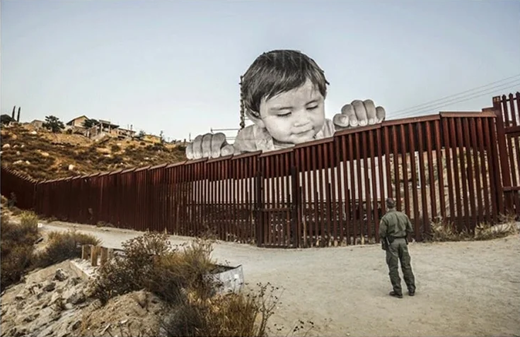
If JR had instead displayed Kikito (2017) as a framed photograph in a traditional gallery space, the critical scepticism regarding its location wouldn’t exist, but the piece would lose almost the entirety of its concept.
Kikito, Giants, 2017. JR

Artwork 2
Christo and Jeann-Claudes intention behind Running Fence was to “bring out the contours of the Sonoma hills and the seashore, the changing of the weather. The Running Fence is a celebration of the landscape. – Christo” (Christo’s Running Fence: Grand Vision and Detailed Execution, 2017) Christo and Jeann-Claudes Running Fence is overall well recognised and successful, however it faced multiple obstacles throughout the production process.
Running Fence faced legal complications as this project needed permits due to its location and massive size “5.5 meters (18 feet) high, 39.4 kilometres (24.5 miles) long, extending east-west near Freeway 101, north of San Francisco, on the private properties of 59 ranchers, following the rolling hills and dropping down to the Pacific Ocean at Bodega Bay.” (christojeanneclaude.net, para. 1), permits that they struggled to initially get due to concerns about the project “Concerns over the installation’s environmental impact, along with attacks on its artistic merit” (Chamberlain, 2017, para. 3) which led to “seventeen often-contentious public hearings.” (Chamberlain, 2017, para. 3).
Christo and Jeann-Claude additionally needed to acquire the permission from those on the land, so overall they needed “Five dozen ranchers to allow the artwork to be constructed on their properties; 18 public hearings had to be held; three sessions of California’s Superior Court convened to decide issues; and an Environmental Impact Report was created that was as thick as a prison wall.” (Wood, 2026, para. 2) in order to install Running Fence safely and legally.
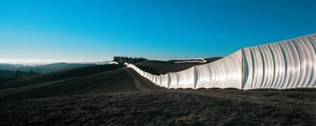

Running Fence, 1972-76. Christo and Jeanne-Claude.

Comparison
When it comes to Kikito (2017) and Running Fence (1972-76), they combined demonstrate the legal, social and environmental hurdles that can arise when putting together or displaying site specific art. Running Fence faced administrative resistance, requiring 18 public hearings and an environmental impact report to address the residents’ concerns. JR’s Kikito faced skepticism and geopolitical tensions.
To avoid issues such as this, artists could consider talking openly to the local people. Christo and Jeanne-Claude spoke to the local farmers and JR immersed himself into the local village and communicated clearly what he intended to create. Artists additionally must ensure that they get the necessary permission needed from the government before they begin the project and ensure that proper clean-up/clearance is in order post display.

Conclusion
When it comes to installing a site-specific project, it is essential to consider what issues may arise, whether it be social, legal, environmental, financial or physical issues. It is important to consider how your artworks will impact the nearby communities and environment. Issues such as this can be avoided with the necessary planning.

Reference list
Bacon, D. (2017). The art of the border: Searching for Kikito. The American Prospect. https://prospect.org/2017/10/30/art-border-searching-kikito/
Chamberlain, C. (2017). The politics of Christo and Jeanne-Claude’s running fence. Artforum. https://www.artforum.com/columns/the-politics-of-christo-and-jeanne-claudes-running-fence-233313/
christojeanneclaude.net. Christo and Jeanne-Claude. https://christojeanneclaude.net/artworks/running-fence/
Christo’s running fence: Grand vision and detailed execution. (2017). Deep in the Heart
of Textiles. https://textileranger.com/2017/03/22/christos-running-fence-grand-vision-and-detailed-execution/
JR Website. (2017). JR Website. https://www.jr-art.net/projects/giants-border-mexico
Morrissey, M. E. (2021). Border matters: A new materialist critique of installation art on the U.S.–Mexico border. Journal of International and Intercultural Communication. https://doi.org/10.1080/17513057.2019.1658798
NCA. (2020). How art installations on the US-Mexico border affected people’s understanding of the border. National Communication Association. https://www.natcom.org/publications-library/how-art-installations-us-mexico-border-affected-peoples-understanding-border/
Redazione. (2017). Kikito, the child who faces off between the U.S. and Mexico. FinestreArte. https://www.finestresullarte.info/en/news/kikito-the-child-who-faces-off-between-the-u-s-and-mexico
Wood, J. (2026). A colossal artwork that almost wasn’t: The man who kept “running fence” running. Marin Magazine. https://marinmagazine.com/community/history/a-colossal-artwork-that-almost-wasnt-the-man-who-kept-running-fence-running/

