How does mainstream primary schools manage behaviours in Looked After Children.
Introduction
School A is in an urban location, about two miles from the city centre. The school was opened in 1879 and continues to operate in the original Victorian building. The school has children that are aged between three and eleven years old, and the majority are living in the local community. There are 165 pupils on roll at School A, which includes 36 children that attend the nursery part time. There are seven classes, most of which have mixed age groups of pupils. Around 52% of the pupils at School A are eligible for free school meals, which is well above the national average. School A identifies 41% of the pupils as having additional learning needs, but only a few have a statement of special educational needs. The mobility rate at School A was about 28% last year, with families moving in and out of the community. The area that School A is situated in is classed as a high deprivation area, with many families from different locations being temporarily housed into the area. Most of the houses are old terraced houses dating back to the late nineteenth century.
A child is looked after by an authority if he or she is in their care or if he or she is provided with accommodation for a continuous period of more than 24 hours by the authority in the exercise of its social services function. Children are taken into care for a variety of reasons, the most common being to protect a child from abuse or neglect. In other cases, their parents could be absent or may be unable to cope due to disability or illness.
Department of Health (2015)
Child A is a five-year-old boy who is currently in temporary foster care and has been in care for the past nine months. Alongside this, Child A has behavioural issues that have seemed to stem from his current living situations. Child A has been located around ten miles out of the area of the school and his family. He has monthly supervised visits with his mother and termly visits with his maternal grandparents. Child A is in a straight year one class with twenty-four other pupils. He appears to not have a steady friendship group within the classroom and struggles with forming relationships with his peers. Child A has not attended School A since the start of his educational journey but joined eleven months ago.
According to the Department of Education (2018) ‘Local Authorities have a duty under the Children Act 1989 to safeguard and promote the welfare of a child looked after by them. This includes a specific duty to promote the child’s educational achievement, wherever they live or are educated. The authority must, therefore, give particular attention to the educational implications of any decision about the welfare of those children.’
So, looking at research and personal experiences with this child, my intent is to find out how mainstream primary schools manage behaviours in Looked After Children.
Methodology
Looked after children have higher rates of exclusion and poorer attendance records in comparison to the peers (Brodie, 2003). Statistics show that looked after children are twelve times more likely to be excluded in comparison to other children. It has been suggested that schools can unfairly associate looked after children with disruptive behaviours and fail to meet their requirements, which can result in exclusion (Blyth and Milner, 1996).
For Child A, I am the teaching assistant in his class and work closely with the ALNco and class teacher in order to give him inclusive education where possible. By looking at Government policies about looked after children and inclusion and my personal setting policies regarding these issues, I intend to find out if we are indeed creating an inclusive environment for Child A, with the current difficulties that he faces, including nurture groups and other interventions that he attends throughout the school day.
Child A spends most of the school day within a mainstream classroom, alongside his peers. Academically, he is performing below average for his age and struggles with the curriculum work, so requires a lot of support. Three times a week, Child A will leave the classroom environment and attend nurture groups and one to one support. Nurture groups were first founded in London in the seventies by an educational psychologist Marjorie Boxall. She realised that children who arrived at the classroom from disrupted or stressful backgrounds could not achieve their potential without being given a safe place in schools where they could develop and grow. With the change in the educational climate, there became fewer schools using her research to nurture children and by 1998 there was only approximately 50 nurture groups in operation. Times have now changed, and with the Government legislation ‘Every Child Matters’ there has been more focus put on to early intervention and looking at the needs of individual children. Nurture groups are focused interventions for children displaying social, emotional and behavioural difficulties that cause barriers to learn in a mainstream classroom. A group will consist of up to 10 children, which are usually between the ages of five to eight and is led by a nurture leader. Nurture groups are there to assess learning, social and emotional needs and support these needs to remove the barriers to learning. Hughes and Schlosser published a systematic review on the effectiveness of nurture groups. They concluded that nurture groups are an effective intervention for improving the well-being of children with social, emotional and behavioural difficulties. Child A also has an IDP (Individual Development plan) which identifies some of his needs and strategies to support these needs and are reviewed termly. An IDP is put into place to help a child make the most out of their education and builds on the curriculum. It includes a plan that sets out targets and actions additional to those set for other pupils in the class. The purpose of an IDP is to inform staff that work the pupil of specific targets and how they can be reached (see example in appendix 1).
Findings
England’s version of Estyn, Ofsted (2012) reported that, even though they have noticed improvements in the outcomes for looked after children in the past three years, there is still a significant gap compared to all children. Improving outcomes for children always sits at the heart of the Government legislation agendas. Cited from Welsh Assembly Government statement (2017), ‘we cannot change their personal experiences, but we have to work harder to mitigate the impact and support them into rewarding, fulfilling and independent adulthood’. The Government suggests that this is a shared responsibility with the government, schools, local authorities and education consortia. Their approach is to have a sharing of good practice and ensure a coherent and collaborative work programme.
All looked after children have a statutory care plan which is reviewed by the Local Authority. Each child will have a PEP (Personal Education Plan) which is the legal part of the care plan and is a statutory requirement for a looked after child between the ages of three and eighteen. The PEP provides roles and responsibilities which are set out by the child’s social worker and provides details of looked after child teams.
Within the school’s policies, they aim to help looked after children achieve the highest standards that they are capable of and that they are included, not only in school activities, but out of school activities also. Within the policy it will consider the schools code of conduct, their behaviour policy, the home school agreement, child protection policies and the special educational needs policies.
Looked after children often have been identified in having attachment issues, which is understandable considering there has probably been times in their lives where they have been unsure of what is happening within their own life and where they will spend the night. John Bowlby first outlined an attachment theory more than 50 years ago. It is a theory of personality development within the context of personal relationships. Although attachment is present throughout our lives, it is the early special bonds that babies and young children develop in their first year with their primary care giver. This is seen as a source of safety, comfort and pleasure and can display as distress when this relationship is removed. A child’s quality of attachment is influenced by their carer. A child who has developed a secure attachment to their carer will have several developmental advantages such as the security to explore with confidence and curiosity. Another important development is the regulation of emotions. If a child has not developed a strong foundation of emotional competence, when they enter school, they will struggle to manage their learning and the social environment of the school the way their peers will. Attachment behaviour can be activated by stress and many childhood mental health disorders are identified with attachment disorders. The 2005 WAVE Report (Hosking and Ita, 2005) identified child abuse and failures in attachment and responsive parenting during the earliest years of children's lives as the most important causes of violence in society. Perry and Hambrick (2008) argue that the brain develops in a neurosequential way. Starting with the brain stem which governs basic physiological survival behaviours right up to the frontal cortex which is the main part of conscious thought. They suggest that a child's brain develops differently depending on the stimulation provided by the physical, sensory, social and emotional environment in which a child grows up. The patterned rhythmic activities associated with a sensitive attached parenting style produce a well-organised functional brain, but for a child exposed to chaotic stimulation or lack of stimulation the outcome was a brain characterised by chaotic dysfunctional organisation or lack of neurological connectedness.
Happer et al. (2006) found that there is a wish for attitudes to be more positive towards looked after children. Similar to this, recent research has shown that attitudes in schools and the community impacts upon inclusion.
Looked after children are now regarded as one of the most vulnerable groups within our society. Under the school’s admission code, a school place must be found that meets the needs of the child as soon as possible, although looked after children have high rates of exclusion, so provisions would need to be put into place if a child is at risk of exclusion. This may be additional support in their current placement or an alternative educational placement such as a pupil referral unit if needed.
Looking at Maslow’s hierarchy of needs, a child needs to be able to feel safe and have a sense of belonging in order to achieve. Looked after children may not have had their basic needs met, so can not be expected to meet the social needs. Although schools can only support in some of the basic needs, there are things that can be put into place to help a child feel more secure within the school environment. Strategies such as a member of staff checking the corridors or room before the child enters, to relax the child and allow them to make the most of the learning opportunities available to them. Visual timetables can be a great help as the child can visualise what is happening throughout the day and be able to predict transitions (see appendix 2 for example of visual timetable). A calm box that contains multi-sensory and concrete activities can give a child respite from the demands of learning tasks and aid in managing stress and anxiety. Where some strategies may work for some children, it may not work for others. With Child A, a visual timetable assists us in the day to day learning in the classroom. Child A can see where he needs to be at each point of the day and notifies him of when he might need to leave the classroom (such as lunchtime/nurture group time).

Conclusion
Child A has shown to really enjoy his nurture group sessions and it does seem to be helping his emotional development at times. He can become very emotional at times and looking at the attachment theory, shows clear traits of low attachment. There are times where he ‘pushes the boundaries’ in the classroom and has to be centre of attention, but it is the only way he knows how to gain attention from adults. By using nurture groups and one to one sessions within the school, it does seem to promote inclusive education for Child A and others in similar situations. Although, with Child A returning to the classroom after one of his nurture groups with a chocolate bar in his hand, it has caused other children wanting to be involved in this process and has caused some friction at times, due to jealousy.
The Welsh Government (2017) report that ‘at Key Stage 4 in summer 2016 23% of looked after children in Wales achieved Level 2 Inclusive threshold, and this represents a ten percent increase since 2012’.
In order to have inclusion with looked after children, there is a need for school staff to have an awareness of how being a looked after child can affect children and young people, there is an importance of addressing the child’s individual needs in a discreet manner, and training and resources need to be freely available to those working with these vulnerable children and young people to gain an understanding of their role and supporting a looked after child.

Reference List
Blyth, E., & Milner, J. (1996). Exclusion from school. Cassell: London.
Boxall, M. (2002). Nurture Groups in School: Principles and Practice. Sage Publications: London
Bowlby, J. (1998). Attachment and loss (No. 3). Random House.
Brodie, I. (2003). Children’s homes and school exclusion: Redefining the problem. In M. Nind, K. Sheehy & K. Simmons (Eds.), Inclusive education: Learners and learning contexts (pp. 31-40). David Fulton: London.
Department of Health (2015) Promoting the Health and Well-being of Looked-After Children. Available at: https://assets.publishing.service.gov.uk/government/uploads/system/uploads/attachment_data/file/413368/Promoting_the_health_and_well-being_of_looked-after_children.pdf [Accessed on 22/02/19]
Department of Education (2018) Promoting the Education of Looked-After Children. Available at: https://assets.publishing.service.gov.uk/government/uploads/system/uploads/attachment_data/file/683556/Promoting_the_education_of_looked-after_children_and_previously_looked-after_children.pdf [Accessed on 22/02/19]
Happer, H., McCreadie, J. & Aldgate, J. (2006). Celebrating success: what helps looked after children succeed. Social Work Inspection Agency.
Hughes. N., and Schlosser, A. (2014). The Effectiveness of Nurture Groups: A Systematic Review. Emotional and Behavioural Difficulties. Vol. 19, Issue 4.
Hosking. G., and Walsh. I. (2005) Wave Report 2005: Violence and what to do about it, Croydon Wave Trust
McLeod, S. A. (2017). Maslow's hierarchy of needs. Available from: www.simplypsychology.org/maslow.html [Accessed on 23/02/19]
Ofsted (2012) The impact of virtual schools on the educational progress of looked after children. October 2012. No 120165
Perry. B., and Hambrick. E. (2008) The Neurosequential Model of Therapeutics, Reclaiming children and youth,17(3)
Welsh Government (2017). Raising the ambitions and educational attainment of looked after children in Wales. Available at https://gov.wales/about/cabinet/cabinetstatements/2017/educationalattainmentlookedafterchildren/?lang=en [Accessed on 25/02/19]

Appendices

Appendix 1: Example of IDP for Child A.
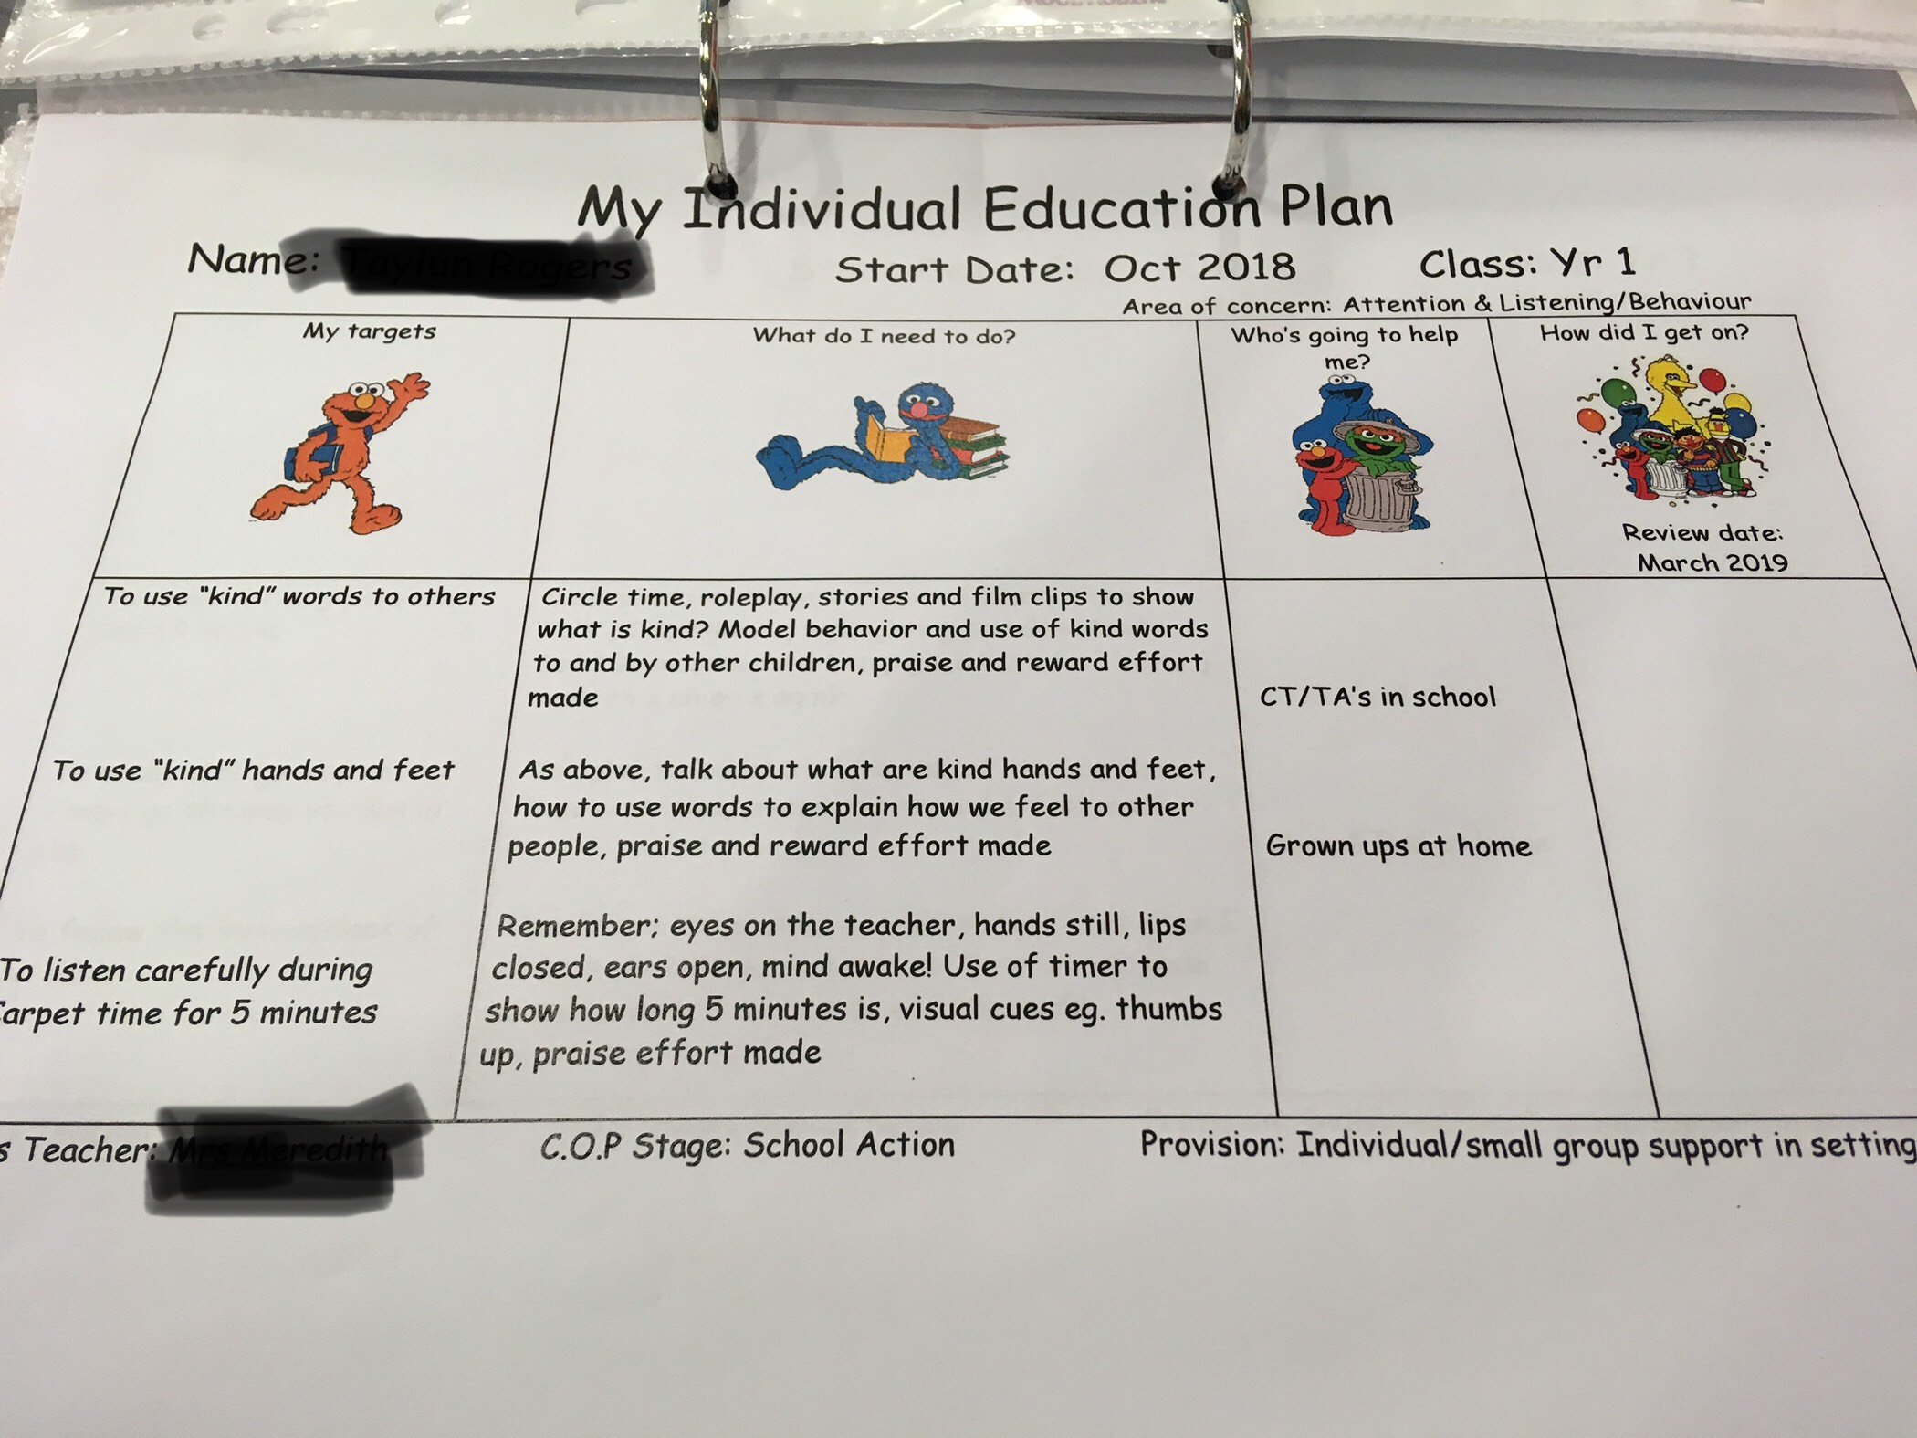

Appendix 2: Example of a visual timetable


