Film Noir and Colour
P146624
BA 3D Computer Animation
6181 words
Scott Smith

1. Intro 2
1.1. The Difficulties 3
1.2. Relevance and reference 5
2.Background 6
2.1. The cinema of black 6
2.2. Back in Black(er) 7
3. Neo(n) Signs 7
3.1. The rivers will run what ? 9
Figure 3. Sin City(2005) Marv wakes up and finds Goldie dead 11
3.2. The colour of the submarines 11
3.3. The supposedly warmest colour 12
3.4. The colour of Oranges 13
3.5. Eat your colour 13
3.6. Tastes like pills 14
4. Strategies 15
5. Red or Green exit sign 17
5.1. Future-noir 18
6. Bibliography: 19
6.1. References: 19
6.2. Additional Reading: 19
6.3. Filmography:* 20

“It's impressive to see a man feeding off his emotion.”
- Se7en(1995)

1. Intro

Very few film styles enveloped cinema in shadow and light as much as film noir. With its roots firmly planted, its tendrils more often than not find its way into modern cinema, either by visual stylistics or by story conventions. Even though it has been more than seventy years from its inception, the topic of film noir still remains debated. If one would go and ask five different film studies lecturers, you could very well get five different answers. Since the definition of what is and what is not classified as film noir, or what actually film noir is remains less like a stone, but more fluid like the water that erodes it, leading to many films being subjectively mislabeled. This paper is concerned much less with trying to define film noir in a cohesive manner, nor diligently box it into genre conventions and other definitions. Therefore, a thought is in place about how does one judge, and debate about the necessities of the story, both in writing and visual department. Leading us to the goal of this paper, which is to devise and present a consistent and cohesive framework of thought for adapting hard boiled, noir and noir-esque stories into a moving visual media.

Adapting stories with noir stylistics is of course more easily said than done. In the process, one will encounter multiple problems, but the outcome, if executed with grace, will yield a great result. One also has to refrain from thoughts akin to ‘’Is it enough noir ?’’ or ‘’Is it too much noir ?’’. Great movies have been labeled with the Noir tag, that when first viewed do not strike the viewer as such. People would be surprised that Big Lebowski(1998) is a neo-noir, almost a full fledged one, but one that almost completely lacks any fog filled alleyways with creepy shadows cast by low-key light.

First of all, we will look at what is the widely referenced and mostly accepted definition of noir and isolate the parts that are relevant to us. Undoubtedly, one will tie to each other, therefore some notes will have to be made on the selection. Then we will take a rather brief, but still in-depth look at the world of colour in cinema, its properties and psychological effects. And lastly, we will discuss some approaches to using the colour in our visual moving media.

1.1. The Difficulties

Adapting stories into a noir cinema is a very mind taxing process. It is far too easy to create just a very generic noir film, which might be very boring to watch, or someone might just use black and white filter and call it a day (or night in this case ?). Surely, it does work sometimes, but unless the story, or the media, requires it to be complete, then it just comes off as a cheap, low effort attempt.

When looking at the differences between Noir and Neo-Noir, first one that is noticeable, even from a still image or a picture frame is, that Neo-Noir tends to be in colour, and by that we mean more colours than monochrome. Films, from their inception were black and white due to the technological limitations, and therefore colour related techniques were unable to translate from the theatre onto the silver screen. During the inception of the noir movies, colour film stock was very expensive to buy, monopolized and even more expensive to shoot on. This started off the noir movies as more down to ground ones, and when the noir cinema made its move onto the colour, many filmmakers were almost afraid to use it to its fullest as it carried a risk with itself of making their movies not noirish enough. The colour was almost thought of as a burden, and making their movies only black and white should have felt as an easy way out. But some Neo-Noirs proved otherwise.

For example, taking a look at Roman Polanski’s Chinatown(1974), which is by most hailed as the greatest Neo-Noir to date, shows us that it’s not only lighting and colour that contributes to the feel of the film. The film takes place summer Los Angeles that is currently being plagued by a season of droughts. The setting itself rids the scenery of the heavy rain and when viewing, one can notice only one noir-esque shot, as Hollis Mulwray(Darrell Zwerling) watches water being illegally dumped into the ocean.
Figure1. Chinatown(1974). Mr. Mullwray watches the dumping of the water
What definitely helps it is the inclusion of other noir, or neo-noir characteristics, which we will talk about later.

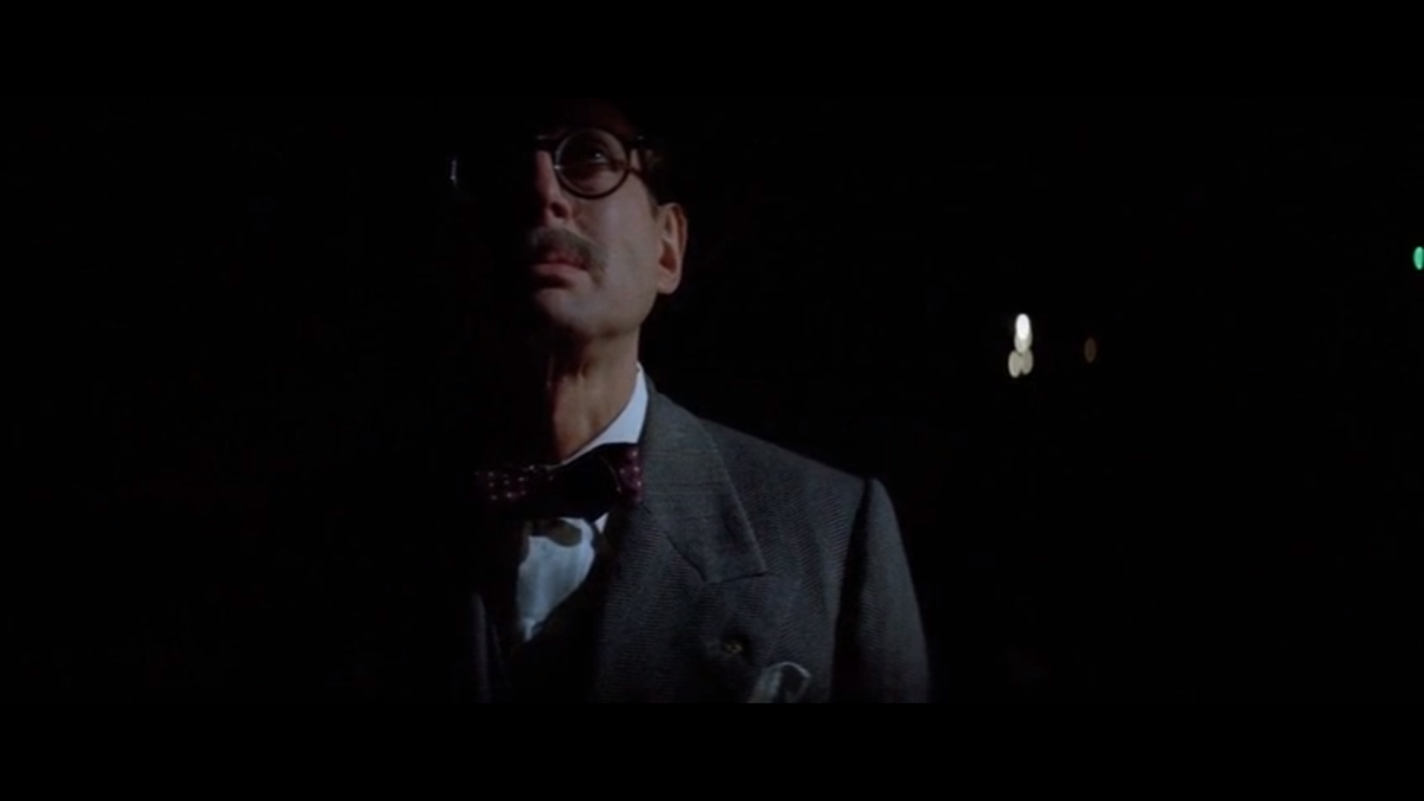
Figure1. Chinatown(1974). Mr. Mullwray watches the dumping of the water

Chinatown was one of the first neo-noirs, and even though the genre conventions were not as developed back then, it is still very much aware of the noir. It, besides being a good movie as it is, did not do anything particularly new or groundbreaking with the conventions. And it really did not need to. A lot of aspiring filmmakers might be tempted to create something original, but even if that might not be in their power, it is a fact that has to be sometimes accepted in the postmodernist society. ‘’And, after all, what is originality? It is merely undetected plagiarism.’’ - H.Paul (1894, p.645)

Huge part of postmodern art is all about subverting and reinventing the wheel, which inherently is not a bad thing, but one has to be wary of his wheel becoming more rectangular than circular in shape. Although, it might seem that the aim here is to curb the creativity of an individual, but it is rather a form of steering the car to stay on the road towards our goal: A (neo-)noir media.

Therefore, one of our goals here will be to understand our tools and use them well. For example, a chisel might be a simple tool, but its uses vary from building houses, creating sculptural masterpieces to breaking egg shells in a fast food restaurant. It is all about knowing the tools well, and properly utilizing them for the desired effect.

Lastly, style. Style is something that cannot be taken away from noir cinema, to the extent that some critics define noir as a style. Deceiving as it is, style itself will not carry the product alone. The great examples use style in conjunction with the story and in regard to story’s necessities to convey the experience, and it is the reason why movies like Se7en, Blade Runner(1982) and others work so well.

1.2. Relevance and reference

As with most papers dealing with film theory, they are goal are always to provide knowledge to bolster the filmmaker’s ability to produce great pictures. Even if it’s just theory, proven concepts or full on movie analysis including wide scope of psychological attribution. Therefore, our goal here is to create something readable, understandable, and importantly, credible for any aspiring filmmakers to refer to when adapting their noirish stories into visual media. This will be in no way a definitive one stop shop, as many techniques like framing, lenses, movement techniques et cetera will be omitted.

A brief run through of Noir conventions and basic definitions(which are not definite, and to this day discussed), to paint a moderate picture for readers to be able to follow along and understand everything.

From the perspective of academic landscape, Noir as a topic is very widely discussed and analyzed. From papers in pursuit of ‘set in stone’ definition, across psychological analysis of profiles to cultural, sociological commentary and feminism. With writers like Hirsch, Naremore and from the very start, Raymond Borde and Etienne Chaumeton there is absolutely no scarcity in acclaimed papers going in depth about various aspects of noir cinema.

The topic of colour is even more bountiful, if researched well, as historically, it has been a point of interest of many cultures and their members, since it has been part of our world since the beginning.

The hunch comes into place when evolving noir into neo-noir, and adding colour into the mix. The landscape consists only of very few papers and mostly of film analysis. Therefore, a lot of insights will be drawn from brilliant paper by Kathrina Glitre, Under the Neon Rainbow: Colour and Neo-noir, and conclusions drawn from analyzing the style of selected movies.

2.Background

2.1. The cinema of black

Interestingly, the term film noir originates not in the United States, but in the post-occupation France. Nino Frank, one of the french film critics, coined the term, after he used it to describe the series of movies produced in America during the occupation of france by germany. When viewing the films, he noticed several similarities in style, tone and story .

The contribution of second world war contributed more to film noir than just throwing america into war time or helping the french coin the term. The political situation in germany led to multiple proven filmmakers fleeing the country to america, thus carrying the previously prevalent style of expressionist cinema overseas and starting to lay down the necessary ingredients for birth of the film noir.

In the 1920s in pre-war america, advancements in technology, namely synchronized sound and better, more light sensitive panchromatic cameras were just the beginnings of the film revolution. Few years later, in 1930s, colour film stock made its appearance and a bit later, one was able to count more cinemas than banks in the united states. As the depressed citizenry sought escape from the reality, spectacle movies as the Disney’s Fantasia(1940) and The Wizard of Oz(1939) were none less than an impressive must see ‘blockbusters’. Technicolour, who owned the patent to technicolour film strip, maintained the monopoly over the field to the extent of having their own colour film consultant, Natalie M. Kalmus, which went on to write an article about colour consciousness, and a cameraman work on each of the movies. Even though these films were full of colour, it came at a huge price mark for the production. Although the cinemas raced to get their hands on the newest colour film, huge production companies were still rather fearful about betting on a single horse, therefore they began the practice of block booking.

Block Booking, a practice later outlawed, was a form of selling films to the cinemas. The cinemas, instead of purchasing each film individually, had to buy this ‘cardboard box’ of films, which indeed, included the newest upcoming blockbuster A-list, but they were tightly packed inside together with numerous b-list productions. This helped offload the profit requirements from the single A-list, and spread them around, or in reverse, still make money back on the other movies with less production value.

We already talked about the colour films being a spectacle, and they were being marketed as that as well. Therefore, even though the world is, undoubtedly, colourful, the black and white B-list productions evoked more realistic feeling. Even though they felt more real, Hays code prevented them from being ‘too’ real. Under tight budgetary constraints, but with less pressure to profit, these movies opened the gates for bigger amount of experimentation. Being ‘too’ real, while adapting pulp and hard-boiled stories, while still upholding the Hays code forced the filmmaker’s hand towards more implicit, than explicit, forms of visual storytelling. Inspired by french poetic realism, influence of the newly immigrated german expressionists, the city scapes in these movies not only reflected the pervasive cynicism, pessimism and overall fear of the future in the era, where great depression spilled into the war, but it also reflected with the characters, as two mirrors placed against each other.

One must note that film noirs, even though they were partially analogous towards the state of the United States in the era, focused mainly on the characters, dwarfed and lost in the oneiric cities. Fear crept behind every corner, and the dark tendrils of the shadows at night time eerily waited their turn to snatch individuals onto the wrong, ‘dark’, path. Mixed, ambivalent morality, morally grey areas and fatalist outlooks were often very important parts, and some carry even a trademark weight. It is the ambivalent morality, or ambivalence itself that is also a part of the 5 elements that duo of film critics, Borde and Chaumeton attributed to film noir, while pursuing its definition, and a framework of identifying noirs. The other elements, in no particular order, described the need of the films to satisfy oneirism, cruelty, eroticism and uncanny strangeness. It is important to note, that both Borde and Chaumeton emphasized the needlessness of encompassing or representing all 5 of them, or in equal measure. (Borde and Chaumeton, 1995)

2.2. Back in Black(er)

As we can see, nailing down exactly what is a noir is rather hard task, but all the discussion led on the topic after it’s coinage helped the noir movies reflect upon themselves, rethink and evolve. In the late 1950s the dreamy noirs entered into its post-classical era. Many critics note, that while noir focused more on the psychological aspects of the individuals, neo-noir bit a bit more of the cake, and tries to point its gaze towards sociological aspects of our lives, while still keeping the main elements of the noir intact. Of course, bringing in a new flavour of ideologies and themes with it.

3. Neo(n) Signs

It is rather daunting task to talk about neo-noir without delving into colour, so let us talk about colour alone for a bit now. As Kathrina Glitre states ‘’Colour is objective and subjective. It is relative, cultural and specific’’ (2009: 11), but to understand all those, we need to at least briefly delve into colour as a subject of study, looking at both psychological and physical properties.

Colour is everywhere, it is one of the first things we see after we open our eyes when we are born, and when we wake up. To build on Glitre’s statement, I must add that the colour is inherent as well. Since we are born, we tend to steer towards some colours more, and some less. It is embedded in our genetic code, as a result of millennia of evolution. Not only we inherently have predetermined reactions to some colours, some others may be subtle, spread out as a long term, passive effect.

From our youth, we get some colours hammered in as a signs of specific things. But that is just scraping the surface. The majority of the population never learns to think about colours further than their subjective preference and situational moments like red traffic light meaning stop, which by itself was a ‘colour conscious’ choice made by someone or a group in the past, an educated choice at that. The ‘colour consciousness’ we will talk about is not the one related to a person’s skin colour and thus attribution to a race, but rather researched awareness about colour as it is. It is essential for anyone concerned with design of anything and everything. It is very rare in the industry for someone to be completely ‘colour blind’ (as in not being ‘colour conscious’). Glitre’s statement essentially sums up anything we could talk about, but it is not in depth, although it does represent the depth that one can go in when talking about colour.

From a filmmaker’s perspective, the colour opens up a multitude of techniques to enhance the cinematic experience. As Kalmus explains in ‘Color Consciousness’ a proper use of colour ‘’amplifies the picture in a similar manner’ as the musical scoring. It is worth noting, that similar to the musical score, it has to enhance the experience in sub-conscious way. Earlier we mentioned that most of the population is only surfacely ‘Colour Conscious’, and in similar manner, that is true about musical theory and scoring. Therefore, it is necessary to tailor both so it reads, albeit unconsciously, to the audience even without the knowledge. As a lot of people will not come back to the film they have seen, unless it is their favourite, the colour design must read the first time around. A great colour design will complement the narrative, deftly paint and enhance the characters and still read well the first time, but carry the ability to be appreciated more in successive viewings. It is as well one of the reasons some movies are watched, or rather observed, multiple times and studied later on (Kalmus, 1935). Therefore, it would be suitable to mention examples with the colours.

3.1. The rivers will run what ?

Earlier we mentioned how painting the stop light colour red was an educated decision. In a same vein, the stop signs are universally red as where-ever you go. The technicolor logic required red to always read as the colour of danger, anger and passion. Evolutionarily, this made a complete sense, as red is the colour of our blood. A wound on our finger after we cut the nail a little too much, our fellow tribesman in a pool after an unfortunate encounter with a wild animal, or a bit dripping from a sword that has recently cut down something, the blood will always run red.

Embedded in our DNA, and hammered in by our parents and teachers from young age, red was always a colour of danger to us, and a warning. Therefore, the stoplights and stop signs being red is rather logical. It signals us to STOP or face the danger that awaits after we pass the point. What danger inherently carries in itself is a power, power of the lives of us or those around us, and therefore the red is the colour of power. When someone is enraged, his face turns red, and its danger, and also power. Red does not only warn us, but it also triggers the psychological response of anxiety and anger. Going down by the logical tree, we will discover that things that anger us, or we are angry about are the things we care about, and the things we get angry about the most are the ones that we are passionate about. It is the passion that more often than not helps us forge our path ahead. Love, called the big lie and whatnot, is what quite a lot of us headlessly chase, and as such, it is both passion, lust, danger and all the rage. Take Sin City(2005) a movie by a trio of directors consisting of Frank Miller, Quentin Tarantino, Robert Rodriguez. With a noir aesthetic which one could almost say it’s shoehorned in, if it was not so great and done well. Besides black, white and all the shades in between, the the colours we get is a bit of green, but red dominates the scene. A bold saturated red that carries the whole scene on its shoulders. The Colonel(Josh Hartnett) approaches The Customer(Marley Shelton), who is clad in a red dress, with her lips are painted red as well. From start, we can see that this will be a scene of seduction. But it is not her who seduces, but rather her who is reversely seduced, as the scene plays out. Successfully seduced to a kiss, The Customer is shown losing control, with a lipstick smeared after the kiss. The control she lost is the control of her red, as her red
changes from the one of the seduction, passion and lust, to the one of the danger and muted anger, as she is mercilessly shot dead a mere frames after, with her red dress concealing her bleeding wound. Green makes its appearance, but we will talk about green in its separate section.
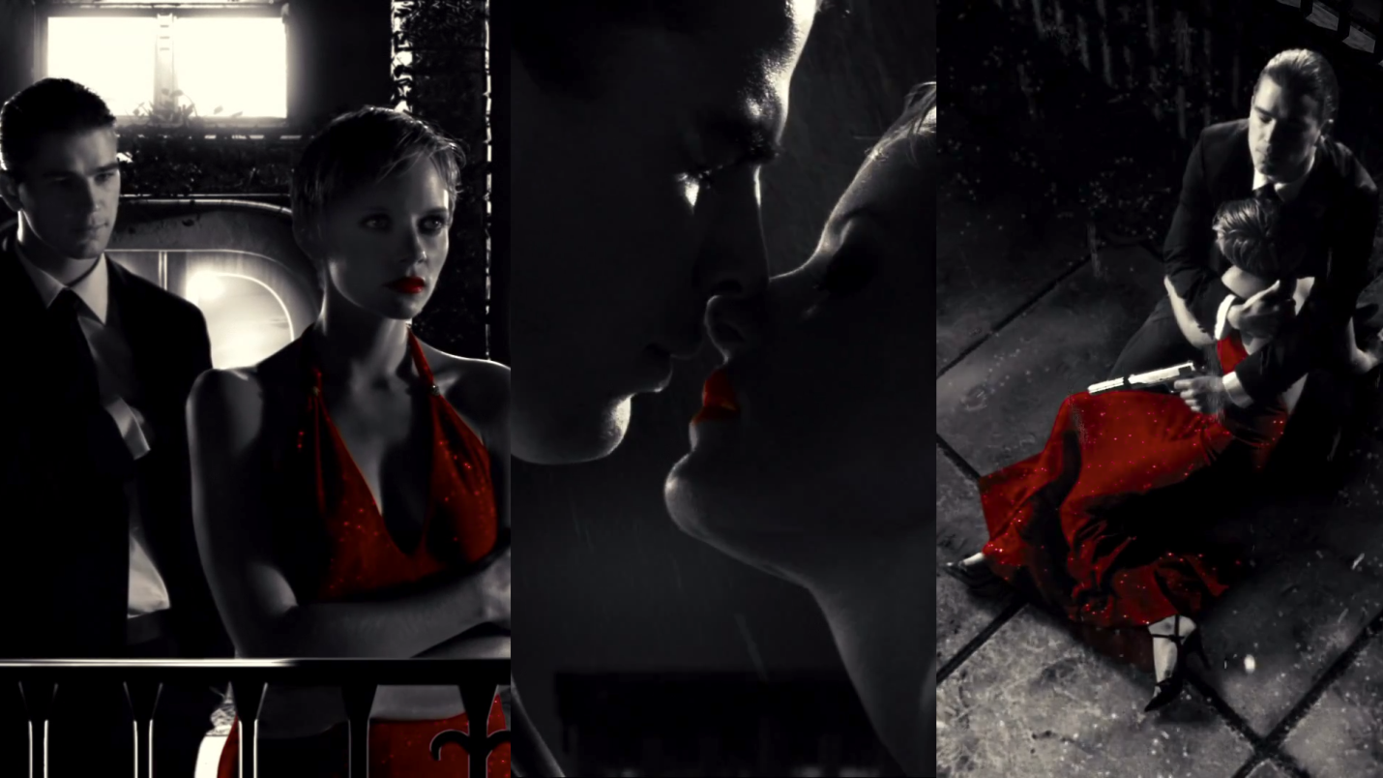
Figure 2. Sin City(2005) The Colonel’s encounter with The Customer

Another, even greater use of red is shown a bit later in the film. It is the scene where Marv(Mickey Rourke) finds out his love and a lover for the night, Goldie(Jaime King) was murdered while he was asleep after the night of passionate love-making. After he wakes up and find Goldie dead, he sits at the side of the bed, angry that the only person to show him love was taken away from him. In this case, the red symbolizes the passion of the night before, the bed taking up most of the space in the room, showing just how much power she has over him, the bed also becomes the pool of blood that Goldie was murdered in, underlining the danger that Marv is, and is in. One more colour that makes appearance is Goldie’s titular gold, or rather yellow.
Figure 3. Sin City(2005) Marv wakes up and finds Goldie dead

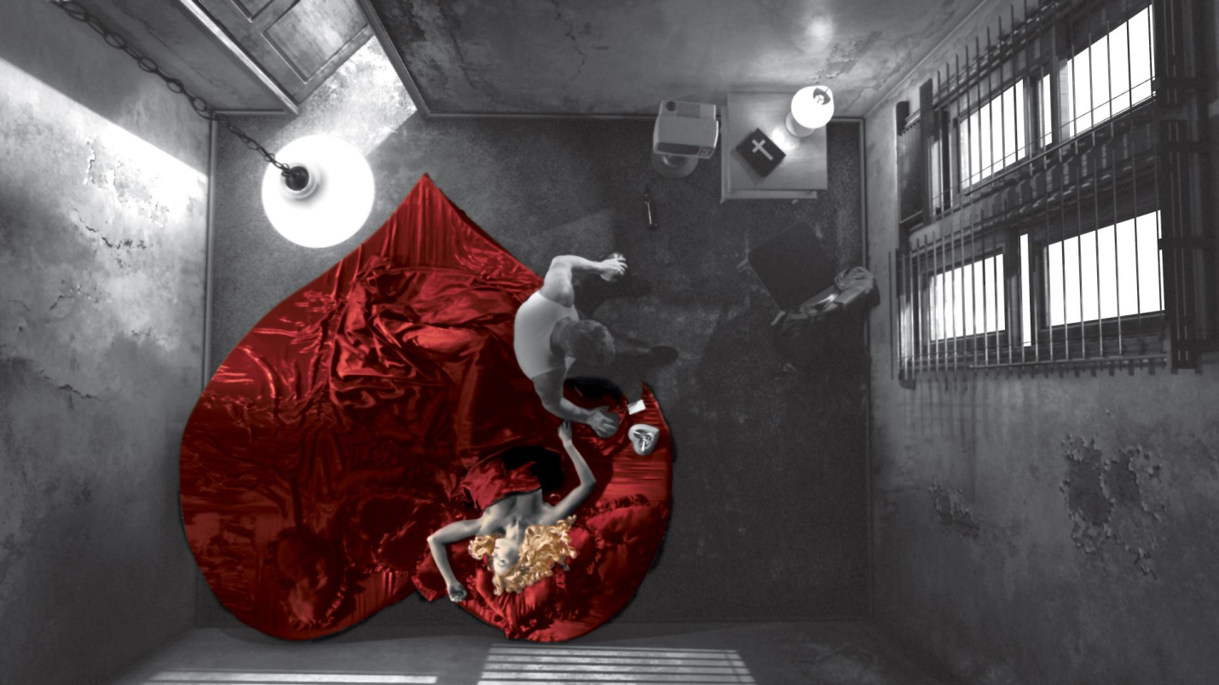
Figure 3. Sin City(2005) Marv wakes up and finds Goldie dead

3.2. The colour of the submarines

Yellow is arguably the most visually aggressive colour. Unlike the red that signals the danger itself, yellow is a colour of warning. It is cautionary and as so is used on caution signs, and a similar to that, venomous snakes and frogs cover themselves in it to deter predators from
attacking. Even though it is cautionary, it is also contrary. And on that contrary, the yellow is the colour of the sun. The thing that gives us life. For example narcissus, with its yellow colour is a symbol of wealth and good fortune in the western culture, and so its perception as such can be attributed to the gold, which was used as symbol of wealth throughout history.

Wealth, the pursuit of which is in modern day very widespread, and could truly be compared to obsession. Obsession, whose colour is yellow as well. Looking back again at Sin City, a character of Roark Junior(Nick Stahl), often dubbed as the Yellow Bastard is a malformed human, whose undying obsession with the only women who was taken from him, Nancy, often leads him down a path of unreasonable decision and loss of temper. Marv is also obsessed by his revenge for killed Goldie, who had yellow hair. Both which also stem from yellow colour’s effect on our psychological state. Furthermore, when our yearning for our obsessions is prolonged, or we are notably cautious, we slip into states of anxiety, and therefore, yellow is also anxious.

3.3. The supposedly warmest colour

Blue is a colour most likely associated with the water and the sky. Elements that, throughout our lives remain a pieces set in stone. Thus they are something we can depend on. Which brings forth the fact, that the blue colour is dependable and as the colour of the sky, and colour of the water, unchanging with loyalty. Writing about water, it is something that is very much quintessential to our lives, yet something that can be extremely hard to fight against. After years, even a soft stream of water will chisel its way through a rock, and when water related natural catastrophes happen, water tends to permeate, undermine and take anything and everything that is in its path for long enough. Adding the fact that two thirds of earth’s surface is covered with water, makes us seem pretty powerless against its might. And when one feels powerless, a blanket of soft sadness covers everything, the very blanket that we conveniently dub melancholy. But in states of melancholy, a sense of tranquillity can be fished out from a stale pond. When we go with the flow of the water, and let it surround us as much as we let it, we feel closer to tranquillity than to powerlessness. Since the relation between water and colour blue is so strong, blue also evokes the perception of cleanliness, purity and therefore sincerity.

Magnificent use of blue colour can be seen in Roman Polanski’s Chinatown. The blue colour in the film is very tied to the water, and its absence in the film. Albeit one could argue, that it is not exactly ‘’using’’ the colour, if we deliberately remove the colour, but it is exactly that what makes it so magnificent. The effect on the whole style and mood of the film supports the narrative and produces very dried looking environment of the drought stricken Los Angeles, where the premise turns around water disputes. The colour palette in the movie is very limited as well, featuring mostly ‘qualitative’ shades of creams, browns and yellows (Arnheim 2006, 53).

Another way, the blue is used for another meaning is to signal integrity and intellect. Firstly, as previously mentioned, Los Angeles is being stricken by severe drought, and since the story twists around corruption and scheming in high ranking positions, the Los Angeles no longer lacks the cleanliness of the water, but also the integrity. As for the second, the intellect, the scenes were important cues and plot points are discovered always feature water of sorts.

The very last meaning behind the colour blue, especially the lighter, more greyed out ones, signals something left unfinished, and as we can observe in the ending of the Chinatown, Jake Gittes, In prevalently grey suit, with slight light blue undertones has an unfinished business, even after being told to leave it alone.

Therefore, the blue, or the severe lack of it, sets the tone for the whole movie, as observed in Chinatown.

3.4. The colour of Oranges

Orange colour is inherently warm, welcoming and therefore one of the more seemingly saturated colours on our list. Its close to the sun, and psychologically upbeat colour while being naturally earthen. It is the combination of red and yellow, and therefore it can be as welcoming as yellow, and as passionate as red, which makes it romantic in a naïve, caring way.

Orange is also a citrus fruit, and citrus fruits for being fresh and refreshing exotic feeling. But being exotic may also mean danger and possible toxins. The use of orange in Apocalypse Now(1979) and both Blade Runner(1982) and Its sequel, Blade Runner 2049(2017) is the one of dangerous toxicity. It is again the mix of red and yellow that enables this. While red lends its impression of danger, the yellow, while being cautious and synonymous to life melds the two together to make orange to be the very antithesis of life. Exemplary, the orange in Apocalypse Now is the one of Napalm and its smell, and the orange in Blade Runner and Blade Runner 2049 is one of improperly maintained polluted atmosphere, and irradiated zone of Los Vegas respectively.

3.5. Eat your colour

The colour green is a colour full of dichotomy. It is the colour of flora, but the one of corruption as well, similar to how different the green in salad and green on meat is. In this sense, it is very similar to yellow by being ironic because of its dichotomous nature. In relation to human body, when your face turns green, it is either a sign of illness, or you turned green with envy, which is a very dangerous emotion.

Even though we view green as the colour of nature, we hold an extensive aversion towards green in liquid form. It is poisonous and repulsive. Similar to the Wicked Witch of the West (Margaret Hamilton) in The Wizard of Oz. Thanking to our hardcoded responses to green, we can see her as evil, the danger and corruption incarnate.

Corruption is another strong meaning tied to green colour, and the use of the colour is masterful in Nicolas Winding Refn’s Drive(2011). The green in the background of this scene symbolizes the corruption of the world that is the Driver(Ryan Gosling) now becoming a bigger part of. The green also contrasts the pink, and by both colours taking up a chunk of screen space, the practice of blasting the screen with excessive colour to signify morally dangerous location comes into place.

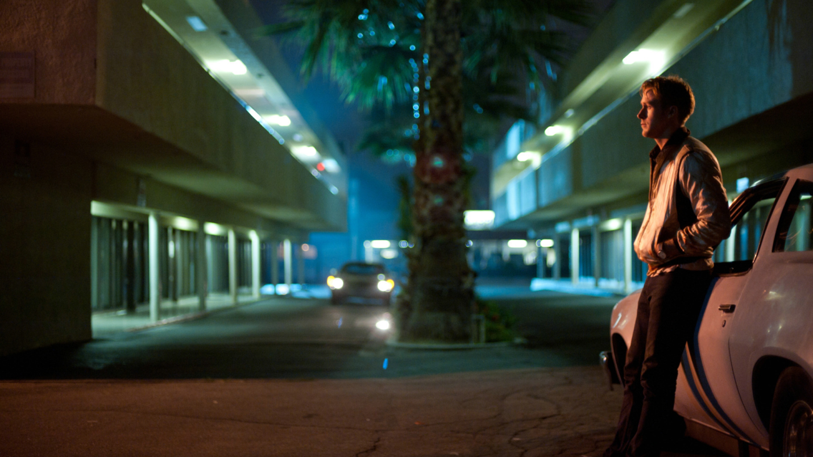
Figure 4. Drive(2011) The driver(Ryan Gosling) awaits Shannon(Bryan Cranston)
Figure 4. Drive(2011) The driver(Ryan Gosling) awaits Shannon(Bryan Cranston)

3.6. Tastes like pills

Tasting purple is a phrase related to being under effects of hallucinatory drugs, especially LSD. The phrase originates from ‘’being able to taste colour’’. Hallucinatory experience can lead to spiritual experiences akin to the ones of tribal shamans in the past. In this sense, purple is associated with the spiritual, mystical and unknown. Many Purple has often been perceived as a religious colour and as such is worn by priests from various churches, mainly Catholic. This was a result of purple being the least naturally occuring colour in nature, as well as the first one to be synthesized. Since it was the least naturally occuring, it meant rarity, and rarity is something that royalty seeks to display. Therefore, purple is a royal colour, and was worn by the Caesar, who was sometimes dubbed ‘’The Purple’’. In Britain, purple is a colour symbolic for mourning as well, and priests in vatican are allowed to wear purple robes when officiating funerals, which brings us to the fact, that the colour purple is viewed as a a one of transformation or death. The death might not be literal, it can be a death of one’s dreams, hopes or youth. Being both tied to transformation, religion and the spiritual, purple is ethereal and illusionary, in which it can be both illusion and disillusionment.

As with many combinated colours purple is visually interesting and ambiguous. It is a combination of red and blue, which are often colour coded to be Male and Female colours.
Therefore, in contemporary arts, purple as a colour in relation to gender is to be viewed as either asexual and transsexual, the latter one being transformation as well.

4. Strategies

Before we start, it is essential we understand the essential properties of colour and a terminology that is in conjunction with the one used by imaging experts. When talking about the properties of colour in analog and digital filming process, we consider the three major terms: Hue, Saturation and Lightness. Together they form the HSL model.

Hue is what we learn as a kids to describe colour. On an angular colour space axis, it can be described with a number from 0 to 359°, and in words like Red, Yellow, Green.

Saturation is defined as ‘’colorfulness of an area judged in proportion to its brightness’’.

Lightness defines a range between 0% (Pure white or Fully Tinted) to 100% (Black or Fully Shaded) with original hue’s average lightness being 50%.

And now we will look into more ways to create visual contrast, then just ‘’through difference between black and white’’(Arnheim, 2006: 54).

As Kathrina Glitre observes, Neo-noir uses mainly neutral colours (greyscale, earthy browns and sepia) that are usually contrasted by saturated primary colours, with the favour skewing towards primaries of light: Red, Green and Blue. While both green can dominate entire films, such as the acidic, medical unhealthy green in Fight Club(1999). Since red is such a vibrant powerful colour in film noir world, it is often reserved for the key scenes and mise-en-scene motives, for example John Doe’s (Kevin Spacey) apartment in Se7en. Or, when blood is involved, using a lot of whites and blacks to offset the red even further, sometimes going even as far as creating a vividly stylized scenes as seen in Sin City.

Another strategy, would be colouring whole scenes and settings with limited amount of colours, creating a powerful mood and supporting the storytelling aim of the scene. Colour scripts are very helpful in this case for planning out the colour of scenes, both alone and in relation to other ones.

Using coloured light is an another for colouring the neo-noir landscapes. Green and blue lighting is more prevalent than warmer tones, and can often dominate whole films. We can observe a typical noirish lighting, with the light being coloured blue near the start of the Blade Runner where Leon(Brion James) is being scrutinized by a police officer using a Voight-Kampff test. The soft haze created using venetian blinds to diffuse the light and cigarette smoke help shape the light into the light shafts that penetrate the room.
Blue, or Cyan lighting in some cases is complimented by red, or slightly purplish light emitted from a mise-en-scene objects in the background, creating the biggest contrast between the two by the standards of RGB additive model. The tactic which can be observed both in action neo-noirs of John Wick(2014) and John Wick: Chapter 2(2017), where the colour combination seem reminiscent of Anaglyph 3D glasses.
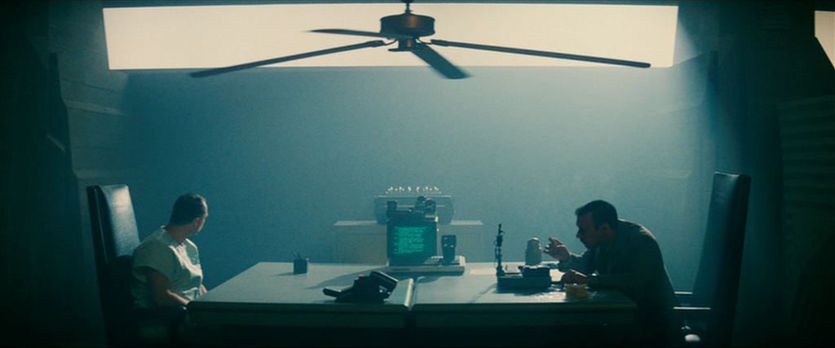
Figure 5. Blade Runner (1982) Leon(Brion James) under the Voight-Kampf Test
Figure 5. Blade Runner (1982) Leon(Brion James) under the Voight-Kampf Test
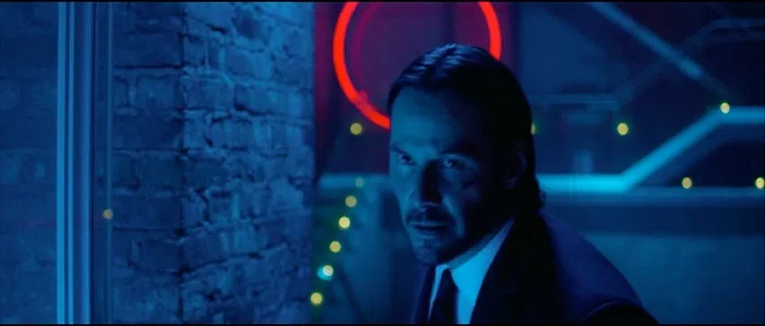
Figure 6. John Wick (2014) Cyan lighting and Red neon sign

Since we can observe the red neon circle in the background in figure 6, it is convenient for us to mention another very common strategy, which is a baseline for lighting many neo-noirs, especially tech-noirs and cyberpunk. Mise-en-scene motivated lighting can be a very powerful tool when properly utilized. Car lights (Inside light, turn signal, rear brake lights), neon signs (very cyberpunk) and lamp shades all help to awash the landscape in unnatural colour. Some neon signs even provide clues for the character, but they never seem to take the advice of green or red exit signs. Cyan-Red colour combination is prevalent, with the lighting partially being very eighties reminiscent, to the degree of inspiring an offshoot of synthwave music called Outrun, where the two and their purple pairing are dominant and supplement the noirish aesthetics of the genre/style.

Lastly, neo-noir sometimes folds upon itself in very peculiar ways, like combining colour and black-and-white sequences together. Monochrome scenes are mostly featured in flashbacks, and are not limited to neo-noirs, but two movies do it very differently. Memento(2000) (which also sports some of the washed out dust bowl stylistics) provides some context to it’s disjointed narrative by supplementing it with black-and-white sequences, which are more chronological than the colour ones. In this case, ‘’switching between colour and black-and-white footage facilitates the organisation of plot time, but also works thematically to suggest the rupture of past and present as a traumatic event.’’ The folding upon itself becomes quite literal, in D.O.A(1988). The present = colour, past = black-and-white relationship is flipped in a typical post modern way. The present sequences closely remake the 1949’s D.O.A in black and white, while the flashbacks tell a different story. The two stories then come together into one as Dexter(Dennis Quaid) attempts to solve his own murder.

5. Red or Green exit sign

Filming a neo-noir is often a daunting task. There seems to be two ways one can take it: Either go with the lazy way and replicate lighting and colour of noirs and neo-noirs, or head down the path of constant iteration and evaluation while one rethinks all colours (and blacks) in the film, and judge them against each other as well. One can get really creative and try out many of the postmodern approaches towards the filmmaking process. Often than not it may seem that everything has been done to death, but even taking that into account, some films always surprise in new creative ways of stacking the blocks on a top of each other. With that said, there is nothing inherently wrong with sticking to the basics, as they are the basics for the reason, and if nobody stuck with them, they wouldn’t be called basics in the first place. In contemporary media, all is game as long as it works, and since neo-noirs often delve into social issues, perhaps we might soon see a multi-culturally race based neo-noir, where the contrasts are turned on their heads.

Based off Borde/Chaumeton’s categorization guidelines, not every neo-noir needs to be supplemented with typical noir/neo-noir light sets, but it does add on into the mood and style. The story is always pivotal when making a movie, and everything in the film should go towards that single goal of telling a story. From mise-en-scene set designs, to costume design, framing and soundtrack, every piece of production design trickles down into the same result. In the end, film is a visual media, and the ‘show don’t tell’’ approach is always preferable. While the focus of this paper was on the visual side of things, audio and basic filmmaking techniques should never be neglected in favour of strong visuals, as it will all fall apart.

5.1. Future-noir

While noirs mostly dealt with psychological interplays between characters and their environments, Neo-noir tried to put up a mirror with going into sociological issues. With the way technology advances, resurgence of cold-war era fear of a nuclear war and unresolved social and psychological issues remain, we will soon see all piling up onto each other, and we might see a new wave, or perhaps a renaissance of a neo-noir genre in a shape of techn-noir/cyberpunk, as the issues feed into each other, and the philosophy, psychology and sociology will all interplay on each other with neon filled landscapes alienating our troubled characters, as we observe them and ourselves locked into self-destructive behaviour.

Jeff: "That’s not the way to win."
Kathie: "Is there a way to win?"
Jeff: "There’s a way to lose more slowly."
- Out of the past(1947)

6. Bibliography:

6.1. References:

Arnheim, R.(2006[1935]) ‘Remarks on color film’, in Dalle Vacche, Angela, and Brian Price. Color, The Film Reader. 1st ed. London: Routledge, 2006. Print.
Borde, R, Étienne Chaumeton, and Paul Hammond. A Panorama Of American Film Noir, 1941-1953. 1st ed. San Francisco: City Lights Books, 2002. Print.

Bould, M. Glitre, K. and Tuck, Greg. Neo-Noir. 1st ed. New York, NY: Columbia University Press, 2016. Print.

Street, S. (2009). 'Colour consciousness': Natalie Kalmus and Technicolor in Britain. Screen, 50(2), pp.191-215. Re-print.

Bellantoni, P. If it's purple, someone's gonna die. Burlington, Mass.: Focal Press, 2013. Print.

6.2. Additional Reading:
Keesey, D. Neo-noir. Kamera Books. Oldcastle Books, 2010. Print.

HIRSCH, FOST. Detours And Lost Highways. 1st ed. LIMELIGHT EDITIONS, 2004. Print.

Hirsch, Foster. The Dark Side Of The Screen. 1st ed. Cambridge, Mass.: Da Capo P., 2008. Print.

Naremore, James. More Than Night. 1st ed. Berkeley: University of California Press, 2008. Print.

Conard, Mark T, and Robert Porfirio. The Philosophy Of Film Noir. 1st ed. Lexington: University Press of Kentucky, 2007. Print.

Silver, A. and Ursini, J. Film Noir: The directors. Milwaukee, WI: Limelight Editions. 2012. Print.

Silver, A. and Ursini, J. Film noir reader. New York: Limelight Editions. 2005. Print.

Conard, M. The philosophy of film noir. Lexington, Ky.: Univ. Press of Kentucky. 2007. Print

Pettey, H. and Palmer, R). International noir. Edinburgh: Edinburgh University Press. 2014. Print

6.3. Filmography:*

Se7en, 2001. [DVD] David Fincher, USA: Entertainment in Video.

Big Lebowski, 1998. [DVD] Joel Coen, Ethan Coen, USA, UK: PolyGram Video.

Chinatown, 1999. [DVD] Roman Polanski, USA: Paramount Home Entertainment.

Fantasia, 2000. [DVD] James Algar(Uncredited), Samuel Armstrong(Uncredited), USA: Buena Vista Home Entertainment (BVHE).

The Wizard of Oz, 1999. [DVD] Victor Fleming, George Cukor (uncredited), USA: Warner Bros. Family Entertainment.

Sin City, 2005. [DVD] Frank Miller, Robert Rodriguez, USA: Buena Vista Home Entertainment.

Apocalypse Now, 1999. [DVD] Francis Ford Coppola (as Francis Coppola), USA: Paramount Home Video.

Blade Runner, 1997. [DVD] Ridley Scott, USA: Warner Home Video.

Blade Runner 2049, 2017. [Theatrical] Denis Villeneuve, USA, UK, Hungary, Canada: Warner Bros..

Drive, 2012. [DVD] Nicolas Winding Refn, USA: Sony Pictures Home Entertainment.

John Wick, 2015. [DVD] Chad Stahelski, David Leitch (uncredited), USA, China: Lionsgate Home Entertainment.

John Wick: Chapter 2, 2017. [DVD] Chad Stahelski, USA, Hong KOng: Lionsgate Home Entertainment.

D.O.A, 2002. [DVD] Annabel Jankel, Rocky Morton, USA: Touchstone Home Video.

D.O.A, 1995. [DVD] Rudolph Maté, USA: Master Movies.

Out of the past, 2004. [DVD] Jacques Tourneur, USA: Warner Home Video.

*Note on Filmography citations: In text citations are marked by the day of the theatrical release, while filmography citation marks down the year of the DVD Release, unless DVD Release has not been released.

