Wales Academy for Professional Practice and Applied Research office COPY

Student Number: ____________2430841__________________________________

Student’s Name: __________Nadine Thomson_____________________________________

Tutor Name: ___________Julie Crossman______________________________________

Assignment Title: _Authenticity and the role of the leader___

Module Code: _________(BMPF7302D)_________________________________________

Submission Date: ___15/08/2025__________________________________________

Your work will not be marked unless it is accompanied by this statement.
I confirm that this is my original work and that I have adhered to the University’s policy on plagiarism.
Student’s Name: _Nadine Thomson____________________Signature___________________

Wales Academy for Professional Practice and Applied Research Staff only

Received by:_____________________Date submitted:____________________

Student Receipt
Student Number: ______________________________________________

Student’s Name: _______________________________________________

Tutor Name: _________________________________________________

Assignment Title: ______________________________________________

Module Code: __________________________________________________

Submission Date: _____________________________________________

Wales Academy for Professional Practice and Applied Research Staff only

Received by:_____________________Date submitted:____________________


authenticity AND The ROLE OF THE LEADER
Module: BMPF7302D

Student ID: 2430841
Word Count: 7048
A Critica evaluation of five leadership concepts relevant to the senior paramedic role.
The purpose of this essay is to critically evaluate leadership theories, models and concepts in relation to their application to the Senior Paramedic role within the Welsh Ambulance Service Trust. A Senior Paramedic (SP) is an essential leadership role within the Trust providing clinical leadership to their team. Therefore, it is crucial to explore the underpinning theories of leadership to enhance their practice and influence.
This essay will critically appraise the existing leadership theories such as servant leadership, situational leadership, emotional intelligence, transformational leadership and transactional leadership, to determine their strengths and weaknesses and their application to the Senior Paramedic role and thus how they can become more effective within the organisation and towards their team performance.
The definition of leadership is one of contention with Stogdill (1974) affirming that “there are almost as many different definitions of leadership as there are persons who have attempted to define the concept”. Maxwell (1993) states leadership is simply influence whereas Northouse (2010) best describes leadership as “a process whereby an individual influences a group of individuals to achieve a common goal”. Hence, no single definition or concept exists, but is it recognised that leadership is essential to the success of an organisation (Benmira and Agboola 2021).
It is a common misconception that managers are all leaders, however this is untrue since some managers do not lead, and other people show leadership without holding any managerial responsibilities (Algahtani, 2014). It is argued that although management and leadership overlap, the two occupations are not alike (Bass, 2010). Whilst managers keep the organisation running efficiently, leaders are searching for long-term goals because they test the status quo and promote new innovations (Yukl, 1989).
Leadership in paramedic practice is vital as it has been demonstrated to increase innovation and patient-centred care approaches, both of which enhance patient outcomes (Abrashkin et al, 2016). Phillips (2024) agrees that paramedic leaders may promote innovation, improve patient care, and help create a more robust and efficient healthcare system by utilising their distinct skill set, clinical knowledge, and frontline experience.
Research into leadership has been ongoing since the 1840’s. There have been four main concepts which are, trait, behavioural, situational and transformational (Benmira and Agboola 2021).
According to trait theory, good leaders possess particular personality qualities that may be inherited or learnt by experience and practice (Buchanan and Huczynski, 2023). Meanwhile, behavioural leadership theory acknowledges that leadership behaviours can be acquired, it places more emphasis on the acts and conduct of the leader rather than on their personal qualities (Denison et al, 1995). This is dissimilar to situational theory which is more focused on leadership in specific circumstances than it is on the traits or behaviours of leaders, behavioural theory does not take the leader's surroundings and context into account (Yevgen, 2018).
As leadership and its theories have developed, new theories of leadership have emerged, such as transformational theory where leaders engage, inspire, and attend to the needs of everyone. Transactional theory (Bass, 1990) is centred on rewards and punishments, whilst inclusive leadership (Thompson and Matkin, 2020) is a more contemporary approach that encourages team participation and input. Inclusive leadership is advocated for in the National Health Service (NHS) as managing staff with compassion and respect ensures improved patient satisfaction and outcomes. It also encourages psychological safety and increases staff morale (Kline, 2019). As a Senior Paramedic, adopting an inclusive leadership style is useful to encourage team collaboration but may be limited in emergency situations where a directing approach is needed.
Servant leadership was developed by Robert Greenleaf (1970) in the 1970’s. The purpose is that the leader’s goal is to serve others by being attentive to the growth of individuals. Traditionally, an autocratic leader at the top of an organisational hierarchy makes the decisions, and others at the bottom follow them. This is reversed in a servant leadership framework, where the main responsibility of the leaders is to develop, support, and encourage their team members to reach their full potential (Savel and Munro 2017). Coetzer et al, (2017) identified seven characteristics of a servant leader, authenticity, humility, compassion, accountability, courage, altruism, integrity and listening. The study also identified four competencies of a servant leader which could maintain a standardised performance, 1) Empowerment 2) Stewardship 3) Building Relationships 4) Compelling Vision. This concept can be applied to the Senior Paramedic role where a primary focus is on serving their respected teams who in turn serve their patients. On ride outs working on a one-to-one basis with members of the team it allows for direct demonstration of the attributes of a servant leader, listening, awareness, empathy, stewardship, and compassion (Spears, 1995). This would help team members to feel supported and empowered as the Senior Paramedics would emphasise their team members development and well-being by recognising their team members as the individual that they are (Rafferty and Griffin 2006).
Eva et al, (2019) found servant leadership can create a trust in leadership, improve job satisfaction and staff morale. Dierendonck and Xiu (2024) agrees as their study found servant leadership increased meaningfulness which encouraged empowerment. Therefore, with this approach Senior Paramedics could improve the team’s success which has overall benefits for patients. Servant leadership has also been associated with improved work-related engagement and a decreased occurrence with burnout (Coetzer et al, 2017). In high pressured environments such as the ambulance service, this would be a beneficial application by Senior Paramedics. If Senior Paramedics can create an empowered culture by providing a supportive and positive environment for their team, staff can provide excellent care for patients and create a supportive and compassionate environment (The King’s Fund, 2025) which in turn would benefit the ambulance organisation with improved quality of care being delivered.
However, Coetzer et al, (2017) suggest there is a lack of research on how to implement servant leadership as the responsibilities and the role of a servant leader are not yet clarified fully in the literature. In concurrence, Canavesi and Minnelli (2022) found that further research into the limitations on servant leadership should be explored and that too much empathy could cause employee dependency on the leader. That said, the systematic review (Canavesi and Minnelli 2022) does recommend servant leadership in organisations which require learning new skills and that are creating an empowerment culture, again, this could be applied to the ambulance service organisation as learning new skills is a frequent occurrence.
The situational leadership model was developed in the 1970’s by Paul Hersey and Ken Blanchard (1969). In contrast to servant leadership, situational leadership suggests that leaders adjust their leadership style to each situation, with the main principle being that not one leadership style fits all situations, and that effective leadership is relevant to the task.
The model has four stages of which leadership style to take depending on what are the relationship behaviours with the leader and task behaviour (S1-S4). The model also depends on the development level (D1-D4) of the individual (Hersey and Blanchard 1977). This model has applications for the Senior Paramedic role as Phillips (2024) suggests that it is important for leaders in paramedicine to be able to adapt their leadership style to various situations as it allows them to handle complex challenges effectively in their role.
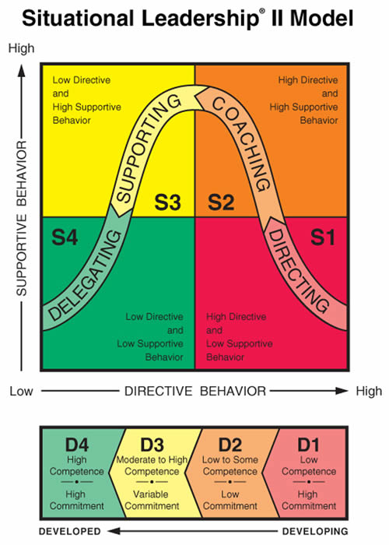
Figure 1: The Situational Leadership II (SLII) model (Blanchard et al, 1985)
S1 could be applied by Senior Paramedics when there are new staff in the service, and they require direct instructions to carrying out tasks. It could also be applied when new procedures and protocols emerge, a directing approach for the team is needed to ensure an initial set standard.
S2 could be applied by Senior Paramedics when working with newly qualified paramedics and student paramedics by giving them directional cues on incidents such as ‘What is your plan and management of this patient?’ and by giving opportunities to reflect after incidents would allow them to improve their own self-assessment alongside developing their critical thinking. Also, by providing practical feedback and setting goals, this would assist in their development and build their confidence.
S3 this could be applied in the Senior Paramedic role when working with a competent team if a new skill or equipment has been developed, a supportive style would be of benefit to build confidence within the team.
S4 would be implemented to experienced paramedics and emergency medical technicians (EMT) by Senior Paramedics allowing them to take the lead on the decision-making when managing patients on incidents and instead focusing on listening to the team member’s concerns, well-being and support they require.
Wang et al, (2024) found that situational leadership has many applications within healthcare, but that further research is needed into measuring the effectiveness of its application. Although, Phillips (2024) concludes that paramedic leaders can be effective leaders when situational leadership is used and that empathy, listening, and empowerment are essential abilities for paramedic leaders. Paramedic leaders also have a unique frontline perspective to understanding the needs and concerns of colleagues and patients.
Salovey and Mayer (1990) first developed the definition of emotional intelligence, suggesting that it is a person’s ability to process their own emotions and the emotion of other people. They propose that there are four abilities a person must possess to be emotionally intelligent:
- Ability to identify their own emotions and that of others and to express them correctly.
- The use of emotions to promote thoughts.
- Ability to understand emotions through emotional gestures and language.
- The ability to regulate their own emotions and those of others to achieve the desired goals.
Emotional intelligence is a crucial set of skills for effective leadership in leaders who are found to possess it at a high level (Goleman, 2004). Foltin and Keller (2012) found that emotional intelligence contributes to teamwork, an effective work environment, increased morale and motivation. Carragher and Gormley (2017), in turn agree that there is a significant link between the models of leadership and emotional intelligence, and by building emotionally intelligent leaders in the healthcare setting, it helps ensure that patients in turn receive compassionate, high-quality care. Heikkinen, Kuha, and Kanste, (2025) further supports this as they suggest emotionally intelligent leaders contribute to improved organisational performance as they create empowerment with their team. They also advocate that emotional intelligence should be discussed in education programmes, training and recruitment. This concludes the importance of Senior Paramedics possessing emotional intelligence in their skill set to be an effective team leader as it creates empowerment within their team which allows the team to increase their performance and provide optimal patient care. However, applying emotional intelligence as a whole concept may not be beneficial in leading in emergency situations which require direct instruction, where a transactional approach would be more applicable.
Having emotional intelligence when there is a need for change is of particular importance as an emotionally intelligent leader can facilitate change by managing the emotions of others. When there is change in an organisation this can be achieved by the emotionally intelligent leader creating an open communication environment and allowing for other to give their contributions (Issah, 2018). As there is constant change in the ambulance frontline environment, Senior paramedics need to be emotionally intelligent to recognise the needs of the team to then provide their teams with support. This would increase morale which would motivate the team to improve their performance and achieve their goals.
The research behind emotional intelligence is mostly focused on western contexts and therefore cannot be applied generally to the whole population as behaviours may be perceived differently across cultures (Tan et al, 2022). Therefore, it is important to consider that when managing a culturally diverse team the emotional intelligence approaches may not be applicable.
Furthermore, emotional intelligence needs further research to include follower specific inclusion by including the follower’s assessment of the leader’s emotional intelligence to counteract any leaders’ self-bias (Tan et al, 2022). This would improve the validity of emotional intelligence on leadership effectiveness. Antonakis et al (2009) also questions the validity the emotional intelligence evaluation tools. Further support from this argument comes from Dasborough et al, (2022) as self-reporting scores can be manipulated and rely on accurate self-awareness. They advocate that emotional intelligence should not be a construct but rather a variable to be considered in the broader behavioural and personality literature.
The origin of transformational leadership started by James Downton (1973) but was further expanded upon by James MacGregor Burns (1978) and by Bernard Bass in (1985). The idea of transformational leadership is that the leader creates inspiration to their followers to transform them to surpass their expectations and accomplish more (Korejan and Shahbazi, 2016). This can be done by understanding the individual and their values to be able to associate them with the values and goals of the organisation (Givens, 2008). Bass (1985) promotes that having a team awareness of the task creates motivation and that having a common organisational goal promotes improved results and performance. He identified four components to transformational leadership:
- Idealized influence- Senior Paramedics could influence their team by setting a good example with their work ethic, morals, values and accountability as the team would then follow this example as an idealised leader.
- Intellectual stimulation- Senior Paramedics if approached by team members about issues with equipment or current practices, they could be encouraged to be innovative and create solutions and if applicable these ideas would be passed on to be implemented into practice.
- Inspirational motivation- Senior Paramedics on a ride out could promote motivation by providing a clear objective of tasks and goals for their team and support them in achieving this.
- Individualized considerations- Senior Paramedics on a ride out get the chance to get to know their team as valuable individuals to be able to learn what their needs are. Here, the individual can have direct support and mentoring to align their goals with the organisational goals.
Transformational leadership is effective at increasing job satisfaction and commitment to the organisation (Bass, 1998). Dvir et al, (2002) agrees with this as they found there was an increase in morale, empowerment and motivation when there was a transformational leadership style used.
However, transformational leadership has its limitations in emergency, high-pressure settings. It can cause emotional exhaustion on the leaders as they are expected to persistently support and motivate others (Lin et al, 2019). Additionally, dependence on the leader can occur by team members as they become reliant on the leader which may inhibit the team’s ability of independent decision-making (Eisenbeis and Boerner 2013), which is vital in the ambulance emergency situations. Yukl (2013) argues that transformational leadership does not clearly define the skills or actions which poses difficulties when attempting to train people. Also, Yukl (2013) states that transformational leadership may not be as effective in emergency settings where direct decisions are needed and a transactional leadership approach may be better suited. Most of transformational leadership is focused on education or corporate settings and therefore may not convert to the hierarchical structure in the NHS and ambulance services as they are constrained to protocols and strict guidelines (Yukl, 2013).
Transactional leadership was influenced by James McGregor Burns (1978) and consists of two main characteristics. These are that leaders give rewards based on performance and leaders manage by exception when standards are not met. The theory operates on a system of exchanges which are focused on set tasks and definitive goals. In contrast to transformational leadership, the aim of transactional leadership is to achieve organisational goals through rewards and punishment.
Dong (2023) suggests the traits of a transactional leader are that they are confident and determined to reach their goals and carry out decision making under pressure with the ability to communicate effectively. They need to have empathy and understand the needs of their team and be adept with their leadership to suit or they run the risk of becoming authoritarian.
Transactional leaders have an awareness of their teams’ motivations, and the required goals needed to be reached and is predominantly successful for short-term goals (Bass et al, 1994). Richards (2020) also supports that transactional leadership is useful in healthcare for reaching short term goals but that it should be applied with other leadership concepts to be the most effective. This is unlike transformational leadership which leads to innovation and motivation, transactional leadership may offer minimal motivation beyond completion of the required task. Dong (2023) further supports this as transactional leadership does not promote personal development or long-term team engagement, and it can decrease morale if the team feel the leader is only concerned with their own interests.
Dong (2023) also found that transactional leadership creates a high performance within organisations but that future in depth research is needed to specifically identify the characteristics and behaviours of transactional leaders. Verma and Singh (2023), in a meta-analysis found that combining both transactional and transformational leadership lead to improved job satisfaction and performance. Hamstra et al (2014) agrees that in organisations which require team competition to outperform transactional leadership should be promoted. However, in organisations which require learning and development, a transformational approach is more effective.
Transactional leadership can be beneficial for Senior Paramedics in emergency scenarios which require adherence to protocol, but its approach should be balanced with other empowering leadership approaches to promote long term goals. It is also difficult to have tangible rewards in the ambulance service as positive feedback during Senior Paramedic ride-outs is one of the few practical incentives. Nonetheless, the managing by exception principle is applied on ride outs where the team members’ performances are evaluated.
Overall, each leadership concept discussed does have a place in the ambulance service and can be utilised by Senior Paramedics in practice. However, awareness, understanding and adoption of all the concepts discussed is needed and to apply them accordingly to the needs of the organisation and the team. Senior Paramedics can promote team empowerment, authentically lead and improve patient outcomes. Critically evaluating these leadership concepts and theories has broadened my knowledge and understanding to inform my future practice and decision making in a leadership role.

The purpose of this reflection is to explore my own leadership style and how I have developed my leadership style into working in the Senior Paramedic role. I will incorporate leadership concepts, utilise my insights report (Appendix 1) and use the Gibbs reflective model (Gibbs, 1988) to critique my current leadership approach.
From a young age I was heavily involved in athletics and competing, this was an individual sport and was not subject to leading which suited me as I was a reserved and introverted individual. This is backed by the insights report “may be very reserved until she has broken the ice” and “quiet and reserved, especially around strangers”. This at times was problematic as it did stop me mixing and integrating with others in the sport and became an aspect I needed to work and develop on.
My leadership journey began from before I became a qualified Paramedic. My first position in a leadership role was being a lifeguard. I was drawn to this position with the need and satisfaction of helping others and an interest in first aid. My insights report supports this where my “energy is given to the world in the service of others.” As a lifeguard I was responsible for maintaining safety, coordinating with other lifeguards and leading in emergencies and conflict on the poolside. In this role, I developed confidence in leading under pressure and developed my communication style to be effective. I had no previous knowledge of leadership theories or concepts but after learning on this course, I can see that I applied a situational leadership approach (Hersey and Blanchard,1977) (Figure 1). I utilised directing approaches when carrying out rescues or first aid, but I also supported and coached new lifeguards into the role and I supported the public with instilling rules of the pool. Furthermore, I used a coaching approach when teaching children swimming lessons.
From working as a lifeguard this led to me applying for a student paramedic apprenticeship in Birmingham. This meant moving away from my family and living in a busy city, but I was determined that this was the career I wanted. I felt I was a considerate and caring person who always wanted to attend to the needs of others. This is reflected in my insights report “charmingly supportive of others, she can stay behind the scenes working at practical jobs requiring empathy and service”.
I was young and lacked in confidence at the time. I wondered if my introverted personality would hinder my growth, as I knew the role involved leadership and this was not my perceived strength. This self-doubt is reflected in my insights report that I “often underestimates herself and either takes anything she does well for granted or regards it as no great achievement at all”. Spark et al (2018), supports this suggesting that introverts are less likely to emerge into leadership roles compared to extroverts. This is illustrated in table 1, which shows behavioural differences between introverts and extroverts. For example, introverts prefer solitude and small groups this may make them less likely to emerge into leadership roles. Although my progression as an introvert into a leadership role challenges these assumptions and shows the importance of recognising different leadership styles.
However, Grant et al (2011) found introverted leaders were more effective than extroverted leaders at leading proactive teams as they were receptive to the teams’ ideas and contributions. This is relevant to the ambulance service teams for collaboration, planning, prevention and innovation. Therefore, the emergence of leaders should not solely rely on personality types and instead focus on their ability to empower and engage teams. Nevertheless, Stephens-Craig et al (2015) argues that both extroverted and introverted leaders can both be positive leaders, but that extroverted qualities are needed to be successful (Table 1).
Introverts | Extroverts
Energised by solitude—need to have breaks | Energised by other people— breaks are nice but not required
Reserved Enthusiastic | Enthusiastic
Express thoughts after reflection | Express thoughts immediately
Private at first | Share openly
Prefer talking Like small group, one-on-one focused conversations | Prefer larger groups where they can move fast and change topics
Humble | Talk about their accomplishments
Need time to prepare | Wing it
Calm | Excited
Table 1: Characteristics of Introverts vs Extroverts (Kahnweiler and Conant, 2018)

Working on the frontline as a Paramedic, I did not see myself as being a leader. However, with reflection I have realised I was being a leader, and I continued to adopt a situational leadership approach (Hersey and Blanchard, 1977). I would use a directing approach in life threatening situations which required following protocol, quick decision making and delegating tasks to other members of the team. As I gained more experience I would then mentor students which I used a coaching and supportive approach. With this experience my confidence grew as I became competent in my role. During this time, I became interested in the needs of others and how I could support them more effectively (Boud et al, 1985).
To understand the needs of others, Maslow’s hierarchy of needs (Maslow, 1943) is useful as it provides a framework to understanding the needs and motivations of people.
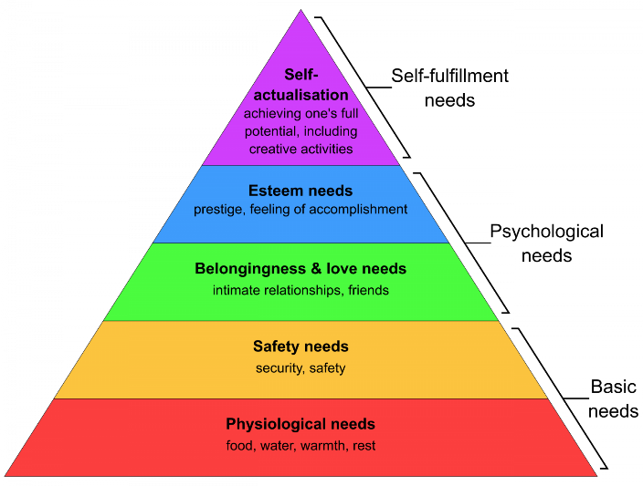

Figure 2: Maslow’s hierarchy of needs (Maslow, 1943).
I was able to be a better leader by understanding and supporting the needs of others when mentoring. I recognised I could meet their esteem needs through positive and constructive feedback. I could then recognise where staff were in the hierarchy, whether that be safety or belonging and I could then support them to progress. Personally, my esteem needs were met through the contribution of helping others. Seeing others develop and improve made me feel accomplished. It also gave me a sense of belonging as I felt valued and respected by others. I still felt I lacked in confidence and remained reserved and introverted, so I questioned my readiness and ability to progress into a formal leadership role.
However, the self-fulfilment needs of wanting to grow in the profession to make positive change, support and serve others outweighed my self-doubts. I then applied for a Senior Paramedic post.
Salovey and Mayer (1990) define emotional intelligence as the ability of a person to understand and process their own emotions and other people’s emotions. From understanding the needs of myself and others, it has enabled me to develop my emotional intelligence (Goleman 2004). This allows me to be a better leader and a team member. As Heikkinen et al, (2025) suggest leaders in healthcare who possess high levels of emotional intelligence create empowerment in their team. My insights reports suggest I “generate trust for the team”, “encourages team allegiance”, “makes great effort to build and maintain relationships with others”. I feel these attributes stem from having a high level of emotional intelligence and the ability to understand the needs of others. I have had positive feedback since being in the role from my managers and the team as they report I am approachable, efficient, reliable and accommodating to their needs.
This leadership course has improved my emotional intelligence as my self-awareness has developed by reflecting on my current leadership style to identify areas for improvement. My social awareness has improved by learning about emotional intelligence and concepts which consider the needs of others. This will enable me to adapt my communication style to the individual to improve the support I provide to my team.
Working as a Senior Paramedic my motivation is to ensure I foster a safe and supportive culture so that the team can develop to their full potential. My insights report supports this as I have a “strong commitment to team performance”. In my current role I feel my leadership style has changed from being situational to predominantly transformational (Bass, 1985). Liegl and Furtner (2023) highlight that transformational leadership behaviours were not strongly related to an extroverted personality which suggests introverts can effectively use a transformational approach. Introversion traits are useful in transformational leadership such as active listening, building trust and thoughtful support which encourage team engagement, empowerment and psychological safety (Liegl and Furtner 2023). Islam (2019) further supports this by finding that introversion leaders possess qualities in, good listening, demonstrate humility, calming presence, and are highly empathetic. In comparison, these traits are also beneficial for the principles of servant leadership.
In practice I carry out the four components of transformational leadership:
- Idealized influence- I set a good example with a strong work ethic, values, a sense of duty and accountability. Leading by my example inspires the team to also adopt these behaviours.
- Intellectual stimulation- I am regularly approached by the team about questions regarding guidelines, equipment and training. I encourage their own problem-solving abilities and pass on their innovative ideas and solutions to the relevant departments.
- Inspirational motivation- On ride outs I promote the team’s motivation by giving individual positive and constructive feedback, whilst also setting clear goals and a plan to achieving these goals.
- Individualized considerations- I ensure on ride outs I listen well, and I try to get to know everyone on my team. Following this I can then support each individual by learning their needs to align with organisational goals.
Pulido-Martos et al (2024) supports this approach as they suggest emotional intelligence and transformational leaders contribute to an improved team performance and commitment.
On ride outs I adopt a transformational (Bass 1985) and servant leadership (Greenleaf 1970) approach. Muss et al (2025) found that when leaders were empathetic, it improved morale and increased team performance. Thus, supporting the use of servant leadership. Servant leadership is supported by my insights report by affirming my strengths “good listener, can help others achieve their goals”, “respectful of other’s needs”, “conscientious, industrious and dependable”, “open-minded and tolerant of others”, “sensitive to the needs of others”. This supports my ability to adopt a servant leadership approach. I have found that combining both styles of leadership allows me to adapt to the operational and team needs.
However, in contrast to transformational and servant leadership approaches, situational leadership and transactional leadership are more appropriate for life-threatening emergencies. These approaches allow me to adapt to varying capabilities with team members to decipher which approach from directing to delegating is needed. Although I do find it hard to move from a collaborative to directive style, recognising the need for transactional leadership in these scenarios has helped my confidence in adopting this style. A transactional leadership approach is beneficial in these scenarios as they become task focused and require a clear command structure with usually immediate feedback via outcomes (Burns, 1978).
On reflection of my leadership approaches since being in the Senior Paramedic role, I have struggled with imposter syndrome. Imposter syndrome refers to behaviours where individuals doubt their abilities and fear the exposure of being a fraud (Clance and Imes 1978). Langford and Clance (1993) highlighted that imposter syndrome was associated with introverted personality traits.
Mullangi and Jagsi (2019), found particularly in women, that they put their accomplishments down to good timing or luck and that they had deceived others. Imposter syndrome also impairs leadership and career progression (Freeman and Peisah 2022). Szilak (2023) agrees that there is an underrepresentation of women in leadership roles due to imposter syndrome and gender role beliefs for leadership positions. Galloway (2025) further supports that imposter syndrome can obstruct the development of leaders. In my role this has led to working more unofficial hours to avoid errors and to overprepare. I have found myself striving for perfection and holding myself to what feels like an unachievable high standard as I feel I need to prove myself and avoid failure at all costs. Whilst Maqsood et al (2018) links imposter syndrome with burnout and psychological stress, this is something I need to be mindful of.
Feigofsky (2022), suggests overcoming imposter syndrome by asking for honest feedback from others, setting reasonable goals and taking time to acknowledge success before moving on to something else, this can help alleviate the thoughts. Kotanko (2025) supports this and suggests addressing imposter syndrome through mentorship and leadership development programmes which reduces the effects of imposter syndrome.
Through completing this leadership course, researching and understanding imposter syndrome, I feel this will alleviate these feelings as I will reflect on my achievements for what they are. This will ensure my imposter syndrome does not affect my leadership abilities. With this knowledge I can now empathise with other colleagues who experience imposter syndrome and self-doubt. This can create openness and vulnerability to normalise this.
Another barrier to my leadership approach is I found if I was in a conflict situation, this would make me uncomfortable and therefore to avoid those situations it would result in me not being assertive and indecisive to avoid any potential upset. My insights also suggest I am indecisive and “may not forcefully express her ideas or feelings”.
I will use the Gibbs reflective model (1988) to elaborate on this barrier further as it provides a structure to evaluating my leadership approach. In addition, I also recognise the value of the IFEAR model, (Smart, 2011) which is an adaptation from the Gibbs model, which is specifically for paramedic practice and something I could consider applying to my practice in the future. In healthcare, reflection is an important aspect to develop learning and improve practice (Préfontaine et al, 2022).
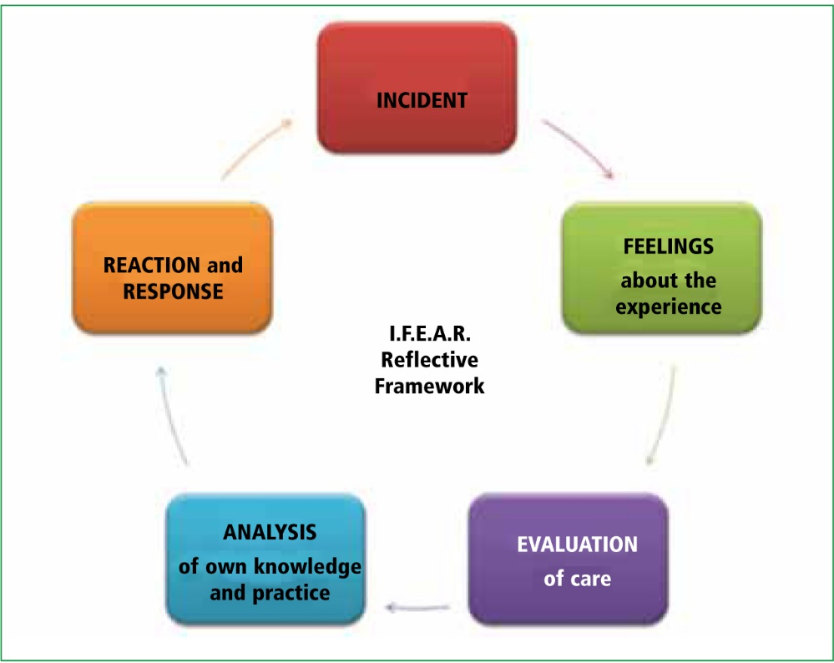
Figure 3: IFEAR reflective framework (Smart, 2011)
Description
Whilst working as a Senior Paramedic, I attended an incident which involved being a back up to a crew who needed assistance to extricate a patient from a property. The patient had fallen down a full flight of stairs and had managed to get themselves to their sofa. A GP (general practitioner) had been to see the patient and was questioning if they had a pelvic injury so contacted 999.
Feelings
Initially I felt a sense of urgency due to a likely pelvic injury and was working out my management approach on the way to the incident. I also felt some hesitation as I did not know the crew very well and it can be difficult being assertive when you arrive second on the incident. When I arrived, it was unclear what the crew needed from me, which caused me to feel confused. I was mindful to not tread on their toes which led me to hold back, rather than take an assertive leadership role. This was caused by my need for not wanting to upset any team members or cause conflict.
Evaluation
The patient was safely assessed and extricated, and the situation was handled professionally. The crew were not forthcoming with what they thought would be a good extrication plan. Therefore, they were probably looking to me for direction, and my hesitation to speak up may have delayed decision-making slightly. It could have caused uncertainty for the team who were awaiting a decision and impacted their confidence. By not being assertive an opportunity was missed to be the most effective leader
Analysis
Reflecting on this incident, I have realised that being assertive does not mean being overbearing or causing upset, and that being assertive can be respectful, display confidence and ensure situations are handled effectively.
Assertiveness can be defined as advocating for what is right in an honest and direct way which displays confidence (Maloney and Moore 2020). Maloney and Moore (2020), suggest improving being assertive by listening actively, making eye contact, adding comments such as ‘I have a suggestion on this topic’, to be aware of your tone of voice, choice words and body language. Also, Williams (2000) agrees that tone of voice, stance, and eye contact is important when being assertive. Assertiveness can be confused with aggressive behaviours; however, the main difference is ensuring respect for others. Williams (2000) suggest having an assertive communication style can be effective in conflict management. To have an assertive communication style, the message needs to come across at the correct time and the content of the message should be short, descriptive and direct.
Conclusion
In future, I aim to build rapport quickly and ensure I am assertive to ensure a clear goal is communicated. This incident has shown the importance of balancing emotional intelligence with assertiveness to ensure quick decision-making and effective leadership for the team. As from this incident I tended to be cautious with my leadership style to avoid any possible conflict scenario if the crew weren’t receptive to my opinions. This incident reflects the barrier of assertiveness and my indecisive traits which I addressed from my insights report and highlights an area I need to improve on my development in a leadership role. This reflection has highlighted the importance of being assertive and that it does not lead to conflict as there is a difference between displaying assertive and aggressive behaviours. Assertiveness can help build clarity, trust and confidence within the team.
Action Plan
If this situation arose again, I would consider the Williams (2000) 7 step approach below which assists in being assertive. If I adopt this approach and develop an assertive communication style by utilising emotional intelligence, this will avoid any conflict scenarios.
1.Attention-Listen to each other and gain attention in a way that is of interest.
2.Situation- Brief description. Specify when, where and what the conditions relating to the interaction are.
3.Emotion-Summarise concisely the emotional impact of the situation.
4.Reaction- Acknowledge the behavioural response because of the emotion. What are the consequences because of the emotion felt.
5.Test-Offer a solution to the other person or include them by asking them for their opinion.
6.Involvement- Find a review method to monitor the progress.
7.Valorisation Thank the person for listening and that they are willing to accept change. Show them that they are valuable and you value your relationship with them.
Another incident I would like to reflect on has come from learning about leadership theories and their concepts which has allowed me to improve my confidence and development as a leader. This has enabled me to lead in change.
Description
In my role as a Senior Paramedic, I frequently witnessed staff struggle with having to complete electronic patient documentation (ePCR) on an iPad. It was challenging for people to navigate the app and ensure accurate completion of patient records. From recognising these struggles, I took the initiative to support staff as it could impact on patient care and the wellbeing of staff.
There is a scoring system for ePCR which we use as Senior Paramedics when a clinical concern arises. Therefore, it is important that staff understand ePCR and can navigate it effectively to support their assessment and management of patients. I decided to support staff by giving informal training on ride outs to discuss how ePCR can be used optimally.
Feelings
I felt concerned that staff were feeling worried and stressed about completing ePCR as they lacked confidence in using it. I was feeling happy that staff felt they could approach me about their concerns and that they felt comfortable to disclose that they didn’t feel confident in using ePCR to its full capacity. This made me realise the importance of trust and creating psychological safety within the team.
I felt a sense of duty to help the staff as I wanted to ensure they can do their role to the best of their abilities. I felt motivated to ensure staff felt supported to achieve this. I also felt confident in my abilities to give the staff the correct information so learning could take place. I did feel worried about getting the learning across sensitively so that staff did not feel offended. I also felt unsure if adapting to this change in documentation would be well received by some staff members.
Evaluation
It was overwhelmingly surprising how well this learning was received. Staff felt very supported on ride outs and felt the in-depth discussion on ePCR and completing it to optimum levels were beneficial. It was of great benefit carrying out this discussion on ride outs on a one-to-one basis as staff felt more forthcoming with their concerns. This highlighted the importance of emotional intelligence, servant and transformational leadership.
I noticed improvements to their documentations and that they were utilising different sections of the app which improved their overall scoring percentages. Confidence in using ePCR was improved which led to reduced stress and worry by staff members. Clinical decision making was supported due to staff having the ability to support this with effective and accurate documentation.
Analysis
This situation highlights the importance of transformational leadership (Bass 1985) and emotional intelligence and my ability to apply this.
- Idealised influence- Demonstrating to staff how I complete an ePCR.
- Individualised consideration- Aligning the organisational needs of accurate ePCR completion to the individual needs of wanting to learn more about how to use the system effectively. Considering how to support the needs of the staff and conducting this on ride outs where people feel comfortable to speak out.
- Intellectual stimulation- Encouraging staff to use the training mode to create their own learning and problem-solving.
- Inspirational motivation- Encouraging the importance of ePCR documentation. Giving staff members their current score percentage and post score following the learning, this gives them a clear goal and a plan to develop an achieve this.
This demonstrated my ability to apply transformational leadership which showed empowerment and development for the team. This instilled confidence in my abilities to be an effective leader as I was able to show support which reduced a resistance to change, and relieved staff members worry.
In addition to this, emotional intelligence (Goleman 2004) was needed to ensure I had self-awareness about my own abilities with the use of ePCR and the feelings of frustration of staff towards its use. I could then demonstrate empathy which allowed me to have better communication and build trust. I felt this created psychological safety as staff were able to openly discuss their concerns with me.
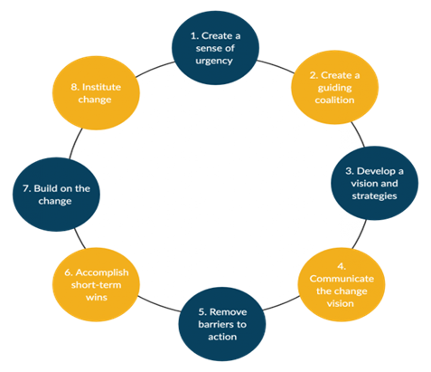

Figure 4: Kotter’s 8-step change model (Kotter, 2012)
Applying the Kotter’s (2012) model assisted me in carrying out change.
- Creating a sense of urgency by emphasising the importance of accurate and fully completed documentation
- Creating a guiding coalition by informal on-to-one training
- Develop a vision by creating a goal which was to improve score percentages and a plan to achieve this by teaching and own learning
- Communicate the change by encouraging use of training mode and own development
- Remove barriers by direct demonstrating to show ease of use and ability to use training mode at any time
- Accomplish short term wins by giving direct feedback of improved percentage scores and staff confidence
- Build on the change by carrying out this procedure as a standard for all
- Institute change by all staff knowing the expectations of ePCR and therefore develop their awareness and confidence in its use
Conclusion
This situation has given me confidence in my leadership abilities and the ability to lead in change which can sometimes feel unachievable. My emotional intelligence has improved and been developed. It has shown me that applying transformational leadership with emotional intelligence is successful and it encourages empowerment and change within teams. I have learnt that creating trust, being understanding and having clear goals provides influence for change.
Action Plan
As my approach to this situation was successful, I will continue to approach change in the same way. I will continue to apply Kotter’s model as this provides a structured approach. In future, I will try to reflect on how to approach those who are hesitant to be forthcoming with their concerns.
Overall, my self-reflection and utilising the insights report has allowed me to identify areas for growth in my leadership development. This has allowed me to explore different concepts to understand how to overcome barriers, especially imposter syndrome, being introverted and assertiveness. I have learnt that I can be assertive without causing conflict and that assertiveness is needed in some situations to ensure effective leadership.
Reflecting has highlighted the importance of my preferred leadership style which is transformational and emotional intelligence which are shown to work well together and seem well received by the team.
From direct experience, applying the leadership theories has tangible benefits of improving outcomes and leading to change. This reflection has increased my confidence in my leadership abilities and my commitment to continuing to develop as a leader.

Appendix 1: Insights Report Overview.
Nadine Thomson © The Insights Group Ltd, 1992-2025. All rights reserved.
These statements provide a broad understanding of Nadine's work style. Use this section to gain a better understanding of her approaches to her activities, relationships and decisions. Personal Style Because she lives by principles and rules, Nadine is very consistent and dependable. She may impress others, albeit unintentionally, by knowing something worthwhile about many things, especially when she speaks about one of her specialised subjects. She is a well of warmth and support, but may be very reserved until she has broken the ice. She likes structure and systematic processes. She tends to be disinterested in subjects for which she sees no practical application. She finds her source of energy within but primarily perceives the world through her senses. She tends to be fiercely loyal to her friends, prepared to sacrifice her own wants for the needs of the other person. She may speak of or express her ideals indirectly. Nadine combines affability and amiability with a high sense of duty. One of Nadine's strengths is an ability to let others work at their own pace coupled with an awareness of the unique contribution each person makes. If she makes a serious mistake at work she may feel guilty for a long time. Enjoying a “low profile”, one of Nadine's great strengths is her natural, unobtrusive, accepting manner. She is driven by a high sense of allegiance and obligation, resulting in a commitment to serve her partner, organisation and humanity in general. Nadine is seen by others as open, mild, modest and rather self-effacing. She may underestimate herself and either takes anything she does well for granted, or regards it as no great achievement at all. In everyday activities, Nadine is tolerant, open-minded, flexible and adaptable, enjoying the present moment. She is at her best in work that involves people and task, where co-operation can be achieved through goodwill. Nadine's energy is given to the world in the service of others, and in an orderly, realistic and practical way. Nadine is independent and objective, with a strong sense of personal values. She may have difficulty asserting herself and in saying “No”. She has a distrust for the ostentatious, the speedy and the fanciful. She will stick to her ideals with passionate conviction, even though she may find these difficult to talk about at times. In her own work, she can become intent upon doing things her own way in order to ensure her high standards of operating are met. She will make an effort to remember names and special occasions and make her office or home a pleasant place in which to work. If her efforts are not recognised, or approval is withheld, she may feel deflated as her feeling of worth can depend on how others regard her. Interacting with Others At work, Nadine is good at blending productivity with an interest in, and compassion for, the workforce. If she experiences what she believes is disloyalty her hurt is reflected in an outward rigidity which instils in her a refusal to forgive or forget. Nadine probably prefers more relaxed social interaction. Do not assume this to be an indication that she is not serious about important issues. She conveys an image of stability and reliability - an image which can be trusted. She is often friendly, although she tends to avoid socialising at a superficial level. Nadine Thomson © The Insights Group Ltd, 1992-2025. All rights reserved. Page 7 Her deepest feelings will rarely be articulated. She prefers to build close relationships with small groups of people and likes to retain the familiar and predictable. Nadine brings harmony and goodwill to any situation in which she finds herself. She will readily forgive but rarely forget. She prefers to play a supporting role at work in a loyal and conscientious way. Displaying modesty and reserve, she is a very warm person who tends not to show that warmth except with people she knows and trusts. Intent on keeping a low profile, Nadine is quiet and reserved, especially around strangers. Charmingly supportive of others, she can stay behind the scenes working at practical jobs requiring empathy and service. Bringing a quiet enthusiasm and loyalty to her work, Nadine encourages co-operation and flexibility on the team. As she gets to know you, she becomes more enthusiastic and open. Decision Making Nadine is good at easing tense situations, enabling competing or conflicting groups to unite. She recognises judgements that rely heavily on logical analysis, but then may ignore this in making her decisions. Above all, she is concerned with what is “right“ and because of this may appear slow in the decision making process. She will support those she considers as friends but can feel rather pressured if made to act against what she considers as her better judgement. Non-judgemental and accepting of others' behaviour in a rather factual way, she notices things around her and will generally find the deeper meanings within most situations. She will tend to be concerned with the effect that the decision making process, and its result, will have on others. Nadine makes better decisions when other people she knows share her values. Her quiet demeanour often allows her to get agreement to her alternative solutions. She is prepared to make decisions through group consensus. She may appear dismissive of decisions made on “gutfeel” rather than objective analysis. She takes a personal approach to living, assessing events through the personal values and ideals which govern her life. She is very firm about her inner loyalties and sets very high standards for herself in this area. She can be overly lenient with non-producers, which often results in problems in matters that require the application of discipline. Nadine is a good mediator or peacekeeper because she can agree while not being fully drawn to any one view. She usually delays decision making until all the facts and details are available.

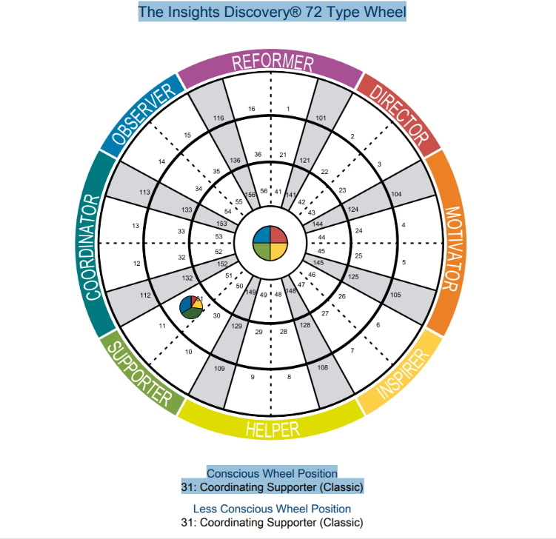

Appendix 2– Personal SWOT Analysis

Strengths:  - I like to work for the common good.  - Good listener. I can help others achieve their goals.  - Conscientious, industrious and dependable.  - I am respectful of other’s needs.  - I am sensitive to the needs of others  - I am curious and a keen observer of life.  - I gain personal fulfilment through helping others.  - I am open-minded and tolerant of others.  - Relaxed about what others may think of her.  - I have a sound sense of duty | Weaknesses:  - Indecisiveness  - I don’t always respond well to sudden change.  - I don’t forcefully express her ideas or feelings.  - I am seen as a private individual, who prefers her own company.  - My persistence and loyalty may delay decisive action.  - I can be stubborn when feeling threatened.  - I can feel deflated if my efforts are not recognised.  - I don’t always want to understand abstract theories.
Opportunities  - Continue to build from my strengths and acknowledge them for what they are.  - Utilise my strengths to become a better leader in my Senior Paramedic role.  - Leadership PGCert course to develop my leadership skills and change management.  - Use reflective writing and journaling to contribute to professional development. | Threats  - Unpredictable change could hinder my performance.  - Not expressing my ideas may cause problems with team dynamics and decision-making.  - Not being recognised for my efforts could result in me lacking in motivation.  - Being indecisive could affect quick decision-making.

Appendix 3: Personal Development Plan

Areas to be addressed | Activity to address this | Resources/ Support required | Completion Date | Measures of success | Review method / Review Date
Improve Assertiveness | Research tools and techniques.  Reflection. | Online learning tools.  Reflective cycles framework. | Ongoing – to be reviewed quarterly until progress is evident | Reflecting on incidents where I have applied assertiveness.  Feedback from peers. | Review with written reflection.  October 2025
Imposter syndrome | Study more to learn about it.  Research techniques to overcome it. | Self-reflection.  Acknowledging achievements.  Feedback from peers. | Ongoing – to be reviewed quarterly until progress is evident | Thought and feelings no longer there relating to imposter syndrome. | Reflective journal  November 2025
Leadership | Continue leadership course programme. | From tutor and peers.  Online research and use of resources. NHS Leadership Academy  Apply theory into practice-leading team briefings. | January 2026 | Completion of course.  Feedback from team.  Self-reflection | Course feedback.  Manager’s feedback.  November 2025
Articulating thoughts and feelings | Develop self-awareness | Mindfulness.  Ted Talks.  Journaling.  Emotional intelligence tools | Ongoing – to be reviewed quarterly until progress is evident | Feeling more confident expressing myself with staff and patients.  Ability to initiate difficult conversations. | Reflective journal  December 2025

Reference List
Abrashkin, K.A., Washko, J., Zhang, J., Poku, A., Kim, H. and Smith, K.L., 2016. Providing acute care at home: community paramedics enhance an advanced illness management program—preliminary data. Journal of the American Geriatrics Society, 64(12), pp.2572–2576.
Algahtani, A., 2014. Are leadership and management different? A review. Journal of Management Policies and Practices, 2(3), pp.71–82.
Bass, B., 2010. The Bass handbook of leadership: Theory, research, and managerial applications. New York, NY: Simon & Schuster.
Bass, B.M., 1985. Leadership and Performance Beyond Expectations. New York: Free Press.
Bass, B.M., 1990. From transactional to transformational leadership: Learning to share the vision. Organizational Dynamics, 18(3), pp.19–31.
Bass, B.M. and Avolio, B.J., 1994. Improving organizational effectiveness through transformational leadership. Thousand Oaks, CA: Sage.
Bass, B.M., 1985. Leadership and Performance Beyond Expectations. New York: Free Press.
Bass, B.M., 1998. Transformational Leadership: Industrial, Military, and Educational Impact. Mahwah, NJ: Lawrence Erlbaum Associates.
Benmira, S. and Agboola, M., 2021. Evolution of leadership theory. BMJ Leader, pp.leader-2020.
Boud, D., Keogh, R. and Walker, D., 1985. Reflection: Turning Experience into Learning. London: Kogan Page.
Buchanan, D.A. and Huczynski, A., 2023. Organizational Behaviour. Pearson.
Burns, J.M., 1978. Leadership. New York: Harper & Row.
Burns, J.M., 1978. Leadership. New York: Harper and Row.
Canavesi, A. and Minelli, E., 2022. Servant leadership and employee engagement: A qualitative study. Employee Responsibilities and Rights Journal, 34(4), pp.413–435.
Carragher, J. and Gormley, K., 2017. Leadership and emotional intelligence in nursing and midwifery education and practice: a discussion paper. Journal of Advanced Nursing, 73(1), pp.85–96.
Clance, P.R. and Imes, S.A., 1978. The imposter phenomenon in high achieving women: Dynamics and therapeutic intervention. Psychotherapy: Theory, Research & Practice, 15(3), pp.241–247.
Coetzer, M.F., Bussin, M. and Geldenhuys, M., 2017. The functions of a servant leader. Administrative Sciences, 7(1), p.5.
Dasborough, M.T., Ashkanasy, N.M., Humphrey, R.H., Harms, P.D., Credé, M. and Wood, D., 2022. Does leadership still not need emotional intelligence? Continuing “The Great EI Debate”. The Leadership Quarterly, 33(6), p.101539.
Denison, D.R., Hooijberg, R. and Quinn, R.E., 1995. Paradox and performance: Toward a theory of behavioral complexity in managerial leadership. Organization Science, 6(5), pp.524–12.
Dong, B., 2023. A systematic review of the transactional leadership literature and future outlook. Academic Journal of Management and Social Sciences, 2(3), pp.21–25.
Downton, J.V. Jr., 1973. Rebel Leadership. New York, NY: Free Press.
Dvir, T., Eden, D., Avolio, B.J. and Shamir, B., 2002. Impact of transformational leadership on follower development and performance: A field experiment. Academy of Management Journal, 45(4), pp.735–744.
Eisenbeis, S.A. and Boerner, S., 2013. A double‐edged sword: Transformational leadership and individual creativity. British Journal of Management, 24(1), pp.54–68.
Eva, N., Robin, M., Sendjaya, S., Van Dierendonck, D. and Liden, R.C., 2019. Servant leadership: A systematic review and call for future research. The Leadership Quarterly, 30(1), pp.111–132.
Feigofsky, S., 2022. Overcoming imposter syndrome in medicine. Journal of the American College of Cardiology, 79(11), pp.1121–1123.
Foltin, A. and Keller, R., 2012. Leading change with emotional intelligence. Nursing Management, 43(11), pp.20–25.
Freeman, B. and Peisah, C., 2022. Imposter syndrome in medical leadership: A barrier to success. Australasian Psychiatry, 30(1), pp.7–9.
Galloway, L., 2025. Leadership and Imposter Syndrome: A Challenge to Performance in Organisations. In Leadership and Leadership Development, pp.174–181. Routledge.
Givens, R.J., 2008. Transformational leadership: The impact on organizational and personal outcomes. Emerging Leadership Journeys, 1(1), pp.4–24.
Goleman, D., 2004. Emotional Intelligence: Why It Can Matter More Than IQ. London: Bloomsbury.
Goleman, D., 2004. What makes a leader?. Harvard Business Review, 82(1), pp.82–91.
Grant, A.M., Gino, F. and Hofmann, D.A., 2011. Reversing the extraverted leadership advantage: The role of employee proactivity. Academy of Management Journal, 54(3), pp.528–550.
Greenleaf, R.K., 1970. The Servant as Leader. Westfield, IN: The Greenleaf Center for Servant Leadership.
Hamstra, M.R., Van Yperen, N.W., Wisse, B. and Sassenberg, K., 2014. Transformational and transactional leadership and followers’ achievement goals. Journal of Business and Psychology, 29(3), pp.413–425.
Heikkinen, A., Kuha, R. and Kanste, O., 2025. Emotional intelligence in healthcare leadership. Journal of Paramedic Practice, 17(3), pp.45–52.
Heikkinen, H., Kuha, S. and Kanste, O., 2025. Exploring the Core of Emotional Intelligence in Healthcare Leadership: A Concept Analysis. Journal of Advanced Nursing.
Hersey, P. and Blanchard, K.H., 1977. Situational Leadership. Center for Leadership Studies, Escondido, CA.
Hersey, P. and Blanchard, K.H., 1969. Life cycle theory of leadership. Training and Development Journal, 23(5), pp.26–3.
Islam, R.M.S., (2019). Leadership and characteristics of introvert leader. Leadership, 6(1), pp.177-179.
Issah, M., 2018. Change leadership: The role of emotional intelligence. Sage Open, 8(3), p.2158244018800910.
Kahnweiler, J.B. and Conant, D.R. (2018). The introverted leader : building on your quiet strength. Oakland, Ca: Berrett-Koehler Publishers, Inc
Kline, R., 2019. Leadership in the NHS. BMJ Leader, 3(4), pp.129–132. doi:https://doi.org/10.1136/leader-2019-000159.
Korejan, M.M. and Shahbazi, H., 2016. An analysis of the transformational leadership theory. Journal of Fundamental and Applied Sciences, 8(3), pp.452–461
Kotanko, J., (2025). How Does Imposter Syndrome Impact Senior Leader Performance and Decision-Making?. Muma Business Review, 9, pp.113-121.
Kotter, J.P., 2012. Leading Change. Boston: Harvard Business Review Press
Langford, J. and Clance, P.R., 1993. The imposter phenomenon: Recent research findings regarding dynamics, personality and family patterns and their implications for treatment. Psychotherapy: Theory, Research, Practice, Training, 30(3), pp.495–501. https://doi.org/10.1037/0033-3204.30.3.495
Liegl, S. and Furtner, M.R. (2023). Introverted and yet effective? A faceted approach to the relationship between leadership and extraversion. Frontiers in Psychology, 14, 1185271. https://doi.org/10.3389/fpsyg.2023.1185271
Lin, S.H., Scott, B.A. and Matta, F.K., 2019. The dark side of transformational leader behaviors for leaders themselves: A conservation of resources perspective. Academy of Management Journal, 62(5), pp.1556–1582.
Maxwell, J.C., 1993. Developing the Leader Within You. Thomas Nelson Inc.
Maloney, M.E. and Moore, P., 2020. From aggressive to assertive☆. International journal of women's dermatology, 6(1), pp.46-49.
Maqsood, H., Shakeel, H.A., Hussain, H., Khan, A.R., Ali, B., Ishaq, A. and Shah, S.A.Y., (2018). The descriptive study of imposter syndrome in medical students. Int J Res Med Sci, 6(10), pp.3431-3434
Maslow, A.H. (1943) ‘A Theory of Human Motivation’, Psychological Review, 50(4), pp. 370–396.
Mullangi, S. and Jagsi, R. (2019) ‘Imposter syndrome: Treat the cause, not the symptom’, Journal of the American Medical Association, 322(5), pp. 403–404.
Muss, C., Tüxen, D. and Fürstenau, B. (2025) ‘Empathy in leadership: a systematic literature review on the effects of empathetic leaders in organizations’, Management Review Quarterly, 75, pp. 1–37.
Northouse, P.G., 2010. Leadership: Theory and Practice (5th ed.). Thousand Oaks, CA: Sage.
Phillips, J.S., 2024. From frontline to forefront: paramedics as healthcare leaders within the NHS. Journal of Paramedic Practice, 16(9), pp.370–378. doi:https://doi.org/10.12968/jpar.2024.0038.
Préfontaine, C., Gaboury, I., Corriveau, H., Beauchamp, J., Lemire, C. and April, M.J., 2022. Assessment tools for reflection in healthcare learners: A scoping review. Medical Teacher, 44(4), pp.394-400.
Pulido-Martos, M., Gartzia, L., Augusto-Landa, J.M. and Lopez-Zafra, E. (2024) ‘Transformational leadership and emotional intelligence: allies in the development of organizational affective commitment from a multilevel perspective and time-lagged data’, Review of Managerial Science, 18, pp. 2229–2253
Rafferty, A.E. and Griffin, M.A., 2006. Refining individualized consideration: Distinguishing developmental leadership and supportive leadership. Journal of Occupational and Organizational Psychology, 79(1), pp.37–61.
Richards, A., 2020. Exploring the benefits and limitations of transactional leadership in healthcare. Nursing Standard, 35(12), pp.46–50.
Salovey, P. and Mayer, J.D., 1990. Emotional intelligence. Imagination, Cognition and Personality, 9(3), pp.185–211.
Savel, R.H. and Munro, C.L., 2017. Servant leadership: The primacy of service. American Journal of Critical Care, 26(2), pp.97-99.
Smart, G. (2011). I.F.E.A.R reflection: an easy to use, adaptable template for paramedics. [online] Journal of Paramedic Practice. Available at: https://www.paramedicpractice.com/content/features/ifear-reflection-an-easy-to-use-adaptable-template-for-paramedics.
Spears, L.C. ed., 1995. Reflections on leadership: How Robert K. Greenleaf's theory of servant-leadership influenced today's top management thinkers. John Wiley & Sons.
Spark, A., Stansmore, T. and O'Connor, P., 2018. The failure of introverts to emerge as leaders: The role of forecasted affect. Personality and Individual Differences, 121, pp.84-88.
Stephens-Craig, D., Kuofie, M. and Dool, R., 2015. Perception of introverted leaders by mid to high-level leaders. Journal of Marketing and Management, 6(1), p.62.
Stogdill, R. M. 1974. Handbook of Leadership: A Survey of Theory and Research. New York: The Free Press.
Szilak, K., (2023). Women’s Perceptions of Self and Leadership: Exploring Gender Roles, Implicit Gender Biases, Imposter Syndrome, and Confidence in Leadership Potential (Doctoral dissertation, University of the Cumberlands)
Tan, K.T.L., Voon, M.L. and Ngui, K.S., 2022. Emotional intelligence and leadership effectiveness: A critical review for future research. Global Business and Management Research, 14(3s), pp.536-551.
The King’s Fund. 2025. The King’s Fund, Improving NHS culture. Available at: https://www.kingsfund.org.uk/insight-and-analysis/projects/improving-nhs-culture.
Thompson, H., & Matkin, G. 2020. The Evolution of Inclusive Leadership Studies: A literature review. Journal of Leadership Education, 19(3).
van Dierendonck, D., Lv, F. and Xiu, L. 2024 ‘Servant leadership, meaningfulness and flow: an upward spiral’, The Journal of Positive Psychology, pp. 1–11. doi: 10.1080/17439760.2024.2427578.
Verma, S.K. and Singh, S. (2023) The impact of transactional and transformational leadership on employee job satisfaction and job performance: A meta-analysis. International Journal of Creative Research Thoughts (IJCRT), [online] Available at: https://ijcrt.org/papers/IJCRT2504329.pdf
Wang, X., Liu, Y., Peng, Z., Li, B., Liang, Q., Liao, S. and Liu, M., 2024. Situational leadership theory in nursing management: a scoping review. BMC nursing, 23(1), p.930.
Williams, C., 2000. Being assertive. Dr CJ Williams and University of Leeds Innovations Ltd (ULIS).
Yevgen, M. 2018. Evolution and modern tendencies in the theory of leadership/Yevgen Maslennikov, Yuri Safonov, Nataliia Lenska. Baltic Journal of Economic Studies.–Riga: Izdevnieciba «Baltija Publishing, 4(1), 304-310.
Yukl, G., 1989. Managerial Leadership: a review of theory and research. Journal of Management, Vol. 15 Issue 2, p. 251-290

